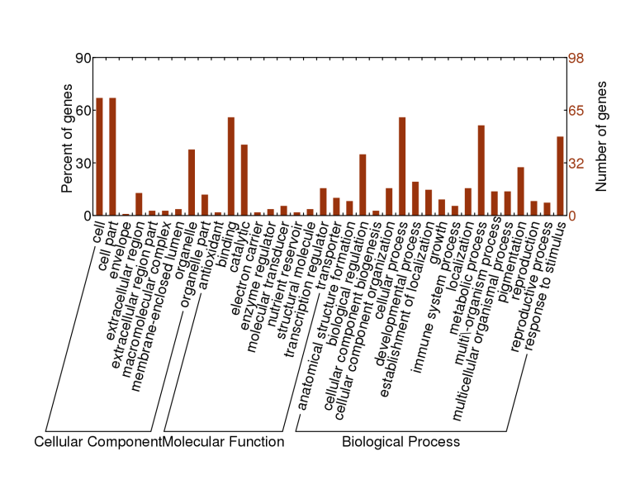

**C**

**A**

**Figure S1.** Detection of differentially expression genes and GO analysis.

A: DEGs detection between *Gmdwarf1* mutant and wild type in cotyledon (FC: fold change; CPM: counts-per-million).

B: DEGs detection between *Gmdwarf1* mutant and wild type in root (FC: fold change; CPM: counts-per-million).

C: GO distribution analysis of DEG.

D: GO enrichment result from agriGO.

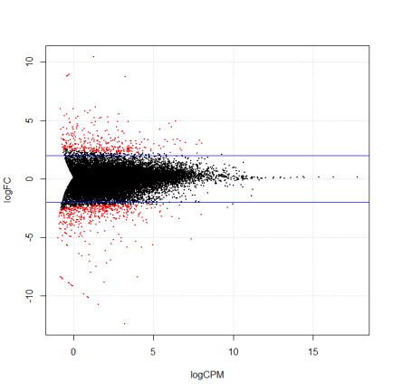

cotyledon

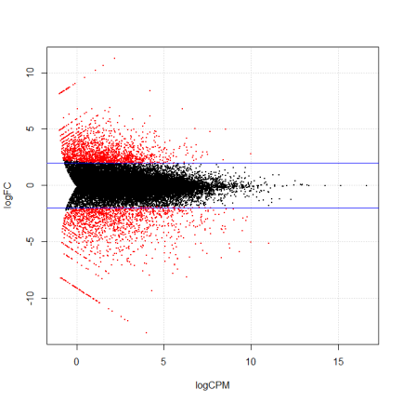

**B**

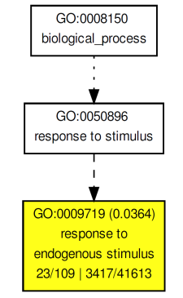

**D**

level 1

two significant nodes