**Supporting Information**

**Figure S1**. Distribution of the Toledo Area Metroparks in Lucas County, Ohio. The populations included in this study are identified by the name of the park where the trees were sampled. The parks that were included are Pearson, Wildwood, Secor, Swan Creek, Oak Openings, Blue Creek, Fallen Timbers, and Side Cut.

**Figure S2.** Relationship of log geographical distance and genetic differentiation Fst/(1-Fst) between populations as proposed by Rousset (1997). (Mantel test, R2 = -0.056, P = 0.54).

**Figure S3.** Determination of the number of clusters present in the sample of 8 populations of *Fraxinus pennsylvanica* as estimated by the program Structure (Hubisz *et al*. 2009). Δ*K* is an *ad* *hoc* measure based upon the second order rate of change of the likelihood function with respect to each *K* value (Evanno *et al*. 2005). The number of clusters corresponds to the modal value, which in this case corresponds to *K* = 3.

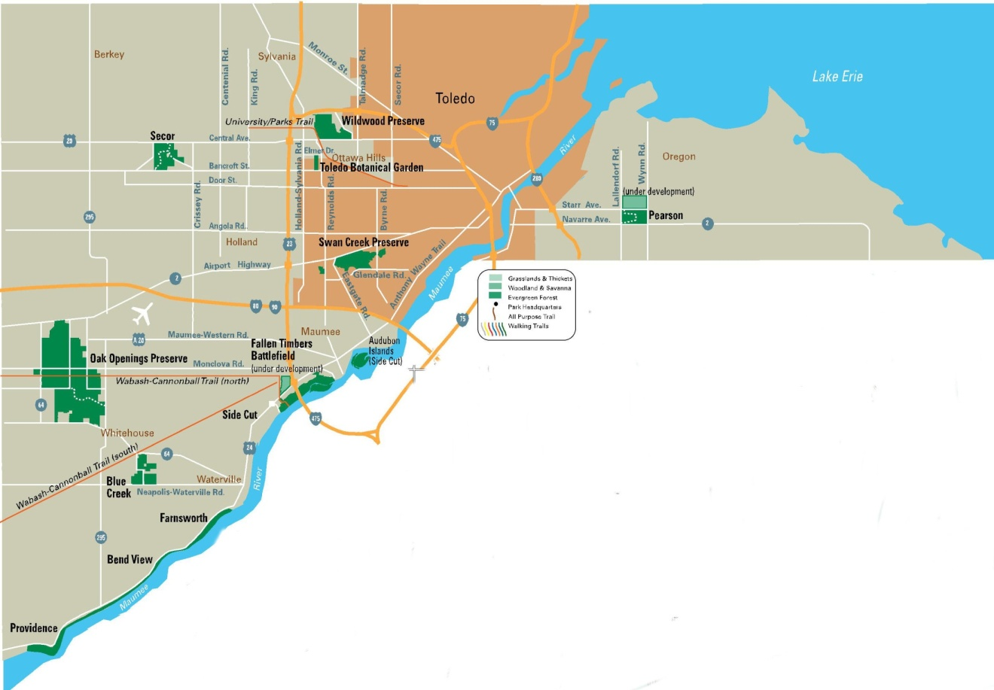

**Figure S1**.



**Figure S2.**

**Figure S3.**

Table S1. Summary of Wright’s F-Statistics for all microsatellite loci. *FIS*, inbreeding coefficient; *FIT*, deviation from Hardy-Weinberg proportions in the total population; *FST*,relative differentiation between populations. Loci are described by Lefort *et al.* (1999).

|  |  |  |  |
| --- | --- | --- | --- |
| Locus | *FIS* | *FIT* | *FST* |
| *Femsatl* 1 | -0.148 | -0.079 | 0.06 |
| *Femsatl* 4 | -0.164 | -0.093 | 0.061 |
| *Femsatl* 11 | -0.109 | -0.027 | 0.074 |
| *Femsatl* 16 | -0.128 | -0.009 | 0.105 |
| *Femsatl* 19 | -0.3165 | -0.168 | 0.112 |
| Mean | -0.1711 | -0.073 | 0.083 |

Table S2. Pairwise fixation index (FST) values for all combinations of the eight populations of *Fraxinus pennsylvanica* considered in this study.

|  |  |  |  |  |  |  |  |  |  |
| --- | --- | --- | --- | --- | --- | --- | --- | --- | --- |
| Population | Blue Creek | Fallen Timbers | Oak Openings | Pearson | Providence | Sidecut | Secor | Swan Creek | Wildwood |
| Blue Creek |  | 0.0170 | 0.0937 | 0.0428 | 0.0409 | 0.0460 | 0.0953 | 0.0818 | 0.0269 |
| Fallen Timbers |  |  | 0.0665 | 0.0314 | 0.0323 | 0.0389 | 0.0607 | 0.0567 | 0.0223 |
| Oak Openings |  |  |  | 0.0829 | 0.0682 | 0.0869 | 0.0909 | 0.0385 | 0.1048 |
| Pearson |  |  |  |  | 0.0471 | 0.0641 | 0.0783 | 0.0741 | 0.0341 |
| Providence |  |  |  |  |  | 0.0645 | 0.0688 | 0.0490 | 0.0418 |
| Sidecut |  |  |  |  |  |  | 0.0853 | 0.0805 | 0.0370 |
| Secor |  |  |  |  |  |  |  | 0.0799 | 0.0660 |
| Swan Creek |  |  |  |  |  |  |  |  | 0.0818 |