Supplementary online material 2:
Table S2. Description of locations used for the evaluation of 225 pearl millet accessions during the 2010 season in Sudan.
Location | Water regime | Longi-tude (dec.) | Lati-tude (dec.) | Alti-tude (m) | Soil type | Soil pH | Rainfall² (mm) | RH¹ (%) | T¹ (°C)
El Fasher | Rainfed | 25.323 | 13.637 | 710 | Sandy soil | 7.3 | 172.0 | 24.3 | 27.1
El Obeid | Rainfed | 30.290 | 13.126 | 570 | Sandy soil | 6.5–7.4 | 214.8 | 25.2 | 28.0
Wad Medani | Irrigated | 33.483 | 14.381 | 407 | Cracking vertisol | 7.5–8.5 | 206.4 | 28.0 | 29.7
¹ Mean relative humidity (RH %) and Temperature (T) per year; ²Total amount of rainfall per year.

Table S3. Range of variation for Fe, Zn, Ca and Mg in edible tissues of some common field crops.
Crop | Genotypes | Fe  (mg kg⁻¹) | Zn  (mg kg⁻¹) | Ca  (mg kg⁻¹) | Mg  (mg kg⁻¹) | Number of genotypes | Reference
Wheat  (Triticum aestivum) | Bread wheat genotypes | 29 – 57 | 25 – 53 | 250 – 730 | 920 – 1430 | 132 | Graham et al. (1999)
Triticale  (Triticosecale) | Selected cultivars | 28 – 36 | 21 – 31 | 350 – 500 | 1200 – 1460 | 10 | Feil and Fossati, (1995)
Rice  (Oryza sativa) | Collected genotypes | 1 – 27 | 13 – 44 | 42 – 342 | 63 – 539 | 274 | Jiang et al. (2007)
Maize (Zea mays) | Core collection | 10 – 63 | 13 – 58 | – | – | 1814 | Bänziger and Long, (2000)
Sorghum (Sorghum bicolor) | Diverse germplasm | 20 – 37 | 13 – 31 | – | – | 84 | Reddy et al. (2005)
Finger millet (Eleusine coracana) | Core collection | 22 – 65 | 17 – 25 | 1840 – 4890 | – | 622 | Upadhyaya et al. (2011)
Pearl millet (Pennisetum glaucum) | Diverse germplasm | 30 – 76 | 25 – 65 | – | – | 120 | Velu et al. (2007)
Bean (Phaseolus vulgaris) | Selected genotypes | 48 – 74 | 17 – 28 | 1390 – 2040 | 1470 – 1960 | 8 | Ariza-Nieto et al. (2007)
Chickpea (Cicer arietinum) | Commercial cultivars | 24 – 41 | 35 – 60 | 1900 – 2200 | 40 – 50 | 4 | Zia-Ul-Haq et al. (2007)
Cowpea (Vigna unguiculata) | Collected accessions | 34 – 80 | 22 – 58 | 310 – 1395 | 1515 – 2500 | 1541 | Boukar et al. (2011)

Fig. S1. Frequency distribution of 225 pearl millet accessions for panicle density, panicle length, plant height and days to 50% flowering.

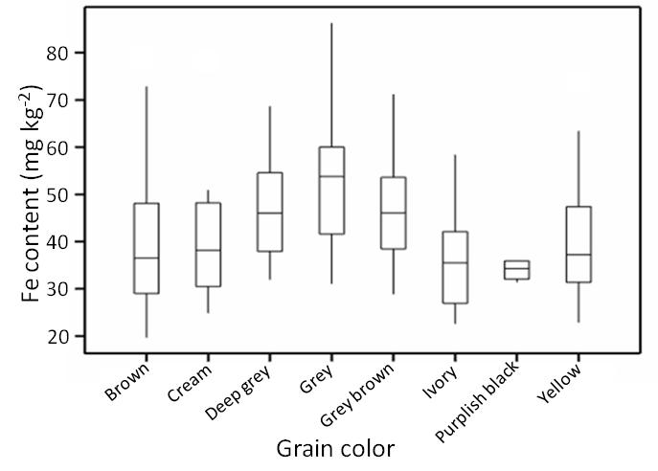
Fig. S2. Box-plots of mean grain Fe content of different color grains of Sudanese pearl millet.

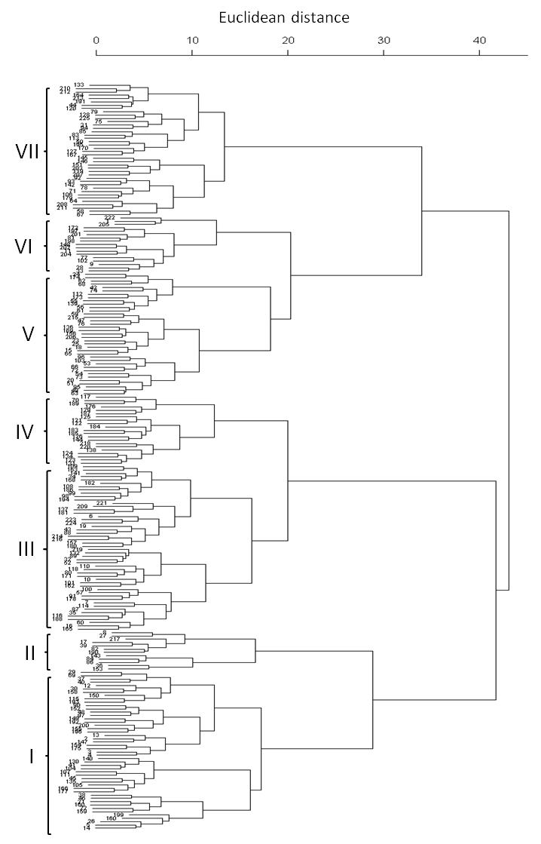
Fig. S3. Neighbor-joining tree showing the phenotypic relationship of 225 pearl millet accessions based on 16 agro-morphological traits.

