Table S1: Grouping of genotypes from two Indian subcontinent landrace collections into Mesoamerican and Andean genepool subgroups based on microsatellite marker analysis.
HPK Collection  (Set I) |  |  |  |  |  |  | FAO Collection (Set II)
M1 | M2 |  | A1 | A2 |  | A3 |  | M1 | M2 |  | M2 |  | M3 | A1 |  | A1
KR-201 | KR-216 |  | KR-157 | KR-257 |  | KR-260 |  | G14204 | G13114 |  | G13110 |  | G14211 | G20602 |  | G13113
KR-248 | KR-133 |  | KR-227 | KR-39 |  | KR-45 |  | G14205 | G20575 |  | G486 |  | G20618 | G20626 |  | G13892
KR-197 | KR-131 |  | KR-94 | KR-158 |  |  |  | G20659 | G20577 |  | G183 |  | G20690 | G20632 |  | G14200
KR-24 | KR-172 |  | KR-221 | KR-90 |  |  |  | G20667 | G20579 |  | G183A |  | G464 | G474 |  | G20568
KR-64 | KR-117 |  | KR-43 | KR-82 |  |  |  | G20668 | G20586 |  | G183B |  |  | G13886 |  | G20603
KR-62-2 | KR-240 |  | KR-9 | KR-293 |  |  |  | G20669 | G20590 |  | G449 |  |  | G13894 |  | G20604
KR-95 | KR-190 |  | KR-130 | KRC-1 |  |  |  | G20669A | G20601 |  | G467 |  |  | G20653 |  | G20622
KR-246 | KR-166 |  | KR-62 | KRC-2 |  |  |  | G20682 | G20605 |  | G16830 |  |  | G20654 |  | G20640
Kullu-3 | KR-84 |  | KR-256 | KRC-22 |  |  |  | G20683 | G20629 |  | G7223 |  |  | G20655 |  | G20692
Kullu-5 | IC-415517 |  | Kullu-7 | KRC-6 |  |  |  | G20690A | G20630 |  |  |  |  | G146
Sirmour-4 | Hans |  | Kullu-8 | KRC-7 |  |  |  | G5773* | G20633 |  |  |  |  | G1380
IC-448907 | IC-423495 |  | Kullu-9 | KRC-9 |  |  |  | DOR364* | G20644 |  |  |  |  | G1382
IC-415334 | IC-421101 |  | Nichar | Kullu-2 |  |  |  |  | G13100 |  |  |  |  | G13106
IC-329505 | IC-415408 |  | Sirmour-1 | Lari-1 |  |  |  |  | G14202 |  |  |  |  | G13107
 | IC-319370 |  | Sirmour-5-II | Contender |  |  |  |  | G14203 |  |  |  |  | G13898
 | ICAPIJAO |  | Jwala | Baspa |  |  |  |  | G20656 |  |  |  |  | G13899
 | DOR364 |  | KRC5 |  |  |  |  |  | G20657 |  |  |  |  | G13900
 |  |  | Him-1 |  |  |  |  |  | G20658 |  |  |  |  | G463
 |  |  | IC-311080 |  |  |  |  |  | G20660 |  |  |  |  | G448
 |  |  | IC-329499 |  |  |  |  |  | G20670 |  |  |  |  | G468
 |  |  | G4494 |  |  |  |  |  | G20671 |  |  |  |  | G469
 |  |  | G19833 |  |  |  |  |  | G20681 |  |  |  |  | G470
 |  |  |  |  |  |  |  |  | G20691 |  |  |  |  | G20698
 |  |  |  |  |  |  |  |  | G145 |  |  |  |  | IJR
 |  |  |  |  |  |  |  |  | G1379 |  |  |  |  | G4494*
 |  |  |  |  |  |  |  |  | G711 |  |  |  |  | G19833*

Table S2. Allele size, number, heterozygosity and polymorphism information contents (PIC) based on evaluation of 157 common bean collections, analysis in germplasm set I from the HPK collection, germplasm set II from the FAO collection and for the total germplasm set with genomic and gene-based microsatellite markers.
 |  |  |  | Set I (HPK collection) |  |  |  | Set II (FAO collection) |  |  |  | Total
 | Allele size (bp) |  |  | na | He | Ho | PIC | na | He | Ho | PIC | na | He | Ho | PIC
Marker | Min | Max | Range
Genomic
AG1 | 124 | 142 | 22 | 4 | 0.134 | 0.000 | 0.130 | 5 | 0.133 | 0.000 | 0.130 | 5 | 0.113 | 0.000 | 0.110
BM139 | 84 | 118 | 34 | 7 | 0.716 | 0.000 | 0.674 | 7 | 0.635 | 0.000 | 0.601 | 8 | 0.684 | 0.000 | 0.647
BM140 | 160 | 200 | 40 | 3 | 0.378 | 0.000 | 0.317 | 4 | 0.465 | 0.000 | 0.423 | 4 | 0.434 | 0.000 | 0.403
BM143 | 150 | 174 | 24 | 10 | 0.744 | 0.083 | 0.708 | 7 | 0.778 | 0.145 | 0.746 | 12 | 0.772 | 0.121 | 0.740
BM151 | 144 | 155 | 11 | 3 | 0.430 | 0.015 | 0.368 | 3 | 0.663 | 0.000 | 0.588 | 3 | 0.606 | 0.007 | 0.533
BM155 | 105 | 120 | 15 | 2 | 0.466 | 0.014 | 0.357 | 2 | 0.499 | 0.000 | 0.374 | 2 | 0.496 | 0.007 | 0.373
BM157 | 100 | 118 | 18 | 3 | 0.574 | 0.042 | 0.494 | 3 | 0.490 | 0.023 | 0.390 | 3 | 0.528 | 0.033 | 0.442
BM160 | 180 | 255 | 75 | 6 | 0.731 | 0.085 | 0.685 | 8 | 0.703 | 0.013 | 0.659 | 10 | 0.733 | 0.041 | 0.694
BM181 | 178 | 200 | 22 | 4 | 0.637 | 0.029 | 0.566 | 3 | 0.535 | 0.023 | 0.449 | 5 | 0.602 | 0.026 | 0.524
BM197 | 196 | 202 | 6 | 4 | 0.654 | 0.014 | 0.584 | 3 | 0.611 | 0.000 | 0.530 | 4 | 0.653 | 0.007 | 0.580
BM210 | 165 | 190 | 25 | 7 | 0.675 | 0.014 | 0.641 | 6 | 0.774 | 0.012 | 0.738 | 9 | 0.757 | 0.013 | 0.723
BMd33 | 98 | 114 | 16 | 4 | 0.598 | 0.014 | 0.539 | 4 | 0.691 | 0.000 | 0.634 | 4 | 0.660 | 0.007 | 0.597
BMd36 | 164 | 188 | 24 | 5 | 0.566 | 0.028 | 0.497 | 5 | 0.612 | 0.000 | 0.535 | 6 | 0.601 | 0.013 | 0.526
Gene based
BMd15 | 165 | 204 | 39 | 2 | 0.271 | 0.000 | 0.234 | 2 | 0.242 | 0.000 | 0.213 | 2 | 0.242 | 0.000 | 0.213
BMd20 | 113 | 130 | 17 | 4 | 0.577 | 0.014 | 0.499 | 3 | 0.552 | 0.035 | 0.451 | 4 | 0.567 | 0.020 | 0.478
BMd26 | 132 | 142 | 10 | 2 | 0.498 | 0.000 | 0.374 | 3 | 0.483 | 0.000 | 0.377 | 3 | 0.494 | 0.000 | 0.378
BMd45 | 92 | 130 | 38 | 2 | 0.499 | 0.000 | 0.375 | 2 | 0.498 | 0.000 | 0.374 | 2 | 0.499 | 0.000 | 0.374
BMd46 | 320 | 325 | 5 | 2 | 0.438 | 0.000 | 0.342 | 2 | 0.311 | 0.000 | 0.263 | 2 | 0.487 | 0.000 | 0.369
BMd53 | 106 | 110 | 4 | 2 | 0.499 | 0.000 | 0.375 | 2 | 0.483 | 0.000 | 0.366 | 2 | 0.492 | 0.000 | 0.371
Pv-ctt1 | 150 | 178 | 28 | 5 | 0.714 | 0.043 | 0.673 | 4 | 0.670 | 0.000 | 0.599 | 5 | 0.706 | 0.020 | 0.654
Pv-ag1 | 148 | 158 | 10 | 3 | 0.133 | 0.000 | 0.127 | 4 | 0.509 | 0.012 | 0.402 | 4 | 0.400 | 0.007 | 0.343
Pv-gaa1 | 158 | 168 | 10 | 2 | 0.473 | 0.000 | 0.361 | 3 | 0.506 | 0.023 | 0.389 | 3 | 0.493 | 0.014 | 0.378
Pv-ag003 | 165 | 168 | 3 | 2 | 0.041 | 0.014 | 0.041 | 2 | 0.090 | 0.000 | 0.086 | 2 | 0.070 | 0.007 | 0.067
Pv-gaat001 | 135 | 145 | 10 | 3 | 0.514 | 0.042 | 0.395 | 2 | 0.483 | 0.000 | 0.366 | 3 | 0.502 | 0.020 | 0.382
Mean | 147 | 168 | 21 | 3.8 | 0.498 | 0.019 | 0.431 | 3.7 | 0.517 | 0.012 | 0.445 | 4.5 | 0.525 | 0.015 | 0.454

na = Observed number of alleles, He= Expected heterozygosity Nei's (1976), Ho = Observed heterozygosity, PIC polymorphism information contents.

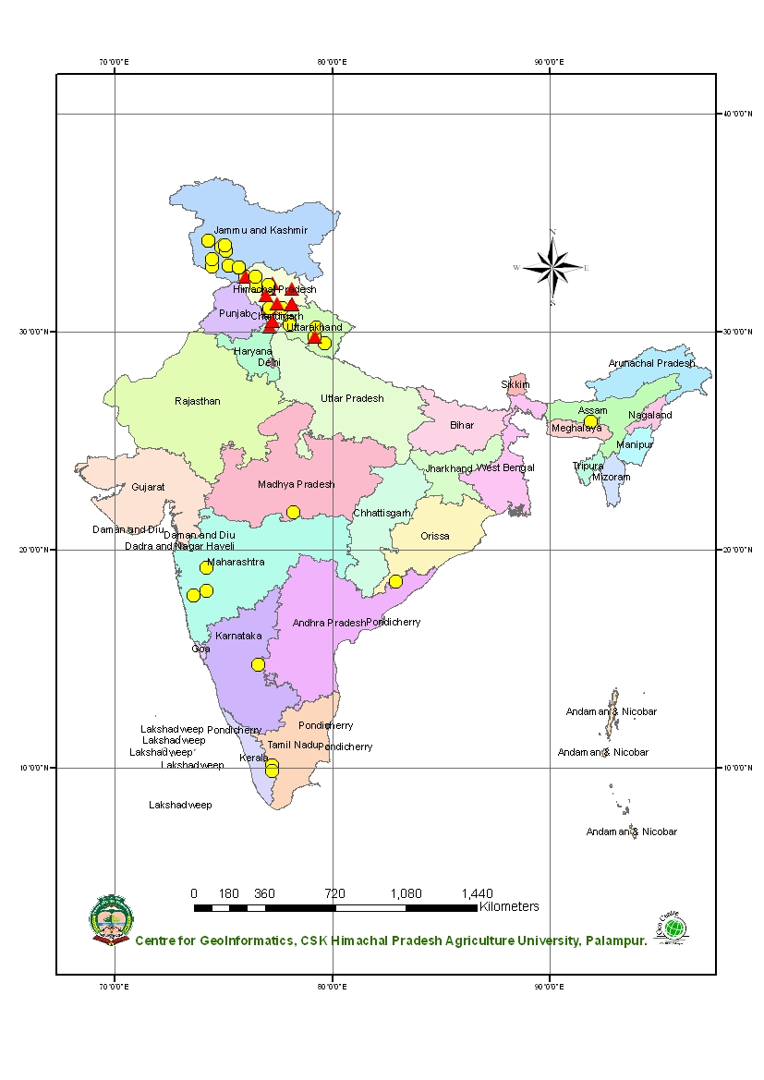

Figure S1. Geographic distribution of common bean land races from India that were used in the diversity analysis. Round dots represent the FAO (set I) genotypes and triangles represent the HPK (set II) genotypes.

