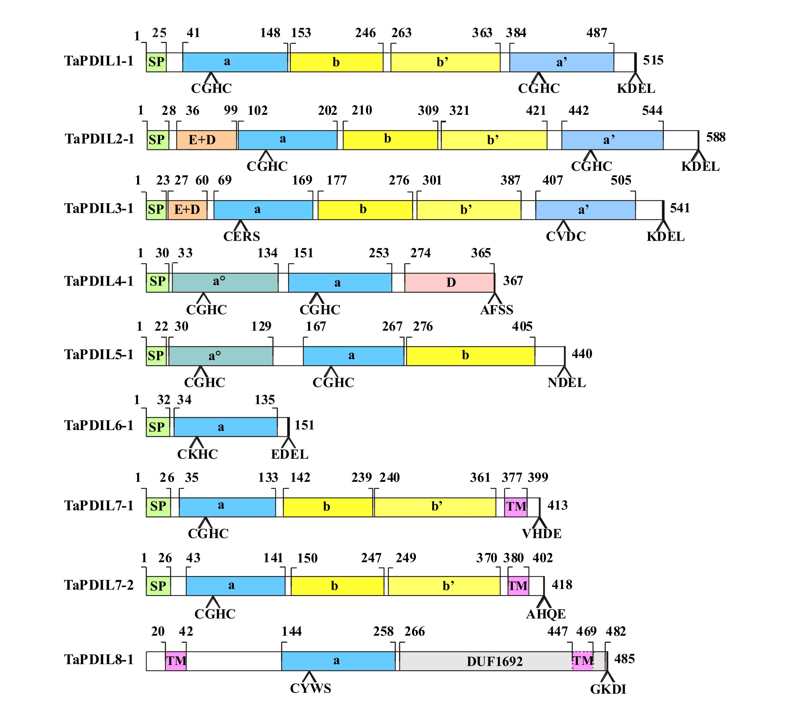

Figure S1 Domain structure of the deduced amino acid sequences of the wheat PDI and PDI-like genes.
When multiple putative homoeologous cDNA sequences were identified, the domain structure reported in the figure refers to the cDNA sequence identified by letter a. Putative signal peptides (SP), a and b type domains, N-terminal acidic domains (E+D), D domains (Erp29c), transmembrane domains (TM) and DUF domain of TaPDIL8-1 are reported. Thioredoxin-like catalytic site tetra-peptides and C-terminal tetra peptides are also reported. Numbers above indicate domain boundaries (aa), numbers on the right ORF (aa).

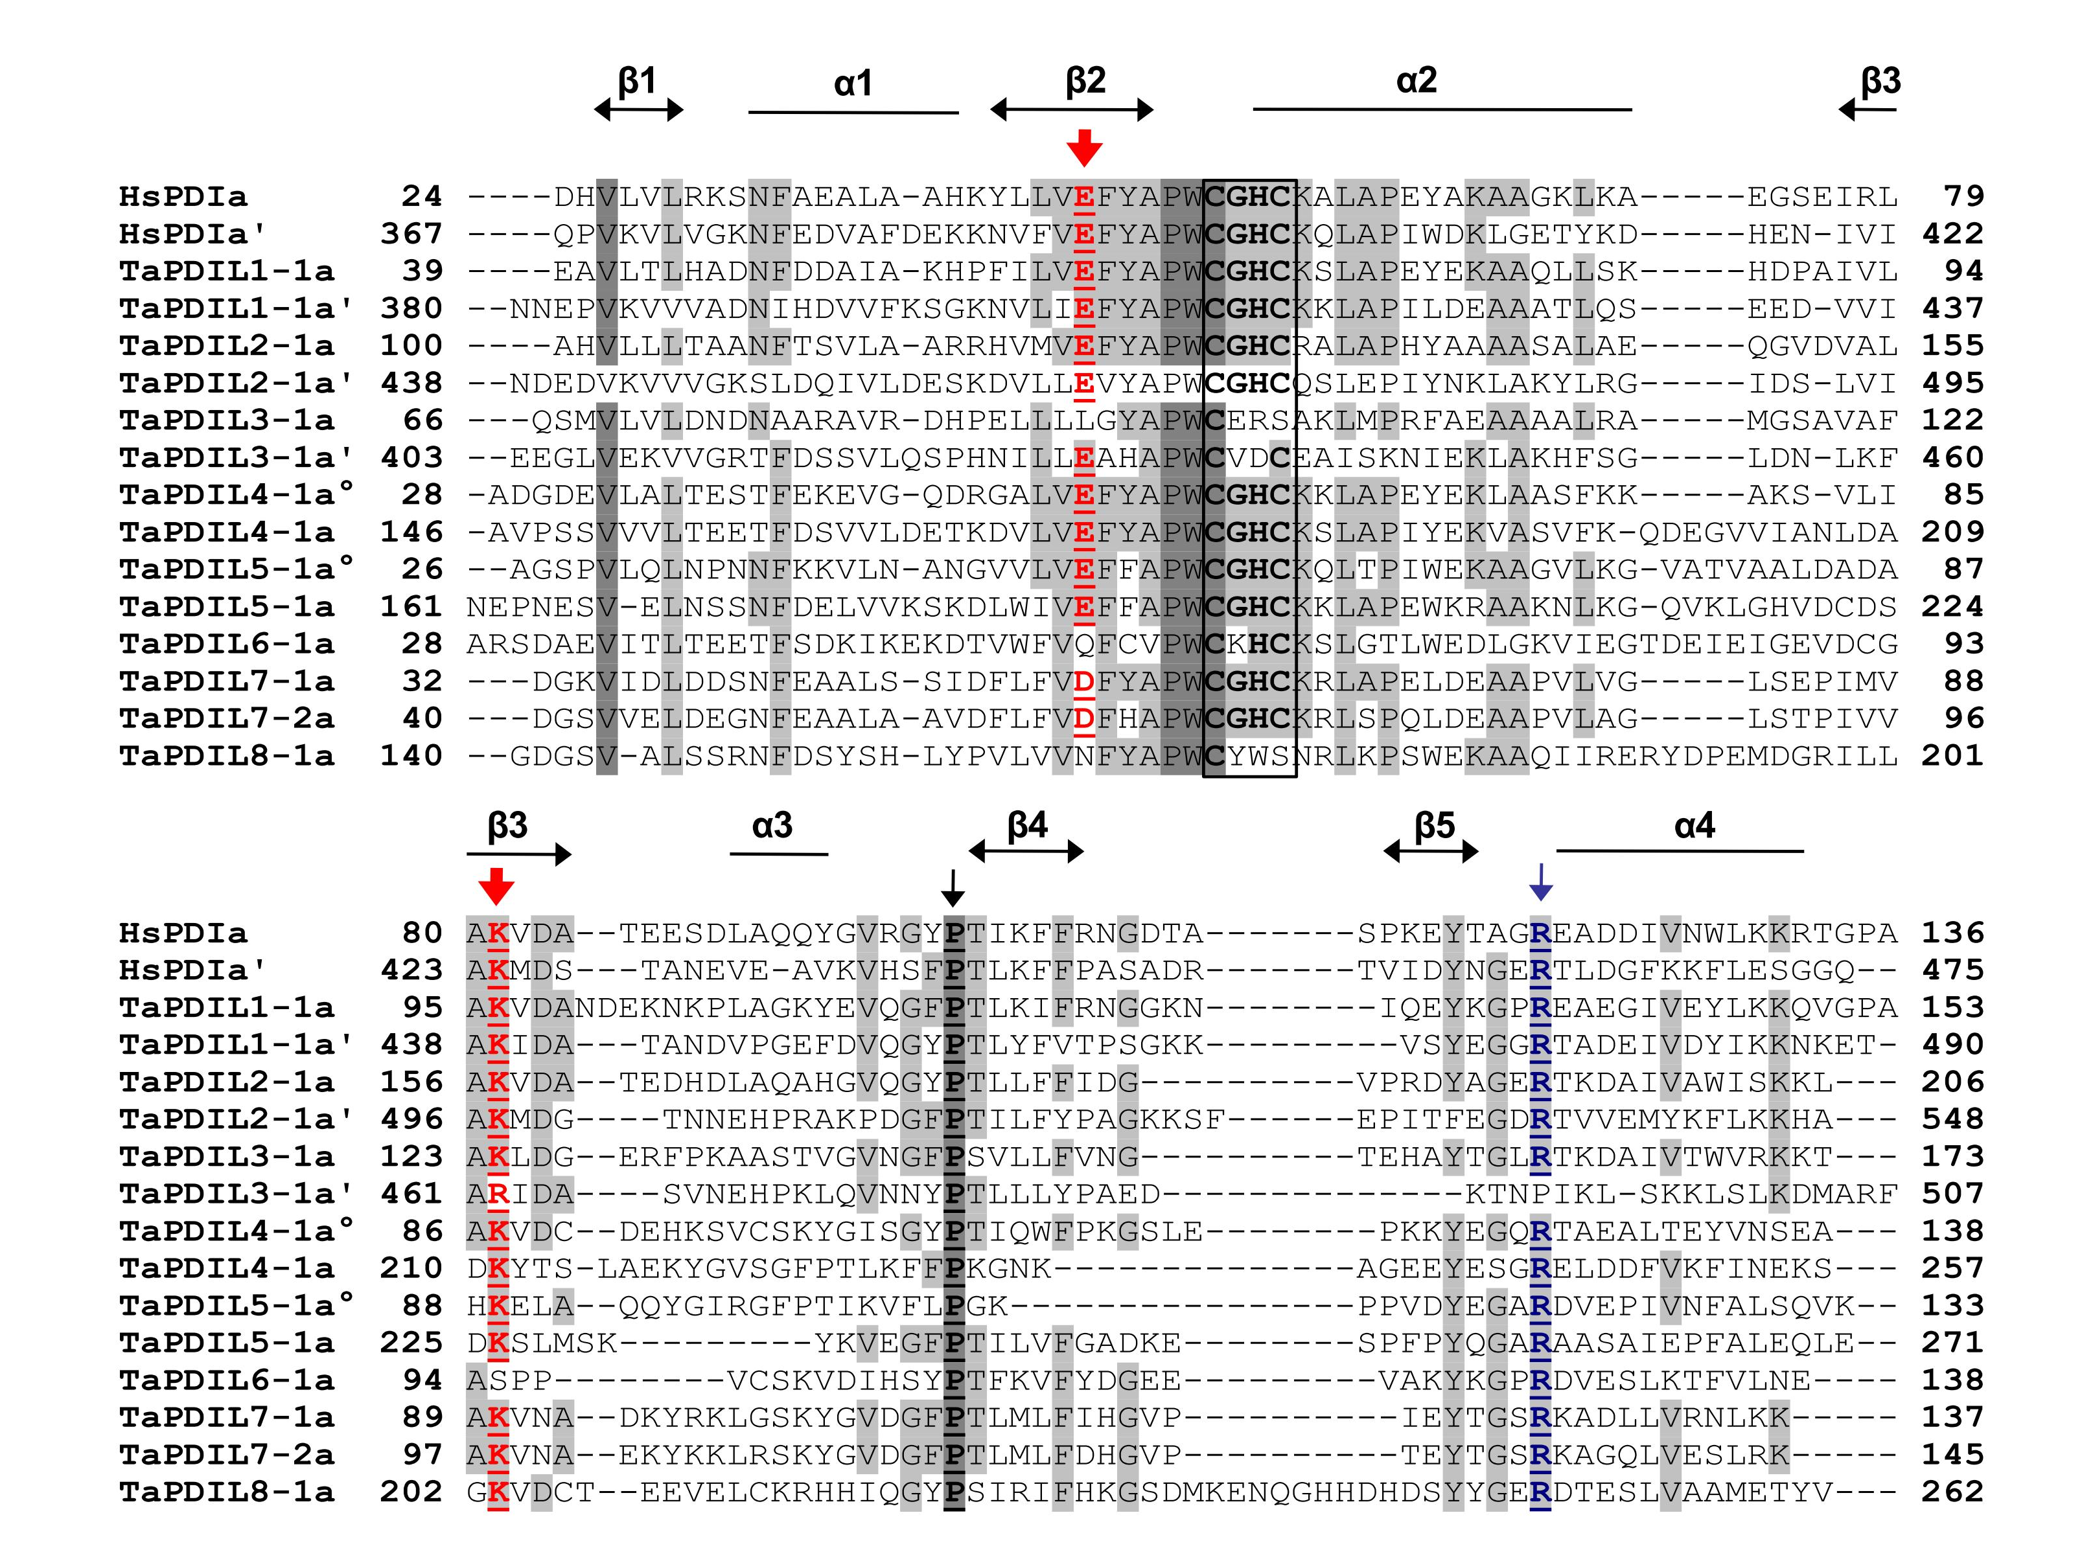

Figure S2 Multiple sequence alignment of a-type domains of wheat PDI-like proteins and human typical PDI.
The alignment was obtained using ClustalX version 1.83 with the following parameters: gap penalty 10, gap extension penalty 0.5, BLOSUM protein weight matrix. The alignment was also manually adjusted, considering the secondary structure predictions of wheat PDI-like proteins and the known structure of the a domain of the human PDI. Residues highlighted in grey and light grey showed 100% and >50% identity conservation, respectively. Elements of the secondary structure are delimited by open bars (α helices) and arrowheads (β strands). Red arrows indicate the two buried charged residues close to the active site, blue arrow indicates the conserved arginine (R) located in the loop between β5 and α4 of the catalitic domains and black arrow the cis prolines (P) near each active site. Active-site residues within the a-type domains are boxed.

