Appendix 1. Survey sent to participants
Study Information and Consent

Welcome.

This project aims to determine the current level of psychological support services available within Palliative Care Services in Australia. This will provide a useful insight into the adequacy of current services and any gaps that can be addressed in future funding initiatives.

The project involves completing an anonymous online survey that includes both multiple choice and free text questions. The survey contains 12 parts and will likely take up to 10 minutes to complete. Participation is completely voluntary. All answers are anonymous. By continuing with the survey, you are consenting to your involvement in this project. You can withdraw from the online survey at any stage before it is submitted.

You have been invited to participate because you have been identified as a member of staff involved in delivering psychological support services in your palliative care service. If you think a different person within your service may be better placed to answer this survey, please forward the original email to them. We are aiming to only collect one response from each palliative care service in Australia.

This research project has been approved by the Human Research Subcommittee in the School of Psychology at the University of Adelaide (approval number 21/73). This research project will be conducted according to the NHMRC National Statement on Ethical Conduct in Human Research 2007 (Updated 2018). Any concerns can be directed to the Human Research Ethics Committee’s Secretariat on telephone (08) 8313 6028, email hrec@adelaide.edu.au, or post Level 4, Rundle Mall Plaza, 50 Rundle Mall, Adelaide SA 5000.

Thank you for your participation.

Please click the green arrow below to begin.
Basic Information
Q1. What is your job title? Please select all that apply.
- Chief Executive
- Senior Manager - Please specify which discipline:
- Clinical Lead of Psychosocial Service
- Social Worker
- Other - Please specify:
Q2. What year did your palliative care service begin?
Q3. Approximately how many referrals are made to your service each month? If you are unsure, please leave blank.
Q4. Approximately what percentage of referrals to your service are for patients with a malignant diagnosis? If you are unsure, please leave blank.
Q5. Does your service use any screening instruments to assess psychological distress? If yes, please specify which ones from the list below.
- Edinburgh Depression Scale
- Hospital Anxiety and Depression Scale (HADS)
- Visual Analogue Scale
- Beck Depression Inventory
- Bereavement Risk Assessment Tool (BRAT)
- Other – Please specify:
- No screening instruments used
Q6. Which of the following does your palliative care service offer? Please select all that apply.
- Hospice inpatient beds
- Community palliative care team
- Palliative care outpatient clinics
- Hospital consult-liaison service
Outpatient Service
Q6a. Approximately how many patients are reviewed in outpatient palliative care clinics each week? If you are unsure, please leave blank.
Community Service
Q6b. Approximately how many new referrals does your community team receive each week? If you are unsure, please leave blank.
Q6c. Approximately how many patients are known to your community team at any one time? If you are unsure, please leave blank.
Inpatient Service
Q6d. How many inpatient beds are available in your hospice?
Q6e. How many new referrals are made to the hospice each week? If you are unsure, please leave blank.
Palliative Care Consultant
Q7. Does your service have access to a Palliative Care Consultant (FRACP/FAChPM)?
- Yes
- No
Q7a. Is the Palliative Care Consultant:
- Full time
- Part time - Please indicate amount of full time equivalent (FTE):
- Visits if requested

Types of Psychological Supports Available
Q8. This question relates to the availability of psychological health professionals within your palliative care service. Please select all that apply.
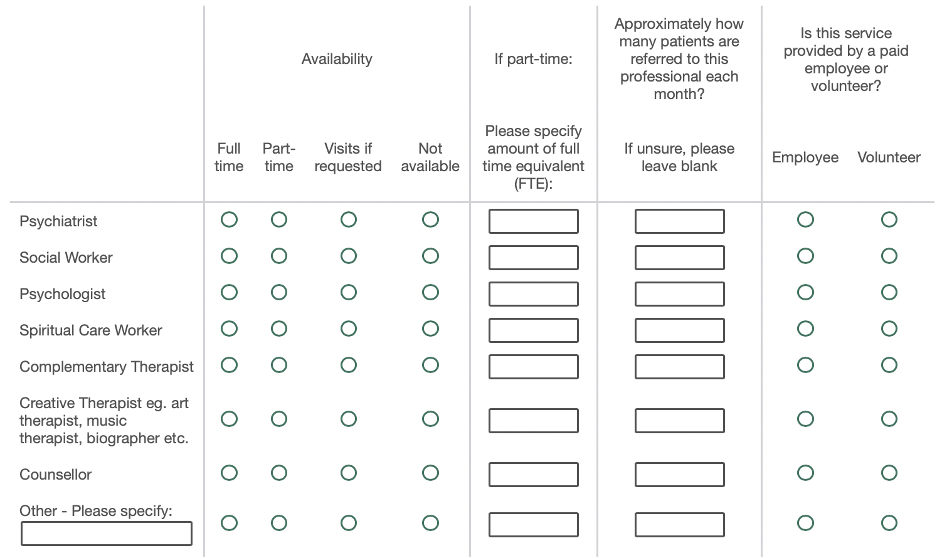
Q9. This question relates to the skills and roles of psychological health professionals within your palliative care service. Please select all that apply.
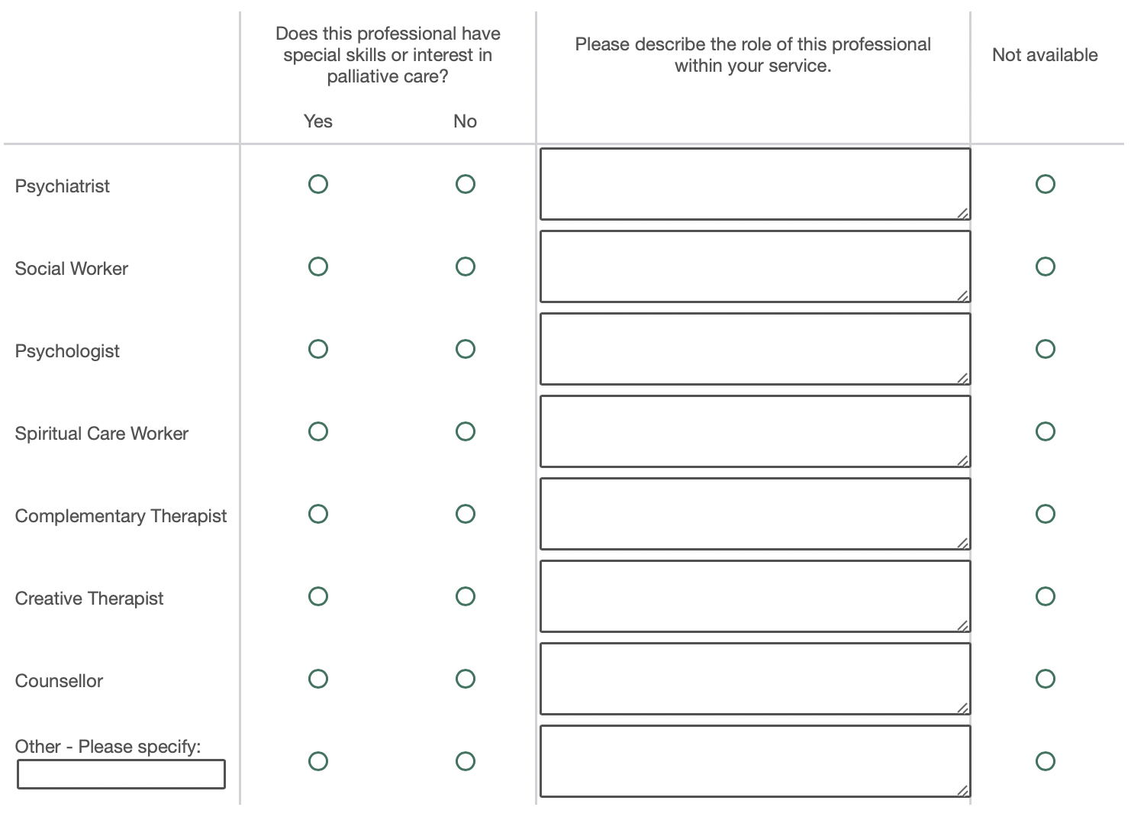
Q10. Do these professionals attend multi-disciplinary meetings/ward rounds? Please select the relevant boxes.
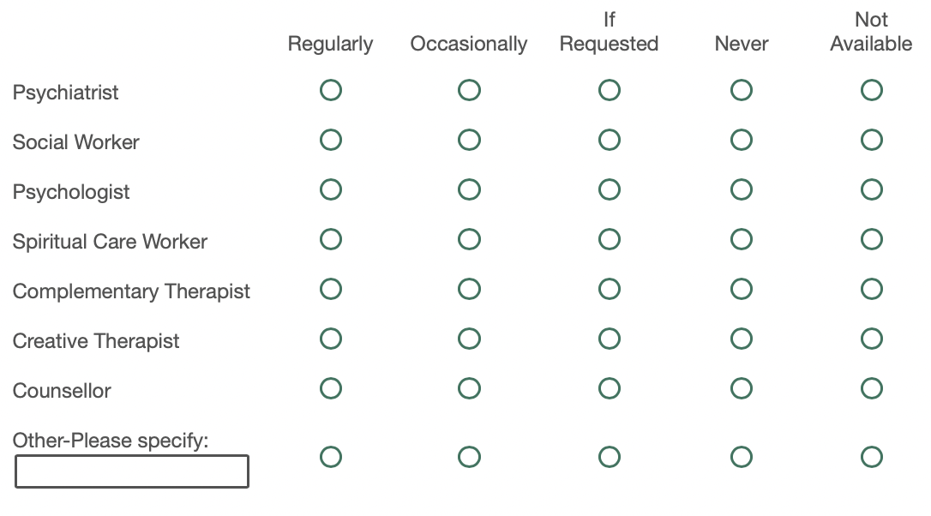
Adequacy of Psychological Supports
Q11. How would you rate access to psychological support services within your Palliative Care service?
- Very poor
- Poor
- Fair
- Good
- Very good
Q12. Do you have any further comments about psychological support services provided by your service?

