Supplement
Supplementary Figure 1. Vignette 1
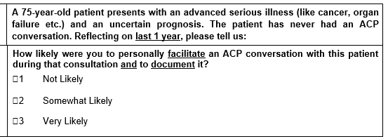
Supplementary Figure 2. Vignette 2
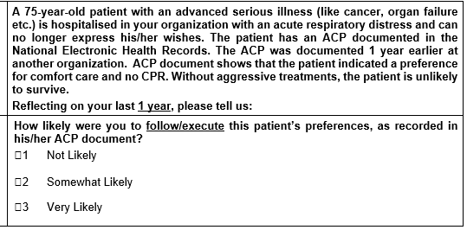

Supplementary Figure 3. Flow chart of study participants
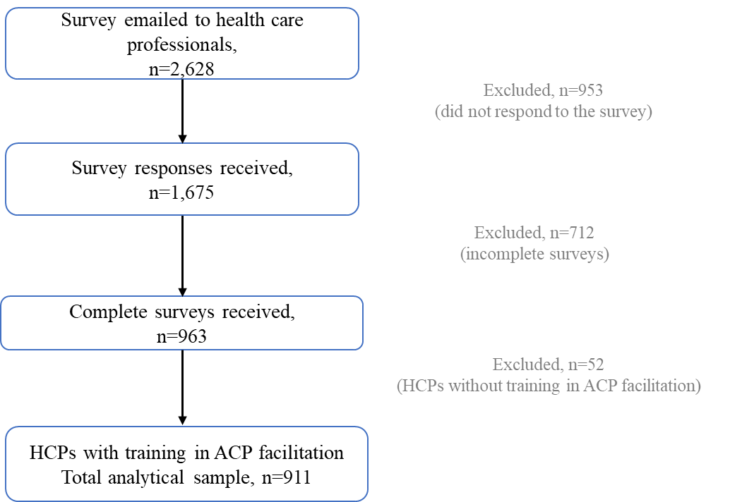

Supplementary Table 1. Participants conducting ACP in the last one year stratified by profession, n=911
 | Physician | Non-Physician | p-value | Total
Number of ACP facilitated in the last one year, n(%)
None | 58 (14.8) | 334 (85.2) | <0.01* | 392 (43.0)
One or more | 131 (25.3) | 387 (74.7) |  | 518 (56.9)
No response | 0 (0) | 1 (100.0) |  | 1 (0.1)
Total | 189 (20.8) | - (79.3) |  | 911 (100.0)
* Chi-square test was used to test for statistical difference between the groups
Supplementary Table 2. Association between conducting an advance care planning (ACP) conversation in the past one year and perceived barriers for doing so.
 | Odds Ratio (95% CI)
HCP factors
I do not have protected time to conduct ACP, n=909 | 0.71 (0.64, 0.79) ***
ACP facilitation is time-consuming, n=906 | 0.82 (0.73, 0.92) ***
ACP documentation is time-consuming, n=907 | 0.86 (0.77, 0.96) **
It is not my role/job to facilitate ACP, n=905 | 0.55 (0.49, 0.62) ***
I do not feel confident in facilitating ACP conversations, n=906 | 0.49 (0.43, 0.56) ***
I do not see the benefit in doing ACP since it is never used to inform patients’ end-of-  life care, n=905 | 0.82 (0.71, 0.94) ***
I do not know enough about patient’s disease to facilitate ACP, n=906 | 0.73 (0.65, 0.83) ***
I fear ‘upsetting’ the patient and/or family, n=907 | 0.71 (0.62, 0.80) ***
ACP facilitation is not recognized and rewarded at my performance review, n=904 | 0.80 (0.73, 0.88) ***
Patient-related factors
Patient does not want to do ACP, n=907 | 0.98 (0.85, 1.13)
Patient has an uncertain prognosis, n=906 | 0.92 (0.80, 1.05)
I do not have a pre-existing relationship with patient, n=905 | 0.94 (0.85, 1.05)
Patient is not accepting of prognosis, n=903 | 1.05 (0.92, 1.21)
Patient’s life can be extended, n=901 | 0.85 (0.74, 0.97) **
Patient has difficulty understanding pros and cons of life sustaining interventions, n=905 | 0.92 (0.80, 1.06)
Caregiver-related factors
No one can be identified as a nominated health care spokesperson for the patient, n=904 | 0.91 (0.80, 1.03)
Family fears ‘upsetting’ the patient, n=906 | 0.82 (0.71, 0.93) ***
Family feels that patient will not be able to understand ACP, n=906 | 0.79 (0.69, 0.91) ***
Family has difficulty accepting patient’s poor prognosis, n=905 | 0.85 (0.74, 0.98) **

