Figure 1. Updated Serious Illness Conversation Guide

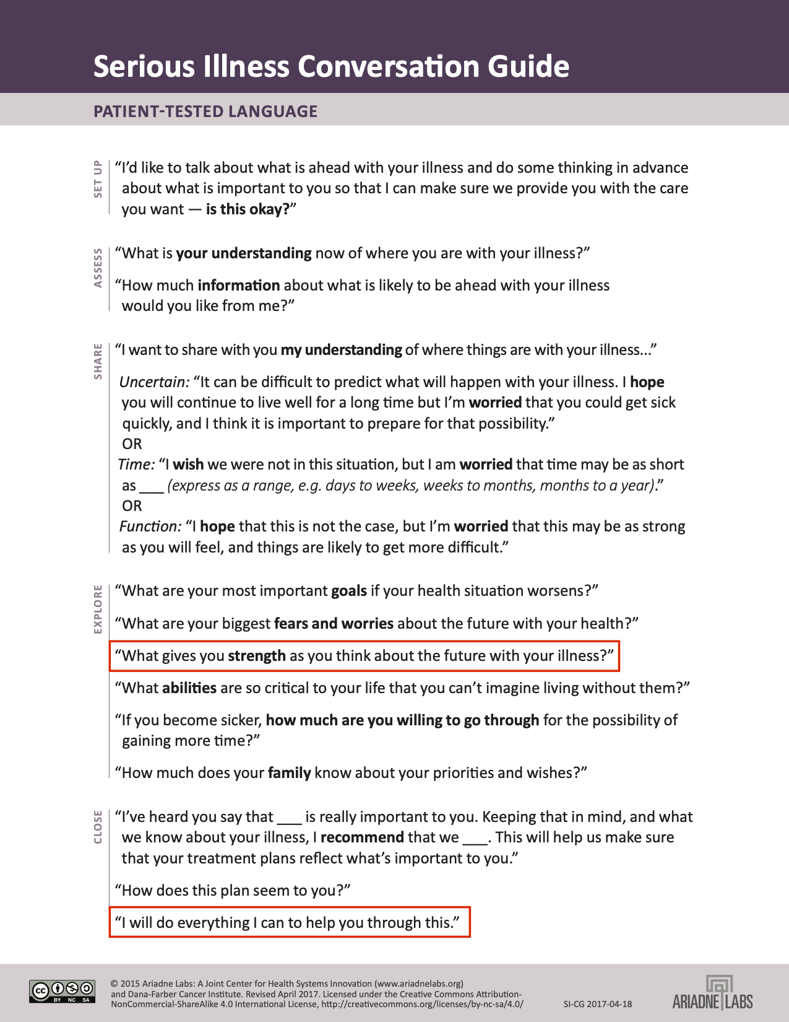
Note: Updates to the guide based on focus group findings appear in boxes lined in red.

Figure 2. Patient end-of-life care preferences and beliefs about dying and ACP (baseline)

Figure 3. Patient ratings of Serious Illness Conversation Guide conversation acceptability by content domain

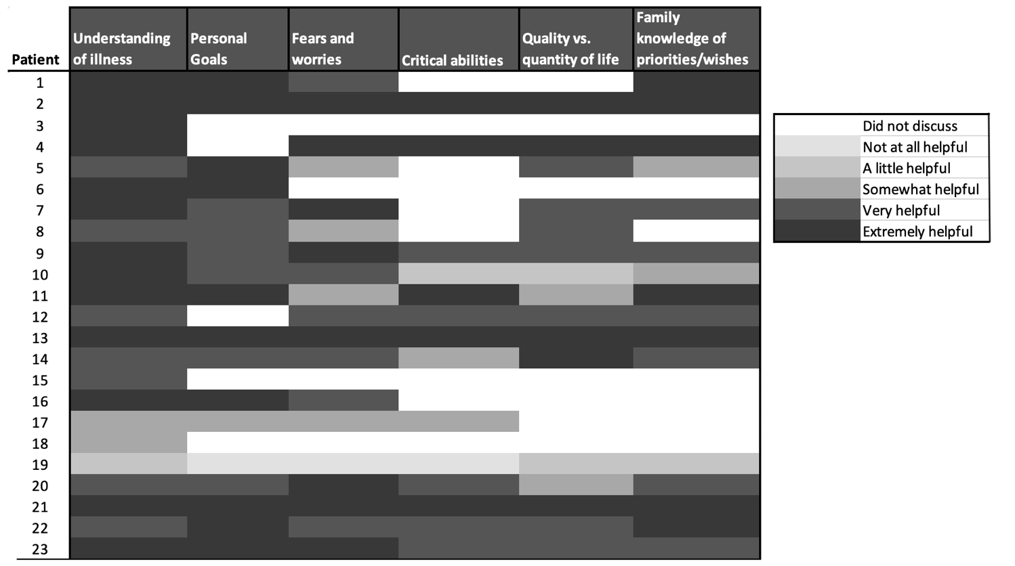

Table 1. Pilot study participant characteristics (n=23)

Characteristic | N (%)
Male gender | 6 (26)
Age, average (range) | 71 (50-88)
Marital Status
Married | 6 (26)
Widowed | 6 (26)
Divorced | 2 (9)
Single, never married | 9 (39)
Highest education
Less than high school | 9 (39)
High school graduate | 6 (26)
Some college or technical school | 4 (17)
College graduate | 4 (17)
Income
<$10,000 | 15 (65)
$10,000-$20,000 | 3 (13)
$20,000-$40,000 | 1 (4)
$40,000-$60,000 | 2 (9)
$60,000-$70,000 | 1 (4)
>$75,000 | 1 (4)
Self-rated health
Poor health | 4 (17)
Fair health | 5 (22)
Good health | 11 (48)
Very good health | 2 (9)
Excellent health | 1 (4)
ER visits in last 12 months, average (range) | 1.5 (0-6)
Hospital stays in last 12 months, average (range) | 2.6 (0-21)
Self-reported cancer diagnosis | 21 (91)
Primary Cancer diagnosis
Lung | 2 (9)
Genitourinary (Prostate/Bladder) | 3 (13)
Gynecologic (Uterine, Cervix, Ovary) | 7 (30)
Gastrointestinal (Gastric, Pancreas, Colon) | 5 (22)
Glioblastoma | 1 (4)
Other | 5 (22)
Living will in place | 7 (30)
Durable Power of Attorney for Healthcare in place | 5 (22)

Table 2. Clinician confidence in communication topics with seriously ill patients at baseline and follow-up

Communication Topic* | Clinician Confidence
 | Baseline Average (range) n=6 | Follow-up Average (range) n=4 | Average Change Over Time  n=4
Discussing end of life issues | 5.00 (4-6) | 5.83 (5-6) | 1.00
Demonstrating empathy | 5.5 (5-6) | 6.00 (5-7) | 0.25
Estimating prognosis | 4.5 (4-5) | 5.17 (4-6) | 0.50
Assessing patient understanding of prognosis | 4.5 (4-5) | 5.17 (4-6) | 0.75
Determining information preferences | 4.75 (4-6) | 5.5 (4-7) | 0.50
Inquiring about fears/worries | 3.75 (3-5) | 5.67 (5-7) | 1.75
Eliciting patient goals | 3.75 (3-5) | 5.17 (3-7) | 1.25
Assessing views on functional impairment | 4.25 (3-6) | 5.17 (3-7) | 0.75
Assessing tradeoffs | 4.75 (4-6) | 4.83 (3-7) | -0.25
Telling a patient he/she has a poor prognosis | 5.25 (5-6) | 5.50 (4-6) | 0.50
Using therapeutic silence | 5.25 (4-6) | 5.50 (4-7) | 0.00
Responding to patients’ emotions | 5.00 (4-6) | 6.00 (5-7) | 0.50
Discussing discontinuing disease-modifying therapy | 5.25 (4-7) | 5.67 (5-7) | 0.25
Discussing palliative care | 5.25 (4-6) | 5.83 (5-7) | 0.25
Determining timing of hospice care | 5.00 (4-6) | 5.83 (5-7) | 0.50
*Clinicians self-rated self-efficacy on a scale of 1: Very unskilled to 7: Very skilled. Baseline data missing for 2 clinicians.

Table 3. Joint display of quantitative and qualitative results for clinician acceptability: experiences using the guide

Domain | Quantitative* | Qualitative
Allows for discussion about end of life in a timely manner | 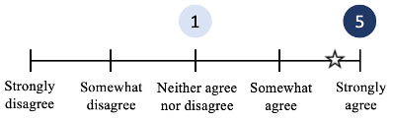 | “I think I enter the conversation earlier and a little more gently. Just in general in practice. I tend to bring it up at any fork in the road, not just when things take a turn for the worse.” (Clinician 4)  “I think it escalated – it accelerated treatment decisions, goal decision making. The ability to get into important elements of care. To get there quicker.” (Clinician 2)  “I feel like this is a great introductory conversation…But for the patient who is in the throws of the decision …towards the end of the conversation, the questions weren’t specific enough.” (Clinician 4)
Easy to use | 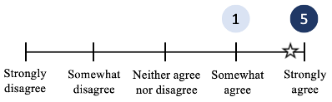 | “It covers a lot of detail with very focused questions. And yes, you still manage to get a lot out of the patients in a short period of time.” (Clinician 3)  “Time constraints could make it difficult to get all the questions in.” (Clinician 3)
Degree to which increased or decreased one's role in patients’ care | 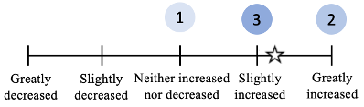 | “My overall feelings were that I found it helpful, in fact very helpful, for a number of tough cases allowed for an opportunity to bring up a tough conversation in a structured way…allowed a deeper conversation that they hadn’t gone through.” (Clinician 2)  “Overall experience was very positive. I think it helped open up a conversation regarding patient beliefs and understanding.” (Clinician 5)  “On the one hand it was a great way to initiate the conversation but I don’t think had enough meat at the end to really guide the patient through some critical decision-making steps.” (Clinician 4)  “Helps me understand my [patients’] religious convictions better and focus on their goals more.” (Clinician 5)
Ability to evaluate patient understanding of prognosis | 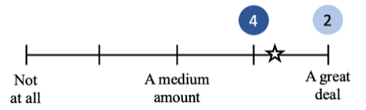 | “I think it helped open up a conversation regarding patient beliefs and understanding. Where patients were.” (Clinician 5)  “Mainly opened up my understanding of what their understanding was of their disease and what they thought was good.” (Clinician 5)
Gain useful information from asking about the patient's fears and worries | 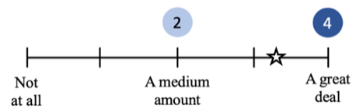 | “What I really liked is that what I didn’t ask patients about – fear, goals - I realize that there were a lot of things I didn’t ask [previously]. I thought that it was productive to ask those – if anything it improved the relationship. Did with one patient and his wife and it was a really nice conversation and it opened up him talking about some things. There was more depth to our doctor patient relationships.” (Clinician 1)  “You get to the loss of abilities is the one thing that you fear. Everybody wants to be as able as possible for as long as possible.” (Clinician 4)
Overall effectiveness of this discussion in understanding patients’ values and goals about end-of-life care | 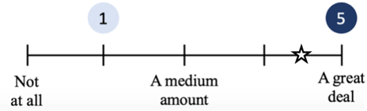 | “It has just helped me focus more as a clinician on those things. I’d like to think I was focused on that before. But it has helped me focus on their goals more. Which direction we’re going and why we’re going there.” (Clinician 6)  “I think with African American patients, you kind of…it helps you understand their religious convictions/understanding better. Faith to some degree. That’s where it helped out.” (Clinician 5)  “I think it helped refine and sharpen the goals of care.” (Clinician 6)
*Numbers in each scale indicate the number of clinicians endorsing each response
Supplemental Table 1. Themes Derived from Qualitative Interviews with Community Members and Seriously Ill Patients and Family Members: Reactions to Serious Illness Conversation Guide

Theme | Community Members  African-American church members (N=9) | Patients  Seriously ill African-American patients & their caregivers (N=11)
Approach builds rapport and a connection with one’s clinician. | “...to just come out and tell me that, ‘well, you got six months to live...’ ... You’re not God. That would make a person angry. But to put it the way you have put it: I think you can appreciate that.” (#5) | “You brought up more in the explanation of each than the average doctor would. They don’t explain it deeply or in details to make you feel comfortable with it. ... I think this guide would help a lot of doctors, if they follow it.” (#2)  “To me it looked like it was helpful…Almost like going back in the old days when you say you have one doctor… you know one doctor for everybody…you know you go to…’cause at that time you have one doctor you can tell him everything.” (#4)  “Don’t cut any corners and tell me everything straight out, and yes, I may fall apart. ...I’d just rather know. ...I would...respect you more as being my physician because you are so open.” (#7)
Communication supports shared decision-making and offers a sense of control. | “You’re trying to make me comfortable; you’re trying to bring me in to help make the decision along with you. And I can tell the doctor, ‘now what do you think is best for me if I don’t know or understand, then bring my family in...and that helps.” (#6)  “I believe what [the conversation is] trying to do is to help the patient have more control over his or her situation. The questions give the patients control over their situation.” (#2) | “You’ve explained everything clearly and even when she did say she didn't, you went back and you explained it, broke it down even clearer for her. So, as long as it's where we're understanding everything and we walk away from your office with a full understanding, it's perfect.” (#7)
Conversation fosters incorporating religion and spirituality. | “The "strength” question... “brought a smile to my face when I heard it... because the first thing that cross my mind is my god, my faith, and my peace.” (#6) | “You know, everybody’s faith is different so it doesn’t, you know, you don’t hit heads with that. ... Because it’s not the issue. It’s about the patient issue and what works for her.” (#10)  “I don’t know if it will matter for certain doctors, but I mean…you wanna give that information…I have a strong, you know, belief in God.” (#2)  “Church say that. No matter what the doctors say, that’s the last word. You know you have to have faith, you know.” (#2)
Preferences regarding when and with whom | “I would like to see this come from my primary care doctor.” (#6) | “I want to talk to the expert...the one who was treating the cancer.” (#4)  “The doctor that’s treating you (should be having this conversation) because that's the one you're gonna be looking at every appointment time.” (#10)

