**Supplementary material**

**Appendix Section (A): Feedback on case vignettes and questionnaire design:**

Questions asked in feedback form:

1. The scenarios presented were realistic
2. I was able to identify with the situations in the scenarios and this allowed me to respond appropriately
3. I was able to understand the issues involved in the scenarios present
4. The questions affected me emotionally
5. I was left feeling disturbed by the scenarios presented
6. The questions were asked in an appropriate and sensitive manner
7. After doing the questionnaire, I am interested to find out more about palliative care

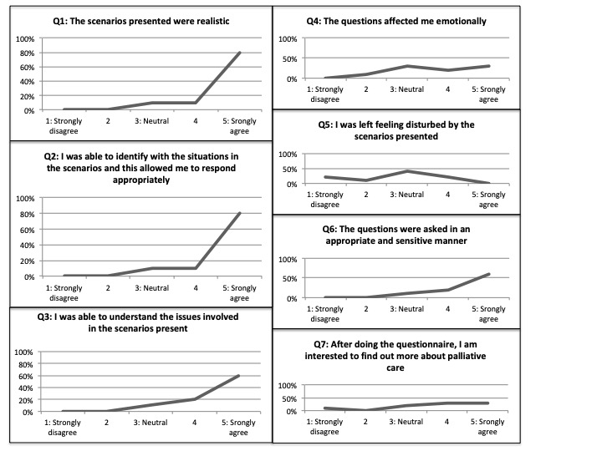

**Appendix Section (B): Case vignettes used in questionnaire**

**Case 1: Severe traumatic brain injury**

John is 14 years old and is the middle in a family of 3 children. He was a healthy, active teenager, and was doing well in his secondary school prior to a road traffic accident. 6 days ago, John was involved in a road traffic accident on his way home from school. He was hit by a bus while crossing the road and was severely injured. The most severe of his injuries was to his head. There was a large area of bleeding in his brain, which required urgent brain surgery soon after he was stabilized in the emergency department. During the surgery, the blood in his brain was removed. Unfortunately, the injury to John’s brain was so severe that his brain continued to swell even after the surgery, and he was in a deep coma. After 5 days of maximum support on a machine to help him to breathe, medication to keep him sedated, and medication to support his blood pressure, his condition continued to deteriorate.

Due to gradual swelling of his brain despite all the medical intervention, the pressure inside his skull became so great that it began compressing on the vital centers of the brain that allow a person to breathe on their own. After thorough testing, the doctors have certified him to be brain-dead. This means that there is no hope for recovery of his brain. His heart still continues to beat with medication to support the blood pressure, and his breathing is fully supported by the breathing machine.

**Case 2: Acute respiratory distress syndrome**

Kelly is 8 years old and has cerebral palsy, which is a condition of the brain caused by irreversible brain injury early in life. She was born extremely premature (at 5 months of pregnancy), and suffered bleeding in the brain in the newborn period, which resulted in cerebral palsy. This means that she has suffered irreversible brain injury that has left her completely dependent on her caregivers for simple tasks of daily living. One parent is her main caregiver and this occupies all his/her time. The other parent works long hours to make ends meet. Kelly is bed-bound, unable to communicate with her caregivers and needs to be on diapers. She can only be fed milk through a tube inserted into her stomach.

Kelly has had multiple episodes of lung infections because of her condition. She frequently chokes while swallowing and this makes her susceptible to lung infections. So far, she has managed to recover from the previous infections with antibiotics and has not required insertion of the breathing tube.

This time, she has been admitted to the hospital for a week. Unlike before, her lung infection is very severe and she has ended up with a breathing tube inserted and needs a machine to help to her breathe. Despite the standard breathing machine, she still continued to lack oxygen. The doctors switched her to a stronger breathing machine in the hope that she would receive more oxygen. Unfortunately, her condition continued to deteriorate. She now also requires medication to support her blood pressure. The doctors have said that she is very sick and may not survive.

**Case 3: Acute viral myocarditis on ECMO with left intracranial hemorrhage**

Vincent is 4 years old. He was an active and healthy child before he suddenly fell very sick. A few days ago, he seemed to have caught a viral infection – he had fever for 2 days with 1 to 2 episodes of vomiting each day. He was unable to take any food or drink so his parents brought him to emergency department. He was diagnosed to have a severe infection of his heart muscles, which caused his heart to fail gradually over a few hours after he was admitted.

Due to this infection of the heart muscles, the main function of his heart, which is to pump sufficient blood to the rest of the body organs in order to deliver oxygen for survival, has failed and needs a form of support. Vincent has been put on a machine, which serves to take over this function of his heart while waiting for his heart muscles to recover. The chance of survival is 70% and it usually takes 1 to 2 weeks for the heart to recover fully so that he can be taken off the machine. Vincent has been on this machine support for the last 5 days. While on this machine, he requires medication to thin his blood so that it does not clot in the machine. This medication increases his risk of bleeding. He is also sedated and is on pain relief medication so that he does not experience discomfort. This has made him completely sedated and his parents are not able to communicate with him at the moment. The doctors have just informed his parents that Vincent has had a bleed in his brain that they have confirmed on a CT scan of the brain. The bleeding is on the left side of his brain and may cause him to be paralyzed on the right side of his body, if he recovers from the infection of his heart.

**Case 4: Congenital central hypoventilation syndrome**

Julie is a 3-week-old infant and was having trouble breathing. Her parents noticed that she would turn blue intermittently at home and would appear to stop breathing occasionally for no reason at all.

She was admitted into the hospital, and while being observed closely in the ward, she had a severe episode of turning blue. This indicates that she is not getting enough oxygen. The doctors had to insert a breathing tube to help her breathe and she is now on a breathing machine to support her breathing.

After performing thorough investigations the doctors informed her parents that Julie was born with a condition in which her brain does not remember to breathe. Normally, vital centers in our brain would maintain vital functions such as ensuring adequate breaths are taken without a conscious effort. These vital centers are defective in Julie.

Having this rare condition means that Julie will require an operation to insert a permanent breathing tube in her neck to allow her to go home on a breathing machine. She will be dependent on a breathing machine for the rest of her life. She will also need to have a number of other machines at home, like a suction apparatus to clear her phlegm from her breathing tube and a monitor to check the oxygen levels in her blood. The rest of her brain is otherwise normal and she is still responding and interacting with her parents like a normal 3-week-old baby. The doctors say that some children born with Julie’s condition can go on to lead a fruitful life as they are likely to be of normal intelligence, as long as her breathing is supported by the machine all the time. Julie has 2 older siblings who are normal and healthy.