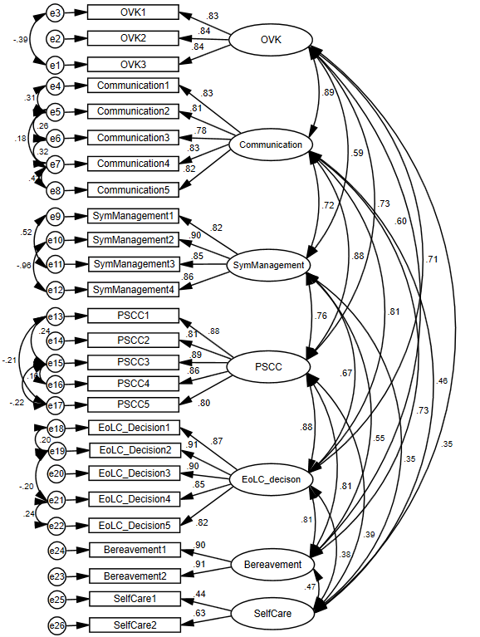Supplementary figure 1. Confirmatory factor analysis of revised CECCS questionnaire (397 of n₂ = 450). OVK = overarching values and knowledge, Communication = communication skills, SymManagement = symptom management, PSCC = psychosocial and community care, EoLC_decision = EoLC decision making, Bereavement = bereavement care.

Supplementary Table 1. Inter-item correlation analysis for the 35-item questionnaire in the randomized sample (Pearson r).
Overarching value and knowledge
 | 2 | 3 | 4 | 5
1 | .645** | .580** | .516** | .653**
2 | 1 | .662** | .662** | .551**
3 | .662** | 1 | .736** | .478**
4 | .662** | .736** | 1 | .456**
5 | .551** | .478** | .456** | 1
Communication skills
 | 7 | 8 | 9 | 10 | 11 | 12 | 13
6 | .886** | .721** | .794** | .765** | .773** | .739** | .672**
7 | 1 | .761** | .825** | .787** | .790** | .751** | .712**
8 | .761** | 1 | .864** | .724** | .746** | .727** | .709**
9 | .825** | .864** | 1 | .818** | .840** | .817** | .774**
10 | .787** | .724** | .818** | 1 | .908** | .842** | .747**
11 | .790** | .746** | .840** | .908** | 1 | .874** | .763**
12 | .751** | .727** | .817** | .842** | .874** | 1 | .812**
13 | .712** | .709** | .774** | .747** | .763** | .812** | 1
Symptoms management
 | 15 | 16 | 17 | 18 | 19
14 | .769** | .873** | .664** | .584** | .705**
15 | 1 | .805** | .738** | .642** | .619**
16 | .805** | 1 | .708** | .623** | .732**
17 | .738** | .708** | 1 | .822** | .614**
18 | .642** | .623** | .822** | 1 | .564**
19 | .619** | .732** | .614** | .564** | 1
Psycho-social and spiritual care
 | 21 | 22 | 23 | 24 | 25
20 | .824** | .690** | .706** | .790** | .753**
21 | 1 | .704** | .719** | .788** | .760**
22 | .704** | 1 | .943** | .714** | .681**
23 | .719** | .943** | 1 | .716** | .701**
24 | .788** | .714** | .716** | 1 | .817**
25 | .760** | .681** | .701** | .817** | 1
EoLC decision making
 | 27 | 28 | 29 | 30 | 31 | 32
26 | .903** | .820** | .765** | .740** | .762** | .742**
27 | 1 | .863** | .817** | .793** | .774** | .789**
28 | .863** | 1 | .846** | .803** | .786** | .738**
29 | .817** | .846** | 1 | .874** | .767** | .719**
30 | .793** | .803** | .874** | 1 | .782** | .703**
31 | .774** | .786** | .767** | .782** | 1 | .762**
32 | .789** | .738** | .719** | .703** | .762** | 1
Bereavement care
 | 34 | 35
33 | .882** | .812**
34 | 1 | .799**
35 | .799** | 1
Note: items with high inter-items correlations (r > .85) need be modified.

Supplementary Table 2. 26-item Comprehensive competences end-of-life scale (CECCS)
Instruction: How competent do you feel, as stated below, in end-of-life care? Please rate on a scale from 1 to 10, with 1 meaning “Not competent at all” to 10 meaning “Very competent”. Please choose N/A if you think that the question is irrelevant to your situation.
 | Not competent at all Very competent
Overarching values and knowledge
- Understanding how society and culture influence people’s attitudes towards dying and death | 1 | 2 | 3 | 4 | 5 | 6 | 7 | 8 | 9 | 10 | N/A
- Handling ethical issues that arise in caring for patients near the end of life | 1 | 2 | 3 | 4 | 5 | 6 | 7 | 8 | 9 | 10 | N/A
- Maintaining appropriate professional boundaries when helping patients at their end-of-life and their families | 1 | 2 | 3 | 4 | 5 | 6 | 7 | 8 | 9 | 10 | N/A
Communication Skills
- Listening to and talking with patients with advanced illnesses about issues surrounding their death, e.g. breaking bad news about his/her illness, discussing advance care planning | 1 | 2 | 3 | 4 | 5 | 6 | 7 | 8 | 9 | 10 | N/A
- Discussing with patients with advanced illnesses and family members about their psychosocial needs and concerns | 1 | 2 | 3 | 4 | 5 | 6 | 7 | 8 | 9 | 10 | N/A
- Recognizing patients’ and family members’ verbal/non-verbal communication cues | 1 | 2 | 3 | 4 | 5 | 6 | 7 | 8 | 9 | 10 | N/A
- Facilitating communication among patients, family members and end-of-life care team | 1 | 2 | 3 | 4 | 5 | 6 | 7 | 8 | 9 | 10 | N/A
- Able to collaborate with multi-disciplinary end-of-life care team efficiently and appreciate their respective roles in providing end-of-life care | 1 | 2 | 3 | 4 | 5 | 6 | 7 | 8 | 9 | 10 | N/A
Symptom management
- Helping patients with their pain | 1 | 2 | 3 | 4 | 5 | 6 | 7 | 8 | 9 | 10 | N/A
- Using non-pharmaceutical, complementary and alternative therapies to help patients cope with distressing symptoms at the end-of-life | 1 | 2 | 3 | 4 | 5 | 6 | 7 | 8 | 9 | 10 | N/A
- Helping patients with other distressing symptoms that are commonly experienced at the end-of-life (e.g. breathing problems, fatigue, nausea and vomiting) | 1 | 2 | 3 | 4 | 5 | 6 | 7 | 8 | 9 | 10 | N/A
- Recognizing signs when a patient is dying | 1 | 2 | 3 | 4 | 5 | 6 | 7 | 8 | 9 | 10 | N/A
Psychosocial and Community Care
- Using holistic assessment with patients with advanced illnesses and their families | 1 | 2 | 3 | 4 | 5 | 6 | 7 | 8 | 9 | 10 | N/A
- Applying evidence-based psychosocial intervention based on the needs assessments | 1 | 2 | 3 | 4 | 5 | 6 | 7 | 8 | 9 | 10 | N/A
- Applying an individualized end-of-life care plan | 1 | 2 | 3 | 4 | 5 | 6 | 7 | 8 | 9 | 10 | N/A
- Informing patients and families of other available support services | 1 | 2 | 3 | 4 | 5 | 6 | 7 | 8 | 9 | 10 | N/A
- Understanding available community resources and services in supporting patients and family at end-of-life | 1 | 2 | 3 | 4 | 5 | 6 | 7 | 8 | 9 | 10 | N/A
End-of-Life Decision Making
- Understanding how “Advance Care Planning” can enhance end-of-life care | 1 | 2 | 3 | 4 | 5 | 6 | 7 | 8 | 9 | 10 | N/A
- Finding out patients’ wishes over care decisions should they lose capacity | 1 | 2 | 3 | 4 | 5 | 6 | 7 | 8 | 9 | 10 | N/A
- Preparing patients and families for death by discussing unfinished business, after-death care, funeral and ritual, and body disposition wishes with patients and families | 1 | 2 | 3 | 4 | 5 | 6 | 7 | 8 | 9 | 10 | N/A
- Understanding legal issues relating to end-of-life care (e.g. advance directives, will, enduring power of attorney, guardianship, professional codes of practice) | 1 | 2 | 3 | 4 | 5 | 6 | 7 | 8 | 9 | 10 | N/A
- Discussing and preparing Advance Directives (AD) and Do-Not-Attempt Cardiopulmonary Resuscitation (DNACRP) with patients and their families | 1 | 2 | 3 | 4 | 5 | 6 | 7 | 8 | 9 | 10 | N/A
Bereavement Care
- Understanding normal and complicated grief reactions | 1 | 2 | 3 | 4 | 5 | 6 | 7 | 8 | 9 | 10 | N/A
- Offering bereavement counselling to bereaved families and individuals | 1 | 2 | 3 | 4 | 5 | 6 | 7 | 8 | 9 | 10 | N/A
Self-care
- Fully accepting that I cannot completely control life, for example, the life and death of patient/service user | 1 | 2 | 3 | 4 | 5 | 6 | 7 | 8 | 9 | 10 | N/A
- Effectively coping with my emotions induced by work | 1 | 2 | 3 | 4 | 5 | 6 | 7 | 8 | 9 | 10 | N/A

