Appendix A
QUASAD 2 Signalling questions 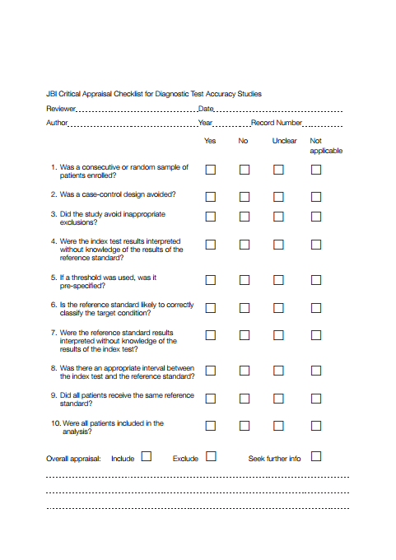

Appendix B
Modified Data Extraction Form

Title
Author/year of publication/Journal
Geographic location of data collection
Setting of data collection
Study population
Sample size
Participant demographics
Study methodology (e.g., consecutive or random; retrospective or prospective)
Prevalence of religious/spiritual suffering
Inclusion/exclusion criteria (i.e. presenting symptoms, results from previous tests) | Inclusion:  Exclusion:
Period that study was carried out (beginning and end date)
Index test description (including criteria for positive test)
Reference test description (including criteria for positive test)
Persons executing and interpreting index tests (numbers, training, and expertise)
Persons executing and interpreting reference test
Index/reference time interval (and treatments carried out in between)
Distribution of severity of disease in those with target condition
Other diagnoses in those without target condition
Adverse events from index test
Adverse events from reference test
Time takes to do the screening with index or reference test
Sensitivity
Specificity
Other diagnostic criteria
Cut-off point
Study limitations

