The experience of informal caregivers of patients with Motor Neurone Disease: A thematic synthesis

Supplementary file

Appendix One:
Example audit-trail for Akiyama et al., 2006
Table 1. Stage one: open coding
Author | Quote | Comment
Brown 2003 | “I hate it. I hate it. It takes away your future. It’s kind of gone.” | Loss of control, progression, patient or carer future?
 | “This is horrible. It is worse than cancer.” | MND specific, progression, hopeless
 | “I used to go weeks and sometimes months before I saw anybody.” | Isolation, interaction, communication
 | “I’m suffering an emotional upset at the same time as caring… I’m emotionally upset by it all so that’s the added stress and strain, it’s not just caring it’s suffering.” | Stress, mood, health, grief, self-less
 | “I don’t think I could ever be ill now. I don’t know what we’d do.” | Health, choice
 | “It’s a dreadful situation for me, very frightening…I think he has given up. Now it’s very near… you have to accept it” | Acceptance, loss, grief
 | “Shattered, because it’s pulled me down” | Fatigue
 | “You mustn’t try to hide it and think that it’s going to go away because it’s not” | Acceptance,
 | “Damned hard work” | Fatigue
 | “need for moral support” | Isolation
 | “I know what it’s like now to have to care for someone. I just feel sorry for everybody who has to do it” | Empathy, challenge, suffer
 | “We used to have half a dozen professional faces and I just couldn’t pace them all and I never knew which one to speak to ” | Communication with healthcare, support, interaction, over-whelming
 | “ I think it’s all talked about mainly in a business-like manner rather than in an emotional way” | Emotion, routine, personal, communication
 | “I’d love to do my job and look after Liz but what do I do when Liz’s gone and there’s no job and probably a five year void in my career. A future employer wouldn’t really want to take a risk. ” | Finance, future. Family role and responsibility

Figure 1. Stage two: idea webbing
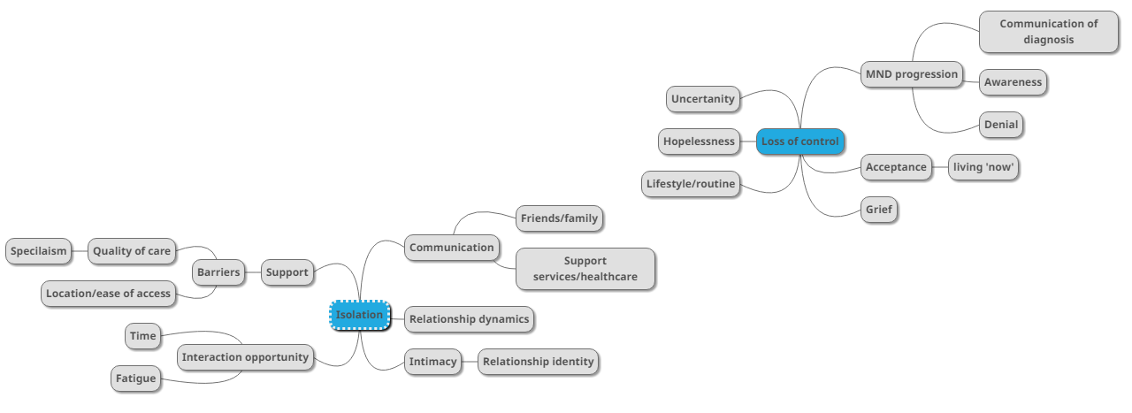
Table 2. Stage three: translation
Theme | Sub-theme | Unit
Isolation | Opportunity for interaction | “I used to go weeks and sometimes months before I saw anybody.” [3]
Note: [3] = Brown 2003
Table 3. Stage four: synthesis of translations
Theme | Subtheme | Unit | Studies
Isolation | Opportunity for interaction | Explanation: This subtheme looks at the idea of decreased social interaction and its impact on the experience of isolation. Caregivers experienced physical isolation due to loss to social interaction due to lack of time or fatigue. Others were not physically isolated from others however still experienced sense of being alone and isolated. Other caregivers reported decreased social opportunity with their spouse due to the progressive symptoms of MND. Also discussed was isolation in the bereavement phase and the sense of being supported and not isolated during the caregiving phase.  Example Units:  “I used to go weeks and sometimes months before I saw anybody.” [3] | 1,2,3,4,6,8,9
Note: [1] = Akiyama et al., (2006), [2]= Aoun et al., (2012), [3]=Brown (2003), [4]= Herz et al., (2006) [5]=Hyunjin and Schepp (2013), [6]=O’Brien et al., (2012), [7]= Oyebode et al., (2013), [8]=Ray and Street (2007), [9]= Weisser et al., (2015), [10]=Whitehead et al., (2012)

Appendix Two:
Table 4. Summary of included studies
Study | Study aim | Study design | Evaluation | Study country | Participant  (n) | Participant characteristic  (included) | Carer relationship | Main themes
Akiyama et al., 2006 | Carers experience for ALS patients receiving ventilation | Qualitative | Semi-structured interview | Japan | Current carers (n=12) | Age=56.1 yrs (mean)  Male=2  Female= 10  Duration since diagnosis= not reported | Spouse (n=9)  Mother (n=2)  Daughter (n=1) | Uncertainty of future, communication, maintaining their own life, support
Aoun et al., 2012 | Former MND Carers experience focusing upon grief, services and palliative care | Qualitative | Semi-structured interview | Australia | Former carers (n=16) | Age=65.25 yrs (mean)  Male=3  Female=13  Duration bereaved = 27.5 months (mean) | Spouse (n=16) | Caring tasks, identity, series of losses, coping mechanisms, support
Brown, 2003 | MND carers experience | Qualitative | Guided interview | UK | Lay carers (n=6)  MND patients (n=6)  Professional carers (n=9) | Age=56.5 yrs (mean)  Male= 4  Female=2  Duration since diagnosis= not reported | Spouse (n=5)  No relation (n=1) | support, vulnerability, changing ‘normality’
Herz, et al., 2006 | Current and former MND carers experience | Qualitative | Focus group | Australia | Former carers (n=8)  Current carers (n=3) | Age= <35-85 yrs (range)  Male= 4  Female= 7  Duration since diagnosis= 0->12 months (range)  Duration bereaved=0-36 months (range) | Spouse (n=8)  Child (n=3) | Support, love, unremitting care, financial burden, suspension of own needs
Hyunjin and Schepp, 2013 | MND carers (wives) experience | Qualitative | Observation Semi-structured interviews and observation | South Korea | Current Carers (n=11) | Age=47.73 yrs (mean)  Male= 0  Female=11  Duration since diagnosis= 63 months  Care giving hours=19.18/day (mean) | Wife (n=11) | New roles, sexual relationships, relationships with in-laws
O’Brien et al., 2012 | MND carers experiences to enable service development | Qualitative | Semi-structured interviews | UK | Current (n=18)  Former carers (n=10) | Age= not reported  Male=14  Female =14  Duration since diagnosis=18.8 months (mean)  Bereaved= 30.6 months (mean) | Family (n=28) | Emotional and physically draining, Support, carers training needs,
Oyebode et al., 2013 | MND carers (spouse) experience | Qualitative | Semi-structured interviews | UK | Current Carers (n=8) | Age= 40-70 yrs (range)  Male=2  Female=6  Duration since diagnosis= 6months-6 yrs (range) | Spouse (n=8) | Lifestyle changes, loss of intimacy, uncertainty, coping strategies
Ray and Street 2007 | MND carers loss and emotional challenges | Qualitative | Semi-structured interviews | Australia | Primary carers (n=18)  Peripheral carers (n=6) | Age=41-82 yrs (range)  Male=4  Female=14  Duration since diagnosis=not reported | Spouse (n=17)  Daughter (n=1) | Uncertainty, spousal relationships, lifestyle change, identity, loss of future
Weisser et al., 2015 | Positive and negative experience of MND carers | Qualitative | Questionnaire and semi-structured interviews | UK | Current Carers (n=10) | Age= 52.9 yrs (mean)  Male= 3  Female=7  Duration since MND onset= 3.6yrs (mean) | Spouse/ partner (n=10) | Resilience, reward, carrying a burden, carers needs
Whitehead et al., 2012 | Current and former MND carers experience. End-of-life focus | Qualitative | Semi-structured interviews | UK | Current (n=18)  Former carers (n=10)  Patients (n=24) | Age= not reported  Male=14  Female=14  Duration since diagnosis=18.8 months (mean)  Bereaved= 30.6 months (mean) | Family (n=28) | Fear of future, support, bereavement

Appendix Three
Table 5: COREQ Results
 |  | 1 | 2 | 3 | 4 | 5 | 6 | 7 | 8 | 9 | 10
 |  | Akiyama et al., 2006 | Aoun et al., 2012 | Brown, 2003 | Herz et al., 2006 | Hyunjin et al., 2013 | O'Brien et al., 2012 | Oyebode et al., 2013 | Ray and Street, 2007 | Weisser et al., 2015 | Whitehead et al., 2012
Domain 1: Research team and reflexivity
Personal Characteristics
1 | Interviewer/facilitator Which author/s conducted the interview or focus group? | 0 | 1 | 1 | 0 | 1 | 1 | 1 | 1 | 0 | 0
2 | Experience and training. What experience or training did the researcher have? | 0 | 1 | 1 | 1 | 0 | 0 | 0 | 0 | 1 | 0
Relationship with participants
3 | Relationship established Was a relationship established prior to study commencement? | 0 | 0 | 0 | 0 | 0 | 0 | 0 | 1 | 0 | 0
4 | Participant knowledge of the interviewer. What did the participants know about the researcher? | 0 | 0 | 0 | 0 | 0 | 0 | 0 | 0 | 0 | 0
5 | Interviewer characteristics What characteristics were reported about the interviewer/facilitator? | 0 | 0 | 0 | 0 | 0 | 0 | 0 | 1 | 1 | 0
Total score (average score/5) |  | 0 | 2 | 2 | 1 | 1 | 1 | 1 | 3 | 2 | 0
Domain 2: study design
Theoretical framework
6 | Methodological orientation and theory. What methodological orientation was stated to underpin the study? | 1 | 0 | 1 | 0 | 1 | 1 | 1 | 1 | 0 | 1
7 | Non-participation How many people refused to participate or dropped out? Reasons? | 0 | 0 | 0 | 1 | 0 | 1 | 0 | 0 | 0 | 0
Data Collection
8 | Interview guide: Were questions, prompts, guides provided by the authors? Was it pilot tested? | 1 | 1 | 1 | 1 | 1 | 1 | 1 | 1 | 0 | 1
9 | Field notes -Were field notes or reflective diary made during and/or after the interview or focus group? | 0 | 0 | 1 | 0 | 1 | 0 | 0 | 1 | 1 | 0
10 | Data saturation: Was data saturation discussed? | 0 | 0 | 0 | 1 | 0 | 0 | 0 | 0 | 0 | 0
Total score (average score/5) |  | 2 | 1 | 3 | 3 | 3 | 3 | 2 | 3 | 1 | 2
 |  | 9+D22:M2
Domain 3: analysis and findings
Data analysis
11 | Description of the coding tree: Did authors provide a description of the coding tree or audit trail? | 1 | 1 | 1 | 1 | 1 | 1 | 1 | 1 | 1 | 1
12 | Derivation of themes: Were themes identified in advance or derived from the data? | 0 | 1 | 1 | 1 | 1 | 1 | 1 | 1 | 1 | 1
Reporting
13 | Clarity of minor themes Is there a description of diverse cases or discussion of minor themes? | 1 | 1 | 0 | 0 | 0 | 0 | 1 | 0 | 1 | 0
Total score (average score/ 3) |  | 2 | 3 | 2 | 2 | 2 | 2 | 3 | 2 | 3 | 2
Grand total (13) |  | 4 | 6 | 7 | 6 | 6 | 6 | 6 | 8 | 6 | 4

