Online Appendices

Stereotypes of Older Workers and Perceived Ageism in Job Ads: Evidence from an Experiment

Appendix A (online): Job Ad Templates

Administrative Assistants

Administrative Assistants Template 1 (Admin Assistant)
Psychiatric office is in need of a full or part time Administrative Assistant to assist in front/back office general clerical duties. This individual will work on a several tasks and stay on course at all times. The Administrative Assistant we hire will be trained in various duties that cover the entire office.

This individual MUST possess the following:

-Exceptional customer service background to greet and register patients, answer phones, schedule appointments.
-Can multitask.
-High School diploma or GED.
-Professional attitude.
-*Communication Skill Requirement*.
-*Technology Requirement*
-*Physical Requirement*
-Available for flexible hours.
(Schedule hours and days will alternate every other week)

Please email us a CV or resume and put “full-time” or “part-time” in the subject line.

Administrative Assistants Template 2 (Administrative Job)
About the Employer: We are a well-established but growing law office looking for a Full-Time Receptionist/Administrative Assistant. We have a team of dedicated attorneys who work with a range of independent and corporate clients. Prior background is preferred, but not required.

Responsibilities include:
-Answering up to 6 phone lines
-Coordinating mail in and out of the office
-Filing and basic paperwork

The ideal candidate will possess the following qualifications:
-Can multitask
-*Physical Requirement*
-Organized and detail-oriented
-*Communication Skill Requirement*
-Maintain a professional attitude at all times
-High School diploma or equivalent
-Be a team player
-*Technology Requirement*
-Can work in a fast paced environment!

If you meet these requirements, please send a resume and some interview hours to the provided email.

Administrative Assistants Template 3 (Office Assistant)
About: Growing company, over 30 years history, family owned and operated.

About the position: Office Assistant
* will train, prior background preferred;
* fast paced environment;
* answer 6 phone lines;
* record daily records;

Qualifications:
* can multitask;
**Physical Requirement*;
**Technology Requirement*;
* organized;
* *Communication Skill Requirement*;
* a team player, the company is run by the team.

Please email your resume and availability for more information.

Administrative Assistants Template 4 (HIRING ADMIN ASSISTANT)
Job Description: Administrative Assistant position open now. Email resumes with a start date in the header!

We are a Commercial Roofing company. All applicants need the judgement to make independent decisions when circumstances warrant. Excellent time management and strong organization are required. This position requires you to work under pressure, be self-directed with good business judgment and handle confidential information appropriately.

In this position you will be responsible for:
-Answering a multi-line phone system.
-Greeting incoming guests.
-Filing incoming faxes.
-Light data entry.
-Filing and other basic clerical duties.
-Help co-workers as needed

To qualify for this position, you must have:
-*Communication Skill Requirement*.
-*Physical Requirement*
-*Technology Requirement*
-Can multitask
-Detail oriented

Administrative Assistants Template 5 (Looking for Admin Assistant)
A well-established service company is currently seeking an Administrative Assistant.

Qualified candidates will possess the following:

Proficiency in answering, screening, or forwarding calls, providing information, taking messages, or scheduling appointments.
Maintain a professional presence at all times.
*Communication Skill Requirement*.
Be self-motivated.
Pay attention to detail and multitask.
*Physical Requirement*.
Possess strong organizational and critical thinking
*Technology Requirement*
Please submit your resume via email. Put “Re: Administrative Assistant Position” in the subject line.

Administrative Assistants Template 6 (ADMINISTRATIVE ASSISTANT)
Our accounting firm is seeking an administrative assistant to work in account receivable.

Minimum Qualifications:
H.S. Graduate or GED (higher education is a plus)
Administrative background useful
*Technology Requirement*
*Communication Skill Requirement*
Other assorted office duties

Responsibilities include, but are not limited to:
Managing contracts, certificates, releases, etc.
Handling invoices, collections, liens, etc.
*Physical Requirement*

Email resumes to us at: * email address*. Be sure to let us know when your earliest possible start date is!

Administrative Assistants Template 7 (Administrative Assistant)
Our family-run business is looking for an Administrative Assistant in *City*. We would like someone who is detail oriented, has a solid work ethic, and *Communication Skill Requirement*. If you fit this description, then please submit your resume by email and preferred work hours!

Duties include client interaction, filing paperwork and testing, *Physical Requirement*, *Technology Requirement*, answering phone calls and emails, and scheduling.

Administrative Assistants Template 8 (Office Admin Assistant)
We are searching for an administrative assistant for our office manager. Our work hours are fast paced. Your main tasks would be to greet clients, answer the phone, schedule appointments also organize tax returns, filing, light cleaning and other office jobs as needed.

The following are absolute must haves:
*Communication Skill Requirement*
*Technology Requirement*
*Physical Requirement*
High School Diploma (equivalents also acceptable)

Please send resume via email with the heading “Administrative Opening”.

Administrative Assistants Template 9 (Office Assistant Wanted)
We are a furniture store in need of a part or full time administrative assistant in downtown *City*. Candidate must be highly organized and reliable. Job duties include but are not limited to:

- *Communication Skill Requirement*

- Making appointments for project managers and clients

- Making calls and greeting clients as the enter the store.

- *Technology Requirement*

- *Physical Requirement*

Simply reply to this posting by email with “part time” or “full time” and attach your resume.

Administrative Assistants Template 10 (Admin Position)
We are looking for an administrative assistant that can operate in a team environment. Candidates will assist visitors to the company and handle office tasks. Ideal candidates can provide professional assistance via phone, mail, and email.

Job Responsibilities:

- *Physical Requirement*.
- Greet and assist visitors.
- *Communication Skill Requirement*
- Handle tasks, like filing paperwork, setting up for meetings, and reordering supplies.

Requirements:

- Good time management and organization.
- *Technology Requirement*
- Attention to detail.

If you’re interested in this position, email us your resume and let us know the earliest you begin working. We can discuss details of the position in an interview.

Administrative Assistants Template 11 (Admin Job)
Are you interested in an administrative assistant position in a growing business? We are hiring qualified candidates in *City*! Apply with your resume and your preferred work hours. Submissions accepted via email.

Duties include but are not limited to; greeting and checking-in guests, sending and receiving packages via Fedex/UPS/USPS, as well as admin support to management.

Qualifications:
• Relevant background or high school diploma (or equivalent) required
- *Technology Requirement*
• *Communication Skill Requirement*
• Organized and great follow through on tasks

Additional Responsibilities:
- *Physical Requirement*
- Assist in greeting and escorting high profile guests.
• Assisting with various administrative duties as needed.
• Provide executive assistance as required.

Administrative Assistants Template 12 (Administrative Assistant Wanted)

Our firm is seeking an Office Administrative Assistant committed to providing premier client service and working well in a team environment. The best candidate *Communication Skill Requirement*, *Physical Requirement*, and maintain and organized work environment. General duties include managing space reservations and serving as a contact for facilities related issues.

Responsibilities and Qualifications:
-*Technology Requirement*
-Work with team with individuals at all levels
-Follow-up and address issues in a timely and prompt manner.
-Strong attention to detail, commitment to producing accurate work
-Manage and maintain inventory of kitchen and office supplies, including printer paper and toner supplies
-High School Diploma/GED required
-Place catering orders, including set up for office meeting meals
-Provide administrative support to the administrative team
-Assist in other projects and responsibilities as assigned

Please contact us if you are interested. We accept resumes or curricula vitae at * email address*. Put “Office Assistant Position” in the first line of your email. Thanks!

Retail Sales Associate

Retail Sales Associate Template 1 (Retail Sales Job)
Our women’s clothing store in *City* is looking for a sales associate to help us out weekday afternoons. We are pretty busy store and you must *Physical Requirement*. We are looking for someone with open to working in retail, who *Communication Skill Requirement*. We need you to *Technology Requirement*. So if this sounds like you, send us your resume and your earliest possible starting date and we will be in touch.

Retail Sales Associate Template 2 (SALES ASSOCIATE WANTED)
Seeking a sales associate for our hardware store in *City*. We have flexible hours available during the week. You *Physical Requirement*. Previous retail background is a plus, and our ideal candidate has a proven *Communication Skill Requirement*. *Technology Requirement*. Email a resume and specify your ideal work hours.

Retail Sales Associate Template 3 (Sales Associate)
Position: Retail Sales Associate (Retail Store)
Requirements and duties:
- Greet retail customers
- Answering phones/email
- Receive inventory
- Stock merchandise
- *Communication Skill Requirement*
- *Technology Requirement*
- *Physical Requirement*
- High school diploma or college degree
- Access to transportation
Full Time and Part Time Available + Competitive Wages
If you meet the above mentioned qualifications, please reply with resume (put full or part-time in the subject line). We look forward to your application!

Retail Sales Associate Template 4 (Entry-Level Retail Sales Associate)
Entry-level sales position. Please read all requirements and apply if you are looking for a long-term position. This can be either full-time or part-time position.
Requirements:
- *Communication Skill Requirement*
- Work in sales preferred but not required
-*Technology Requirement*
- Can multitask and work as a team
- GED or High School Diploma
- *Physical Requirement*
More information will be discussed during the interview. Please email resumes and list your schedule availability.

Retail Sales Associate Template 5 (RETAIL SALES ASSOCIATE)
Seeking enthusiastic, part time or full time Retail Associate for our store.
Responsibilities Include
- Customer Service: greeting customers, assisting them as they shop, answering their questions
- Over The Counter Sales: manage the cash register, handle product returns
- Packing & Shipping Online Orders
Qualifications
- Applicants must have good attendance and punctuality, access to transportation
- Applicants must be 18 years old or older
- Applicants must have at least a high school diploma
- Applicants must *Communication Skill Requirement*
- Applicants must *Physical Requirement*
- Applicants must *Technology Requirement*
Email us a resume and indicate part-time or full-time if you are interested.

Retail Sales Associate Template 6 (Hiring Sales Associate)
We are a shoe store hoping to hire a new sales associate in *City*!

Our ideal candidate can:
- *Physical Requirement*
- *Technology Requirement*
- Assist customers with in-store purchases.
- Has a High School diploma or equivalent
- Confirm labels match the correct products.
- Inspect for damaged deliveries and merchandise.
- Finalize work orders and *Communication Skill Requirement*

If you’re interested please reply to this ad with your résumé! (List your hours.)

Retail Sales Associate Template 7 (Family Owned Store: Retail Sales Position)
Be a part of our family owned, fabric wholesaler! We are searching for a part or full time sales assistant in our *City* location. Our business is committed to quality design and excellent service. As an employee you will work with staff, handle transactions, schedule deliveries, and *Technology Requirement*.

Qualifications:

-Qualified applicants will have a welcoming presentation.
-We are looking for candidates with a High School diploma or equivalent GED, having a retail background is a plus.
-Excellent customer service, *Communication Skill Requirement*.
-*Physical Requirement*.
-Complete our pre-employment background screening.

Please send in your preferred schedule and resume to apply.

Retail Sales Associate Template 8 (Furniture Showroom Sales Associate)
Seeking a sales associate for a furniture showroom who has solid design training for a part time position (full time is available as well) in a fast-moving environment. Candidate must have the following qualifications:

- Strong interest in retail.
- High School Diploma/GED.
* Interest or background in interior design.
* *Physical Requirement*.
- *Technology Requirement*.
* Passion for interior design.
- *Communication Skill Requirement*.

Email us your resume/cv for consideration. Let us know if you are looking for part-time or full-time work in the header of email.

Retail Sales Associate Template 9 (Pawnshop Job)
We’re running a small pawnshop in *City* and are looking for a new team member. Qualified applicants will:
· Be a team player.
· *Physical Requirement*
· Have familiarity with retail environment
· *Technology Requirement*

Your duties will include but are not limited to organizing paperwork, selling watches and other items, evaluating new items, write loans, *Communication Skill Requirement* and all general store duties. Email us a resume and list of available work hours if interested.

Retail Sales Associate Template 10 (Floral Design Sales Associate)
We are searching for a full or part-time sales associate to join our small business in floral design. We offer flexible work hours with competitive pay. You will have to *Communication Skill Requirement*. You need to *Physical Requirement*, *Technology Requirement*, and be organized. Please send a resume and potential in-person interview hours. Thank you!

Retail Sales Associate Template 11 (Novelty Products Shop Opening)
We are a local retail shop in the novelty products business looking for sale associate. We are looking for someone with strong sales techniques and with good customer service.

We require:
*Communication Skill Requirement*
*Technology Requirement*
*Physical Requirement*
flexible work hours

To apply for a position:
Please email your resume.
Please indicate your M-F availability in the email.

Retail Sales Associate Template 12 (Retail Job Opening)
We are an upscale business working with select clients and are looking for a talented sales associate. This can be a part time or full time position and the number hours will vary, but the schedule will be posted far in advance. We prefer candidates with a track record in sales. Our business is growing and we are looking for someone to continue to grow with our team.

Qualified candidate should:
* *Technology Requirement*
* Be available to work on weekends
* *Communication Skill Requirement*
* *Physical Requirement*
- Work well in a team environment

This position pays competitive wages. To apply, email your resume or curricula vitae and let us know many hours per week you prefer.
Security Guard

Security Guard Template 1 (HIRING UNARMED SECURITY GUARDS)
We currently have a position for a full-time or part-time security officer available. Training and uniforms will provided. We offer flexible working hours and have shifts any day of the week. Our pay scale is competitive. Email your resume and potential work hours to apply.

Requirements
-Professional appearance & attitude
-Detail oriented
-*Communication Skill Requirement*
-*Physical Requirement*
-*Technology Requirement*
-At least 18 years of age
-Access to transportation

Security Guard Template 2 (Security Guard)
Responsibilities
* Monitor and report flow of people on client property.
* Monitor and inform any illegal or incorrect activity.
* Give protection for individuals and property.
* Take control of emergency conditions and inform to authorities as appropriate.

Job requirements
* Proficient in English.
* Respond to emergency conditions fast and appropriately.
*Technology Requirement*
*Physical Requirement*
* Can work flexibly and/or late night hours as needed.
* Meet requirements for professional conduct and ethics.
*Communication Skill Requirement*

Send resumes and propose interview time/dates via email.

Security Guard Template 3 (Security Officer)
We’re looking for security guards for a local office park.

Duties:
* Report suspicious things and look out for felony acts or law infractions at or near assigned post that may be a danger to the property, client or workers at the site
* Report all incidents as required

Requirements:
*Communication Skill Requirement*.
* Capability to perform important tasks of the position.
**Technology Requirement*
**Physical Requirement*.
* Capacity to maintain satisfactory attendance standard

If you’re interested in this posting send us your resume and list a few hours for a sit-down interview. We will correspond by email.

Security Guard Template 4 (HIRING UNARMED SECURITY GUARDS)
Hiring UNARMED SECURITY GUARDS for a construction site!

Overview:
We are looking for guards to keep materials, tools, and trailers secured in *city*. You are expected to patrol the site and prevent vandalism and theft while on duty. Guards must *Technology Requirement* each day and report suspicious or criminal activity.

Requirements:
- High level of integrity
- *Communication Skill Requirement*
- *Physical Requirement*

Reply to this ad with your resume plus your earliest start date and a member of our team will contact you.

Security Guard Template 5 (Event Security)
We are seeking qualified applicants for UNARMED security officers to staff local events.

MEET THE FOLLOWING QUALIFICATIONS:
-*Physical Requirement*
-Bring and own a flashlight and a pair of boots
-Carry and use a pair of handcuffs
-High School Diploma are equivalent
-*Communication Skill Requirement*
-*Technology Requirement*

Note: Veterans/reservist background is a plus

EMAIL YOUR RESUME AND TYPICAL WEEKLY SCHEDULE FOR CONSIDERATION

Security Guard Template 6 (Hiring Security Guards)
HIRING *UNARMED* SECURITY GUARDS FOR A CLUB.
PAID IN CASH WEEKLY.

We are looking for security officers that can:
- Check guest I.D.s upon entry
- *Physical Requirement*
- Frisk/pat down guests for weapons

Job Description:
- *Technology Requirement*
- *Communication Skill Requirement*
- Report unusual or suspicious activity to managers
- Must be 18 years of age

If you are qualified to this position contact us soon with your workday preferences.
PLEASE EMAIL RESUMES FOR A RESPONSE

Security Guard Template 7 (Unarmed Security)
Our golf club is searching for security professionals in *City*

JOB: Unarmed Security Guard

QUALIFICATIONS:

- *Technology Requirement*
- Minimum age of 18 years old,
- High School Diploma or Equivalent
- *Communication Skill Requirement*
- *Physical Requirement*

-Duties include…
Enforce parking rules and regulations
Report incidents and suspicious activity
Look and monitor doors and gates

PLEASE EMAIL ALL RESUMES AND SPECIFY FULL OR PART-TIME

Security Guard Template 8 (UNARMED GAURDS)
Join our team if you’re a security professional seeking a full-time or part-time position! We are a local warehouse and delivery company operating in *City*.

REQUIREMENTS:
• Must be at least 18 years of age.
• *Physical Requirement*.
• Must meet, follow, and maintain company policy at all times.
• Must pass a background check.
• *Communication Skill Requirement*.
• Must have a High School Diploma or GED.
• *Technology Requirement*.

Join our team today! Tell us how many hours you’d like to sign up for! Submit resumes by email!

Security Guard Template 9 (SECURITY GUARD JOBS)
FULL OR PART TIME SECURITY GUARD OPENING
Location: *City*

We are hiring security guards for corporate offices in *city*. You are expected to patrol entry points and verify I.D.s upon entry. Work may involve contacting emergency services, responding to fire alarms, or interviewing suspicious people.

DAILY FUNCTIONS:
- Office patrols to deter criminal activity.
- *Technology Requirement*.
• Activity reporting to investigate and record suspicious persons.

MINIMUM QUALIFICATIONS:
• Must be at least 18 years of age.
• *Physical Requirement*.
• *Communication Skill Requirement*.
• Must have a High School Diploma or GED.

Interested in these positions? Send us an email with your resume and a few possible dates for an interview.

Security Guard Template 10 (Retirement Community Residential Security)
Security officers wanted for part-time and full-time work at a retirement community in *City*. Email resumes and say part-time/full-time to express interest.

Position Summary: This role involves responding to emergencies, offering assistance, as well as monitoring the security to ensure resident safety.
Qualifications:
- *Physical Requirement*
• *Technology Requirement*
• Detail-oriented, and can multitask
- *Communication Skill Requirement*

Duties:
• Record information on units, keys, and deliveries
- Monitor security of the buildings
- Maintain resident roster: Use and maintain current resident information
• Enforce policies such as parking policies and amenity reservations

Security Guard Template 11 (Security Officers Wanted)
We are a security company looking for new guards that can join our ranks. Our business contracts locally in *City* and has several upcoming openings.

We want our team members to have the following:

*Knowledge of security service, defense, etc.
*High school diploma or GED
*Attention to detail
* *Physical Requirement*
* *Technology Requirement*
* *Communication Skill Requirement*

Please email your resume or summary of experience and suggested work hours for review.

Security Guard Template 12 (Unarmed Security Officer)
NEW OPENINGS for Security Guards in *City* *State*. Contact us by email with your resume and start date.

Professional duties:

*Conducting patrols and security checks.
*Maintain consistent attendance.
*Responding to alarms as needed.
* *Technology Requirement*
*Monitor, address, and report fire & safety hazards.
*Maintain security of a complex, building and/or premises.

Requirements:

*Must be at least 18 years of age.
*Must have High School diploma or GED equivalent.
* *Communication skill Requirement*.
* *Physical Requirement*.

Veterans encouraged to apply but previous service is NOT required!

Appendix B (online)
Appendix Figure B1: Cosine Similarity Score of Administrative Assistant Templates
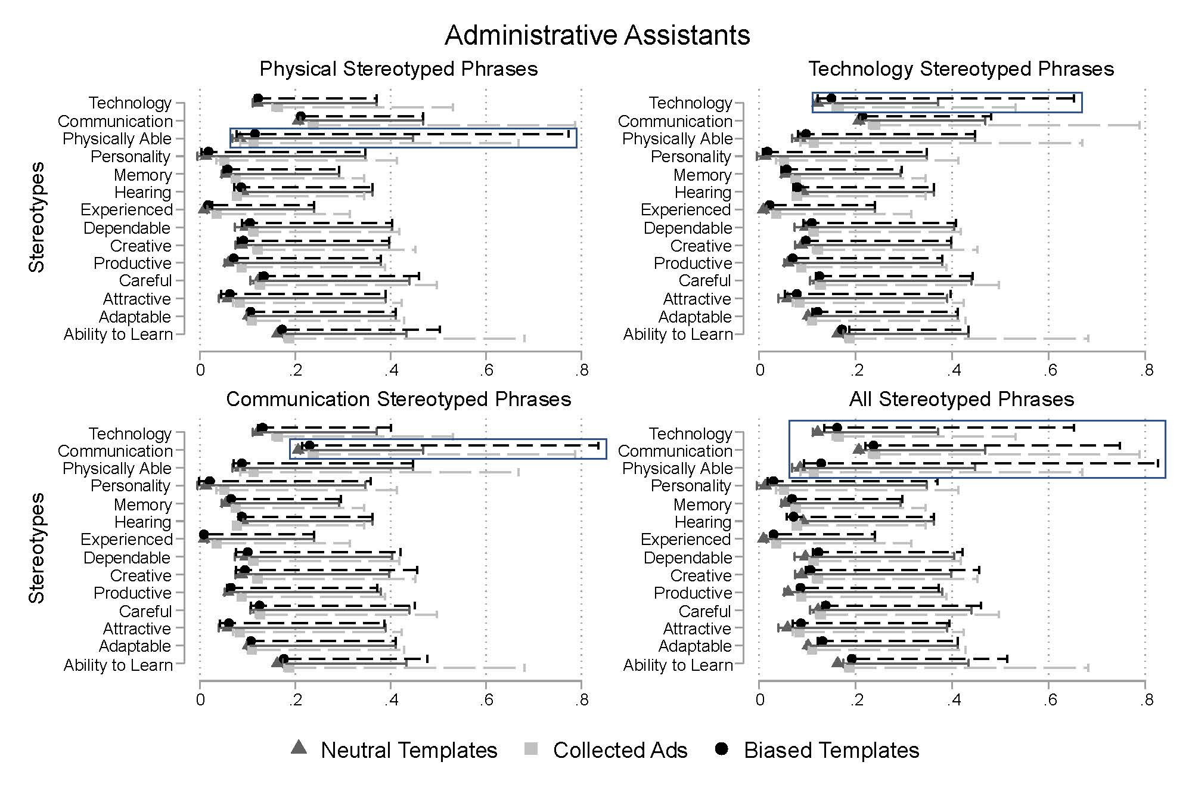
Note: Graphs display median to 99th percentile range of trigram semantic similarity scores for each stereotype for Administrative Assistant ads. The average trigram semantic similarity score for each stereotype is represented by the respective shape for each template. Control (“neutral”) templates contain trigrams from the created ad templates with only non-stereotyped phrases included. Collected ads comprise trigrams from all Administrative Assistant job ads. Treatment templates contain trigrams from the created ad templates with the respective stereotyped phrase or phrases included. This is an expanded version of Figure 3 in the paper.
Appendix Figure B2: Cosine Similarity Score of Retail Sales Templates
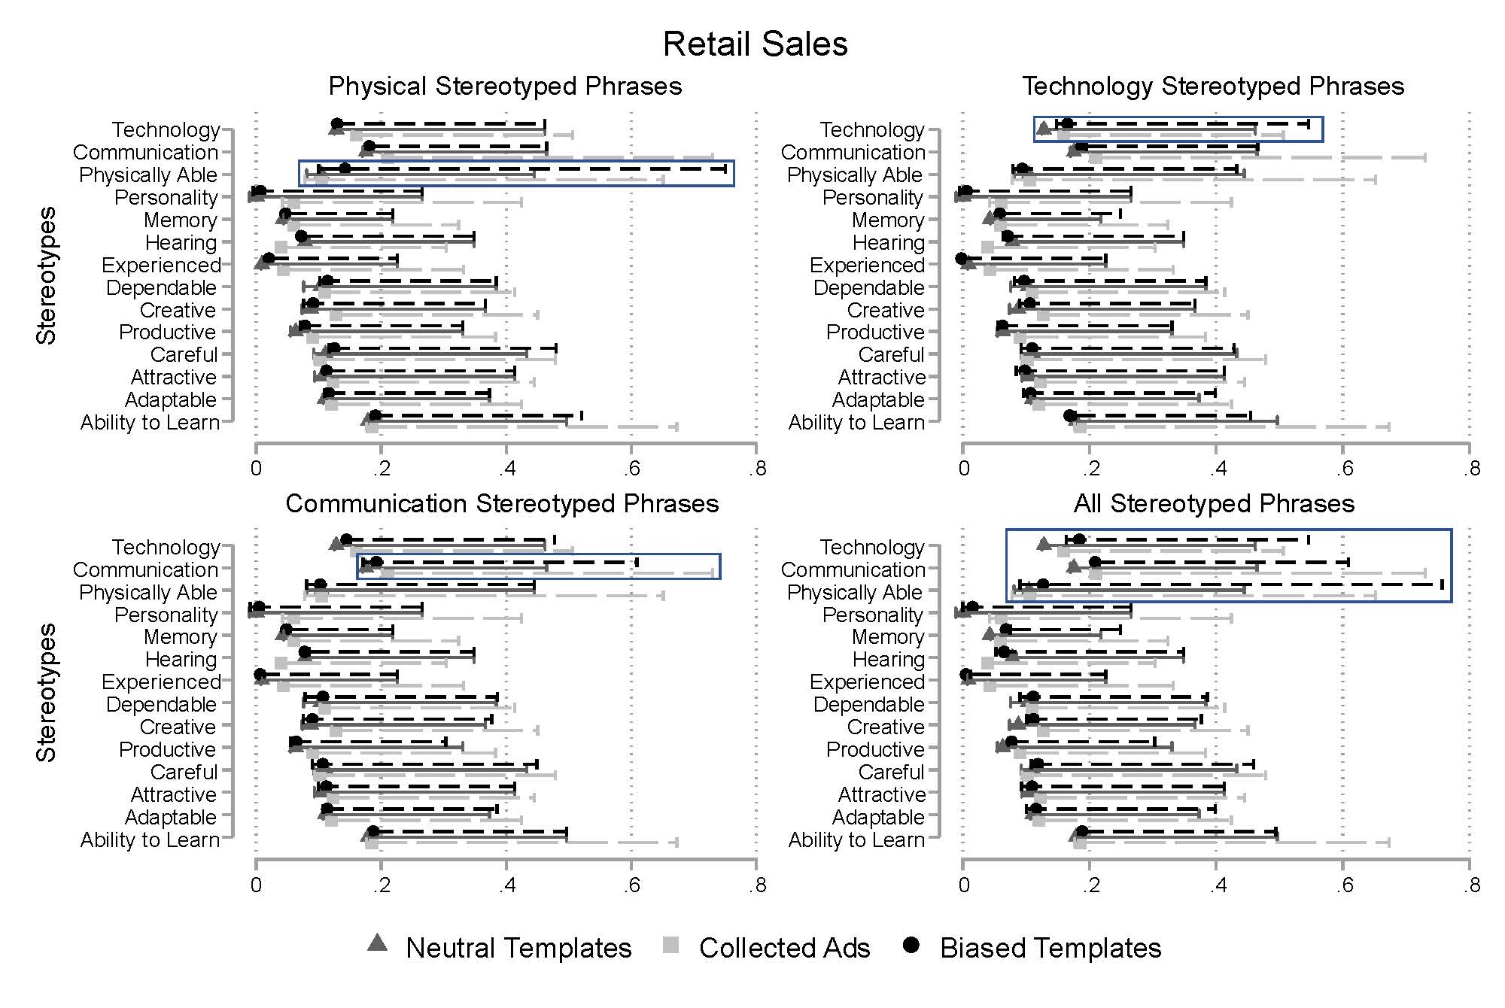
Note: Graphs display median to 99th percentile range of trigram semantic similarity scores for each stereotype for Retail Sales ads. The average trigram semantic similarity score for each stereotype is represented by the respective shape for each template. Control (“neutral”) templates contain trigrams from the created ad templates with only non-stereotyped phrases included. Collected ads comprise trigrams from all Retail Sales job ads. Treatment templates contain trigrams from the created ad templates with the respective stereotyped phrase or phrases included. This is an expanded version of Figure 4 in the paper.
Appendix Figure B3: Cosine Similarity Score of Security Guard Templates
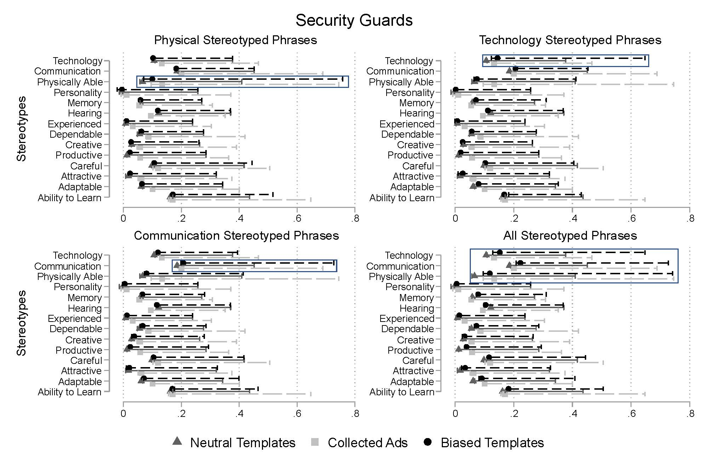
Note: Graphs display median to 99th percentile range of trigram semantic similarity scores for each stereotype for Security Guard ads. The average trigram semantic similarity score for each stereotype is represented by the respective shape for each template. Control (“neutral”) templates contain trigrams from the created ad templates with only non-stereotyped phrases included. Collected ads comprise trigrams from all Security Guard job ads. Treatment templates contain trigrams from the created ad templates with the respective stereotyped phrase or phrases included. This is an expanded version of Figure 5 in the paper.

Appendix C (online)
Appendix Figure C1: Manipulation Checks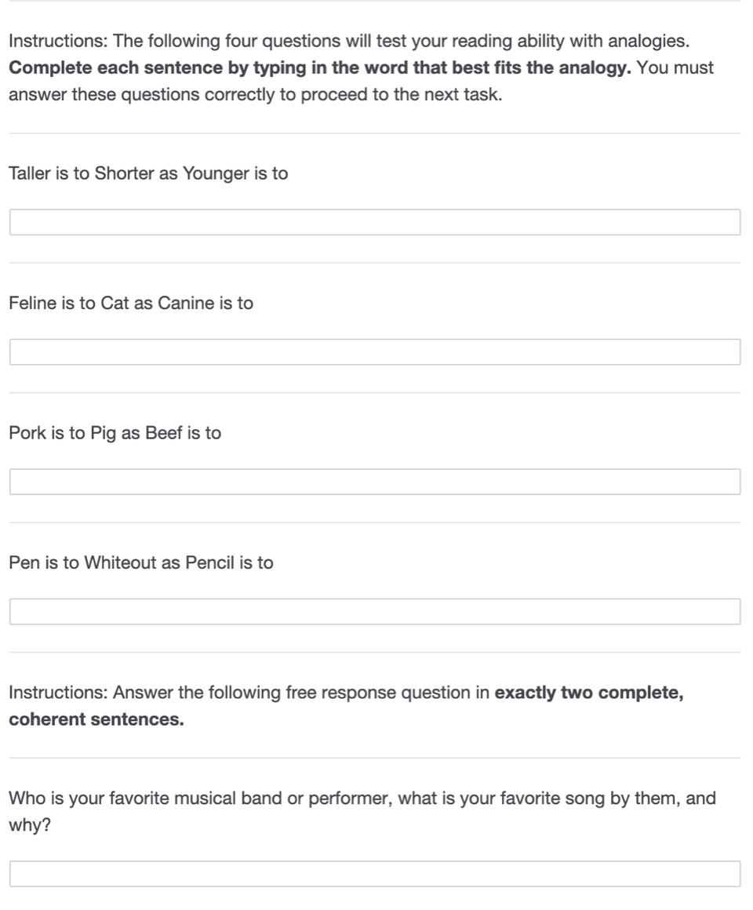

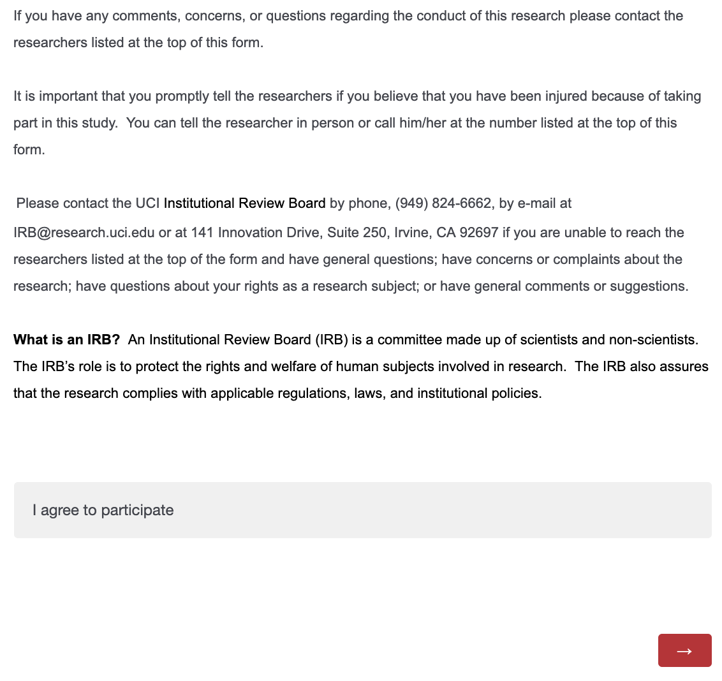
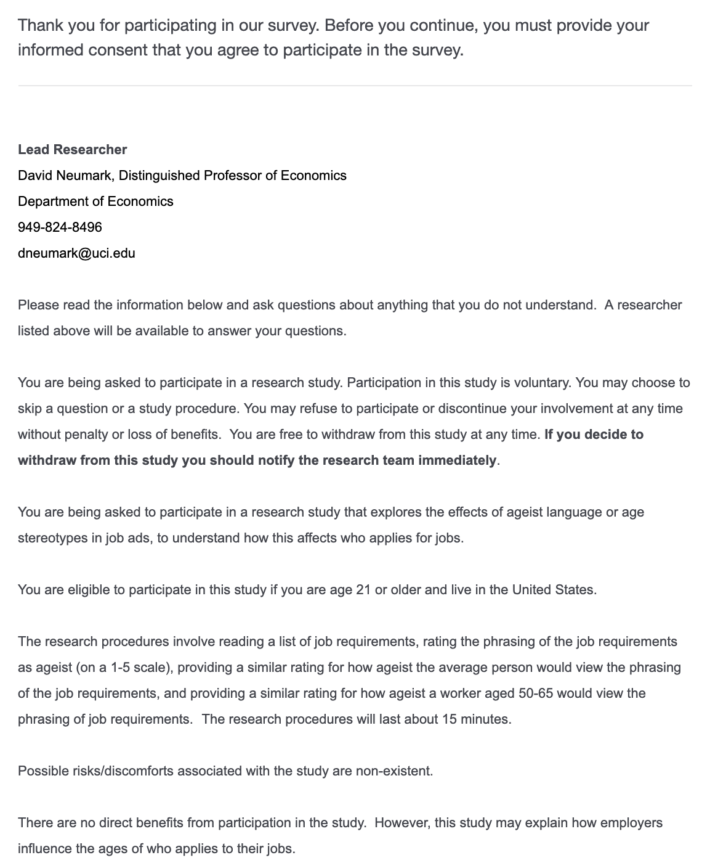
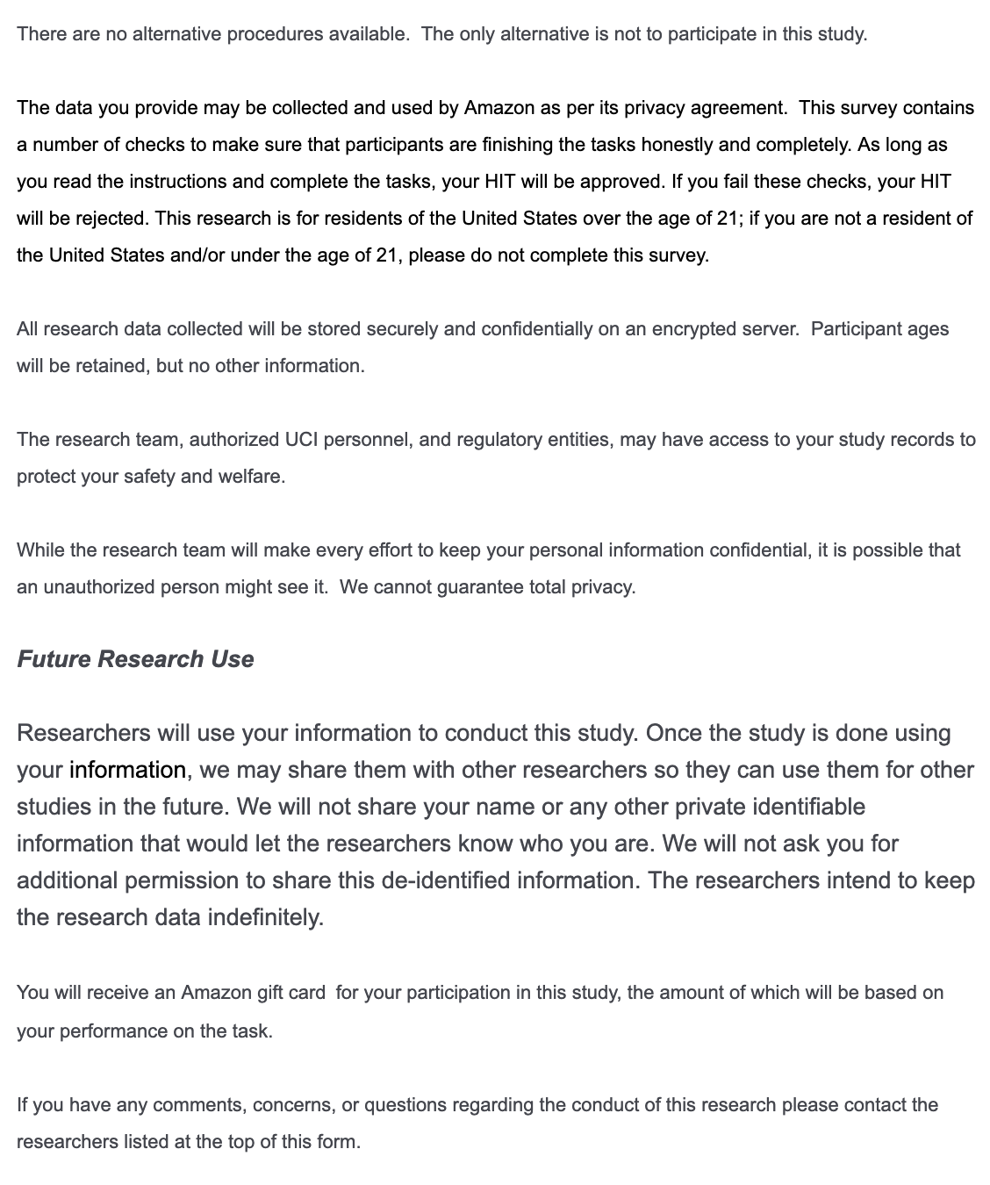
Appendix Figure C2: Informed Consent
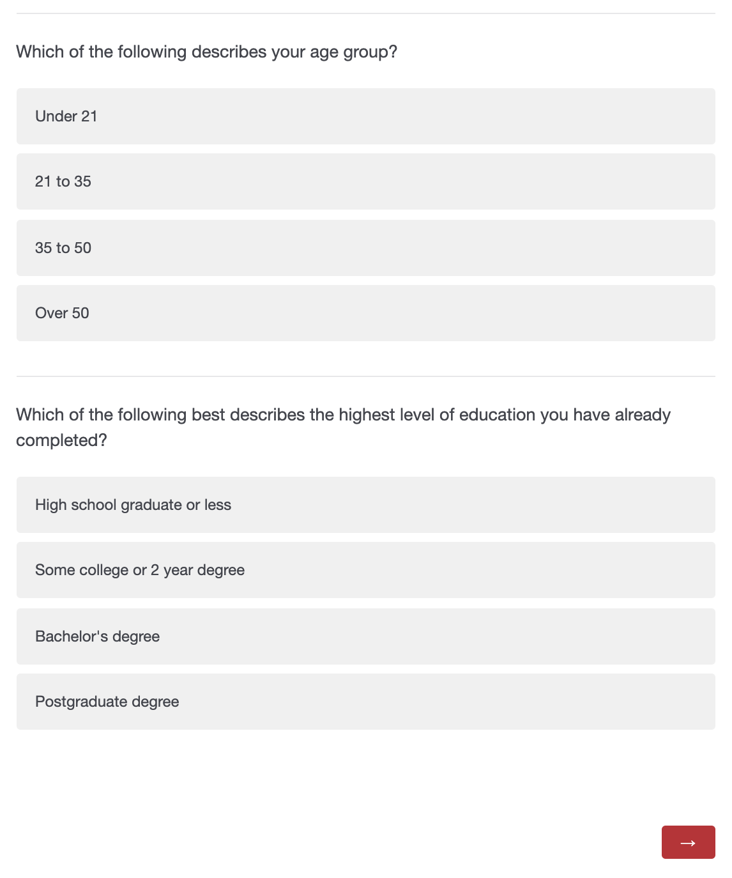
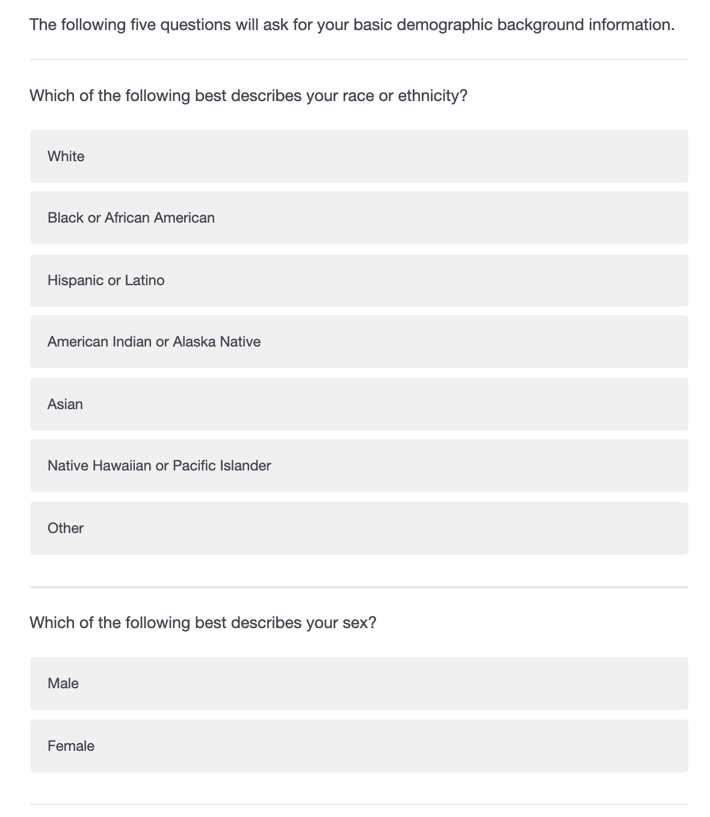
Appendix Figure C3: Demographic Questions

Appendix D (online): Experiment Page Examples

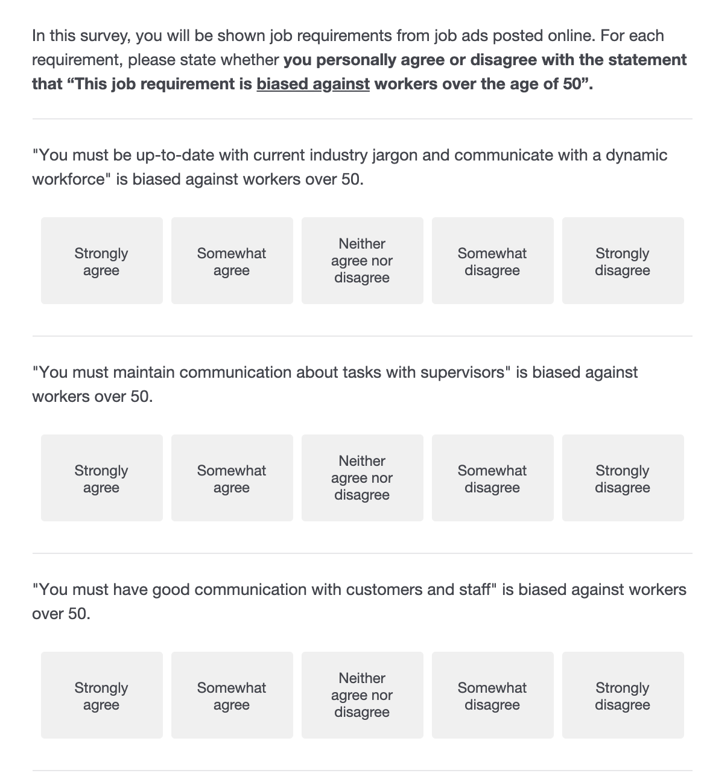
Appendix Figure D1: Block 1 Example (Exists in Survey 1 and Survey 2)
Note: Respondents were asked about their opinions for all of the treatment and control phrases within a given age-related stereotype. The treatment and control phrases within the communication, physical, and technology categories were shown on three separate pages, and the Qualtrics software disallowed skipping or going back between sections. The order of phrases was randomized for each participant, and they were required to provide an answer in order to proceed to the next section of the survey. In this example, the first three phrases for the communication category are shown.

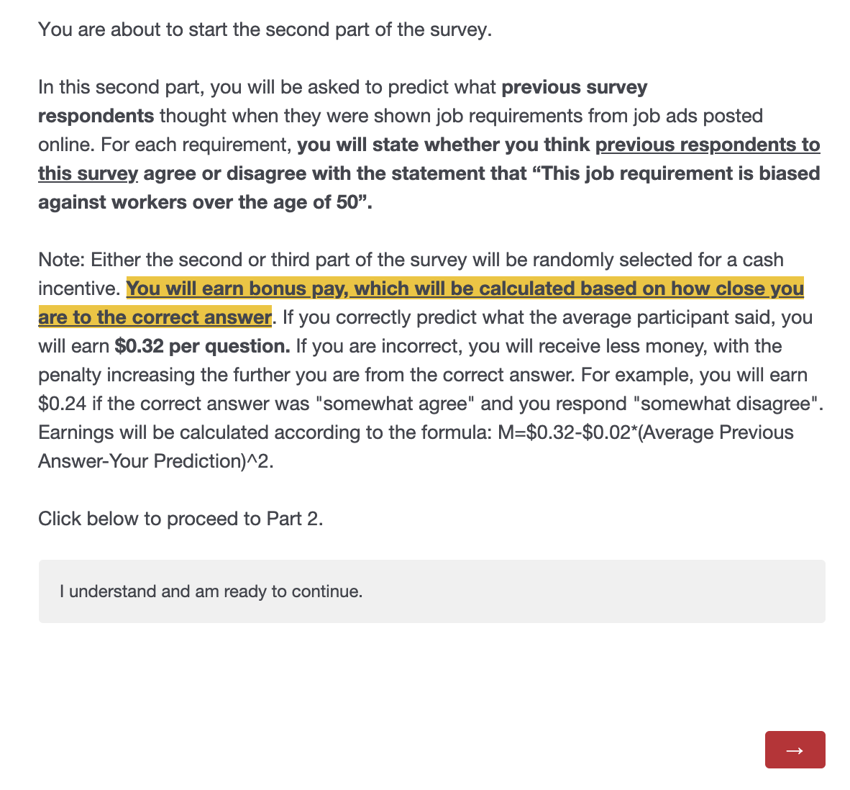
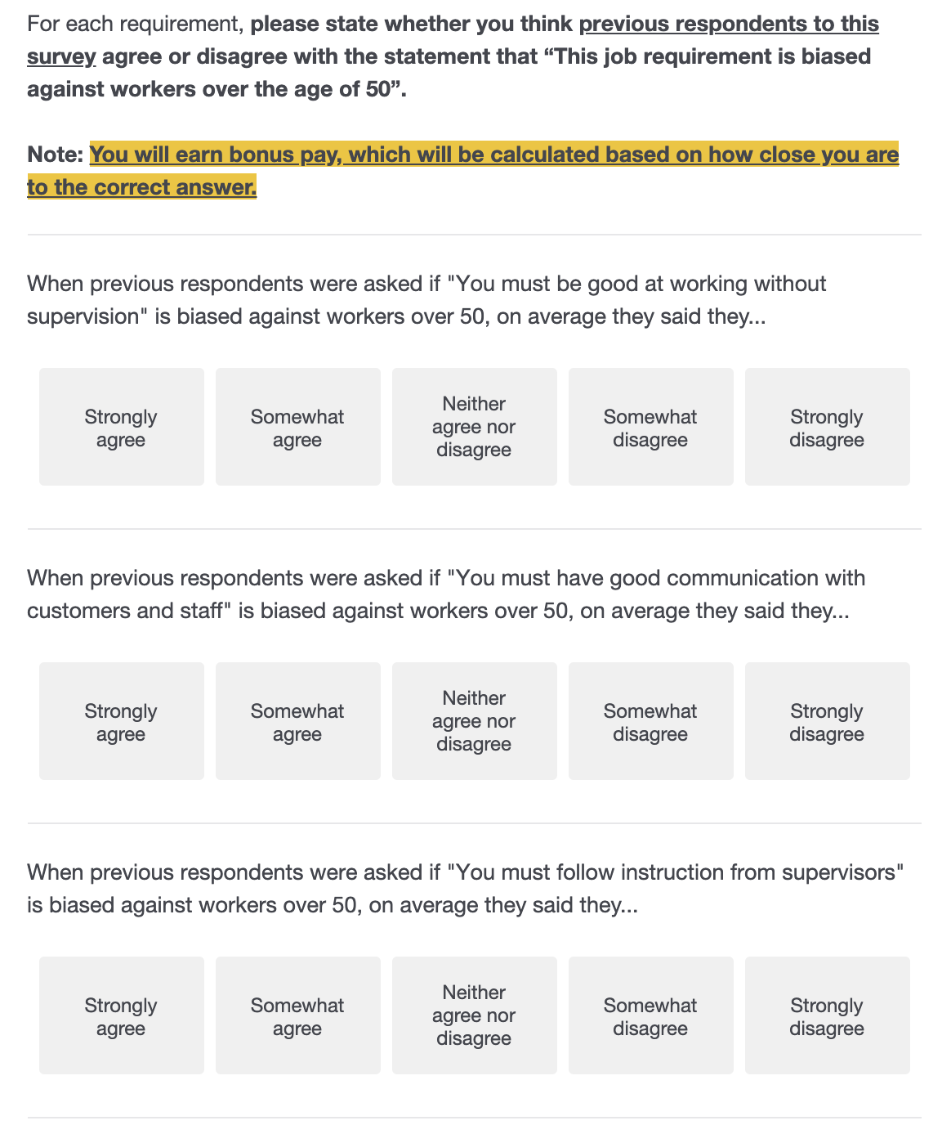
Appendix Figure D2: Block 2 Landing Page and Example
Note: After survey participants completed the block soliciting their personal opinions on whether certain phrases were age-biased, they were directed to the landing page pictured on the left-hand side of the figure. The landing page stressed the incentivized nature of the subsequent section and that bonus pay would be based on how accurately they could identify what the average respondent to the baseline survey said. The questions in the section reflected the new prompt and a highlighted portion at the top of each page reminded MTURK participants that their answers were incentivized based on accuracy.
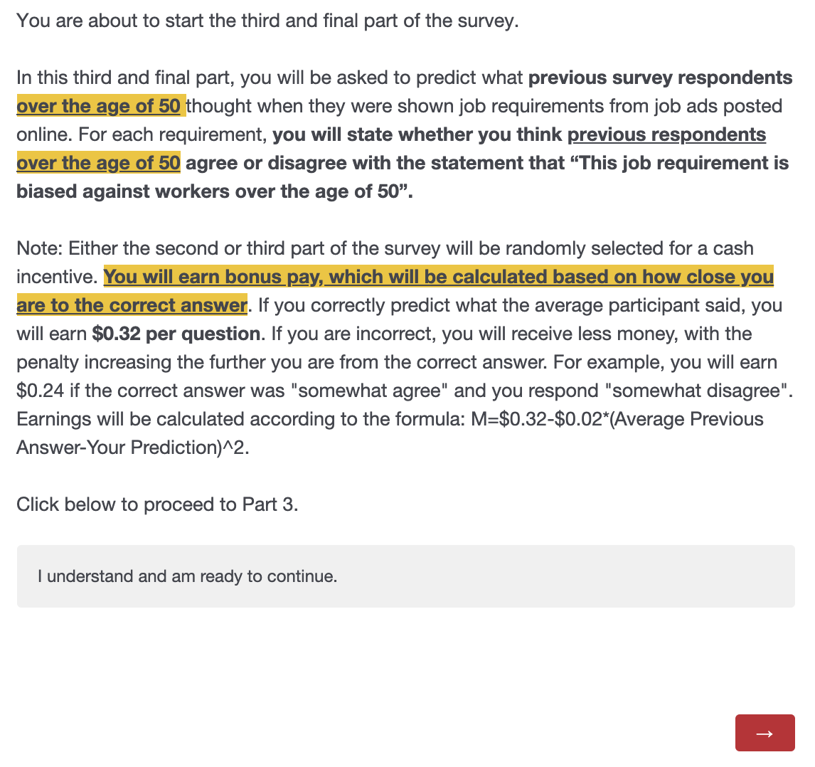
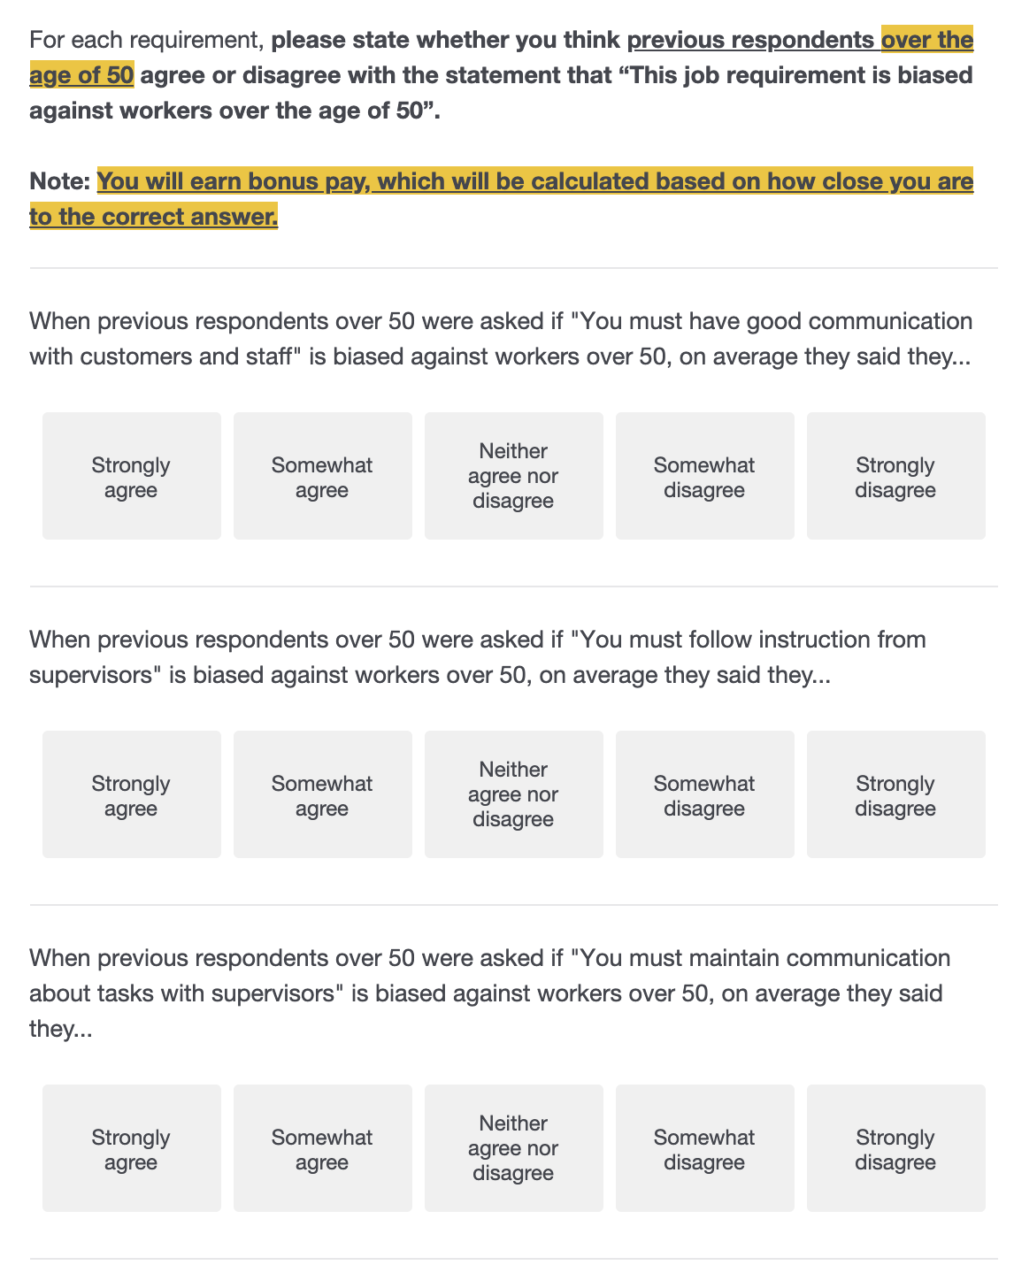
Appendix Figure D3: Block 3 Landing Page and Example (Exists only Survey 2)

Note: After survey participants completed the block soliciting their personal opinions on whether certain phrases were age-biased, they were directed to the landing page pictured on the left-hand side of the figure. The landing page stressed the incentivized nature of the subsequent section and that bonus pay would be based on how accurately they could identify what the respondents over the age of 50 to the baseline survey said. The questions in the section reflected the new prompt and a highlighted portion at the top of each page reminded MTURK participants that their answers were incentivized based on accuracy.

