**Appendix Tables**

**Table A.1** Age at retirement by pathway and birth cohort



*Notes:* * Individuals born before Nov. 17, 1950 and who were severely handicapped on Nov. 16, 2000 can retire at age 60 without deductions.

< 63: Disability retirement prior to age 63 was charged with benefit discounts of up to 10.8 % if retirement entry occurred after 2001.

^ Until 31.12.2000, the "old" disability retirement enabled eligible persons to enter the retirement independently of the age without deductions after the person became disabled.

*Source:* SGB VI, BMAS (2017), Steffen (2018), and own calculations.

**Table A.2** Benefit reductions after disability retirement by month of age and retirement



*Source:* Steffen (2018), own calculations.

**Table A.3** Duration of unemployment benefit receipt (in months) by age



*Notes:* Column 1 describes the age cutoffs. The cut in benefit durations as of February 2006 affected those unemployed since February 1, 2006. The prolongation of unemployment benefit durations as of January 2008 affected those entering unemployment on or after January 1, 2008 and aged 50 or 58 at that time, or those still receiving unemployment benefits from a prior entry to unemployment on January 1, 2008 and aged at least 50 or 58 at that time.

*Source:* Riphahn and Schrader (2020).

**Table A.4** Sample Selection Steps



*Source:* SUFVSKT2002_FAU_Schrader-SUFVSKT2013_FAU_Schrader, own calculations.

**Table A.5** Reform 1 (NRA) – List of variables



**Table A.6** Reform 2 (ERA) – List of variables



**Table A.7** Reform 1 (NRA) – Descriptive statistics of variables as listed in **Table A.5**



*Source:* SUFVSKT2002_FAU_Schrader-SUFVSKT2013_FAU_Schrader, own calculations.

**Table A.8** Reform 2 (ERA) – Descriptive statistics of variables as listed in **Table A.6**

**

*Source:* SUFVSKT2002_FAU_Schrader-SUFVSKT2013_FAU_Schrader, own calculations.

**Table A.9** Intensity of reform 1 (NRA) by retirement age and date of birth



*Notes:* The cells show the number of months for which an individual has to accept benefit discounts depending on retirement age and date of birth. As an example, individuals born in December of 1937 have to accept 12 months of discount (0.3 % each, totaling 3.6%) if they retire as soon as they reach age 60 (0 months).

*Source:* SGB VI Anlage 19, own calculations.

**Table A.10** Intensity of reform 2 (ERA) by retirement age and date of birth



*Notes:* The cells show the number of months by which the first option for early retirement at a given age has been postponed after reform 2 (ERA) depending on retirement age and date of birth. As an example, individuals born in December of 1946 who wanted to retire exactly up reaching age 60 have to wait 12 months after the reform until early retirement becomes available to them for the first time.

*Source:* SGB VI Anlage 19, own calculations.

**Table A.11** Reform 1 (NRA) and 2 (ERA) – List of variables for cross section estimations (section5)



**Table A.12** Reform 1 (NRA) and 2 (ERA) – Descriptive statistics of variables in **Table A.11**



*Notes:* The sample of reform 1 (NRA) consists of 11,240 observations and the sample of reform 2 (ERA) of 8,566 observations. The "Insurance group" variable is equal to “1” for blue collar workers, to “2” for white collar workers, and to “0” for others. Statistics of "Deductions disability retirement" and "UB months" relate to the observations in age range 60-62.

*Source:* SUFVSKT2002_FAU_Schrader-SUFVSKT2013_FAU_Schrader, own calculations.

**Figure A.1** ERA und NRA by birth month and year and retirement pathway

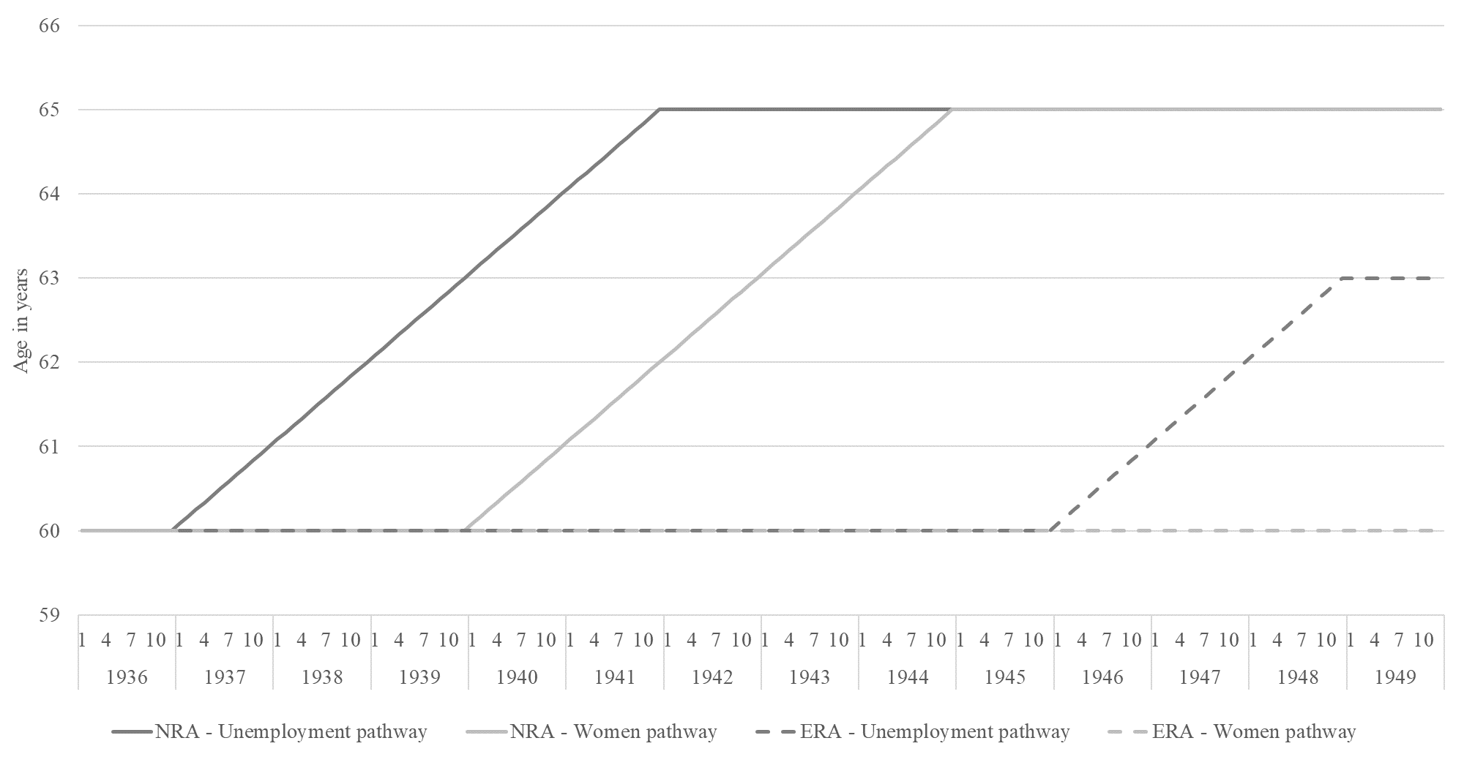

**Figure A.2** Mean number of months in employment by birth cohort and gender (age 57-62)



**Figure A.3** Mean number of months in unemployment by birth cohort and gender (age 57-62)



**Figure A.4** Mean number of months in old age retirement by birth cohort and gender (age 60-62)



**Figure A.5** Mean number of months in sev. handicapped retirement by birth cohort and gender (age 60-62)



**Figure A.6** Mean number of months in disability retirement by birth cohort and gender (age 57-62)



*Source:* SUFVSKT2002_FAU_Schrader-SUFVSKT2013_FAU_Schrader, own calculations.