Appendix A: Tables & Figures

Table A.1: Treatment Effects on Treated (TOT)

 | (1) Directional  Accuracy | (2) Directional  Difference | (3) Directional  Difference | (4) Percent  Correct | (5) Consequential  Difference
A. Annuities
Written | 0.067* | 0.056*** | 0.056*** | 9.860*** | -0.108
 | (0.04) | (0.02) | (0.02) | (1.44) | (0.09)
 | 864 | 864 | 864 | 864 | 856
Video | 0.052 | 0.026 | 0.024 | 13.129*** | -0.171**
 | (0.04) | (0.02) | (0.02) | (1.47) | (0.09)
B. Social Security | 864 | 864 | 864 | 864 | 856
Written | 0.045 | 10.417*** | 7.381*** | 13.540*** | -0.012
 | (0.03) | (2.67) | (2.31) | (1.39) | (0.08)
 | 902 | 902 | 902 | 902 | 888
Video | 0.042 | 11.820*** | 6.038** | 14.452*** | -0.151*
 | (0.03) | (2.73) | (2.38) | (1.42) | (0.08)
 | 902 | 902 | 902 | 902 | 888
This table shows treatment coefficients from regressions of outcome variables on the written and video vignettes, as well as controls for age, gender, race, household income, education level, numeracy, recruitment wave and the order in which the scenarios were presented. We exclude all respondents who answered that they "could not view" the written or video vignette. Specification (1) uses whether or not the respondent was directionally accurate as the outcome. Specification (2) uses the raw difference in recommended investment/claim age between the long life and short life scenarios as the outcome. Specification (3) uses the same measure, but controls for the baseline amount in the unhealthy scenario. Specifications
11
(4) and (5) use the percent correct on True/False questions and the difference in likert scale valuation of consequence and non-consequence-related concerns respectively.
*p<0.10 **p<0.05 ***p<0.01

Table A.2: Treatment Effects: Annuities

 | (1) | (2) | (3) | (4) | (5)
 | Dir. Accurate | Dir. Spread | Dir. Spread | Percent Correct | Conseq. Differential
Written Vignette | 0.06 | 0.05*** | 0.05*** | 9.47*** | 0.13
 | (0.04) | (0.02) | (0.02) | (1.48) | (0.09)
Video Vignette | 0.05 | 0.02 | 0.02 | 12.30*** | 0.19**
 | (0.04) | (0.02) | (0.02) | (1.49) | (0.09)
Age | -0.00 | 0.00 | 0.00 | 0.17*** | 0.01**
 | (0.00) | (0.00) | (0.00) | (0.06) | (0.00)
Gender - Male | 0.03 | 0.02 | 0.02 | -2.33* | -0.04
 | (0.03) | (0.02) | (0.02) | (1.28) | (0.07)
Black | -0.04 | -0.01 | -0.00 | -6.55*** | -0.09
 | (0.05) | (0.03) | (0.03) | (2.16) | (0.13)
Other Race | 0.05 | 0.05* | 0.05* | 1.45 | 0.03
 | (0.05) | (0.03) | (0.03) | (2.07) | (0.12)
Span./Hisp/Latino | -0.19*** | -0.05 | -0.04 | -1.60 | -0.39***
 | (0.06) | (0.03) | (0.03) | (2.45) | (0.14)
$<30,000 | 0.02 | -0.06** | -0.06** | -3.06 | 0.25**
 | (0.05) | (0.03) | (0.02) | (1.95) | (0.11)
$30,000-59,000 | 0.05 | -0.03 | -0.02 | -1.65 | 0.27***
 | (0.05) | (0.02) | (0.02) | (1.79) | (0.10)
$60,000-99,999 | 0.04 | -0.02 | -0.00 | -0.70 | 0.29***
 | (0.05) | (0.02) | (0.02) | (1.77) | (0.10)
Some College | -0.04 | 0.01 | 0.01 | 2.62 | 0.08
 | (0.05) | (0.02) | (0.02) | (1.80) | (0.11)
Bachelor | 0.01 | 0.02 | 0.03 | -1.75 | 0.12
 | (0.05) | (0.03) | (0.02) | (1.91) | (0.11)
Assc. College Degree | 0.04 | 0.01 | 0.03 | 2.34 | 0.02
 | (0.05) | (0.02) | (0.02) | (1.91) | (0.11)
Master/Prof/Dr | 0.00 | 0.01 | 0.02 | -4.57** | -0.01
 | (0.06) | (0.03) | (0.03) | (2.24) | (0.13)
Numeracy Score | 0.00** | 0.00*** | 0.00*** | 0.69*** | 0.00
 | (0.00) | (0.00) | (0.00) | (0.08) | (0.00)
Baseline Scenario |  |  | -0.00***
 |  |  | (0.00)
Constant | 0.49*** | -0.13* | -0.01 | 39.22*** | -1.12***
 | (0.14) | (0.07) | (0.07) | (5.69) | (0.33)
R2 | 0.03 | 0.08 | 0.18 | 0.19 | 0.04
N | 879.00 | 879.00 | 879.00 | 879.00 | 804.00
Notes: This table shows coefficients from regressions of outcome variables in the annuities condition on the written and video vignettes, as well as controls for age, gender, race, household income, education level, numeracy, recruitment wave and the order in which the scenarios were presented. Specification (1) uses whether or not the respondent was directionally accurate as the outcome. Specification (2) uses the raw difference in recommended investment between the long life and short life scenarios as the outcome. Specification (3) uses the same measure, but controls for the baseline amount in the unhealthy scenario. Specifications (4) and (5) use the percent correct on True/False questions and the difference in likert scale valuation of consequence and non-consequence-related concerns respectively.
12
*p<0.10 **p<0.05 ***p<0.01

Table A.3: Treatment Effects: Social Security

 | (1) | (2) | (3) | (4) | (5)
 | Dir. Accurate | Dir. Spread | Dir. Spread | Percent Correct | Conseq. Differential
Written Vignette | 0.05 | 10.22*** | 7.13*** | 13.54*** | 0.00
 | (0.03) | (2.66) | (2.31) | (1.42) | (0.08)
Video Vignette | 0.04 | 10.94*** | 5.43** | 13.44*** | 0.19**
 | (0.03) | (2.69) | (2.34) | (1.43) | (0.08)
Age | 0.00 | 0.16 | 0.03 | 0.11* | 0.02***
 | (0.00) | (0.11) | (0.10) | (0.06) | (0.00)
Gender - Male | -0.05** | -3.96* | -4.84** | -1.11 | -0.06
 | (0.03) | (2.31) | (2.00) | (1.23) | (0.07)
Black | -0.11*** | -3.88 | -3.68 | -5.61*** | -0.30**
 | (0.04) | (3.83) | (3.31) | (2.04) | (0.12)
Other Race | 0.01 | -0.68 | -0.09 | 0.14 | 0.12
 | (0.04) | (3.90) | (3.37) | (2.07) | (0.12)
Span./Hisp/Latino | 0.04 | 1.64 | 0.43 | -4.39* | 0.14
 | (0.05) | (4.36) | (3.76) | (2.32) | (0.14)
$<30,000 | -0.07* | -8.76** | -3.48 | -3.31* | 0.19*
 | (0.04) | (3.60) | (3.12) | (1.91) | (0.11)
$30,000-59,000 | -0.08** | -7.73** | -6.15** | -1.28 | 0.11
 | (0.03) | (3.20) | (2.76) | (1.70) | (0.10)
$60,000-99,999 | -0.05 | -5.87* | -5.34* | 1.31 | 0.06
 | (0.03) | (3.19) | (2.75) | (1.69) | (0.10)
Some College | 0.03 | 2.95 | 3.44 | -0.09 | -0.08
 | (0.04) | (3.25) | (2.81) | (1.73) | (0.10)
Bachelor | 0.03 | 4.40 | 6.00** | 1.39 | -0.20*
 | (0.04) | (3.54) | (3.06) | (1.88) | (0.11)
Assc. College Degree | 0.03 | -0.08 | 0.87 | 1.04 | 0.18
 | (0.04) | (3.50) | (3.02) | (1.86) | (0.11)
Master/Prof/Dr | -0.01 | 3.84 | 7.89** | 1.83 | -0.07
 | (0.04) | (4.15) | (3.59) | (2.20) | (0.13)
Numeracy Score | 0.01*** | 1.06*** | 0.76*** | 0.49*** | -0.00
 | (0.00) | (0.15) | (0.13) | (0.08) | (0.00)
Baseline Scenario |  |  | -0.71***
 |  |  | (0.04)
Constant | 0.45*** | -18.16* | 15.25* | 52.20*** | -1.06***
 | (0.11) | (10.04) | (8.87) | (5.33) | (0.31)
R2 | 0.07 | 0.14 | 0.36 | 0.21 | 0.07
N | 922.00 | 922.00 | 922.00 | 922.00 | 841.00
Notes: This table shows coefficients from regressions of outcome variables in the Social Security condition on the written and video vignettes, as well as controls for age, gender, race, household income, education level, numeracy, recruitment wave and the order in which the scenarios were presented. Specification (1) uses whether or not the respondent was directionally accurate as the outcome. Specification (2) uses the raw difference in recommended claim age between the long life and short life scenarios as the outcome. Specification (3) uses the same measure, but controls for the baseline amount in the unhealthy scenario. Specifications (4) and (5) use the percent correct on True/False questions and the difference in likert scale valuation of consequence and non-consequence-related concerns respectively.
13
*p<0.10 **p<0.05 ***p<0.01

Table A.4: Interaction Treatment Effects: Annuities

 | (1) | (2) | (3) | (4) | (5) | (6)
 | Dir. Accurate | Dir. Spread | Dir. Accurate | Dir. Spread | Dir. Accurate | Dir. Spread
Written*Over 60 | -0.07 | -0.00
 | (0.09) | (0.05)
Video*Over 60 | 0.09 | -0.00
 | (0.09) | (0.04)
Written*Finlit |  |  | 0.03*** | 0.01**
 |  |  | (0.01) | (0.01)
Video*Finlit |  |  | 0.02 | 0.00
 |  |  | (0.01) | (0.01)
Written*Some College |  |  |  |  | 0.12 | 0.03
 |  |  |  |  | (0.11) | (0.06)
Written*Bachelor |  |  |  |  | 0.18 | 0.11**
 |  |  |  |  | (0.11) | (0.06)
Written*Assc. College Degree |  |  |  |  | 0.09 | -0.03
 |  |  |  |  | (0.12) | (0.06)
Written*Master/Prof/Dr |  |  |  |  | 0.22* | 0.05
 |  |  |  |  | (0.13) | (0.06)
Video*Some College |  |  |  |  | -0.05 | 0.04
 |  |  |  |  | (0.11) | (0.06)
Video*Bachelor |  |  |  |  | 0.01 | 0.04
 |  |  |  |  | (0.11) | (0.06)
Video*Assc. College Degree |  |  |  |  | 0.03 | -0.01
 |  |  |  |  | (0.12) | (0.06)
Video*Master/Prof/Dr |  |  |  |  | -0.10 | -0.04
 |  |  |  |  | (0.12) | (0.06)
R2 | 0.04 | 0.08 | 0.04 | 0.09 | 0.04 | 0.09
N | 879.00 | 879.00 | 879.00 | 879.00 | 879.00 | 879.00
Notes: This table shows treatment-interaction coefficients from regressions of outcome variables in the annuities condition. Treatments are interacted with a dummy for whether the respondent is over 60, respondent financial literacy score (continuous) and respondent's highest level of education (binary). In each case, the first column uses whether or not the respondent was directionally accurate as the outcome. The second column uses the raw difference in recommended investment between the long life and short life scenarios as the outcome. All regressions control for the written and video vignettes, as well as age (replaced by over 60 dummy in columns 1 and 2), gender, race, household income, education level, numeracy, recruitment wave and the order in which the scenarios were presented.
14
*p<0.10 **p<0.05 ***p<0.01

Table A.5: Interaction Treatment Effects: Social Security

 | (1) | (2) | (3) | (4) | (5) | (6)
 | Dir. Accurate | Dir. Spread | Dir. Accurate | Dir. Spread | Dir. Accurate | Dir. Spread
Written*Over 60 | -0.07 | -5.80
 | (0.07) | (6.18)
Video*Over 60 | 0.01 | -2.17
 | (0.07) | (6.60)
Written*Finlit |  |  | -0.01 | 0.16
 |  |  | (0.01) | (0.80)
Video*Finlit |  |  | 0.00 | 0.30
 |  |  | (0.01) | (0.85)
Written*Some College |  |  |  |  | 0.05 | 9.80
 |  |  |  |  | (0.09) | (7.94)
Written*Bachelor |  |  |  |  | 0.01 | 0.19
 |  |  |  |  | (0.09) | (7.89)
Written*Assc. College Degree |  |  |  |  | -0.00 | 6.93
 |  |  |  |  | (0.09) | (8.27)
Written*Master/Prof/Dr |  |  |  |  | 0.05 | 13.31
 |  |  |  |  | (0.09) | (8.63)
Video*Some College |  |  |  |  | 0.10 | 13.82*
 |  |  |  |  | (0.09) | (8.06)
Video*Bachelor |  |  |  |  | 0.01 | -1.95
 |  |  |  |  | (0.09) | (7.91)
Video*Assc. College Degree |  |  |  |  | 0.02 | 6.52
 |  |  |  |  | (0.09) | (8.43)
Video*Master/Prof/Dr |  |  |  |  | 0.13 | 11.13
 |  |  |  |  | (0.10) | (9.16)
R2 | 0.07 | 0.14 | 0.06 | 0.13 | 0.07 | 0.14
N | 922.00 | 922.00 | 922.00 | 922.00 | 922.00 | 922.00
Notes: This table shows treatment-interaction coefficients from regressions of outcome variables in the Social Security condition. Treatments are interacted with a dummy for whether the respondent is over 60, respondent financial literacy score (continuous) and respondent's highest level of education (binary). In each case, the first column uses whether or not the respondent was directionally accurate as the outcome. The second column uses the raw difference in recommended claim age between the long life and short life scenarios as the outcome. All regressions control for the written and video vignettes, as well as age (replaced by over 60 dummy in columns 1 and 2), gender, race, household income, education level, numeracy, recruitment wave and the order in which the scenarios were presented.
15
*p<0.10 **p<0.05 ***p<0.01

Table A.6: Preference Demographics

 | (1) | (2) | (3)
 | Prefer Video | Prefer Online Article | Prefer Mail
Age Over 60 | -0.07** | -0.06* | 0.12***
 | (0.03) | (0.03) | (0.03)
Gender - Male | 0.03 | 0.00 | -0.03
 | (0.02) | (0.02) | (0.02)
Black | 0.04 | -0.09** | 0.05
 | (0.04) | (0.04) | (0.04)
Other Race | 0.00 | -0.07 | 0.06
 | (0.04) | (0.04) | (0.04)
Span./Hisp/Latino | 0.07 | -0.10** | 0.03
 | (0.04) | (0.04) | (0.05)
$<30,000 | -0.06 | -0.04 | 0.09**
 | (0.04) | (0.04) | (0.04)
$30,000-59,000 | -0.04 | -0.00 | 0.05
 | (0.03) | (0.03) | (0.03)
$60,000-99,999 | -0.01 | -0.00 | 0.01
 | (0.03) | (0.03) | (0.03)
Some College | 0.10*** | 0.01 | -0.11***
 | (0.03) | (0.03) | (0.04)
Bachelor | 0.10*** | 0.05 | -0.15***
 | (0.04) | (0.04) | (0.04)
Assc. College Degree | 0.15*** | -0.00 | -0.15***
 | (0.04) | (0.04) | (0.04)
Master/Prof/Dr | 0.09** | 0.15*** | -0.24***
 | (0.04) | (0.04) | (0.04)
Scenario Order | -0.01 | 0.00 | 0.01
 | (0.02) | (0.02) | (0.02)
Numeracy Score | -0.00* | 0.01*** | -0.01***
 | (0.00) | (0.00) | (0.00)
R2 | 0.02 | 0.07 | 0.09
N | 1589.00 | 1589.00 | 1589.00
This table shows OLS regressions of respondent preferences for receiving communica- tions on demographics including age, gender, race, household income, education level, numeracy, recruitment wave and the order in which the scenarios were presented.
*p<0.10 **p<0.05 ***p<0.01

16

Figure A.1: Heterogeneous Treatment Effects: Demographic Groups

Panel A: Written Vignette
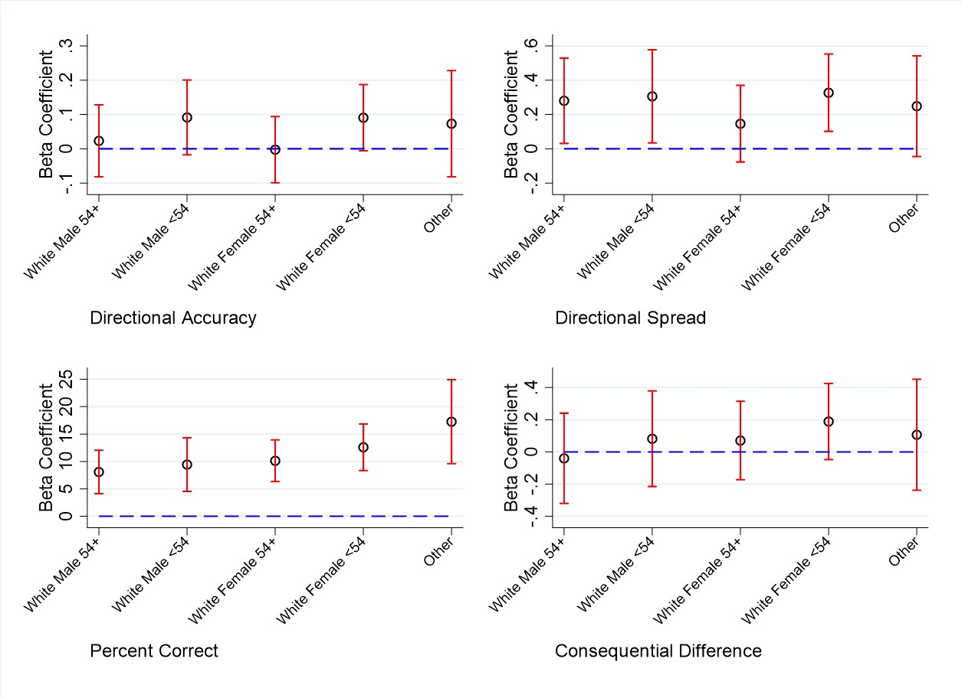
Panel B: Video Vignette
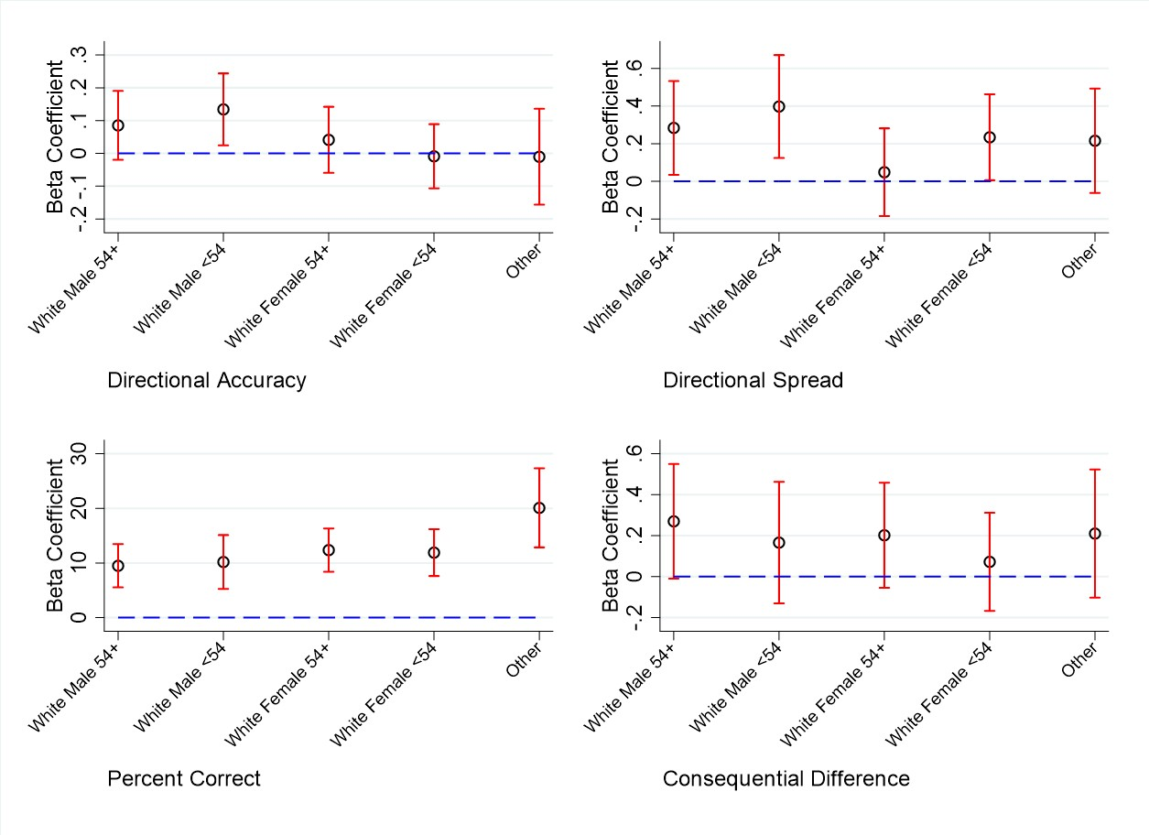

Notes: These figures show treatment coefficients for the written and video vignettes from regressions of outcomes on treatment for specific demographic groups. The annuity and social security scenario are pooled together. Regressions include controls for household income, education level, numeracy, recruitment wave and the order in which the scenarios were presented. 95% confidence intervals are shown in red. The "Other" category represents
non-white respondents of all ages. 17

Figure A.2: Heterogeneous Treatment Effects: Age Quintiles

Panel A: Written Vignette
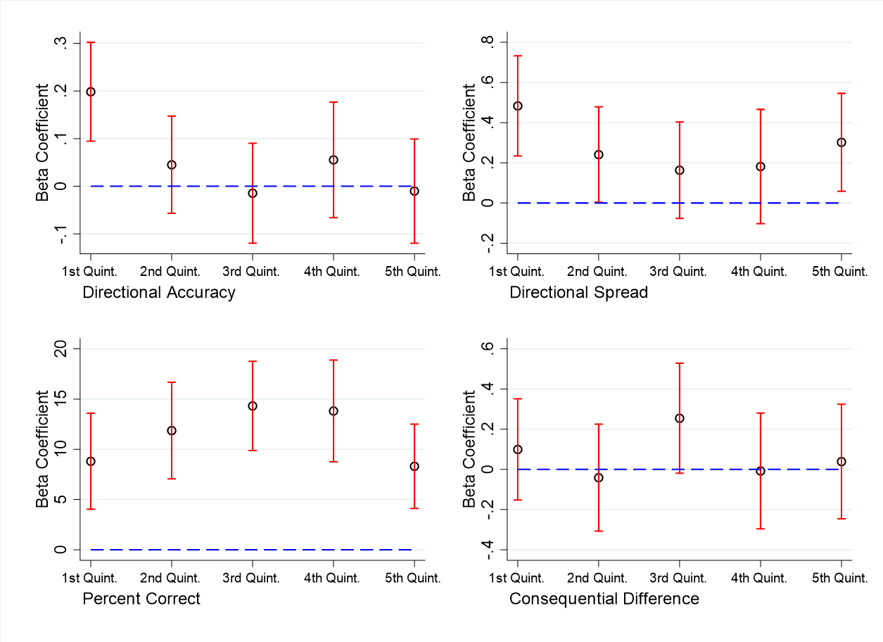
Panel B: Video Vignette
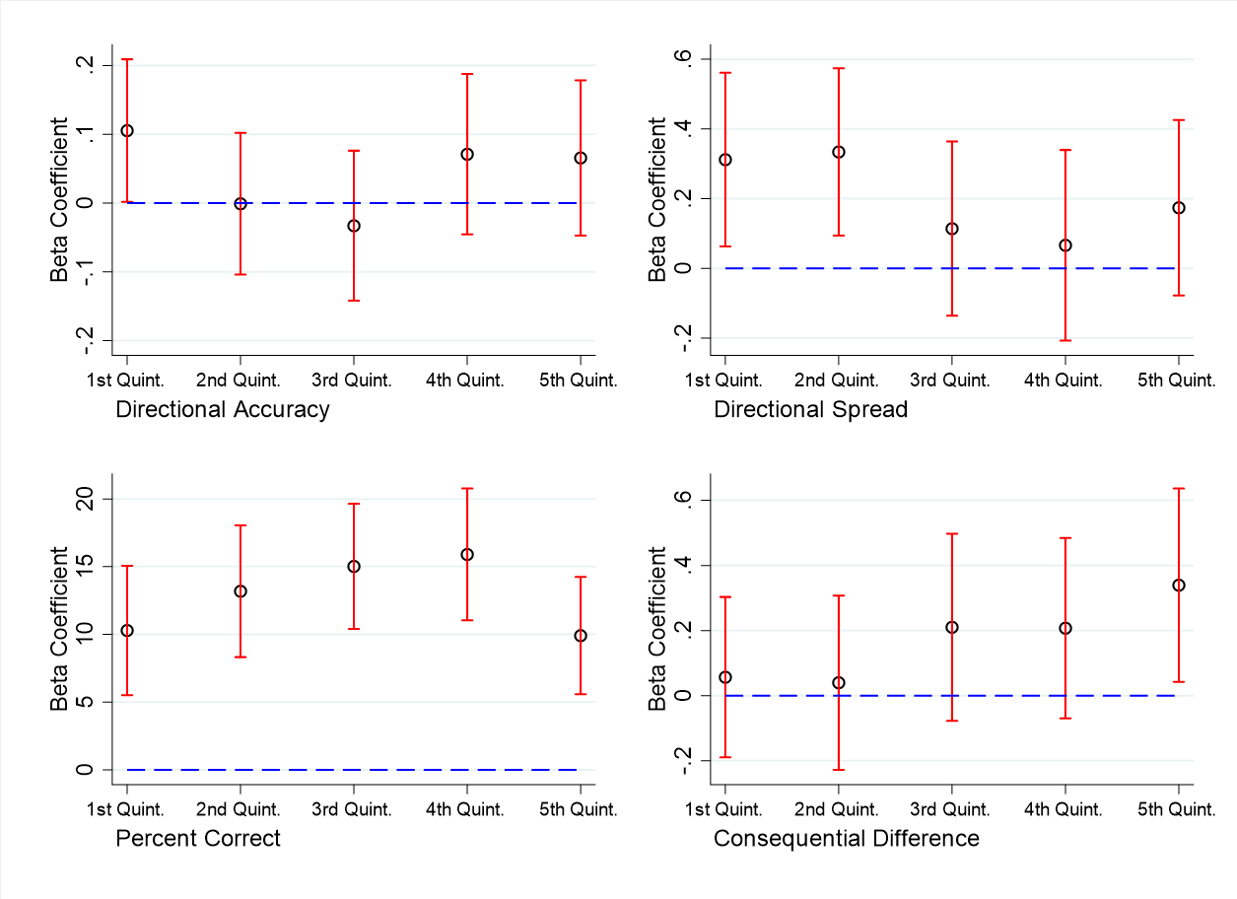

Notes: These figures shows treatment coefficients for the written and video vignettes from regressions of outcome on treatment by age quintiles. The annuity and social security scenario are pooled together. Regressions include controls for gender, race, household income, education level, numeracy, recruitment wave and the order in which the scenarios were presented. 95% confidence intervals are shown in red.

18

Table A.7: Treatment Effects on Concerns: Annuities

 | (a) | (b) | (c) | (d) | (e) | No Consequence | Consequence
Written Vignette | -0.17* | 0.35*** | -0.15 | -0.08 | -0.16 | -0.12 | 0.01
 | (0.09) | (0.11) | (0.11) | (0.09) | (0.11) | (0.08) | (0.08)
Video Vignette | -0.11 | 0.35*** | 0.02 | -0.04 | -0.16 | -0.10 | 0.09
 | (0.09) | (0.11) | (0.11) | (0.09) | (0.11) | (0.08) | (0.08)
R2 | 0.06 | 0.07 | 0.03 | 0.06 | 0.13 | 0.08 | 0.03
N | 804.00 | 804.00 | 804.00 | 804.00 | 804.00 | 804.00 | 804.00
Notes: This table shows coefficients from regressions of consequence and non-consequence related concerns in the annuities condition on the written and video vignettes, as well as controls for age, gender, race, household income, education level, numeracy, recruitment wave and the order in which the scenarios were presented. Column (a) is risk of running out of money, (b) is risk of not getting to spend all your money, (c) is uncertainty about how long you will live, (d) is whether you have enough money in retirement, (e) is leaving money to children. Columns 6 and 7 show results for the average rating of no consequence and consequence related concerns respectively. Each concern is rated on a 5-point scale from 1 (not at all important) to 5 (very important). See Appendix Survey C1 for the exact wording of the question.
*p<0.10 **p<0.05 ***p<0.01

Table A.8: Treatment Effects on Concerns: Social Security

 | (a) | (b) | (c) | (d) | (e) | No Consequence | Consequence
Written Vignette | 0.12 | -0.13 | -0.07 | 0.04 | -0.10 | -0.03 | -0.03
 | (0.10) | (0.10) | (0.10) | (0.08) | (0.11) | (0.08) | (0.07)
Video Vignette | 0.24** | 0.08 | 0.07 | 0.05 | -0.17 | -0.06 | 0.13*
 | (0.10) | (0.10) | (0.10) | (0.08) | (0.11) | (0.08) | (0.08)
R2 | 0.06 | 0.04 | 0.01 | 0.06 | 0.10 | 0.07 | 0.03
N | 841.00 | 841.00 | 841.00 | 841.00 | 841.00 | 841.00 | 841.00
Notes: This table shows coefficients from regressions of consequence and non-consequence related concerns in the annuities condition on the written and video vignettes, as well as controls for age, gender, race, household income, education level, numeracy, recruitment wave and the order in which the scenarios were presented. Column (a) is risk of claiming SS too late, (b) is risk of claiming SS too early, (c) is uncertainty about how long you will live, (d) is whether you have enough money in retirement, (e) is leaving money to children. Columns 6 and 7 show results for the average rating of no consequence and consequence related concerns respectively. Each concern is rated on a 5-point scale from 1 (not at all important) to 5 (very important). See Appendix Survey C2 for the exact wording of the question.
*p<0.10 **p<0.05 ***p<0.01

19

Table A.9: Self-Reported Likelihood of Annuity Purchase

 | (1) | (2) | (3) | (4)
 | Likelihood | Likelihood | Likelihood | Likelihood
Written Vignette | 0.13 | 0.17* | 0.30 | 0.17
 | (0.09) | (0.09) | (0.49) | (0.11)
Video Vignette | 0.17** | 0.23** | 0.53 | 0.23**
 | (0.09) | (0.10) | (0.49) | (0.11)
Written*Black |  | -0.36
 |  | (0.29)
Video*Black |  | -0.23
 |  | (0.28)
Written*Hispanic |  | -0.09
 |  | (0.32)
Video*Hispanic |  | -0.46
 |  | (0.31)
Written*Age |  |  | -0.00
 |  |  | (0.01)
Video*Age |  |  | -0.01
 |  |  | (0.01)
Written*Male |  |  |  | -0.12
 |  |  |  | (0.17)
Video*Male |  |  |  | -0.14
 |  |  |  | (0.17)
R2 | 0.06 | 0.07 | 0.06 | 0.06
N | 723.00 | 723.00 | 723.00 | 723.00
Notes: This table shows treatment coefficients from regressions of self-reported likelihood of annuitiy purchase on the written and video vignettes, as well as con- trols for age, gender, race, household income, education level, numeracy, recruit- ment wave and the order in which the scenarios were presented. Specification (2) includes treatment interacted with whether the respondent is black or Hispanic. Specification (3) includes treatment interacted with age, and specification (4) in- cludes treatment interacted with gender. Likelihood of annuity purchase was asked on a 5-point scale from 1 (extremely unlikely) to 5 (extremely likely). See Appendix Survey C1 for the exact wording of the question.
*p<0.10 **p<0.05 ***p<0.01

20

Table A.10: Self-Reported Age of Claim

 | (1) | (2) | (3) | (4)
 | Age | Age | Age | Age
Written Vignette | -0.20 | -0.36 | -1.40 | -0.14
 | (0.26) | (0.29) | (1.53) | (0.35)
Video Vignette | -0.04 | 0.01 | -1.82 | -0.06
 | (0.26) | (0.28) | (1.53) | (0.35)
Written*Black |  | 1.06
 |  | (0.81)
Video*Black |  | -0.41
 |  | (0.82)
Written*Hispanic |  | 0.42
 |  | (1.01)
Video*Hispanic |  | -0.23
 |  | (1.05)
Written*Age |  |  | 0.02
 |  |  | (0.03)
Video*Age |  |  | 0.04
 |  |  | (0.03)
Written*Male |  |  |  | -0.14
 |  |  |  | (0.53)
Video*Male |  |  |  | 0.04
 |  |  |  | (0.51)
R2 | 0.10 | 0.10 | 0.10 | 0.10
N | 640.00 | 640.00 | 640.00 | 640.00
Notes: This table shows treatment coefficients from regressions of self-reported age of social security claim on the written and video vignettes, as well as controls for age, gender, race, house- hold income, education level, numeracy, recruitment wave and the order in which the scenarios were presented. Specification
(2) includes treatment interacted with whether the respondent is black or Hispanic. Specification (3) includes treatment in- teracted with age, and specification (4) includes treatment in- teracted with gender. Age of claim was recorded as an integer from 62-70. See Appendix Survey C2 for the exact wording of the question.
*p<0.10 **p<0.05 ***p<0.01

21

