Mandatory annuitization and money’s worth: Evidence from Singapore
Online Supplementary material
Appendix A
A.1 Estimating the basic and modified Li and Lee (2005) model
A.1.1 Additional notes on fitting the Li and Lee (2005) model
Our base mortality projection model used in the paper is the augmented common factor Lee-Carter model (Li and Lee, 2005). Specifically, we implement the Li (2013) version of the augmented common factor model, which can allow for more than one additional sex-specific factor. The number of deaths is assumed to follow the (over-dispersed) Poisson distribution. This is fitted to Singapore population data drawn from the period 1980 to 2017. Based on the Bayesian Information Criterion (BIC), the optimal choice for the Singapore data is one additional factor for each sex.
The estimated parameters of the augmented common factor Lee-Carter model fitted to the 1980-2017 Singaporean mortality data is given in the main text (Figure 3). A key observation from the fitting is that the common mortality index $K(t)$ exhibits a linearly decreasing trend over the last four decades. It suggests that $K(t)$ can be modelled by a random walk with drift:
$K\left(t\right)= μ+K\left(t-1\right)+e\left(t\right)$,
where $μ$ is the drift term (being negative here) and ${e\left(t\right)\sim N(0,σ}^{2})$. In addition, the sex-specific time-varying parameters, $k\left(t,i\right)$, demonstrate some autoregressive patterns over time. Accordingly, we model $k\left(t,i\right)$ using an autoregressive process AR($p$):
$k\left(t,i\right)= α\left(0,i\right)+α\left(1,i\right)∙k\left(t-1,i\right) + ... + α\left(p,i\right)∙k\left(t-p,i\right)+z(t,i)$,
in which $α(h,i)$’s are the autoregressive parameters and ${z(t,i)\sim N(0,ω(i)}^{2})$. A close examination of the partial autocorrelation functions (PACFs), significance of the parameter estimates, and autocorrelations in the residuals suggest that AR(1) is the most suitable choice for both sexes.
We find that the estimated values of $\left| α(1,i)\right|$ are smaller than one and the fitted AR(1) processes are weakly stationary. This result has two implications. First, the sex-specific additional factor i.e. $b\left(x,t\right)∙k\left(t,i\right)$ accommodates any short-term difference from the main trend for each sex. Second, as the projected values of $k\left(t,i\right)$ level off, the projected male-to-female ratio of death rates converges to a constant at each age. This convergence is important since it avoids deviating trends between females and males in the long-term, prevents mortality crossover in the projected rates, and so produces coherent mortality forecasts between males and females. This is especially critical to our context since our length of projection period is fairly long (from 2018 to 2071).
Define $T$ as the year of most recent data (being 2017 in this study). Using the estimated parameters (denoted ^) and the projected time-varying components (denoted ~), the future death rates in year $t$ (where $t>T$) are projected as follows:
$\tilde{m}\left(x,t,i\right)=m\left(x,T,i\right)∙exp⁡\left\{\hat{B}\left(x\right)∙\left(\tilde{K}\left(t\right)-\hat{K}\left(T\right)\right)+\hat{b}\left(x,i\right)∙\left(\tilde{k}\left(t,i\right)-\hat{k}\left(T,i\right)\right)\right\}$.
The projected male-to-female ratio of death rates is given by:
$\frac{\tilde{m}\left(x,t,1\right)}{\tilde{m}\left(x,t,2\right)}=\frac{m\left(x,T,1\right)}{m(x,T,2)}×exp\left\{\hat{b}\left(x,1\right)∙\left(\tilde{k}\left(t,1\right)-\hat{k}\left(T,1\right)\right)-\hat{b}\left(x,2\right)∙\left(\tilde{k}\left(t,2\right)-\hat{k}\left(T,2\right)\right)\right\}$.
As $\tilde{k}\left(t,1\right)$ and $\tilde{k}\left(t,2\right)$ converge to their own long-term levels, this ratio tends to a constant at each age group. Figure A1 illustrates our projected values of period log death rates by sex and abridged age groups (ages 50-59, 60-69, 70-79, and 80-89) for year 2018 onwards.
[Figure A1 here]

To compute the projected death rates for exact ages in each year, we apply a logit equation given by:
$logit m\left(x,t,i\right)=α\left(t,i\right)+β\left(t,i\right)∙\left(x-\overline{x}\right)+γ(t,i)∙({\left(x-\overline{x}\right)}^{2}-η^{2})$
The terms $α\left(t,i\right), β\left(t,i\right)$ and $γ(t,i)$ refer to the intercept, slope, and curvature of the mortality curve in year $t$, $\overline{x}$ is the average age, and $η^{2}$ is the average value of ${\left(x-\overline{x}\right)}^{2}$ (e.g. Cairns et al., 2006). This is implemented for ages 50 through to 89. For ages 90 to 109, we apply the Coale and Guo (1989) method to extrapolate the projected death rates. For ages 110 to 119, we fix the death rates at a constant level of 0.7 following Gampe (2010). Putting all these together, Figure A2 shows our estimated sex-specific values of period log death rates by exact ages (spanning age 50 to 117) for two illustrative future years. In each plot, the dots show the pre-treatment mortality estimates (based on 5-year age groups) while the fitted curve shows the post-treatment mortality estimates (for single ages).
[Figure A2 here]

A.1.2 Modified Li and Lee (2005) model for stress-test
One of the sensitivity analysis performed is to test the resilience of the high money’s worth of CPF annuities estimated in the base model against a possible adverse scenario whether there are major structure changes in mortality. To do so, we fit a modified version of the augmented common factor model incorporating the possibility of future structural changes in mortality. Specifically, we modify the random walk with drift process for the common mortality index, $K(t)$, under the Li and Lee (2005) model as follows:
$K\left(t\right)=μ\left(t\right)+K\left(t-1\right)+e(t)$ (with variable drift $μ\left(t\right)$, i.e. structural changes)
$μ\left(t\right)=\left(1.5μ, μ, 0.5μ\right)$ (with transition matrix ).

The possible mortality shifts and the transition matrix are determined approximately by examining the frequency and severity of past structural changes in other developed countries such as Australia and the UK. Figure 3 in the main text compares the 95% prediction intervals of $K(t)$ generated from the original versus modified Li and Lee (2005) model. We observe that the prediction intervals of $K(t)$ are much wider using the modified model as compared to those from the original model. This increased variability stems from the assumed possibility of major structural changes in mortality in the modified model.
Figure A3 compares the outputs from the original base model and the modified version. Not surprisingly, the variability of the projected period death rates is greater under the modified model used for stress-testing (see Panel A). The fan chart shows that the variability of the projected cohort survival probabilities is also greater under the modified model used for stress-testing as compared to the original model (see Panel B).
[Figure A3 here]

A.2 Estimating the Lee-Carter model
The stochastic mortality model proposed by Lee and Carter (1992) is arguably the most popular model in the literature and is very well documented. In essence, it expresses the (log) central death rate at age in year as $\ln{m_{x,t}}=a_{x}+b_{x}k_{t}+e_{t}$, in which $a_{x}$ is the mortality schedule across age, $k_{t}$ is the time-varying mortality index with $b_{x}$ as the age-specific sensitivity measure, and $e_{t}$ is normally distributed with mean zero and variance $σ^{2}$. The empirical trend of $k_{t}$ is usually downward and often quite linear, representing a steady overall mortality improvement, and it is commonly modelled by a random walk with drift process. The estimated parameters of the Lee and Carter (1992) model fitted to the 1980-2017 Singaporean mortality data is given in Figure A4.
[Figure A4 here]

A.3 Estimating the Hyndman, Booth, and Yasmeen model
To further test the sensitivity of the valuation results to the model choice, we also experiment with the product-ratio model proposed by Hyndman et al. (2013). The model allows coherent forecasting of mortality rates for two or more subpopulations, based on principal components modelling of simple and interpretable functions of death rates. This product-ratio functional forecasting method models and forecasts the square root of product (and ratio) of subpopulation rates to generate future rates. Coherence is imposed by constraining the forecast ratio equation through stationary time series models. Like the augmented common factor Lee-Carter model, it produces coherent mortality forecasts between males and females. In fact, it can be viewed as a generalization of the Li and Lee (2005) model. Figure A5 shows the estimated parameters of the Hyndman et al. (2013) model fitted to the 1980-2017 Singaporean mortality data.
[Figure A5 here]

Figure A1.
Projected period (log) death rates from Augmented Common Factor Lee-Carter model by abridged age groups for 2018 to 2090
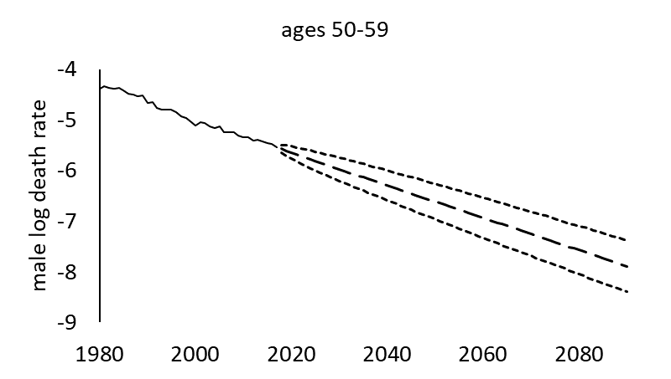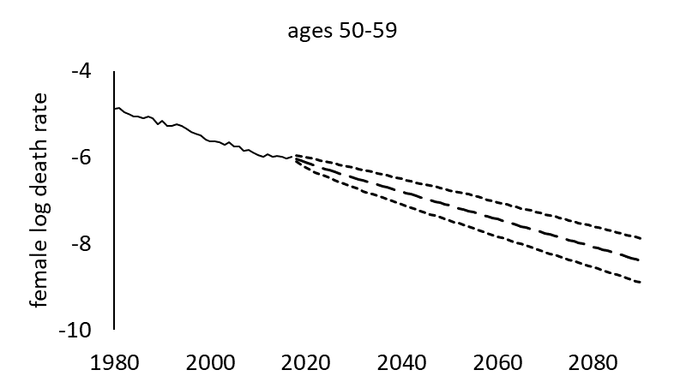
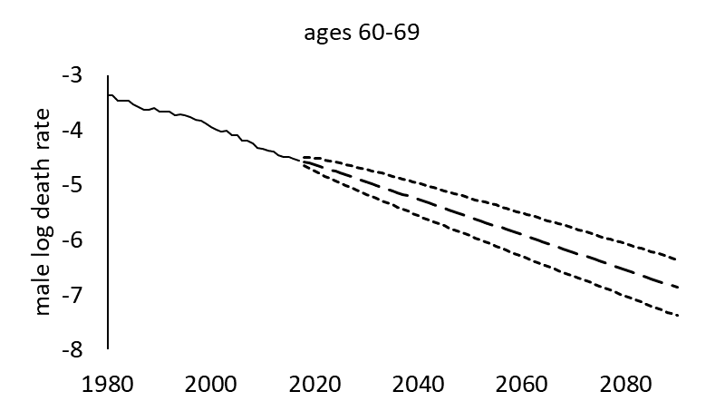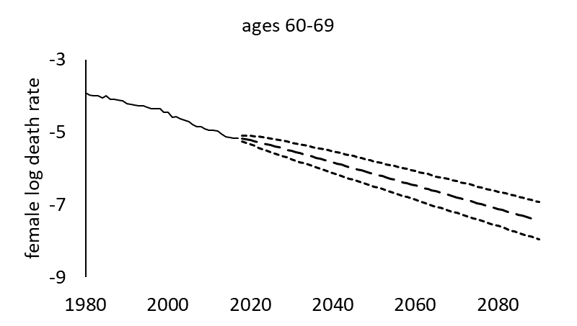
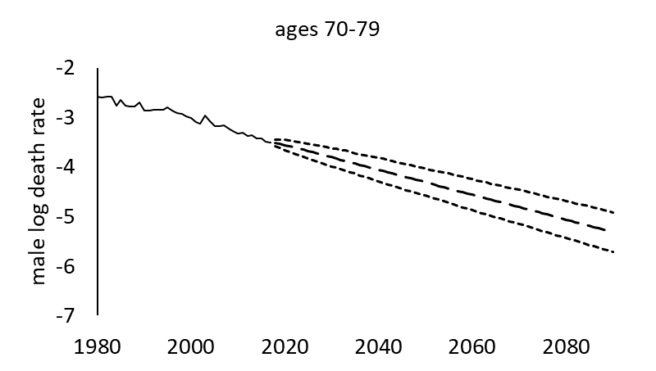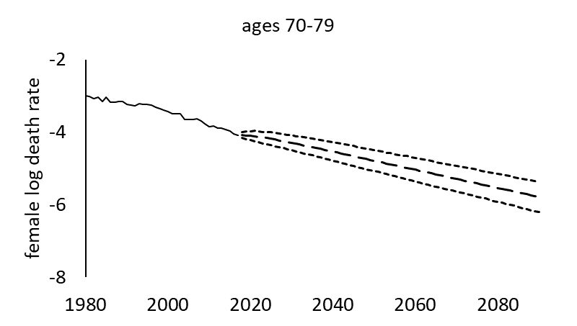
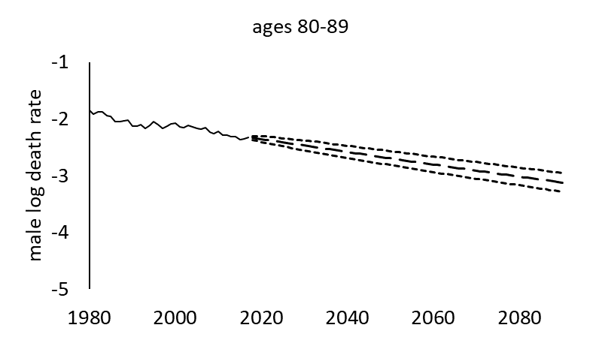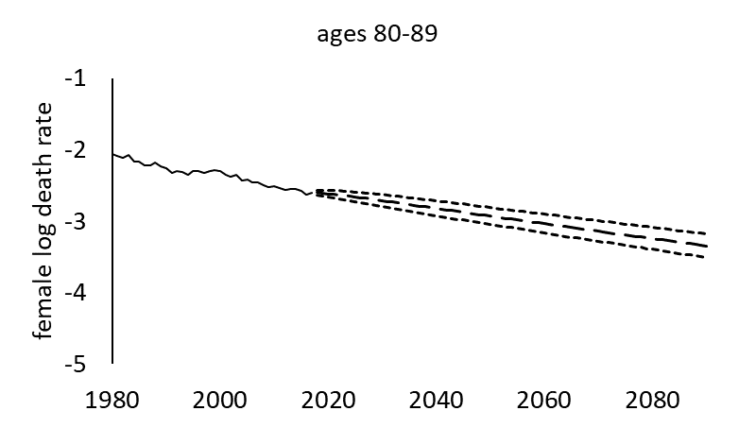

Source: Authors’ own.
Notes: The dashed lines show the mean projection values. The dotted lines on both sides of the mean projection values are the 95% prediction intervals.

Figure A2.
Estimated period log death rates by exact ages for 2018 and 2045
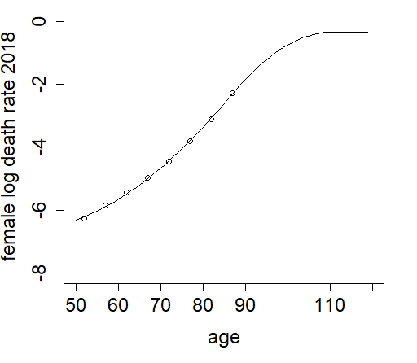 | 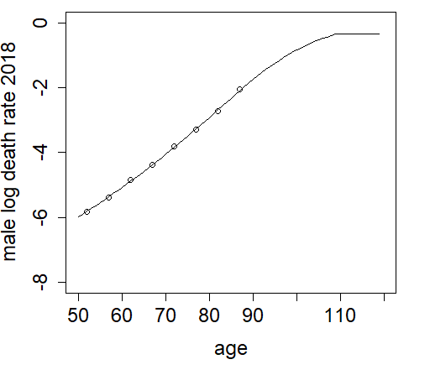
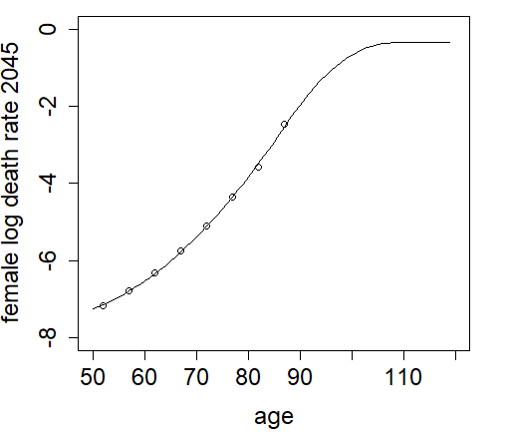 | 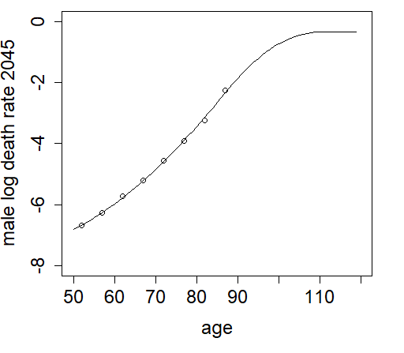

Source: Authors’ own.

Figure A3.

Panel A: Comparison of projected period (log) death rates from the original model (left) and its modified version (right) for females, age group 60-69

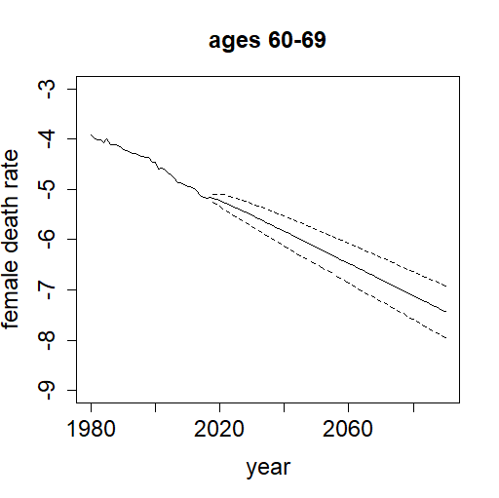 | 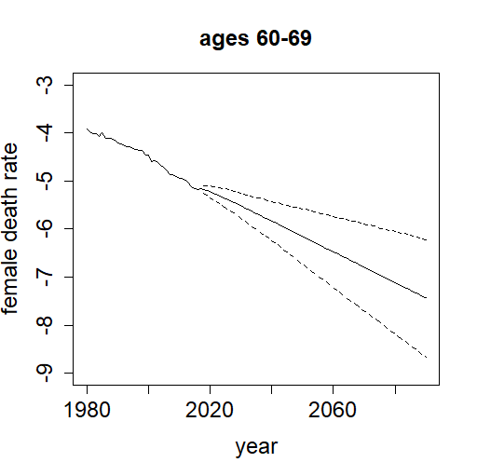
Source: Authors’ own.
Notes: The dotted lines on both sides of the mean projection values are the 95% prediction intervals. The 60-69 age group is chosen for illustration only; similar patterns are observed for other age groups.

Panel B: Comparison of cohort survival probabilities for a female annuitant aged 55 in 2017 using the original model (left) and its modified version (right)

Source: Authors’ own.
Notes: This fan chart illustrates the uncertainties surrounding the projections of survival probabilities for a female Singaporean annuitant aged 55 who joined the CPF LIFE scheme in 2017. The central heavy black line shows the most likely outcome (median), while the two solid red lines on either side of the median show the 75th and 25th percentiles. The outer dotted lines show the 95th and 5th percentiles. The figure on the left is presented as Figure 4 in the main text.
Figure A4.
Estimated parameters of the Lee and Carter (1992) model fitted to 1980-2017 Singapore mortality data
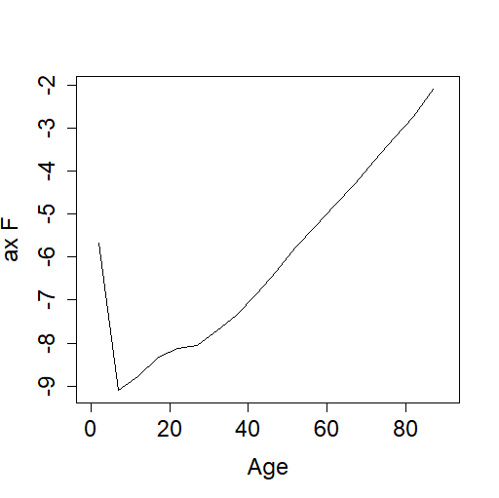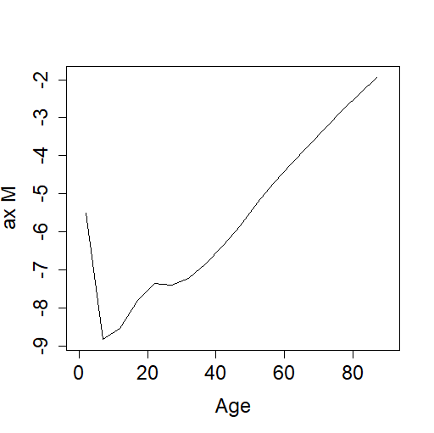
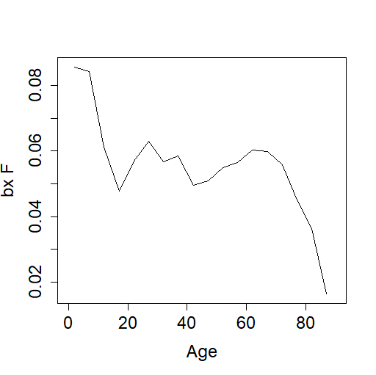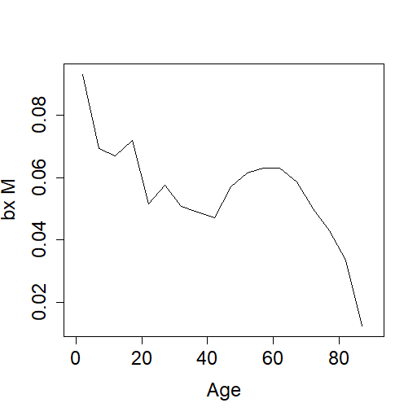
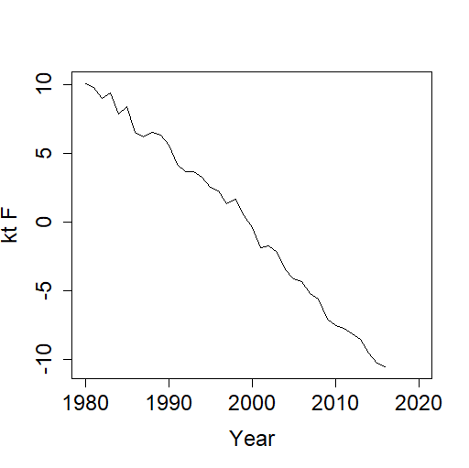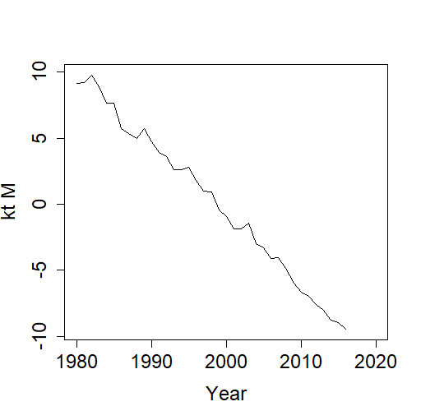

Source: Authors’ own.

Figure A5.
Estimated parameters of the product-ratio model fitted to 1980-2017 Singapore mortality data
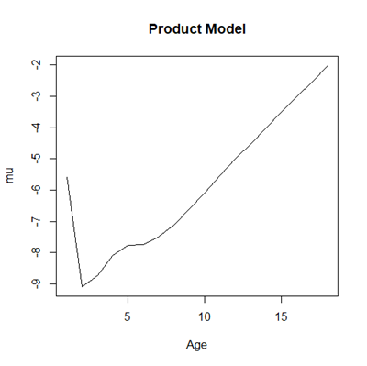  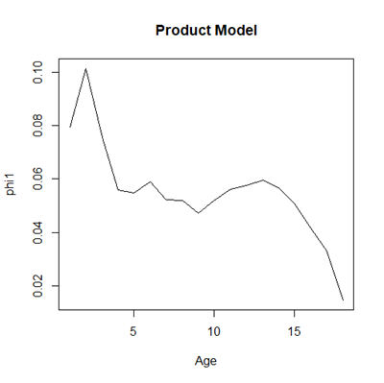 | 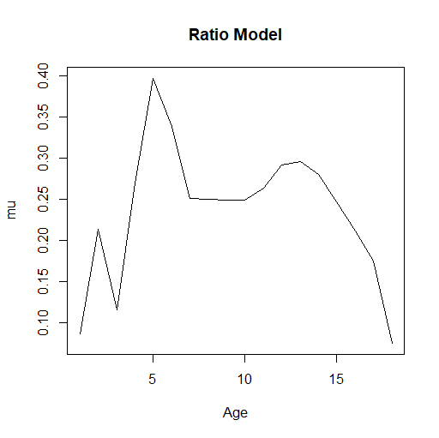  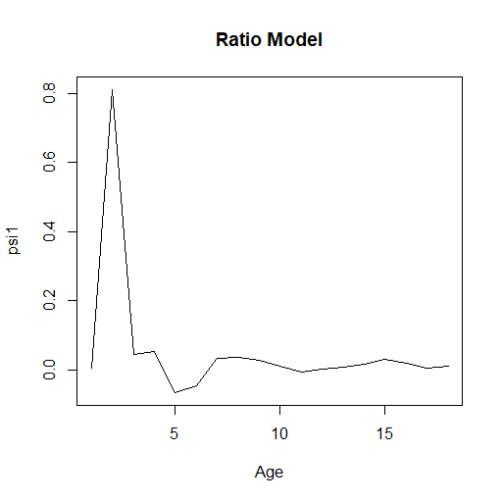
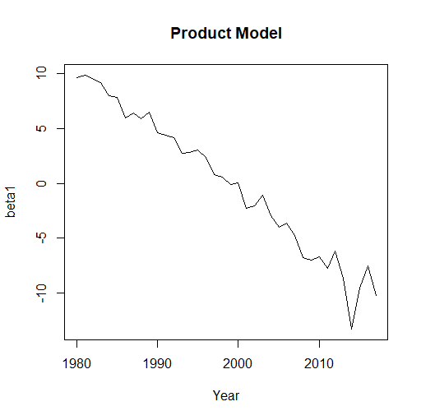 | 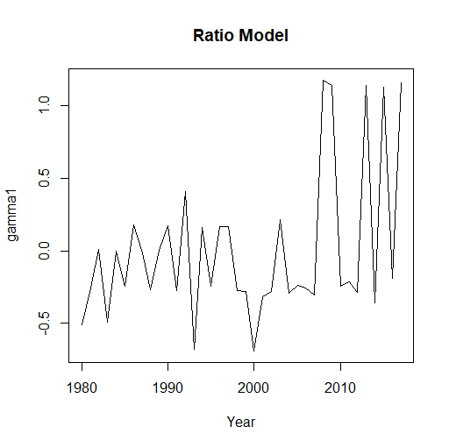
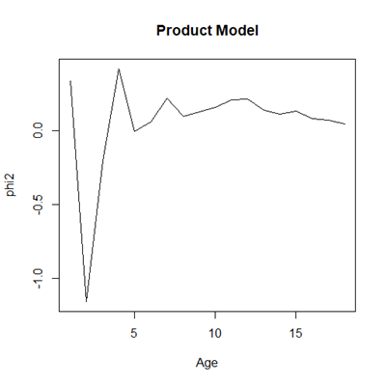 | 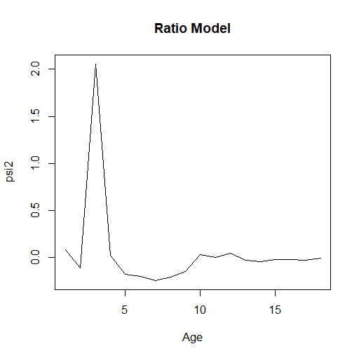
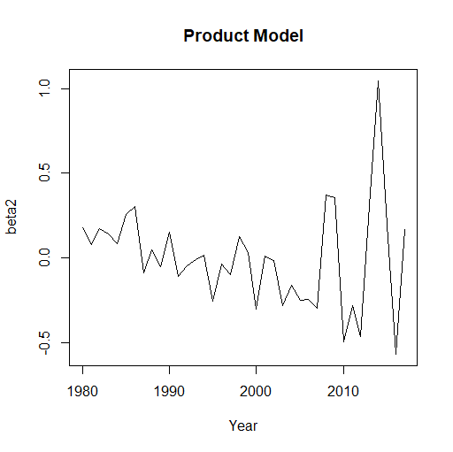 | 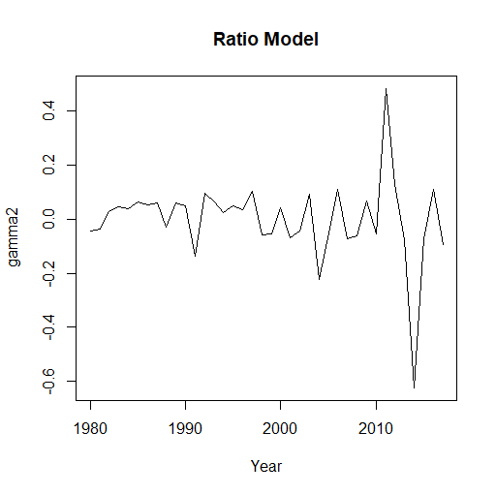
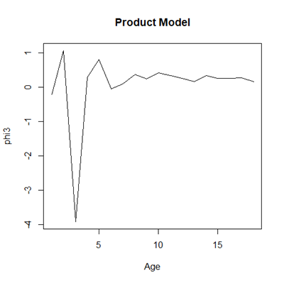  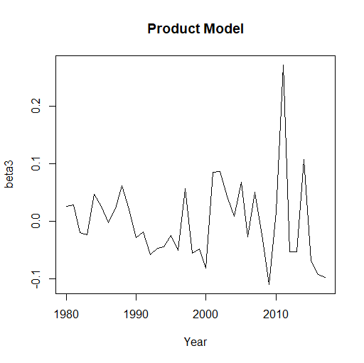 | 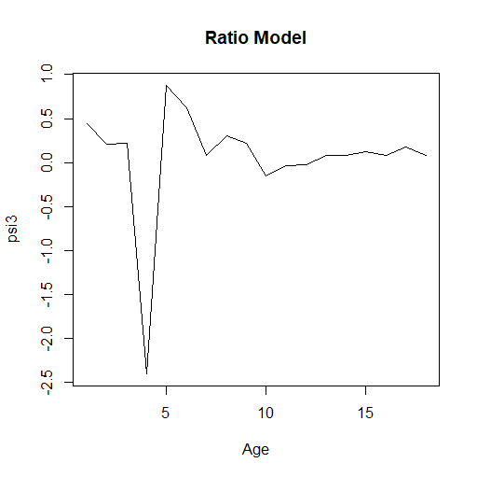  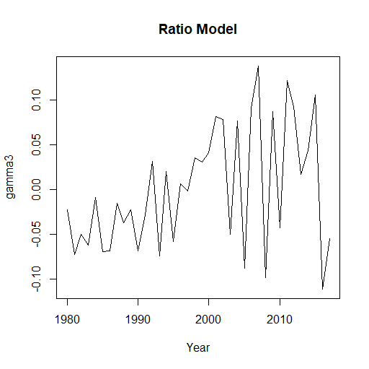

Source: Authors’ own.

References
Cairns AJG, Blake D and Dowd K (2006) A two-factor model for stochastic mortality with parameter uncertainty: theory and calibration. Journal of Risk and Insurance 73, 687–718.

Coale A and Guo G (1989) Revised regional model life tables at very low levels of mortality. Population Index 55, 613–643.

Gampe J (2010) Human mortality beyond age 110. In Maier H, Gampe J, Jeune B, Vaupel JM and Robine JM (eds), Supercentenarians. Demographic Research Monographs. Heidelberg: Springer-Verlag Berlin, pp. 219–230.

The BIC is defined as $-2\hat{l}+ n_{p}ln⁡(n_{d})$, where $\hat{l}$ is the calculated maximum log-likelihood, $n_{p}$ is the number of parameters, and $n_{d}$ is the number of data points. A lower BIC value is preferred.

