**Appendix Figure 1a: Frequency of Occupations by Share of Workers Reporting They Are in the Public Sector**

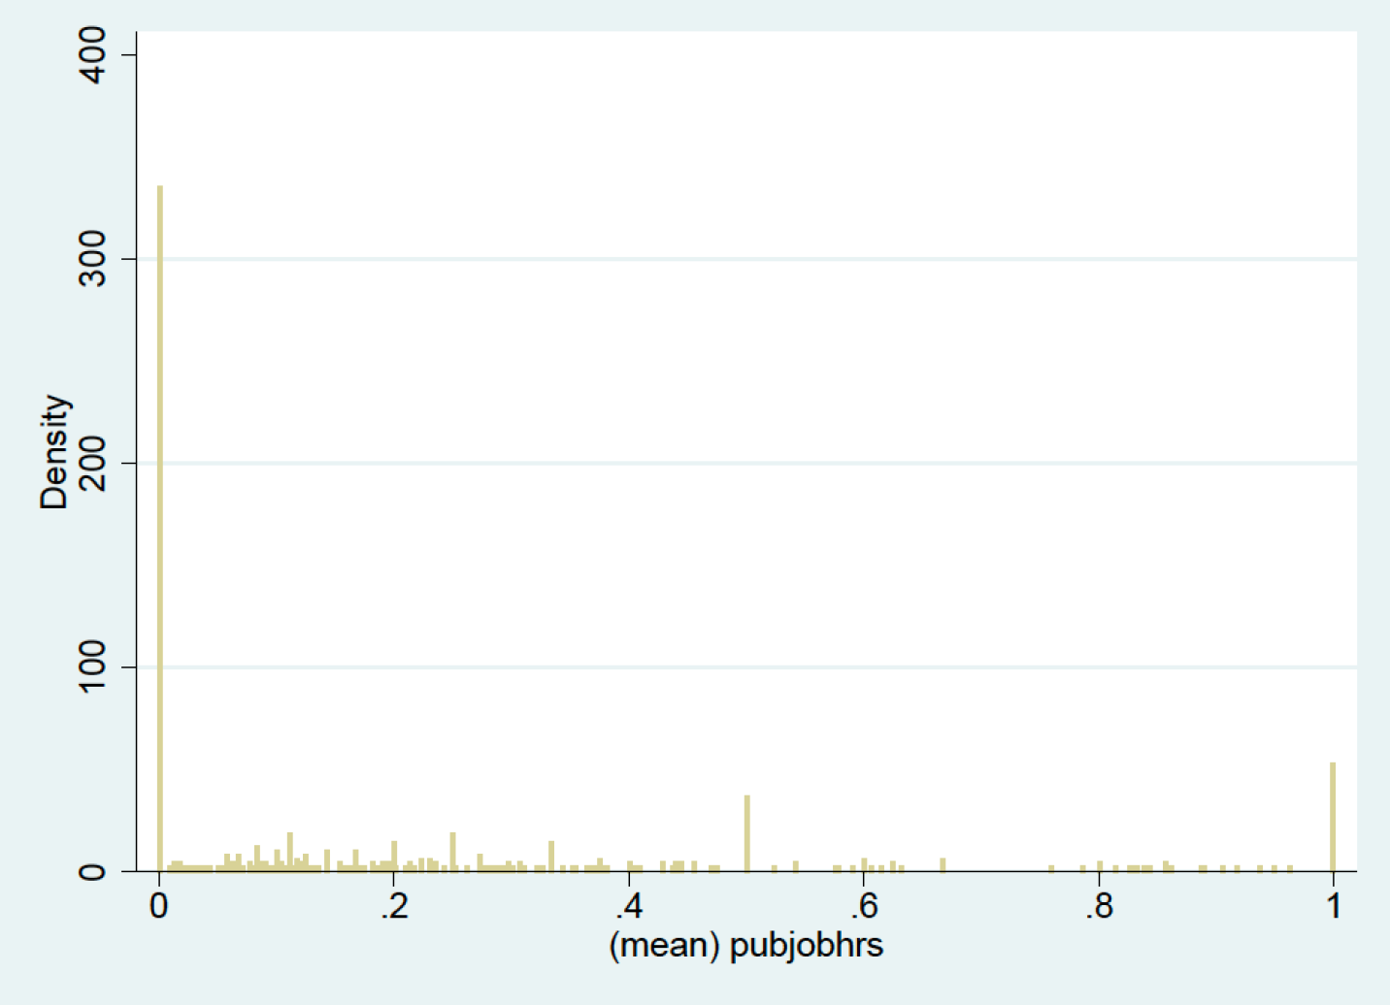

Source: authors’ calculations from the HRS public data and restricted detailed occupation data, 2006-2016.

**Appendix Figure 1b: Frequency of Occupations by Share of Workers Reporting They Are in the Public Sector (weighted by number of workers)**

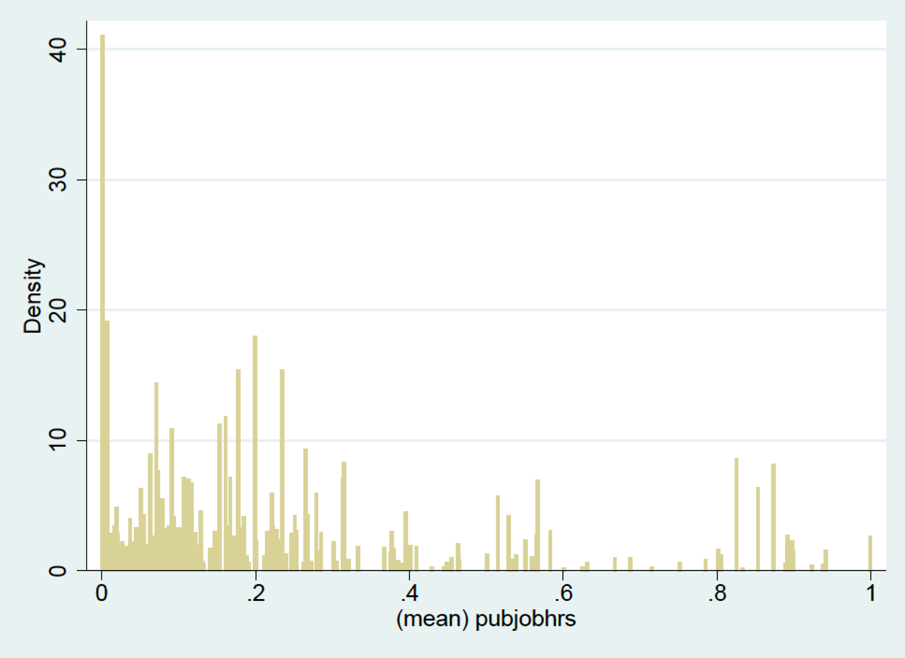

Source: authors’ calculations from the HRS public data and restricted detailed occupation data, 2006-2016.





|  |  |  |  |
| --- | --- | --- | --- |
|  |  |  |  |
| **Appendix Table 1: Most Common Occupations, by Assigned Sector** | | | |
|  |  |  |  |
| **Sector** | **Occupation Title** | **Share** | **# Obs** |
|  |  | **Public** |  |
|  |  |  |  |
| Public | Elementary and Middle School Teachers | 82.5% | 292 |
|  | Secondary School Teachers | 87.3% | 277 |
|  | Teaching Assistants | 85.2% | 217 |
|  | Special Education Teachers | 89.6% | 77 |
|  | Library Assistants, Clerical | 89.1% | 46 |
|  | Court, Municipal, and License Clerks | 89.1% | 46 |
|  | Postal Service Mail Carriers | 80.0% | 45 |
|  |  |  |  |
|  |  |  |  |
| Private | Retail Salespersons | 0.8% | 384 |
|  | First-Line Supervisors/Managers of Retail Sales Workers | 0.7% | 269 |
|  | Sales Representatives, Wholesale and Manufacturing | 0.0% | 179 |
|  | Laborers and Freight, Stock, and Material Movers, Hand | 4.5% | 112 |
|  | Miscellaneous Assemblers and Fabricators | 1.8% | 109 |
|  | Marketing and Sales Managers | 2.1% | 97 |
|  | Other Agricultural Workers | 1.0% | 96 |
|  |  |  |  |
|  |  |  |  |
| Unclear | Secretaries and Administrative Assistants | 19.8% | 615 |
|  | Janitors and Building Cleaners | 23.5% | 527 |
|  | Nursing, Psychiatric, and Home Health Aides | 17.6% | 431 |
|  | Driver/Sales Workers and Truck Drivers | 7.1% | 423 |
|  | Registered Nurses | 16.1% | 403 |
|  | First-Line Supervisors/Mgrs of Office & Admin. Support Wkrs | 26.4% | 318 |
|  | Personal and Home Care Aides | 31.4% | 283 |
|  |  |  |  |

Source: authors’ calculations from the HRS public data and restricted detailed occupation data, 2006-2016.

|  |  |  |  |  |
| --- | --- | --- | --- | --- |
|  |  |  |  |  |
| **Appendix Table 2: Self-Reported vs. Assigned Sector** | | | | |
|  |  |  |  |  |
|  |  |  |  |  |
|  |  | Assigned Sector | | |
|  |  | Private |  | Public |
|  |  |  |  |  |
| Self-Reported | Private | 94.2% |  | 5.8% |
|  |  |  |  |
| Public | 6.7% |  | 93.3% |
|  |  |  |  |  |

Note: Comparison is of self-reported sector in waves 8-13 (2006-2016) with sector assigned using imputation method described in the text.

|  |  |
| --- | --- |
|  |  |
| **Appendix Table 3:** | |
| **Share of Workers in Public Sector** | |
|  |  |
| Wave | Share Public |
|  |  |
|  |  |
| 1 | 23.2% |
| 2 | 23.6% |
| 3 | 22.4% |
| 4 | 23.2% |
| 5 | 24.3% |
| 6 | 23.0% |
| 7 | 23.2% |
| 8 | 22.0% |
| 9 | 22.2% |
| 10 | 23.8% |
| 11 | 23.2% |
| 12 | 21.9% |
| 13 | 23.8% |
|  |  |

Note: Reflects the share of workers assigned to public sector, using method described in the text (including primarily self-reported data for waves 8-13 and primarily imputations for waves 1-7)