ONLINE APPENDIX
Supplemental Plan Offerings and Retirement Saving Choices:
An Analysis of North Carolina School Districts
Robert L. Clark, Emma Hanson, Melinda Sandler Morrill, and Aditi Pathak
October 2015

APPENDIX A

Public Retirement Saving Plans

Public employers have the option of offering alternative types of saving plans regulated under special tax codes. Both state and local governmental employers have the option of offering 457 plans. In addition, state governments may offer a state-managed 457 plan that local employers can allow their employees to join. States may also offer 401(k) plans that were grandfathered in before 1986 legislation, but no new 401(k) plans are allowed. Public schools, hospitals, and charitable organizations are allowed to offer 403(b) plans. In some states, public school employees are considered state workers and are thus able to contribute to any available plans offered by their school district or the state government. All of these plans allow employees to make pre-tax contributions; however, government employers can also offer Roth options in the various plans.
Historically, 403(b) plans were the primary option selected by school districts. Prior to the passage of the Economic Growth and Tax Relief Reconciliation Act in 2001, 401(k), 403(b) and 457 plans were subject to difference regulations related to elective deferrals, employer contributions and other areas. After the passage of new legislation, 403(b) plans were subject to greater oversight.
Two important distinctions exist between 401(k)/403(b) and 457 plans. The annual dollar limit on employee contributions is the same in all of the plans, $18,000 in 2015, and this maximum is typically increased annually. Importantly, contributions to 401(k) and 403(b) plans count toward the same maximum contribution limit; however, contributions to 457 plans are viewed independently from the other two plans. Second, distributions without tax penalties are allowed at retirement after age 55 in both the 401(k) and 403(b) plans while the 457 plans allow such distributions at termination of employment at any age. In service distributions are allowed prior to age 59 and a half in both the 401(k) and 403(b) plans with a 10 percent tax penalty. In service distributions are not allowed in 457 plans.
All of the plans have age 50 and over catch-up provisions, but the policies are slightly different. All of the plans have a required minimum distribution at age 70 and a half. All distributions in each of the non-Roth plans are treated as ordinary income for federal income tax purposes. All of the plans allow rollovers to other retirement saving plans or IRAs.

APPENDIX B
Sample Descriptive Statistics and Comparison to National Data

For more information, please see:
“Introduction of State Managed 403(b) Plan in North Carolina: Phase I Research Methods and Data,” https://sites.google.com/a/ncsu.edu/msmorrill/files/Phase_I_Research_Methods_and_Data.pdf

This paper uses March 2013 payroll data from 53 North Carolina public school districts merged with a district-level survey of supplemental plan managers. The sample is restricted to full-time employees who were age 17 or older. Online Appendix Table B1 provides a comparison of our data with the American Community Survey (ACS). We first show the ACS data only for school district employees in the same 53 North Carolina counties. Then, we present descriptive statistics for all full-time school district employees in the United States, to highlight the representativeness of our data.
The ACS sample was created using 2008-2012 ACS 5-year Public Use Microdata Samples. The sample includes full-time employees, in the public sector, in the education industry, in specific Public Use Microdata Areas (PUMAs). Individuals with missing demographics (age, gender, marital status, and income), and those with wage income less than $14,240, are dropped.
First, we see that the age distribution of our data roughly matches what we anticipate from the individual-level data in the ACS. About a quarter of the sample are individuals over age 55. Next, we observe that our measure of salary is quite a bit lower than that for both our 53 districts and the US sample from the ACS, $34,623 per year relative to $42,818 and $46,383, respectively. The salary measure in the ACS does not exclude income from other sources, such as summer jobs. However, we believe salary may be understated for several reasons. First, many districts provide a local salary supplement, which may be paid monthly, annually, or in two installments. The payment frequency and month of payment differ among districts. If the district provides a local supplement but not in March, salary will be understated. Second, in North Carolina school district employees on a 10 or 11 month contract can choose to be paid over those months or over 12 months. The data do not report pay-out period, so we have an underestimate of the salary for 10 month employees paid out over 12 months. Finally, we observe longevity pay and other non-recurring income only for the month of March and only in some districts. Where possible, we exclude irregular payments. Because we will include some non-recurring payments when we calculate annual salary, we may be overstating salary for those whose March pay-check was higher than average, but understating salary for those that only received non-recurring payments in other months.
In the payroll data, individuals’ marital status is from self-reports for tax purposes, so will not correctly reflect the marital status of individuals that are married but filing separately. Compared with nationally representative data, we see far fewer married individuals (58 percent in the payroll data versus 72 percent in the American Community Survey). As expected, the labor force in K-12 schools is disproportionately female (78 percent of the labor force) including one third of employment being single women. The racial composition of the labor force closely mirrors the ACS estimates of the population for our districts with about 72.9 percent being white and 20.6 percent being black. The national sample of public school employees is 9.7 percent black and about 7.1 percent Hispanic.
The data include a “start date”, which will either be the original date of hire or the date of hire of the most recent employment spell, depending on how the district organizes their data. Since tenure is determined based on the date of hire at a particular school district, previous employment tenure in another district is not considered. Thus, we anticipate that our measure of tenure will be less than total retirement service years for many of the workers. In the ACS, we do not observe tenure at the current job so simply impute experience as age minus education minus 6. This leads to a large overestimate of tenure.

Online Appendix Table B2: Payroll Data Means and Comparison to NC and US Data
Characteristics | Payroll Data | ACS 53 NC Districts | ACS National Sample
School Districts | 53 | 53
Number of Individuals | 71,156 | 4,898 | 221,344
Age below 35 | 20.61% | 27.62% | 26.83%
Age 35-49.99 | 39.57% | 39.88% | 38.17%
Age 50-54.99 | 14.65% | 13.34% | 13.42%
Age 55+ | 25.16% | 19.16% | 21.58%
Annual Salary | $34,623 | $39,679 | $49,852
Female | 78.39% | 81.62% | 76.88%
Married | 58.01% | 70.38% | 68.02%
Married Female | 45.67% | 57.14% | 51.70%
Single Male | 9.27% | 5.14% | 6.79%
Married Male | 12.34% | 13.24% | 16.32%
Single Female | 32.72% | 24.48% | 25.18%
White | 72.90% | 79.10% | 77.84%
Black | 20.61% | 17.78% | 10.30%
Hispanic | 1.41% | 2.12% | 9.01%
Other | 5.08% | 0.99% | 2.85%
Tenure |  | Imputed Years of Service
Less than 1 | 7.71% | 7.50% | 7.40%
1 – 2.99 | 10.01% | 3.40% | 3.25%
3 – 4.99 | 8.75% | 5.15% | 4.85%
5 - 10 .99 | 29.21% | 14.18% | 15.29%
11 – 20.99 | 29.61% | 26.17% | 24.85%
21 or more | 14.63% | 50.36% | 51.03%
Notes: Column (1) merged payroll and survey data, reported at the individual-level.
Columns (2) and (3) data were extracted from the American Community Survey (ACS) 5 year estimates (2008-2012) for full-time public school employees. Imputed years of service is equal to age minus education minus 6.

APPENDIX C
Simulations of Variation in Supplemental Plan Participation

In our econometric framework, we consider the effect of individual and district characteristics on the choice to participate in a supplemental retirement saving plan.
We assume the following true model:
$\operatorname{Pr}\left(Participation_{i}=1\right)= Φ(X_{ij}β+ δ_{j})$
Note that the ‘true model’ represented in equation (1) suggests that the average effect of individual characteristics (β) is not a function of district characteristics (as would yield a random coefficients type model). To better quantify the amount of variation across districts, we construct two measures of observed variation. For this exercise, we do not include district fixed effects and simulate random assignment to districts both with and without adjusting for individual characteristics. We preserve the size of each district and randomly assign individuals to districts. We calculate the residual by subtracting the predicted likelihood of participating from the observed data and define hat(ε_{ij}) to be the regression-predicted residual when individual characteristics are included in the regression model.
First, we assign each individual to their own district and calculate the ‘unadjusted’ participation rate. We calculate the unadjusted participation:
- 90th percentile participation rate is 47.0%
- 10th percentile participation rates is 21.6%
- 90-10 Range: yielding a 25.2 percentage point difference

Next, we instead use the regression adjusted participation rate in the district (equal to the mean of hat(ε_{ij}) within the district). We calculate the adjusted participation:
- 90th percentile participation rate is 14.2%
- 10th percentile participation rates is -11.5%
- 90-10 Range: yielding a 25.6 percentage point difference

SIMULATION 1: The ‘unadjusted’ spread is calculated by randomly assigning individuals to districts while preserving the original number of employees in each district. We calculate the difference between the 90th and 10th percentile in participation rates, the ‘90-10 Range’. We repeat the simulation 1,000 times and plot the resulting 90-10 Ranges. The distribution is approximately normal with a low mean of 0.052 (Std Dev. 0.008).
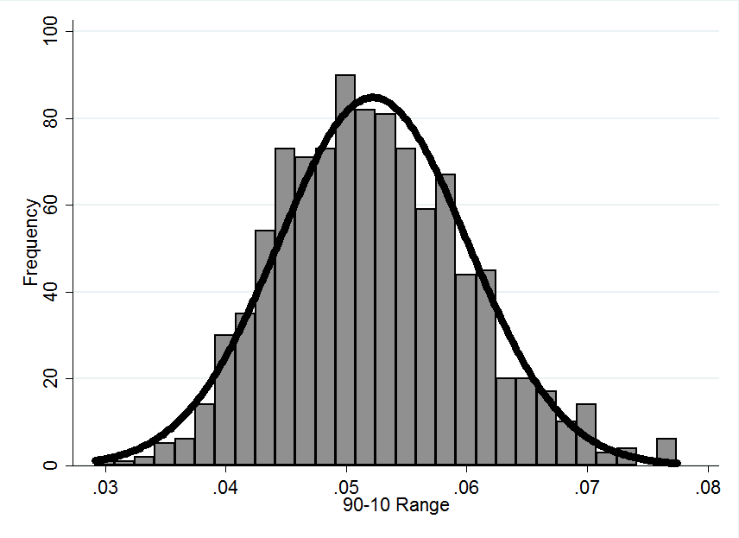

SIMULATION 2: We calculate the regression-adjusted residual (hat(ε_{ij})) for each individual. Then, we randomly assign individuals to districts (again, preserving the district sizes) and calculate the difference between the 90th and 10th percentile in participation rates, the ‘90-10 Range’. We repeat the simulation 1,000 times and plot the resulting 90-10 Ranges. The distribution is approximately normal with a low mean of 0.050 (std. dev. 0.007).
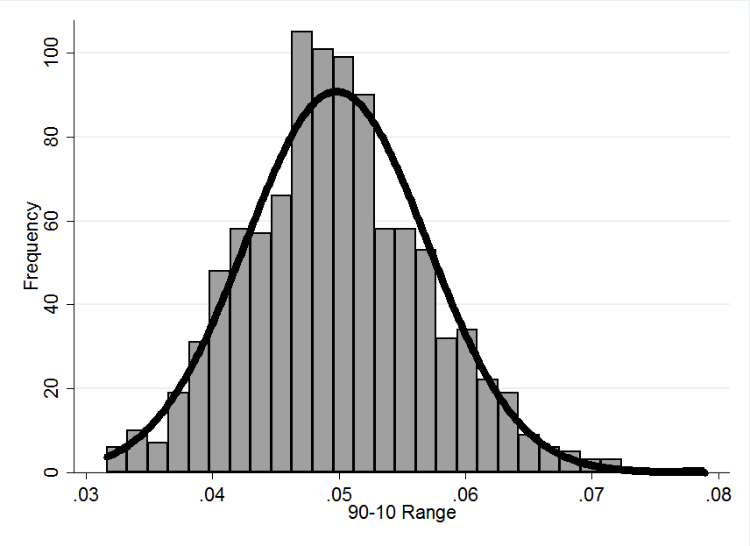

CONCLUSION: The observed 90-10 spread of 25 percentage points is far outside the region of what would be expected from random variation.

APPENDIX D
Supplemental Tables

Table D1. Plan Participation and Individual Characteristics (no district fixed effects)
 | Means of Covariates | Any Plan | 403(b) Plan | 403(b) Plan Among Participants
 | (1) | (2) | (3) | (4)
Annual Salary (10K) | $34.62 | 0.116*** | 0.078*** | 0.035*
 |  | (0.017) | (0.012) | (0.020)
(Annual Salary (10K))² |  | -0.009*** | -0.007*** | -0.003*
 |  | (0.002) | (0.001) | (0.002)
Tenure | 11.28 | 0.036*** | 0.020*** | 0.007
 |  | (0.002) | (0.002) | (0.005)
Tenure Squared |  | -0.001*** | -0.001*** | -0.000**
 |  | (0.000) | (0.000) | (0.000)
Managers | 0.031 | 0.108*** | 0.022 | -0.093***
 |  | (0.042) | (0.021) | (0.033)
Support Personnel | 0.183 | -0.101*** | -0.071*** | -0.092***
 |  | (0.009) | (0.012) | (0.034)
Black | 0.206 | 0.015 | 0.045*** | 0.122***
 |  | (0.019) | (0.016) | (0.038)
Hispanic | 0.014 | -0.041** | -0.008 | 0.044
 |  | (0.017) | (0.014) | (0.034)
Other | 0.051 | 0.063** | 0.065** | 0.088
 |  | (0.025) | (0.028) | (0.062)
Single Male | 0.093 | -0.015** | 0.006 | 0.045**
 |  | (0.007) | (0.006) | (0.017)
Married Male | 0.123 | -0.028*** | -0.013** | -0.000
 |  | (0.006) | (0.006) | (0.016)
Single Female | 0.327 | 0.022*** | 0.028*** | 0.056***
 |  | (0.005) | (0.005) | (0.012)
Observations |  | 71,156 | 71,156 | 22,791
Pseudo R² |  | 0.077 | 0.057 | 0.013
Mean Dependent Variable |  | 0.320 | 0.167 | 0.522
Notes: Data are from payroll records. All models include district fixed effects. Marginal effects, calculated at the mean, are estimated from Probit regressions. Robust standard errors are in parentheses and are clustered at the district level. *** p<0.01, ** p<0.05, * p<0.1.

Table D2: Plan Participation, Individual Characteristics, and District Fixed Effects
 | Means of Covariates | Any Plan | 403(b) Plan | 403(b) Plan Among Participants
 | (1) | (2) | (3) | (4)
Age | 46.06 | 0.004** | 0.002 | -0.001
 |  | (0.002) | (0.002) | (0.004)
Age Squared |  | -0.0001*** | -0.00003** | 0.00001
 |  | (0.00002) | (0.00002) | (0.00004)
Annual Salary (10K) | $34.62 | 0.113*** | 0.067*** | 0.026**
 |  | (0.016) | (0.008) | (0.013)
(Annual Salary (10K))² |  | -0.008*** | -0.006*** | -0.003**
 |  | (0.002) | (0.001) | (0.001)
Tenure | 11.28 | 0.039*** | 0.021*** | 0.008**
 |  | (0.002) | (0.001) | (0.004)
Tenure Squared |  | -0.001*** | -0.0005*** | -0.0003**
 |  | (0.00004) | (0.00004) | (0.0001)
Managers | 0.031 | 0.065** | -0.003 | -0.093***
 |  | (0.029) | (0.015) | (0.032)
Support Personnel | 0.183 | -0.090*** | -0.066*** | -0.111***
 |  | (0.010) | (0.006) | (0.025)
Black | 0.206 | 0.023** | 0.039*** | 0.099***
 |  | (0.010) | (0.005) | (0.017)
Hispanic | 0.014 | -0.026** | -0.012 | -0.004
 |  | (0.013) | (0.009) | (0.020)
Other | 0.051 | 0.027** | 0.018** | 0.014
 |  | (0.011) | (0.008) | (0.023)
Single Male | 0.093 | -0.015* | 0.004 | 0.041***
 |  | (0.008) | (0.005) | (0.015)
Married Male | 0.123 | -0.021*** | -0.009* | 0.001
 |  | (0.006) | (0.006) | (0.017)
Single Female | 0.327 | 0.025*** | 0.026*** | 0.052***
 |  | (0.003) | (0.003) | (0.008)
Observations |  | 71,156 | 71,156 | 22,791
Pseudo R2 |  | 0.106 | 0.110 | 0.135
Mean Dependent Variable |  | 0.320 | 0.167 | 0.522
Notes: Data are from payroll records. All models include district fixed effects. Marginal effects, calculated at the mean, are estimated from Probit regressions. Robust standard errors are in parentheses and are clustered at the district level.
*** p<0.01, ** p<0.05, * p<0.1.
Table D3: Plan Participation and District Characteristics for Recent Hires
 | Any Plan | 403(b) Plan | 403(b) Plan | Participation
 | (1) | (2) | (3)
Plan Offerings:
3-5 vendors | 0.067* | 0.014 | -0.057
 | (0.037) | (0.016) | (0.094)
6 or more vendors | 0.074** | 0.020 | -0.006
 | (0.033) | (0.015) | (0.110)
Offers NC 457 | 0.048 | 0.033* | 0.161
 | (0.036) | (0.019) | (0.099)
Offers Local 457 | 0.015 | -0.003 | -0.156
 | (0.026) | (0.015) | (0.110)
District Oversight:
Adopted NC 457 w/in 5 yrs | 0.008 | -0.004 | -0.127
 | (0.034) | (0.012) | (0.084)
Removed 403(b) vendors w/in 5 yrs | -0.019 | 0.009 | 0.125*
 | (0.020) | (0.009) | (0.074)
Selective | 0.015 | -0.023* | -0.252***
 | (0.025) | (0.014) | (0.093)
Evaluate plan offerings | -0.040 | -0.020 | -0.033
 | (0.027) | (0.014) | (0.099)
Criteria reviewed w/in 5 years | -0.013 | 0.026* | 0.243**
 | (0.021) | (0.013) | (0.097)
District Information Provision:
Moderate quality website | 0.107*** | 0.032** | -0.109
 | (0.036) | (0.016) | (0.093)
High quality website | 0.044 | 0.002 | -0.039
 | (0.029) | (0.016) | (0.114)
Directly Provide Information | 0.039* | 0.002 | -0.125
 | (0.023) | (0.013) | (0.092)
District Size (in 00s) | -0.002*** | -0.00003 | 0.009***
 | (0.001) | (0.0003) | (0.003)
Observations | 9,174 | 9,174 | 1,038
Pseudo R2 | 0.052 | 0.061 | 0.128
Mean Dependent Variable | 0.1131 | 0.0455 | 0.4017
Notes: Data are from payroll records merged with district survey responses. The sample is restricted to individuals hired within the two years prior to data collection (2011-2012.) All models include individual characteristics reported in Table 3 but exclude district fixed effects. Marginal effects, calculated at the mean, are estimated from Probit regressions. Robust standard errors are in parentheses and are clustered at the district level. *** p<0.01, ** p<0.05, * p<0.1.

See the Tax Reform Act of 1986, which prohibited governmental employers from establishing new 401(k) plans. Governmental employers who had established 401(k) plans prior to the new legislation were allowed to continue offering these plans.
A comparison of the provisions of the 401(k) and 457 plans offered by the state of North Carolina can be seen at https://www.nctreasurer.com/ret/401k%20Plan%20Features/PlanComparisonChart.pdf, [accessed March 29, 2015]. Also see the following for a discussion of the new NC403(b) plan https://www.nctreasurer.com/Retirement-and-Savings/Managing-My-Retirement/Pages/NC-403b-Program.aspx, [accessed March 29, 2015].
IRS discussion of 403(b) plans can be found at: http://www.irs.gov/publications/p571/index.html, [accessed March 29, 2015] and at: http://www.irs.gov/Retirement-Plans/Retirement-Plans-FAQs-regarding-403(b)-Tax-Sheltered-Annuity-Plans, , [accessed March 29, 2015]. Readers may also find the Department of Labor’s discussion of 403(b) interesting: http://www.dol.gov/ebsa/regs/fab2010-1.html, [accessed March 29, 2015]. The California Teachers association provides a useful comparison of all three types of plans, http://ctainvest.org/home/403b-457-Plans/403b-457-overview/comparing-401k-403b-457-plans.aspx, [accessed March 29, 2015].
For more information about the data, please see Clark, et al. (2015). Out of the 115 school districts in North Carolina, we received data from a total of 68 districts. We excluded ten that did not respond to our survey and five that provided incorrect or incomplete data.
For more information about the ACS sample, please see Clark, et al. (2015). U.S. Census Bureau; American Community Survey, 2010 American Community Survey 5-Year Estimates, using American FactFinder; <http://factfinder2.census.gov>; [November, 2014].
As described further in Clark, et al. (2015), supplemental data from the North Carolina Retirement System finds that among education personnel the average salary is $36,237.
For more information, see: http://www.ncga.state.nc.us/EnactedLegislation/Statutes/HTML/BySection/Chapter_115C/GS_115C-302.1.html, [accessed April 2015].

