Appendix
“Pension Plan Participant Choice: Evidence on Defined Benefit and Defined Contribution Preferences”. Gerrans, P. and Clark, G.L.
UniSuper Background Information
UniSuper began in in 1983 as the Superannuation Scheme for Australian Universities (SSAU) as a fully-funded defined benefit (DB) plan through the amalgamation of several DB plans operated by individual Australian universities. The plan received employer contributions equal to 14 per cent of gross salary and an employee contribution of 7 per cent. Members, whether DB or DC, also have a supplementary DC account which receives three per cent employer contribution. Membership of this account does not impact on DB membership. Employees with a minimum two-year employment contract automatically join the DB plan and contribute 7 per cent of gross salary to UniSuper, with a matching 17 per cent contribution from their employer. Those who do not meet the two-year rule have nine per cent contributions made by their employer to a DC-only plan and are not the subject of analysis. This nine per cent contribution meets the mandatory requirement, in Australia since 1992, of a minimum nine per cent of gross salary contribution by employers. The mandatory amount will increase to 12 per cent by 2019.
UniSuper is a multi-employer plan wherein individual employers have no additional financial burden associated with the DB plan. For the Existing member sample (members at June 1998), the experience of the 1990s was one where “the DB was comfortably over-funded, at times exceeding 140% of its vested liabilities” (UniSuper 2010, p.11) and lump-sum benefits increased as a consequence. Improving benefits for Existing members arguably made the DB plan more attractive in that it indicated members could share in superior returns without the risks associated with the DC plan. Equally, the experience of strong market returns may have encouraged the view that DC plans offered opportunities to further enhance individual welfare. In contrast, for the New member sample period there were two periods where the financial ability of UniSuper to meet its benefits may have been questioned. In 2003 and 2009, following periods of poor returns, UniSuper initiated a formal process (as required by their Trust Deed) as a consequence of the value of fund assets falling below a threshold value of vested benefits. One potential outcome of this process was a reduction in member benefits. Following this experience, the fund deed was amended to remove any “real or implied obligation” (UniSuper, 2010, p.15) on employers to underwrite the benefits. This emphasised that given a repeat situation members would bear this risk through a reduction in member benefits. No such reduction was required following 2003 or 2009, when the process was initiated again.
A history of the DC investment menu is provided in Table S1. Significant changes made in October 2002 included a rebadging and expansion of the number of options. At the same time investment choice was introduced for the three per cent supplementary contributions. This was separate to the investment choice made for those members who chose to move from the DB to the DC plan. Since July 2005, the two possible investment choices have been consolidated. The investment choice selected for the three per cent applies to the consolidated choice with the member able to change if they select the DC plan.

Table S1 Investment Option History
This table summarises the investment option history for the primary DC plan. In periods one to five, all options were pre-mixed options meaning the fund specified the asset allocation. In period six, the four new investment options introduced were single asset class options, bringing the total number of options to twelve. However, to invest across all twelve options a member is required to choose a “Self-Select” option requiring a $30 fee, each six-months. A fee is not required if one of the eight pre-mixed options is selected. Since period three, where switching was available more frequently than annually, the first choice each financial year is free with subsequent switches attracting a fee, initially $20, each. The fee has increased to $26.
Period | Member Joined | Investment Options  (Default underlined) | Investment Construction,  Frequency
1 | Members at 30/06/1998 | Four investment options: Secure, Stable, Trustees’ Selection, Shares | One option, Annually
2 | 1/07/1998 – 30/09/2002 | Four investment options(Default): Secure, Stable, Trustees’ Selection, Shares | One option, Annually
3 | 1/10/2002 – 30/06/2005 | Seven investment options (Three new, three rebadged, Default changed):Cash (Rebadged Secure), Capital Stable (New), Conservative Balanced (Rebadged Stable), Balanced (New), Growth (Rebadged Trustees’ Selection), Shares, Socially Responsible Shares (New) | One option, Monthly
4 | 1/07/2005 – 31/12/2007 | Seven investment options (Two rebadged): Cash , Capital Stable, Conservative Balanced, Balanced, Growth, High-Growth (Rebadged Shares), Socially Responsible High Growth (rebadged Socially Responsible Shares) | Mix options, Monthly
5 | 1/01/2008 – 30/06/2008 | Eight investment options (One new): Cash, Capital Stable, Conservative Balanced, Balanced, Socially Responsible Balanced, Growth, High-Growth, Socially Responsible High Growth. | Mix options, Monthly
6 | 1/07/2008 – 31/12/2008 | Twelve investment options: (Four new single asset options): Cash , Australian Fixed Interest, Capital Stable, Conservative Balanced, Balanced, Growth, High-Growth, Socially Responsible High Growth, Listed Property, Australian Shares, International Shares. | Choose one of 8 pre-mixed options, or “Self Select” – mix all 12 options for $30 six-month fee, Weekly

Table S2 Choice Summary by Calendar Year for Existing and New Member Samples
This table summarises member DB/DC choice for both the Existing and New samples. The italicised numbers provide a breakdown of the investment risk chosen by those who selected the DC option.
 | Chose DC | DC Investment Risk |  |  | Remain DB | Total
Calendar Year |  | Same | Lower | Higher
Existing Sample
1998 | 1,504 | 640 | 277 | 587 | 2,622 | 4,126
 | 36.45% | 42.55% | 18.42% | 39.03% | 63.55% | 100%
1999 | 11,986 | 6,212 | 2,337 | 3,437 | 25,203 | 37,189
 | 32.23% | 51.83% | 19.50% | 28.68% | 67.77% | 100%
n | 13,490 | 6,852 | 2,614 | 4,024 | 27,825 | 41,315
 | 32.65% | 50.79% | 19.38% | 29.83% | 67.35% | 100%
New Sample
1999 | 2,605 | 1,120 | 494 | 991 | 2,035 | 4,640
 | 56.14% | 42.99% | 18.96% | 38.04% | 43.86% | 100%
2000 | 3,454 | 1,496 | 667 | 1,291 | 4,282 | 7,736
 | 44.65% | 43.31% | 19.31% | 37.38% | 55.35% | 100%
2001 | 2,475 | 1,204 | 452 | 819 | 4,579 | 7,054
 | 35.09% | 48.65% | 18.26% | 33.09% | 64.91% | 100%
2002 | 2,319 | 1,210 | 444 | 665 | 5,302 | 7,621
 | 30.43% | 52.18% | 19.15% | 28.68% | 69.57% | 100%
2003 | 2,096 | 834 | 364 | 898 | 6,033 | 8,129
 | 25.78% | 39.79% | 17.37% | 42.84% | 74.22% | 100%
2004 | 2,471 | 1,098 | 167 | 1,206 | 6,041 | 8,512
 | 29.03% | 44.44% | 6.76% | 48.81% | 70.97% | 100%
2005 | 1,838 | 793 | 120 | 925 | 5,459 | 7,297
 | 25.19% | 43.14% | 6.53% | 50.33% | 74.81% | 100%
2006 | 870 | 404 | 56 | 410 | 6,559 | 7,429
 | 11.71% | 46.44% | 6.44% | 47.13% | 88.29% | 100%
2007 | 262 | 55 | 23 | 184 | 5,945 | 6,207
 | 4.22% | 20.99% | 8.78% | 70.23% | 95.78% | 100%
2008 | 541 | 118 | 52 | 371 | 6,702 | 7,243
 | 7.47% | 21.81% | 9.61% | 68.58% | 92.53% | 100%
2009 | 1,074 | 225 | 100 | 749 | 8,433 | 9,507
 | 11.30% | 20.95% | 9.31% | 69.74% | 88.70% | 100%
n | 20,005 | 9,670 | 2,883 | 7,600 | 61,370 | 81,375
 | 24.58% | 48.34% | 14.41% | 37.99% | 75.42% | 100%
Total | 33,495 | 16,522 | 5,497 | 11,624 | 89,195 | 122,690
 | 27.30% | 49.33% | 16.41% | 34.70% | 72.70% | 100

Marginal Effect of Gender on DC Risk Choice Level Relative to Remaining in the DB Plan by Balance: Existing Members
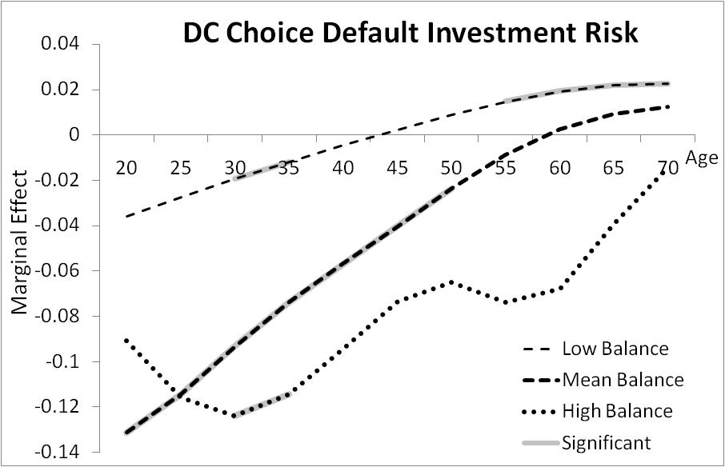
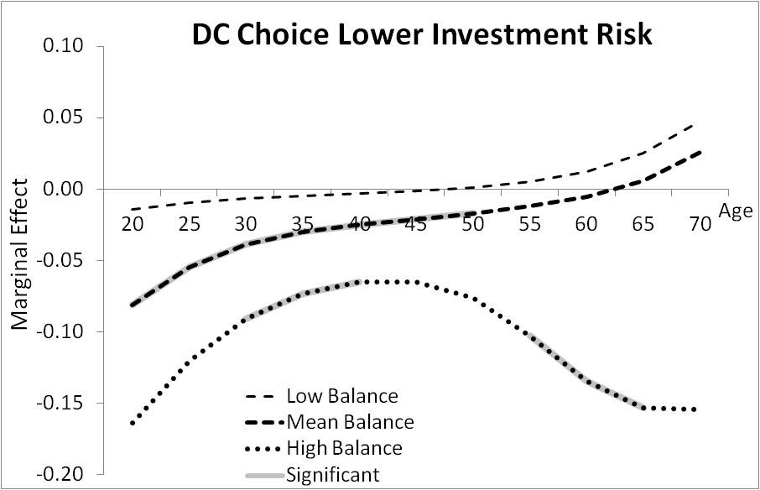
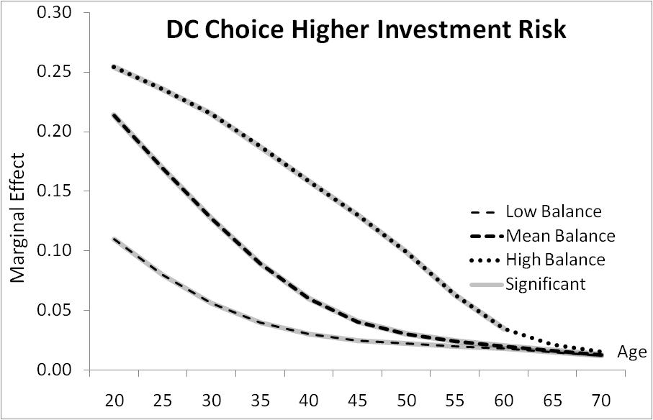
Figure S1 Marginal Effect of Gender on DC Risk Level Choice Relative to Remaining in DB over Age by Balance and Contributions
(Low $3000 Mean $6000 High $13000 Contributions, Low $5000 Mean $50000 High $200000 Balance)

Marginal Effect of Gender on DC Risk Choice Level Relative to Remaining in the DB Plan by Contributions: Existing Members
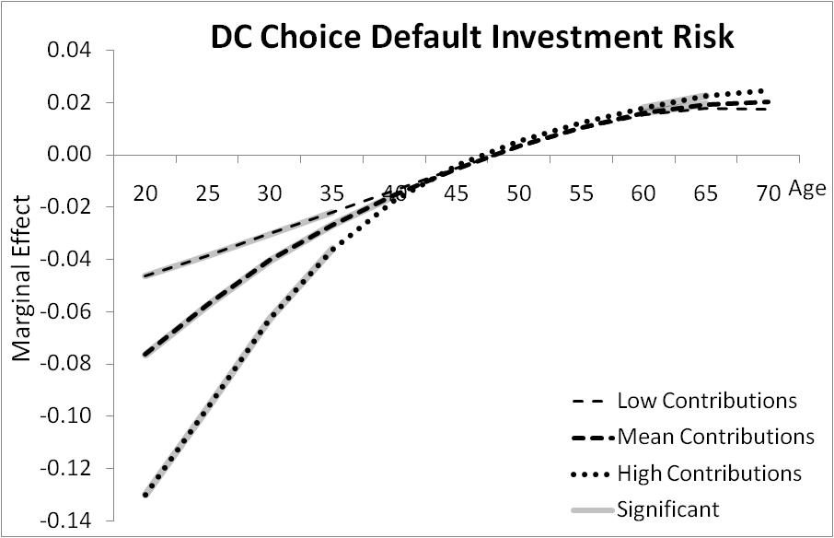
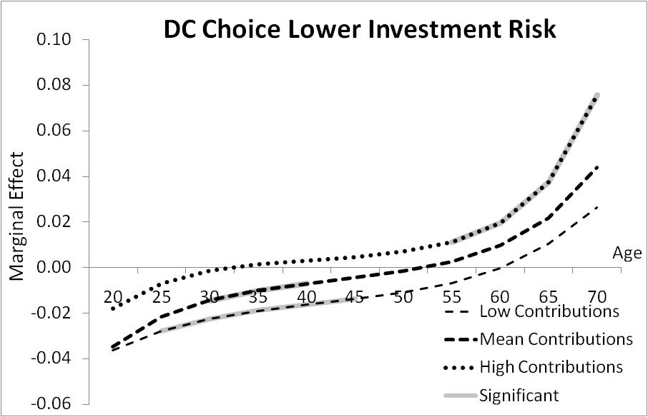
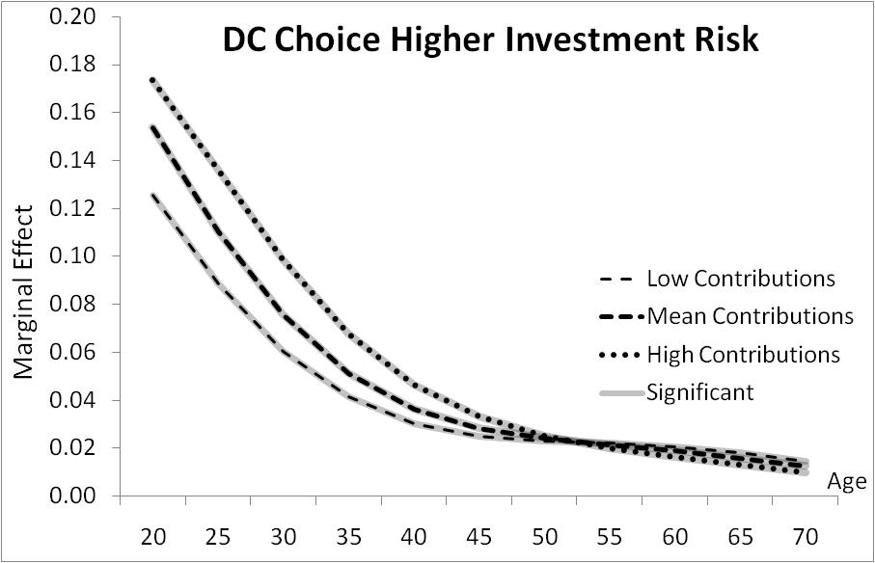
Marginal Effect of Gender on DC Risk Choice Level Relative to Remaining in the DB Plan by Contributions: New Members
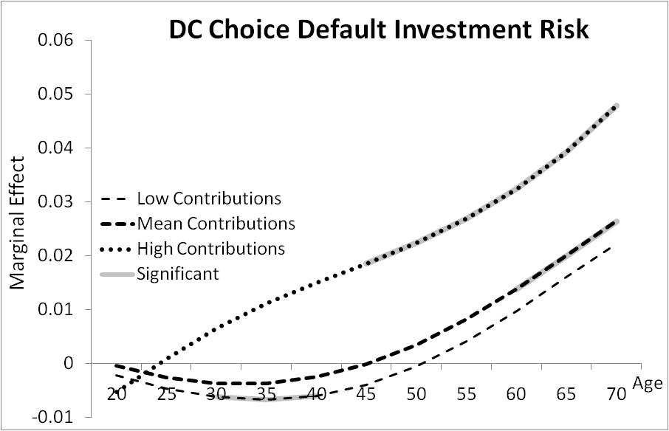
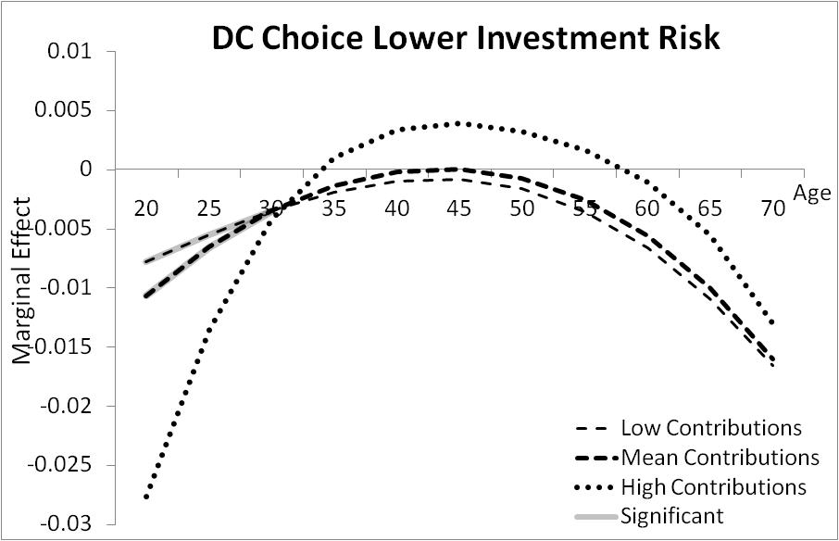
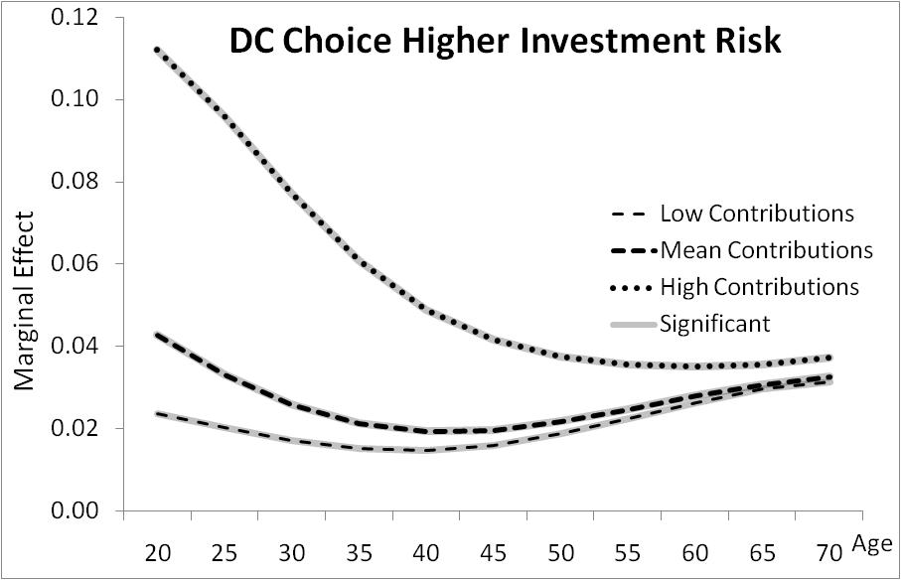

References
UniSuper (2010). Submission to the Super System Review Phase 3: Structure. Available at http://www.unisuper.com.au/download.cfm?oid=4562DD61-5056-BE7A-AC265A8983E61DCA

