Appendix A: Examples of labels
Argument label | Position towards UBI | Tweet (excerpt) example
Welfare conditionality
Free money | neutral (frame) | Municipalities plan to hand out 'free money' to welfare recipients.
Unconditional | neutral (frame) | A basic income that is discussed, is unconditional. See also: http://t.co/cJhO2MAfoF
Capitalism | neutral (problem) | #basicincome. What capitalism owes you in expenses
Control | neutral (problem) | Is basic income the same as our social assistance without the municipal bully-policy? #Tegenlicht
Consumption | pro | Finance a #basicincome with a green tax system - two birds with one stone http://t.co/IQ8iT1R44K
Freedom | pro | #basicincome can be living in freedom for many
Participation | pro | The #basicincome seems to me an indispensable step to realising the idea of the #participationsociety.
Stigma | pro | Simply belonging also without paid labour, what a relief! #freemoney #basicincome #Tegenlicht
Trust | pro | I dream of a society based on #trust. In #Utrecht they will try it out. Are we worth #basicincome
Wellbeing | pro | Less stress and psychological diseases because of #basicincome #mincomeproject More happiness
Freeriding | con | Would a basic income make people lazy (…)? #Tegenlicht
Immigration | con | Besides, this will attract even more immigrants #basicincome
Responsibility | con | Why would you want basic income? Why not in principal take your individual responsibility (…)? #tegenlicht
Economic redistribution
Redistributive | neutral (frame) | Oooh, now I understand. They want to use #basicincome to #level incomes (…).
Social benefits | neutral (frame) | isn't #basicincome the same as social assistance? #tegenlicht
Universal | neutral (frame) | Idea of #basicincome is that all Dutch people will receive it! (…) ..https://t.co/QihaEJ9Eyh
Inequality | neutral (problem) | The income inequality has become obscene #basicincome
Precariat | neutral (problem) | About 'precariat' and basic income: https://t.co/xZCNccatKJ
Affordable | pro | Exactly. No idea where all this money is supposed to come from. (…)
Fair | pro | Every human being has the right to a basic income, just like education, safety, healthcare, etc.
Security | pro | NL : Free money effective against poverty (…) http://dlvr.it/6z625M
Vlaktaks | con | The basic income. First a flat-rate income tax. Then we will continue talking #tegenlicht
Socialist | con | Ah, fortunately #NPO2 - a basic income for everyone. That is also a resounding success in Cuba, N-Korea, Venezuela etc. *ahem*
Liberal | con | Exactly, like this it is a libertarian attempt to abolish all social security
Need | con | Also directly indicates that people who cannot do something extra [red: in addition to UBI] will end up in a position of poverty #basicincome #tegenlicht
Resources | pro | The polluter can pay the #basicincome though #ecotax as earth-dividend.
Wage subsidy | con | If there are decent jobs you don’t need that basic income. It will mostly lead to lousy jobs next to BI.
Inflation | con | This will become a stagflation scenario. Shrinking consumption and still rising prices
Welfare state efficiency
Innovation | neutral (frame) | In a minute #tegenlicht the #basicincome. The most important social innovation of the coming 50 years.
Bureaucracy | neutral (problem) | That entire benefit- and deduction system needs to go. Basic income is an excellent idea.
Poverty trap | neutral (problem) | Basic income solves poverty trap (…). #tegenlicht
Deregulation | pro | The basic income. Interesting. #Tegenlicht Definitely saves a lot of hassle. And "fraud". Which often isn’t fraud but mistake.
Minimum wage | pro | With additional advantage: wages can go down. That version is still interesting. Canadian setup is nonsense.
Activation | pro | Exactly. Basic income actually stimulates work. #tegenlicht
Entrepreneurs | pro | Because of basic income people become more entrepreneurial (…) #Tegenlicht
Automation and structural unemployment
Automation | pro | Soon not everybody can work for their money because the jobs are done by robots or cut out #basisinkomen
Leisure | pro | The hunter-gatherer only worked 3 hours per day and lived in #abundance. #basicincome #Tegenlicht
Revolutionary | pro | Can #basic income offer a solution to a new economy in a new age? #tegenlicht
Structural unemployment | pro | There simply aren't jobs for everyone, let alone a prosperous future. There are just too many pigs at the trough.
Miscellaneous
Crowdfunding | neutral | Crowdfunding action for 'free salary' inhabitant Groningen #basicincome http://t.co/wtfCl2L3fT
Experiment | neutral | Experiment! That’s a good idea. (Woerden?)
Evidenced | pro | Free money works! #basicincome #Tegenlicht
Growth | pro | #Tegenlicht With a #basicincome people will also save less, basic income is their anyway. Positive for economy.
Political support | pro | Supporting basic income. Now [to convince] the politicians. #tegenlicht
Popular | pro | Nice documentary. Basic income is totally back in the picture!
Synthesis | pro | #basicincome is new dimension: social-liberal / liberal-social… neither socialism nor capitalism suffices as ideology
Unrealistic | con | We already have a show for this. Its called Utopia. (…) #tegenlicht #basisinkomen

Appendix B: Arguments covered in Tegenlicht documentaries on UBI
All three thematic episodes of Tegenlicht use the threat of automated labour to argue for the necessity of UBI policy. If unaddressed, the automation of labour would increase economic inequalities and create an insecurely employed underclass. A second tenet throughout the episodes criticizes the existing welfare state as inefficient and unable to protect citizens from poverty or guide them towards employment. The first two episodes both use the Mincome experiment as a proof of concept, while the last discusses several pilots, and the Alaskan permanent fund. Thirdly, the leftist and rightist political appeal is mentioned in all three documentaries.
The most notable reasons to implement UBI policy are (a) providing income security in the face of automation, (b) allowing the working poor to invest in education, childcare and basic goods and (c) increase happiness, social trust and reduce poverty stress.
The first documentary more strongly emphasizes the ‘politization of technology’, in an attempt to raise awareness of the social and political consequences of technological progress. The second documentary additionally includes an rough calculation of costs, a more comprehensive critique of the existing welfare system and a first call for experiments. The third documentary introduces the precariat and a resource dividend.
Most arguments in favour of UBI are also mentioned in at least one of the documentaries. Exception are the (marginal) arguments that UBI would reduce consumerism – a very green argument, and that UBI would allow for abolishing minimum wage legislation – a very liberal argument. Counterarguments are naturally much less addressed in the documentaries. Only the freeriding argument is mentioned in two of the three episodes. The affordability of UBI is also defended in one episode.
The documentaries are available (in Dutch) on: https://www.npostart.nl/vpro-tegenlicht
Tegenlicht also hosts a thematic collection of materials on UBI: https://www.vpro.nl/programmas/tegenlicht/kijk/bundels/onderwerpen/actueel/basisinkomen.html
Episode 1: The necessity of a utopia (2014-02-23)
We live in a world of abundance, thanks to our globalized economy. In spite of this, continued feelings of societal resentment suggest that there is much to improve in society. We need to start thinking more collectively, and recognize technological progress as a political opportunity to create a ‘world without work’. Universal Basic Income is an alternative to existing welfare programmes that can help us achieve this utopia: it does not stigmatize the unemployed, eliminates poverty, increases well-being and reduces hospitalization rates and school dropout rates. The people that started working less are doing so to invest in their children or in themselves.
Episode 2: Free money (2014-09-21)
The automation of work threatens the existing economic system, by taking jobs and by increasing economic inequalities. In addition, the current welfare system is inefficient, stigmatizing and discourages work. The Mincome experiment shows that a UBI made the working poor invest in themselves – through healthcare, basic goods, education – and take up caring tasks. The suggestion is that a UBI would create economic growth and reduce health costs. UBI would also simplify the welfare bureaucracy, reduce income inequality, and enable people to develop themselves. Robots will be the new wage slaves. Still, its implementation would require higher taxes in some form, and people would have to accept that some people choose not to work. Experiments may help us understand how people would react to a UBI.
Episode 3: Experimenting with free money (2015-04-12)
Digital technologies will automate work, and the resulting inequalities can only be tackled by income without work. The current welfare system cannot provide income security. UBI would grant income security to the precariat, make unpaid work as equally valued as paid work, reduce poverty stress and its mental effects, increase self-investments and lead to more social trust. Community-based experiments with UBI are held in Berlin, Groningen and India. Alaska has a permanent fund that allocates dividends from oil, which is considered as a common resource. The political stalemate with respect to work is recognized. The Alaskan fund has been set up as a mechanism to elicit self-interest in its provision, to protect it against reforms.

Arguments mentioned in each episode of Tegenlicht
Label | Description | Ep. 1 | Ep. 2 | Ep. 3
SECURITY | UBI will end poverty, provide a sufficient liveable income, as a social right | yes | yes | yes
STRUCTURAL UNEMPLOYMENT | There aren't enough jobs for everyone now or in the future | yes | yes | yes
CAPITALISM | Capitalism is unsustainable, the value of work cannot be expressed in terms of money | no | no | yes
RESOURCES | UBI should be funded by redistribution the gains from natural resources (such as natural gas) | no | no | yes
REVOLUTIONARY | UBI will create a new social contract / social system, fits the future economy, leads to utopian society, takes power away from elites | yes | yes | yes
UNCONDITIONAL | UBI removes the work obligation, the relation between work and income | yes | no | yes
UNIVERSAL | Everyone receives UBI (not just the unemployed) | yes | no | no
LEISURE | UBI will afford more free time, parttime employment, the good life | yes | no | yes
CONTROL | The existing welfare system is controlling, repressive, humiliating, distrusting | yes | yes | no
FREEDOM | UBI liberate, emancipates, frees us from wage slavery, grants freedom of choice | no | yes | no
WELLBEING | UBI reduces stress, improves health, increases happiness | yes | yes | yes
TRUST | UBI promotes social trust, social solidarity, trust between people & govt | no | no | yes
ENTREPRENEURS | UBI stimulates entrepreneurship, innovation, creativity, personal development, education | no | yes | no
PARTICIPATION | UBI rewards unpaid meaningful labour like caring, volunteering | yes | yes | yes
CONSUMPTION | UBI reduces consumption/consumerism by taxing consumer goods | no | no | no
SYNTHESIS | UBI is liberal-egalitarian (bridging the political divide) | yes | yes | yes
POVERTY TRAP | Existing welfare disincentivizes work | no | yes | no
PRECARIAT | The existing welfare system excludes a group (forcibly) flexible self-employed, UBI enables flexicurity | no | no | yes
ACTIVATION | UBI activates the unemployed (into paid employment) | no | yes | no
MINIMUM WAGE | UBI will allow lower wages, no minimum wage laws | no | no | no
GROWTH | UBI will create economic growth/stability, people consume more | no | yes | no
VLAKTAKS | UBI will (or should) be accompanied by a flat-rate income tax | no | no | no
BUREAUCRACY | the welfare state bureaucracy is inefficient | no | yes | yes
DEREGULATION | UBI will simplify the system of social security: it removes means-testing & activation policy, replaces supplements & subsidies. It is more efficient and less sensitive to welfare fraud | no | yes | no
INEQUALITY | There is high income/wealth inequality | yes | yes | yes
REDISTRIBUTIVE | UBI is about income redistribution | yes | yes | yes
FAIR | UBI will (un)fairly redistribute income | yes | yes | yes
RESPONSIBILITY | people should take individual responsibility, UBI makes people dependent on govt | no | no | no
FREERIDING | With UBI, people will stop working, it encourages emigration, it makes people lazy, it appeals to parasites | yes | yes | no
IMMIGRATION | UBI attracts immigrants | no | no | no
INFLATION | UBI causes inflation, raises prices | no | no | no
SOCIAL BENEFITS | Social assistance/ pensions is the same as UBI (pro) or UBI is not the same (con) | no | no | no
SOCIALIST | UBI is socialist/communist | no | no | no
NEED | The rich don’t deserve UBI, the needy are left behind, UBI destroys social security | no | no | no
WAGE SUBSIDY | UBI will lower wages and thus force people to work for less | no | no | no
LIBERAL | UBI is a liberal concept, liberals support UBI | yes | yes | no
UNREALISTIC | UBI will never work, unrealistic, utopian | no | no | no
AFFORDABLE | UBI is affordable | no | yes | no
EVIDENCED | there is evidence that UBI works | yes | yes | yes
EXPERIMENT | we should experiment with UBI / unconditional social assistance | no | yes | yes
POLITICAL SUPPORT | politicians (should) support ubi, there is political momentum | no | yes | yes
POPULAR | UBI is popular (on Twitter) | yes | yes | yes
FREE MONEY | UBI is free money | yes | yes | no
Note: Two independent coders coded the second and third documentary, yielding an average agreement of 79% and an average interrater reliability of k=.560.

Appendix C: Comparison of argument frequency between days
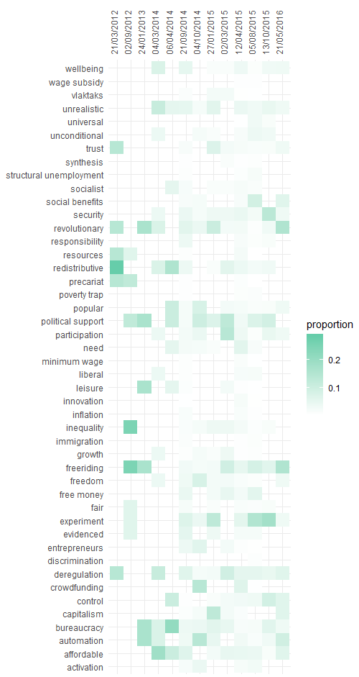
Note: only arguments that occur more than 10 times are shown.

