Appendix

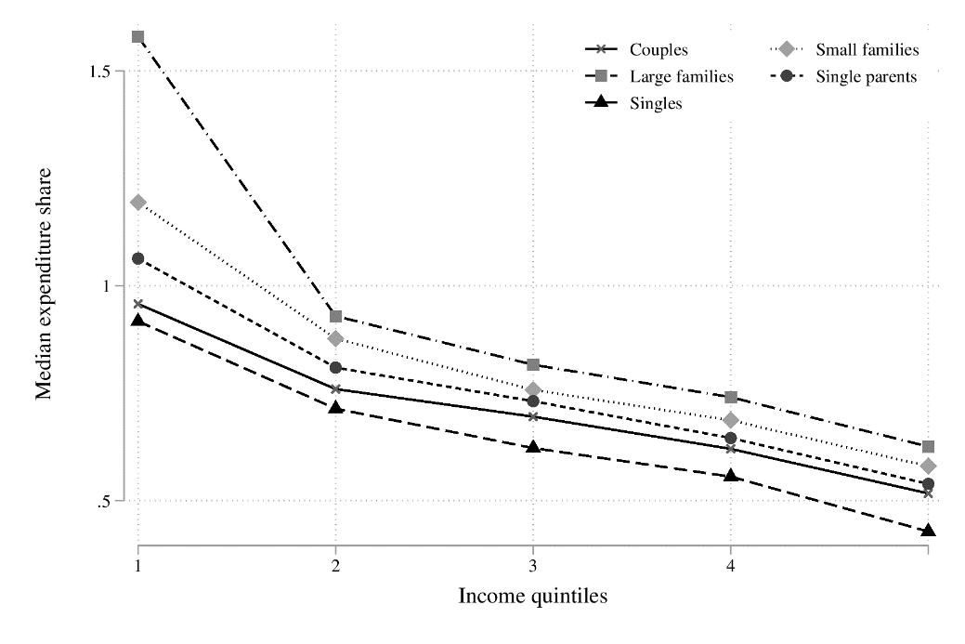
Figure A1. Average median consumption expenditure share per income quintile across countries
Source. Own calculation based on LIS data.

Table A1 VAT rates and implicit indirect tax rate (ITR)
 | Year | Standard VAT | Reduced VAT | Implicit ITR | N
Mexico¹ | 2016 | 16.0 | - | 09.72 | 70286
Switzerland | 2004 | 7.6 | 3.6/2.4 | 10.90 | 3225
Australia | 2010 | 10.0 | 0.0 | 13.75 | 17920
South Korea | 2012 | 10.0 | 0.0 | 18.22 | 10313
Italy | 2016 | 22.0 | 10.0/5.0/4.0 | 19.04 | 7284
France | 2010 | 19.6 | 5.5/2.1 | 19.58 | 15594
Estonia | 2000 | 18.0 | 5.0 | 19.86 | 5844
Poland | 2016 | 23.0 | 8.0/5.0 | 19.96 | 36577
Israel | 2016 | 17.0 | - | 20.44 | 8836
Slovenia | 2015 | 22.0 | 9.5 | 23.82 | 3727
Hungary | 2015 | 27.0 | 18.0/5.0 | 33.40 | 2771
Source. LIS, OECD and Eurostat.
Note. ¹ The implicit indirect tax rate is well below the VAT rate. This could be due to significant household consumption in the shadow economy that remains untaxed.

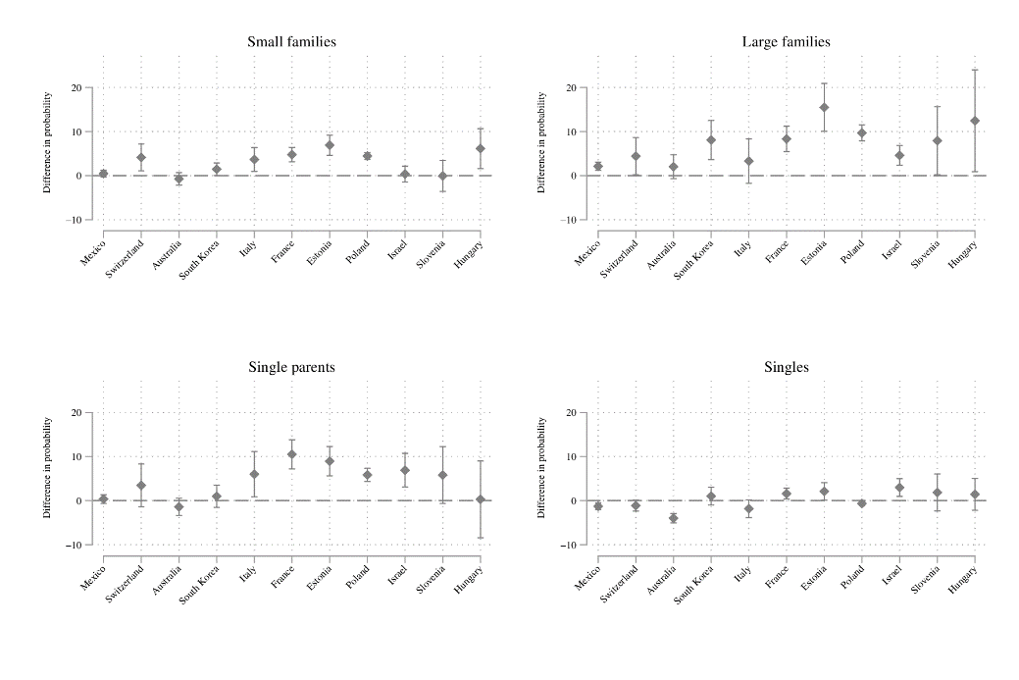
Figure A2. Difference in the probability of falling under the poverty line due to consumption taxes compared to couple households without children (poverty line at 50% of median per capita disposable income)
Note. Spikes indicate 95% confidence intervals (robust standard errors).

Statutory tax information for France 2010
Statutory VAT rates and selected excise taxes are used to estimate household consumption tax payments based on household expenditure per COICOP category. Notably, due to data availability, not all excise taxes are included and results should be interpreted as minimum values.
Table A2 Statutory tax rates per COICOP category in France 2010
Classification of Individual Consumption by Purpose (COICOP) |  | VAT (%) | Excise tax (as % of retail price) | Total tax (%)
1 | Food and non-alcoholic beverages | 4.00 |  | 4.00
2 | Alcoholic beverages, tobacco and narcotics | 19.60 | 39.60¹ | 59.20
3 | Clothing and footwear | 19.60 |  | 19.60
4 | Housing, water, electricity, gas and other fuels | 4.10 | 7.90² | 5.30⁴
5 | Furnishings, household equipment maintenance | 15.20 |  | 15.20
6 | Health | 7.00 |  | 7.00
7 | Transport | 17.80 | 44.90³ | 31.35⁵
8 | Communications | 18.90 |  | 18.90
9 | Recreation and culture | 16.50 |  | 16.50
10 | Education | 0.00 |  | 0.00
11 | Restaurants and hotels | 5.50 |  | 5.50
12 | Miscellaneous goods and services | 16.70 |  | 16.70
Sources. Eurostat Experimental statistics (Eurostat, 2020), OECD Consumption Tax Trends (OECD, 2020) and Ngo et al. (2021).
Notes. ¹ Mean excise tax on alcoholic beverages (15.2%) and tobacco (64.0%).
² Only light fuel oil for households.
³ Based on a gasoline litre price of 1.35€ in 2010 with an excise of 0.606€ per litre.
⁴ Estimation based on 15 per cent of French households heating with light fuel oil. Not including other excises on electricity and gas.
⁵ Estimation based on half of transport expenditures spent on fuel, see European Environment Agency (2021).

References
European Environment Agency (2021) Expenditure on Personal Mobility: Share of Household Expenditure on Transport by Consumption (transport) Purpose.
Eurostat (2020) Experimental Statistics: VAT Rate by COICOP Consumption Purpose.
Ngo, A. P., Wang, X., Slater, S., Chriqui, J. F., Chaloupka, F. J., Lin, Y., Smith, L., Li, Q. and Shang, C. (2021) ‘Alcohol excise taxes as a percentage of retail alcohol prices in 26 OECD countries’, Drug and Alcohol Dependence, 219.
OECD (2020) Consumption Tax Trends 2020: VAT/GST and Excise Rates, Trends and Policy Issues, Paris: OECD Publishing.

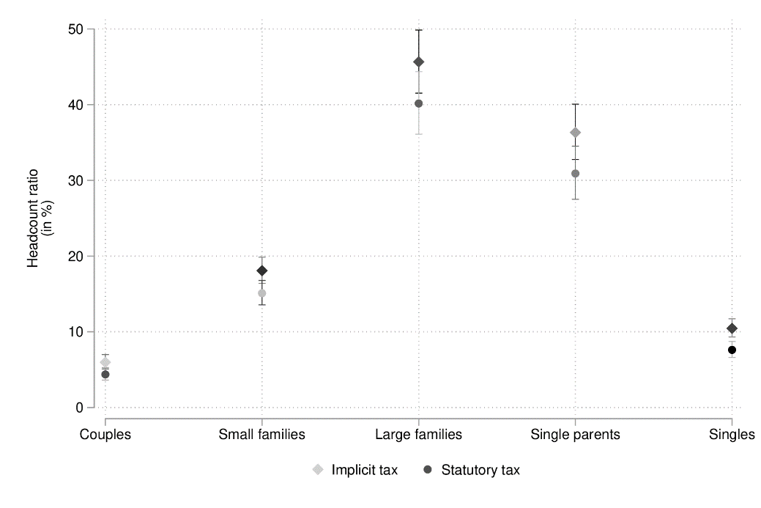
Figure A3. Consumable income poverty rates per household type estimated with implicit tax vs. statutory tax information in France

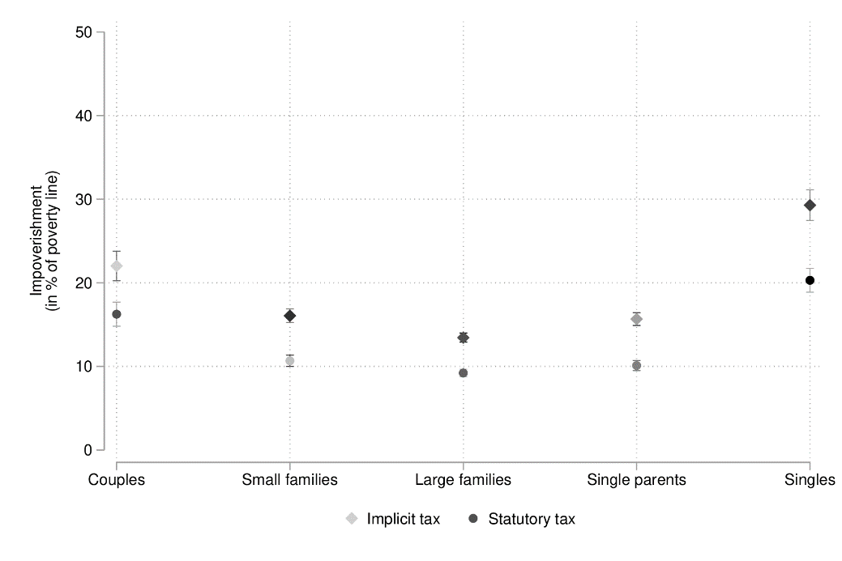
Figure A4. Consumption tax impoverishment per household type estimated with implicit tax vs. statutory tax information in France
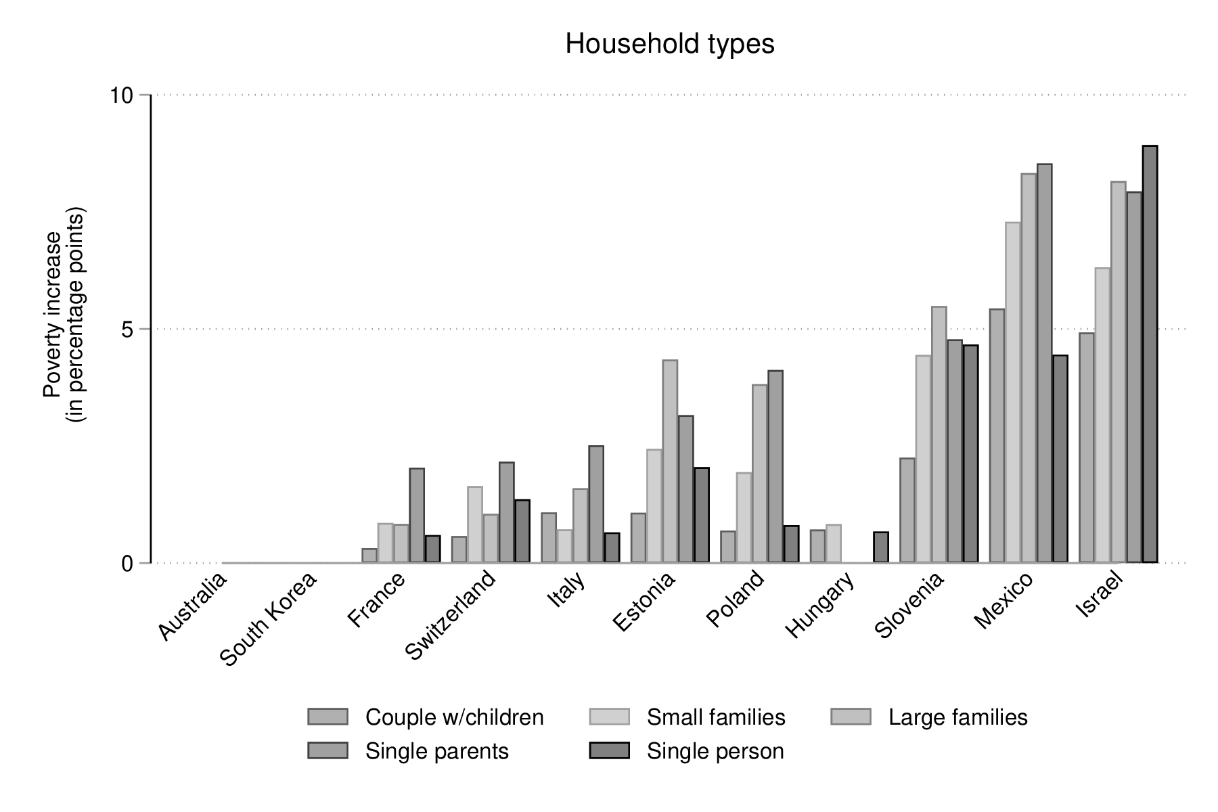
Figure A5. Poverty increase due to consumption taxes across household types compared to couple households (poverty line at 60% of median per capita disposable income)
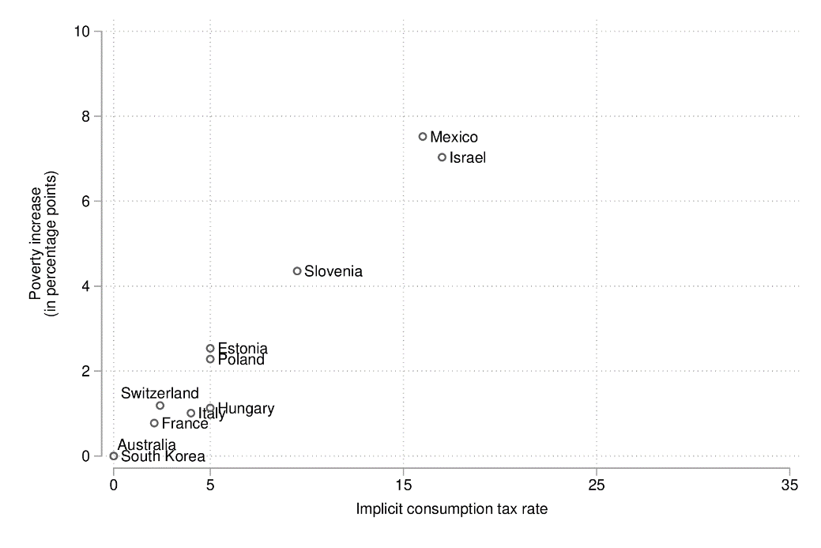
Figure A6. Overall poverty increase and implicit consumption tax rate (poverty line at 60% of median per capita disposable income)

