Table A1 Structure of cooperative public finance
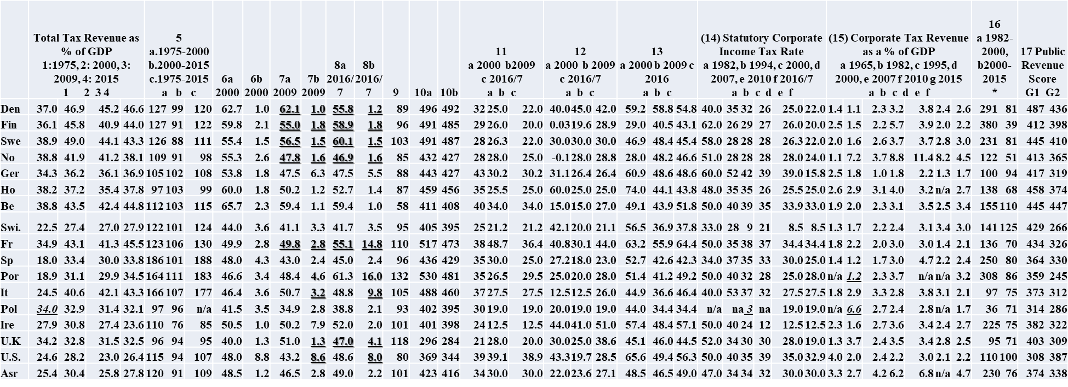
Globalisation 1 (G1) covers the first phase of contemporary globalisation from mid 1970s till around 2000, whereas Globalisation 2 (G2) covers the period thereafter. The scores are used to better visually represent and compare the slowly changing structure of public finance, and the relative position of countries in inter-temporal terms.
Column 5: Total Tax Revenue as % of GDP, earlier year as 100. Column 6-8: a: Top marginal tax rate, b: Multiple of average wage where sets in.
Column 9: Top marginal tax rates 2000-2015, 2000 as 100. Column 10: a: (4*3)+(5b)+(8a*3)+(9), b: (4*3)+(5b)+(8a*3)-(8b*3)+(9).
Column 11: Corporate Income Tax on Distributed Profits. Column 12: Net Statutory Tax Rates on Dividend Income (Shareholder).
Column 13: Overall Personal Income Tax and Corporate Income Tax Rates on Dividend Income. Column 16: Corporate Tax Rev as % of GDP
Index calculations and Sources for Table A1
Public revenue index score (column 17):
Globalisation 1 (G1): (2(*4)) + (5a/10) + (6a(*2)) - (6b*10)) + (13a*2) + (14c) + (15d*2) + (16a/20).
Globalisation 2 (G2): (4(*4)) + (5b/10) + (8a(*2)) - (8b*10)) + (13c*2) + (14f) + (15f*2) + (16b/20).
Columns 1-4 | OECD (2016c) Tax Revenue Statistics, Comparative Table of OECD Countries (Total Tax Revenue as a percentage of GDP) (Accessed 2017) https://stats.oecd.org/Index.aspx?DataSetCode=REV  - The figures for Eastern European countries, which only became market-governed economies after the end of the Cold War in the late 1980s, are based on the 1991 figure for Hungary and Poland, and 1993 for the Czech Republic, and 1995 for the Slovak Republic. The earliest available figure for Mexico is 1980.  - For Poland, Japan and Australia the 2015 figure is really 2014 because 2015 not available. For Mexico (16) I use the trend from 2010-2015, as previous figures are not available
 | *Poland, Australia & Japan scores as 2014
Columns 6-8 | OECD (2016c) Table I.7. Top Statutory Personal Income Tax Rate and Top Marginal Tax Rates for Employees, http://stats.oecd.org/index.aspx?DataSetCode=TABLE_I7
 | a) Personal Income Tax & Employee Social Security Contributions (All-In Rate),
 | b) Threshold (expressed as a multiple of the average wage) (Accessed 2016).
Column 11 | OECD (2016c) Table II.4. Overall Statutory Tax Rates on Dividend Income (CIT Rate on Distributed Profit, expressed as a percentage) (2016) https://stats.oecd.org/Index.aspx?DataSetCode=TABLE_II4
Column 12 | OECD (2016c) Table II.4. Overall Statutory Tax Rates on Dividend Income (Net Personal Tax - the net top statutory rate to be paid at the shareholder level, taking account of all types of reliefs and gross-up provisions at the shareholder level -, expressed as a percentage) (2016) https://stats.oecd.org/Index.aspx?DataSetCode=TABLE_II4
Column 13 | OECD (2016c) Table II.4. Overall Statutory Tax Rates on Dividend Income (Overall PIT + CIT Rate, expressed as a percentage) (2016) https://stats.oecd.org/Index.aspx?DataSetCode=TABLE_II4
Column 14 | OECD (2016c) Table II.1. Corporate Income Tax Rate (2016) https://stats.oecd.org/Index.aspx?DataSetCode=TABLE_II1
Column 15 | OECD (2016c) Tax Revenue Statistics, Comparative Table of OECD Countries (Tax Revenue as a percentage of GDP on the taxes on income, profits & capital gains of corporates) (2015) (Accessed 2017) https://stats.oecd.org/Index.aspx?DataSetCode=REV  (15) The figures for Eastern European countries, which only became market-governed economies after the end of the Cold War in the late 1980s, are based on the 1991 figure for Hungary and Poland, and 1993 for the Czech Republic, and 1995 for the Slovak Republic. The earliest available figure for Mexico is 2002 and is reproduce here. * Poland as 2014
Column 16 | * Trend adjusted to 1995 as data too sparse for earlier years

Table A2 Public spending on human development
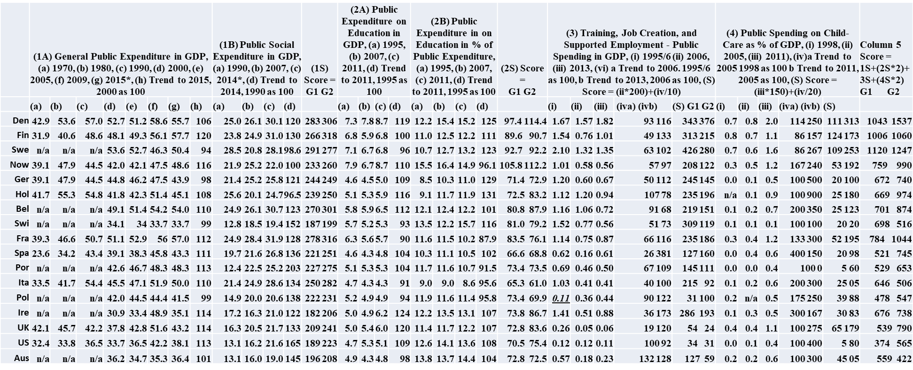
Globalisation 1 covers the first phase of contemporary globalisation from mid 1970s till around 2000, whereas Globalisation 2 covers the period thereafter.

Index calculations and Sources for Table A2
1S score General public and social expenditure:
Globalisation 1 (G1): (Ad*4)+(Ah/10)+(Bb*2)+(Bd/10),
Globalisation 2 (G2): (Ag*4)+(Ah/10)+(Bc*2)+(Bd/10)
Globalisation 1 covers the first phase of contemporary globalisation from mid 1970s till around 2000, whereas Globalisation 2 covers the period thereafter. Both include the same figure for long term trend in social expenditure since 1990-2014, and in general public expenditure from 2000-2015. The main difference in the two scores in therefore between the 2000 and 2015 figure for general public expenditure in GDP, and the 1990 and 2014 figure in public social expenditure in GDP. I used the 2000 data for general public expenditure because it is more complete. Had I used the 1990 figure for Graph 2 the trend evidenced in Table A.B.2 of growing divergence would have been even greater. Countries like Japan, France, Denmark and Japan see very large increases in public spending between 1970 and 1990. Anglo-liberal countries see less change over the whole period. Public social spending counties to grow but more so in countries with historically higher levels
The scores are used to better visually represent and compare the slowly changing structure of public finance, and the relative position of countries in inter-temporal terms.
2S score Education expenditure in GDP and public expenditure: Globalisation 1 (Aa*10)+(Ad/20)+(Ba)+(Bd/20), Globalisation 2 (Ac*10)+(Ad/20)+(Bc)+(Bd/20)
On this score globalisation 1 is indicated by 1995, and globalisation 2 by 2011. Both scores include the same indicator for trend so the main difference is between the level of public expenditure in GDP, and the share of education in public expenditure in the two periods
3S Score : Globalisation 1 (i*200) + (iii/10), Globalisation 2 (ii*200)+(iii/10). The i figure for the Slovak Rep., Poland, the Czeck Rep. are from 2002. and Hungary 2004, the other countries from 1995/6
4S Score: Globalisation 1 (i*150)+(iva/20), Globalisation 2 (iii*150)+(ivb/20)
Column 1
OECD (2016b) National Accounts at a Glance (6 - Government), Total Expenditure of General Government (as % of GDP) (2015) https://stats.oecd.org/Index.aspx?DataSetCode=NAAG
*Switzerland, Austria, USA, Australia, New Zealand and Japan as 2014, Mexico as 2013
OECD Social Expenditure Aggregated Data (public, as a % of GDP) (2014) http://stats.oecd.org/Index.aspx?datasetcode=SOCX_AGG
*New Zealand as 2013, Mexico as 2012, Japan as 2011
Column 2
OECD (2014a) Education at a glance 2014 (p.257), http://dx.doi.org/10.1787/eag-2014-en.
OECD (2011) Education at a Glance, https://www.oecd.org/education/skills-beyond-school/48631582.pdf
OECD (2010) Employment Outlook 2010. https://doi.org/10.1787/empl_outlook-2010-en.*There was no figure for 2008/9 for Mexico, so the 2006 figure was re-entered
OECD (2015) Employment Outlook 2015, https://doi.org/10.1787/empl_outlook-2015-en.Table Q. ‘Public Expenditure and Participant Stocks in Labour Market Programmes in OECD Countries, 2012 and 2013 http://www.oecd.org/els/emp/employment-outlook-statistical-annex.htm
*France, Spain, New Zealand, South Korea & Poland data for 2013 unavailable so 2012 data used. UK Data unavailable so 2008/2009 data left in.
Column 3
OECD Employment Outlook, various years
Column 4
OECD (2014b) Family Database, PF3.1 Public Spending on Childcare and Early Education (2014) http://www.oecd.org/els/family/database.htm
*Data for Switzerland unavailable, so 2005 data left in.

