Web Appendix

Web Appendix 1: Descriptive characteristics for 175 local authorities over 2008/09 to 2014/15.

Web Appendix 2: Association between demographic characteristics of JSA claimants and the adverse sanction rate, 2008 to 2014, adjusting for rates of employment and economic inactivity

Web Appendix 3: Association between demographic characteristics of JSA claimants and the adverse sanction rate, 2008 to 2014, adjusting for labour market slack

Web Appendix 4: Interaction model examining the association between disability and long parents with adverse sanctions before and after the change in sanction regime

Web Appendix 5: Association between demographic characteristics of JSA claimants and the adverse sanction rate, adjusting for time dummies, 2008 to 2014

Web Appendix 6: Association between demographic characteristics of JSA claimants and the adverse sanction rate, including local authorities with small samples, 2008 to 2014

Web Appendix 7: Association between demographic characteristics of JSA claimants and the adverse sanction rate, excluding local authorities with zero disabled, lone parent, ethnic minority or highly educated JSA claimants, 2008 to 2014

Web Appendix 8: Association between demographic characteristics of JSA claimants and the adverse sanction rate, excluding local authorities with 100% disabled, lone parent, ethnic minority or highly educated JSA claimants, 2008 to 2014

Web Appendix 9: Association between demographic characteristics of JSA claimants and the adverse sanction rate, without weighting by the size of local authorities, 2008 to 2014

Web Appendix 10: Association between demographic characteristics of JSA claimants and the adverse sanction rate, weighted by number of JSA claimants, 2008 to 2014

Web Appendix 11: Association between demographic characteristics of JSA claimants and the sanction referral rate, 2008 to 2014

Web Appendix 12: Examining the association between lone parents and the sanction rate in more detail.

Web Appendix 13: Association between demographic characteristics of JSA claimants and the demographic-specific sanction rate, 2008 to 2014

Web Appendix 1: Descriptive characteristics for 175 local authorities over 2008/09 to 2014/15.

Variable | N | Mean | Std. Dev. | Min | Max
JSA claimants adversely sanctioned (%) | 1205 | 3.54 | 1.25 | 1.03 | 9.42
JSA claimants referred to be sanctioned (%) | 1205 | 7.41 | 2.72 | 2.21 | 20.42
JSA claimants who report a disability (%) | 1205 | 28.27 | 12.64 | 0 | 100
JSA claimants who are lone parents (%) | 1205 | 21.03 | 10.79 | 0 | 100
JSA claimants who are an ethnic minority (%) | 1205 | 15.85 | 21.12 | 0 | 100
JSA claimants with high level of education (NQF level 4 or above) (%) | 1205 | 15.65 | 11.29 | 0 | 100
JSA claimants claiming for >12 months (%) | 1205 | 19.45 | 8.84 | 3.17 | 41.25
JSA claimants aged 55-64 (%) | 1205 | 1.72 | 0.84 | 0.31 | 6.04
JSA claimants aged 18-24 (%) | 1205 | 27.73 | 4.63 | 13.78 | 41.32

Web Appendix 2: Association between demographic characteristics of JSA claimants and the adverse sanction rate, 2008 to 2014, adjusting for rates of employment and economic inactivity
 | Proportion of JSA claimants adversely sanctioned
Variable | (1) | (2)
Proportion of JSA claimants who report a disability | 0.015**  (0.0035) | 0.015**  (0.0035)
Proportion of JSA claimants who are lone parents | 0.017**  (0.0037) | 0.017**  (0.0038)
Proportion of JSA claimants who are an ethnic minority | -0.0027  (0.0030) | -0.0018  (0.0031)
Proportion of JSA claimants that have a high level of education (NQF level 4 or above) | 0.0029  (0.0035) | 0.0023  (0.0034)
Proportion of JSA claimants claiming for over 12 months | 0.056**  (0.0067) | 0.061**  (0.0068)
Proportion of JSA claimants aged 55-64 | 0.11  (0.067) | 0.070  (0.068)
Proportion of JSA claimants aged 18-24 | -0.024  (0.015) | -0.020  (0.016)
Employment rate (%) | __ | 0.025  (0.023)
Economically inactive (%) | __ | 0.019  (0.031)
Constant | 2.09**  (0.55) | -0.24  (2.48)
Observations | 1205 | 1205
R² | 0.35 | 0.35
Notes: Standard errors in parentheses. All models include weighting by local authority size.
* p < 0.05, ** p < 0.01

Web Appendix 3: Association between demographic characteristics of JSA claimants and the adverse sanction rate, 2008 to 2014, adjusting for labour market slack
 | Proportion of JSA claimants adversely sanctioned
Variable | (1) | (2)
Proportion of JSA claimants who report a disability | 0.015**  (0.0035) | 0.0082*  (0.0032)
Proportion of JSA claimants who are lone parents | 0.017**  (0.0037) | 0.014**  (0.0031)
Proportion of JSA claimants who are an ethnic minority | -0.0027  (0.0030) | 0.0024  (0.0032)
Proportion of JSA claimants that have a high level of education (NQF level 4 or above) | 0.0029  (0.0035) | 0.0058  (0.0034)
Proportion of JSA claimants claiming for over 12 months | 0.056**  (0.0067) | 0.055**  (0.0074)
Proportion of JSA claimants aged 55-64 | 0.11  (0.067) | -0.047  (0.11)
Proportion of JSA claimants aged 18-24 | -0.024  (0.015) | -0.020  (0.016)
Unemployment rate (%) | __ | -0.019  (0.39)
Ratio of vacancies advertised in the job centre and number of JSA claimants | __ | -0.026  (0.019)
Constant | 2.09**  (0.55) | 2.47**  (0.55)
Observations | 1205 | 862
R² | 0.35 | 0.23
Notes: Standard errors in parentheses. All models include weighting by local authority size. The sample size in model 2 declines because of missing data on the variable measuring the ratio of advertised job centre vacancies and the number of JSA claimants.
* p < 0.05, ** p < 0.01

Web Appendix 4: Interaction model examining the association between disability and long parents with adverse sanctions before and after the change in sanction regime
 | Proportion of JSA claimants adversely sanctioned
Variables | (1)
Proportion of JSA claimants who report a disability before reform | 0.0059  (0.0037)
Proportion of JSA claimants who are lone parents | 0.012**  (0.0031)
Change in sanction rate after the reform | 0.058  (0.27)
Proportion of JSA claimants who report a disability x change in sanction rate after the reform | 0.016**  (0.0057)
Proportion of JSA claimants who are lone parents x change in sanction rate after the reform | 0.012*  (0.0060)
Proportion of JSA claimants who are an ethnic minority | -0.0023  (0.0027)
Proportion of JSA claimants that have a high level of education (NQF level 4 or above) | 0.0022  (0.0034)
Proportion of JSA claimants who have been claiming for more than 12 months | 0.029**  (0.0094)
Proportion of JSA claimants aged 55-64 | -0.080  (0.070)
Proportion of JSA claimants aged 18-24 | -0.026  (0.014)
Constant | 2.99**  (0.55)
Observations | 1205
R² | 0.37
Notes: Standard errors in parentheses. All models include weighting by local authority size.
* p < 0.05, ** p < 0.01

Sensitivity tests:

First, we include time dummies (indicators for each fiscal year), which controls for geographical correlations between local authorities that may confound the observed relationships, finding that – as described above – sanction rates remain correlated with the proportion of disabled and lone parent claimants but not the proportion of ethnic minority claimants (Web Appendix 5). We also reran our models including all local authorities, regardless of sample sizes in the Annual Population Survey. We would expect this to bias our findings towards the null, given the error associated with estimating the socio-demographics of claimants from small sample sizes. Even including these local authorities, the associations we observed remained robust (Web Appendix 6). Next, we restricted our sample to only local authorities with non-zero values on our measures of the socio-demographics of claimants (i.e., those with disabilities, who were lone parents, in ethnic minority groups, or who were highly education). Although this reduced the number of local authority observations from 1205 to 748, our findings remained robust (Web Appendix 7). The same was true when we excluded local authorities where area samples, implausibly, provided estimates that showed all claimants had these characteristics (n=10) (Web Appendix 8).
We also examined how different specifications of model weighting affected our findings, first examining if results change when no weights were included, and finding that our results remain stable (Web Appendix 9), and then, instead, weighting by the Annual Population Survey sample size for each local authority and finding, again, that our results are qualitatively unchanged (Web Appendix 10).
Data on adverse sanctions – as mentioned above – is only collected after various appeals procedures have been completed. This may bias our results if certain vulnerable groups are more likely to have their sanctions overturned. To explore this possibility, we examine whether sanction referrals (and not just adverse decision) are also associated with the socio-demographic composition of JSA claimants. Consistent with adverse sanction decisions, sanction referral rates are higher when the proportion of claimants who are disabled is higher and where there are more lone parents claiming JSA (Web Appendix 11).

Web Appendix 5: Association between demographic characteristics of JSA claimants and the adverse sanction rate, adjusting for time dummies, 2008 to 2014
 | Proportion of JSA claimants adversely sanctioned
Variables | (1)
Proportion of JSA claimants who report a disability | 0.0092**  (0.0033)
Proportion of JSA claimants who are lone parents | 0.011**  (0.0034)
Proportion of JSA claimants who are an ethnic minority | 0.0027  (0.0021)
Proportion of JSA claimants that have a high level of education (NQF level 4 or above) | -0.00070  (0.0030)
Proportion of JSA claimants who have been claiming for more than 12 months | -0.036**  (0.010)
Proportion of JSA claimants aged 55-64 | -0.41**  (0.11)
Proportion of JSA claimants aged 18-24 | 0.0042  (0.012)
Time dummies | Y
Constant | 2.46**  (0.52)
Observations | 1205
R² | 0.54
Notes: Standard errors in parentheses. All models include weighting by local authority size.
* p < 0.05, ** p < 0.01

Web Appendix 6: Association between demographic characteristics of JSA claimants and the adverse sanction rate, including local authorities with small samples, 2008 to 2014
 | Proportion of JSA claimants adversely sanctioned
Variables | (1)
Proportion of JSA claimants who report a disability | 0.0040**  (0.0013)
Proportion of JSA claimants who are lone parents | 0.0048**  (0.0013)
Proportion of JSA claimants who are an ethnic minority | -0.0018  (0.0024)
Proportion of JSA claimants that have a high level of education (NQF level 4 or above) | 0.0014  (0.0015)
Proportion of JSA claimants who have been claiming for more than 12 months | 0.072**  (0.0052)
Proportion of JSA claimants aged 55-64 | 0.14**  (0.048)
Proportion of JSA claimants aged 18-24 | -0.0031  (0.011)
Constant | 1.78**  (0.39)
Observations | 2625
R² | 0.29
Notes: Standard errors in parentheses. All models include weighting by local authority size.
* p < 0.05, ** p < 0.01

Web Appendix 7: Association between demographic characteristics of JSA claimants and the adverse sanction rate, excluding local authorities with zero disabled, lone parent, ethnic minority or highly educated JSA claimants, 2008 to 2014
 | Proportion of JSA claimants adversely sanctioned
Variables | (1)
Proportion of JSA claimants who report a disability | 0.020**  (0.0049)
Proportion of JSA claimants who are lone parents | 0.020**  (0.0049)
Proportion of JSA claimants who are an ethnic minority | -0.0019  (0.0037)
Proportion of JSA claimants that have a high level of education (NQF level 4 or above) | 0.0020  (0.0054)
Proportion of JSA claimants who have been claiming for more than 12 months | 0.059**  (0.0076)
Proportion of JSA claimants aged 55-64 | 0.082  (0.079)
Proportion of JSA claimants aged 18-24 | -0.020  (0.017)
Constant | 1.73**  (0.63)
Observations | 748
R² | 0.37
Notes: Standard errors in parentheses. All models include weighting by local authority size.
* p < 0.05, ** p < 0.01

Web Appendix 8: Association between demographic characteristics of JSA claimants and the adverse sanction rate, excluding local authorities with 100% disabled, lone parent, ethnic minority or highly educated JSA claimants, 2008 to 2014
 | Proportion of JSA claimants adversely sanctioned
Variables | (1)
Proportion of JSA claimants who report a disability | 0.015**  (0.0037)
Proportion of JSA claimants who are lone parents | 0.018**  (0.0036)
Proportion of JSA claimants who are an ethnic minority | -0.0031  (0.0031)
Proportion of JSA claimants that have a high level of education (NQF level 4 or above) | 0.0041  (0.0039)
Proportion of JSA claimants who have been claiming for more than 12 months | 0.057**  (0.0068)
Proportion of JSA claimants aged 55-64 | 0.11  (0.069)
Proportion of JSA claimants aged 18-24 | -0.024  (0.015)
Constant | 2.08**  (0.56)
Observations | 1195
R² | 0.35
Notes: Standard errors in parentheses. All models include weighting by local authority size.
* p < 0.05, ** p < 0.01

Web Appendix 9: Association between demographic characteristics of JSA claimants and the adverse sanction rate, without weighting by the size of the local authorities, 2008 to 2014
 | Proportion of JSA claimants adversely sanctioned
Variables | (1)
Proportion of JSA claimants who report a disability | 0.013**  (0.0032)
Proportion of JSA claimants who are lone parents | 0.014**  (0.0034)
Proportion of JSA claimants who are an ethnic minority | -0.0019  (0.0026)
Proportion of JSA claimants that have a high level of education (NQF level 4 or above) | 0.00052  (0.0031)
Proportion of JSA claimants who have been claiming for more than 12 months | 0.058**  (0.0056)
Proportion of JSA claimants aged 55-64 | 0.10  (0.061)
Proportion of JSA claimants aged 18-24 | -0.018  (0.014)
Constant | 2.10**  (0.51)
Observations | 1205
R² | 0.32
Notes: Standard errors in parentheses.
* p < 0.05, ** p < 0.01

Web Appendix 10: Association between demographic characteristics of JSA claimants and the adverse sanction rate, weighted by number of JSA claimants, 2008 to 2014
 | Proportion of JSA claimants adversely sanctioned
Variables | (1)
Proportion of JSA claimants who report a disability | 0.013**  (0.0033)
Proportion of JSA claimants who are lone parents | 0.015**  (0.0032)
Proportion of JSA claimants who are an ethnic minority | -0.0019  (0.0026)
Proportion of JSA claimants that have a high level of education (NQF level 4 or above) | 0.0016  (0.0032)
Proportion of JSA claimants who have been claiming for more than 12 months | 0.055**  (0.0055)
Proportion of JSA claimants aged 55-64 | 0.11  (0.060)
Proportion of JSA claimants aged 18-24 | -0.020  (0.014)
Constant | 2.10**  (0.48)
Observations | 1205
R² | 0.32
Notes: Standard errors in parentheses.
* p < 0.05, ** p < 0.01

Web Appendix 11: Association between demographic characteristics of JSA claimants and the sanction referral rate, 2008 to 2014
 | Proportion of JSA claimants referred for sanction
Variable | (1) | (2) | (3)
Proportion of JSA claimants who report a disability | 0.064**  (0.0078) | 0.027**  (0.0068) | 0.014*  (0.0068)
Proportion of JSA claimants who are lone parents | 0.061**  (0.0086) | 0.038**  (0.0071) | 0.019**  (0.0065)
Proportion of JSA claimants who are an ethnic minority | -0.0095*  (0.0038) | -0.026**  (0.0059) | -0.016**  (0.0059)
Proportion of JSA claimants that have a high level of education (NQF level 4 or above) | 0.013  (0.0077) | 0.015*  (0.0075) | 0.011  (0.0067)
Proportion of JSA claimants claiming for over 12 months | __ | 0.14**  (0.013) | 0.26**  (0.012)
Proportion of JSA claimants aged 55-64 | __ | 0.13  (0.15) | -1.64**  (0.19)
Proportion of JSA claimants aged 18-24 | __ | -0.053  (0.032) | -0.26**  (0.059)
Local authority fixed-effects | N | N | Y
Constant | 4.27**  (0.33) | 4.55**  (1.17) | 11.5**  (2.01)
Observations | 1205 | 1205 | 1205
R² | 0.14 | 0.37 | 0.58
Notes: Standard errors in parentheses. All models include weighting by local authority size. Model 3 includes local authority fixed effects.
* p < 0.05, ** p < 0.01

Web Appendix 12: Examining the association between lone parents and the sanction rate in more detail.

First, we examined the correlation between the proportion of claimants who are lone parents and the sanction rate (Figure A), finding a strong positive association (r = 0.66. p <0.001). This suggests that – consistent with our results – as the proportion of lone claimants increases so too does the sanction rate for lone parents.

Figure A: Association between the proportion of lone parent claimants and the adverse sanction rate among lone parents at the aggregate level (Great Britain), 2008 to 2014
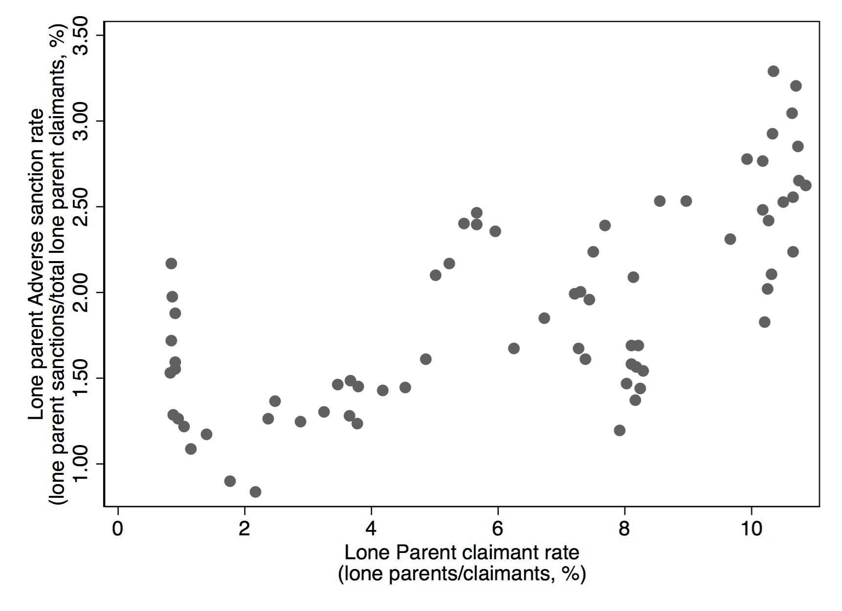
Source: nomisweb. Each observation represents one month (e.g., March 2011).

However, this correlation may be confounded by something else, namely the policy changes that are happening during this period which affect both the number of lone parents claiming JSA and the sanction rate. To test this possibility, we estimate a time series regression model which adjusts for the secular time trend during our sample period. We estimate this time trend as both a linear relationship and as a second-order polynomial (allowing the temporal relation to be a curve rather than a straight-line). We find this association remains at the aggregate level (β = 0.11, p = 0.035), even after adjusting for the background changes in sanctions and lone parents.

These results do not, however, necessarily explain why our regression models suggest the sanction rate increases when there are more lone parents claiming JSA while the national level data suggests the opposite. One possible explanation is that the association between lone parents and the sanction rate varies depending on what proportion of claimants are lone parents. For example, imagine that lone parents are less likely to be sanctioned when they constitute a smaller proportion of claimants but more likely to be sanctioned when they constitute a larger proportion of claimants. In this scenario, lone parents would look like they are less likely to be sanctioned at the national level if, on average, lone parents constitute a small proportion of all claimants. However, at the local authority level we may still see a positive association, especially among local authorities with a high proportion of lone parent claimants.

We test this possibility by examining whether the association between the proportion of lone parent claimants varies according to the number of lone parents who are claiming.

We find that – consistent with our results and the aggregate-level data – the association between the sanction rate and lone parents is either flat or largely negative in LAs where there are few lone parents claiming but increases sharply if the proportion of lone parents is high>10% (Figure B). For example, if the proportion of lone parent claimants rises from 1% to 2% then the sanction rate may well be lower. However, if the proportion of lone parent claimant rises from 12% to 13% (around the average in the summer of 2014) then the sanction rate will go up. This is not the case for the proportion of disabled claimants, which is a consistently linear association.

Figure B: Testing whether there is a non-linear association between the proportion of lone parent or disabled claimants and the sanction rate
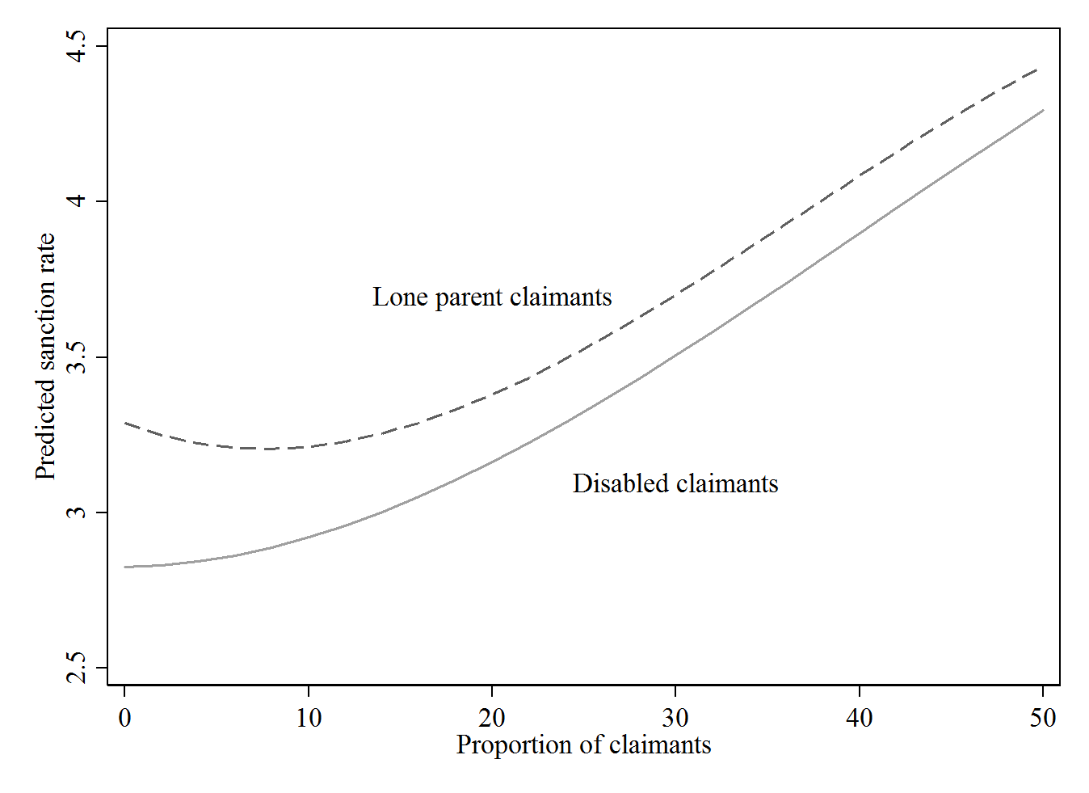
Notes: We added a third-order polynomial to capture any differences in the direction of the association at very high and very low levels of lone parents and disabled claimants.

Web Appendix 13: Association between demographic characteristics of JSA claimants and the demographic-specific sanction rate, 2008 to 2014
 | Proportion adversely sanctioned
 | Disabled claimants | Lone parent claimants | Ethnic minority claimants
Variable | (1) | (2) | (3)
Proportion of JSA claimants who report a disability | 0.0042**  (0.0010) | 0.00073*  (0.00034) | 0.0030  (0.0016)
Proportion of JSA claimants who are lone parents | 0.0035**  (0.0010) | 0.0012**  (0.00033) | 0.0049**  (0.0019)
Proportion of JSA claimants who are an ethnic minority | -0.0040**  (0.00076) | -0.000041  (0.00028) | 0.029**  (0.0017)
Proportion of JSA claimants that have a high level of education (NQF level 4 or above) | 0.00024  (0.0011) | 0.00063  (0.00035) | -0.0012  (0.0015)
Proportion of JSA claimants claiming for over 12 months | 0.0047**  (0.0018) | 0.0024**  (0.00064) | 0.014**  (0.0033)
Proportion of JSA claimants aged 55-64 | 0.094**  (0.020) | 0.064**  (0.0088) | -0.19**  (0.040)
Proportion of JSA claimants aged 18-24 | -0.0040  (0.0046) | -0.0040*  (0.0016) | -0.049**  (0.0087)
Constant | 0.56**  (0.17) | 0.099  (0.057) | 1.65**  (0.32)
Observations | 1205 | 1031 | 1205
R² | 0.24 | 0.46 | 0.74
Notes: Standard errors in parentheses. All models include weighting by local authority size. The sample size declines in model 2 (lone parents) because of missing data on the dependent variable.
* p < 0.05, ** p < 0.01

