Figure S1: Aggregate value of agricultural assistance, by country, 2019 (current US$ billion)

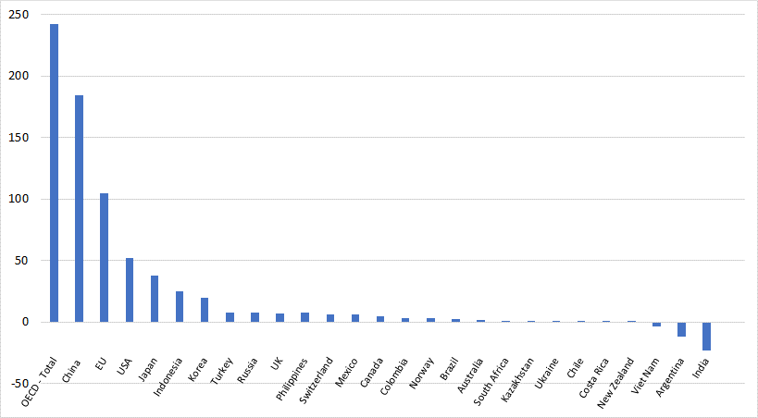

Source: OECD (2021).

Figure S2: Aggregate value of agricultural assistance, by product, OECD and non-OECD countries, 2016-18 (current US$ billion per year)
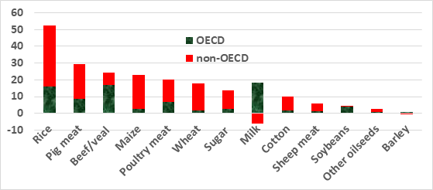
Source: OECD (2021).

Figure S3: Aggregate agricultural consumer tax equivalent (CTE) at the farm gate, by country, 2019 (current US$ billion)

Source: OECD (2021).

Table S1: Gains in welfare from global elimination of domestic subsidies disaggregated by target, and of import tariffs on all agricultural and food products,ª 2017 (current US$ billion and %)

 | Welfare (US$ billion) in: |  |  |  | % of total gain in:
 | HICs | DCs | World |  | HICs | DCs | World
Domestic subsidies:
Primary factors | 2.4 | -2.3 | 0.0 |  | 10 | -10 | 0
Intermediate inputs | 1.9 | 0.3 | 2.2 |  | 8 | 1 | 5
Outputs | 0.0 | 0.5 | 0.5 |  | 0 | 2 | 1
Total subsidies | 4.3 | -1.5 | 2.7 |  | 18 | -6 | 6
Import tariffs | 19.5 | 25.2 | 44.8 |  | 82 | 106 | 94
Total impact on welfare | 23.7 | 23.7 | 47.5 |  | 100 | 100 | 100
ª The few remaining subsidies on agri-food exports are also removed, but have a negligible impact.
Source: Authors’ GTAP model results and Anderson and Martin (2005).

