Appendix to

Improving Market Access for Developing Countries: A Case study of Jordan’s Exports to the EU*

Stéphanie Brunelin§, Jaime de Melo♣, Alberto Portugal
March 7, 2018
Figure A1: US imports from Jordan by HS2 category 2002-16 (90% of yearly trade)
a) Including imports from QIZs
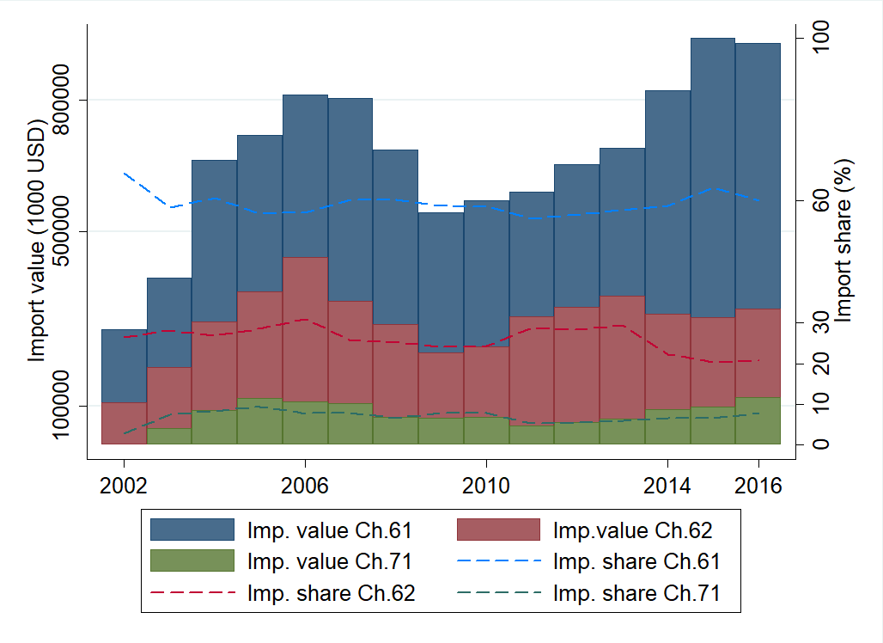

b) Excluding imports from QIZs
* Available at http://www.ferdi.fr/sites/www.ferdi.fr/files/publication/fichiers/p169-ferdi-brunelin_-_demelo_-_portugal.pdf

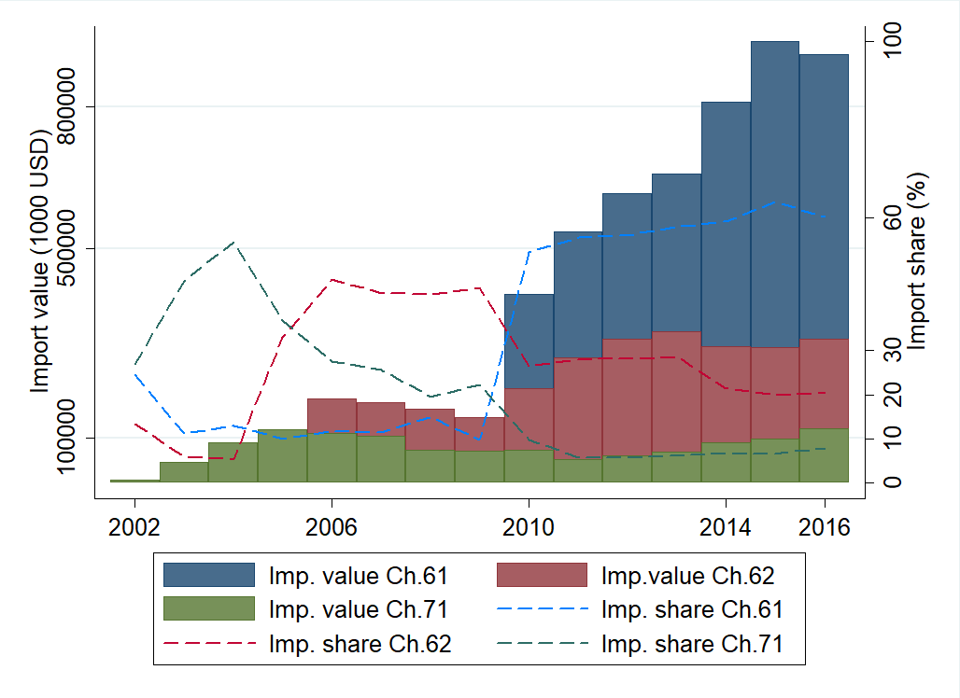
Notes: Boxes represent dollar values and dashed lines the corresponding import shares. Source: USITC for figure A1a and A1b
CH 61: Apparel & Clothing, knitted or crocheted
CH 62: Apparel & Clothing, not knitted or crocheted
CH72: Iron & Steel

Figure A2: EU imports from Jordan by HS2 category 2002-16 (90% of trade in 2016)

Source: Eurostat
CH 84: Nuclear reactors, boilers
CH 28: Inorganic chemicals
CH 61: Apparel & clothing, knitted or crocheted
CH 71: Pearls, precious stones, precious metals
CH 31: Fertilisers
CH 29: Organic chemicals
CH 25: Salt, sulphur, lime & cement
CH 07: Edible vegetables and tubers
CH 24: Tobacco
CH 76: Aluminium & articles
CH 40: Rubber and articles thereof
CH 74: Copper & articles
CH 20: Preparations of vegetable, fruit, nuts or other parts of plants
CH 08: Coffee, tea, mate and spices
CH 85: Electrical machinery & equipment
CH 63: Other made-up textile articles; sets; worn clothing and worn textile articles; rags
CH 39: Plastics and articles thereof

Table A1: Utilization rates of MFN dutiable imports from Jordan by section (2016)
 | JUSFTA |  | EUJFTA
 | Utilization rate | Adjusted preferential margin | Utilization rate | Adjusted preferential margin
Section I : Live animals, animal products | 100 | 4.3 | 0 | 2.9
Section II: Vegetable products | 91 | 0.8 | 95 | 5.6
Section III: Animal or vegetable fats and oils, animal or vegetable waxes | 100 | 1.2 | 94 | 17.4
Section IV: Prepared foodstuffs, beverages, spirits and vinegard; tobacco | 99 | 2.0 | 96 | 8.0
Section V: Mineral products |  | 0 | 95 | 0.5
Section VI: Products of the chemical or allied industries | 27 | 0.5 | 90 | 1.9
Section VII: Plastics and articles thereof; rubber and articles thereof | 38 | 1.9 | 28 | 3.3
Section VIII: Raw hides, skins & leather; articles of leather; furskins & artificial fur | 80 | 8.4 | 54 | 1.9
Section IX: Wood products; cork products; manufactures of straw | 78 | 4.0 | 39 | 0.7
Section X: Pulp of wood cellulosic material; paper & paperboard; printed books |  | 0 |  | 0.0
Section XI: Textiles and apparel articles | 100 | 12.0 | 12 | 6.0
Section XII: Footwear; headgear; umbrellas: feathers & down | 41 | 5.8 | 0 | 4.9
Section XIII: Articles of stone, plaster, cement; ceramic products; glass & glassware | 93 | 5.1 | 49 | 3.2
Section XIV: Pearls, precious stones, precious metals | 100 | 4.1 | 83 | 1.3
Section XV: Base metals and articles of base metal | 94 | 1.3 | 71 | 1.8
Section XVI: Nuclear reactors, boilers; electrical machinery & equipment | 98 | 0.6 | 1 | 1.2
Section XVII: Vehicles, aircraft, vessel and associated transport equipment | 8 | 1.0 | 12 | 3.0
Section XVIII: Optical, photographic, medical instruments; clocks & watches, musical instruments | 12 | 0.2 | 0.1 | 0.8
Section XX: Miscellaneous manufactures articles | 100 | 0.6 | 39 | 2.1
Section XXI: Works of art |  | 0 |  | 0
Total

. Source: Eurostat for trade data and TRAINS for tariff data for the EU; USITC for trade and tariff data for the USA.

Table A2: US Preferential margins and utilization of Preferences by Jordan (HS2-2016)
HS2 | Description | Utilization rate | Unadjusted preferential margin | Adjusted preferential margin | Imports (1000USD) | Import share (%) | Nb obs HS8
1 | Live animals |  | 0.00 | 0.00 | 3 | 0.00 | 1
2 | Meats |  |  |  |  |  | 0
3 | Fish |  |  |  |  |  | 0
4 | Dairy produce; birds' eggs; natural honey | 1.00 | 8.68 | 5.01 | 234 | 0.02 | 6
5 | Products of animal origin, NES |  |  |  |  |  | 0
6 | Live trees & other plants |  |  |  |  |  | 0
7 | Edible vegetables and tubers | 0.77 | 2.83 | 1.38 | 72 | 0.00 | 6
8 | Edible fruits & nuts |  |  |  |  |  | 0
9 | Cofee, tea, maté and spices | 0.96 | 1.88 | 1.14 | 2151 | 0.15 | 16
10 | Cereals | 1.00 | 1.78 | 0.09 | 6 | 0.00 | 1
11 | Products of the milling industry | 1.00 | 4.50 | 0.02 | 8 | 0.00 | 1
12 | Oil seeds and oleaginous fruits | 0.88 | 0.85 | 0.38 | 1417 | 0.10 | 13
13 | Lac; gums, resins and extracts |  | 0.00 | 0.00 | 14 | 0.00 | 2
14 | Vegetable plaiting materials |  |  |  |  |  | 0
15 | Animal or vegetable fats and oils | 1.00 | 1.53 | 1.17 | 517 | 0.03 | 9
16 | Meat of fish or of crustaceans |  |  |  |  |  | 0
17 | Sugars and sugar confectionery | 0.96 | 6.13 | 2.49 | 469 | 0.03 | 9
18 | Cocoa & cocoa preparations | 1.00 | 3.05 | 0.72 | 280 | 0.02 | 7
19 | Cereals, flour, starch or milk | 0.99 | 6.30 | 1.52 | 3228 | 0.22 | 16
20 | Vegetables, fruits, plants | 1.00 | 6.16 | 3.20 | 2254 | 0.15 | 28
21 | Miscellaneous edible | 0.99 | 7.09 | 2.92 | 2142 | 0.14 | 21
22 | Beverages, spirits and vinegar | 0.98 | 0.29 | 0.26 | 222 | 0.01 | 5
23 | Residues food industries |  |  |  |  |  | 0
24 | Tobacco |  | 0.00 | -0.53 | 6104 | 0.41 | 9
25 | Salt; sulphur, lime & cement |  | 0.00 | 0.00 | 42 | 0.00 | 4
26 | Ores, slag and ash |  |  |  |  |  | 0
27 | Mineral fuels, mineral oils |  | 0.00 | 0.00 | 4 | 0.00 | 1
28 | Inorganic chemicals |  | 0.00 | 0.00 | 5171 | 0.35 | 4
29 | Organic chemicals |  |  |  |  |  | 0
30 | Pharmaceutical products |  | 0.00 | 0.00 | 38800 | 2.62 | 4
31 | Fertilisers |  | 0.00 | 0.00 | 7 | 0.00 | 1
32 | Tanning, paints and varnishes | 0.00 | 3.40 | 3.29 | 8 | 0.00 | 1
33 | Essential oils and resinoids | 1.00 | 1.40 | 0.68 | 450 | 0.03 | 11
34 | Soap |  | 0.00 | 0.00 | 2135 | 0.14 | 3
35 | Albuminoidal substances |  |  |  |  |  | 0
36 | Explosives, pyrotechnic products |  |  |  |  |  | 0
37 | Photographic |  | 0.00 | 0.00 | 9 | 0.00 | 1
38 | Miscellaneous chemicals | 0.12 | 3.83 | 0.92 | 34 | 0.00 | 3
39 | Plastics | 0.38 | 4.04 | 2.11 | 2984 | 0.20 | 33
40 | Rubber and articles | 0.06 | 2.48 | 1.21 | 26 | 0.00 | 6
41 | Raw hides and skins & leather |  |  |  |  |  | 0
42 | Articles of leather | 0.80 | 9.42 | 8.39 | 11 | 0.00 | 7
43 | Furskins and artificial fur |  |  |  |  |  | 0
44 | Wood products | 0.87 | 5.10 | 4.43 | 17 | 0.00 | 4
45 | Cork products |  |  |  |  |  | 0
46 | Manufactures of straw | 0.52 | 3.50 | 2.54 | 5 | 0.00 | 2
47 | Pulp of wood cellulosic material |  |  |  |  |  | 0
48 | Paper and paperboard |  | 0.00 | 0.00 | 49 | 0.00 | 2
49 | Printed books, newspapers |  | 0.00 | 0.00 | 149 | 0.01 | 7
50 | Silk |  |  |  |  |  | 0
51 | Wool, fine or coarse animal hair |  |  |  |  |  | 0
52 | Cotton | 1.00 | 6.50 | 6.41 | 50 | 0.00 | 1
53 | Other vegetable textile fibres |  |  |  |  |  | 0
54 | Man-made filaments |  |  |  |  |  | 0
55 | Man-made staple fibres |  |  |  |  |  | 0
56 | Wadding, felt and nonwovens |  |  |  |  |  | 0
57 | Carpets and other textile floor | 1.00 | 1.55 | 1.51 | 65 | 0.00 | 7
58 | Special woven fabrics |  |  |  |  |  | 0
59 | Impregnated, coated |  | 0.00 | 0.00 | 10 | 0.00 | 1
60 | Knitted or crocheted fabrics |  |  |  |  |  | 0
61 | Apparel & clothing, knitted or crocheted | 1.00 | 16.45 | 14.02 | 930000 | 62.81 | 127
62 | Articles of apparel & clothing, not knitted or crocheted | 1.00 | 14.26 | 11.83 | 322000 | 21.74 | 195
63 | Other made-up textiles articles | 0.98 | 9.72 | 8.60 | 5558 | 0.38 | 12
64 | Footwear |  |  |  |  |  | 0
65 | Headgear | 0.29 | 7.57 | 7.25 | 14 | 0.00 | 3
66 | Umbrellas |  |  |  |  |  | 0
67 | Feathers & down | 1.00 | 4.70 | 2.96 | 3 | 0.00 | 1
68 | Articles of stone, plaster, cement | 0.95 | 3.94 | 2.19 | 478 | 0.03 | 13
69 | Ceramic products | 0.84 | 7.07 | 6.41 | 73 | 0.00 | 11
70 | Glass and glassware | 0.67 | 7.13 | 6.70 | 149 | 0.01 | 8
71 | Pearls, precious stones, precious metals | 1.00 | 7.20 | 4.08 | 121000 | 8.14 | 20
72 | Iron and steel |  |  |  |  |  | 0
73 | Articles of iron or steel | 0.48 | 1.64 | 1.31 | 801 | 0.05 | 10
74 | Copper & articles |  |  |  |  |  | 0
75 | Nickel & articles |  |  |  |  |  | 0
76 | Aluminium & articles | 1.00 | 2.90 | 0.84 | 907 | 0.06 | 6
78 | Lead & articles |  |  |  |  |  | 0
79 | Zinc & articles |  |  |  |  |  | 0
80 | Tin & articles |  |  |  |  |  | 0
81 | Other base metals |  | 0.00 | 0.00 | 22 | 0.00 | 1
82 | Tools, cutlery, of base metal | 0.00 | 6.22 | 5.68 | 4 | 0.00 | 1
83 | Miscellaneous articles of base metal | 1.00 | 2.10 | 0.85 | 31 | 0.00 | 4
84 | Nuclear reactors, boilers | 0.99 | 1.52 | 0.56 | 22000 | 1.48 | 60
85 | Electrical machinery & equipment | 0.93 | 1.81 | 0.67 | 6144 | 0.41 | 26
86 | Railway or tramway locomotives |  |  |  |  |  | 0
87 | Vehicles other than railway | 0.08 | 1.67 | 1.00 | 720 | 0.05 | 4
88 | Aircraft, spacecraft & parts |  |  |  |  |  | 0
89 | Ships, boats & floating structures |  |  |  |  |  | 0
90 | Optical, photographic, medical instruments | 0.23 | 0.60 | 0.23 | 318 | 0.02 | 16
91 | Clocks and watches and parts thereof |  | 0.00 | 0.00 | 60 | 0.00 | 4
92 | Musical instruments |  |  |  |  |  | 0
93 | Arms and ammunitions |  |  |  |  |  | 0
94 | Furniture; bedding mattresses | 1.00 | 1.07 | 0.79 | 345 | 0.02 | 19
95 | Toys, games and sports requisites |  | 0.00 | 0.00 | 26 | 0.00 | 6
96 | Miscellaneous manufactured articles | 1.00 |  |  | 435 | 0.03 | 4
97 | Works of art |  | 0.00 | 0.00 | 1041 | 0.07 | 9
Total number of lines |  |  |  |  |  |  | 813

Source: USITC for trade and tariff data. Note: Blanks indicate that all imports in the HS category have zero MFN duties.

Table A3: EU Preferential margins and utilization of Preferences by Jordan (HS2-2016)
HS2 | Description | Utilization rate | Unadjusted pref. margin | Adjusted pref. margin | Imports (1000 Euros) | Import share (%) | Nb obs HS8
1 | Live animals | 0.00 | 3.83 | 3.16 | 16 | 0.00 | 4
2 | Meats
3 | Fish |  | 0.00 | -7.15 | 2 | 0.00 | 2
4 | Dairy produce; birds' eggs; natural honey | 0.00 | 25.14 | 7.71 | 0 | 0.00 | 4
5 | Products of animal origin, NES
6 | Live trees & other plants | 0.54 | 5.68 | 1.05 | 3 | 0.00 | 7
7 | Edible vegetables and tubers | 1.00 | 9.52 | 3.35 | 10881 | 3.31 | 120
8 | Edible fruits & nuts | 0.90 | 6.58 | 2.01 | 5816 | 1.77 | 61
9 | Cofee, tea, maté and spices | 0.98 | 2.62 | 0.53 | 940 | 0.29 | 131
10 | Cereals | 0.96 | 24.12 | 13.23 | 62 | 0.02 | 14
11 | Products of the milling industry | 0.95 | 31.77 | 21.99 | 34 | 0.01 | 32
12 | Oil seeds and oleaginous fruits | 0.61 | 0.95 | 0.62 | 720 | 0.22 | 30
13 | Lac; gums, resins and extracts | 0.00 | 5.60 | 1.17 | 13 | 0.00 | 7
14 | Vegetable plaiting materials |  | 0.00 | 0.00 | 6 | 0.00 | 4
15 | Animal or vegetable fats and oils | 0.94 | 25.01 | 17.42 | 1959 | 0.60 | 31
16 | Meat of fish or of crustaceans | 0.00 | 48.54 | 34.70 | 0 | 0.00 | 2
17 | Sugars and sugar confectionery | 0.91 | 18.53 | 11.99 | 770 | 0.23 | 53
18 | Cocoa & cocoa preparations | 0.98 | 11.03 | 5.60 | 29 | 0.01 | 17
19 | Cereals, flour, starch or milk | 0.96 | 13.56 | 7.04 | 1041 | 0.32 | 85
20 | Vegetables, fruits, plants | 0.97 | 18.58 | 8.13 | 6314 | 1.92 | 179
21 | Miscellaneous edible | 0.92 | 9.19 | 4.32 | 1072 | 0.33 | 69
22 | Beverages, spirits and vinegar | 0.83 | 3.77 | 1.49 | 494 | 0.15 | 64
23 | Residues food industries | 0.00 | 5.71 | 5.06 | 39 | 0.01 | 6
24 | Tobacco | 0.96 | 44.59 | 24.91 | 9491 | 2.89 | 41
25 | Salt; sulphur, lime & cement | 0.95 | 0.96 | 0.37 | 10958 | 3.34 | 44
26 | Ores, slag and ash |  | 0.00 | 0.00 | 26 | 0.01 | 2
27 | Mineral fuels, mineral oils | 0.00 | 2.53 | 1.34 | 2 | 0.00 | 8
28 | Inorganic chemicals | 1.00 | 4.67 | 2.00 | 57695 | 17.56 | 43
29 | Organic chemicals | 0.31 | 4.42 | 2.83 | 11369 | 3.46 | 44
30 | Pharmaceutical products |  | 0.00 | 0.00 | 2785 | 0.85 | 48
31 | Fertilisers | 1.00 | 4.29 | 2.23 | 26765 | 8.15 | 43
32 | Tanning, paints and varnishes | 0.00 | 6.50 | 3.41 | 367 | 0.11 | 7
33 | Essential oils and resinoids | 0.91 | 2.29 | 1.34 | 942 | 0.29 | 123
34 | Soap | 0.93 | 2.31 | 1.16 | 572 | 0.17 | 39
35 | Albuminoidal substances | 1.00 | 7.70 | 2.70 | 0 | 0.00 | 1
36 | Explosives, pyrotechnic products
37 | Photographic
38 | Miscellaneous chemicals | 0.14 | 5.28 | 2.40 | 1165 | 0.35 | 33
39 | Plastics | 0.86 | 6.06 | 3.65 | 3765 | 1.15 | 126
40 | Rubber and articles | 0.00 | 3.11 | 1.98 | 7744 | 2.36 | 21
41 | Raw hides and skins & leather | 0.00 | 1.36 | 0.13 | 3217 | 0.98 | 10
42 | Articles of leather | 0.01 | 4.28 | 2.89 | 19 | 0.01 | 20
43 | Furskins and artificial fur | 1.00 | 3.70 | 2.36 | 22 | 0.01 | 1
44 | Wood products | 0.83 | 0.88 | 0.50 | 25 | 0.01 | 16
45 | Cork products
46 | Manufactures of straw | 0.00 | 3.70 | 2.67 | 2 | 0.00 | 1
47 | Pulp of wood cellulosic material
48 | Paper and paperboard |  | 0.00 | 0.00 | 539 | 0.16 | 49
49 | Printed books, newspapers |  | 0.00 | 0.00 | 118 | 0.04 | 65
50 | Silk | 0.00 | 7.20 | 5.94 | 0 | 0.00 | 1
51 | Wool, fine or coarse animal hair | 0.00 | 8.00 | 3.37 | 21 | 0.01 | 1
52 | Cotton | 0.00 | 8.00 | 2.36 | 49 | 0.01 | 5
53 | Other vegetable textile fibres
54 | Man-made filaments | 0.99 | 6.00 | 3.91 | 25 | 0.01 | 3
55 | Man-made staple fibres | 0.94 | 8.00 | 5.43 | 2 | 0.00 | 3
56 | Wadding, felt and nonwovens | 0.00 | 4.05 | 2.66 | 10 | 0.00 | 2
57 | Carpets and other textile floor | 0.96 | 6.95 | 5.03 | 72 | 0.02 | 11
58 | Special woven fabrics | 0.08 | 7.75 | 4.14 | 1 | 0.00 | 4
59 | Impregnated, coated | 0.04 | 6.67 | 4.11 | 3 | 0.00 | 3
60 | Knitted or crocheted fabrics | 0.00 | 7.25 | 3.23 | 0 | 0.00 | 2
61 | Apparel & clothing, knitted or crocheted | 0.01 | 11.94 | 6.38 | 31294 | 9.53 | 285
62 | Articles of apparel & clothing, not knitted or crocheted | 0.07 | 11.44 | 6.11 | 3321 | 1.01 | 301
63 | Other made-up textiles articles | 0.97 | 10.12 | 6.24 | 4348 | 1.32 | 55
64 | Footwear | 0.00 | 9.99 | 5.95 | 156 | 0.05 | 25
65 | Headgear | 0.00 | 2.70 | 2.37 | 2 | 0.00 | 7
66 | Umbrellas | 0.00 | 4.70 | 4.51 | 2 | 0.00 | 2
67 | Feathers & down | 0.00 | 2.20 | 1.80 | 1 | 0.00 | 1
68 | Articles of stone, plaster, cement | 0.72 | 1.20 | 0.66 | 99 | 0.03 | 23
69 | Ceramic products | 0.38 | 5.32 | 3.99 | 92 | 0.03 | 23
70 | Glass and glassware | 0.00 | 5.13 | 4.05 | 24 | 0.01 | 21
71 | Pearls, precious stones, precious metals | 0.83 | 1.69 | 1.27 | 25803 | 7.85 | 52
72 | Iron and steel |  | 0.00 | 0.00 | 314 | 0.10 | 11
73 | Articles of iron or steel | 0.04 | 2.68 | 1.78 | 578 | 0.18 | 49
74 | Copper & articles | 0.96 | 1.87 | 1.08 | 7602 | 2.31 | 14
75 | Nickel & articles |  | 0.00 | 0.00 | 30 | 0.01 | 1
76 | Aluminium & articles | 1.00 | 5.81 | 2.83 | 8709 | 2.65 | 35
78 | Lead & articles | 0.34 | 2.50 | 0.75 | 3089 | 0.94 | 8
79 | Zinc & articles |  | 0.00 | 0.00 | 24 | 0.01 | 1
80 | Tin & articles
81 | Other base metals | 0.00 | 3.50 | 3.44 | 18 | 0.01 | 2
82 | Tools, cutlery, of base metal | 0.00 | 2.88 | 2.27 | 73 | 0.02 | 33
83 | Miscellaneous articles of base metal | 0.07 | 2.09 | 1.58 | 210 | 0.06 | 29
84 | Nuclear reactors, boilers | 0.00 | 1.45 | 1.04 | 62412 | 19.00 | 380
85 | Electrical machinery & equipment | 0.06 | 1.89 | 1.34 | 4807 | 1.46 | 374
86 | Railway or tramway locomotives |  | 0.00 | 0.00 | 152 | 0.05 | 2
87 | Vehicles other than railway | 0.31 | 6.22 | 3.56 | 1032 | 0.31 | 44
88 | Aircraft, spacecraft & parts | 0.00 | 1.61 | 1.33 | 1638 | 0.50 | 39
89 | Ships, boats & floating structures | 0.00 | 2.20 | 1.84 | 37 | 0.01 | 2
90 | Optical, photographic, medical instruments | 0.00 | 0.79 | 0.64 | 2496 | 0.76 | 205
91 | Clocks and watches and parts thereof | 0.00 | 2.81 | 1.59 | 33 | 0.01 | 38
92 | Musical instruments | 0.00 | 3.20 | 2.76 | 0 | 0.00 | 1
93 | Arms and ammunitions
94 | Furniture; bedding mattresses | 0.08 | 2.03 | 1.65 | 641 | 0.20 | 67
95 | Toys, games and sports requisites | 0.00 | 2.13 | 1.99 | 16 | 0.00 | 21
96 | Miscellaneous manufactured articles | 0.49 | 3.70 | 2.92 | 1435 | 0.44 | 66
97 | Works of art |  | 0 | 0 | 46 | 0.01 | 21
Total number of lines |  |  |  |  |  |  | 3980

Source: Eurostat for trade data and TRAINS for tariff data. Note: Blanks in column 3 indicate that all imports in that HS category have zero MFN duties. Blanks on column 4 indicate no data for tariff due to specific tariff.

Table A4 Top 10 preferential margins: Imports and utilization rates (HS4) (2016)
EU imports from Jordan |  |  |  |  | USA imports from Jordan
HS4 | Description | Adjusted pref. margin | Import value (1000 euros) | Utilization rate | HS4 | Description | Adjusted pref. margin | Import value (1000 USD) | Utilization rate
1510 | Other oils and their fractions, obtained solely from olives, whether or not refined | 62 | 0.3 | 0.00 | 7013 | Glassware for table, kitchen, toilet, office, indoor decoration or similar purposes nesoi | 25 | 3.0 | 1.00
1701 | Cane or beet sugar and chemically pure sucrose, in solid form | 47 | 29.6 | 0.00 | 6111 | Babies' garments and clothing accessories, knitted or crocheted | 23 | 158.0 | 1.00
1509 | Olive oil and its fractions, whether or not refined, but not chemically modified | 41 | 24.9 | 0.57 | 6911 | Ceramic, tableware, kitchenware, other household and toilet articles of porcelain or china | 21 | 3.2 | 0.00
2403 | Other manufactured tobacco and manufactured tobacco substitutes | 39 | 9476.8 | 0.96 | 6102 | Women and girls' overcoats, car coats, capes, , anoraks and similar articles, knitted or crocheted | 20 | 61400.0 | 1.00
1602 | Other prepared or preserved meat, meat offal or blood | 35 | 0.2 | 0.00 | 6101 | Men's or boys' overcoats, car coats, capes, anoraks and similar articles, knitted or crocheted | 18 | 39400.0 | 1.00
1101 | Wheat or meslin flour | 32 | 0.3 | 0.00 | 6114 | Other garments, knitted or crocheted | 17 | 6999.9 | 1.00
1102 | Cereal flours other than of wheat or meslin | 25 | 5.7 | 1.00 | 6208 | Women's or girls singlest and other vest, slips, petticoats, briefs, panties, nightdresses, pyjamas and similar articles | 16 | 5.5 | 1.00
1103 | Cereal groats, meal and pellets | 25 | 8.5 | 0.89 | 6103 | Men's or boys' suits, jackets, dresses, skirts, trousers, knitted or crocheted | 16 | 49700.0 | 0.99
1104 | Cereal grains otherwise worked (for example, hulled, rolled, flaked, pearled, sliced or kibbled), except rice of heading 1006; germ of cereals, whole, rolled, flaked or ground | 21 | 10.8 | 0.98 | 6105 | Men's or boys' shirts, knitted or crocheted | 16 | 95300.0 | 1.00
1108 | Starches; inulin | 18 | 8.1 | 1.00 | 6104 | Women's or girls' suits, jackets, dresses, skirts, trousers, knitted or crocheted | 15 | 136000.0 | 1.00
Source: Eurostat for trade data and TRAINS for tariff data for the EU; USITC for trade and tariff data for the USA.

Table A5: Exports > 2% total: utilization Rates and preferential margins (HS4) (2016)
Jordan exports to EU |  |  |  |  | Jordan exports to USA
HS4 | Description | Export share (%) | Adjusted pref. margin | Utilization rate | HS4 | Description | Export share (%) | Adjusted pref. margin | Utilization rate
8411 | Turbojets, turbopropellers and other gas turbines | 16.0 | 1.3 | 0.00 | 6110 | Jerseys, pullovers and similar articles, knitted or crocheted | 30.8 | 13.8 | 1.00
2834 | Nitrates | 10.5 | 0.2 | 1.00 | 6204 | Women's or girls' suits, jackets, dresses, skirts, trousers, not knitted or crocheted | 16.0 | 13.8 | 1.00
2801 | Fluorine, chlorine, bromine and iodine | 5.2 | 0.1 | 1.00 | 6104 | Women's or girls' suits, jackets, dresses, skirts, trousers, knitted or crocheted | 9.2 | 14.8 | 1.00
3105 | Mineral or chemical fertilisers ; goods of this chapter in tablets or similar forms or in packages of a gross weight not exceeding 10 kg | 4.8 | 3.2 | 1.00 | 7113 | Articles of jewellery | 8.1 | 2.9 | 1.00
3104 | Mineral or chemical fertilisers containing two or three of the fertilising elements nitrogen, phosphorus and potassium | 3.3 | 0.0 |  | 6105 | Men's or boys' shirts, knitted or crocheted | 6.4 | 15.6 | 1.00
6110 | Jerseys, pullovers and similar articles, knitted or crocheted | 3.3 | 5.5 | 0.00 | 6102 | Women's or girls' overcoats, car coats, capes, anoraks and similar articles, knitted or crocheted | 4.1 | 20.1 | 1.00
2510 | Natural calcium phosphates, natural aluminium calcium phosphates and phosphatic chalk | 3.1 | 0.0 |  | 6203 | Men's or boys' suits, jackets, dresses, skirts, trousers, not knitted or crocheted | 3.7 | 12.6 | 1.00
7108 | Gold (including gold plated with platinum), unwrought or in semi-manufactured forms, or in powder form | 3.1 | 0.0 |  | 6103 | Men's or boys' suits, jackets, dresses, skirts, trousers, knitted or crocheted | 3.4 | 15.7 | 0.99
2403 | Other manufactured tobacco and manufactured tobacco substitutes | 2.9 | 39.0 | 0.96 | 6109 | T-shirts, singlets and other vests, knitted or crocheted | 3.2 | 11.8 | 0.99
7112 | Waste and scrap of precious metal | 2.9 | 0.0 |  | 6101 | Men's or boys' overcoats, car coats, capes, anoraks and similar articles, knitted or crocheted | 2.7 | 17.8 | 1.00
6109 | T-shirts, singlets and other vests, knitted or crocheted | 2.6 | 4.0 | 0.00 | 3004 | Medicaments | 2.6 | 0.0
7404 | Copper waste and scrap | 2.3 | 0.0
2933 | Heterocyclic compounds with nitrogen hetero-atom(s) only | 2.2 | 3.2 | 0.00
0709 | Other vegetables, fresh or chilled | 2.2 | 4.6 | 1.00
4011 | New pneumatic tyres, of rubber | 2.1 | 3.1 | 0.00
Source: Eurostat for trade data and TRAINS for tariff data for the EU; USITC for trade and tariff data for the USA

