Supplementary Data

Robustness-plated volume

To facilitate incorporation into the NASA Standard Assay, the 3M™ Petrifilm™ Rapid Aerobic Count (RAC) plates were assessed for robustness in enumeration results over variations of plated volume. NASA Standard Assay procedures involve manually pipetting samples acquired from spacecraft surfaces via swabbing, wiping, and air sampling. TSA plates within the NASA Standard Assay are often plated with up to 4 mL samples, depending on the expected number of organisms on the plates; however, the new membrane filtration technique involves straining anywhere from 1 mL to 200 mL of sample (including microorganisms) on the filter, itself. According to manufacturers instructions, the RAC plates can accommodate a 1 mL sample solution, but the range of possible plated solution within the NASA Standard Assay is important knowledge for future Planetary Protection flight sampling activities. Therefore, 1 mL, 1.5 mL, and 2 mL of *B. atrophaeus* spores (NASA Standard Assay indicator organism) were plated onto the RAC plates and directly compared to CFUs from TSA plates. A targeted range of CFU concentrations, namely 10, 25, 100, and 300 CFU per plate were evaluated, and the enumerated results after 24 hours of incubation are in shown in Figure S1.

Overall, at 24 hours the acquired CFUs were lower than theoretical target CFUs across the board; however, the difference in CFUs between plates were not significantly different despite plated volume or CFU target. At the highest concentration tested with the 1mL plated volume, a significant difference was observed with counts of 163 of and 214 on RAC and TSA respectively; however, this was the only significant difference of data sets in the experiment. The reasoning for this difference is unclear, and as the first experiment performed may be due to a mistake from the operators or may be that Petrifilm plates tested at 300 CFU per plate are outside of the operating range recommended by the manufacturer (250 CFU). More importantly, volumes of 1.5 mL or more resulted in solution running off of the culturable area on the RAC plates. A one-way ANOVA with Tukey’s multiple comparison post-hoc test was performed comparing each plate type to the volume plated for each B. atrophaeus CFU target amount (NS, not significant; *, P < 0.05).

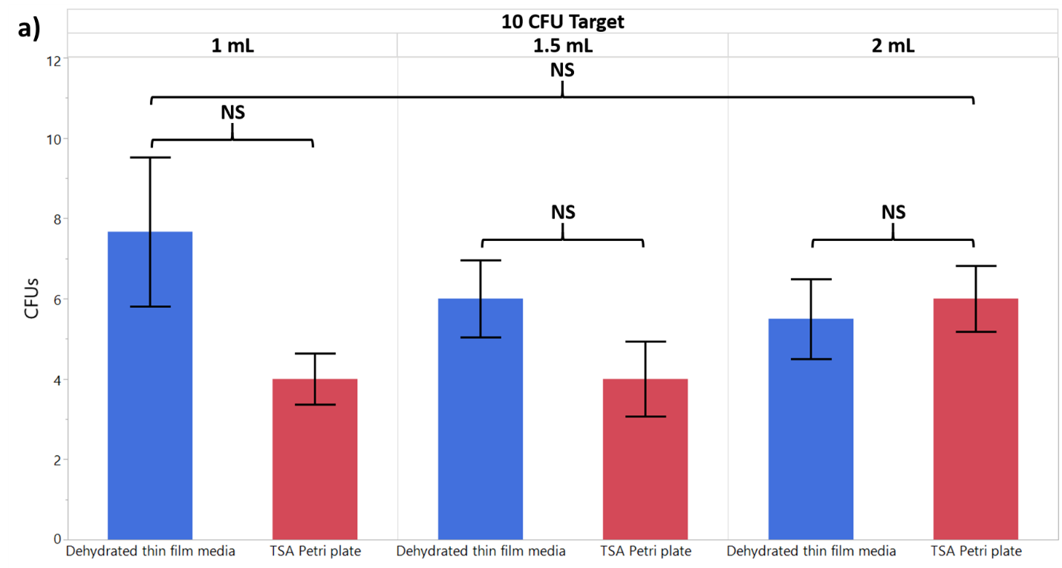

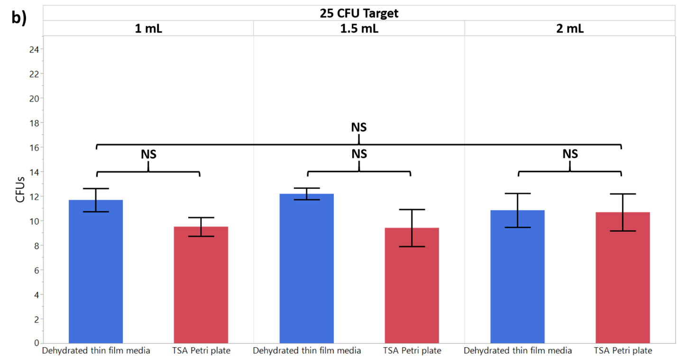

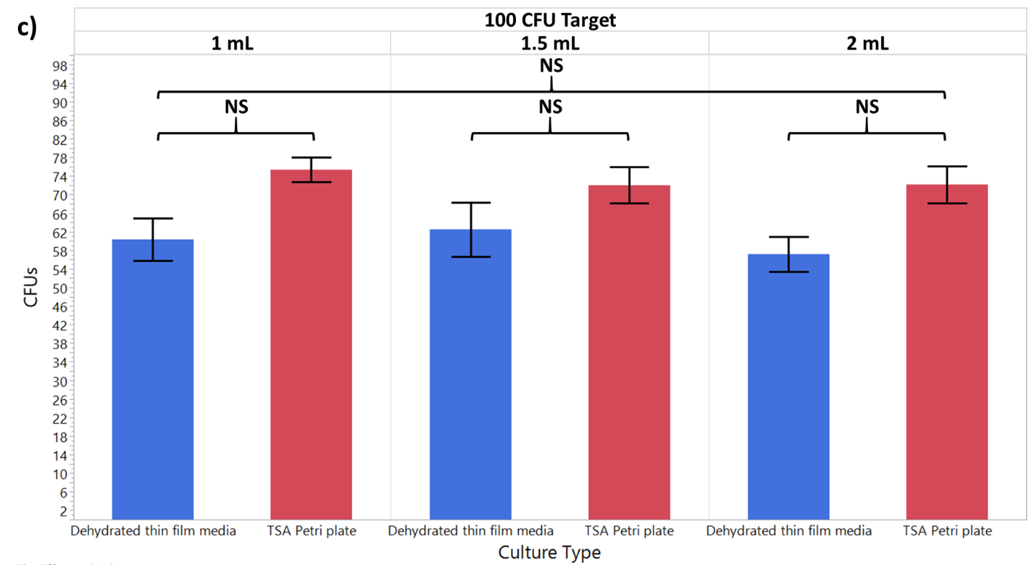

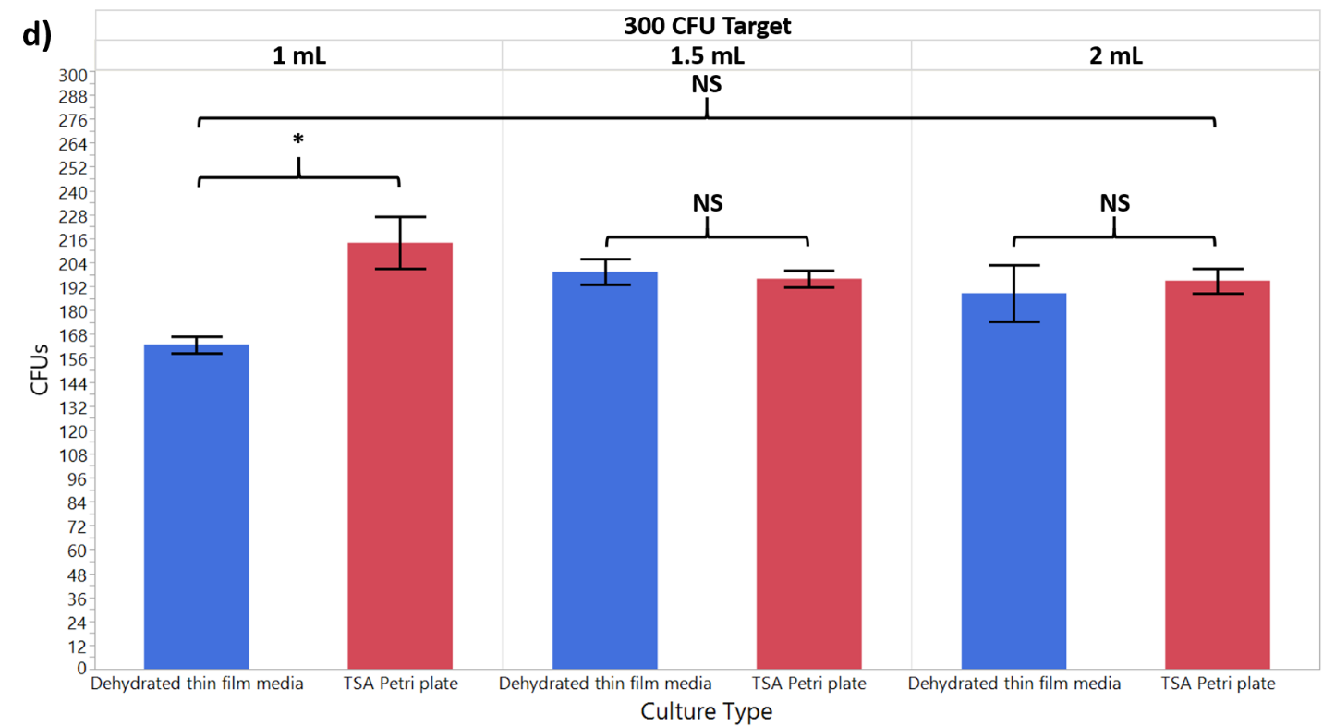

Figure S Evaluation of various plated volumes (1 mL, 1.5 mL, and 2 mL) of B. atrophaeus on TSA and RAC. a) 10 CFU, b) 25 CFU, c) 100 CFU, and d) 300 CFU of B. atrophaeus organisms were evaluated. The error bars shown are ±SEM.

Besides the plated volume variation in counted colonies seen in Figure S1, an increase in plated volume above 1 mL (1.5 mL was tested) caused sample to leak off of the RAC target plate within the NASA Standard Assay protocols. This phenomenon is illustrated in Figure S2, which shows 1.5 mL and 2.0 mL of sample *B. atrophaeus* organisms plated on RAC with increasing amounts of sample seeping off of the target media. In addition, as close to complete hydration of the RAC plate as possible is important to maximize the plate growth area; this is more important as the number of plated organisms increases to close to 250 CFUs as a plated volume under 1 mL can cause under-hydration of the plate. Therefore, in hydrating RAC plates with either sample or with DI water post-membrane filtration adhering to a plated volume of 1 mL ±0.25 mL is recommended. Practice with Petrifilm plates for Planetary Protection personnel is also recommended prior to working with flight samples.It is to be noted that the intended volume to be used with the Petrifilm plate is 1ml and our data substantiates this requirement.

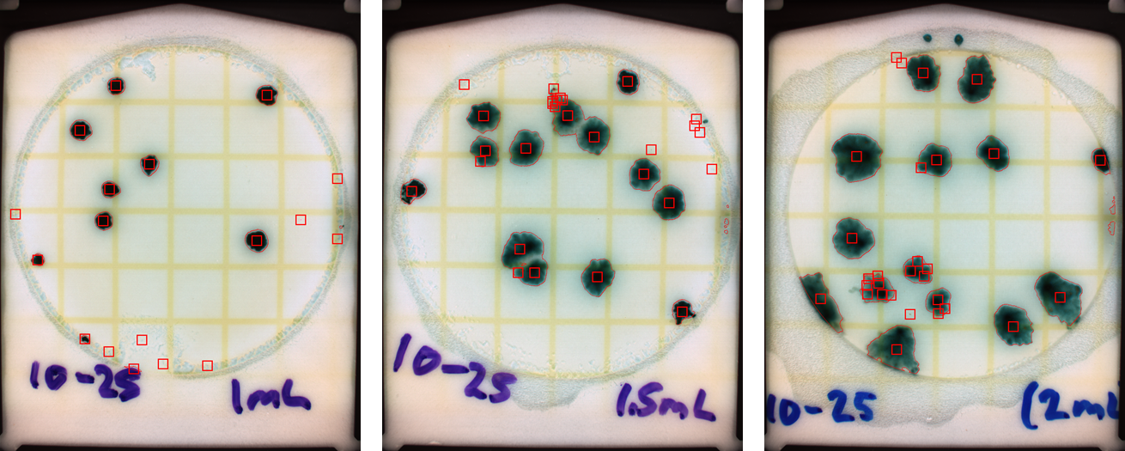

Figure S Example images of RAC plates from Figure S1. The images were taken with the Petrifilm Plate Reader, and the red boxes are the reader’s estimate of the colony locations in the images. As the plated volume increased the sample leaking out of the culture area also increased and the colonies began to increase in size, which brings the potential for spreaders as well.

Detailed Microorganism Archival Information for Future Research Reference

Microorganisms acquired from spacecraft and cleanrooms are regularly archived and stored for future research or flight sample reference needs. The organisms used in this manuscript are no different. Therefore, the precise location code and information within the Planetary Protection Microbial Archive are included in Supplementary Table S1 below. Note that while the *P. lactis*, *B. subtilis*, and Mars 2020 *Bacillus* isolate are stored permanently in the Planetary Protection Archive the 4th organism, the B. atrophaeus spores, were purchased from Mesa Labs and not permanently stored in the Planetary Protection Archive; however, some additional information on the *B. atrophaeus* spores is still included for reference.

Table S The location of the samples used in this study within the Planetary Protection Archive. This location is provided for reference for future follow-up studies.



Environmental Microorganism Detection and Evaluation

The environmental microorganism sampling done to demonstrate the incorporation of RAC plates directly into the Planetary Protection NASA Standard Assay was followed-up with post-processing steps including harvesting microorganisms from the plates to identify the organisms present via MALDI-TOF MS analysis. Microorganisms have been identified and archived since the Viking Mars Landers launched in the mid-1970s with the Planetary Protection Group at the Jet Propulsion Laboratory in Pasadena, CA. The MALDI-TOF analysis employed the stock Bruker MALDI-TOF database as well as an addition of hundreds of isolates found on spacecraft through the Planetary Protection archive. The Planetary Protection MALDI-TOF database was established entirely through TSA plates using the NASA Standard Assay, complete with 80°C heat shock for 15 minutes (Seuylemezian *et al.*, 2018). For this reason, RAC plate isolates were measured for their ability to grow isolates with matching spectra to the MALDI-TOF Planetary Protection database. The results, shown in Figure S3, illustrate the ability of RAC plates to archive organisms via MALDI-TOF. More information is needed to confirm that other post-growth tasks such as ATP and LAL are possible using RAC plates, but given the sensitivity of MALDI-TOF spectra other analyses are highly likely.

Table S The growth on RAC and TSA plates from environmental samples after 24 hours of incubation.

|  |  |  |  |
| --- | --- | --- | --- |
| Sample Number | Heat Shocked | RAC Plate  + / - | TSA Plate  + / - |
| 1 | Yes | - | - |
| 2 | Yes | - | - |
| 3 | Yes | - | - |
| 4 | Yes | + | + |
| 5 | Yes | + | + |
| 1 | No | - | - |
| 2 | No | - | - |
| 3 | No | + | + |
| 4 | No | + | + |
| 5 | No | + | + |
| Handling Control | Yes | - | - |
| Negative Control | No | - | - |
| Positive Control | No | Growth | Growth |
| + Low level bioburden, <1 Colony Forming Units (CFU) / mL  - No growth | | | |

Table of Membrane Filtration Data

The membrane filtration data used in Figure 4 is included below for reference. 5 replicates were used for each sample.

Table S3 The membrane filtration data from the Figure 4 experiment is included below along with the average, standard deviation, and standard error calculated for each group of CFUs.



Detailed waste savings estimate based on Mars Science Laboratory Flagship Flight Mission

A waste savings calculation from a flagship mission (Mars 2020, which became the Mars Perseverance rover) is included in a footnote in the manuscript Introduction on page 3, here we present an additional calculation based on Mars Science Laboratory, MSL (the Mars Curiosity rover) (Benardini *et al.*, 2014). On MSL, more than 500 sampling events used 3541 swabs (4 TSA plates each) and 1312 wipes (25 TSA plates each); this equates to 46,964 TSA plates. 1 gram of TSA on the plates with 20 grams of water and a 15 gram petri plate (36 grams total) means that during the entire MSL mission 1,690,704 grams of TSA plates were used in total. This equates to about 11,752 plates and 421.2 kilograms of material per year during the mission. Using the 3MTM sustainability calculator (<https://multimedia.3m.com/mws/media/1359805O/3m-petrifilm-sustainability-calculator-pdf.pdf>), 352.6 kg/year can be saved using PetrifilmTM Rapid Aerobic Count Plates (68.6 kg total during the duration of the Mars Science Laboratory rover mission).

Thin Film Media Versus TSA Plates: Time to Count Plates

Figure S A comparison of the time taken to count 10 CFUs and 250 CFUs on thin film media using the automated plate reader and manually counting TSA plates. The count times were comparable for 10 CFU samples at 6.75 seconds and 4.60 seconds for automated count plate reader RAC plates and manual count TSA plates, respectively. At 250 CFUs, the count times were vastly different at 6.27 seconds for automated count plate reader RAC plates and at 88.51 seconds for manual count TSA plates, respectively.

Detailed comparison between automated Plate Reader and NASA Standard Assay manual counting over time

We manually counted the RAC plates using the NASA Standard Assay alongside the Plate Reader Advanced. The results are illustrated in Figure S4. At 24 hours and for CFUs of 100 or more the manual counts fell behind, or above, the automated Plate Reader counts; however, Plate Reader counts matched NASA Standard Assay counts for all CFUs at 48 hours and at 72 hours. Therefore, the 3M Plate Reader Advanced, with proper operator training, is a possibility for use within the NASA Standard Assay during future flight missions, with at least 48 hours of plate count data to ensure accurate counts.

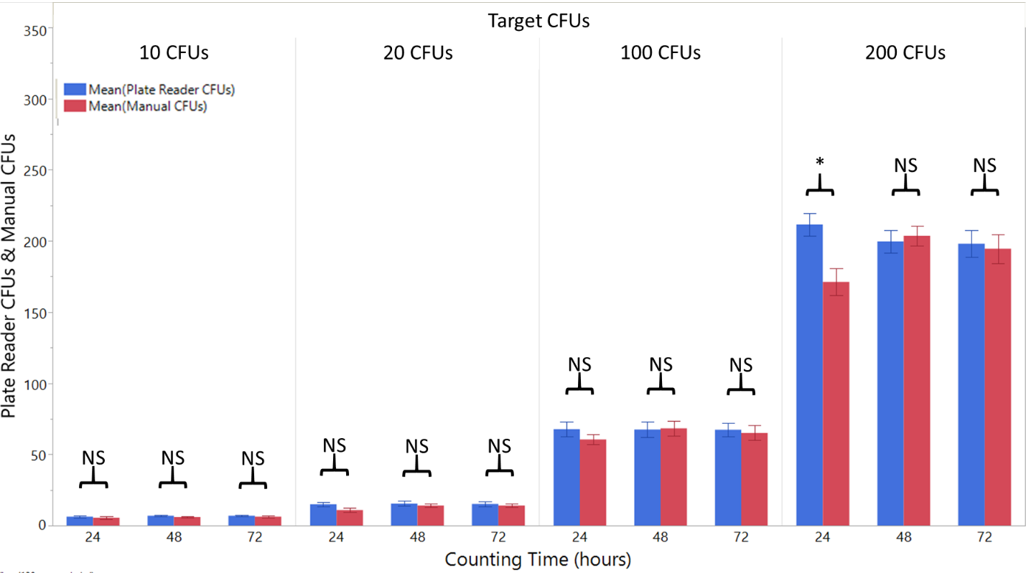

Figure S4 An illustration of B. atrophaeus plated and grown via the NASA Standard Assay. Then, the RAC plates are either counted manually (manual CFUs) or counted using the Plate Reader Advanced (Plate Reader CFUs). None of the datapoints were statistically significant save for the 200 CFU count at 24 hours. Therefore, the Plate Reader Advanced, with proper operator training, is a possibility for use within the NASA Standard Assay during future flight missions, with at least 48 hours of plate count data to ensure accurate counts (The error bars are standard error. NS, not significant; *, P < 0.05.)

References

Benardini, J. N. *et al.* (2014) ‘Implementing planetary protection measures on the mars science laboratory’, *Astrobiology*, 14(1), pp. 27–32. doi: 10.1089/ast.2013.0989.

Seuylemezian, A. *et al.* (2018) ‘Development of a custom MALDI-TOF MS database for species-level identification of bacterial isolates collected from spacecraft and associated surfaces’, *Frontiers in Microbiology*, 9(MAY), pp. 1–8. doi: 10.3389/fmicb.2018.00780.