Supplementary

Mixture of nucleobases before shock

Figure S1 and S2 show SEM micrographs of the unprocessed mixture of nucleobases. These samples do not show the presence of any complex structures. As these samples were very much charging during SEM, we had to apply thick coating on the top surface and surface features are not so clear. However, the micrograph clearly shows the presence of few micron-sized particles only.

Figure S1: SEM micrograph of AGCT mixture before shock

Figure S2: SEM micrograph of AGCU mixture before shock

Shock processing of single nucleobases
Single nucleobase adenine and cytosine were also shock processed at a temperature of approximately 3800 K. SEM observations of these shock processed residue did not show any complex structures as we observed in the mixture of four nucleobases. Large particles of size few microns were observed, as shown in Figure S3 and Figure S4

Figure S3: SEM micrograh of shock processed residue of single nucleobase cytosine.

Figure S4: SEM micrograh of shock processed residue of single nucleobase adenine.

Aluminium Diaphragm

Figure S5: Aluminium diaphragm (a) before shock with V grooves and (b) petals are opened after bursting.

IR Spectroscopy of samples before and after shock
All reported FT-IR spectra were obtained with a Thermo Scientific Nicolet iS50 FTIR Spectrometer in ATR mode.
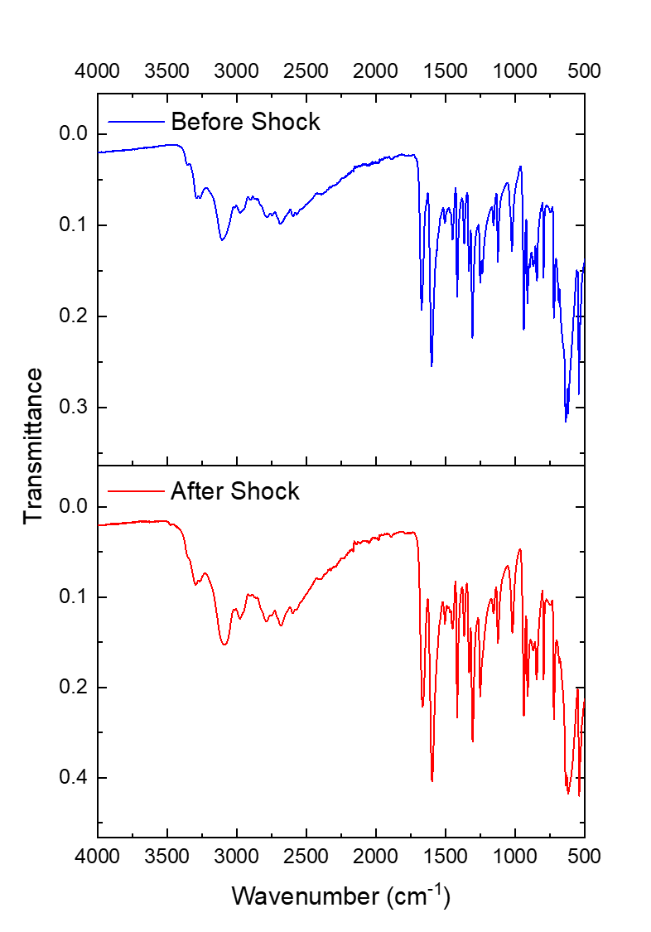
Figure S6: IR spectra of adenine before and after shock
(at shock temperature of ~ 3910 K)

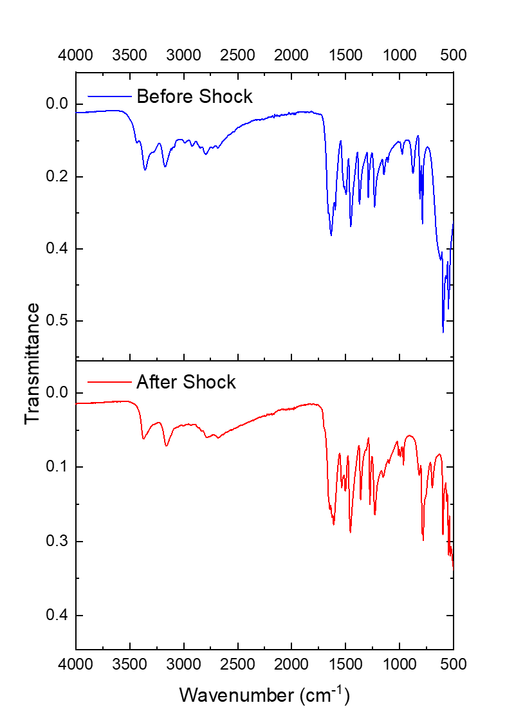
Figure S7: IR spectra of cytosine before and after shock
(at shock temperature of ~ 4050 K)
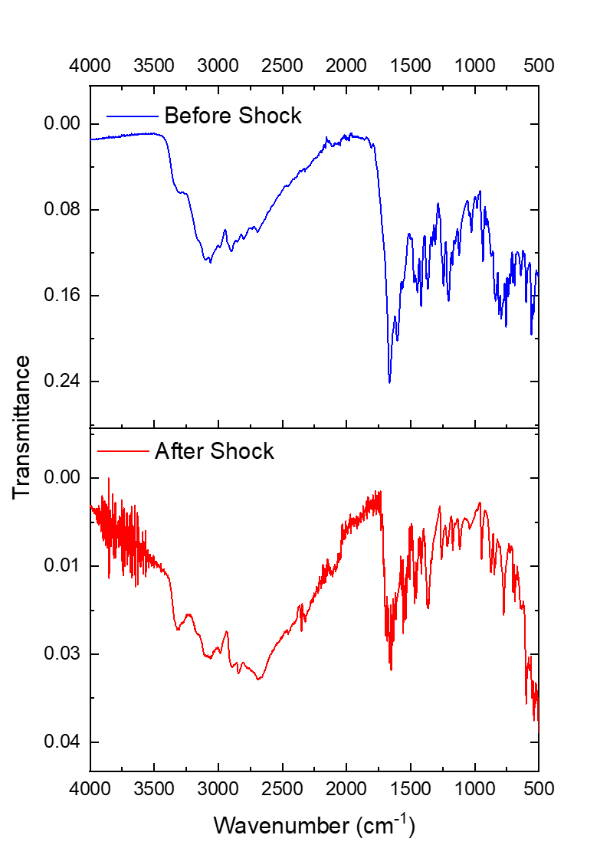

Figure S8: IR spectra of AGCT mixture before and after shock
(at shock temperature of ~ 3700 K)

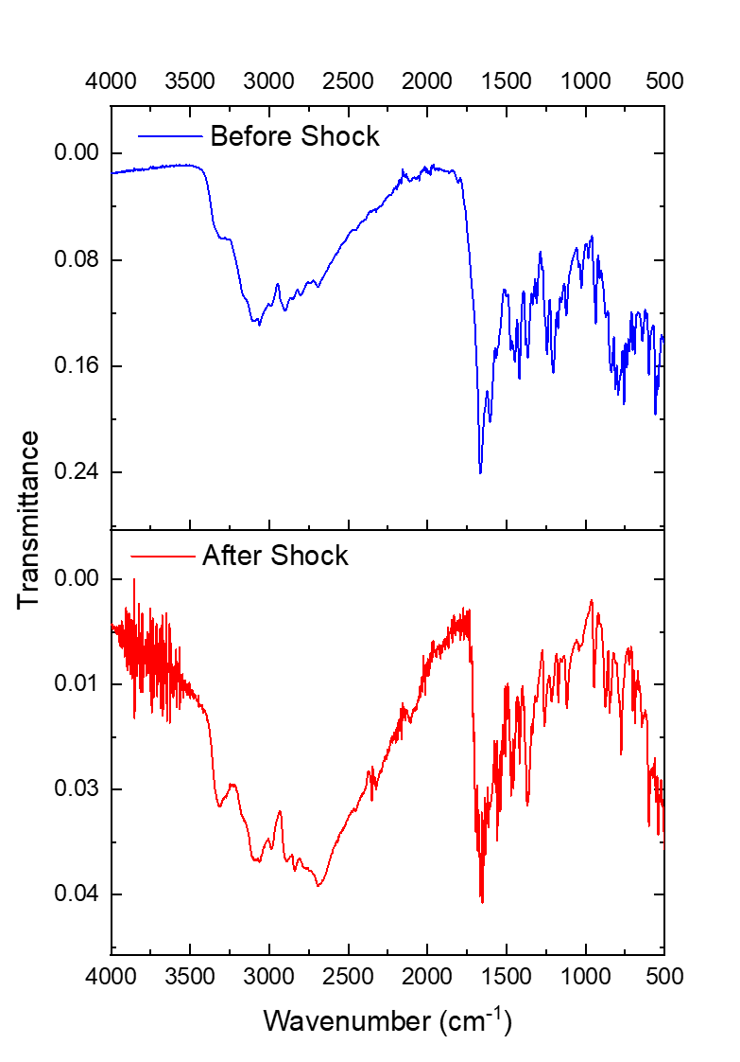

Figure S9: IR spectra of AGCT mixture before and after shock
(at shock temperature of ~ 6360 K)

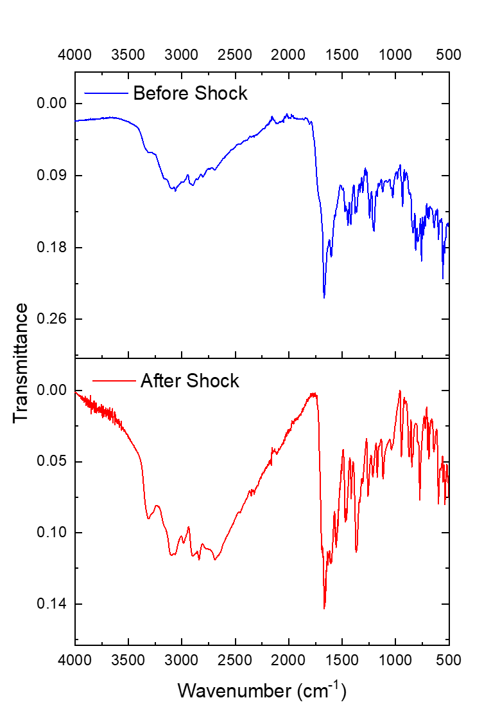

Figure S10: IR spectra of AGCT and ribose mixture before and after shock
(at shock temperature of ~ 6900 K)

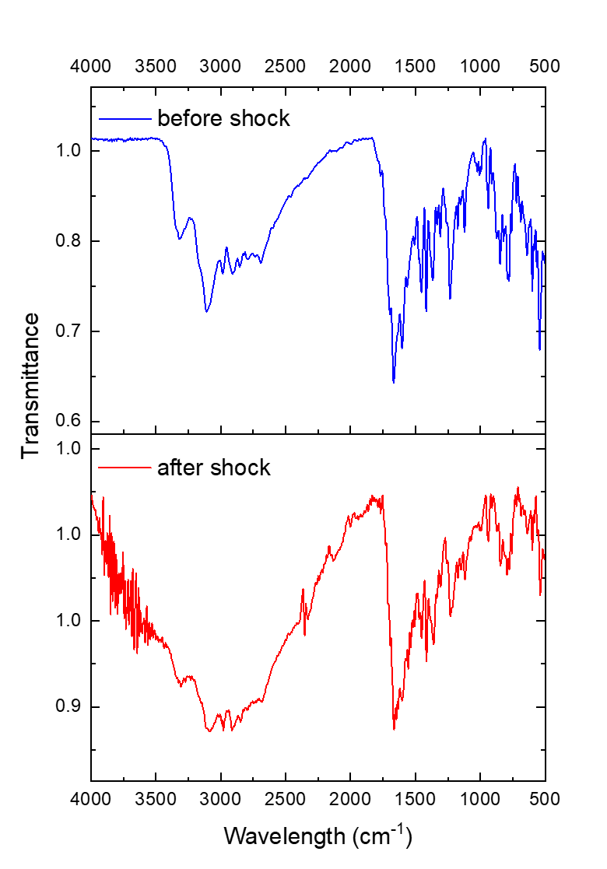

Figure S11: IR spectra of AGCU mixture before and after shock
(at shock temperature of ~ 6320 K)

