Supplementary Information
Table 1. The results of EDX represents the general element compositions analyzed the growth layers and nuclei colonies (Fig.5c). Sp. Refers to EDX spectrum.
Element | Nuclei colonies region
 | Sp.2 | Sp.3 | Sp.5 | Sp.6 | Sp.16 | Sp.17 | Sp.18 | Sp.19 | Sp.20 | Sp.21 | Sp.22 | Sp.23
C | 0.0 | 0.0 | 0.0 | 0.0 | 7.1 | 3.4 | 0.0 | 0.0 | 0.0 | 0.0 | 0.0 | 0.0
Al | 0.0 | 0.0 | 0.0 | 0.0 | 0.6 | 0.0 | 0.0 | 0.0 | 0.0 | 0.0 | 0.0 | 0.0
Si | 0.0 | 0.0 | 0.2 | 1.3 | 0.5 | 0.0 | 0.0 | 0.0 | 0.4 | 1.8 | 0.0 | 0.0
Fe | 77.7 | 75.8 | 77.4 | 75.6 | 55.8 | 68.0 | 77.7 | 77.7 | 77.0 | 73.9 | 76.6 | 77.7
O | 22.3 | 22.5 | 22.4 | 23.1 | 36.0 | 28.6 | 22.3 | 22.3 | 22.6 | 23.6 | 22.4 | 22.3
P | 0.0 | 0.0 | 0.0 | 0.0 | 0.0 | 0.0 | 0.0 | 0.0 | 0.0 | 0.0 | 0.0 | 0.0
Element | Growth layers
 | Sp.1 | Sp.4 | Sp.7 | Sp.8 | Sp.9 | Sp.10 | Sp.11 | Sp.12 | Sp.13 | Sp.14 | Sp.15 | Sp.24
C | 0.0 | 7.5 | 8.7 | 7.5 | 4.4 | 0.0 | 6.9 | 0.0 | 10.7 | 8.0 | 6.6 | 4.2
Al | 0.6 | 0.0 | 0.0 | 0.7 | 0.0 | 0.0 | 5.8 | 0.4 | 0.0 | 0.7 | 0.4 | 0.6
Si | 0.4 | 1.0 | 1.5 | 1.5 | 0.0 | 0.0 | 4.8 | 0.5 | 1.0 | 1.0 | 1.0 | 0.9
Fe | 76.2 | 52.5 | 50.4 | 53.0 | 65.2 | 77.7 | 41.6 | 76.4 | 43.5 | 52.5 | 56.8 | 62.8
O | 22.8 | 37.8 | 39.4 | 37.4 | 30.4 | 22.3 | 40.9 | 22.8 | 43.7 | 37.9 | 35.3 | 30.9
P | 0.0 | 1.2 | 0.0 | 0.0 | 0.0 | 0.0 | 0.0 | 0.0 | 1.2 | 0.0 | 0.0 | 0.0

Table 2. Table of ICP-MS analysis of soil profile (3rd soil layer), weathered rock, and fresh rock by weight %.
Element | 3rd soil profile | Weathered rock | Fresh rock
Li | 150 | 39 | 8
Be | 18 | 28 | 13
Al | 1609243 | 59521 | 94081
K | 10512 | 8779 | 5380
Ca | 10411 | 7624 | 2938
V | 7807 | 860 | 893
Cr | 6414 | 54 | 506
Mn | 11395 | 738635 | 3715
Fe56 | 2056070 | 2653912 | 2228084
Fe57 | 1832596 | 2534581 | 2188078
Co | 655 | 8254 | 163
Ni | 1797 | 668 | 126
Cu | 3788 | 2059 | 521
Zn | 3431 | 2692 | 314
Ga | 844 | 431 | 76
As | 390 | 82 | 14
78Se | 92 | 93 | 32
Rb | 47 | 13 | 8
Sr | 200 | 149 | 18
Ba | 1420 | 238743 | 1111
Tl | 0 | 176 | 13
206Pb | 395 | 371 | 171
207Pb | 339 | 317 | 146
208Pb | 363 | 287 | 155
Na | 3654 | 10226 | 4161
Mg | 9702 | 1289 | 610

Table 3. The results of EDX represent the general element compositions analyzed in the EPS-like structures (Fig.SI 2). Sp. Refers to EDX spectrum.
Element | Sp1 | Sp2 | Sp3 | Sp4
C | 2.58 | 2.83 | 3.13 | 0.00
Al | 0.00 | 0.00 | 0.00 | 0.78
Si | 0.83 | 1.05 | 1.33 | 1.39
Fe | 67.70 | 66.4 | 65.12 | 73.02
O | 28.16 | 28.86 | 29.58 | 24.11
P | 0.74 | 0.86 | 0.84 | 0.71

Table 4. The results of EDX represent the general element compositions analyzed in the EPS-like structures (Fig.SI 3). Sp. Refers to EDX spectrum.

Element | Sp1 | Sp2 | Sp3 | Sp4 | Sp5
C | 16.88 | 15.24 | 13.76 | 4.23 | 11.21
Al | 4.48 | 3.80 | 10.91 | 1.68 | 11.19
Si | 3.62 | 8.16 | 10.75 | 1.20 | 10.73
K | 0.14 | 0.14 | 0.07 | 0.00 | 0.13
Ca | 0.26 | 2.78 | 0.01 | 0.15 | 0.02
Fe | 16.64 | 12.00 | 4.56 | 61.09 | 11.38
O | 57.98 | 57.87 | 59.94 | 31.69 | 55.34

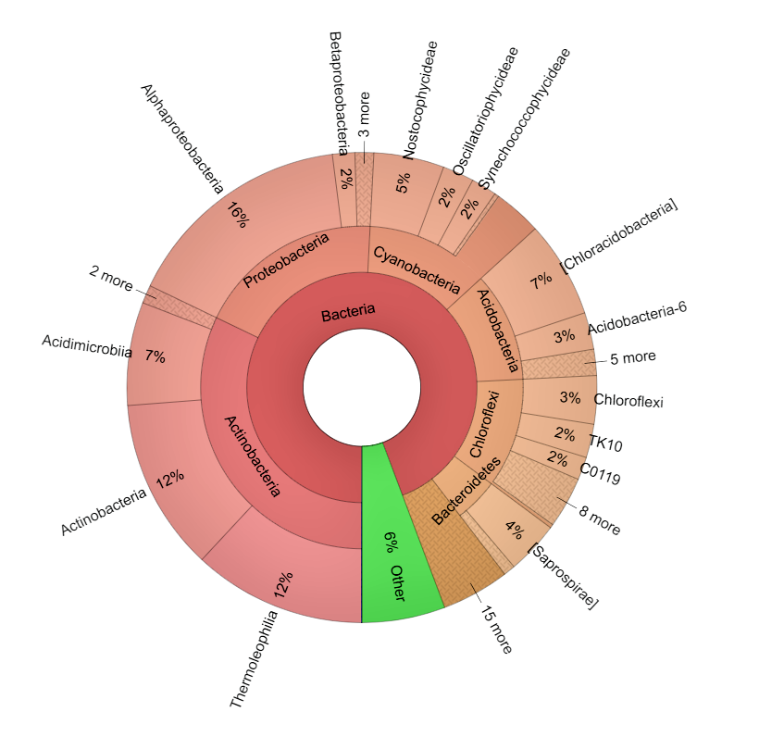
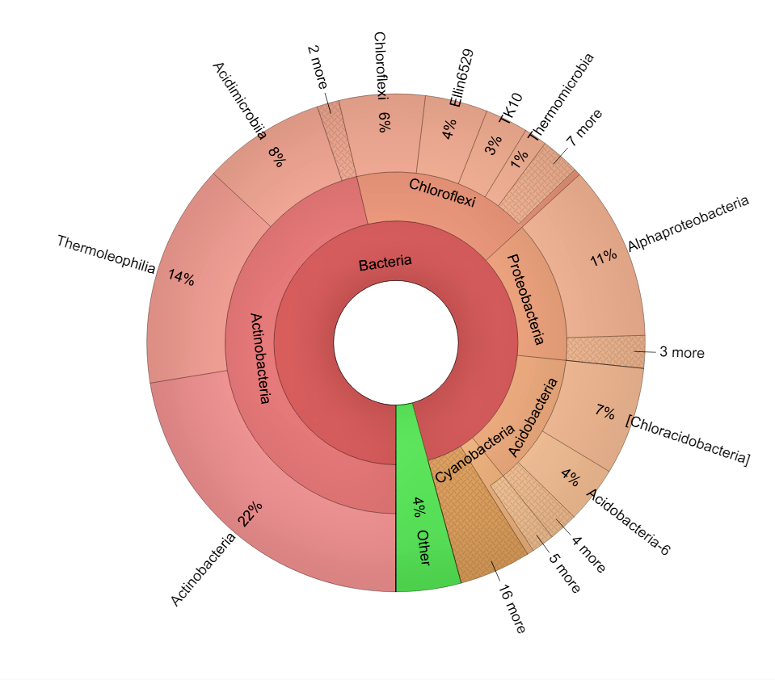
(a)
(b)

Figure 1. Krona plot of 16S rRNA Gene Sequencing showing identified bacterial species present in weathered hematite sample. (a) HR fragments soaked in nuclease-free water and (b) crushed HR sample mixed well in nuclease-free water (from 3rd soil profile).
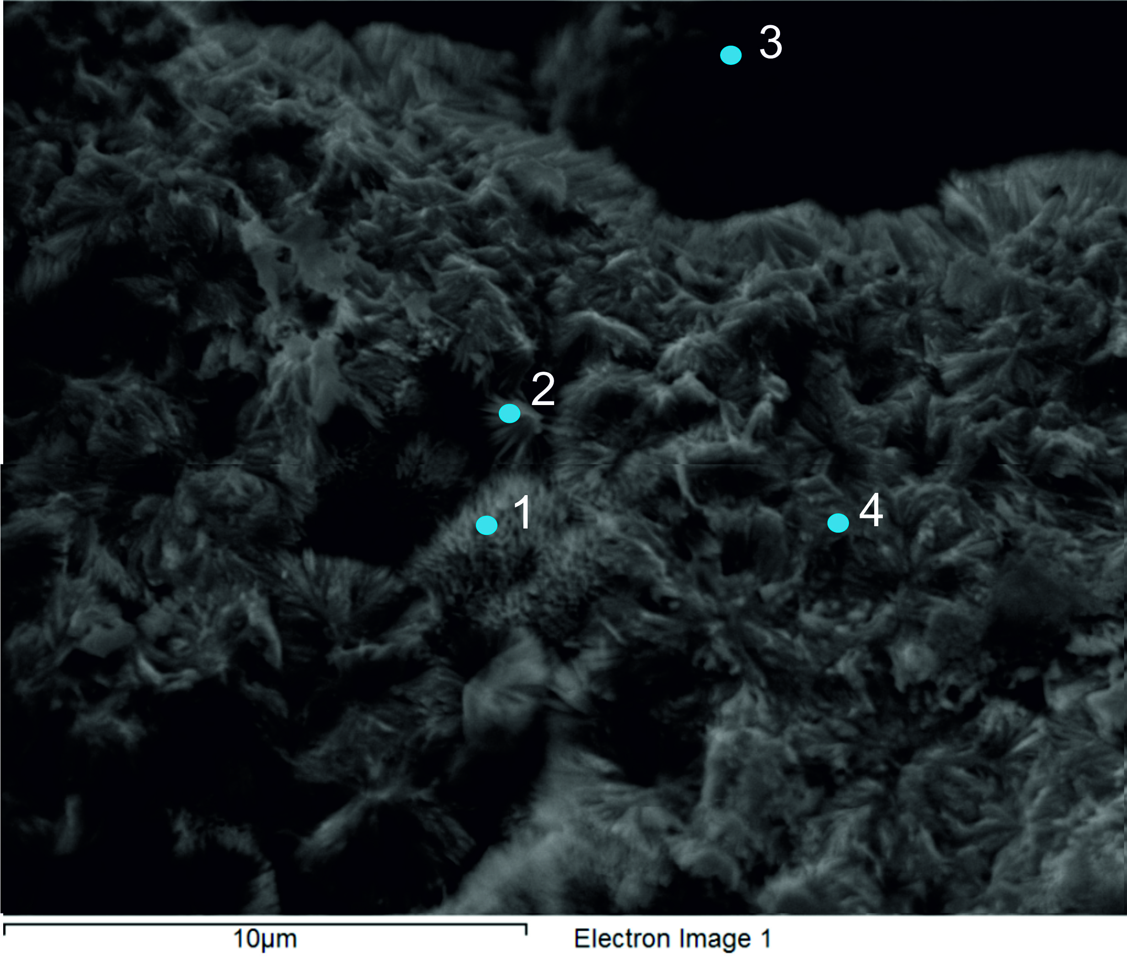

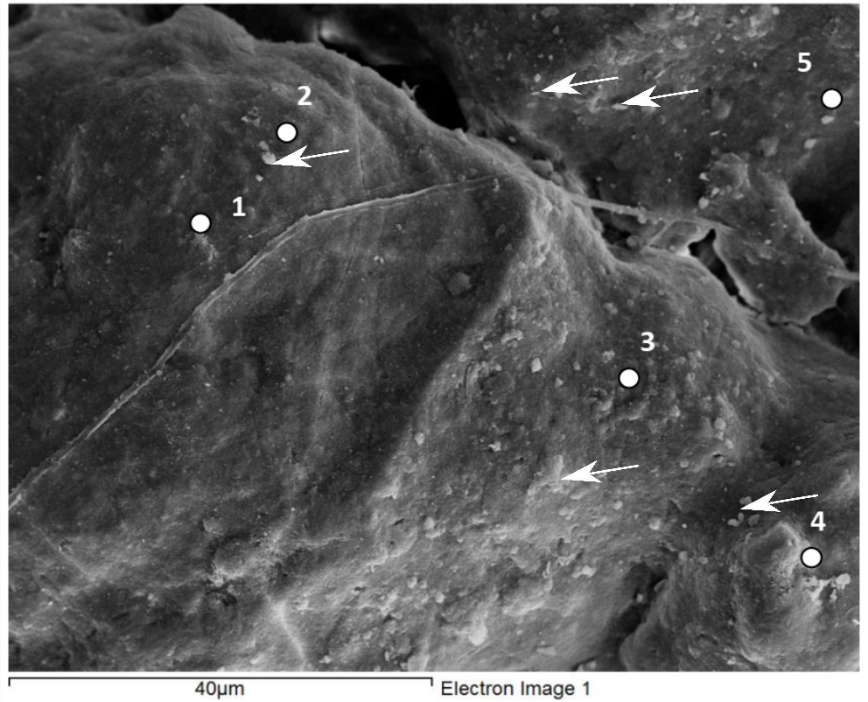
Figure 2. The image showing the points of a scanning electron microscope- Energy Dispersive X-Ray (SEM-EDX) focusing on the remnant EPS like structures.

Figure 3. Scanning electron microscope- Energy Dispersive X-Ray (SEM-EDX) analysis carried out in the blue-green granular section from a sample collected in 2018. Arrow marks indicate the examples of EPS like structure. The numbered points indicate the locations where SEM-EDX analysis was carried out for the EPS-like structures.

