Supplementary Information for
Possible Role of Prussian Blue Nano Particles in Chemical Evolution: Interaction with Ribose Nucleotides
Rachana Sharma, Md. Asif Iqubal and Kamaluddin*
Department of Chemistry, Indian Institute of Technology Roorkee,
Roorkee-247667 (U.K), India

Author for Correspondence
*Dr. Kamaluddin
Department of Chemistry
Indian Institute of Technology Roorkee
Roorkee-247667 (U.K), India
Tel.: +91-1332-285796
Fax: +91-1332-274473
Email: kamalfcy@iitr.ernet.in

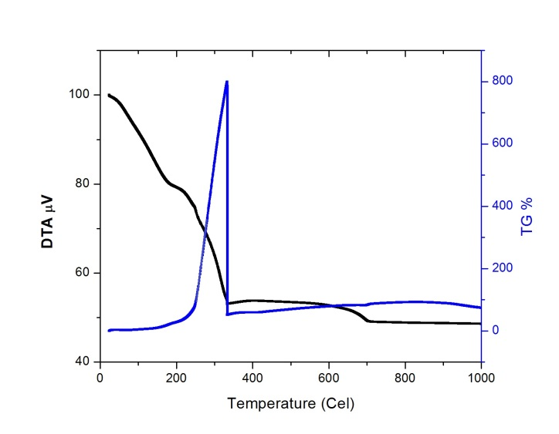

Figure S1: A thermogravimetric and differential thermal analysis curve of Prussian blue

Figure S2: UV-visible spectrum of Prussian blue. Inset: Digital camera image of PB nanoparticles

Figure S3: The typical XRD pattern of Prussian blue. Inset: crystal structure sketch map of PB consisting of alternating iron(II) and iron(III) located on a face centered cubic lattice.

Figure S4: Effect of contact time on ribonucleotide adsorption

Figure S5: Effect of amount of adsorbent of ribonucleotide on adsorption

Table S1: Characteristics of the Ribonucleotides
Name | Abbreviations | Structure of Nucleotide | Solubility  (g/L) | pK_{a}
 |  |  |  | pK_{a1}  (RMP$⇄$ RMP⁻ + H⁺) | pK_{a2}  (RMP⁻$⇄$ RMP²⁻ +H⁺)
Adenosine  5΄-monophosphate | 5΄-AMP | R = Adenine (A) | 3.3 | 0.9 | 6.1
Guanosine  5΄-monophosphate | 5΄-GMP | R = Guanine (G) | 3.6 | 0.7 | 6.1
Cytidine  5΄-monophosphate | 5΄-CMP | R = Cytosine (C) | 16.3 | 0.8 | 6.3
Uridine  5΄-monophosphate | 5΄-UMP | R = Uracil (U) | 12.0 | 1.0 | 6.4

Table S2: Elemental composition of Prussian blue
Weight of the sample (mg) | % C | %N | % H | %Fe
1.6130 | 19.02 (19.43) | 22.25(22.67) | 2.527(2.51) | 33.47(35.27)
(Bracket values representing theoretical values)

Table S3: Typical infrared spectral frequencies (cm⁻¹) of ribonucleotides before and after absorption on Prussian blue
Ribonucleotide | $δ$NH₂ | $υ$C-4=O | $υ$PO₃²⁻(symmetric) | $υ$PO₃²⁻(antisymmetric)
5׳-AMP | 1636 (1645) | ---- | 985 (978) | 1114 (1103)
5׳-GMP | 1646 (1642) | 1697(1685) | 973(978) | 1043(1080)
5׳-UMP | ---- | 1675(1682) | 992(981) | 1109 (1083)
5׳-CMP | 1675(1688) | ---- | 979 (985) | 1107(1088)
(Bracket values representing infrared spectral frequencies (cm⁻¹) of ribonucleotides before adsorption)

