SUPPLEMENTARY FIGURES

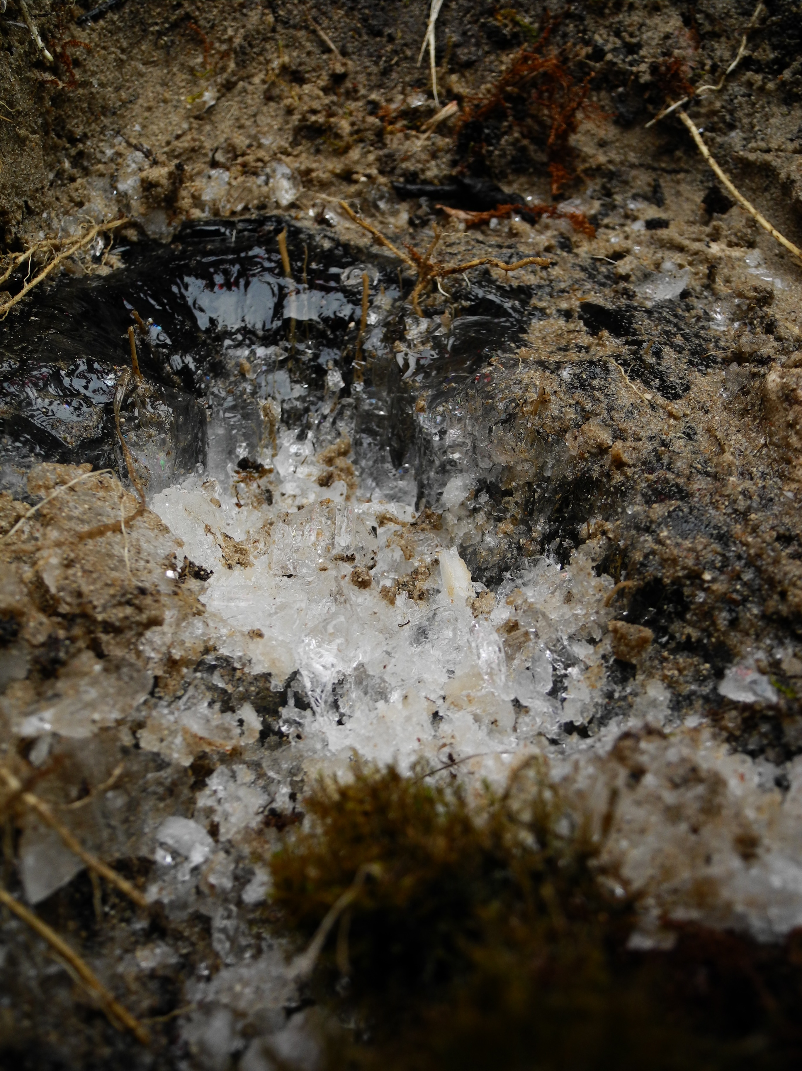
Figure 1. Frozen peat sample (scale ~1:2).
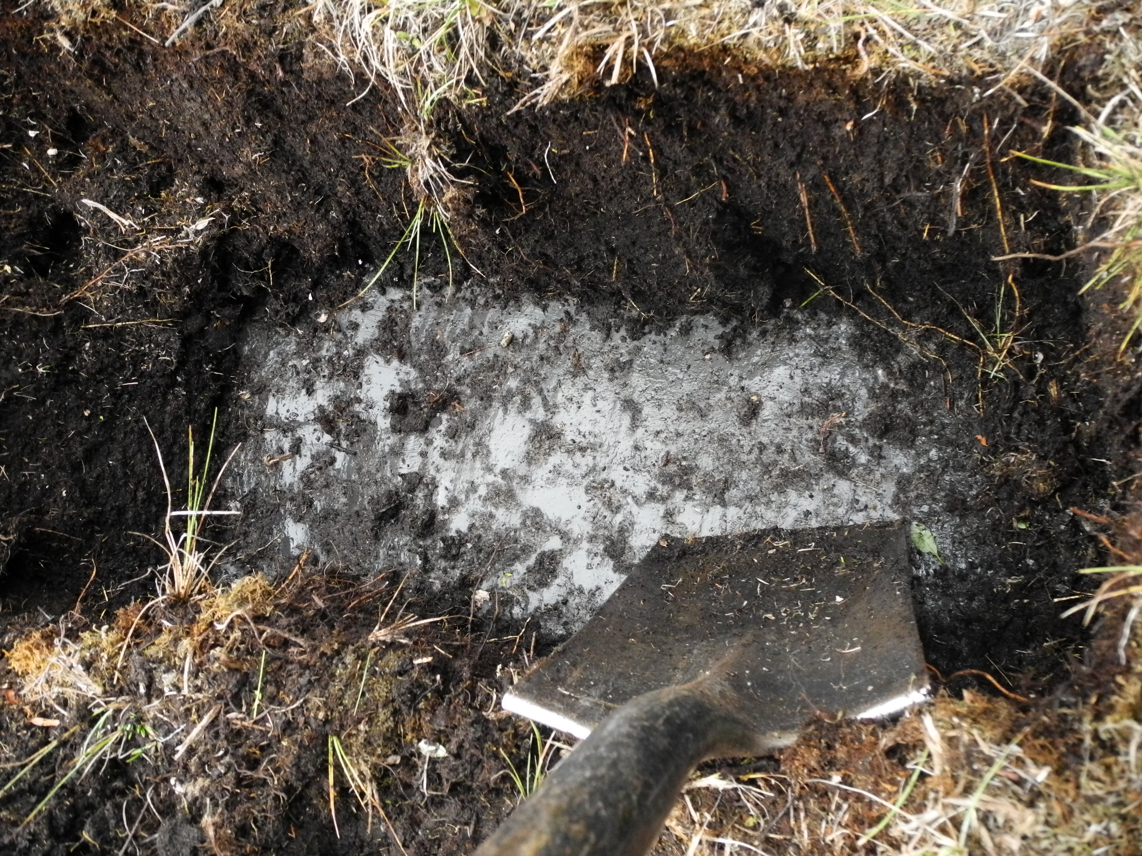
Figure 2. Clear ice sample (scale ~1:20).

