Supplementary Material for
Reversible transformation between α-oxo acids and α-amino acids on ZnS particles: A photochemical model for tuning the prebiotic redox homeostasis
Wei Wang, Xiaoyang Liu, Yanqiang Yang and Wenhui Su

Temperature dependence
The temperature dependence of the amination and deamination reactions is shown in Fig. S1. In the studied range, the efficiency of α-KG amination almost remained constant; while for the deamination reaction, the production rate of α-KG increased slightly linearly with the temperature. However, if taking into consideration the reproducibility of separate experiments (see the data at 30 ℃), it is hard to tell whether the slight fluctuation of the product yield is dependent of temperature.

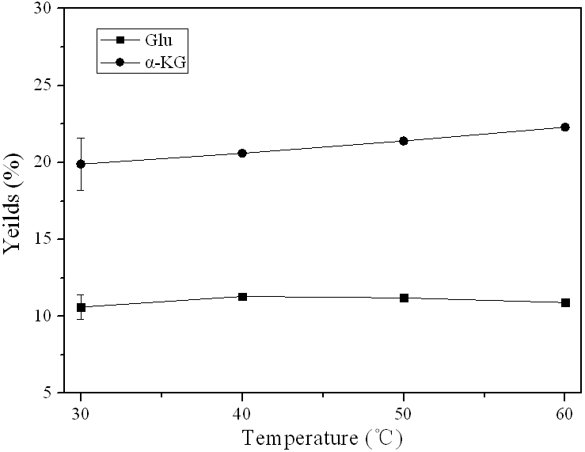
Fig. S1 Temperature dependence of glutamate and α-KG production in the reductive amination and oxidative deamination reactions, respectively. Conditions are the same as in Tables 1 and 2. Lines are drawn to aid the eye but not to fit the plotted points. Error bars are shown for the data at 30 ℃

