Personnel Power: Governing State-Owned Enterprises

Online Appendix

Sample Selection
We choose the start year of 2003 because that is the year in which the State-Owned Assets Supervision Commission (SASAC) was established and central SOEs first existed as a discrete set of firms for analysis. The end year of 2017 is selected to coincide with the end of Xi Jinping’s first five-year term; it is also the most recent year for which data is available. The core central SOEs are a stable grouping across the study’s 15 year time period, with fewer than five firms ceasing to exist due to mergers. If firm ceases to exist, its leaders are no longer coded and included in the sample starting from the following year.

A leader is marked as starting in a given year if his appointment begins before July, that is in the first half of the year. The exit rule also uses the June/July cut off, as it is standard in the field. This means our dataset drops any leaders who worked less than six months from 2003 to 2017, which includes 13 individuals: eight of whom either exited in 2003 or started in 2017 and five of whom had a total tenure of less than six months. When SOE leaders leave their positions they also exit the dataset; if they are transferred outside of the state sector but then are appointed back to another core central SOE executive position, they reenter the dataset.

Measuring Mobility
Biographical information about these leaders’ backgrounds and their career trajectories was compiled from their official CVs, available on company websites or publicly online, as well as media reports and the Chinese Political Elites Database hosted by National Chengchi University. All of the models presented in the paper include all three types of leaders pooled into one sample. Robustness checks verify that there are no systematic differences between types of leaders.

Measuring ROA
Regulatory authorities do not require public disclosure of performance data for overall enterprise groups. SASAC does publish performance data for entire enterprise groups in its annual yearbooks, but these data are highly suspect and reported inconsistently. We therefore use performance data for the publicly listed subsidiaries of core central SOEs to proxy for performance of the overall business group. Since publicly listed subsidiaries typically contain the best quality productive assets from core central SOEs, their performance represents a conservative upper bound for assessing that of the overall enterprise group.
To measure ROA, we calculate core central SOEs’ largest listed subsidiaries’ ratio of net profit to net assets, using data from the WIND financial database. Using ROA (level) may unintentionally capture variation in firm performance not attributed to leader quality, creating measurement error.
Return on assets (ROA) is available via stock market data portals, but these data show high variance and significant outliers, increasing concerns about data quality. Our calculated measure has significantly fewer outliers than the available ROA data and, once extreme outliers are removed from the WIND ROA data, there is a strong correlation between the existing data and our own measure (ρ=0.78). For data completeness and due to concern about outliers, we use our calculated ROA measure throughout this analysis. Four core central SOEs did not have subsidiaries listed domestically in mainland China but did have subsidiaries listed on stock exchanges in Hong Kong and New York; we included performance data from overseas listed subsidiaries for these firms. Of the 54 firms in the dataset, two rely on data from the Hong Kong stock exchange: Shenhua Group and China Unicom. An additional two firms rely on data from the New York Stock Exchange: China Telecom and China Mobile. Where data from international stock markets were used, an additional control for foreign stock exchange is included.

Modeling Strategies
Existing studies model these measures using ordered logit models. These models assume exit is less desirable than maintaining one’s position or a lateral transfer and that promotions are most sought after. While these models may be appropriate for some samples, we decided to use the less structured multinomial model for two reasons. First, core central SOE leaders are officials relatively advanced in their careers—the average age is 55—and they operate in an area of the Chinese bureaucracy in which no clear lines of promotion exist. Promotion to a ministerial-ranked position within the state-owned economy is not possible; lateral moves to another central-level SOE can represent either a holding pattern in advance of impending retirement or a step forward in one’s career. Moreover, there may be cases in which appointments to government may be less of a career advancement than remaining in the state-owned economy. Second, ordered logit models have strict assumptions of parallel regression or proportional odds, meaning there is a parallel trend between different outcomes. As a robustness check, we repeated our models with an ordered logit and each model clearly violates this assumption. Therefore, we follow existing work to conclude that a multinomial logit is more appropriate than an ordered logit to model political mobility.
An alternative modeling strategy option is survival analysis using event history. There are three reasons why we choose a discrete model rather than a classic event history analysis. First, the logit and multinomial logit models are the standard in the field for research on elite management in China. Multinomial models allow our results to be more readily comparable to the existing literature to facilitate the accumulation of knowledge.
Second, event history analysis, including parametric, non-parametric, and the semi-parametric Cox proportional hazard models, all assume a continuous time measure. The fundamental assumption is that failure can occur at any time and that the time units are sufficiently close to each other. Time units that are more discrete in nature, including year intervals, undermine these assumptions and should be modeled using a discrete model, such as the one presented in the original analysis. Presumably, this shortcoming could be ignored, and year-based data modeled continuously if there is a sufficient spread of events over a broad timeline. Indeed, the maximum “time to failure,” the longest tenure in our dataset, is 18 years, which is a borderline case for treating time continuously. Looking at the distribution of observations, however, suggests a skew to the data: the average tenure is only 6 years. This skew combined with the non-continuous time parameter makes us wary of fitting a model with a continuous assumption.
Finally, we are concerned about the appropriateness of event history analysis with our measure of connections. Connectedness variables are always defined as 1 at the start and cannot extend after 10, which biases the underlying hazard function. This combined with the skewed, discrete time variable greatly increases our concern of using event history analysis as the primary, or even robustness check, using the connectedness variable over the entire sample.
We evaluate the potential appropriateness of an event history analysis by applying a discrete-time event history analysis to our sample. Looking at the results of this analysis, we find further evidence that the underlying assumptions of the event history analysis may be inappropriate. Appendix Table A8 shows that the time elements in our sample do not act linearly. Only three time periods are statistically significant: the second, third, and ninth years of tenure. In these years, exit is less likely.

Robustness Checks
The other source for data on firm performance is from SASAC itself. SASAC publishes annual yearbooks with data including performance measures that SASAC itself uses for evaluation criteria, such as preservation of state-owned asset value. These data, however, are reported highly irregularly both across time and firms and are more susceptible than stock exchange data to political manipulation or even falsification, due to lack of information disclosure requirements. This creates serious concerns about omitted data not being missing at random, so we do not use this data in our main models or attempt to impute missing values because this would risk introducing bias. As a robustness check, we repeat the analysis using the SASAC data on the highly restricted sample. Both preservation of assets and business group income are negatively correlated with the likelihood of transfer to a government position (Table A9). These findings broadly support our finding of performance being correlated with staying in one’s position, specifically not being pulled into government.
The models presented above utilize one measure of performance, ROA, to test the performance hypothesis. There are other performance measures that both SASAC leaders and the COD could use to assess performance, meaning our proxy would not appropriately capture performance. To validate the findings, we repeat the analysis using return on equity (ROE) and earnings per share (EPS), two other standard indicators of firm performance. The results with the other indicators are similar, although both ROE and EPS are negatively correlated with exit whereas the correlation is not statistically significant for ROA. Model diagnostics suggest that ROA models are a better fit for the data than ROE and EPS is less comparable across stock exchanges, so we use ROA in our final models presented above.
Formal connections could be picking up endogenous career paths. If a COD director wants to promote a given SOE leader, they could appoint the leader to a government commission during their tenure to make future government appointment more likely. If this were the case, the formal experience indicator would be picking up informal connections. As a robustness check, we re-run the models with an indicator for previous government experience, which only includes government experience prior to their SOE leadership role. The results remain unchanged.
Informal connections with China’s key leaders have also been measured on a looser basis, by looking at networks within the CCP. Instead of the patron-based model presented above, we could include standard measures for factions related to Hu Jintao and Xi Jinping based on work experience within the CCP. A leader is defined as being in Hu Jintao’s network if they have experience in the Communist Youth League, which Hu Jintao headed as First Secretary early in his career (1984-1985). Leaders are considered connected with Xi Jinping if they have previous work experience in Shanghai or Zhejiang, where Xi served as party secretary (2002-2007 and 2007, respectively). We prefer the patron method discussed above because of its closer ties to an actual working relationship and because the sample size of Youth League and Shanghai/Zhejiang connections is small in our dataset (11 and 17 respectively).
Finally, we find limited evidence of position effects: that serving in particular executive leadership positions—or combinations of them—affects political mobility. The sample presented here includes individuals serving in all three types of core central SOE leadership posts—Party secretary, general manager, and chair of the board of directors, if one exists—and all possible combinations of these positions. It is possible that political mobility outcomes may vary by leadership position. For example, the Party secretary of a firm may be more closely integrated into the CCP and be more likely to move into the government. To test for position effects, we implement a model with the full specifications above, but including indicators for positions. On average, Party secretaries have a slightly higher rate of exiting the dataset than chairmen and a slightly higher probability of staying in their position than chairmen, all else equal, but these differences are small. Having concurrent positions did not increase the likelihood of promotion on their own, likely because concurrent positions with the chairman position increased in later years of the panel, due to a developmental trend of an increasing number of core central SOEs establishing boards of directors at the holding company level throughout the 2000s (Rosen, Leutert and Guo 2018, 21). We control for this possible time effect through the Xi administration control variable.

References
Allison, Paul D. 1982. “Discrete-Time Methods for the Analysis of Event Histories.” Sociological Methodology 13. 61-98.
Bo, Zhiyue. 2013. “Paths to the Top Leadership in China: The Case of Provincial Leaders.” In Chien-wen Kou and Xiaowei Zang, eds., Choosing China’s Leaders. London: Routledge, 65-96.
Brødsgaard, Kjeld Erik, Paul Hubbard, Guilong Cai and Linlin Zhang. 2017. “China’s SOE Executives: Drivers of or Obstacles to Reform?” Copenhagen Journal of Asian Studies 35 (1): 52–75.
Choi, Eun Kyong. 2012. “Patronage and Performance: Factors in the Political Mobility of Provincial Leaders in Post-Deng China.” The China Quarterly 212: 965–981.
Huang, Yasheng. 1999. Inflation and Investment Controls in China: The Political Economy of Central-Local Relations During the Reform Era. New York: Cambridge University Press.
Landry, Pierre F. 2008. Decentralized Authoritarianism in China: The Communist Party’s Control of Local Elites in the Post-Mao Era. New York: Cambridge University Press.
Li, Hongbin, and Li-An Zhou. 2005. “Political Turnover and Economic Performance: The Incentive Role of Personnel Control in China.” Journal of Public Economics 89: 1743-62.
Rosen, Daniel H., Wendy Leutert, and Shan Guo. 2018. Missing Link: Corporate Governance in China’s State Sector. San Francisco: Asia Society of Northern California.
Shih, Victor C., Christopher Adolph and Mingxing Liu. 2012. “Getting Ahead in the Communist Party: Explaining the Advancement of Central Committee Members in China.” American Political Science Review 106 (1): 166-187.

Tables and Figures
Table A1
List and Summary Statistics of Central SOEs Included in Sample
Name of SOE Business Group | Industry* | Years in Dataset | Av. ROA** | Av. Diff. ROA
China National Nuclear Corporation | Comprehensive industry | 2003-2017 | 0.44 | 0.0241
China Nuclear Industry Construction Corporation | Architecture and Engineering | 2003-2017 | 0.16 | -0.0095
China Aerospace Science and Technology Corporation | Aerospace and Defense | 2003-2017 | 0.45 | -0.0064
China Aerospace Science and Industry Corporation | Aerospace and Defense | 2003-2017 | 0.28 | 0.0062
China Aviation Industry Corporation | Aerospace and Defense | 2009-2017 | 0.25 | -0.0104
China State Shipbuilding Corporation | Construction machinery and heavy trucks | 2003-2017 | 0.28 | -0.0094
China Shipbuilding Industry Corporation | Construction machinery and heavy trucks | 2003-2017 | 0.21 | -0.0129
China North Industries Group Corporation | Aerospace and Defense | 2003-2017 | 0.27 | 0.0514
China North Industries Group Corporation | Motor vehicle parts and equipment | 2003-2017 | 0.65 | -0.0531
China Electronics Technology Group Corporation | Aerospace and Defense | 2003-2017 | 0.72 | -0.0337
China National Petroleum Corporation | Comprehensive oil and gas | 2003-2017 | 0.81 | -0.0892
China Petrochemical Corporation | Comprehensive oil and gas | 2003-2017 | 0.55 | 0.0163
National China Offshore Oil Corporation | Comprehensive oil and gas | 2003-2017 | 0.42 | 0.0595
State Grid Corporation | Electricity | 2003-2017 | 0.29 | -0.0267
China Southern Power Grid Co. Ltd. | Electricity | 2003-2017 | 0.58 | -0.0098
China Huaneng Group Corporation | Electricity | 2003-2017 | 0.35 | 0.0041
China Datang Corporation | Electricity | 2003-2017 | 0.21 | -0.0298
China Huadian Corporation | Electricity | 2003-2017 | 0.16 | 0.0175
China Guodian Corporation | Electricity | 2003-2017 | 0.28 | 0.0122
China Power Investment Corporation | Electricity | 2003-2014 | 0.26 | -0.0067
China Three Gorges Corporation | Electricity | 2003-2017 | 0.66 | -0.0069
Shenhua Group Co. Ltd | Coal and consumer fuel | 2004-2017 | 1.05 | -0.0293
China Telecom Corporation | Integrated telecommunications services | 2003-2017 | 0.37 | -0.0027
China United Network Communications Group Co., Ltd. | Communication equipment | 2003-2017 | 0.11 | -0.0367
China Electronics Information Industry Group Co. Ltd. | Electronic Manufacturing Service | 2003-2017 | 0.25 | 0.0726
China FAW Corporation | Automobile Manufacturing | 2003-2017 | 0.37 | -0.0111
Dongfeng Motor Company | Automobile Manufacturing | 2003-2017 | 0.32 | -0.0840
China First Heavy Machinery Group Corporation | Industrial Machinery | 2004-2017 | 0.00 | 0.0003
Harbin Electric Group Company | Heavy electrical equipment | 2003-2017 | -0.44 | 0.0806
China Dongfang Electric Group Co. Ltd. | Heavy electrical equipment | 2003-2017 | 0.27 | 0.0123
Anshan Iron and Steel Group Company | Steel | 2003-2017 | 0.29 | 0.0718
Baosteel Group Co., Ltd. | Steel | 2003-2016 | 0.56 | -0.0486
Wuhan Iron and Steal (Group) Company | Steel | 2003-2016 | 0.42 | -0.0949
Aluminum Corporation of China | Aluminum | 2003-2017 | 0.31 | -0.1402
China Ocean Shipping (Group) Corporation | Shipping | 2003-2016 | 0.38 | -0.0876
China Shipping (Group) Corporation | Shipping | 2003-2015 | 0.21 | -0.2020
China National Aviation Corporation | Aviation | 2003-2017 | 0.27 | 0.0962
China Eastern Airlines Corporation | Aviation | 2003-2017 | 0.01 | -0.0545
China Southern Airlines Corporation | Aviation | 2003-2017 | 0.14 | -0.0125
China Sinochem Corporation | Trading company and industrial product distributor | 2003-2017 | 0.49 | -0.0382
COFOC Corporation | Consumer Goods Distributor | 2003-2017 | -0.15 | 0.0198
China Minmetals Corporation | Trading company and industrial product distributor | 2003-2017 | -0.02 | 0.1439
China General Technology (Group) Holding Co., Ltd. | trading company and industrial product distributor | 2003-2017 | 0.54 | 0.0062
China State Construction Engineering Corporation | Architecture and Engineering | 2003-2017 | 0.33 | 0.0045
National Development and Investment Corporation | Comprehensive industry | 2003-2017 | 0.13 | 0.0093
China Merchants Group Co., Ltd. | Comprehensive industry | 2003-2017 | 0.10 | 0.0057
China Resources (Group) Co., Ltd. | Investment Holding and Property Lease | 2003-2017 | 0.44 | -0.0140
China Hong Kong China Travel Service Corporation | Hotels, resorts and luxury cruise ships | 2003-2016 | 0.46 | -0.0466
National Nuclear Power Technology Corporation | Electricity | 2007-2015 | 0.59 | -0.4498
Commercial Aircraft Corporation of China Limited*** | Aerospace and Defense | 2008-2017
China Grain Reserve Management Corporation*** | Comprehensive industry | 2004-2016
China Second Heavy Machinery Group Corporation*** | Industrial Machinery | 2003-2013

* WIND industry coding of largest subsidiary
** ROA refers to the ROA of the largest listed subsidiary. Amount listed is averaged over the years in the sample
***Firms excluded from the analysis because of data availability.

Table A2
Key Central Leaders
Central Party | SASAC Directors | Central Organization Department Directors
Hu Jintao  (2003-2012) | Li Rongrong  (2003-2010) | He Guoqiang  (2002-2007)
Xi Jinping  (2012-present) | Wang Yong  (2011-2013) | Li Yuanchao  (2008-2012)
 | Zhang Yi  (2014-2015) | Zhao Leji  (2013-2017)

Table A3
Summary Statistics
Variable | Obs | Mean (SD) | Min | Max
Power Continuation | 1,045 | 0.899 (0.302) | 0 | 1
3-level
Exit | 75 | 0.068
Stay SOE | 991 | 0.895
Government | 41 | 0.037
ROA | 1,045 | 0.319 (0.490) | -2.4 | 2.99
Connected
Central | 1,109 | 0.609 (0.488) | 0 | 1
SASAC | 1,109 | 0.340 (0.490) | 0 | 1
COD | 1,109 | 0.444 (0.497) | 0 | 1
Cumulative | 1,109 | 1.45 (1.239) | 0 | 3
Party School | 1,045 | 0.138 (0.345) | 0 | 1
Leadership Years | 1,045 | 5.133 (3.285) | 1 | 18
Central Experience | 1,045 | 0.133 (0.340) | 0 | 1
Local Experience | 1,045 | 0.167 (0.373) | 0 | 1
Age | 1,045 | 54.970 (5.200) | 40 | 69
Graduate Degree | 1,045 | 0.393 (0.489) | 0 | 1

Table A4: Full model results for Power Continuation Logit Models
 | (1) | (2) | (3) | (4) | (5)
ROA | 0.399* |  | 0.468**
 | (0.207) |  | (0.233)
ROA (Diff) |  | 0.606* |  | 0.546
 |  | (0.312) |  | (0.332)
ROA |  |  |  |  | -0.436*
(Diff Neg) |  |  |  |  | (0.243)
Connections |  |  | 0.292** | 0.222 | 0.242
(Cumulative) |  |  | (0.149) | (0.169) | (0.169)
Experience:
Central |  |  | -0.206 | -0.0705 | -0.0928
 |  |  | (0.388) | (0.421) | (0.414)
Local |  |  | 0.104 | 0.0419 | 0.0551
 |  |  | (0.266) | (0.291) | (0.292)
Leadership |  |  | -0.0908** | -0.0711 | -0.0663
Years |  |  | (0.0428) | (0.0481) | (0.0481)
Party School | 0.310 | 0.337 | 0.578 | 0.615 | 0.578
 | (0.492) | (0.519) | (0.623) | (0.639) | (0.637)
Age | 2.197*** | 2.309*** | 1.923*** | 2.061*** | 2.015***
 | (0.369) | (0.445) | (0.387) | (0.461) | (0.469)
Age Squared | -0.0222*** | -0.0230*** | -0.0194*** | -0.0206*** | -0.0201***
 | (0.00348) | (0.00417) | (0.00366) | (0.00432) | (0.00440)
Grad. Degree | 0.141 | 0.171 | 0.249 | 0.298 | 0.289
 | (0.278) | (0.289) | (0.322) | (0.338) | (0.337)
Xi | -0.160 | -0.374 | 0.0313 | -0.185 | -0.130
 | (0.225) | (0.245) | (0.228) | (0.251) | (0.239)
Constant | -50.26*** | -53.57*** | -43.63*** | -47.30*** | -45.86***
 | (9.547) | (11.63) | (10.07) | (12.12) | (12.35)
Observations | 1,109 | 881 | 1,045 | 826 | 826
Pseudo R2 | 0.213 | 0.206 | 0.240 | 0.222 | 0.220
Robust standard errors clustered at individual level in parentheses
*** p<0.01, ** p<0.05, * p<0.10
Models include foreign exchange indicator for data source and industry fixed effects.

Table A5
Logit Models of Political Connectedness and Power Continuation
 | (1) | (2) | (3) | (4) | (5) | (6) | (7) | (8)
Connections
Central Admin. | 0.499* | 0.433
 | (0.294) | (0.321)
SASAC Director |  |  | 0.471 | 0.366
 |  |  | (0.337) | (0.347)
COD Director |  |  |  |  | 0.682** | 0.686**
 |  |  |  |  | (0.323) | (0.332)
Cumulative |  |  |  |  |  |  | 0.321** | 0.292**
 |  |  |  |  |  |  | (0.139) | (0.149)
ROA |  | 0.493** |  | 0.469** |  | 0.442** |  | 0.468**
 |  | (0.229) |  | (0.234) |  | (0.225) |  | (0.233)
Experience
Central | -0.110 | -0.202 | -0.0745 | -0.160 | -0.153 | -0.247 | -0.115 | -0.206
 | (0.344) | (0.382) | (0.341) | (0.380) | (0.354) | (0.397) | (0.349) | (0.388)
Local | 0.115 | 0.109 | 0.214 | 0.210 | 0.179 | 0.154 | 0.111 | 0.104
 | (0.250) | (0.264) | (0.244) | (0.256) | (0.246) | (0.263) | (0.251) | (0.266)
Leadership Years | -0.109*** | -0.115*** | -0.119*** | -0.125*** | -0.0930** | -0.0933** | -0.0846** | -0.0908**
 | (0.0375) | (0.0402) | (0.0369) | (0.0398) | (0.0416) | (0.0441) | (0.0399) | (0.0428)
Party School | 0.412 | 0.545 | 0.389 | 0.518 | 0.342 | 0.485 | 0.449 | 0.578
 | (0.565) | (0.621) | (0.548) | (0.597) | (0.539) | (0.592) | (0.566) | (0.623)
Age | 1.853*** | 1.916*** | 1.907*** | 1.966*** | 1.961*** | 2.014*** | 1.864*** | 1.923***
 | (0.362) | (0.383) | (0.362) | (0.382) | (0.373) | (0.394) | (0.368) | (0.387)
Age Squared | -0.0188*** | -0.0193*** | -0.0193*** | -0.0198*** | -0.0198*** | -0.0202*** | -0.0189*** | -0.0194***
 | (0.00341) | (0.00363) | (0.00340) | (0.00362) | (0.00351) | (0.00373) | (0.00346) | (0.00366)
Graduate Degree | 0.203 | 0.249 | 0.177 | 0.229 | 0.204 | 0.244 | 0.196 | 0.249
 | (0.289) | (0.323) | (0.286) | (0.319) | (0.290) | (0.321) | (0.288) | (0.322)
Xi | 0.0515 | 0.0372 | 0.0400 | 0.0226 | -0.0576 | -0.0664 | 0.0478 | 0.0313
 | (0.217) | (0.229) | (0.209) | (0.223) | (0.217) | (0.231) | (0.215) | (0.228)
Constant | -40.99*** | -43.10*** | -42.41*** | -44.37*** | -43.91*** | -45.76*** | -41.66*** | -43.63***
 | (9.434) | (9.930) | (9.464) | (9.938) | (9.759) | (10.24) | (9.658) | (10.07)
Observations | 1,165 | 1,045 | 1,165 | 1,045 | 1,165 | 1,045 | 1,165 | 1,045
Pseudo R2 | 0.242 | 0.237 | 0.241 | 0.236 | 0.244 | 0.240 | 0.246 | 0.240
Robust standard errors clustered at individual level in parentheses
*** p<0.01, ** p<0.05, * p<0.10
Models include foreign exchange indicator for data source and industry fixed effects.

Table A6
Multinomial Performance Models of Exit, Stay in SOE, or Transfer to Government

 | (1) | (3) | (4) | (6) | (7) | (9) | (10) | (12) | (13) | (15)
VARIABLES | Exit | Gov’t | Exit | Gov’t | Exit | Gov’t | Exit | Gov’t | Exit | Gov’t
ROA | -0.389 | -0.460 |  |  | -0.392 | -0.458
 | (0.287) | (0.410) |  |  | (0.307) | (0.406)
ROA (Difference) |  |  | -0.409 | -1.187*** |  |  | -0.358 | -1.187***
 |  |  | (0.445) | (0.406) |  |  | (0.470) | (0.402)
ROA (Difference Negative) |  |  |  |  |  |  |  |  | 0.523 | 0.371
 |  |  |  |  |  |  |  |  | (0.331) | (0.398)
Connections (Cumulative) |  |  |  |  | -0.451** | -0.189 | -0.417* | 0.0465 | -0.439* | 0.0170
 |  |  |  |  | (0.213) | (0.235) | (0.237) | (0.266) | (0.237) | (0.264)
Experience: Central | 0.0154 | 0.532 | -0.461 | 0.630 | 0.126 | 0.541 | -0.378 | 0.618 | -0.339 | 0.540
 | (0.476) | (0.583) | (0.564) | (0.657) | (0.493) | (0.579) | (0.571) | (0.665) | (0.569) | (0.648)
Experience: Local | 0.0141 | 1.474*** | 0.169 | 1.472** | 0.191 | 1.476*** | 0.311 | 1.471** | 0.310 | 1.385**
 | (0.371) | (0.516) | (0.438) | (0.585) | (0.402) | (0.520) | (0.469) | (0.590) | (0.472) | (0.583)
Leadership Years | 0.101** | 0.292*** | 0.0784 | 0.266*** | 0.0412 | 0.243*** | 0.0274 | 0.277*** | 0.0241 | 0.260**
 | (0.0475) | (0.0772) | (0.0508) | (0.0927) | (0.0503) | (0.0885) | (0.0592) | (0.104) | (0.0598) | (0.108)
Party School | -2.359 | 0.892 | -2.385 | 0.749 | -2.778 | 0.840 | -2.787 | 0.756 | -2.757 | 0.651
 | (1.635) | (0.618) | (1.769) | (0.588) | (1.792) | (0.621) | (1.967) | (0.595) | (1.887) | (0.594)
Age | -3.639*** | 0.776 | -4.095*** | 0.582 | -3.549*** | 0.821 | -4.054*** | 0.583 | -4.063*** | 0.701
 | (0.669) | (0.629) | (0.770) | (0.656) | (0.641) | (0.627) | (0.749) | (0.657) | (0.755) | (0.709)
Age Squared | 0.0364*** | -0.00853 | 0.0405*** | -0.00683 | 0.0354*** | -0.00894 | 0.0400*** | -0.00685 | 0.0401*** | -0.00790
 | (0.00647) | (0.00608) | (0.00742) | (0.00639) | (0.00620) | (0.00605) | (0.00721) | (0.00641) | (0.00728) | (0.00690)
Graduate Degree | -1.088* | 0.421 | -1.272** | 0.767* | -1.055* | 0.394 | -1.254** | 0.780 | -1.265** | 0.691
 | (0.588) | (0.424) | (0.597) | (0.465) | (0.555) | (0.428) | (0.574) | (0.478) | (0.561) | (0.462)
Xi | -0.133 | 0.104 | 0.0263 | 0.398 | -0.182 | 0.000607 | -0.116 | 0.433 | -0.134 | 0.282
 | (0.335) | (0.395) | (0.390) | (0.449) | (0.318) | (0.412) | (0.374) | (0.438) | (0.354) | (0.434)
Constant | 83.98*** | -22.02 | 96.26*** | -16.78 | 82.82*** | -22.68 | 96.23*** | -16.93 | 96.12*** | -20.02
 | (16.79) | (16.20) | (19.34) | (16.72) | (16.07) | (16.12) | (18.84) | (16.74) | (18.99) | (18.08)
Observations | 1,044 | 1,044 | 825 | 825 | 1,044 | 1,044 | 825 | 825 | 825 | 825
Pseudo R2 | 0.332 | 0.332 | 0.337 | 0.337 | 0.338 | 0.338 | 0.341 | 0.341 | 0.334 | 0.334
Robust standard errors in parentheses
*** p<0.01, ** p<0.05, * p<0.1
Models with ROA include foreign exchange indicator for data source and industry fixed effects.

Table A7
Multinomial Connections Models of Exit, Stay in SOE, or Transfer to Government

 | (1) | (3) | (4) | (6) | (7) | (9) | (10) | (12)
VARIABLES | Exit | Gov’t | Exit | Gov’t | Exit | Gov’t | Exit | Gov’t
Connected
Central | -0.793* | -0.240
 | (0.421) | (0.524)
SASAC Director |  |  | -0.741 | -0.204
 |  |  | (0.513) | (0.491)
COD Director |  |  |  |  | -0.681* | -0.424
 |  |  |  |  | (0.412) | (0.548)
Connections (Cumulative) |  |  |  |  |  |  | -0.451** | -0.189
 |  |  |  |  |  |  | (0.213) | (0.235)
ROA | -0.437 | -0.465 | -0.362 | -0.459 | -0.365 | -0.448 | -0.392 | -0.458
 | (0.296) | (0.409) | (0.322) | (0.409) | (0.285) | (0.406) | (0.307) | (0.406)
Experience: Central | 0.113 | 0.537 | 0.0316 | 0.507 | 0.0869 | 0.597 | 0.126 | 0.541
 | (0.489) | (0.579) | (0.475) | (0.581) | (0.498) | (0.602) | (0.493) | (0.579)
Experience: Local | 0.224 | 1.472*** | 0.00522 | 1.490*** | 0.0965 | 1.447*** | 0.191 | 1.476***
 | (0.393) | (0.513) | (0.386) | (0.518) | (0.381) | (0.514) | (0.402) | (0.520)
Leadership Years | 0.0690 | 0.269*** | 0.0755 | 0.278*** | 0.0587 | 0.250*** | 0.0412 | 0.243***
 | (0.0500) | (0.0880) | (0.0490) | (0.0793) | (0.0503) | (0.0841) | (0.0503) | (0.0885)
Party School | -2.722 | 0.864 | -2.696 | 0.861 | -2.378 | 0.889 | -2.778 | 0.840
 | (1.761) | (0.618) | (1.828) | (0.623) | (1.637) | (0.618) | (1.792) | (0.621)
Age | -3.459*** | 0.816 | -3.648*** | 0.819 | -3.657*** | 0.709 | -3.549*** | 0.821
 | (0.649) | (0.635) | (0.660) | (0.622) | (0.658) | (0.619) | (0.641) | (0.627)
Age Squared | 0.0347*** | -0.00890 | 0.0363*** | -0.00894 | 0.0365*** | -0.00786 | 0.0354*** | -0.00894
 | (0.00627) | (0.00612) | (0.00637) | (0.00601) | (0.00637) | (0.00596) | (0.00620) | (0.00605)
Graduate Degree | -1.075* | 0.418 | -1.072* | 0.406 | -1.072* | 0.396 | -1.055* | 0.394
 | (0.566) | (0.425) | (0.569) | (0.423) | (0.580) | (0.428) | (0.555) | (0.428)
Xi | -0.228 | 0.0432 | -0.167 | 0.0475 | -0.0764 | 0.104 | -0.182 | 0.000607
 | (0.327) | (0.418) | (0.319) | (0.425) | (0.332) | (0.395) | (0.318) | (0.412)
Constant | 79.92*** | -22.82 | 85.01*** | -22.94 | 85.00*** | -19.98 | 82.82*** | -22.68
 | (16.29) | (16.33) | (16.56) | (15.98) | (16.50) | (16.00) | (16.07) | (16.12)
Observations | 1,044 | 1,044 | 1,044 | 1,044 | 1,044 | 1,044 | 1,044 | 1,044
Pseudo R2 | 0.336 | 0.336 | 0.335 | 0.335 | 0.335 | 0.335 | 0.338 | 0.338
Robust standard errors in parentheses
*** p<0.01, ** p<0.05, * p<0.1
Models with ROA include foreign exchange indicator for data source and industry fixed effects.

Table A8: Discrete Time Analysis
 | Exit | Fitted Odds | Fitted Hazard
Leadership Year | (â_{j}) | e^{(áj)} | 1/(1+e^{(-áj)})
2 | -3.168** | 0.0421 | 0.0404
 | (1.328)
3 | -2.240* | 0.1065 | 0.0963
 | (1.272)
4 | -1.490
 | (1.253)
5 | -0.999
 | (1.247)
6 | -1.427
 | (1.265)
7 | -1.136
 | (1.263)
8 | -0.882
 | (1.268)
9 | -3.219** | 0.04 | 0.0385
 | (1.591)
10 | -0.747
 | (1.282)
11 | -0.363
 | (1.294)
12 | -0.223
 | (1.319)
13 | -0.693
 | (1.387)
14 | -0.154
 | (1.409)
15 | -0.916
 | (1.647)
Observations | 1,125
Pseudo R2 | 0.0795
*** p<0.01, ** p<0.05, * p<0.1

Figure A1 Effects of leadership tenure on key outcomes
Panel A Power Continuation Panel B Multinomial: Government
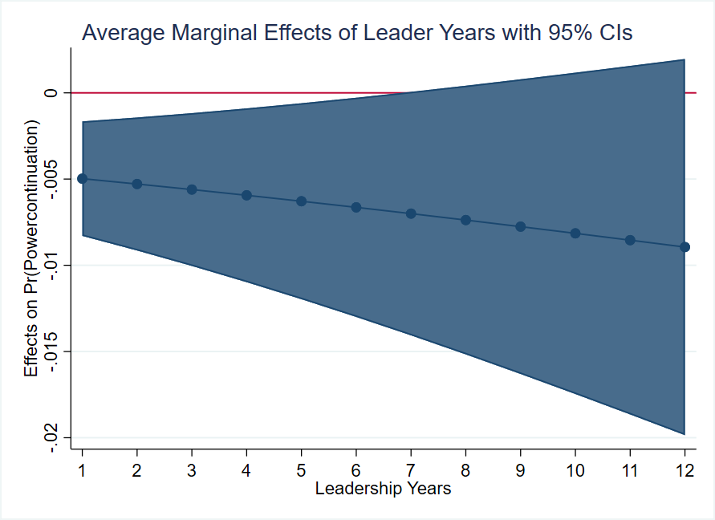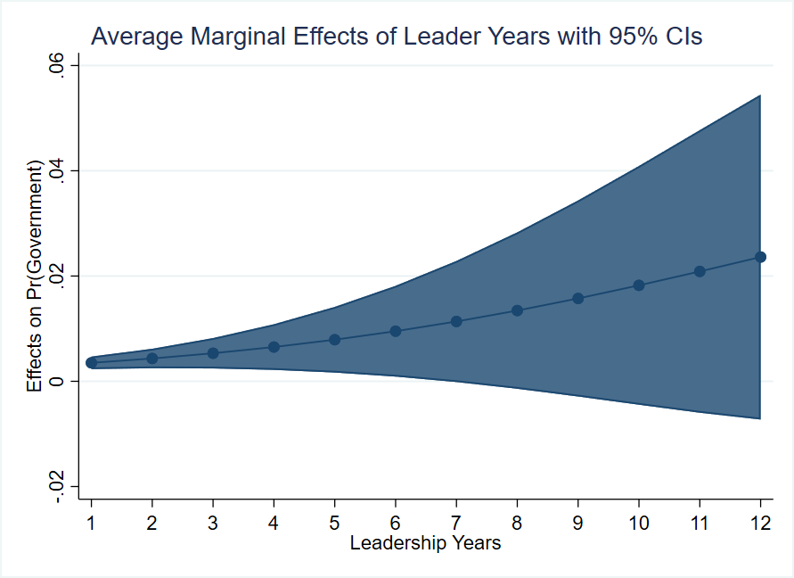

Table A9 Robustness Check: Alternative measures of firm performance
 | (1) | (2) | (3) | (4) | (5) | (6)
VARIABLES | Power Continuation | Power Continuation | Exit | Gov’t | Exit | Gov’t
Asset Preservation | -0.000886 |  | 0.00886 | -0.0484**
Rate (SASAC) | (0.00844) |  | (0.00660) | (0.0215)
Income (SASAC) |  | 1.09e-05 |  |  | -1.77e-07 | -3.81e-07*
 |  | (5.37e-05) |  |  | (1.19e-07) | (2.18e-07)
ROA | 0.755** | 0.495 | -0.484 | -0.0617 | -0.380 | 0.149
 | (0.362) | (0.304) | (0.653) | (0.681) | (0.410) | (0.610)
Observations | 515 | 604 | 538 | 538 | 633 | 633
Industry FE | Yes | Yes | Yes | Yes | Yes | Yes
Pseudo R2 | 0.296 | 0.273 | 0.291 | 0.291 | 0.292 | 0.292
Robust standard errors in parentheses
*** p<0.01, ** p<0.05, * p<0.1
All models include ROA, cumulative connections, party school, leadership years, central and local experience, age and age squared, graduate degree, and Xi Jinping era. Models include foreign exchange indicator for data source.

Table A10 Non-linear Robustness Checks
 | (1) | (2) | (3) | (4) | (5) | (6) | (7) | (8)
VARIABLES
ROA | 0.452* | 0.943 | 0.451
 | (0.235) | (2.434) | (0.284)
ROA X ROA | -0.0427
 | (0.170)
ROA X Age |  | -0.00824
 |  | (0.0424)
ROA X Above Retirement |  |  | 0.0624
 |  |  | (0.479)
ROA (Diff) |  |  |  | 0.453* | 5.063* | 0.904***
 |  |  |  | (0.256) | (3.071) | (0.246)
ROA (Diff) X ROA (Diff) |  |  |  | -0.221
 |  |  |  | (0.162)
ROA (Diff) X Age |  |  |  |  | -0.0785
 |  |  |  |  | (0.0558)
ROA (Diff) X Above Retirement |  |  |  |  |  | -0.949
 |  |  |  |  |  | (0.593)
ROA (Diff, negative) |  |  |  |  |  |  | -0.436* | -0.756*
 |  |  |  |  |  |  | (0.243) | (0.387)
ROA (Diff, negative) X Above Retirement |  |  |  |  |  |  |  | 0.587
 |  |  |  |  |  |  |  | (0.510)
Above Retirement Age |  |  | -0.0809 |  |  | -0.119 |  | -0.415
 |  |  | (0.440) |  |  | (0.483) |  | (0.600)
Age | 1.925*** | 1.927*** | 1.876*** | 2.112*** | 2.059*** | 2.099*** | 2.015*** | 1.984***
 | (0.387) | (0.390) | (0.518) | (0.468) | (0.469) | (0.623) | (0.469) | (0.625)
Observations | 1,045 | 1,045 | 1,045 | 826 | 826 | 826 | 826 | 826
Industry FE | Yes | Yes | Yes | Yes | Yes | Yes | Yes | Yes
Pseudo R2 | 0.240 | 0.240 | 0.240 | 0.225 | 0.225 | 0.227 | 0.220 | 0.223
*** p<0.01, ** p<0.05, * p<0.1
Errors clustered at the individual level. All models include ROA, cumulative connections, party school, leadership years, central and local experience, age and age squared, graduate degree, and Xi Jinping era. Models include foreign exchange indicator for data source.

Figure A2 Robustness Check: Linear trends of performance over age
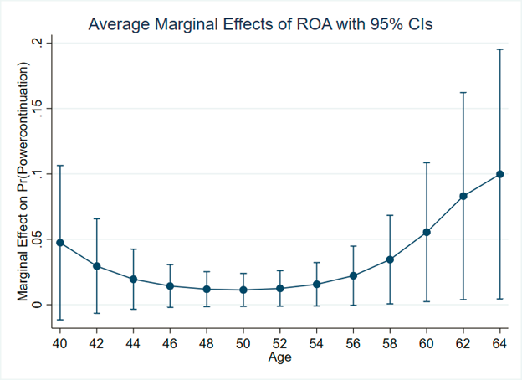

Landry (2008); Shih, Adolph and Liu (2012).
For example, while the mean firm average net profit from 2003 to 2017 is 8 billion RMB, it ranges from -236 million RMB to 107 billion RMB, signaling significant variation in profitability across firms in the sample.
Brødsgaard et al. (2017); Huang (1999); Li and Zhou (2005).
See for example Bo (2002); Choi (2012); Landry (2008). Another possible modeling strategy is a linear probability model. We choose not to implement this for two reasons. First, we do not wish to impose a strict ordering on our outcomes, as discussed above. Second, the sample size is relatively limited and while linear probability models and logistic models do converge asymptotically, we do not wish to incur additional bias in our smaller sample.
Allison (1982).

