Appendix

Appendix A
Table A1: Summary statistics
Variable | Obs | Mean | S.D. | Min | Max
Credit rating | 781 | 18.458 | 1.201 | 14 | 20
Credit rating (2-year moving average) | 731 | 18.457 | 1.182 | 14 | 20
Corruption convictions | 800 | 18.734 | 21.851 | 0 | 166
Corruption convictions/100,000 inhabitants | 800 | 0.340 | 0.325 | 0 | 3.548
Corruption convictions/100,000 inhabitants (cube root) | 800 | 0.628 | 0.231 | 0 | 1.525
Federal transfers | 795 | 0.311 | 0.06 | 0.135 | 0.513
Unemployment | 800 | 5.851 | 2.012 | 2.3 | 13.7
GDP growth | 800 | 3.846 | 3.733 | -15.2 | 41
Total state expenditures/ GDP | 800 | 19.384 | 3.293 | 10.06 | 33.28
Economic freedom (Cato) | 800 | 0.004 | 0.22 | -0.836 | 0.447
Gross public debt/ GDP | 800 | 16.155 | 3.961 | 5.09 | 33.07
GDP (logged) | 800 | 10.776 | 0.187 | 10.328 | 11.288
Population (logged) | 800 | 15.117 | 1.042 | 11.035 | 17.477
Democratic governor | 800 | 0.449 | 0.498 | 0 | 1
Democratic president | 800 | 0.5 | 0.5 | 0 | 1

Appendix B

Table A2: Transformation of credit rating grades into a numeric scale
Grade
Numericalscale
RatingGradeDescription
InvestmentGrade
HighestGradeCredit
AAA
20
AA+
19
VeryHigh-GradeCredit
AA
18
AA-
17
A+
High-GradeCredit
16
A
15
A-
14
BBB+
13
GoodGradeCredit
BBB
12
BBB-
11
BB+
10
SpeculativeGrade
SpeculativeGradeCredit
BB
9
BB-
8
B+
7
VerySpeculativeGradeCredit
6
B
B-
5
CCC+
4
SubstantialRisks-InDefault
CCC | 3
CCC- | 2
CC | 1
C 0
SD
D

Appendix C
Table A3: US states in the sample

Alabama | Louisiana | Ohio
Alaska | Maine | Oklahoma
Arizona | Maryland | Oregon
Arkansas | Massachusetts | Pennsylvania
California | Michigan | Rhode Island
Colorado | Minnesota | South Carolina
Connecticut | Mississippi | South Dakota
Delaware | Missouri | Tennessee
Florida | Montana | Texas
Georgia | Nebraska | Utah
Hawaii | Nevada | Vermont
Idaho | New Hampshire | Virginia
Illinois | New Jersey | Washington
Indiana | New Mexico | West Virginia
Iowa | New York | Wisconsin
Kansas | North Carolina | Wyoming
Kentucky | North Dakota

Appendix D
Table A4: Further robustness checks: Replication of table 2, including partisanship
 | (1) | (2) | (3)
 | FE | REG2SLS | PW, PCSE
Credit rating (t-1) | 0.79*** | 0.95***
 | (0.04) | (0.01)
Corruption | -0.61* | -0.32 | -0.26
 | (0.32) | (0.33) | (0.28)
Federal dependence | -2.41*** | -0.58 | -1.28
 | (1.03) | (0.63) | (1.27)
Interaction | 2.13** | 1.07 | 0.98
 | (0.96) | (0.95) | (0.85)
Democrat governor | -0.03 | -0.05 | 0.03
 | (0.06) | (0.04) | (0.04)
Democrat president | -0.23* | -0.01 | 0.14
 | (0.12) | (0.06) | (0.21)
Partisan alignment | 0.03 | 0.03 | -0.08
 | (0.08) | (0.07) | (0.06)
Constant | 4.66 | 0.31 | 19.32
 | (4.67) | (0.77) | (4.42)
Obs. | 726 | 676 | 732
Within R² | 0.73 | 0.72
Between R² | 0.92 | 0.99
R² total | 0.88 | 0.93 | 0.93
Note: Dependent variable is subnational credit ratings with clustered standard errors by state are in parenthesis. All models include time (year) fixed effects. Model 1 is a fixed effects (within) estimate, while model 2 uses a Generalized, two-stage instrumental estimation (REG2SLS), in which the lagged dependent variable is instrumented with its second order lag (first stage estimates shown only).
Model 3 is a pooled Prais-Winsten model, adjusting for first order autocorrelation.
All models include full control variables from table 2, models 2, 4 and 5.
*** p < 0.01, ** p < 0.05, * p < 0.1

Table A5: Replication of H2 with two-year moving average of credit ratings
 | (1) | (2) | (3)
 | FE | REG2SLS | Prais Winsten
Credit rating 2-yr ave. (t-1) | 0.903*** | 0.796***
 | (0.031) | (0.048)
Corruption | -0.436* | -0.451* | -0.358**
 | (0.228) | (0.251) | (0.165)
Federal dependence | -1.845*** | -1.850*** | -1.916***
 | (0.624) | (0.693) | (0.641)
Interaction | 1.297* | 1.300* | 1.089**
 | (0.732) | (0.782) | (0.507)
Constant | 3.377 | 0.609 | -15.825
 | (3.338) | (3.685) | (29.062)
Obs. | 681 | 631 | 731
Within R² | 0.854 | 0.843
R² total | 0.948 | 0.944 | 0.882
Note: Dependent variable is the two-year average of subnational credit ratings.
All estimates with clustered standard errors by state are in parenthesis.
All models include time (year) fixed effects. Model 1 is a fixed effects (within) estimate, while model 2 uses a generalized, two-stage instrumental estimation (REG2SLS), in which the lagged dependent variable is instrumented with its second order lag (first stage estimates shown only).
Model 3 is a pooled Prais-Winsten model, adjusting for first order autocorrelation.
All models include full control variables from table 2, models 2, 4 and 5.
*** p < 0.01, ** p < 0.05, * p < 0.1

Appendix E
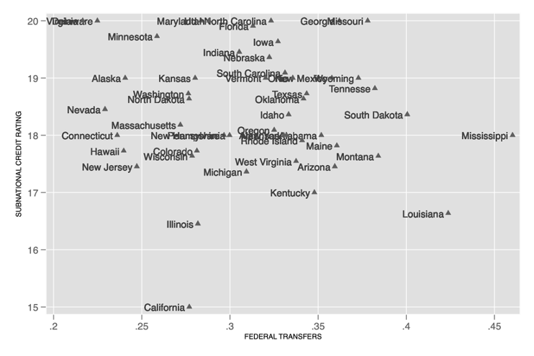
Figure A1: The average relationship between overall levels of federal transfers and subnational credit ratings

Appendix F
Using the techniques developed by Hainmueller et al. (2019), we test for nonlinear effects of corruption on credit ratings over the range of federal transfers. Figure A2 demonstrates these findings. The model shows that the significant and negative effects of corruption apply to observations with roughly 25 percent budget dependence on federal transfers; equivalent to approximately 16 percent of the sample. At higher levels of federal transfers, the effect of corruption on credit ratings is insignificant. However, the graph shows that at very high level of federal transfers (approx. 45 percent) the effect is significant. The latter outcome needs to be treated with caution as there is only a few observation at this high level of federal transfers.
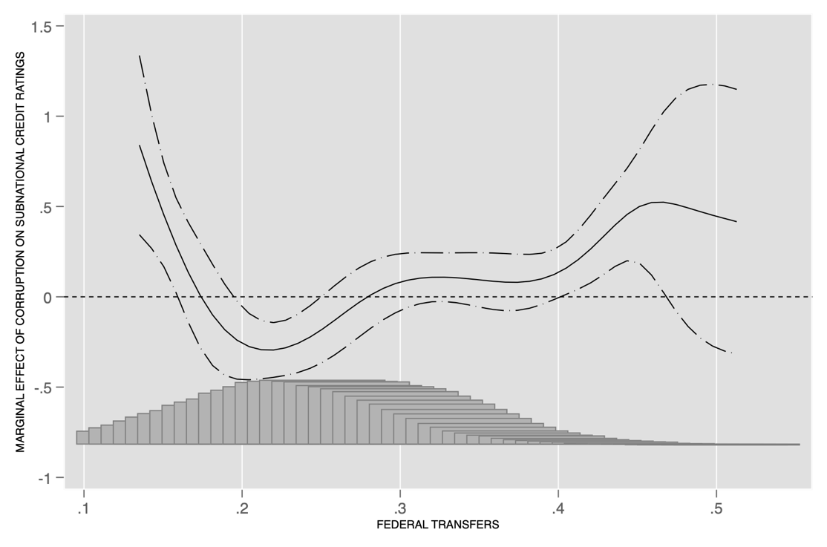
Figure A2: Nonlinear interaction effects
Note: Line represents marginal effect of corruption on the dependent variable with 95 percent confidence interval. Model uses Kernel smoothing estimator from Hainmueller et al. (2019) to show nonlinear effects. Histogram represents the distribution of the federal transfers across the sample.

Appendix G

Description of US transfer system
On whole, federal grants and transfers are a significant part of US states’ revenue, constituting roughly one-third of a state’s budget on average. Moreover, the federal intergovernmental system of transfers is a sizable portion of the federal budget, representing between 15 percent and 17 percent of total federal outlays (Dilger, 2019, 7). Federal transfers to states are typically classified into three broad categories: 1) categorical grants, 2) block grants, and 3) general revenue sharing.
The distinction among these three categories is in the level of discretion that the federal administrator has in allocating the funds as well as the distraction the state has in terms of how flexible they are in spending the funds. Categorical grants award the least amount of discretion, while general revenue sharing allows the most, with the level of discretion for block grants falling in between. Although there is no consensus on how precisely to classify each federal grant to states, the best estimates demonstrate that the overwhelming number of federal transfers to states in the form of categorical grants, followed by block grants, with some years yielding no grans in the category of “general revenue sharing.” In most all documented years the roughly 98% of the grants allocated to sates are classified as “categorical” (Dilger, 2019, 10).
Due to the “stickiness” of the federal budget over time, intergovernmental transfers to states are also highly consistent over time as they represent a combination of progressive need for lesser developed states together with the pork barrel politics of congressional logrolling (Larcinese et al., 2013). The correlation of our first and last years in our sample (2001 and 2015) is shown in in figure A3.
In the order of highest to lowest amount of expenditures, the federal revenue provides states funding on health care, income security, education and training, transportation and regional development, as well as other smaller categories of projects. The largest expenditure, health care, was roughly 45 percent of total federal transfers prior to the
Affordable Care Act, and now represents roughly 60 percent of total transfers.
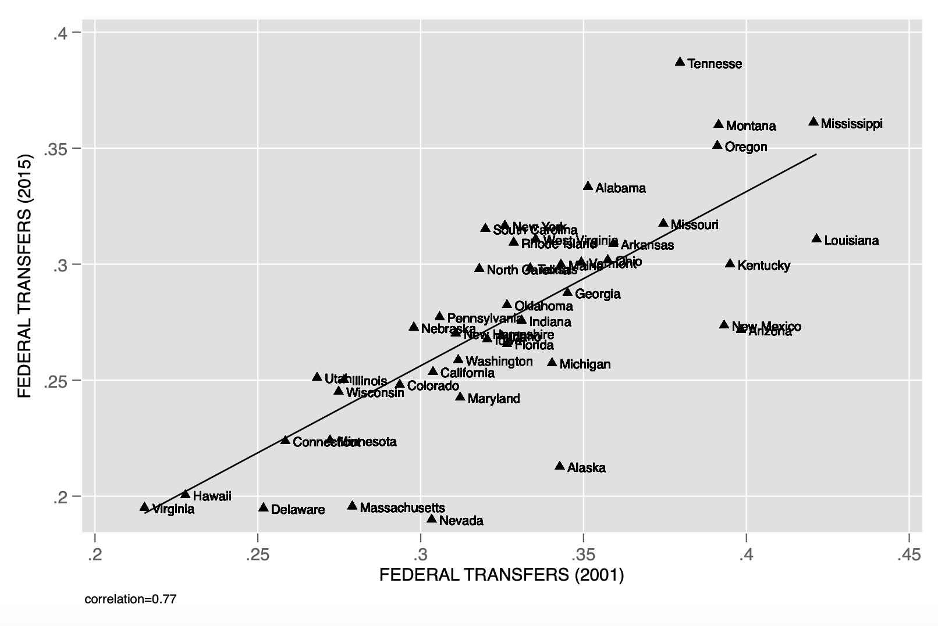

Figure A3: The level of federal dependence in 2001 and 2015

Table A6: Bivariate relationship between federal transfers and subnational credit ratings
 | (1) | (2)
VARIABLES | Fixed Effects | REG2SLS
Lagged Dep. Var. (t-1) |  | 0. 816***  (0.070)
Federal dependence | -2.543 | -1.666**
 | ( 2.833) | (0.797)
Constant | 19.060*** | 3.879***
 | (0.782) | (0.985)
Observations | 776 | 676
Fixed year effects | yes | yes
Instrument |  | CRi t-2
Within R² | 0.063
Between R²  R² total  Number of states | 50 | 50
Note: Dependent variable is subnational credit ratings with clustered standard errors by state are in parenthesis.
All models include time (year) fixed effects. Model 1 is fixed effects (within) estimate, while model 2 uses a generalized, two-stage random effects estimation (REG2SLS), in which the lagged dependent variable is instrumented with its second order lag (first stage estimates shown only). *** p < 0.01, ** p < 0.05, * p < 0.1

