Appendix I. Additional Analyses

Table A1. Without any control variables
 | Feeling thermometer for Korea  OLS | Willingness to cooperate with the Korean government  Ordered logistic |  | Feeling thermometer for China  OLS |  | Willingness to cooperate with the Chinese government  Ordered logistic
 | (1) |  | (2) |  | (3) |  | (4)
Korean Aid | 7.253***  (2.048) |  | 0.129  (0.151) |  | 0.013  (2.389) |  | -0.167  (0.147)
Chinese Aid | 1.571  (2.064) |  | -0.264  (0.152) |  | -1.373  (2.408) |  | -0.049  (0.148)
Constant | 61.859***  (1.453) |  |  |  | 39.282***  (1.695)
Observations | 872 |  | 872 |  | 872 |  | 872
Standard errors are in parentheses
Notes: * p<0.05; ** p<0.01; *** p<0.001

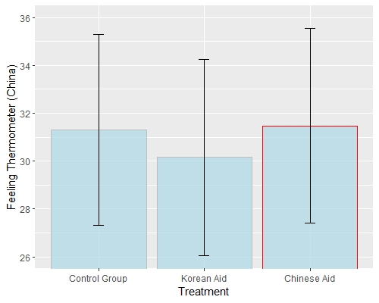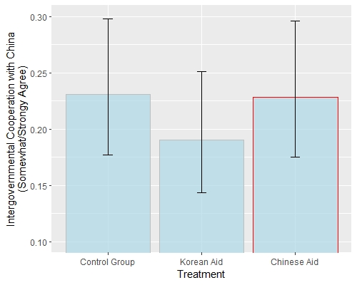
Figure A1. Treatment Effect on the Feeling Thermometer for China (Left, based on Model 6) and Willingness to Cooperate with the Chinese Government (Right, based on Model 8)

Table A2. Group-level difference in the perceived value of Angkor

One-way ANOVA Test
 | DF | Sum Sq | Mean Sq | F value | Pr(>F)
Group | 2 | 1.61 | 0.8041 | 1.187 | 0.306

Tukey's HSD (honestly significant difference) test
 | Difference | Adj. P-value
Group2(Korean Aid Video)-Group1(Control) | -0.142 | 0.295
Group3(Chinese Aid Video)- Group1(Control) | -0.102 | 0.532
Group3(Chinese Aid Video)-Group2(Korean Aid Video) | 0.040 | 0.907

Appendix II. Transcripts for the videos

[Treatment 1: Korean Aid]
Narration:
- 0:00:01: The Angkor in Cambodia Siem Reap is one of the most famous World Heritage sites in Asia.
- 0:00:08: The temples in Angkor are architectural masterpieces laden with tales of Cambodian history and legend.
- 0:00:16: For centuries, it was the center of the Khmer Kingdom that once controlled most of Southeast Asia.
- 0:00:22: However, Temples in Angkor were seriously damaged by a lack of maintenance over the decades.
- 0:00:29: To restore the site, the Cambodian government requested international assistance.
- 0:00:37: South Korea has long been cooperating with Cambodia to help them preserve the endangered Angkor Monument.
- 0:00:45: The “Preah pithu Temple Restoration project” is carried out by the experts from The Korea Cultural Heritage Foundation in collaboration with Cambodia.
- 0:00:56: A range of activities including preliminary research supporting Cambodia with technology and equipment, the temple has successfully been restored.
- 0:01:09: Due to these remarkable preservation efforts Preah pithu Temple can be enjoyed by travelers from all over the world who come to Angkor.

[Treatment 2: Chinese Aid]
Narration:
- 0:00:01: The Angkor in Cambodia Siem Reap is one of the most famous World Heritage sites in Asia.
- 0:00:08: The temples in Angkor are architectural masterpieces laden with tales of Cambodian history and legend.
- 0:00:16: For centuries, it was the center of the Khmer Kingdom that once controlled most of Southeast Asia.
- 0:00:22: However, Temples in Angkor were seriously damaged by a lack of maintenance over the decades.
- 0:00:29: To restore the site, the Cambodian government requested international assistance.
- 0:00:38: China has long been cooperating with Cambodia to help them preserve the endangered Angkor Monument.
- 0:00:44: The “Chau Say Tevoda Temple Restoration project” is carried out by the experts from The Chinese Academy of Cultural Heritage in collaboration with Cambodia.
- 0:00:56: A range of activities including preliminary research supporting Cambodia with technology and equipment, the temple has successfully been restored.
- 0:01:06: Due to these remarkable preservation efforts Chau Say Tevoda Temple can be enjoyed by travelers from all over the world who come to Angkor.

[Control group]
Narration:
- 0:00:01: The Angkor, in Cambodia Siem Reap is one of the most famous World Heritage sites in Asia.
- 0:00:07: The site is located in the northwestern region of the country and is only four miles from the city of Siem Reap.
- 0:00:16: It covers more than 400 square kilometers, an area larger than New York City's five boroughs combined including forested areas and newly discovered suburbs.
- 0:00:28: The center of the Khmer Empire thrived here from the 9th to 15th centuries over an area that stretched from Myanmar to Vietnam.
- 0:00:39: The temples in Angkor are architectural masterpieces laden with artistic treasures like the bar relief galleries that tell enduring tales of Cambodian history and legend.
- 0:00:51: However, Temples in Angkor were seriously damaged by heavy rains, looting, and a lack of maintenance over the decades.
- 0:01:01: It's still a mystery to historians and scientists why the city's rulers abandoned the site.
- 0:01:07: Peak tourist season for the Angkor is December and January when rainfall is less likely and the weather is kinder
- 0:01:15: No matter the time of year, a visit to the Angkor is sure to leave you awestruck.

