Online Supplementary Material of Dyadic Representation in Parliamentary Democracy in Japan:
The Voters and the Candidate Policy Position at the District Level with the Pooled Voter Surveys
As a supplement to the analysis in the manuscript, this section analyzes the association between candidates’ policy positions and their district policy position in Japanese LH by using a direct measurement by pooling three waves of the UTAS voter survey, rather than the district employment structure as a proxy.
For this purpose, I use the three waves of the UTAS voter surveys: (1) the wave of LH2003, UH2004, and LH2005, (2) the wave of LH2009 and UH2010, or (3) the wave of LH2012 and UH2013, by pooling the respondents. Figure R1 shows the number of respondents pooled for three waves at respective districts. Most of the districts (297 out of 300) had some respondents with pooled samples.
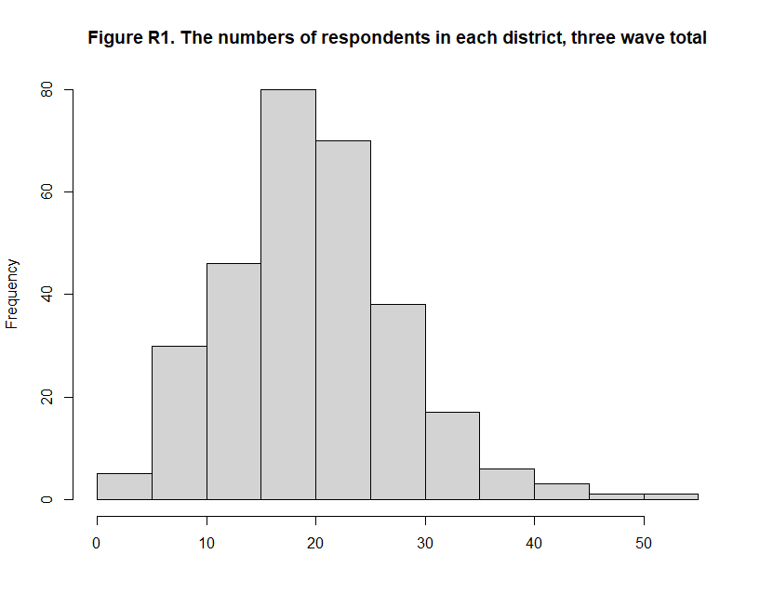
The survey asks the policy position of the respondents once during each wave. Only two questions were asked for all three waves related to the urban-rural economic policy: 1) public work for employment and 2) balanced budget vs. fiscal stimulus to measure the opinion of each district. The wording of the questionnaires is the same as those used for the candidate’s surveys. Their responses are coded into five categories: Agree (1) to Disagree (5). Using their responses, I calculated the policy position of each respondent, which was operationalized to range from 0 (Disagree to both questions) and 1 (Agree to both questions), and then computed the mean of the respondents as the policy position of individual districts. Figure R2 shows the district means of the policy position measured with the UTAS voter surveys.

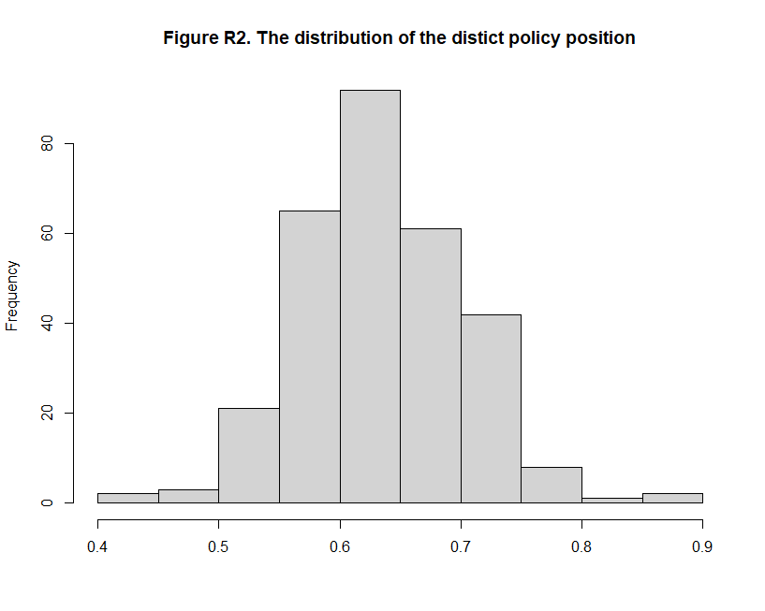

Table 1b. Voter’s mean and candidates’ policy position with OLS model.
 | Coefficient Estimate | Standard Error |  | Hypothesis Test
Party Affiliation (DPJ) | -1.086 | (0.042) | ‡ | Single-Sided (Negative)
Voter’s mean policy position (VMP) | 1.952 | (0.385) | ‡ | Single-Sided (Positive)
(Intercept) | -0.726 | (0.055) | † | Double-Sided
No. of Observations | 859
Adjusted R-square | 0.407
Note: Statistical significance at + 10%; *5%; † 1%; ‡ 0.1%.

Next, I ran the OLS to examine the associations between the candidates’ policy positions and the district mean of the voter’s policy position instead of the district employment structure. Table 1b shows the result of the OLS model. The effect was significant at the 0.1% level: the more the district voters prefer the rural-oriented policy, the more rural-oriented the candidate’s economic policy position will be, given their party affiliation. The standardized coefficient of VMP was 0.147 (1.952*0.0665/0.890), which was much smaller than that of the district employment structure (0.329).
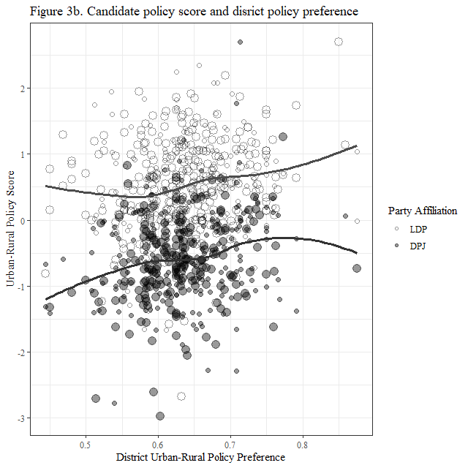
Similarly, Figure 3b graphically presents the association between the candidates’ policy scores and the mean of the district policy preference, although the association is less clear than those with the district employment structure in Figure 3.
These results show that the original result of the manuscript is robust even if we use the direct measurement of the district opinion, which pool the respondents in three waves of the candidate surveys.

Table O1. Difficulty and Discrimination Parameters of Each Variable with Gradual Response Model
Parameters | emp03 | fiscal03 | postal03 | hway03 | transfer03 | emp05 | fiscal05 | emp09 | fiscal09
Extremity 1 | 1.861 | 2.626 | -6.288 | -0.902 | -0.550 | 2.066 | 3.774 | 1.170 | 0.766
Extremity 2 | 0.205 | 0.503 | -2.246 | -0.066 | 0.315 | 0.570 | 2.063 | -0.050 | -0.789
Extremity 3 | -1.269 | -1.067 | 1.634 | 0.695 | 1.317 | -0.758 | 0.154 | -1.030 | -1.948
Extremity 4 | -3.083 | -3.197 | 4.901 | 1.503 | 2.084 | -2.203 | -1.738 | -2.220 | -3.111
Discrimination | -1.331 | -0.854 | 0.374 | 1.652 | 1.598 | -1.625 | -0.920 | -2.440 | -1.622
Parameters | road09 | spend09 | protect09 | emp12 | fiscal12 | tpp12 | equal12 | protect12
Extremity 1 | 1.144 | -0.254 | 3.906 | 1.042 | 1.178 | -1.975 | 4.963 | 3.104
Extremity 2 | 0.319 | 1.160 | 0.227 | -0.262 | -0.588 | -0.827 | 0.829 | 0.759
Extremity 3 | -0.352 |  | -2.618 | -1.345 | -1.588 | 0.302 | -1.968 | -1.226
Extremity 4 | -1.003 |  | -5.897 | -2.458 | -2.832 | 1.057 | -5.860 | -3.492
Discrimination | -3.398 | 2.699 | -0.653 | -2.370 | -1.889 | 1.445 | -0.622 | -0.999

Note: Extremity 1-4 indicates difficulty parameters between five respective responses, such as agree (1), somewhat agree (2), neutral (3), somewhat disagree (4) and disagree (5) for the statement. spend09 has only two Extremity parameters because it is coded into three categories.

The abbreviations on the table correspond to the questionnaire in the appendix as follows. The number indicates the survey year. (e.g., emp03 indicates the question regarding “Public Work for Employment” surveyed in 2003).
emp: Public Work for Employment
fiscal: Balance Budget vs. Fiscal Stimulus
postal: Postal Service Privatization
hway: Free vs. Building New Highway
transfer: Fiscal Transfer from Urban to Rural Areasr
road: Keep Spending for Road Construction
tpp: Should Join TPP
equal: Economic Efficiency vs. Social Equality
protect: Protecting Domestic Industry vs. Trade and Investment Liberalization
spend: Should We Increase/Decrease Spending for Public Works?

