APPENDIX A: SUPPLEMENTARY MATERIAL
Figure 1. Causal diagram for fecal prevalence meta-analysis and meta-regression models constructed a priori.
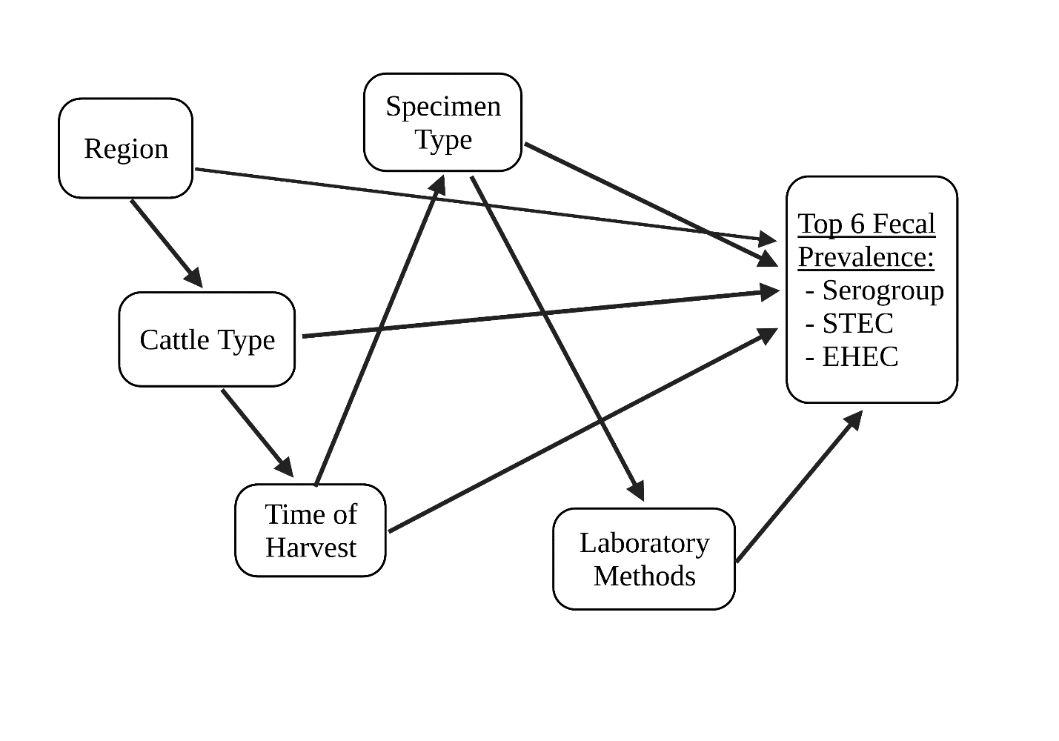
Diagram created with BioRender.com

