Table S1. Main herds, cows, and quarters selection criteria and treatment regimens in 18 trials from 16 manuscripts included in a systematic review of internal teat sealant-based approaches without use of antimicrobials for drying-off dairy cows.
Trial | Udder health selection criteria |  |  | Treatment regimens
 | Herds | Cows and quarters |  | Sealant | Comparators
Cengiz et Bastan 2015 | SCC: 150,000 to 350,000 cells/ml | Cow with no CM, and no AB or AI 30 days pre-dry |  | Teat sealant, 4g, IMM, once at DO | Positive controls: cloxacillin 600mg/quarter, IMM, once at DO.
Kromker et al., 2014 | None mentioned | Cow SCC<100,000 cells/ml and MBC negative |  | Teat sealant, 4g, IMM, once at DO | Negative controls: untreated
Bhutto et al., 2011 | None mentioned | Cow with no AB or AI in last 30 days pre-dry |  | Teat sealant, 4g, IMM, once at DO | Negative controls: untreated
Petrovski et al., 2011 | None mentioned | Cow SCC<200,000 cells/ml 9 days pre-dry |  | Teat sealant, 4g, IMM, once at DO | Negative controls: untreated
Klocke et al., 2010 | None mentioned | MBC negative for major udder pathogen |  | Teat sealant, 4g, IMM, once at DO | Negative controls: untreated
Laven et Lawrence, 2008 | None mentioned | Cows with no CM and SCC ≤150,000 cells/ml in previous lactation |  | Teat sealant, 4g, IMM, once at DO | Negative controls: untreated
Sanford et al., 2006 | None mentioned | All 4 quarters MBC negative 14 days pre-dry |  | Teat sealant, 4g, IMM, once at DO | Negative controls: untreated
Schaeren et Maurer, 2005 | None mentioned | None mentioned |  | Teat sealant, 4g, IMM, once at DO | Positive controls: antibiotic (no precision)  Negative controls: untreated
Berry et Hillerton, 2002 | SCC: 115,000 to 350,000 cells/ml | Cow SCC<200,000 cells/ml and no CM in previous lactation; no AB 30 days pre-dry |  | Teat sealant, 4g, IMM, once at DO | Negative controls: untreated
Huxley et al., 2002 | SCC<200,000 cells/ml | Cow SCC<200,000 cells/ml and no CM in previous lactation; no AB 30 day pre-dry |  | Teat sealant, 4g, IMM, once at DO | Positive controls: cephalosporin 250mg/quarter, IMM, once at DO
Woolford et al., 1998 | None mentioned | Cow SCC<200,000 cells/ml; Cow ≥ 3 uninfected quarters (based on MBC); |  | Teat sealant, 4g, IMM, once at DO | Positive controls: cephalosporin, 250mg/quarter, IMM, once at DO  Negative controls: Untreated
Meaney, 1986 | None mentioned | Cow free of IMI (not defined) |  | Teat sealant (Heavy inorganic salt in a paraffin/wax base), 7.5gr, IMM, once at DO | Positive controls: cloxacillin, no dosage mentioned, IMM, once at DO
Meaney, 1977 | None mentioned | Cow free of IMI (not defined) |  | Teat sealant (Bismuth subnitrate 25%w/w + acriflavine 0.075%), 7.5gr, IMM, once at DO | Negative controls: untreated
Compton et al., 2014 | None mentioned | Cow SCC<200,000 cells/ml and no CM in previous lactation |  | Teat sealant, 2.6g bismuth subnitrate and 20mg chlorhexidine, IMM, once at DO | Negative controls: untreated
Petrovski et al., 2011 | None mentioned | Cow SCC<200,000 cells/ml 9 days pre-dry |  | Chlorhexidine-teat sealant (Bismuth subnitrate 65%+chlorexidine 0.5%), NM, IMM, once at DO | Negative controls: untreated
Elecko et al., 1985 | None mentioned | None mentioned |  | Teat sealant, 5ml syringe, once at DO | Negative controls: untreated
Mullen et al., 2014 | None mentioned | None mentioned |  | Cinnatube (olive and tea tree oil, beeswax, calendula oil, cinammon oil, eucalyptus oil), 10ml/quarter, IMM, once at DO. | Positive controls: penicillin (1,000,000 units) + dihydrostreptomycin (1g) + bismuth subnitrate 65% ITS (4g), IMM, Once at DO  Negative controls: untreated
Mullen et al., 2014 | None mentioned | None mentioned |  | Phyto-mast and cinnatube: 12ml (Phyto-mast) and 10ml (Cinnatube)/quarter, IMM, once at DO. | Positive controls: penicillin (1,000,000 units) + dihydrostreptomycin (1g) + bismuth subnitrate 65% ITS (4g), IMM, once at DO  Negative controls: untreated
SCC: somatic cell count; CM: clinical mastitis; AB: antibiotics; AI: anti-inflammatory; IMM: intramammary; DO: dry-off; MBC: milk bacteriological culture; ITS: internal teat sealant.

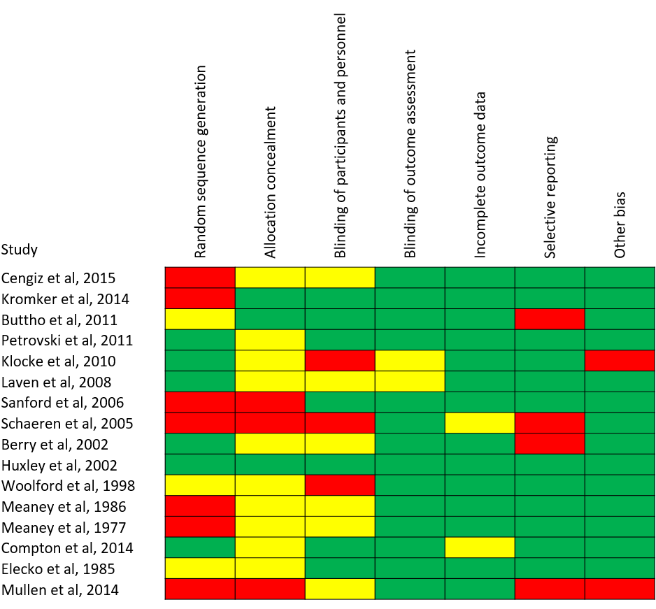
Figure S1. Risk of bias for 16 studies included in a systematic review of internal teat sealant-based approaches without use of antimicrobials for drying-off dairy cows.

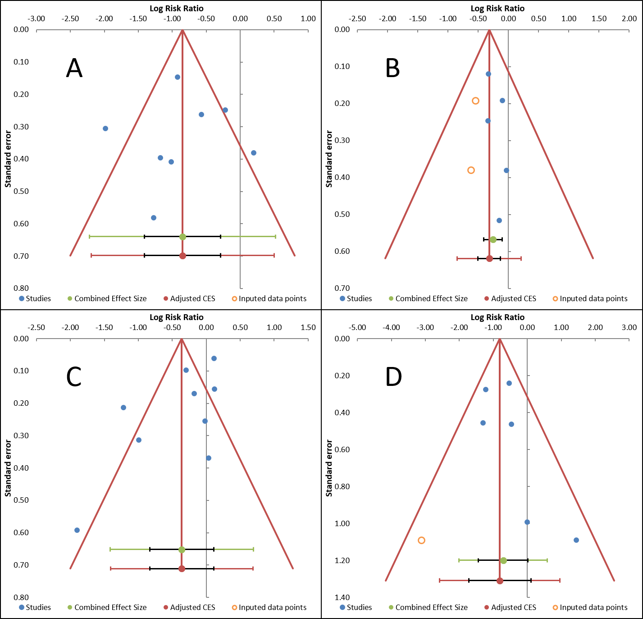
Figure S2. Funnel plots illustrating potential publication bias for four comparisons investigating the efficiency of internal teat sealant (ITS)-based approaches without use of antimicrobials for drying-off dairy cows: A) intramammary infections (IMI) incidence in ITS-treated vs. untreated quarters (studies using naturally acquired IMI); B) IMI incidence in ITS- vs. antimicrobial-treated quarters (bismuth subnitrate-based ITS); C) IMI prevalence at calving in ITS-treated vs. untreated quarters; and D) clinical mastitis incidence in ITS-treated vs. untreated quarters.

