Appendices
Appendix A. diamond CATI questions with participant responses to stopping antidepressant medications.
Note: * indicates revised question for future timepoints
 | Question | CATI Timepoint
 |  | 2  (12m) | 3  (24m) | 4  (36m) | 5  (48m) | 6  (60m) | 7  (72m) | 8  (84m) | 9  (96m) | 10 (108m) | 11 (120m)
1 | We find a lot of people stop taking their medication from time to time. Since you were first prescribed medication for your emotional well-being have you ever stopped taking any of these? (Yes/No). What made you stop (text response)
 | We find that a lot people stop taking their medication from time to time. In the past 12 months, have you stopped taking [antidepressant medication name] even if only for a short time? (Yes/No) What made you stop taking [antidepressant medication name]? (text response)*
2 | Of all that you have done/tried [for your depression, stress or worries], what was the least helpful? (text response) Why? (text response)
 | During the past 12 months, what has help you least of all with depression stress or worries? (text response)*
 | During the past 12 months, of everything you have done or tried for depression, stress or worries, what has been the least helpful? (text response)*
3 | Are you for some reason not taking any (other) medicines which have been prescribed for you (that you are supposed to be taking) for your emotional or physical well-being? (Yes/No) Why are not taking them? (text response)
4 | How have you been feeling since we last spoke about 12 months ago? (text response)
 | Can you describe how you have been feeling since we last spoke about 12 months ago? (text response)*

Appendix B. Breakdown of CATI respondents who stopped antidepressants at each timepoint.

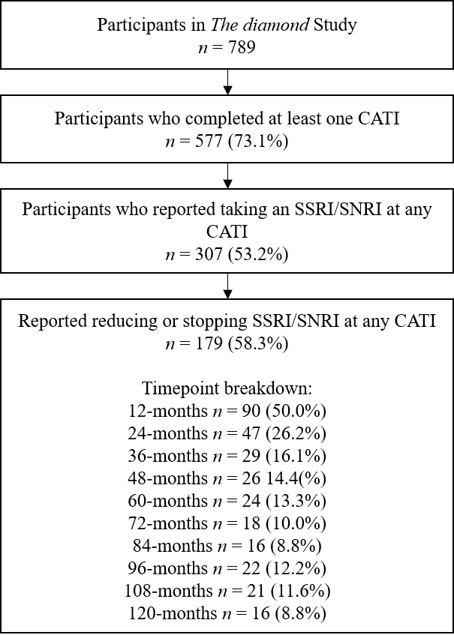

Appendix C. Number of reasons given by number of participants.

Appendix D. Number of CATIs completed and number of CATIs where participants gave a reason for reducing or stopping antidepressant medication, by number of participants.

