Supplementary Figure S1

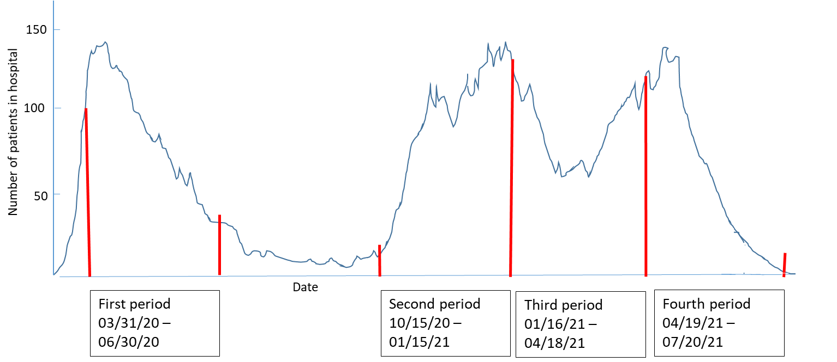

The studied periods of COVID-19 related death in nursing homes and the pandemic waves in the studied region represented by hospitalized COVID-19 patients from the total society population.

