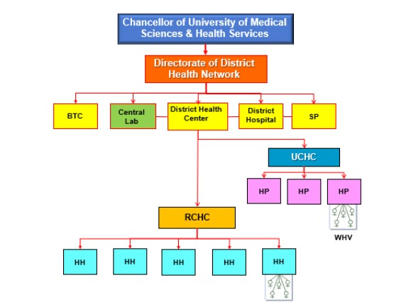

*Additional File 1. The structure of primary health care in Iran*

|  |  |
| --- | --- |
| Number of Facilities | |
| Province University of Medical Sciences | 31 |
| Vice Chancellor for Healthcare (PHC) | 61 |
| District health center Network | 464 |
| Urban Health Center | 3236 |
| Rural Health Center | 2929 |
| Health Post | 5640 |
| Health House | 17958 |