Appendix B:
Map of Punjab indicating districts where data collection took place for this study

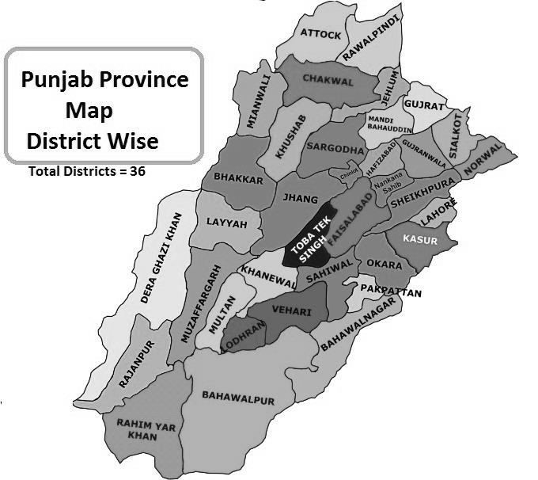
Public domain map of the province of Punjab, not under copyright, retrieved from the website:
https://www.politicpk.com/punjab-province-list-tehsils-districts-divisions-%D8%B5%D9%88%D8%A8%DB%81-%D9%BE%D9%86%D8%AC%D8%A7%D8%A8/

Table: Data collection across 35 districts of Punjab, divided into North Punjab (23 districts) and South Punjab (12 districts).
No | District | Frequency | Percentage
North Punjab
1 | Attock | 12 | 3.4
2 | Chakwal | 12 | 3.4
3 | Chiniot | 9 | 2.6
4 | Hafizabad | 10 | 2.9
5 | Faisalabad | 7 | 2.0
6 | Gujranwala | 2 | 0.6
7 | Lahore | 10 | 2.9
8 | Jhang | 5 | 1.4
9 | Kasur | 7 | 2.0
10 | Jehlum | 1 | 0.3
11 | Khushab | 10 | 2.9
12 | Mandi Bahauddin | 24 | 6.9
13 | Mianwali | 24 | 6.9
14 | Narowal | 12 | 3.4
15 | Nankana Sahab | 30 | 8.6
16 | Okara | 4 | 1.1
17 | Pakpattan | 6 | 1.7
18 | Rawalpindi | 8 | 2.3
19 | Sargodha | 17 | 4.9
20 | Sheikupura | 4 | 1.1
21 | Sialkot | 7 | 2.0
22 | Toba Tek Singh | 10 | 2.9
23 | Sahiwal | 18 | 5.1
South Punjab
1 | Bahalwalpur | 7 | 2.0
2 | Bahawalnagar | 13 | 3.7
3 | Dera Ghazi Khan | 2 | 0.6
4 | Khanewal | 9 | 2.6
5 | Layyah | 10 | 2.9
6 | Lodhran | 7 | 2.0
7 | Multan | 13 | 3.7
8 | Muzaffargarh | 9 | 2.6
9 | Rahim Yar khan | 10 | 2.9
10 | Rajan Pur | 5 | 1.4
11 | Vehari | 10 | 2.9
12 | Bhakkar | 6 | 1.7
 | TOTAL | 350 | 100%

