Electronic Supplementary Material (ESM)
The following five figures represent the PTG subscales for the interaction of Gender X Profession. All the interactions are significant with p < 0.05 or lower.

Supplementary Figure 2. Interaction of Gender X Profession regarding PTG – relating to others subscale.

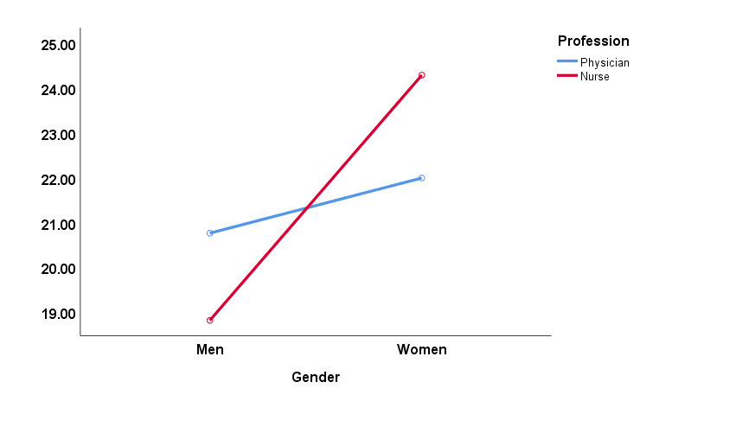

Supplementary Figure 3. Interaction of Gender X Profession regarding PTG – new possibilities subscale.
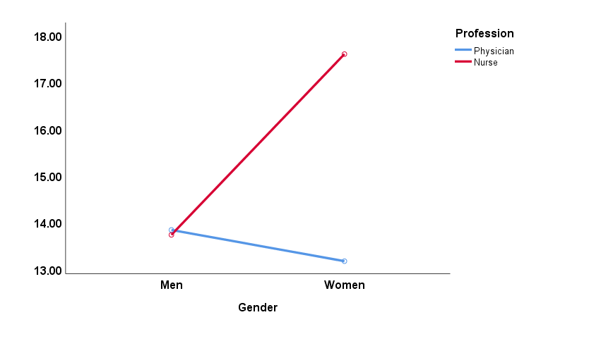

Supplementary Figure 4. Interaction of Gender X Profession regarding PTG – personal strength subscale.

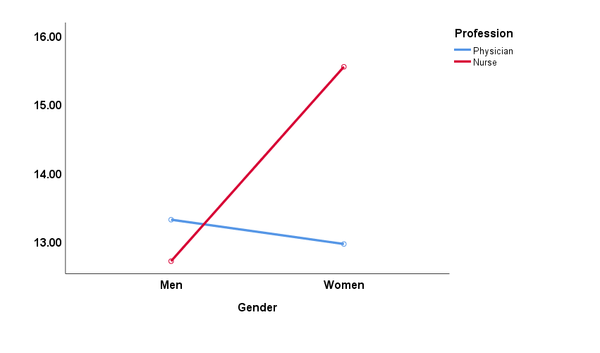

Supplementary Figure 5. Interaction of Gender X Profession regarding PTG – spiritual change subscale.

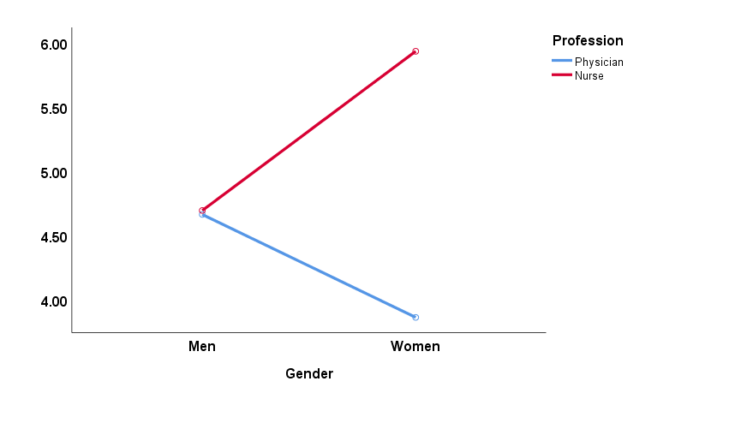

Supplementary Figure 6. Interaction of Gender X Profession regarding PTG – appreciation of life subscale.

