**APPENDIX A – Data Extraction Form for Retrospective Chart Review**

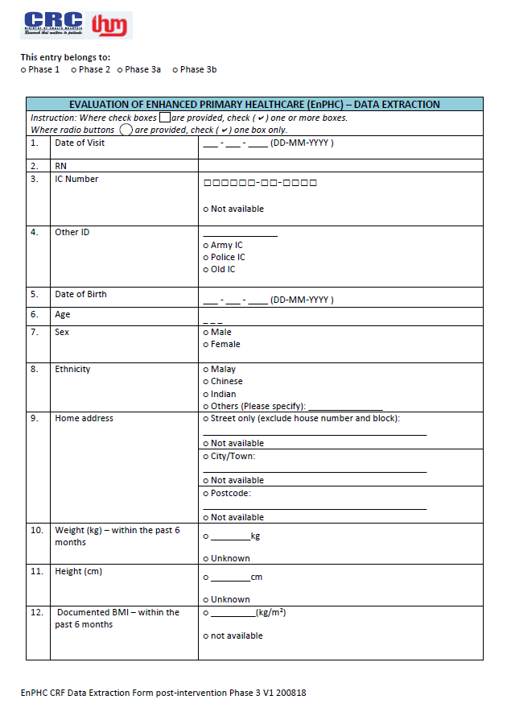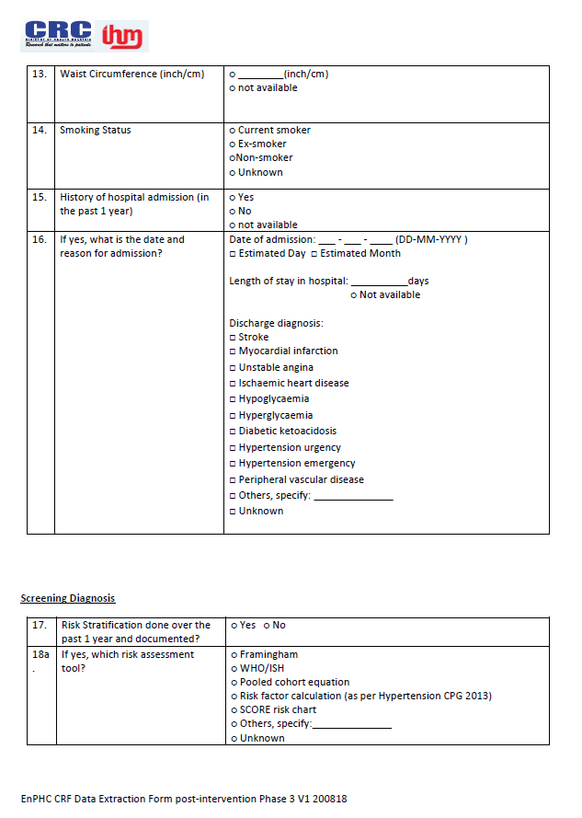

**Appendix A (Continued)**

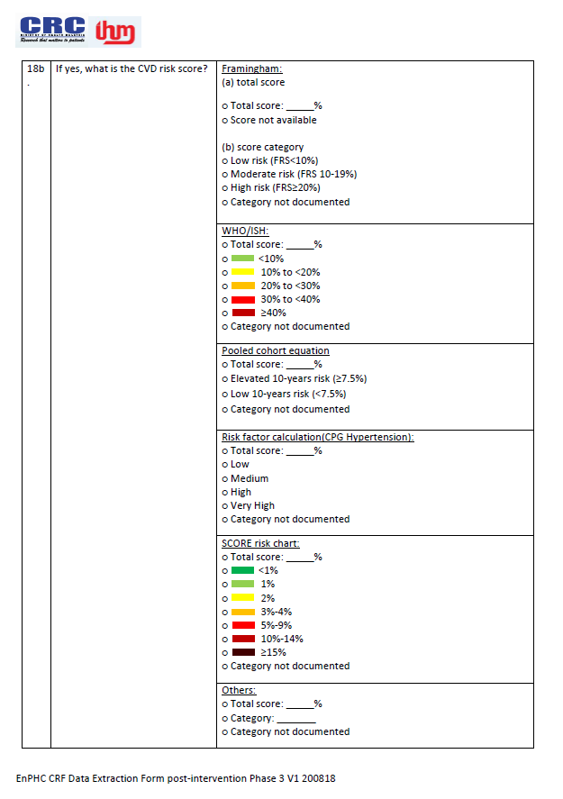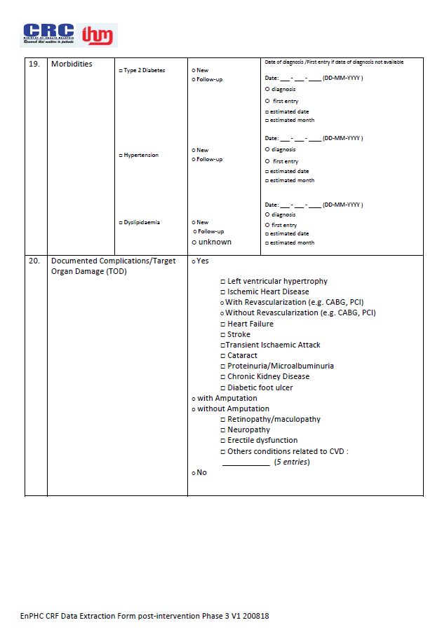

**Appendix A (Continued)**

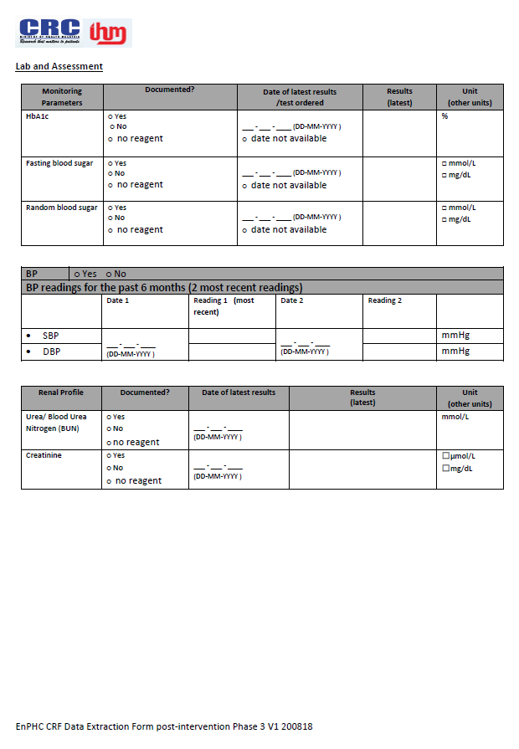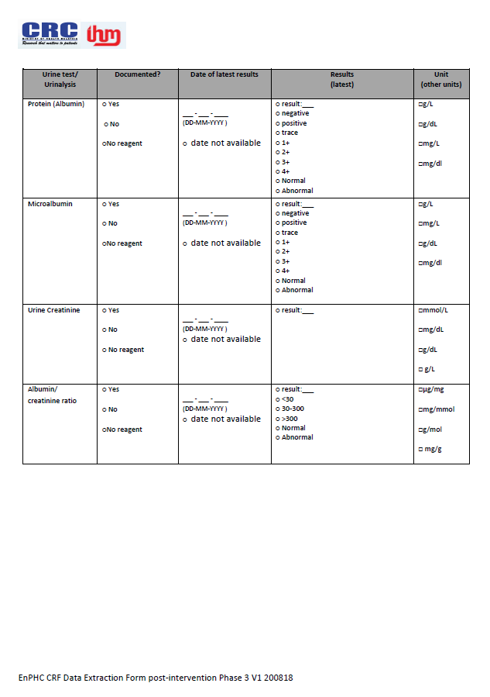

**Appendix A (Continued)**

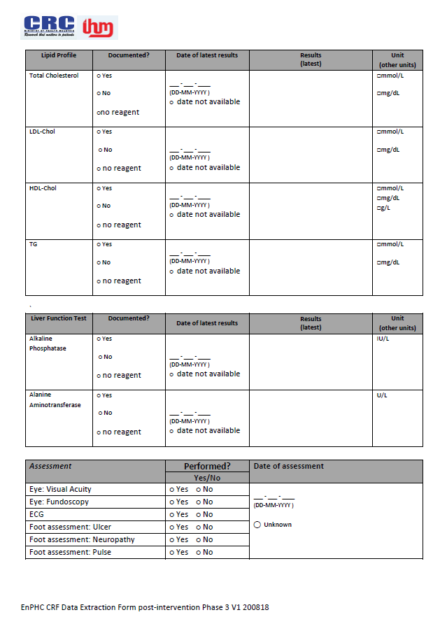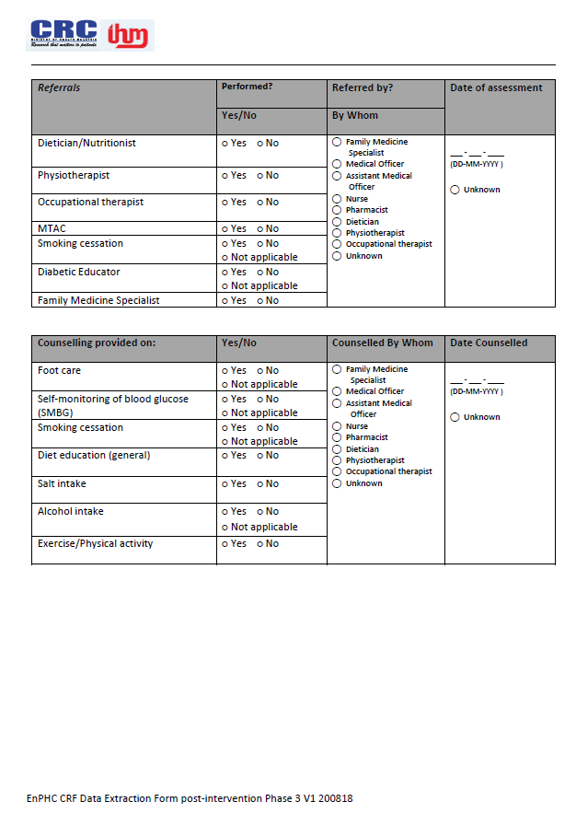

**Appendix A (Continued)**

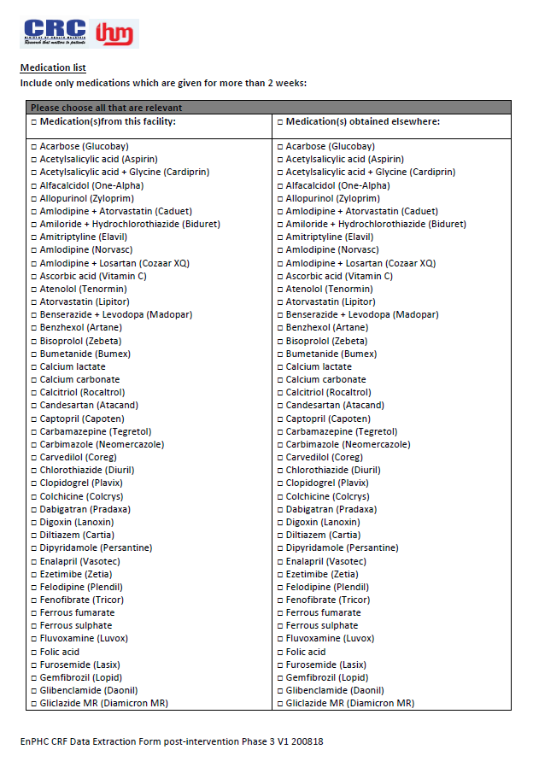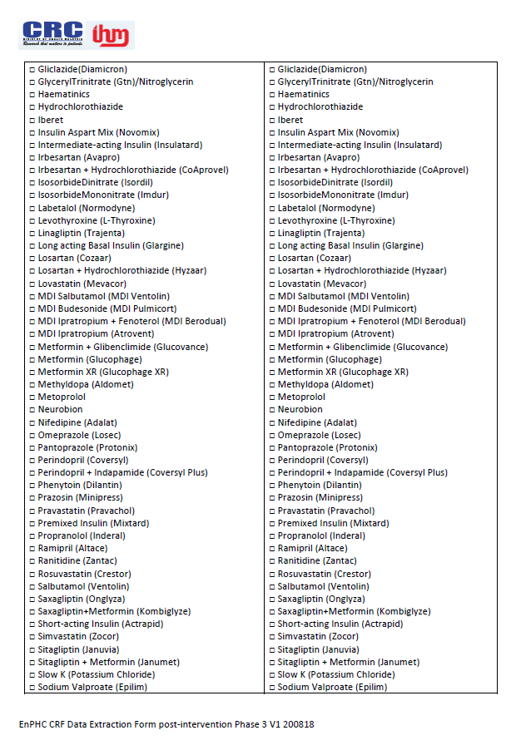

**Appendix A (Continued)**

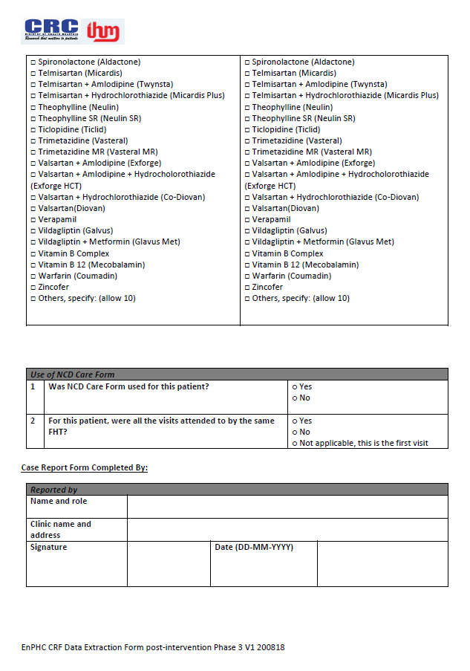

**Appendix B – Patient Exit Questionnaire**

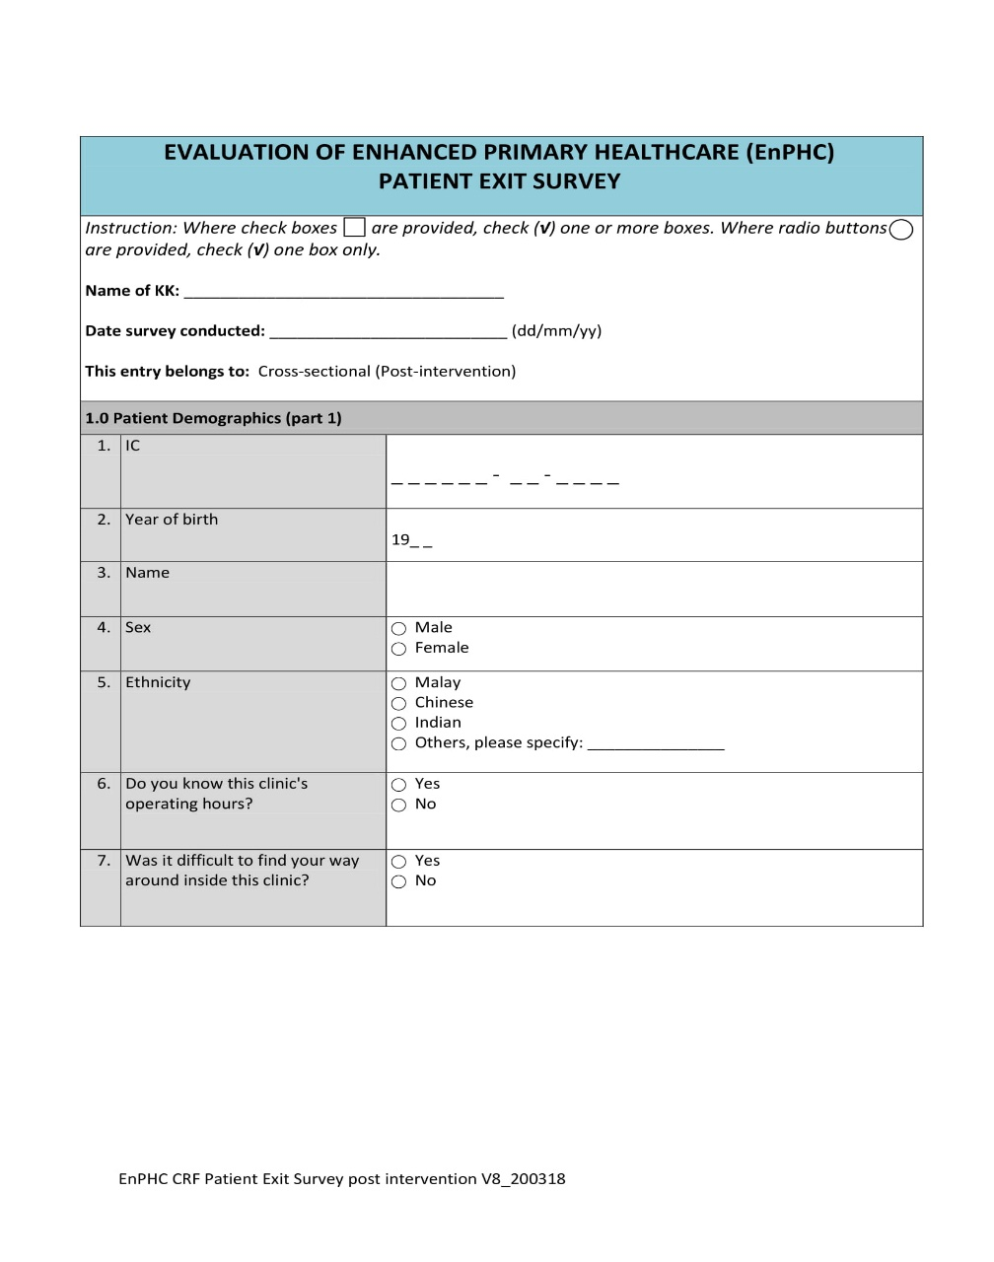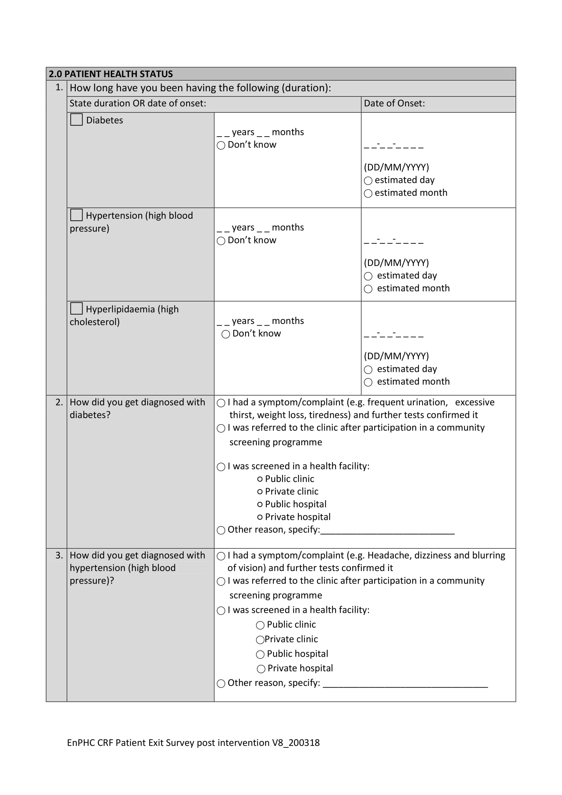

**Appendix B – Patient Exit Questionnaire (Continued)**

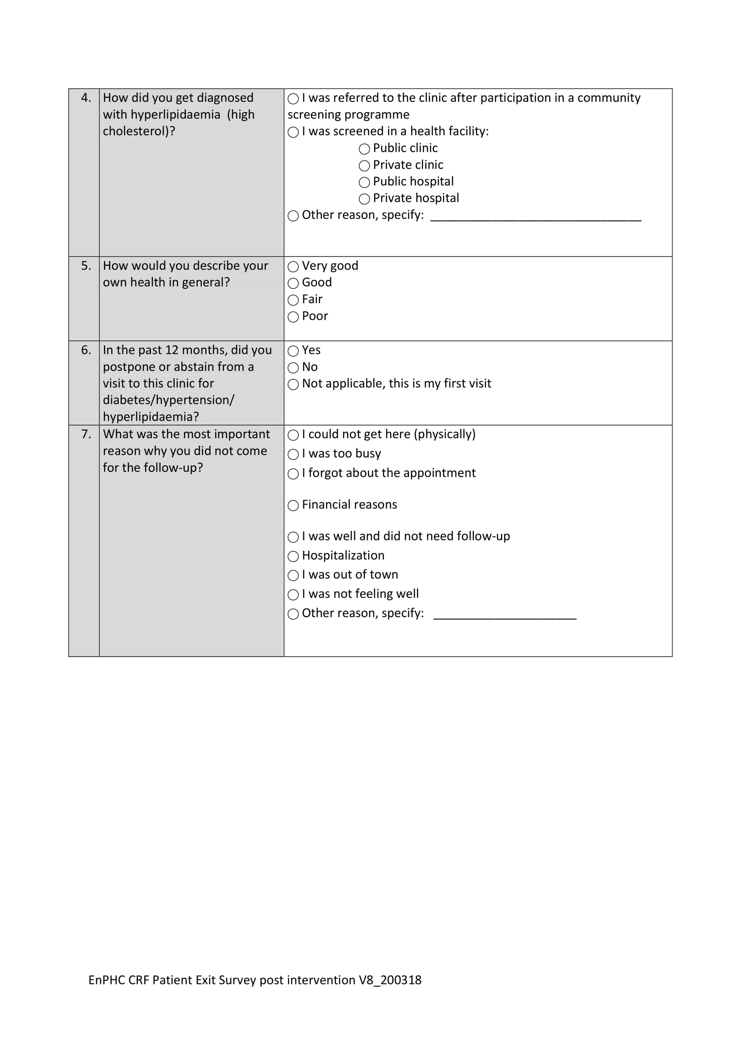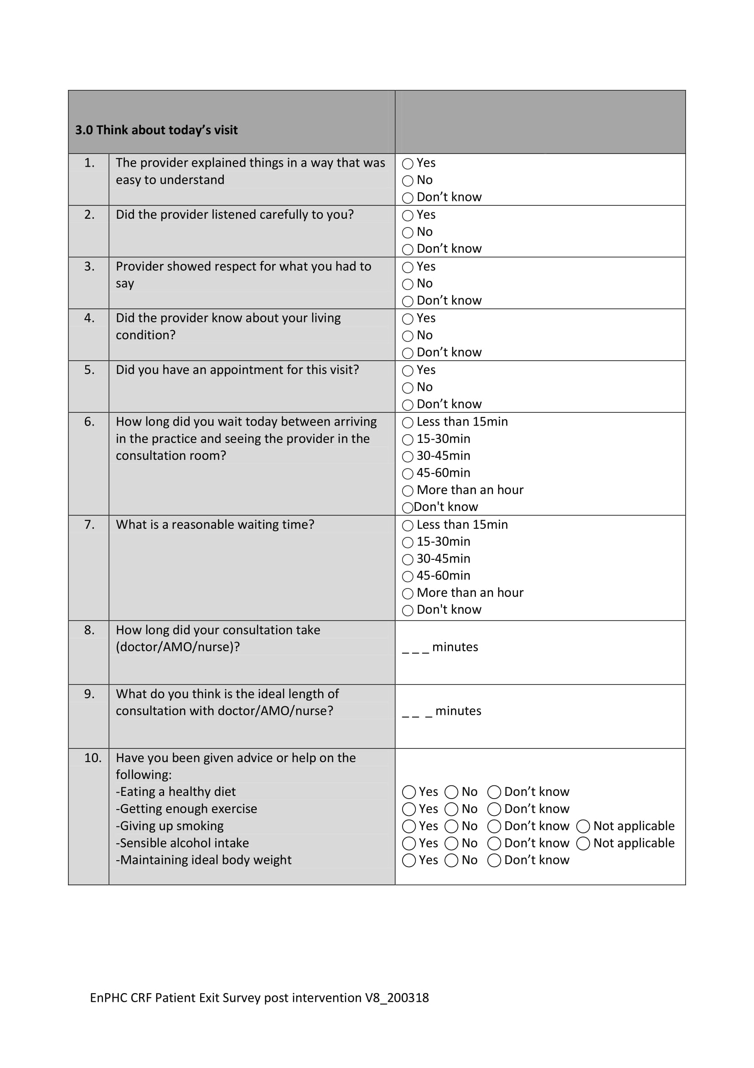

**Appendix B – Patient Exit Questionnaire (Continued)**

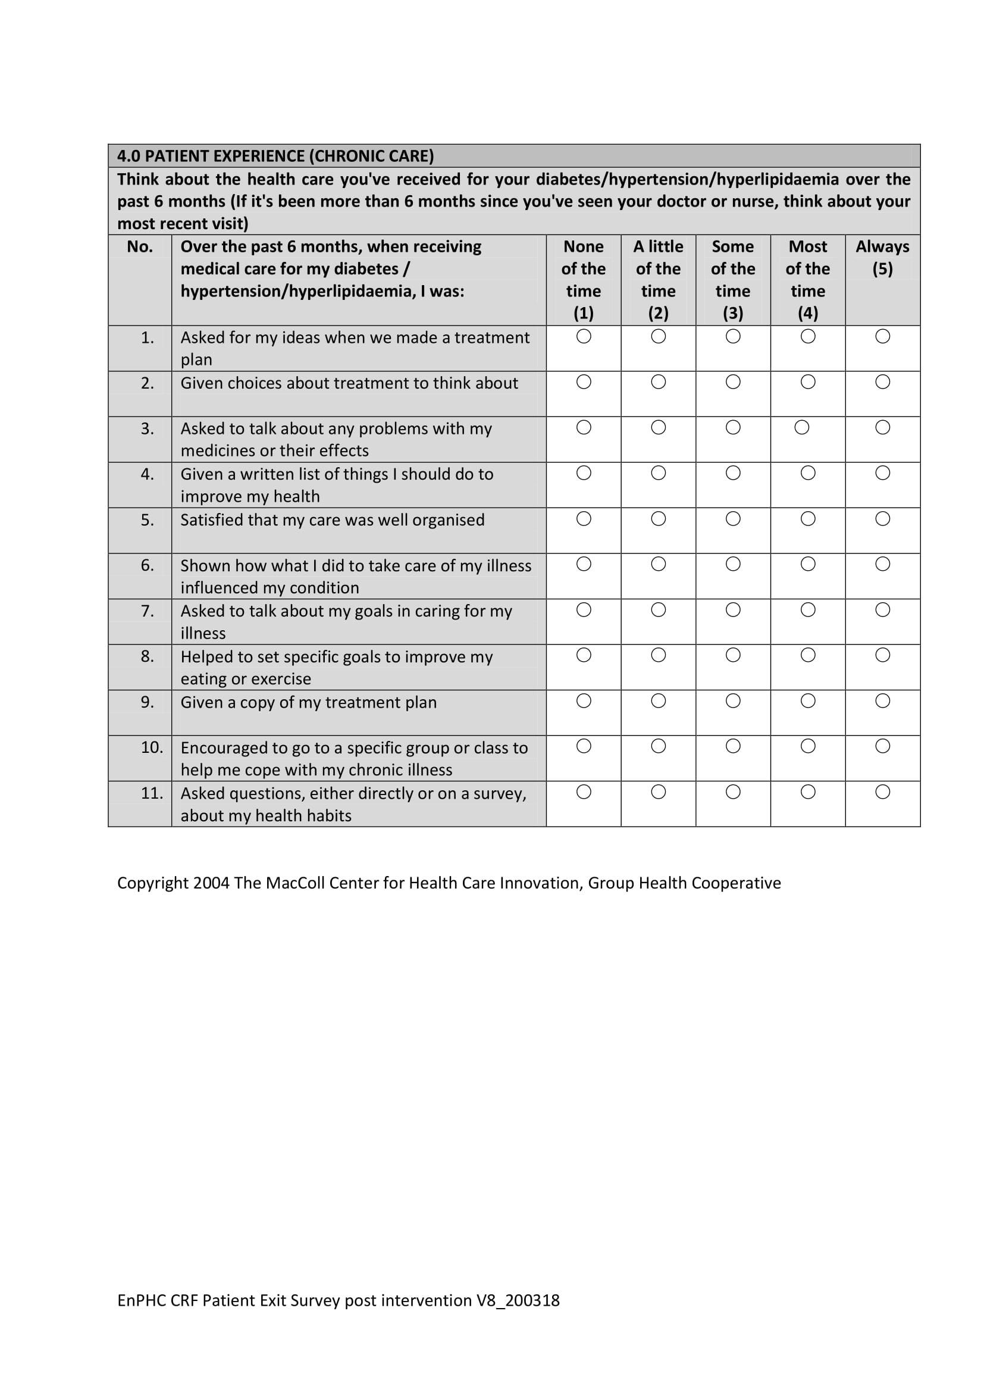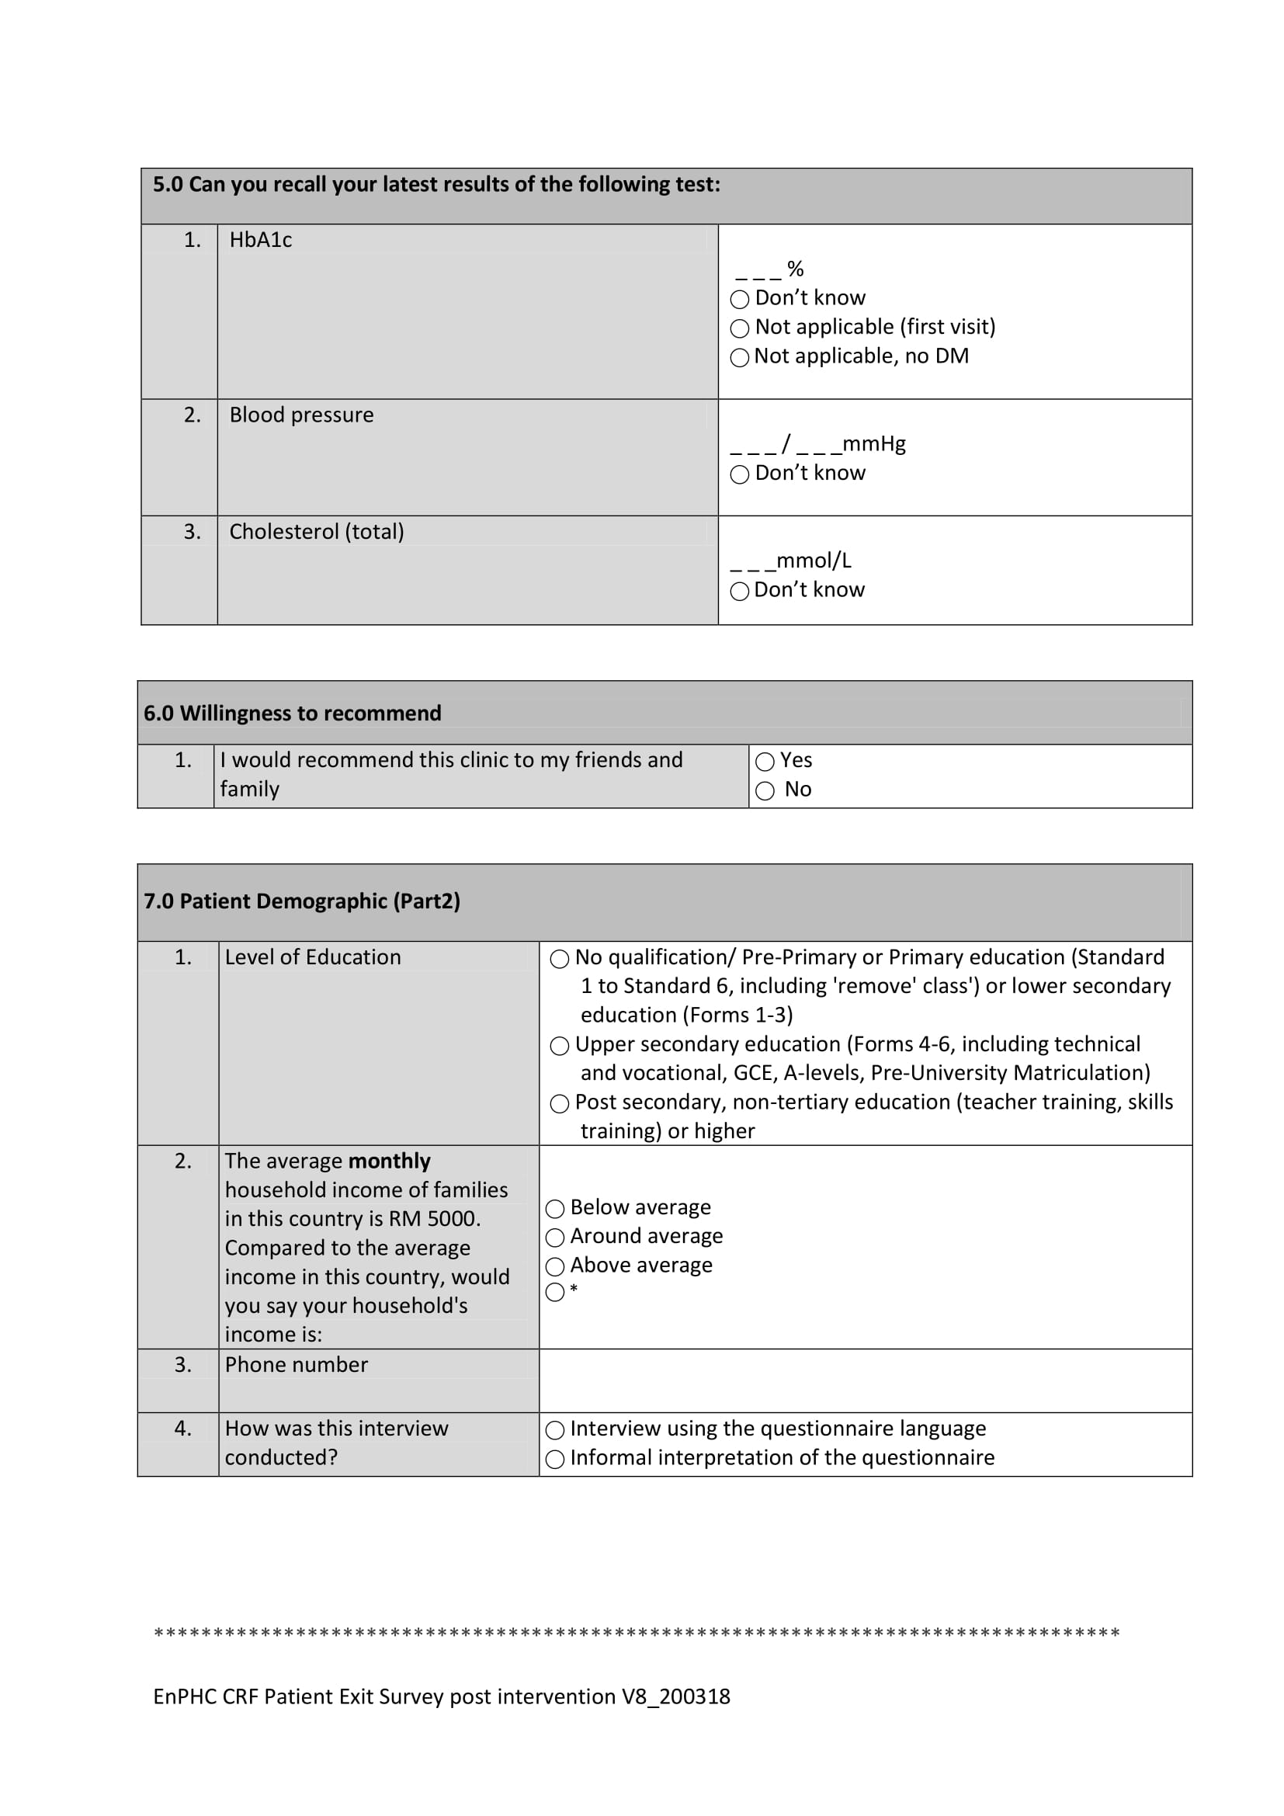

**Appendix B – Patient Exit Questionnaire (Continued)**

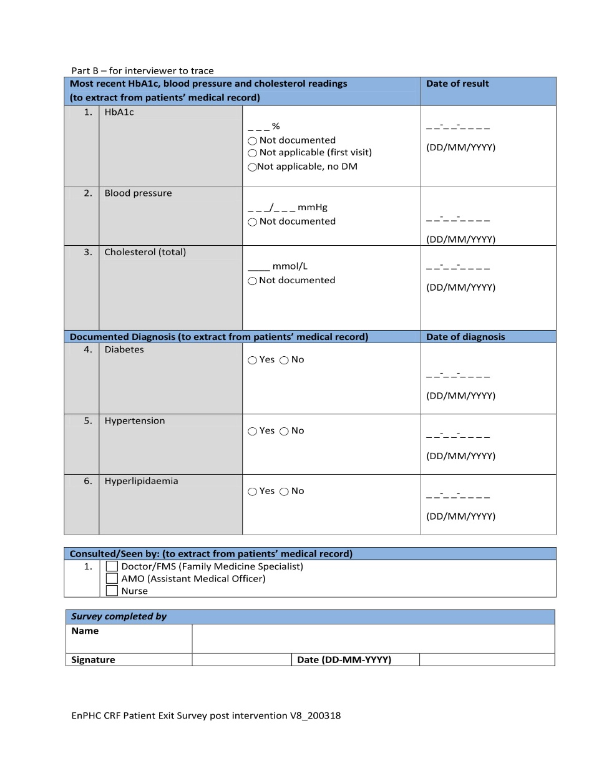

**Appendix C – Provider Questionnaire**

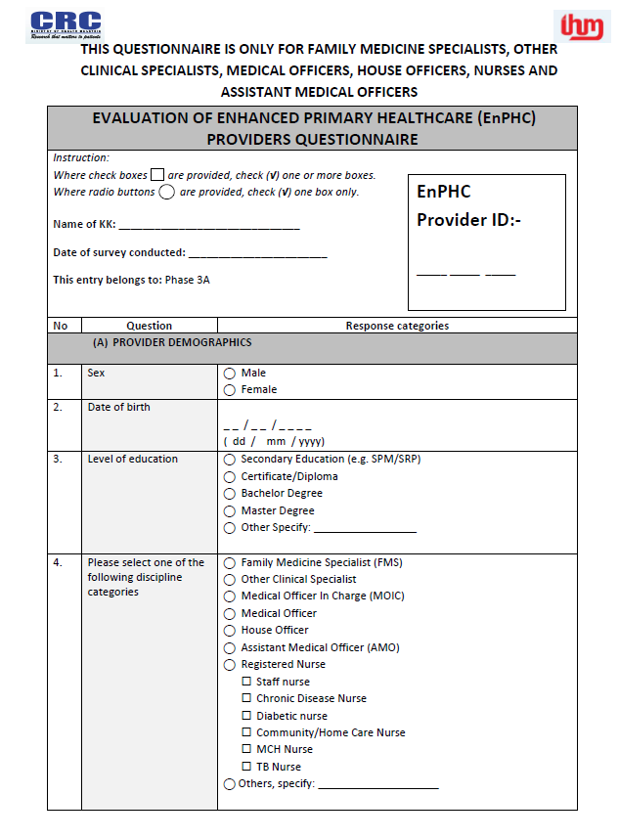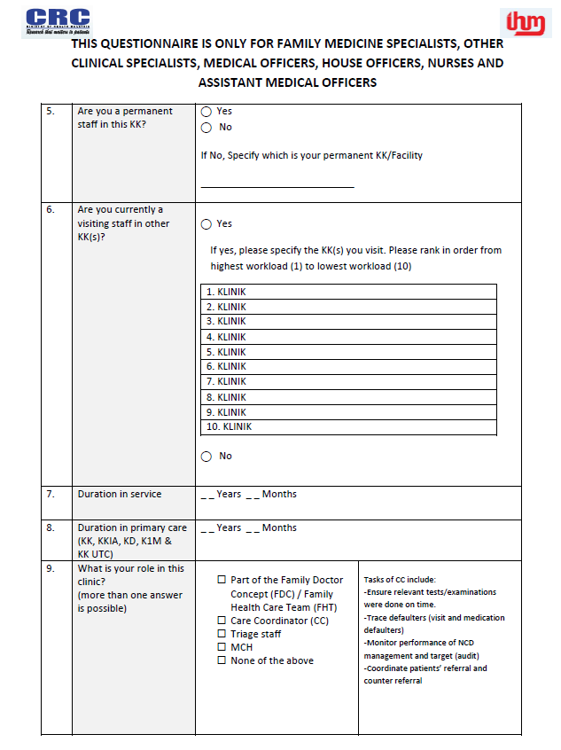

**Appendix C – Provider Questionnaire (Continued)**

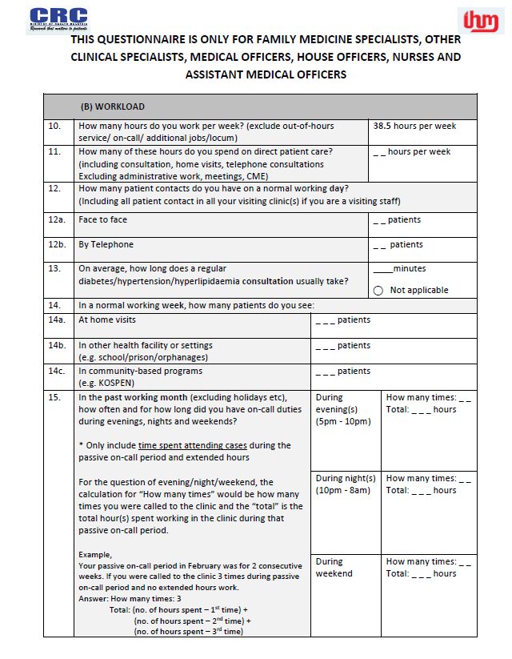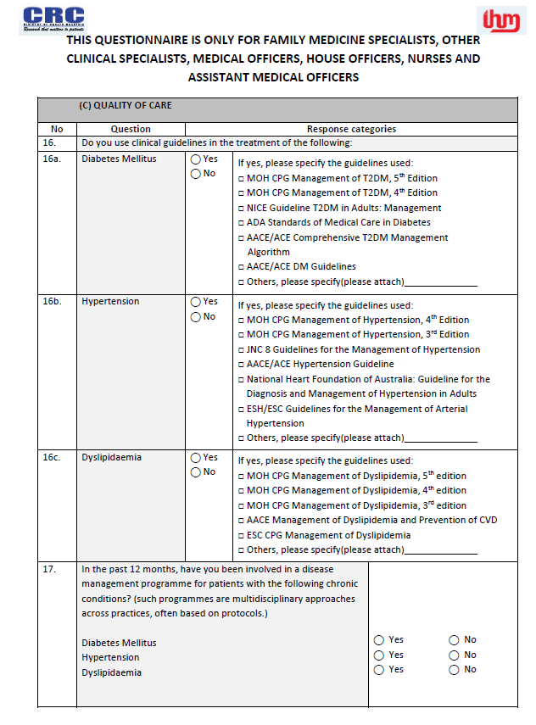

**Appendix C – Provider Questionnaire (Continued)**

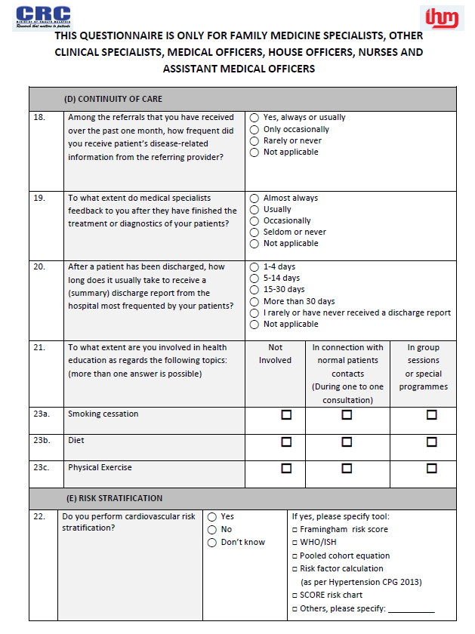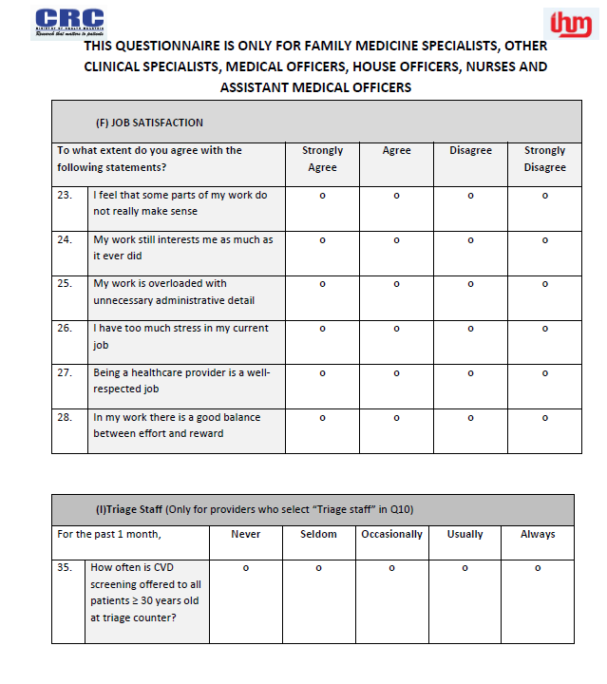

**Appendix D – Facility Questionnaire**

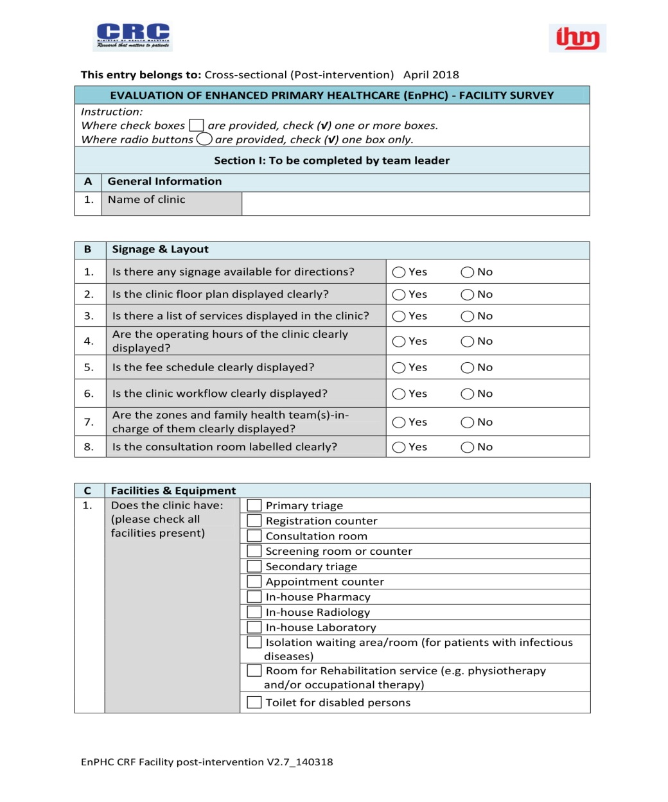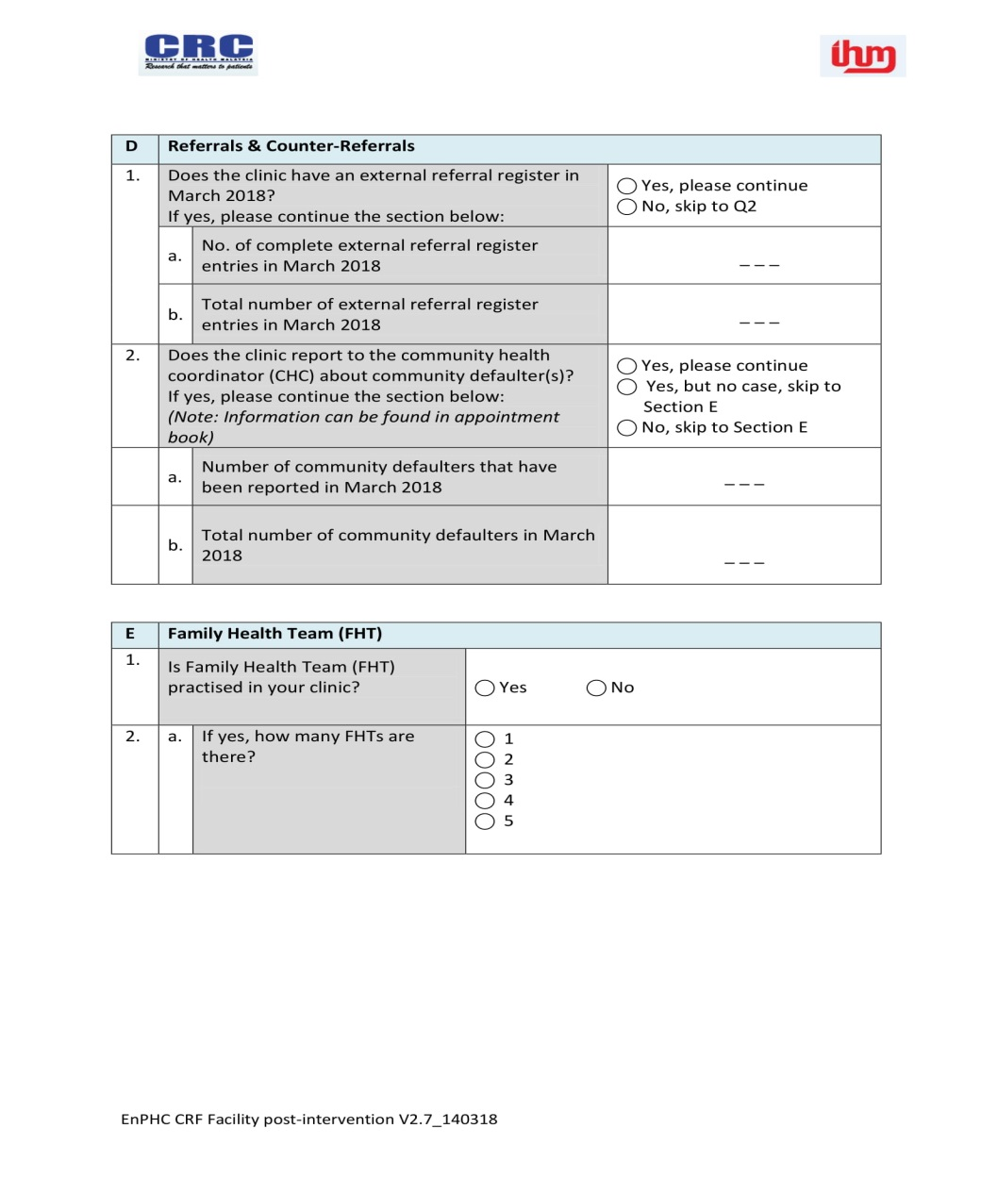

**Appendix D – Facility Questionnaire (Continued)**

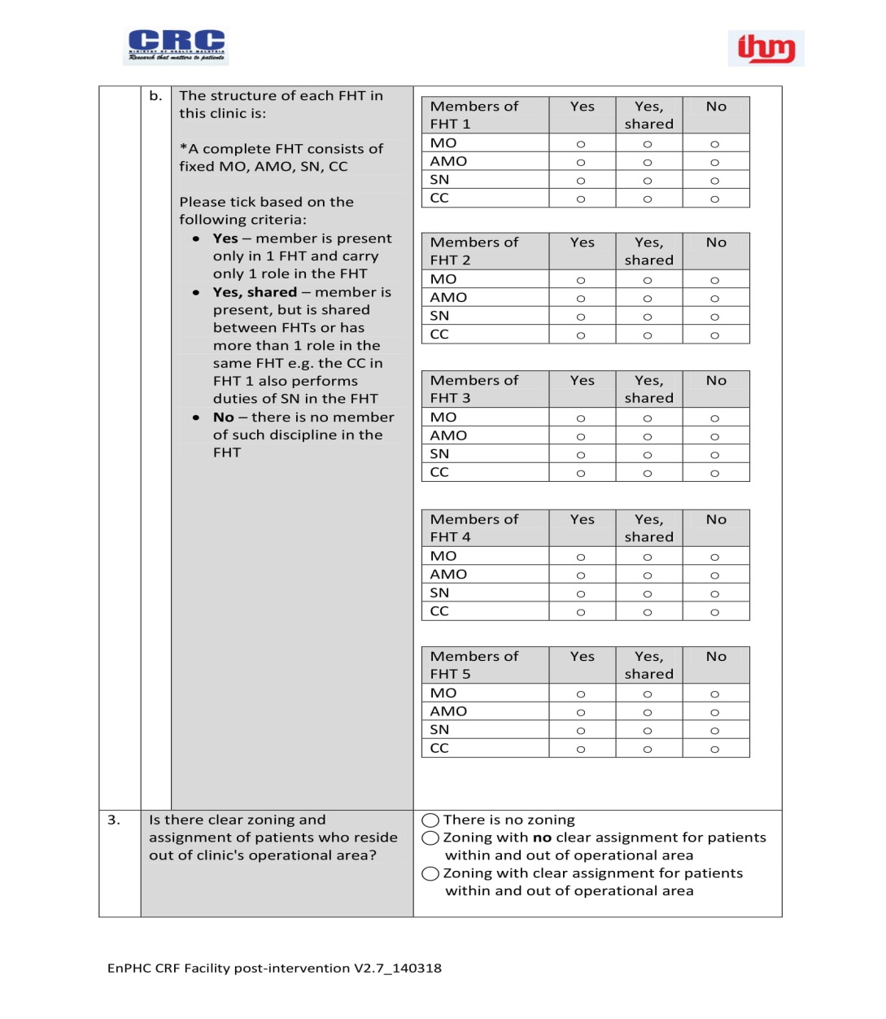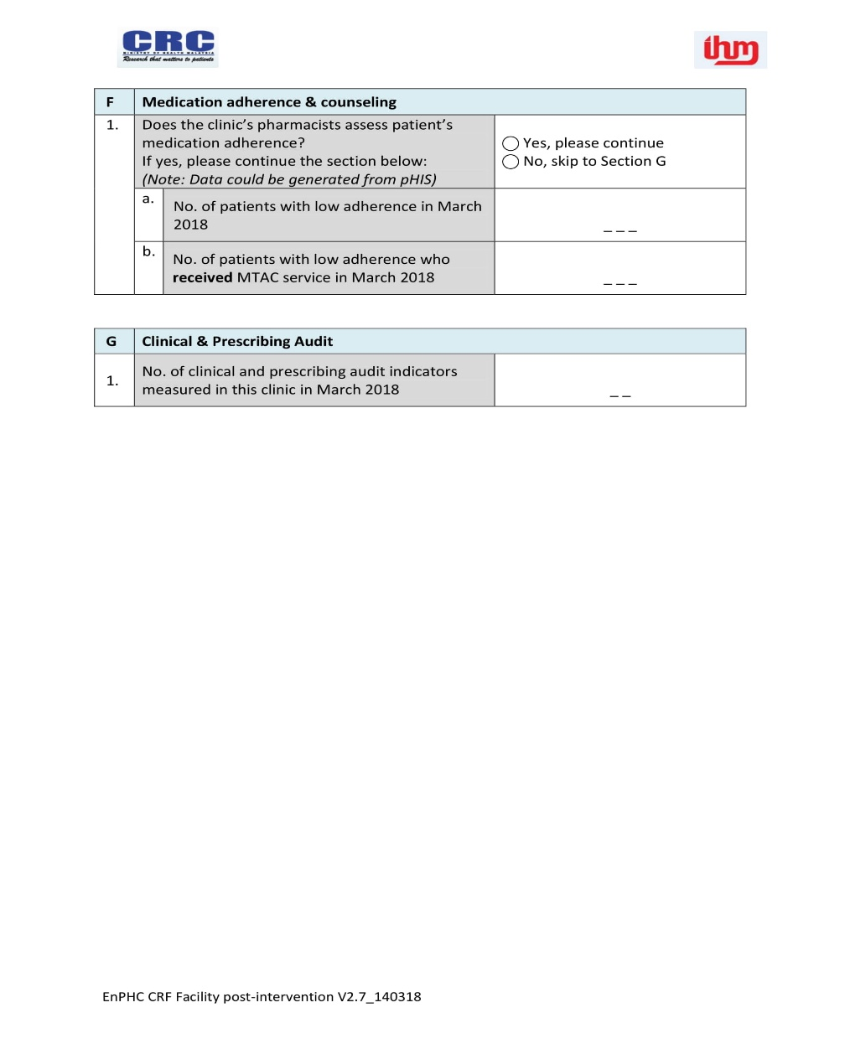

**Appendix D – Facility Questionnaire (Continued)**

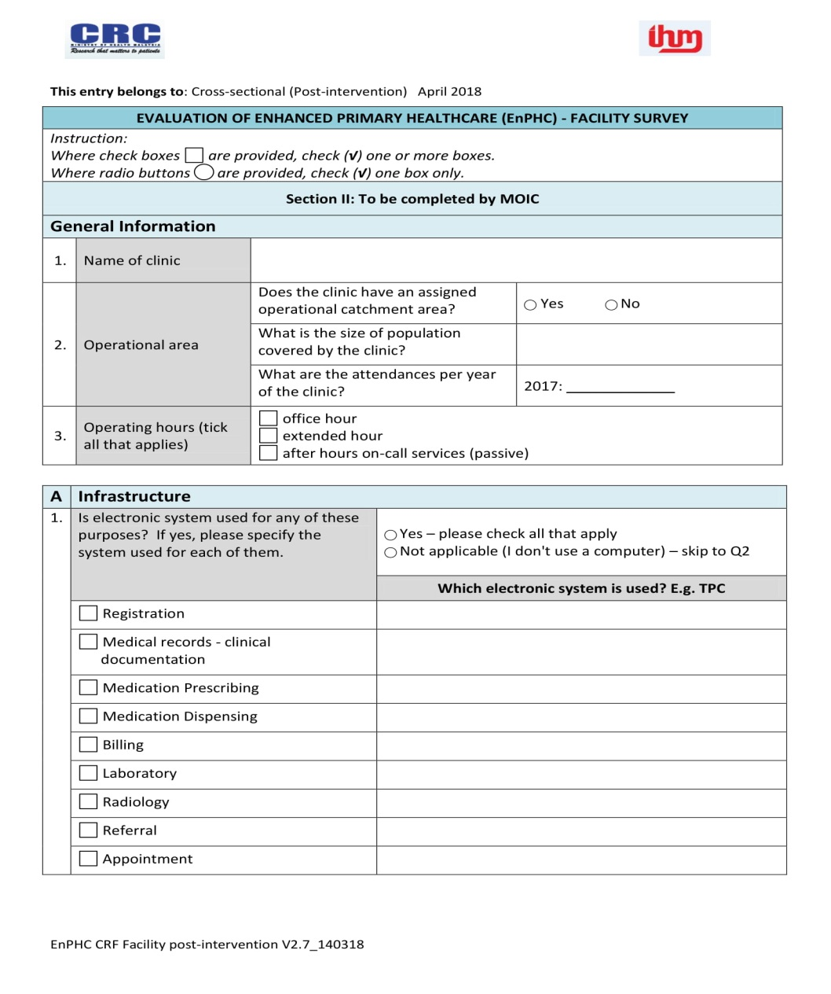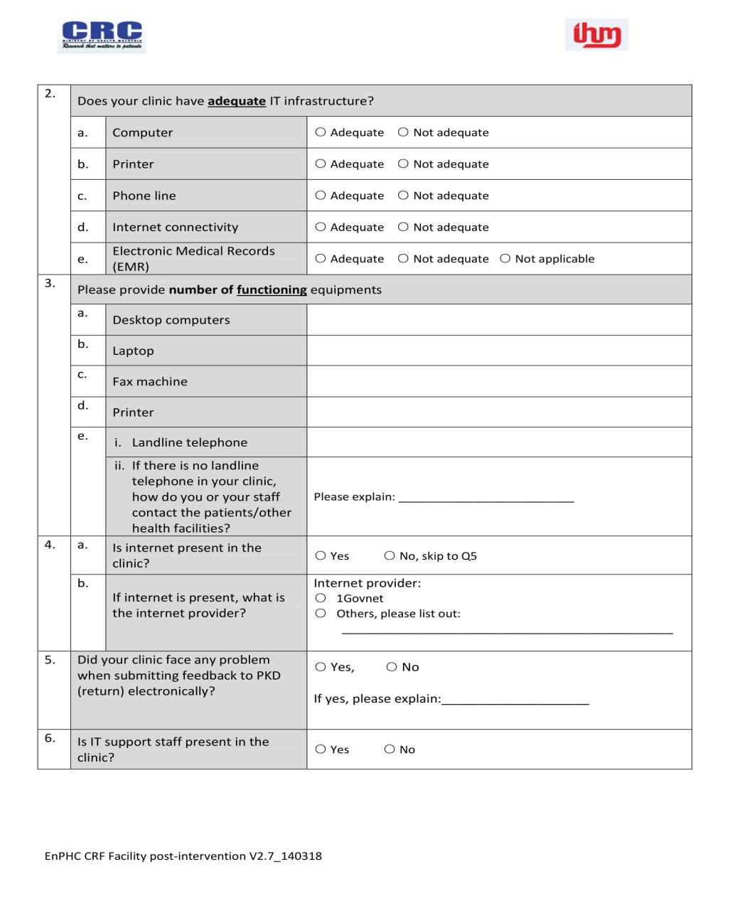

**Appendix D – Facility Questionnaire (Continued)**

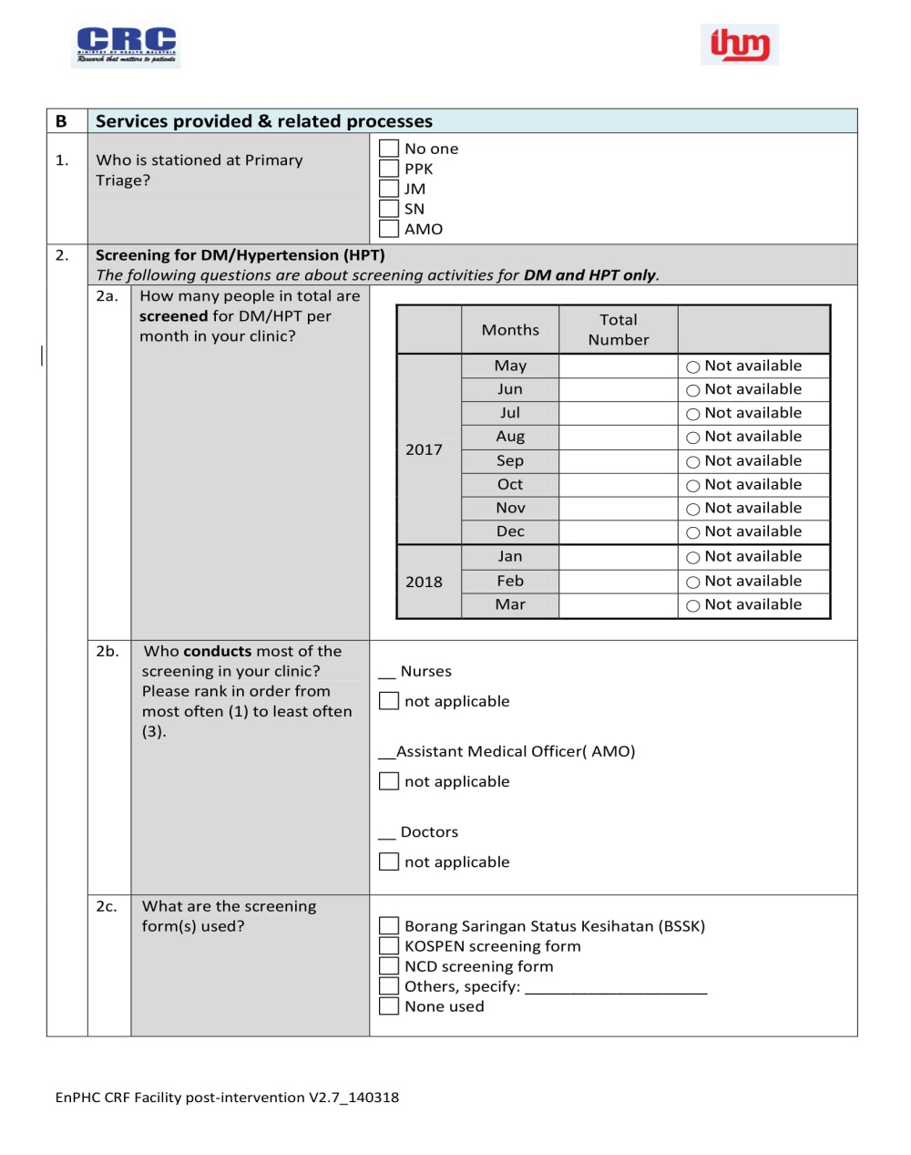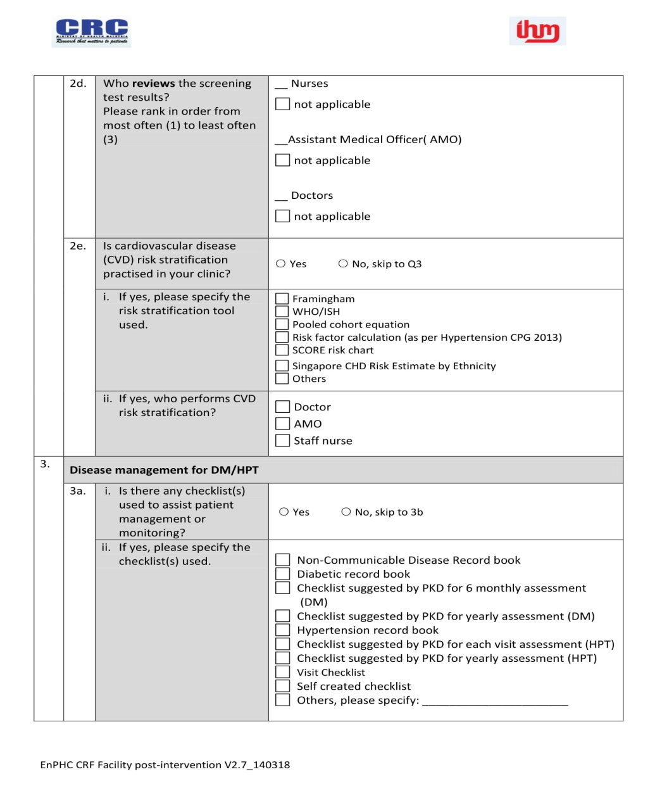

**Appendix D – Facility Questionnaire (Continued)**

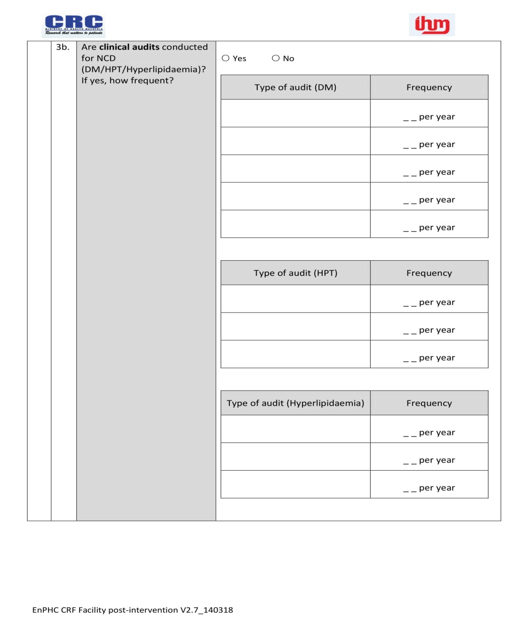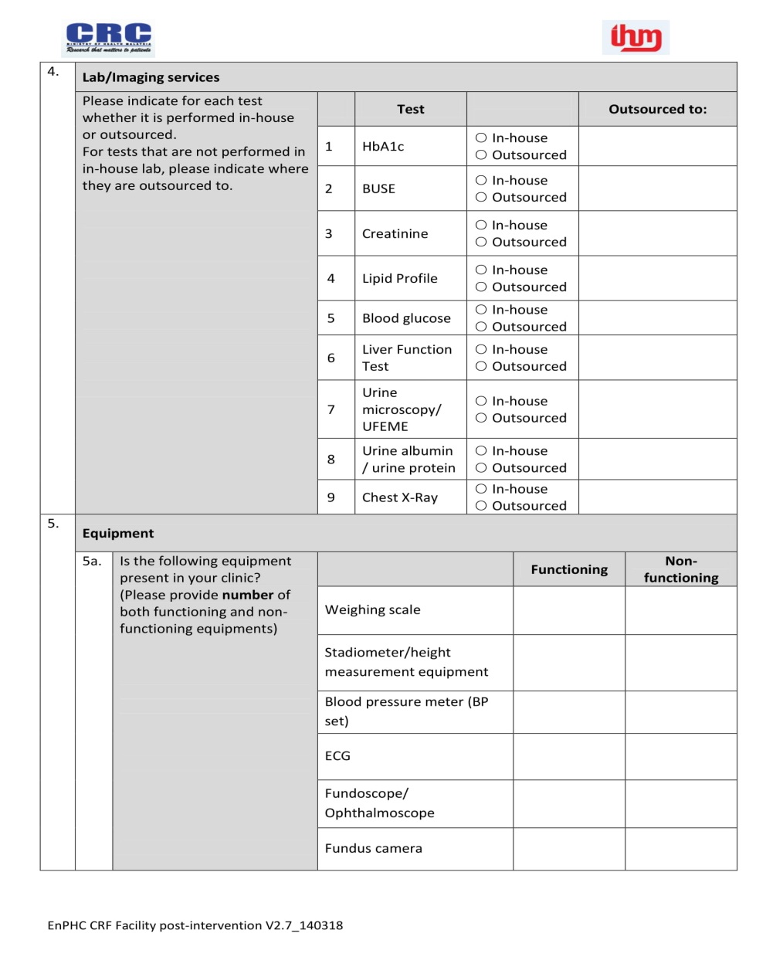

**Appendix D – Facility Questionnaire (Continued)**

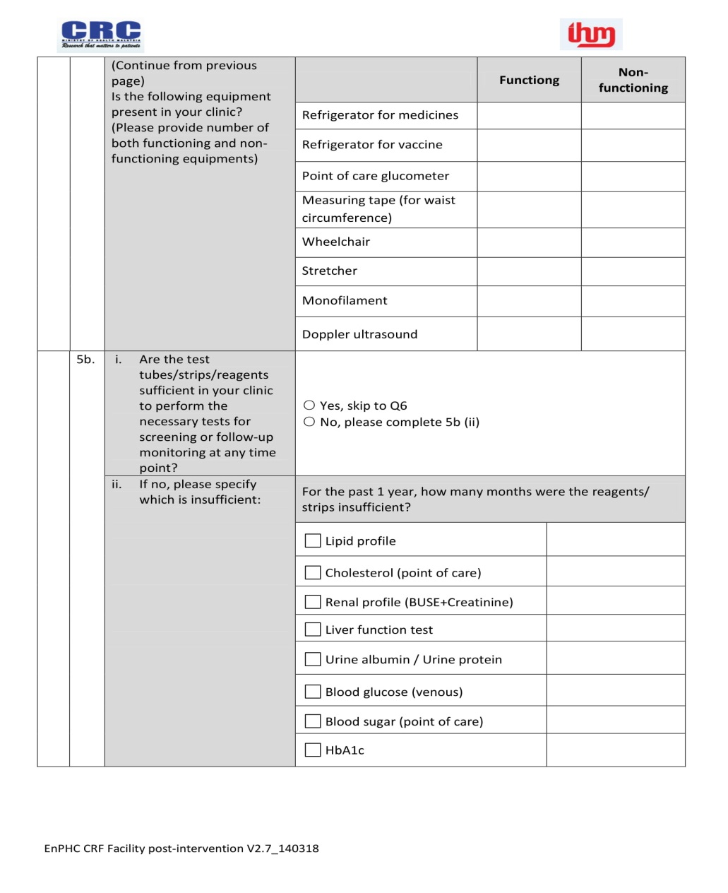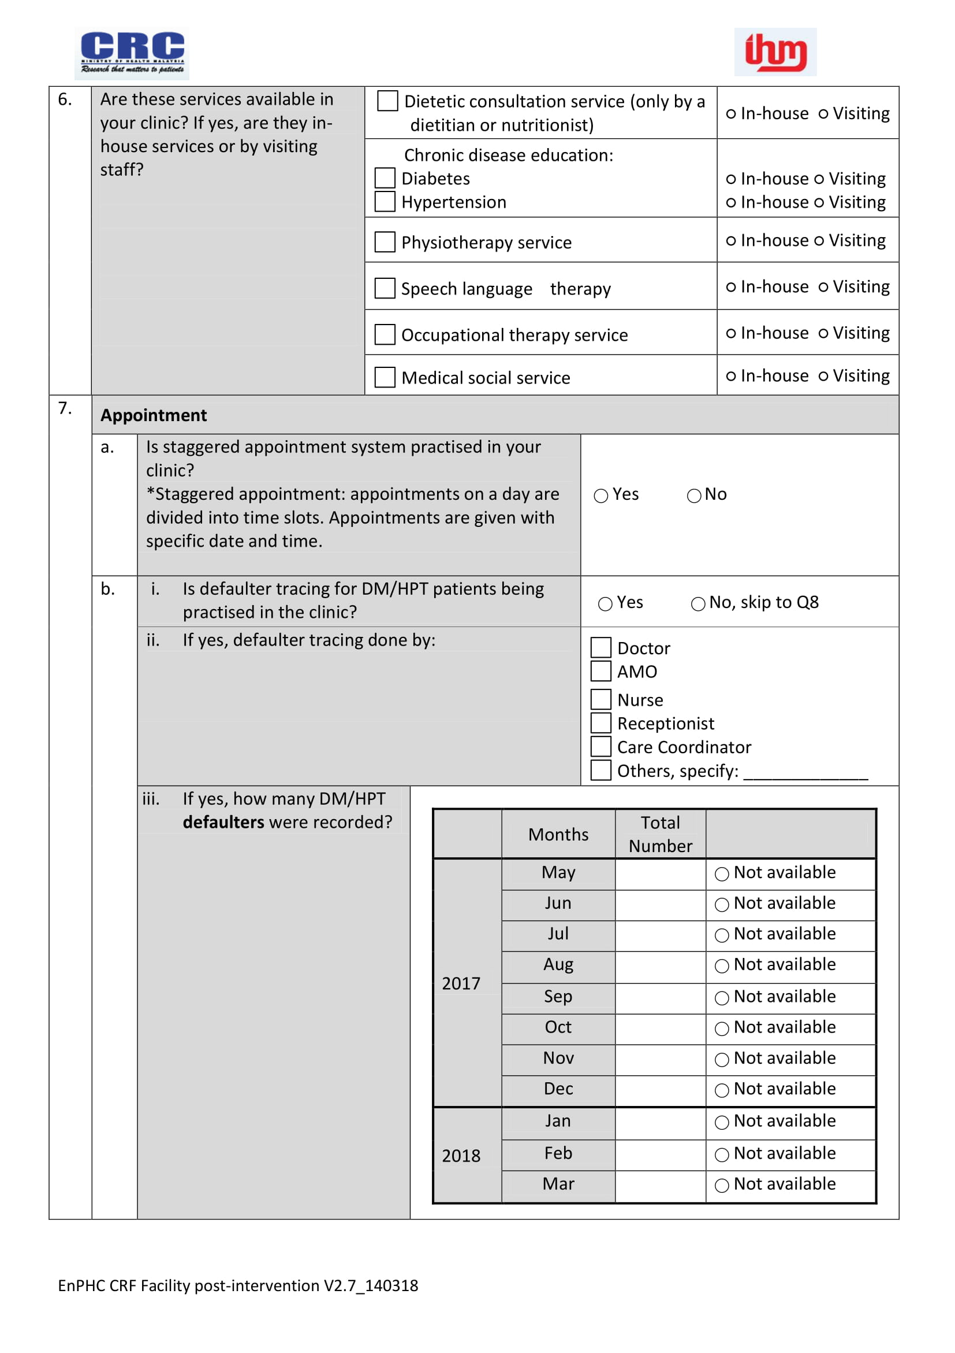

**Appendix D – Facility Questionnaire (Continued)**

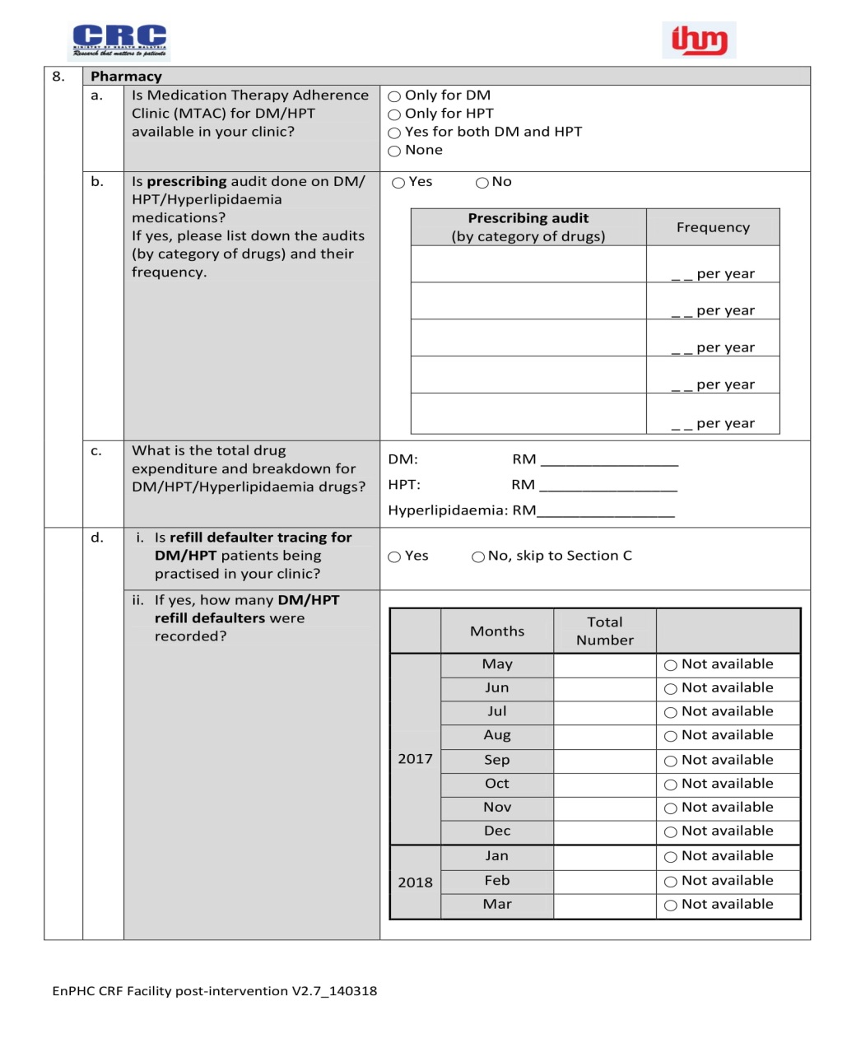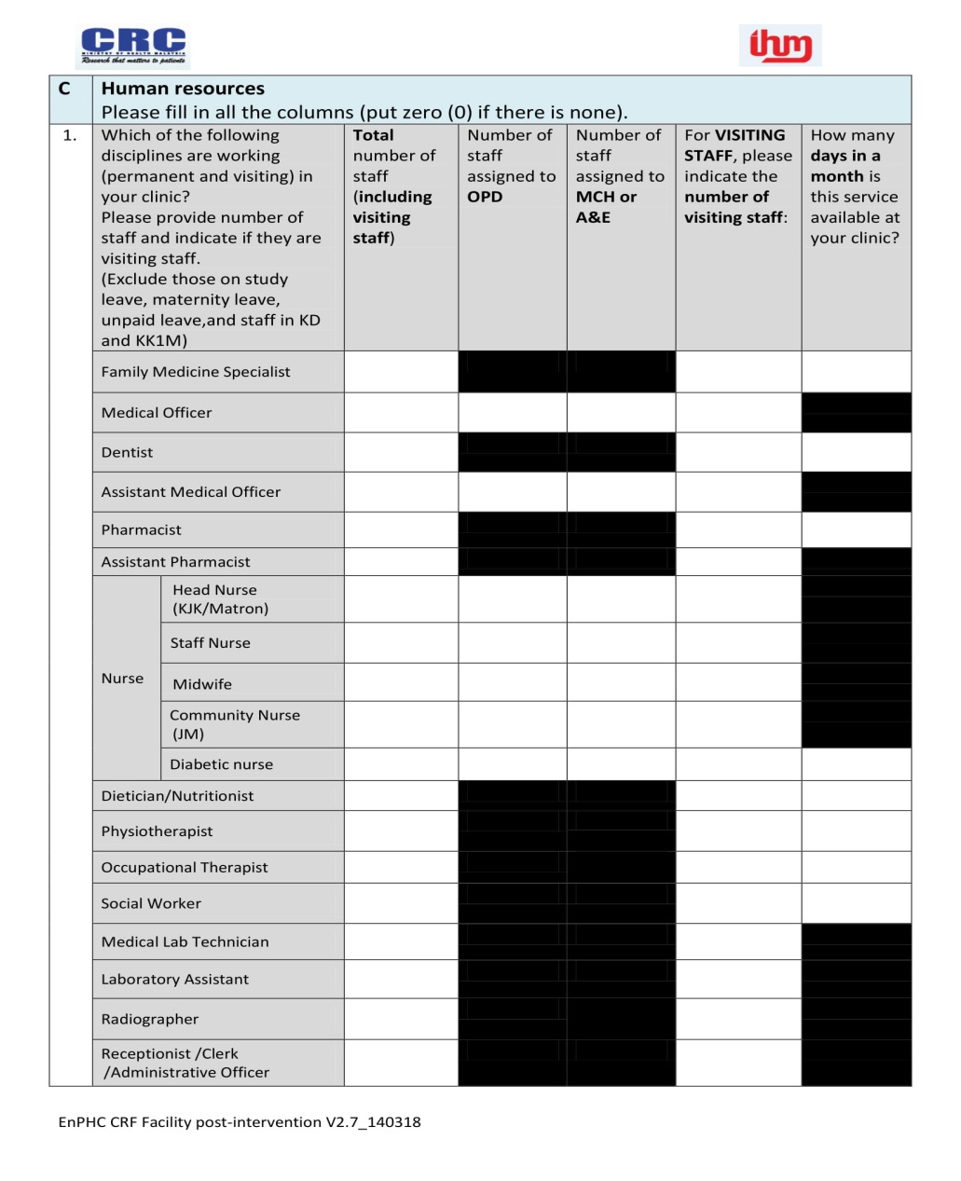

**Appendix D – Facility Questionnaire (Continued)**

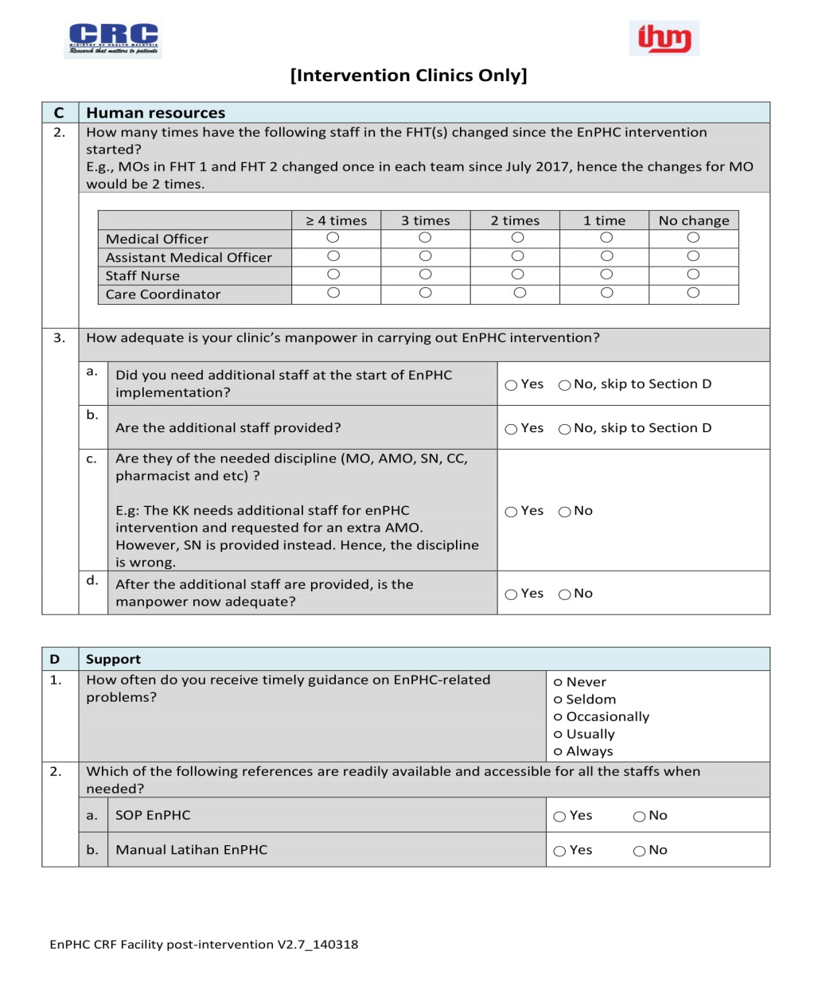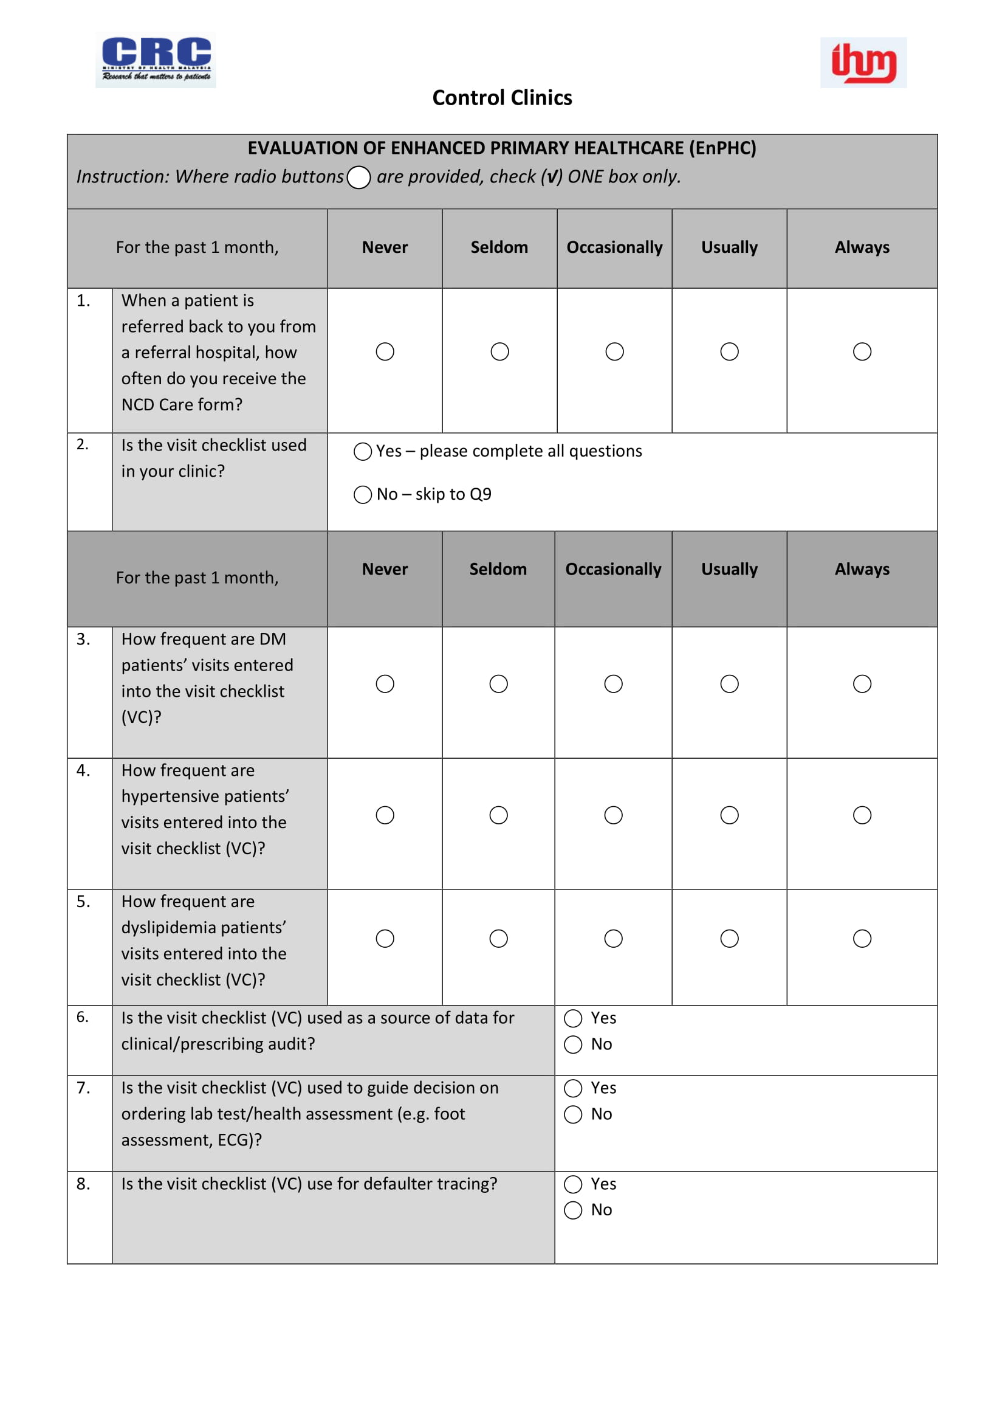

**Appendix D – Facility Questionnaire (Continued)**

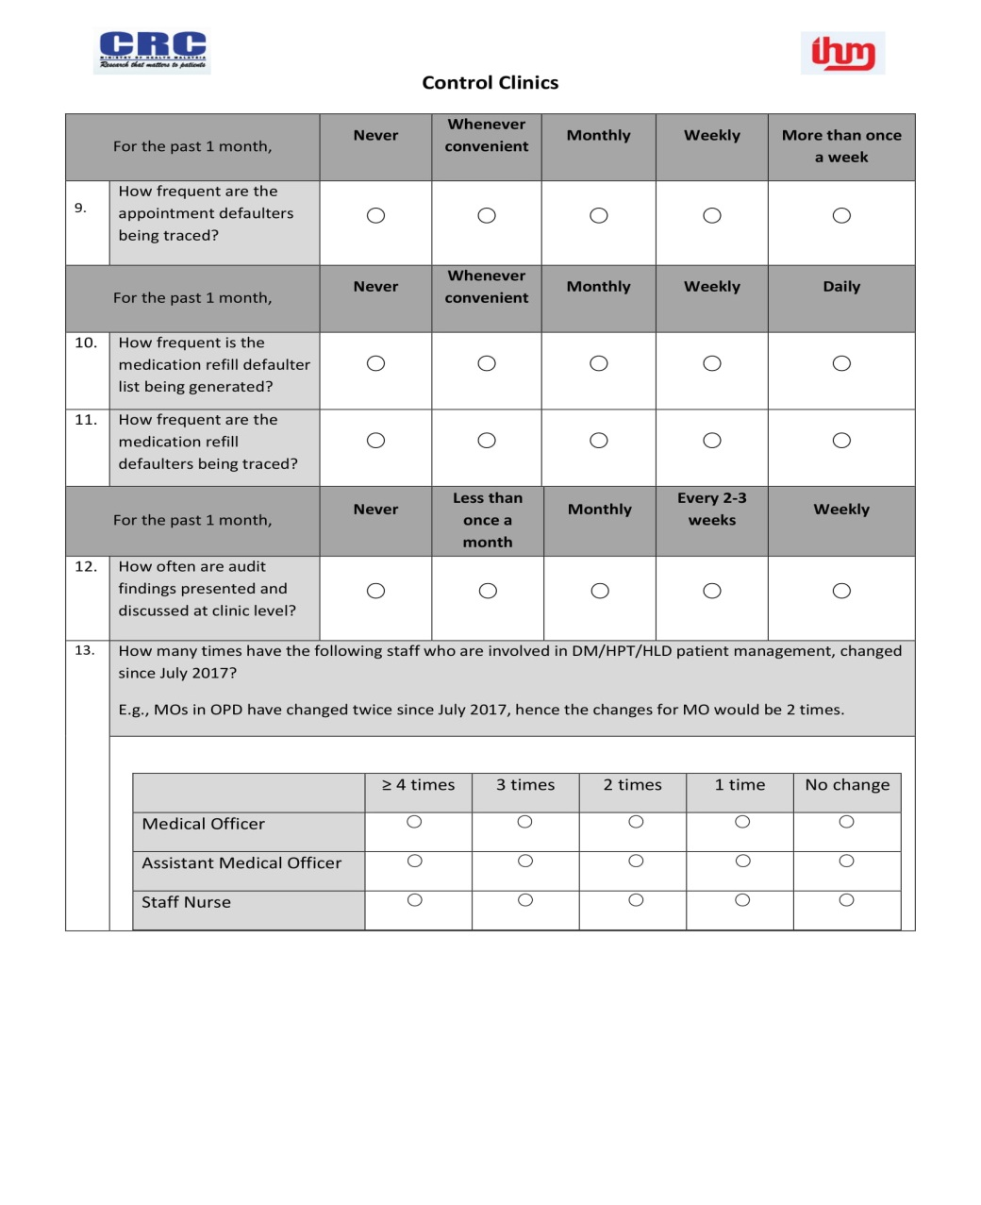

**Appendix E – Intervention Checklist**

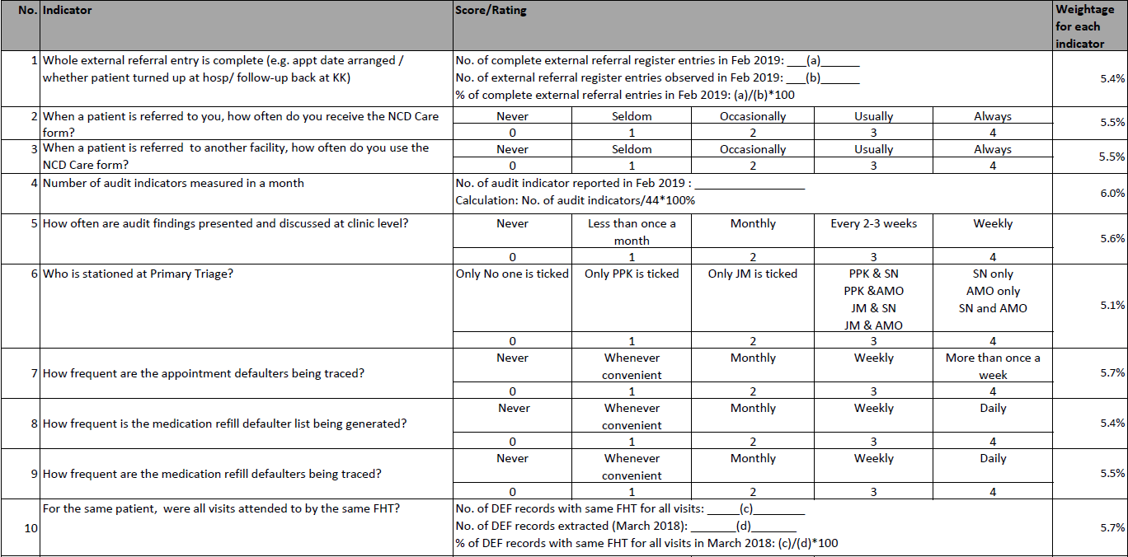

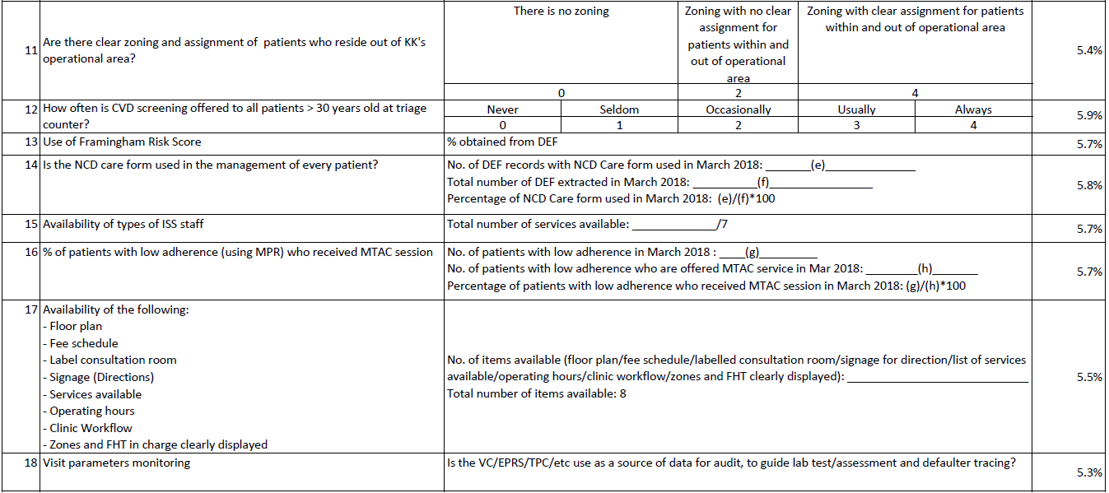

**Appendix F -- Key covariates**

|  |  |  |  |
| --- | --- | --- | --- |
|  | **Processes of Care and Intermediate Clinical Outcomes** | **Patient’s Experience** | **Healthcare Providers Satisfaction** |
| ***Patient level*** | Age  Sex  Race  Presence of target organ damage  Morbidities | Age  Sex  Race  Income  Morbidities  Disease duration  General health status  Difference between actual and ideal consultation time | Age  Sex  Education level  Job categories  Practice duration  Practice duration in primary care |
| ***Clinic level*** | Urban/Rural  Degree of Implementation | Urban/Rural  Degree of Implementation | Urban/Rural  Degree of Implementation |