Supplementary data
Key biological mechanisms involved in high-LET radiation therapies with a focus on DNA damage and repair
Zacharenia Nikitaki¹, Anastasia Velalopoulou², Vassiliki Zanni¹, Ioanna Tremi^{1,3}, Sophia Havaki³, Michael Kokkoris¹, Vassilis G. Gorgoulis^{3,4,5,6,7}, Constantinos Koumenis² and Alexandros G. Georgakilas^{1,#}
1. Department of Physics, School of Applied Mathematical and Physical Sciences, National Technical University of Athens (NTUA), Zografou Campus, 15780 Athens, Greece. znikitaki@mail.ntua.gr, fte17010@mail.ntua.gr, ioannatremi@mail.ntua.gr, kokkoris@central.ntua.gr, alexg@mail.ntua.gr
2. Department of Radiation Oncology, Perelman School of Medicine, University of Pennsylvania, Philadelphia, Pennsylvania, 19104 USA. avela@pennmedicine.upenn.edu, Costas.Koumenis@pennmedicine.upenn.edu
3. Molecular Carcinogenesis Group, Department of Histology and Embryology, School of Medicine, National and Kapodistrian University of Athens, 75 Mikras Asias Street, 11527 Athens, Greece. vgorg@med.uoa.gr, shavaki@med.uoa.gr.
4. Biomedical Research Foundation, Academy of Athens, Greece.
5. Faculty Institute for Cancer Sciences, Manchester Academic Health Sciences Centre, University of Manchester, UK.
6. Center for New Biotechnologies and Precision Medicine, Medical School, National and Kapodistrian University of Athens, Greece.
7. Faculty of Health and Medical Sciences, University of Surrey, Surrey, UK
#Correspondence: Alexandros G. Georgakilas. alexg@mail.ntua.gr

Proton-and neutron-boron capture therapy
To aid the understanding of this topic of proton or boron neutron capture therapy, we present some analysis of the associated phenomena but more is beyond the scope of the present review.
Proton-boron capture therapy
We provide an approximate estimation of the kinetic energy that has to be shared among the three α-particles:
0.675*11/12 + 8.59 = 9.265 MeV (Eq. 1)
From this energy (Eq.1) a fraction of about 2/3 will be transferred to α₀ and the rest will be shared by the two other particles, due to the Momentum Conservation Principle. Moreover, the exact amount of $Τ_{α_{0}}$depends on the emission angle. We have calculated the range of values for each case using catkin 2.03 (http://personal.ph.surrey.ac.uk/~phs1wc/kinematics/) kinematics calculator. The range of the energy values is calculated by considering several emission angles:
$Τ_{α_{0}}$is in the range of 5.476 – 6.837 MeV and the α-particles originating from the subsequent decay of ⁸Be have an equal amount of T, which is within the range of 1.214-1.89 MeV.
$Τ_{α_{1}}$is in the range of 3.58 – 4.7 MeV and the α–particles originating from the subsequent decay of ⁸Be* have an equal amount of T, which is within the range of 2.285-2.843 MeV.
Regarding the one step reaction, since three particles are generated at once, there is a three body system, and no general closed-form solution exists.
By utilizing raw data derived from simulations of previous work [1] we have calculated the corresponding LET values for the abovementioned energy values in water (Table S1).

Table S1: LET values of α-particles in water for characteristic values of Energy in PBCT. The maximum LET value -which corresponds to 0.64 MeV- is also included.

Energy (MeV) | LET in water  (keV/μm)
5.476 – 6.837 | < 91
4.7 | 93
3.58 | 96
2.243 | 132
2.285 | 149
1.89 | 166
1.214 | 207
0.64 | 231
0.04 | 68

Since, by definition, the emitted α-particles present a continuous angular distribution, and taking into account that the corresponding angular emission probabilities cannot be a priori known and have not been thoroughly studied experimentally, e.g. [https://www-nds.iaea.org/exfor/], each one of them may have any amount of energy within the abovementioned ranges. Correspondingly, α-particles can be emitted having a plethora of LET values. Table S1 highlights the PBCT potential, since any emitted particle, during its impeding trajectory will inevitably reach the energy value of 0.64 MeV where the LET reaches its maximum, i.e. 231 keV/μm. It should be noted here that the maximum range of 6.837 MeV a-particles in water is approximately 59.4 μm, following standard SRIM2013 stopping power calculations [2, 3]. It should be noted herein that in contrast to proton-Boron fusion, where the emitted α-particles take energies from a range, in Boron-neutron fusion, the ejectile-α as well as the recoil-Li have –in good approximation- constant values of energy.

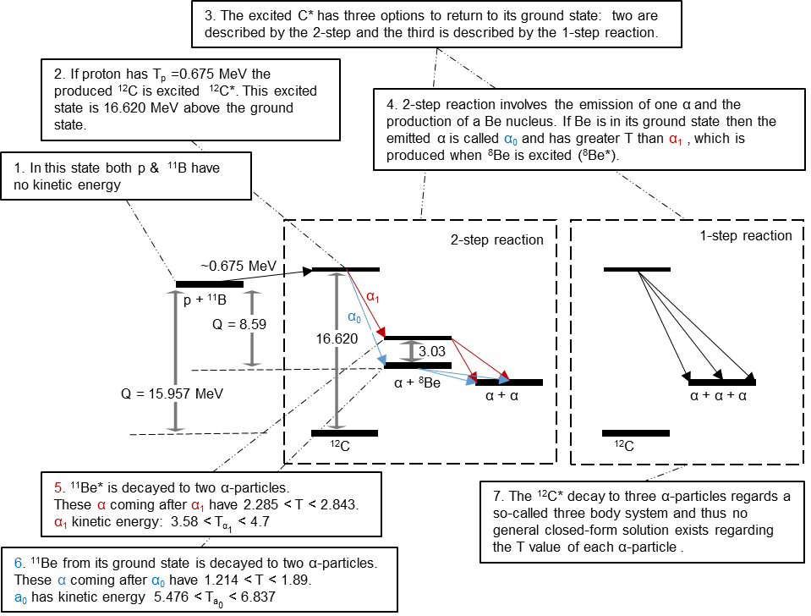

Figure S1. Energy levels implicated in the proton-¹¹Boron fusion and in the subsequent disassociation to α-particle & ⁸Be / ⁸Be*, involved in proton-boron capture therapy-PBCT. Our illustration begins with the system of proton and 11B being motionless. The amount of kinetic energy that is required for the proton is just 0.675 MeV, then if the fusion happens, a compound nucleus, a ¹²C* is created. The excited state of ¹²C that is produced at the resonance of 0.675 MeV is 16.620 MeV above the ground state. The subsequent ¹²C* decay may occur via 1-step or 2-step reactions. In the case of a 2-step reaction the intermediate product is the ⁸Be or the ⁸Be* (excited) nucleus. Both immediately decay to two α-particles. The α-particle that leads the system to the ground state of ⁸Be is called α₀, while α₁ is called the one that leads to the excited state ⁸Be*. ⁸Be can be found either in its ground (see n.r. 2 main text) or in its first excited state, at 3.03 MeV (⁸Be*). ⁸Be or ⁸Be* in its turn disassociates to two α-particles. Between the mechanisms of the 2-step reaction the predominant is the one that involves ⁸Be*. We need to mention here that ⁸Be is an isotope of beryllium, having a half live of 8 x 10⁻¹⁷ s; the stable isotope is ⁹Be.

Boron neutron capture therapy

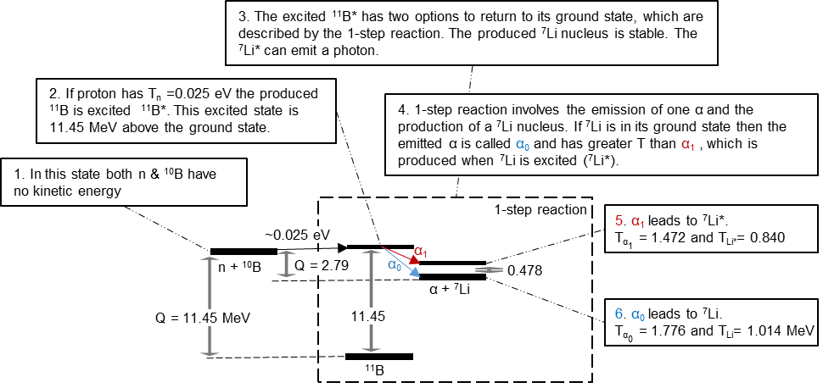
Figure S2. Energy levels implicated in the ¹⁰Boron-neutron fusion and in the subsequent disassociation to α-particle & ⁷Li /⁷Li*, involved in boron-neutron capture therapy-BNCT.

Using simulations from our previous work [1] we have calculated the corresponding LET values for the abovementioned energy values in water (Table S2).

Table S2: LET values of α-particles in water for characteristic values of Energy in NBCT. The maximum LET value -which corresponds to 0.64 MeV- is also included.
Energy (MeV) | LET in water  (keV/μm)
1.776 | 173
1.472 | 191
0.64 | 231
0.04 | 68

References
1. Nikitaki, Z., et al. (2021) Construction and evaluation of an α-particle-irradiation exposure apparatus. 97(10), 1404-16
2. Ziegler, J.F., Ziegler, M.D. and Biersack, J.P. (2010) SRIM–The stopping and range of ions in matter (2010). Nuclear Instruments and Methods in Physics Research Section B: Beam Interactions with Materials and Atoms 268(11-12), 1818-23
3. Ziegler, J. (2013) SRIM & TRIM. http://www.srim.org/

