A Primate on a Fresco from the Mycenaean Acropolis of Tiryns
Dionisios Youlatos, Bernardo Urbani And Julia Binnberg

Supplementary Material

Supplementary Table S1. Chromatic characterization of the primatomorphic miniature fresco from Tiryns using the Munsell Colour Chart™. The location of the reference points is given in Figure S1.
Reference points | Munsell code | Munsell colour
1 | 7.5R/4/1 | dark reddish grey
2 | GLEY2/5/5/BG | greenish grey
3 | 5R/2.5/3 | very dusky red
4 | GLEY1/5/5GY | greenish grey
5 | 5R/2.5/3 | very dusky red
6 | 7.5R/2.5/4 | very dusky red
7 | GLEY2/5/5BG | greenish grey
8 | 5R/3/4 | dusky red
9 | 2.5YR/2.5/3 | dark reddish brown
10 | GLEY2/5/10G | greenish grey
11 | 5R/2.5/6 | dark red
12 | GLEY2/5/5BG | greenish grey
13 | 2.5YR/2.5/4 | dark reddish brown
14 | 2.5YR/3/6 | dark red
15 | GLEY2/4/10G | dark greenish grey
16 | 2.5YR/3/3 | dark reddish brown
17 | GLEY2/5/5BG | greenish grey
18 | 2.5YR/2.5/4 | dark reddish brown
19 | 7.5R/2.5/4 | very dusky red
20 | WHITE/2.5Y-1/8 | white
21 | WHITE/10YR-2/8 | pinkish white
22 | WHITE/2.5Y-1/8 | white
23 | 5YR/4/6 | yellowish red
24 | 7.5R/2.5/4 | very dusky red

Supplementary Figure S1. Reference points for the colour measurements (Munsell Colour Chart™) of the primatomorphic miniature fresco from Tiryns. See Table S1. The bar equals 1 cm.
Photograph by D. Youlatos with permission from the Εθνικό Αρχαιολογικό Μουσείο, Συλλογή Προϊστορικών, Αιγυπτιακών, Κυπριακών και Ανατολικών Αρχαιοτήτων, ©Υπουργείο Πολιτισμού και Αθλητισμού/ ΟΔΑΠ (National Archaeological Museum, Athens, Department Prehistoric, Egyptian, Cypriot and Near Eastern Antiquities), ©Hellenic Ministry of Culture and Sports/ HCRMDO.
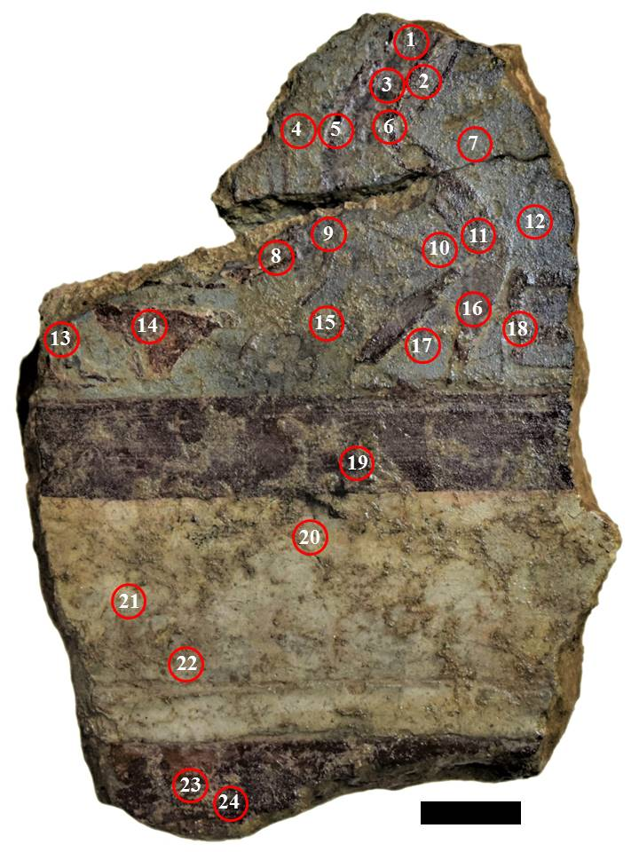

Supplementary Figure S2. Back of the primatomorphic miniature fresco from Tiryns. The bar equals 1 cm.
Photograph by D. Youlatos with permission from the Εθνικό Αρχαιολογικό Μουσείο, Συλλογή Προϊστορικών, Αιγυπτιακών, Κυπριακών και Ανατολικών Αρχαιοτήτων, ©Υπουργείο Πολιτισμού και Αθλητισμού/ ΟΔΑΠ (National Archaeological Museum, Athens, Department of Prehistoric, Egyptian, Cypriot and Near Eastern Antiquities), ©Hellenic Ministry of Culture and Sports/ HCRMDO.
