A Precarious Future: Reflections from a Survey of Early Career Researchers in Archaeology

Maxime Brami, Stephanie Emra, Antoine Muller, Bianca Preda-Bălănică, Benjamin Irvine, Bogdana Milić, Aldo Malagó, Katie Meheux and Manuel Fernández-Götz

SUPPLEMENTARY MATERIAL

Table S1 List of survey questions with range of possible answers, separated by commas. Questions with no answers listed were free response queries.
Survey question | Range of answers
Is or was your degree in archaeology/an archaeology-related subject? | Yes, No
What is the highest level of education you have attained? | Bachelor, Master, PhD, Habilitation, None of the Above
Are you considering a career in academia? | Yes, No, Not sure, Already working in academia
Are you currently employed/studying in a Higher Education Institution? (University, research institute, continuing education centre etc.) | Yes, No
If you have obtained a PhD in archaeology, when did you graduate? | Year
Are you currently based in the same institution as where you did your PhD? | Yes, No, Not currently based in any institution
Is your PhD thesis published? | Yes - as a book/monograph, Yes - in an open access online repository, Yes - as an article/multiple articles, No - PhD thesis under embargo/not published
Do you have one or several publications without your supervisor? | Yes, No, Prefer not to say
How would you describe your academic status? | Permanent position, Fixed-term contract, Adjunct (temporary teaching position), Self-employed, Hourly pay/pay per assignment, Scholarship or stipend, Prefer not to say
If you have a fixed-term contract, how long is your contract for? | Less than a year, 1 year, 2 years, 3 years, 4 years or more, Not applicable
What it the nature of your position | Mainly research, Mainly teaching, Research and teaching, Research and administration, Mainly administration, Support staff, Prefer not to say
What is the nature of your employment/studies? | Full-time, Part-time
Have you had periods of unemployment? | Yes – with benefits, Yes – without benefits, No, Prefer not to say
Have you had periods of under-employment? (working for less hours than desirable/financially sustainable) | Yes, No, Prefer not to say
Have you had any career break? (periods away from work such as maternity leave, parental leave, military service etc.) | Yes, No, Prefer not to say
Do you consider yourself financially independent? | Yes, No, Prefer not to say
Who is funding your research? | Own institution, National research agency, European or international research agency, Private agency, Self-funded, Prefer not to say, No one – currently not doing research
Do you have any experience working in contract/commercial archaeology? | Yes, No, Prefer not to say
Are you currently working a second job (not archaeology-related) in order to stay in academia? | Yes, No, Prefer not to say
Does your salary match your expectations for the position you are in and your level of qualification? | Yes, No, Not sure, Not earning any salary
Do you consider your earnings in academia to be sufficient for your basic necessities (utilities, rent, food, entertainment)? | Yes, No, Not sure, Not earning any salary
Has financial insecurity caused you stress in any moment of your academic career? | Yes, No, Prefer not to say
Do you have your own research project? | Yes, No, Prefer not to say
If you are working on someone else's project, do you have the right to publish your results? | Yes, No, Prefer not to say, Not working on someone else’s project
If you have any positive or negative experiences of working on someone else's project that you would feel comfortable sharing, please share below
If you have been involved in archaeological fieldwork (survey, excavations), how has your participation been acknowledged? | (Co-)authorship of publication(s), Listed as contributor in publications (e.g. in acknowledgements), Received payment, Participation not acknowledged
Have you experienced or do you experience difficulties publishing in peer-reviewed archaeology journals? | Yes, No, N/A, Prefer not to say
If you have any experiences of difficulties publishing in peer-reviewed archaeology journals that you would feel comfortable sharing, please share below
Is there funding available to you for making your articles available Open Access? | Yes, No, Not sure
Do you receive funding for attending conferences? | Yes, No, Prefer not to say
Is there any teaching opportunity available to you at your institution? | Yes, No, N/A
Have you moved, or considered moving to another institution in order to pursue an academic career in archaeology? | Yes, No, Not sure
Where are you currently based? | Drop-down list of countries
Is this the same as your country of birth? | Yes, No, Prefer not to say
What is your country of birth? | Drop-down list of countries
What country did you obtain your most recent degree from? | Drop-down list of countries
Given the opportunity, would you choose to remain in academia for the foreseeable future? | Yes, No, Not sure
In your opinion, how likely is it that... [you will obtain a permanent position in archaeology?] | Highly likely, Likely, Neither likely nor unlikely, Unlikely, Highly unlikely, Don’t know, Already in a tenure-track position
In your opinion, how likely is it that... [your institution will offer you a permanent position?] | Highly likely, Likely, Neither likely nor unlikely, Unlikely, Highly unlikely, Don’t know, Already in a tenure-track position
If you think that your institution is unlikely to offer you a permanent job in the foreseeable future, can you tell us why?
If a professional problem arises, is there anyone you can turn to for support? | Work-committee, Boss/manager, Principal Investigator (PI) of project, Supervisor, Work colleague, None of the above, Prefer not to say
Is there anyone in your institution (‘mentor’) that is following your academic progress? | Yes, No, Not sure
Is there anyone outside your institution that is following your academic progress? | Yes, No, Not sure
How important do you feel mentoring is for your professional outlook? | 0 (not important) to 5 (very important) scale
Are any of the following causes of stress in your career? (tick all that apply) | Competitiveness of work, Unhealthy working environment, Lack of future career development options, High work load, Pressure to create output to publish
Have you ever experienced bullying within your career? | Yes, No, Not sure, Prefer not to say
If yes, from who have you experienced bullying? | Supervisor/boss, Senior peer, Peer-group, Work colleague, Fellow student(s), Other
If yes, and you would be comfortable sharing your experience with us, please share below
Have you ever felt treated negatively within your career due to your gender?’ | Yes, No, Not sure, Prefer not to say
If yes, and you would be comfortable sharing your experience with us, please share below
What is your gender? | Female, Male, Other, Prefer not to say
How old are you? | Dropdown list of ages (17-100)
Do you have dependents? (people that you support financially) | Yes, No, Prefer not to say
Are you a current/former member of the EAA? | Yes, No
Do you have any suggestion to how the European Association of Archaeologists might help?
Is there anything else you'd like to share with us? Please do so below
Would you consider your career having been negatively impacted by the Covid 19 pandemic (whether through lost opportunities, illness, unemployment, or negative impact on mental health)? | Yes, No, Not sure, Prefer not to say
If yes, and are comfortable with sharing, in what way has the Covid 19 pandemic affected you? | Personal illness, or illness of someone close to me, Impacted my ability to conduct my job (e.g. access to libraries, research facilities, etc.), Has prevented me from travelling in the capacity of my job (e.g. to conferences), It has resulted in unemployment (no matter how short), Impacted my mental health, It has caused me to miss important deadlines, I would rather not say
Would you say that the Covid 19 pandemic has had a substantial impact on your long-term career plans? | Yes, No, Not sure, Prefer not to say
If you would like to give a personal anecdote as to how the Covid 19 pandemic has affected your career, please give details here (all responses will be anonymised)
What forms, if any, of assistance been made available to you in order to mitigate the Covid 19 pandemic? | No particularly special assistance has been offered, Financial assistance, Extended deadlines, Training (e.g. how to put together online lectures)

Greyscale versions of the figures from the manuscript for colourblind readers

Figure S1. Profile of the respondents.

Figure S2. Academic and professional status.

Figure S3. Unemployment and second jobs.

Figure S4. Financial issues.

Figure S5. Occupation of PhD holders.

Figure S6. Covid-19 Pandemic.

Figure S7. Recognition and opportunities.

Figure S8. Support and representation.

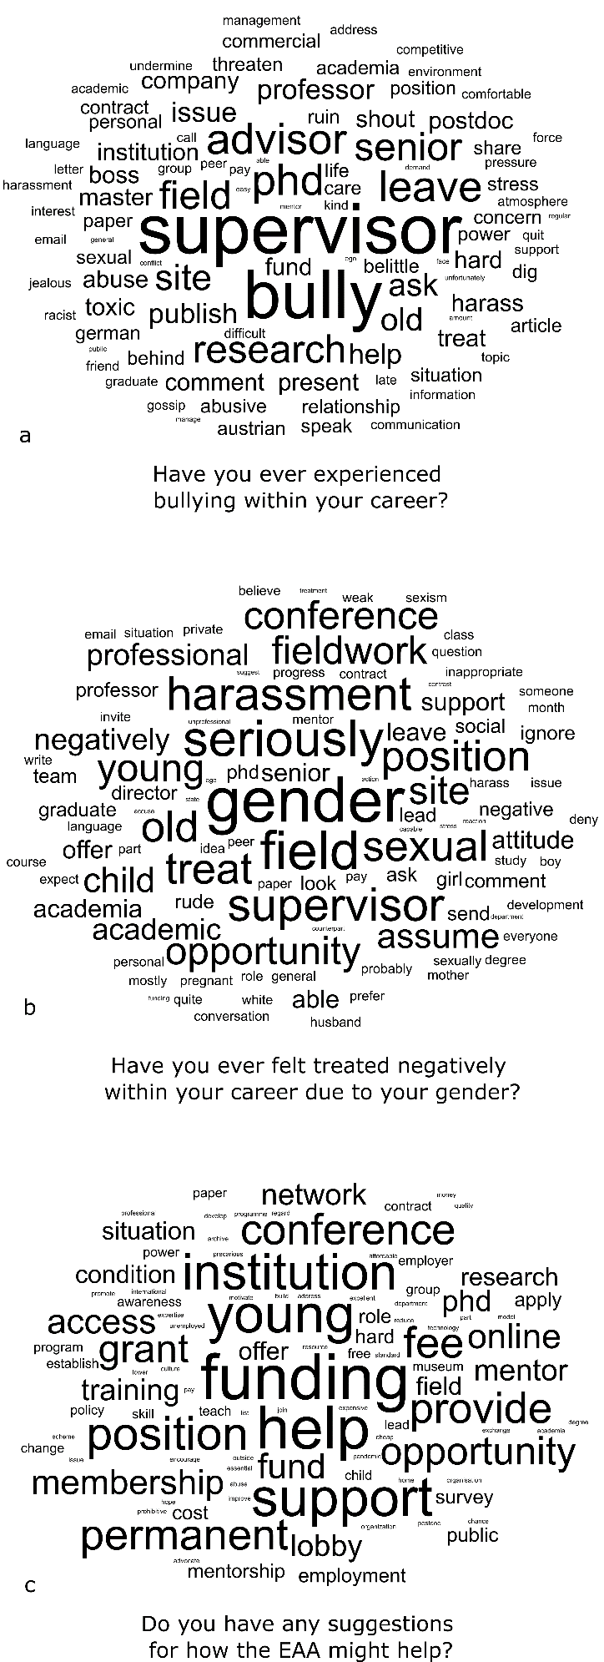
Figure S9. Word clouds generated from a selection of long-form responses.

Figure S10. Bullying culture in the workplace.

