Supplementary Material
A Hierarchical Meta-Analytical Approach to Western European Dietary Transitions in the First Millennium AD
Sam Leggett
School of Archaeology, University of Oxford, UK

Further Statistical Information
A combination of base R functions, the A2R function, and packages ‘ggdendro’, ‘ape’, ‘factoextra’, ‘cluster’, ‘NbClust’ and ‘ggplot2’ (see code for details) were used to run the hierarchical clustering and visualize the outputs (Lamarange, 2006; Kaufman & Rousseeuw, 2009; Charrad et al., 2014; de Vries & Ripley, 2016; Kassambara & Mundt, 2017; R Development Core Team, 2017; Maechler et al., 2019; RStudio Team, 2019; Wickham, 2019; Grolemund & Wickham, 2020).
A mixture of various statistical and graphical methods for determining the optimal number of clusters was employed, thirty of which are automatically computed as part of the “NbClust” package, and the other graphical indices were generated using a combination of “NbClust” and “factoextra” packages in R (Charrad et al., 2014; Kassambara, 2017; Kassambara & Mundt, 2017). All indices were used for every UML iteration, and the majority rule adhered to (optimal number of clusters determined by agreement of the highest number of indices) to avoid user determination. The pre-sets for all indices were kept (generally this also means a 95% confidence interval if they were used by the index, see code and “NbClust” documentation for mathematical details), and the algorithm run for the clustering method used (Ward2 hierarchical).

Hierarchical Clustering “NbClust” outputs
Bone
NbClust(data = EMEUboneclean, diss = NULL, distance = "euclidean", min.nc = 2, max.nc = 15, method = "ward.D2")
*** : The Hubert index is a graphical method of determining the number of clusters.
In the plot of Hubert index, we seek a significant knee that corresponds to a
significant increase of the value of the measure i.e the significant peak in Hubert
index second differences plot.

*** : The D index is a graphical method of determining the number of clusters.
In the plot of D index, we seek a significant knee (the significant peak in Dindex
second differences plot) that corresponds to a significant increase of the value of
the measure.

*******************************************************************
* Among all indices:
* 3 proposed 2 as the best number of clusters
* 8 proposed 3 as the best number of clusters
* 2 proposed 4 as the best number of clusters
* 1 proposed 5 as the best number of clusters
* 6 proposed 6 as the best number of clusters
* 1 proposed 7 as the best number of clusters
* 1 proposed 12 as the best number of clusters
* 1 proposed 15 as the best number of clusters

***** Conclusion *****

* According to the majority rule, the best number of clusters is 3

*******************************************************************
$All.index
KL CH Hartigan CCC Scott Marriot TrCovW TraceW Friedman Rubin Cindex DB Silhouette Duda
2 2.9470 1923.879 1552.1379 -22.9149 3595.199 28062699 10559187.3 5648.984 1.3085 1.4650 0.1413 1.4502 0.3921 0.5151
3 5.2031 2098.406 1291.8626 -42.5995 5804.395 37025991 3765891.2 4107.801 2.1228 2.0147 0.1388 1.0617 0.4075 0.6043
4 1.1856 2265.962 966.0241 -38.5583 8121.882 37602469 1738443.2 3130.121 3.4543 2.6440 0.1565 1.0465 0.3121 0.5344
5 1.5564 2337.445 868.9175 -36.8777 9827.143 38914172 1151233.5 2537.343 4.6931 3.2617 0.1441 1.0428 0.3162 0.5629
6 0.1082 2436.193 337.8742 -34.5102 11286.202 39389006 999386.8 2096.652 5.9249 3.9472 0.1183 1.1218 0.3068 0.6733
7 1.4673 2251.894 367.1101 -39.2452 12000.497 45114845 707889.5 1938.203 6.6749 4.2699 0.1106 1.1897 0.2896 0.5654
8 1.3385 2153.608 357.8757 -41.9811 12646.659 50408444 677554.7 1780.053 7.3405 4.6493 0.1221 1.1786 0.2866 0.6735
9 1.1280 2091.884 324.2138 -43.8069 13311.730 54328058 677271.5 1638.139 8.1065 5.0521 0.1205 1.1299 0.2902 0.5711
10 2.0277 2040.953 348.1011 -45.3730 13966.314 57260534 512580.7 1518.902 8.9695 5.4487 0.1156 1.1308 0.2811 0.5685
11 2.1568 2026.036 345.6806 -45.9072 14668.331 58476296 378339.8 1400.805 9.9641 5.9080 0.1138 1.0910 0.2821 0.4325
12 2.0891 2027.022 329.8978 -45.9650 15291.359 59866562 370837.8 1292.565 10.8585 6.4028 0.1462 1.0017 0.2826 0.6694
13 1.2932 2033.633 328.1841 -45.8458 15957.638 59813276 287846.6 1196.890 11.9718 6.9146 0.1411 1.0205 0.2557 0.6409
14 0.2107 2051.260 244.2454 -45.3911 16548.071 60147063 285571.4 1108.703 12.9476 7.4646 0.1323 1.0586 0.2523 0.5438
15 1.7699 2034.476 246.7738 -45.9523 17020.621 61596685 281030.2 1046.725 13.8212 7.9066 0.1260 1.0494 0.2570 0.5299
Pseudot2 Beale Ratkowsky Ball Ptbiserial Frey McClain Dunn Hubert SDindex Dindex SDbw
2 1146.7191 0.9407 0.3673 2824.4922 0.4729 -0.4888 0.3803 0.0067 2e-04 6.3540 0.9403 1.4088
3 1910.0016 0.6546 0.4087 1369.2671 0.5423 1.7266 0.3885 0.0072 2e-04 4.5541 0.8232 0.8481
4 816.4711 0.8704 0.3940 782.5302 0.4589 0.0132 0.9319 0.0040 2e-04 4.4837 0.7153 0.9543
5 1518.3939 0.7763 0.3723 507.4687 0.4816 0.6693 0.9502 0.0040 3e-04 4.0522 0.6508 0.7618
6 465.7589 0.4847 0.3528 349.4420 0.4437 0.4731 1.3848 0.0040 3e-04 4.2693 0.5742 0.6447
7 214.4304 0.7658 0.3308 276.8862 0.4345 0.0040 1.5027 0.0040 3e-04 4.9696 0.5426 0.5867
8 142.5110 0.4831 0.3132 222.5067 0.4371 -0.0846 1.4936 0.0044 3e-04 4.8725 0.5256 0.5206
9 491.1249 0.7498 0.2985 182.0154 0.4397 0.4829 1.4809 0.0044 3e-04 4.6677 0.5135 0.4678
10 202.6979 0.7563 0.2857 151.8902 0.4331 0.0175 1.5512 0.0044 3e-04 4.6145 0.4920 0.4626
11 356.9464 1.3075 0.2748 127.3459 0.4349 -0.1083 1.5427 0.0044 3e-04 4.3367 0.4798 0.4260
12 641.5641 0.4935 0.2652 107.7137 0.4367 2.3670 1.5319 0.0058 3e-04 5.5693 0.4732 0.4464
13 359.1052 0.5594 0.2565 92.0684 0.3687 0.2772 2.2394 0.0058 4e-04 7.0510 0.4486 0.4399
14 575.4163 0.8376 0.2487 79.1931 0.3624 0.3663 2.3322 0.0058 4e-04 7.1806 0.4299 0.4010
15 187.1673 0.8829 0.2413 69.7817 0.3544 0.0838 2.4430 0.0058 4e-04 7.1968 0.4162 0.3780

$All.CriticalValues
CritValue_Duda CritValue_PseudoT2 Fvalue_Beale
2 0.6110 775.3291 0.3905
3 0.6360 1669.3758 0.5197
4 0.6012 621.6597 0.4189
5 0.6259 1168.4713 0.4602
6 0.6021 634.3506 0.6160
7 0.5345 243.0072 0.4654
8 0.5383 252.2106 0.6171
9 0.5853 463.2995 0.4727
10 0.5312 235.6094 0.4699
11 0.5326 238.6958 0.2713
12 0.6133 819.1438 0.6105
13 0.5844 455.9063 0.5717
14 0.5876 481.4464 0.4330
15 0.5126 200.6259 0.4144

$Best.nc
KL CH Hartigan CCC Scott Marriot TrCovW TraceW Friedman Rubin Cindex DB Silhouette
Number_clusters 3.0000 6.000 6.0000 2.0000 4.000 6 3 3.0000 4.0000 6.0000 7.0000 12.0000 3.0000
Value_Index 5.2031 2436.193 531.0433 -22.9149 2317.486 5251004 6793296 563.5026 1.3315 -0.3629 0.1106 1.0017 0.4075
Duda PseudoT2 Beale Ratkowsky Ball PtBiserial Frey McClain Dunn Hubert SDindex Dindex SDbw
Number_clusters 6.0000 6.0000 2.0000 3.0000 3.000 3.0000 1 2.0000 3.0000 0 5.0000 0 15.000
Value_Index 0.6733 465.7589 0.9407 0.4087 1455.225 0.5423 NA 0.3803 0.0072 0 4.0522 0 0.378

$Best.partition TOO MANY TO PRINT

Dentine
NbClust(data = EMEUdentineclean, diss = NULL, distance = "euclidean", min.nc = 2, max.nc = 15, method = "ward.D2")
*** : The Hubert index is a graphical method of determining the number of clusters.
In the plot of Hubert index, we seek a significant knee that corresponds to a
significant increase of the value of the measure i.e the significant peak in Hubert
index second differences plot.

*** : The D index is a graphical method of determining the number of clusters.
In the plot of D index, we seek a significant knee (the significant peak in Dindex
second differences plot) that corresponds to a significant increase of the value of
the measure.

*******************************************************************
* Among all indices:
* 1 proposed 2 as the best number of clusters
* 11 proposed 3 as the best number of clusters
* 2 proposed 4 as the best number of clusters
* 5 proposed 5 as the best number of clusters
* 2 proposed 11 as the best number of clusters
* 1 proposed 13 as the best number of clusters
* 1 proposed 15 as the best number of clusters

***** Conclusion *****

* According to the majority rule, the best number of clusters is 3

*******************************************************************
$All.index
KL CH Hartigan CCC Scott Marriot TrCovW TraceW Friedman Rubin Cindex DB Silhouette Duda
2 1.1605 689.8837 638.3127 -3.0678 1164.951 943438.6 512552.084 1067.3651 1.9708 1.7426 0.1490 1.1517 0.4481 0.4261
3 2.6473 900.1366 253.6577 -2.3540 1970.244 893803.0 92376.167 632.6639 3.9210 2.9399 0.1860 0.7636 0.4883 0.5277
4 0.7343 847.7568 307.3965 -4.1147 2462.697 936265.0 91811.213 496.8547 5.7963 3.7435 0.2032 0.8730 0.4005 0.6008
5 1.0312 922.5099 119.0435 -1.4182 3000.736 820792.8 36394.359 373.1251 8.5692 4.9849 0.1680 0.9714 0.3386 0.6702
6 1.0541 855.7673 96.4745 -3.7506 3272.885 882355.4 22899.105 330.6215 10.5059 5.6258 0.1540 1.1333 0.2984 0.6277
7 1.3558 802.7278 91.9402 -5.7153 3483.187 958153.5 14718.625 299.3955 12.1124 6.2125 0.1442 1.1617 0.2933 0.4261
8 1.9342 768.8166 95.4013 -7.0374 3623.368 1076532.1 14011.121 272.3009 12.9927 6.8307 0.1390 1.0359 0.2830 0.6240
9 0.8749 753.3544 80.4051 -7.6688 3840.429 1079138.0 8810.811 246.7924 15.0569 7.5367 0.1321 1.1063 0.2787 0.4945
10 2.5513 736.1811 83.6286 -8.3866 3959.482 1172345.9 7775.685 226.9967 15.8773 8.1940 0.1264 1.0674 0.2896 0.6703
11 6.6935 730.2941 82.3841 -8.6536 4093.848 1227897.2 7708.636 208.1007 17.0057 8.9380 0.1171 1.0821 0.2998 0.5143
12 0.1012 730.0500 89.0134 -8.6907 4231.375 1260623.2 6410.307 190.9973 18.2310 9.7384 0.1633 1.0967 0.2933 0.4115
13 0.5441 740.6428 93.8351 -8.2839 4379.846 1261393.5 6026.755 174.1311 19.6721 10.6816 0.2065 1.0337 0.2956 0.5413
14 1.2512 759.9423 84.2959 -7.5343 4561.080 1204142.0 5887.249 157.9826 21.9124 11.7734 0.1913 1.0063 0.2988 0.5232
15 1.6569 775.7033 72.4795 -6.9416 4712.309 1175055.7 5004.047 144.6826 23.7635 12.8557 0.1802 0.9768 0.3089 0.3920
Pseudot2 Beale Ratkowsky Ball Ptbiserial Frey McClain Dunn Hubert SDindex Dindex SDbw
2 507.7796 1.3433 0.4536 533.6826 0.4960 -0.5753 0.4751 0.0062 0.0007 3.9937 0.8394 1.2743
3 307.0376 0.8926 0.4689 210.8880 0.6042 1.1814 0.4414 0.0090 0.0011 2.9269 0.7184 0.6612
4 365.4913 0.6633 0.4280 124.2137 0.5918 1.4329 0.5445 0.0106 0.0012 2.9958 0.6352 0.5551
5 180.1015 0.4907 0.3997 74.6250 0.5044 1.6433 1.0051 0.0105 0.0013 3.3165 0.5475 0.5778
6 132.8464 0.5904 0.3700 55.1036 0.4357 0.6402 1.4856 0.0105 0.0014 4.5300 0.5036 0.4619
7 290.8936 1.3405 0.3461 42.7708 0.4183 1.5417 1.6717 0.0105 0.0014 4.5532 0.4793 0.5807
8 70.5056 0.5975 0.3266 34.0376 0.3855 0.2080 2.0231 0.0105 0.0014 4.5331 0.4476 0.6078
9 151.2832 1.0153 0.3104 27.4214 0.3838 0.4343 2.0624 0.0105 0.0014 4.3006 0.4303 0.4894
10 89.5206 0.4892 0.2963 22.6997 0.3753 0.3896 2.1756 0.0105 0.0014 4.8752 0.4102 0.4409
11 30.2145 0.9156 0.2841 18.9182 0.3621 0.0127 2.3532 0.0105 0.0015 4.7917 0.3952 0.4127
12 70.0885 1.4018 0.2734 15.9164 0.3629 0.0078 2.3400 0.0148 0.0015 4.8309 0.3876 0.3185
13 130.5143 0.8420 0.2640 13.3947 0.3641 0.3873 2.3210 0.0190 0.0015 4.5056 0.3772 0.2832
14 122.1056 0.9045 0.2557 11.2845 0.3503 0.1081 2.4950 0.0190 0.0015 4.6258 0.3560 0.2872
15 105.4624 1.5284 0.2480 9.6455 0.3501 0.2101 2.4658 0.0190 0.0015 4.7841 0.3452 0.2635

$All.CriticalValues
CritValue_Duda CritValue_PseudoT2 Fvalue_Beale
2 0.5549 302.3658 0.2616
3 0.5488 281.9660 0.4101
4 0.5767 403.7767 0.5153
5 0.5530 295.7861 0.6124
6 0.5175 208.8197 0.5545
7 0.5146 203.7829 0.2628
8 0.4555 139.8775 0.5510
9 0.4802 160.2064 0.3635
10 0.4998 182.1721 0.6135
11 0.2585 91.8049 0.4055
12 0.3361 96.7755 0.2511
13 0.4841 164.1092 0.4318
14 0.4701 151.0575 0.4060
15 0.3867 107.8309 0.2206

$Best.nc
KL CH Hartigan CCC Scott Marriot TrCovW TraceW Friedman Rubin Cindex DB
Number_clusters 11.0000 5.0000 3.000 5.0000 3.0000 5.0 3.0 3.0000 5.0000 5.0000 11.0000 3.0000
Value_Index 6.6935 922.5099 384.655 -1.4182 805.2928 177034.9 420175.9 298.8919 2.7728 -0.6005 0.1171 0.7636
Silhouette Duda PseudoT2 Beale Ratkowsky Ball PtBiserial Frey McClain Dunn Hubert SDindex Dindex
Number_clusters 3.0000 4.0000 4.0000 2.0000 3.0000 3.0000 3.0000 1 3.0000 13.000 0 3.0000 0
Value_Index 0.4883 0.6008 365.4913 1.3433 0.4689 322.7946 0.6042 NA 0.4414 0.019 0 2.9269 0
SDbw
Number_clusters 15.0000
Value_Index 0.2635

$Best.partition
CND_01 CND_02 CND_03 CND_04 CND_05 CND_06 CND_07 CND_08 CND_09 CND_10 CND_11 CND_12 CND_13 CND_14 CND_15 CND_16
1 1 1 1 1 1 1 2 1 1 2 2 2 2 2 2
CND_17 CND_18 CND_19 CND_20 CND_21 CND_22 CND_23 CND_24 CND_25 CND_26 CND_27 CND_28 CND_29 CND_30 CND_31 CND_32
2 2 2 2 2 2 2 1 2 2 2 2 2 2 2 2
CND_33 CND_34 CND_35 CND_36 CND_37 CND_38 CND_39 CND_40 CND_41 CND_42 CND_43 CND_44 CND_45 CND_46 CND_47 CND_48
2 2 2 2 2 2 2 2 1 2 2 2 2 2 1 1
CND_49 CND_50 CND_51 CND_52 CND_53 CND_54 CND_55 CND_56 CND_57 CND_58 CND_59 CND_60 CND_61 CND_62 CND_63 CND_64
1 2 2 2 1 2 2 2 2 2 2 2 2 2 2 2
CND_65 CND_66 CND_67 CND_68 CND_69 CND_70 CND_71 CND_72 CND_73 CND_74 CND_75 CND_76 CND_77 CND_78 CND_79 CND_80
2 2 2 1 1 1 2 2 2 1 2 2 1 2 1 1
CND_81 CND_82 CND_83 CND_84 CND_85 CND_86 CND_87 CND_88 CND_89 CND_90 CND_91 CND_92 CND_93 CND_94 CND_95 CND_96
1 2 2 1 1 1 1 1 1 1 1 1 1 2 2 2
CND_97 CND_98 CND_99 CND_100 CND_101 CND_102 CND_103 CND_104 CND_105 CND_106 CND_107 CND_108 CND_109 CND_110 CND_111 CND_112
2 2 2 1 2 2 1 1 1 2 1 1 1 1 1 1
CND_113 CND_114 CND_115 CND_116 CND_117 CND_118 CND_119 CND_120 CND_121 CND_122 CND_123 CND_124 CND_125 CND_126 CND_127 CND_128
1 1 1 1 1 1 1 1 1 2 2 2 2 1 1 2
CND_129 CND_130 CND_131 CND_132 CND_133 CND_134 CND_135 CND_136 CND_137 CND_138 CND_139 CND_140 CND_141 CND_142 CND_143 CND_144
2 1 1 1 2 2 2 1 1 1 2 2 2 1 2 1
CND_145 CND_146 CND_147 CND_148 CND_149 CND_150 CND_151 CND_152 CND_153 CND_154 CND_155 CND_156 CND_157 CND_158 CND_159 CND_160
1 1 1 1 2 2 2 1 1 1 2 2 2 1 1 1
CND_161 CND_162 CND_163 CND_164 CND_165 CND_166 CND_167 CND_168 CND_169 CND_170 CND_171 CND_172 CND_173 CND_174 CND_175 CND_176
1 1 1 2 1 1 1 1 1 1 1 1 1 1 1 2
CND_177 CND_178 CND_179 CND_180 CND_181 CND_182 CND_183 CND_184 CND_185 CND_186 CND_187 CND_188 CND_189 CND_190 CND_191 CND_192
2 1 1 1 1 1 1 1 1 1 1 1 1 1 1 1
CND_193 CND_194 CND_195 CND_196 CND_197 CND_198 CND_199 CND_200 CND_201 CND_202 CND_203 CND_204 CND_205 CND_206 CND_207 CND_208
1 1 1 1 1 1 1 1 1 1 1 1 1 1 2 1
CND_209 CND_210 CND_211 CND_212 CND_213 CND_214 CND_215 CND_216 CND_217 CND_218 CND_219 CND_220 CND_221 CND_222 CND_223 CND_224
1 1 1 1 1 1 1 1 1 1 1 1 1 1 1 1
CND_225 CND_226 CND_227 CND_228 CND_229 CND_230 CND_231 CND_232 CND_233 CND_234 CND_235 CND_236 CND_237 CND_238 CND_239 CND_240
1 1 1 1 1 1 1 1 1 1 1 1 1 1 1 1
CND_241 CND_242 CND_243 CND_244 CND_245 CND_246 CND_247 CND_248 CND_249 CND_250 CND_251 CND_252 CND_253 CND_254 CND_255 CND_256
1 1 1 1 1 1 1 1 1 1 1 1 1 1 1 1
CND_257 CND_258 CND_259 CND_260 CND_261 CND_262 CND_263 CND_264 CND_265 CND_266 CND_267 CND_268 CND_269 CND_270 CND_271 CND_272
1 1 1 1 1 1 1 1 1 1 1 1 1 2 1 1
CND_273 CND_274 CND_275 CND_276 CND_277 CND_278 CND_279 CND_280 CND_281 CND_282 CND_283 CND_284 CND_285 CND_286 CND_287 CND_288
1 1 1 1 1 1 1 1 1 1 1 1 1 1 1 1
CND_289 CND_290 CND_291 CND_292 CND_293 CND_294 CND_295 CND_296 CND_297 CND_298 CND_299 CND_300 CND_301 CND_302 CND_303 CND_304
1 1 1 1 1 1 1 1 1 1 1 1 1 1 1 1
CND_305 CND_306 CND_307 CND_308 CND_309 CND_310 CND_311 CND_312 CND_313 CND_314 CND_315 CND_316 CND_317 CND_318 CND_319 CND_320
1 1 1 1 1 1 1 1 1 1 1 1 1 1 2 1
CND_321 CND_322 CND_323 CND_324 CND_325 CND_326 CND_327 CND_328 CND_329 CND_330 CND_331 CND_332 CND_333 CND_334 CND_335 CND_336
1 1 2 1 1 2 1 2 1 1 2 1 1 1 2 2
CND_337 CND_338 CND_339 CND_340 CND_341 CND_342 CND_343 CND_344 CND_345 CND_346 CND_347 CND_348 CND_349 CND_350 CND_351 CND_352
1 1 1 1 1 1 1 1 1 1 1 1 1 1 1 1
CND_353 CND_354 CND_355 CND_356 CND_357 CND_358 CND_359 CND_360 CND_361 CND_362 CND_363 CND_364 CND_365 CND_366 CND_367 CND_368
1 1 1 1 1 1 1 1 1 1 1 1 1 1 1 1
CND_369 CND_370 CND_371 CND_372 CND_373 CND_374 CND_375 CND_376 CND_377 CND_378 CND_379 CND_380 CND_381 CND_382 CND_383 CND_384
1 1 2 1 1 1 1 1 1 1 1 1 1 1 1 1
CND_385 CND_386 CND_387 CND_388 CND_389 CND_390 CND_391 CND_392 CND_393 CND_394 CND_395 CND_396 CND_397 CND_398 CND_399 CND_400
2 1 1 1 1 1 1 1 1 1 1 1 1 1 1 1
CND_401 CND_402 CND_403 CND_404 CND_405 CND_406 CND_407 CND_408 CND_409 CND_410 CND_411 CND_412 CND_413 CND_414 CND_415 CND_416
1 1 1 1 1 1 1 1 1 1 1 2 1 1 1 1
CND_417 CND_418 CND_419 CND_420 CND_421 CND_422 CND_423 CND_424 CND_425 CND_426 CND_427 CND_428 CND_429 CND_430 CND_431 CND_432
1 1 1 1 1 1 1 1 1 1 1 1 1 1 1 1
CND_433 CND_434 CND_435 CND_436 CND_437 CND_438 CND_439 CND_440 CND_441 CND_442 CND_443 CND_444 CND_445 CND_446 CND_447 CND_448
1 2 1 1 1 1 1 1 1 1 1 1 1 1 1 1
CND_449 CND_450 CND_451 CND_452 CND_453 CND_454 CND_455 CND_456 CND_457 CND_458 CND_459 CND_460 CND_461 CND_462 CND_463 CND_464
1 1 1 1 1 1 1 1 1 2 1 1 1 1 3 1
CND_465 CND_466 CND_467 CND_468 CND_469 CND_470 CND_471 CND_472 CND_473 CND_474 CND_475 CND_476 CND_477 CND_478 CND_479 CND_480
3 3 3 3 3 3 3 3 3 3 3 3 3 3 3 3
CND_481 CND_482 CND_483 CND_484 CND_485 CND_486 CND_487 CND_488 CND_489 CND_490 CND_491 CND_492 CND_493 CND_494 CND_495 CND_496
3 3 3 3 3 3 3 3 3 3 3 3 3 2 2 2
CND_497 CND_498 CND_499 CND_500 CND_501 CND_502 CND_503 CND_504 CND_505 CND_506 CND_507 CND_508 CND_509 CND_510 CND_511 CND_512
2 1 2 1 1 1 2 2 2 2 2 2 2 2 2 2
CND_513 CND_514 CND_515 CND_516 CND_517 CND_518 CND_519 CND_520 CND_521 CND_522 CND_523 CND_524 CND_525 CND_526 CND_527 CND_528
2 2 2 2 2 2 2 2 2 2 2 2 2 2 2 2
CND_529 CND_530 CND_531 CND_532 CND_533 CND_534 CND_535 CND_536 CND_537 CND_538 CND_539 CND_540 CND_541 CND_542 CND_543 CND_544
1 1 1 2 2 2 2 2 2 2 1 2 2 2 2 2
CND_545 CND_546 CND_547 CND_548 CND_549 CND_550 CND_551 CND_552 CND_553 CND_554 CND_555 CND_556 CND_557 CND_558 CND_559 CND_560
2 2 2 2 2 2 2 2 2 1 1 1 1 1 1 1
CND_561 CND_562 CND_563 CND_564 CND_565 CND_566 CND_567 CND_568 CND_569 CND_570 CND_571 CND_572 CND_573 CND_574 CND_575 CND_576
2 1 1 1 1 1 1 1 2 1 1 1 2 2 2 2
CND_577 CND_578 CND_579 CND_580 CND_581 CND_582 CND_583 CND_584 CND_585 CND_586 CND_587 CND_588 CND_589 CND_590 CND_591 CND_592
2 2 2 2 2 2 2 2 2 2 2 2 2 2 2 2
CND_593 CND_594 CND_595 CND_596 CND_597 CND_598 CND_599 CND_600 CND_601 CND_602 CND_603 CND_604 CND_605 CND_606 CND_607 CND_608
2 2 2 2 2 2 2 1 1 1 1 1 1 1 1 1
CND_609 CND_610 CND_611 CND_612 CND_613 CND_614 CND_615 CND_616 CND_617 CND_618 CND_619 CND_620 CND_621 CND_622 CND_623 CND_624
1 1 1 1 1 1 1 2 2 2 2 2 2 2 2 2
CND_625 CND_626 CND_627 CND_628 CND_629 CND_630 CND_631 CND_632 CND_633 CND_634 CND_635 CND_636 CND_637 CND_638 CND_639 CND_640
2 2 2 2 2 2 2 2 2 2 2 2 2 2 2 2
CND_641 CND_642 CND_643 CND_644 CND_645 CND_646 CND_647 CND_648 CND_649 CND_650 CND_651 CND_652 CND_653 CND_654 CND_655 CND_656
2 2 2 2 2 2 2 1 1 1 2 2 2 2 2 2
CND_657 CND_658 CND_659 CND_660 CND_661 CND_662 CND_663 CND_664 CND_665 CND_666 CND_667 CND_668 CND_669 CND_670 CND_671 CND_672
2 1 2 2 2 2 2 2 2 2 2 1 1 1 1 1
CND_673 CND_674 CND_675 CND_676 CND_677 CND_678 CND_679 CND_680 CND_681 CND_682 CND_683 CND_684 CND_685 CND_686 CND_687 CND_688
1 2 2 1 1 1 1 1 1 2 2 2 2 2 2 2
CND_689 CND_690 CND_691 CND_692 CND_693 CND_694 CND_695 CND_696 CND_697 CND_698 CND_699 CND_700 CND_701 CND_702 CND_703 CND_704
2 2 2 2 2 2 1 1 1 1 1 1 1 1 2 1
CND_705 CND_706 CND_707 CND_708 CND_709 CND_710 CND_711 CND_712 CND_713 CND_714 CND_715 CND_716 CND_717 CND_718 CND_719 CND_720
2 1 2 2 1 1 1 1 1 2 1 1 1 1 2 2
CND_721 CND_722 CND_723 CND_724 CND_725 CND_726 CND_727 CND_728 CND_729 CND_730 CND_731 CND_732 CND_733 CND_734 CND_735 CND_736
2 2 2 2 2 2 2 2 2 2 2 2 2 2 2 2
CND_737 CND_738 CND_739 CND_740 CND_741 CND_742 CND_743 CND_744 CND_745 CND_746 CND_747 CND_748 CND_749 CND_750 CND_751 CND_752
2 2 2 1 1 1 1 1 1 1 1 1 2 2 1 1
CND_753 CND_754 CND_755 CND_756 CND_757 CND_758 CND_759 CND_760 CND_761 CND_762 CND_763 CND_764 CND_765 CND_766 CND_767 CND_768
1 1 1 1 2 2 2 2 2 2 2 2 2 2 2 1
CND_769 CND_770 CND_771 CND_772 CND_773 CND_774 CND_775 CND_776 CND_777 CND_778 CND_779 CND_780 CND_781 CND_782 CND_783 CND_784
1 2 2 2 2 2 2 2 2 2 2 2 2 2 2 2
CND_785 CND_786 CND_787 CND_788 CND_789 CND_790 CND_791 CND_792 CND_793 CND_794 CND_795 CND_796 CND_797 CND_798 CND_799 CND_800
2 2 2 2 2 2 1 1 1 1 1 1 1 2 2 2
CND_801 CND_802 CND_803 CND_804 CND_805 CND_806 CND_807 CND_808 CND_809 CND_810 CND_811 CND_812 CND_813 CND_814 CND_815 CND_816
1 1 1 1 1 2 1 2 2 2 2 2 1 1 1 2
CND_817 CND_818 CND_819 CND_820 CND_821 CND_822 CND_823 CND_824 CND_825 CND_826 CND_827 CND_828 CND_829 CND_830 CND_831 CND_832
1 2 2 2 2 2 2 2 2 2 1 2 1 1 1 1
CND_833 CND_834 CND_835 CND_836 CND_837 CND_838 CND_839 CND_840 CND_841 CND_842 CND_843 CND_844 CND_845 CND_846 CND_847 CND_848
1 1 2 2 2 1 1 2 2 2 2 1 1 1 1 2
CND_849 CND_850 CND_851 CND_852 CND_853 CND_854 CND_855 CND_856 CND_857 CND_858 CND_859 CND_860 CND_861 CND_862 CND_863 CND_864
1 1 1 1 1 1 1 1 1 1 1 1 1 1 1 1
CND_865 CND_866 CND_867 CND_868 CND_869 CND_870 CND_871 CND_872 CND_873 CND_874 CND_875 CND_876 CND_877 CND_878 CND_879 CND_880
1 1 1 1 1 1 1 2 2 2 2 1 3 3 1 1
CND_881 CND_882 CND_883 CND_884 CND_885 CND_886 CND_887 CND_888 CND_889 CND_890 CND_891 CND_892 CND_893 CND_894 CND_895 CND_896
1 1 1 1 1 1 1 1 1 1 1 1 1 1 3 1
CND_897 CND_898 CND_899 CND_900 CND_901 CND_902 CND_903 CND_904 CND_905 CND_906 CND_907 CND_908 CND_909 CND_910 CND_911 CND_912
1 1 1 1 1 3 1 1 1 1 1 1 1 1 1 1
CND_913 CND_914 CND_915 CND_916 CND_917 CND_918 CND_919 CND_920 CND_921 CND_922 CND_923 CND_924 CND_925 CND_926 CND_927 CND_928
1 1 2 2 1 1 1 1 1 1 1 1 1 2 1 1
CND_929 CND_930 CND_931
1 2 1

BEST Tests
BEST (Bayesian Estimation Supersedes the t-test) tests were used to compare between groups; these were run with R package “BEST” (Kruschke, 2013). The BEST test uses Markov-chain Monte-Carlo (MCMC) sampling to generate posterior predictive distributions for group data. In Bayesian statistics, posterior predictive distributions (PPDs), and therefore the means of these distributions, are distributions of possible unobserved values which have been predicted based on the observed or ‘real’ data put into the model (Kruschke, 2013, 2014). An important point is that the results are drawn from the PPD generated from the MCMC and not the inputted data directly. For more details on the test and how it works and see Kruschke (2013).

Outputs
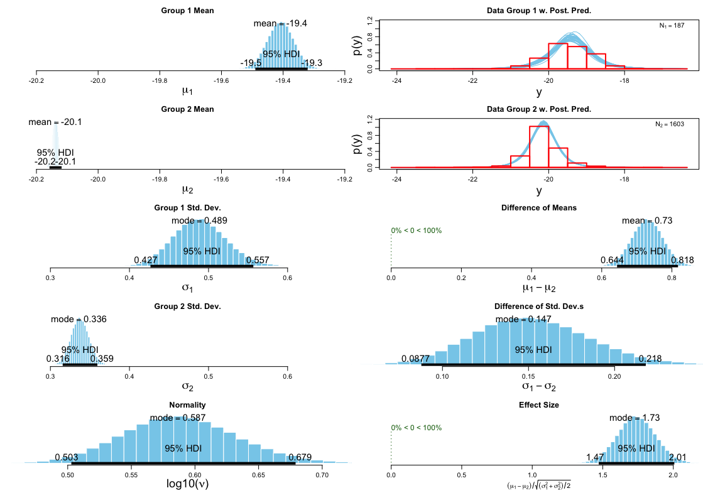
Supplementary Figure 1. BEST test output for c. 200 bc–ad 450 (group 1) vs c. ad 400-790 (group 2) bone $δ$¹³C_{coll} values for England (all sexes).
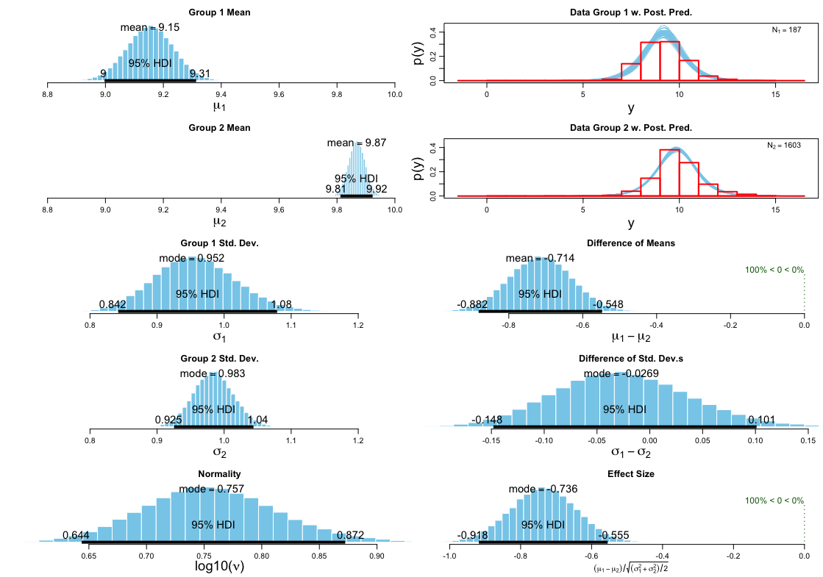
Supplementary Figure 2. BEST test output for c. 200 bc–ad 450 (group 1) vs c. ad 400–790 (group 2) bone $δ$¹⁵N_{coll} values for England (all sexes).
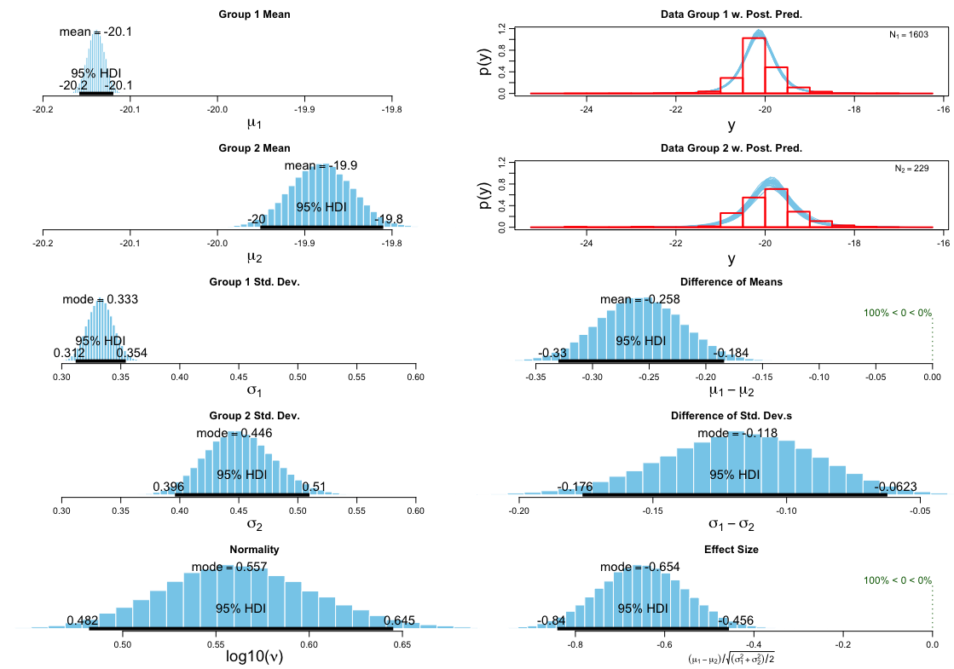
Supplementary Figure 3. BEST test output for c. ad 350–790 (group 1) vs c. ad 790–1200 (group 2) bone $δ$¹³C_{coll} values for England (all sexes).
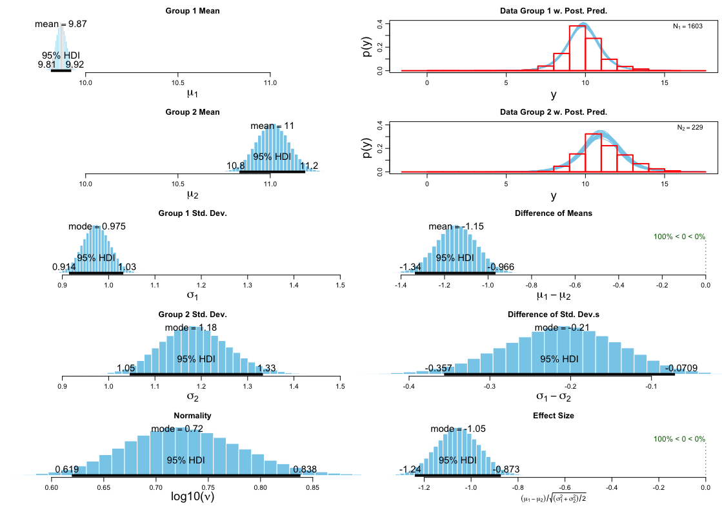
Supplementary Figure 4. BEST test output for c. ad 350–790 (group 1) vs c. ad 790–1200 (group 2) bone $δ$¹⁵N_{coll} values for England (all sexes).

R code
.R file upload not supported on Editorial assistant, see research compendium for full code, data, outputs and associated licenses.
Leggett, S. 2021. Compendium of R code and data for Tackling Early Medieval Dietary Transitions Using a Hierarchical and Multi-Isotope Approach. https://doi.org/10.17605/OSF.IO/6B8MZ

References
Charrad, M., Ghazzali, N., Boiteau, V. & Niknafs, A. 2014. NbClust: An R Package for Determining the Relevant Number of Clusters in a Data Set. Journal of Statistical Software, 61: 1–36. https://doi.org/10.18637/jss.v061.i06
de Vries, A. & Ripley, B.D. 2016. Ggdendro: Create Dendrograms and Tree Diagrams Using ‘Ggplot2’. R. Available at: https://CRAN.R-project.org/package=ggdendro
Grolemund, G. & Wickham, H. 2020. R for Data Science. Available at: https://r4ds.had.co.nz/
Kassambara, A. & Mundt, F. 2017. Factoextra: Extract and Visualize the Results of Multivariate Data Analyses. R. Available at: https://CRAN.R-project.org/package=factoextra
Kaufman, L. & Rousseeuw, P. 2009. Finding Groups in Data: An Introduction to Cluster Analysis. Hoboken (NJ): John Wiley.
Kruschke, J.K. 2013. Bayesian Estimation Supersedes the T Test. Journal of Experimental Psychology: General, 142: 573–603. https://doi.org/10.1037/a0029146
Lamarange, J. 2006. A2R. Paris: R. Available at: http://addictedtor.free.fr/packages/A2R/lastVersion/R/code.R
Leggett, S. 2021. Compendium of R code and data for Tackling Early Medieval Dietary Transitions Using a Hierarchical and Multi-Isotope Approach. https://doi.org/10.17605/OSF.IO/6B8MZ.
Maechler, M., Rousseeuw, P., Struyf, A., Hubert, M., Hornik, K., Studer, M. et al. 2019. ‘Cluster’: “Finding Groups in Data”: Cluster Analysis Extended Rousseeuw et al. Zurich: R.
Wickham, H. 2019. Ggplot2: Elegant Graphics for Data Analysis. 3rd Edition. Available at: https://ggplot2-book.org/.

