The Power of Relics: The Curation of Human Bone in British Bronze Age Burials
Joanna Brück and Thomas J. Booth

Supplementary Material

Chronological modelling
We used the Combine function and chronological modelling in OxCal 4.4 using the IntCal20 curve (Bronk Ramsey, 2009; Reimer et al., 2013) to test whether bone was significantly older than its depositional context. Human bones from these contexts were taken to be anomalously old when their age caused chronological models incorporating dates from associated material to produce poor agreement indices and/or Combine models to fail X² tests. In such cases, we put the dates into new chronological models that assumed that the human bone was older than the material with which it was associated. We compared dates within these models using the Difference function in OxCal to determine the period over which the bone was likely to have been curated. When poor agreement and/or failed X² tests were encountered, the bone was deemed to be anomalously old.

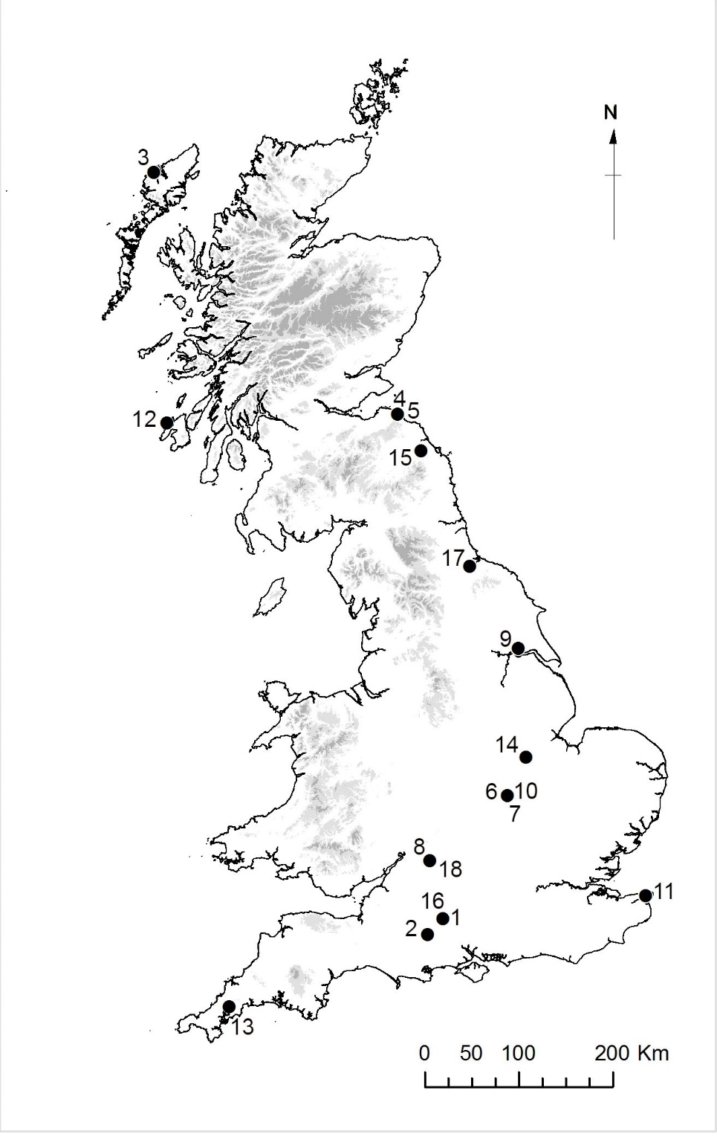
Supplementary Figures and Tables

Figure S1. Location of sites discussed. The numbers refer to the sites in Supplementary Material, Table S1.
Table S1. List of sites included in this analysis (age categories are as defined in the original reports and/or as described by the excavators; see Booth & Brück, 2020 for full listing of all eighty-one dates).
Map no. | Grave | References | Minimum number of individuals (curated and non-curated) | Burnt or unburnt? | Treatment of possible curated individual(s) | Skeletal elements curated | Associated dated material for TAQ | Age of possible curated individual(s) | Sex of possible curated individual(s) | Chronological modelling indicates prolonged curation? | Arrested microbial attack?
1 | Boscombe Bowmen | McKinley, 2011; Fitzpatrick, 2011 | 9, possibly 10 | 1 cremation burial; remainder unburnt | Disarticulated | 1 cranium; unclear if other elements curated | Articulated burial | Adult (25–30 years) | Male | No, except cranium ON 9 | Not analysed
2 | Canada Farm F1 | Smith et al., 2016 | 1 | Unburnt | Articulated | Complete body | Beaker pot | Adult (25–30 years) | Male | No | Yes
3 | Cnip Area A | Lelong 2018 | 3 | Unburnt | Partially articulated skeleton | Most but not all skeletal elements | Disarticulated human bones | Adolescent (12–20 years) | ?Male | Yes | Yes
4 | Dryburn Bridge cist 1 | Dunwell et al., 2007 | 2 | Unburnt | Incomplete, disarticulated skeleton | Skull and longbones; very few other elements present | Articulated burial | Adult (35–45 years) | Male | No | Not analysed
5 | Dryburn Bridge cist 2 | Dunwell et al., 2007 | 2 | Unburnt | Incomplete, disarticulated skeleton | Skull and some longbones; very few other elements present | Articulated burial | Child (6–8 years) | Unknown | No | Not analysed
6 | Irthlingborough 6400 | Mays, 2011 | 2 | Burnt | Cremated | Unclear if either individual curated | Dates for the two burnt individuals compared | Unclear if either curated (1 adult 20–40 years, 1 adolescent 13–14 years) | Unclear if either curated (1 male, 1 unknown) | No | Not analysed
7 | Irthlingborough 6461 | Mays, 2011 | 3 | Burnt | Cremated | Unclear if any individual curated | Dates for the three burnt individuals compared | Unclear if any curated (all young adults, 20–40 years) | Unclear if any curated (1 ?male, 1 ?female, 1 unknown) | No | Not analysed
8 | Kingshill North 1403 | Biddulph & Welsh, 2011 | 2 | Unburnt | Disarticulated | Femur fragment | Articulated burial | Juvenile (age unknown) | Unknown | Dating failed (collagen preservation) | Yes
9 | Melton Quarry 1008 | F. Brown and L. McIntyre, OA South, pers. comm. | 2 | Unburnt | Incomplete, disarticulated skeleton | Unknown (analysis ongoing at time of publication) | Articulated burial | Infant (2–4 months) | Unknown | Yes | Yes
10 | Redlands Farm F131 | Mays, 2011 | 3 | Unburnt | Disarticulated | Humerus fragment | Articulated burial | Subadult (age unknown) | Unknown | Yes | Not analysed
11 | South Dumpton Down B15 | Perkins, 1995 | 3 | Unburnt | Disarticulated | Mandible | Articulated burial | Unknown | Unknown | No | Not analysed
12 | Traigh Bahn cist 1 | Ritchie et al., 1983 | 2 | Unburnt | Incomplete, disarticulated skeleton | Skull and longbones; very few other elements present | Articulated burial | Young adult (20–25 years) | ?Male | Ys | Not analysed
13 | Trelowthas | J. Nowakows-ki, pers. comm. | Multiple (analysis ongoing at time of publication) | Burnt | Cremated | Unknown | Burnt human bone from the cist into which the urn was deposited | Unknown | Unknown | Yes | Not analysed
14 | West Deeping 344 | M. Brittain, pers. comm. | 1 | Unburnt | Partially articulated, complete skeleton | Complete body | Pig scapula | Unknown | Unknown | Dating failed (poor collagen preservation) | Yes
15 | Whitton Hill | Gamble & Fowler, 2013 | 24 | Burnt | Cremated | Skull fragments | Burnt bones belonging to different individuals in the same deposit | Unknown | Unknown | Yes | Not analysed
16 | Wilsford G58 | Woodward & Needham, 2012; Woodward & Hunter, 2015: 114 | 2 | Unburnt | Disarticulated | Femur fragment | Associated artefacts | Adult | Unknown | No | Not analysed
17 | Windmill Fields Sk 6 and 8 | Annis et al., 1997 | 4 | Unburnt | Disarticulated | Two skulls (dated); possible curated longbones not dated | Articulated burial | Skulls belonged to two adults; an adolescent was represented in the undated longbones | Skulls belonged to 1 male and 1 female; the undated adolescent longbones belonged to a possible female | Yes | Yes
18 | Cotswold Community 7971  (NB: pit deposit, not grave) | Smith et al., 2010 | 1 | Unburnt | Disarticulated | 2 femur fragments | Burnt animal bone | Adult (age unknown) | Unknown | Yes | No

References
Annis, R., Anderson, S., Bayliss, A., Bronk Ramsey, C., Huntley, J., Jones, J., et al. 1997. An Unusual Group of Early Bronze Age Burials from Windmill Fields, Ingleby Barwick, Stockton-on-Tees. Unpublished Tees Archaeology report. Hartlepool: Tees Archaeology.
Biddulph, E. & Welsh, K. 2011. Cirencester before Corinium: Excavations at Kingshill North, Cirencester, Gloucestershire (Thames Valley Landscapes Monograph 34). Oxford: Oxford Archaeology.
Booth, T.J. & Brück, J. 2020. Death is not the End: Radiocarbon and Histo-Taphonomic Evidence for Curation and Excarnation of Human Remains in Bronze Age Britain. Antiquity, 94: 1186–1203.
Bronk Ramsey, C. 2009. Bayesian Analysis of Radiocarbon Dates. Radiocarbon, 51: 337–60. https://doi.org/10.1017/S0033822200033865
Dunwell, A., Finlayson, B., Cool, H., Cowie, T., Heald, A., Hunter, F. et al. 2007. Cist Burials and an Iron Age Settlement at Dryburn Bridge, Innerwick, East Lothian (Scottish Archaeological Internet Reports, 24). Edinburgh: Society of Antiquaries of Scotland. http://journals.socantscot.org/index.php/sair/article/view/1139
Fitzpatrick, A. 2011. The Amesbury Archer and the Boscombe Bowmen. Bell Beaker Burials on Boscombe Down, Amesbury, Wiltshire. Salisbury: Wessex Archaeology.
Gamble, M. & Fowler, C. 2013. A Re-Assessment of Human Skeletal Remains in Tyne and Wear Museums: Results and Implications for Interpreting Early Bronze Age Burials from Northeast England and Beyond. Archaeologia Aeliana, 42: 47–80.
Lelong, O., Hamilton, D., Lamb, A.L., McLaren, D., Shearer, I., Evans, et al. 2018. Fluid Identities, Shifting Sands: Early Bronze Age Burials at Cnip Headland, Isle of Lewis (Scottish Archaeological Internet Reports, 75). https://doi.org/10.9750/issn.2056-7421.2018.75
Mays, S. 2011. Cremations from Barrows 1, 3, 4 and 5. In: J. Harding. & F. Healy, eds. The Raunds Area Project. A Neolithic and Bronze Age Landscape in Northamptonshire. London: English Heritage, pp. 709–15.
McKinley, J. 2011. Human Remains. In: A. Fitzpatrick, The Amesbury Archer and the Boscombe Bowmen. Bell Beaker Burials at Boscombe Down, Amesbury, Wiltshire (Wessex Archaeology Report 27). Salisbury: Wessex Archaeology, pp. 18–32.
Perkins, D. 1995. An Assessment/Research Design: South Dumpton Down, Broadstairs. Unpublished Trust for Thanet Archaeology report. Birchington: Trust for Thanet Archaeology.
Reimer, P.J., Bard, E., Bayliss, A., Beck, J.W., Blackwell, P.G., Bronk Ramsey, C., et al. 2013. IntCal13 and Marine13 Radiocarbon Age Calibration Curves 0–50,000 Years cal bp. Radiocarbon, 55: 1869–87. https://doi.org/10.2458/azu_js_rc.55.16947
Ritchie, J., Stevenson, J., Lunt, D., Wickham-Jones, C. & Young, A. 1983. Cists at Traigh Bhan, Islay, Argyll. Proceedings of the Society of Antiquaries of Scotland, 112: 550–59.
Smith, A., Powell, K. & Booth, P. 2010. Evolution of a Farming Community in the Upper Thames Valley. Excavation of a Prehistoric, Roman and Post-Roman Landscape at Cotswold Community, Gloucestershire and Wiltshire. Volume 2: The Finds and Environmental Reports (Oxford Archaeology South Report). Oxford: Oxford Archaeology South. https://library.thehumanjourney.net/314/
Smith, M., Allen, M., Delbarre, G., Booth, T., Cheetham, P., Bailey, L. et al. 2016. Holding on to the Past: Southern British Evidence for Mummification and Retention of the Dead in the Chalcolithic and Bronze Age. Journal of Archaeological Science Reports, 10: 744–56.
Woodward, A. & Hunter, J. 2015. Ritual in Early Bronze Age Grave Goods: An Examination of Ritual and Dress Equipment from Chalcolithic and Early Bronze Age Graves in England. Oxford: Oxbow.
Woodward, A. & Needham, S. 2012. Diversity and Distinction: Characterising the Individual Buried at Wilsford G58, Wiltshire. In: A. Jones, J. Pollard, M. Allen & J. Gardiner, eds. Image, Memory and Monumentality: Archaeological Engagements with the Material World. Oxford: Prehistoric Society & Oxbow, pp. 116–26.

