Dividing the Land: Time and Land Division in the English North Midlands and Yorkshire
Seren Griffiths, Robert Johnston, Rowan May, David McOmish, Peter Marshall, Jonathan Last and Alex Bayliss

Supplementary Material
Contents
Approaches to Data Collection 3
Our Approaches to Scientific Dating 5
Treatment of Different Types of Chronometric Measurements 8
Chronometric Modelling Approaches 8
Site-Specific Modelling Approaches 9
Currency Modelling Approaches 10
Assessment of the Dataset 11
Site-Specific Considerations 12
Balby Carr 12
Bar Brook, Big Moor I 13
Barnsdale Bar Quarry, Norton 13
Becca Banks, Aberford (Asselby to Pannal pipeline Area 8) 13
Billingborough 13
Danby Rigg 14
Doncaster Road, South Elmsall sites 14
Eaglestone Flat 14
Finningley Quarry Northern Extension 14
Fosse Hill, Easington to Salt End Cable Route 14
High Wold, Birlington 14
M1-A1 Grim’s Ditch North 15
M1-A1 South Dyke 15
Site 2, Area 1, Asselby to Pannal natural gas pipeline 15
Site 17.3, Area 4, Asselby to Pannal natural gas pipeline 15
Site 26.3, Area 12, Asselby to Pannal natural gas pipeline 16
Site 35.4, Area 15, Asselby to Pannal natural gas pipeline 16
Sneinton Fruitmarket, Nottingham 16
Swarkeston Lowes 16
Topham Farm, Sykehouse Barrier Bank, Sykehouse, Doncaster 17
Woodhead Open Cast Site 17
Site-Specific Considerations 17
Becca Banks, Aberford (Asselby to Pannal natural gas pipeline, Area 8) 18
Becca Banks, M1-A1 18
BS13, Beverley Southern Relief Road 18
Dalton Parlours 18
Doncaster Road, South Elmsall 19
Elton-on-the-Hill 19
Ferrybridge, Holmfield Interchange 19
Finningley and Rossington Regeneration Route Scheme (FARRRS), Doncaster 19
Rawdales Drain 20
Site 20.4, West South Dyke, Area 7, Asselby to Pannal natural gas pipeline 20
Site Q, A1[M] Darrington to Dishforth 20
South Killingholme, Heron Renewable Energy Plant 21
Timberland, Scunthorpe 21
Tr 76, Asselby to Pannal natural gas pipeline 21
Topham Farm, Sykehouse Barrier Bank, Sykehouse, Doncaster 21
Results 21
The nature of the data 21
The overall currency models 22
Detailed Acknowledgements 23
References 24
Tables 32
Table S1: Definitions of land division used in this research. The definitions have been adapted from the Forum on Information Standards in Heritage (FISH) terms (http://www.heritage-standards.org.uk/fish-vocabularies/) used in Britain. 32
Table S2: Details of radiocarbon dates included in the discussion in this report. 33
Table S3: Sample preparation and measurement techniques used for radiocarbon measurements collated for this study. 64
Table S4: Highest Posterior Density intervals for the currency of different land division types produced by the currency model shown in Figure S107. 65
Figures 66
Appendix 1: CQL2 code defining chronological model for the currency of land divisions 133

Approaches to Data Collection
Chronometric legacy data were collected from a variety of sources. The Council for British Archaeology radiocarbon database was searched for radiocarbon data from the study region. This database is thought to be complete in terms of radiocarbon measurements published for Britain and Ireland up until 1983. In addition, the following regional journals were manually searched:
- Yorkshire Archaeological Journal,
- Archaeology in South Yorkshire,
- Transactions of the Scarborough Archaeological and Historical Society,
- East Riding Archaeologist,
- Transactions of the Hunter Archaeological Society,
- Derbyshire Archaeological Journal,
- Transactions of the Thoroton Society,
- Society for Lincolnshire History and Archaeology.
Digital database searches were undertaken of the Historic Environment Records/Sites and Monuments Records from the region, which were followed by physical archive searches of ‘grey literature’ (unpublished technical reports from developer-funded archaeological investigations) when results were identified. The following Historic Environment Records/Sites and Monuments Records were subject searches:
- City of York Historic Environment Record,
- Humber Historic Environment Record,
- North East Lincolnshire Historic Environment Record,
- North Lincolnshire Historic Environment Record,
- North York Moors National Park Historic Environment Record,
- North Yorkshire Historic Environment Record,
- Lincolnshire County Council,
- South Yorkshire Sites and Monuments Record,
- Yorkshire Dales Historic Environment Record,
- Derbyshire Historic Environment Record,
- Lincoln Heritage Database,
- Lincolnshire Historic Environment Record,
- Nottingham City Historic Environment Record,
- Nottinghamshire Historic Environment Record,
- West Yorkshire Archaeology Advisory Service.
Commercial professional archaeological organizations working in the region were contacted for additional details for measurements identified in the searches, and in order to identify potential additional sites. These included:
- Network Archaeology,
- Trent and Peak Archaeology,
- Pre-Construct Archaeology Ltd,
- WYAS Archaeological Services,
- Oxford Archaeology North.
Additional details of radiocarbon samples were confirmed with Scarborough Archaeology Society and Hugh Wilmott (Sheffield University).
The following laboratories were also contacted in order to providing attribute data missing from publications reporting radiocarbon data:
- SUERC Radiocarbon Laboratory, Glasgow University,
- Beta Analytic Inc Radiocarbon Laboratory,
- University of Arizona AMS Laboratory,
- ¹⁴CHRONO Radiocarbon Laboratory, Queen’s University Belfast.
Further details of individual sites and samples were gathered from published reports and monographs, as well as from international journals including Radiocarbon and Proceedings of the Prehistoric Society.
Some sites with evidence for land division, for example Gunhills, Armthorpe, South Yorkshire (Archaeological Services WYAS, 2008), produced radiocarbon results, but from other features, and so were not included in our analysis. Results from features classified as clearly ‘defensive’ structures, such as Tofts, Stanwick (Hamilton, 2016) or Tattershall Thorpe (Seager Smith, 1998), were also not included.
Chronometric data were identified from across a range of different types of archaeological investigations, including from significant research projects, such as Eaglestone Flat (Bayliss et al., 2013: 64–7; Barnatt, 1994), as well as from development-led projects. These include the output of major utilities schemes (e.g. Brown et al., 2007; Gregory et al., 2013), and the results of relatively small-scale urban projects (e.g. Davies, 2019). Such projects demonstrate the potential of professional or development-led archaeology to address internationally important research questions, through the combined impact of numerous interventions of varying scales, at many different geographical locations (cf. Yates, 2007).
Professional or developer-led fieldwork is therefore key to developing our understandings of wide-ranging, long-term landscape division, this is especially true of linear landscape projects like pipelines or road-schemes. In this project we have used the FISH (http://www.heritage-standards.org.uk/) nomenclature taken from the excavators’ reports or based on identifications by Johnston and May (2016).

Our Approaches to Scientific Dating
Chronometric measurements provide independent date ranges for very specific ‘events’. In the case of a radiocarbon measurement on an uncontaminated, ‘short- life’ sample from a terrestrial species in equilibrium with the atmosphere, this is usually the point of death of an organism. Scientific dating is therefore important as it provides age estimates for events that are independent of the relative chronologies archaeologists have constructed based on typology, seriation or other evidence. However, dealing with groups of related chronometric measurements has provided challenges for archaeologists. Archaeologists have long recognised that, while groups of measurements can be related (for example from a site phase), the multimodal distributions of calibrated radiocarbon dates, together with measurement imprecision, can make groups of measurements difficult to interpret accurately.
Over the last 30 years, statistical developments in the analysis of assemblages of scientific dates have been developed to address these difficulties. Most notable have been the application of Bayesian statistical analysis. These analyses have been applied using several computer programs, including the OxCal program (Bronk Ramsey, 1995; Bronk Ramsey, 2009a and references therein). This program has provided a means to easily calibrate radiocarbon measurements, and in doing so, to provide accurate date ranges that account for the variation in atmospheric radiocarbon over time. It has also provided a means to interrogate groups of data in the light of archaeological ‘prior beliefs’ within Bayesian statistical models.
In the Bayesian statistical models applied to archaeological scientific chronologies, prior beliefs are archaeological interpretations of the relationships within and between groups of data. These beliefs can be derived from a range of different archaeological observations. They could be based on the relationships between different contexts on an individual site, or on the relationships between different types of features, or practices or material culture from across different sites. The fundamental issue is that these prior beliefs allow us to reassess our understandings of individual calibrated radiocarbon likelihoods, based on what we understand about the groups of data. If, given robust stratigraphic evidence, we believe that one radiocarbon measurement must be older than another, not all points in each of the calibrated distributions remain equally likely. Given such a prior belief, it would be appropriate to revise our estimates for the timing of each event. However, in order to develop appropriate models to examine datasets, it is essential to think critically about groups of scientific dating measurements. In terms of radiocarbon results, archaeologists are required to think about many factors, including: taphonomy; sample association with archaeological event of interest; measurement accuracy; and relationships between measured samples.
The OxCal program provides a formal, probabilistic means to produce these revised ‘posterior density estimates’ using the scientific data and the archaeological prior beliefs. The technique used is a form of Markov Chain Monte Carlo sampling. Details of the algorithms employed by this program are available from the on-line manual or in Bronk Ramsey (2009a and references therein). The algorithms used in the models described below can be derived from the structures shown in the illustrations and the code presented below.
In some cases, archaeological prior beliefs might appear relatively neutral. For example, the statement that ‘all these results are produced on activity which is robustly associated with this archaeological phase of activity on a site’ appears relatively neutral. In some cases, however, the application of such seemingly neutral prior beliefs through a Bayesian model can produce significantly more precise posterior density estimates. The impacts on the outputs can depend many factors, including the location on the calibration curve, measurement imprecision, and the number of radiocarbon dates available. In addition, these neutral or ‘uninformative’ prior beliefs (Bayliss et al., 2007) can be used within formal, probabilistic Bayesian models to estimate aspects of a group of data that might not be directly dated; for example the start or end point in time of data from related activity.
More ‘informative’ prior beliefs may have even more impact. This can result in a much more precise chronological estimate for the timing of a particular event. Often informative prior archaeological information about the relationships between dated samples could derive from site stratigraphy or perhaps a highly developed typology of things or sites. Models that employ informative prior information may be sensitive to different archaeological interpretations about the relationships between dated samples. In such models, it is important to recognise that stratigraphic relationships are themselves observations made in the field. It may be that stratigraphic evidence could be interpreted in different ways. For Bayesian models that use stratigraphic relationships as the basis for their prior information, a key concern is the taphonomy of dated samples, and the association of dated samples with archaeological events of interest.
It has long been recognized (e.g. Mook & Waterbolk, 1985) that there are degrees of associations between what we call an archaeological ‘event of interest’ (often the formation of a deposit that is identified as a distinct archaeological context), and the ‘dated event’ in question (often in radiocarbon measurements, the ‘date’ refers to the death of an organism). Recent work (Whittle et al., 2011: chapter 2) has developed approaches to the classification of these relationships between the dated event and the archaeological event of interest.
In the case of this project, the importance of taphonomy and association cannot be under-estimated. Archaeological events of interest in this project might be summarised as the establishment, use, and decommissioning of land divisions.
Unfortunately, the nature of the land divisions under study means that samples are not well-associated with the establishment and decommissioning of these features, with a consequence that their timing is less robustly understood. Rarely do we see placed deposits below the primary silting in the negative features that often comprise land divisions. However, we may have a better assemblage of samples associated with the use and reuse of land divisions. Samples used for radiocarbon measurements in features may represent activity associated with the use of the feature. This said, maintenance of land divisions may require recutting of features, with the associated potential that intrusive material could be incorporated into fills. As a result, stratigraphic sequences of contexts within features may include material that has been redeposited, and therefore is residual and significantly older than the point in time when the parent context formed.
Because of these issues of the potential for reworking, and the prospect of residual or intrusive dated samples, it may be possible to treat groups of measurements in a variety of different ways.

Treatment of Different Types of Chronometric Measurements
This project is entirely reliant on the chronometric measurements contributed by previous generations of researchers. Results included in this analysis have been produced from more than ten laboratories over a period of more than forty years (Table S2). As with any project revisiting ‘legacy data’, there are strengths and challenges in dealing with such an inheritance. A wide variety of techniques has been used to process and measure the radiocarbon samples, using techniques including miniature gas proportional counting (GPC), liquid scintillation counting (LSC), and Accelerator Mass Spectrometry (AMS). Taylor & Bar-Yosef (2014) provide an introduction to these techniques. The sample preparation and measurement techniques used to produce this dataset are outlined in Table S3.
Throughout this report, terminus post quem or termini post quos is indicated by the acronym ‘TPQ’ and terminus ante quem or termini ante quos is indicated by the acronym ‘TAQ’. These contractions can refer both to results that have stratigraphic relationships with archaeological events of interest, or in the case of TPQ, may refer to in-built, ‘old wood’-derived offsets (see detailed discussion below on Bayesian site-specific and currency modelling).

Chronometric Modelling Approaches
All the Bayesian analysis presented in this report has been produced through models constructed using OxCal v4.3 (Bronk Ramsey, 2009a; Bronk Ramsey 2017; Bronk Ramsey & Lee, 2013), and the calibration data of IntCal13 (Reimer et al., 2013) and the probability method (Stuiver & Reimer, 1993). Where there are sufficient radiocarbon results (usually four or more measurements on ‘short-life’ samples), site-based Bayesian chronological models have been produced. These models take into account the nature of the dated samples and their archaeological associations. The date ranges quoted below in italics are the Highest Posterior Density intervals derived from these Bayesian models. They are quoted at 95% probability, unless otherwise stated.

Site-Specific Modelling Approaches
Generally, measurements have been included in the site-specific models as if they provide age estimate for the formation of the archaeological context from which they were recovered. We have done this unless there are archaeological criteria available (from related scientifically dated samples or phasing, or the nature of the dated sample, or the nature of the measurement technique) to suggest that a measurement does not provide an age estimate for the formation of the parent context. Cases where measurements are assessed as problematic are discussed below.
Sample identifications, on which assessments for in-built offsets were made, follow the unpublished grey literature reports or publications. Where measurements are produced on samples that may include ‘in-built’ offsets (such as the ‘old wood’ effect), these have been included as TPQ data in the models below using the After command. Where results are significantly too old or young for their position in the site-based models, and they may represent measurements on redeposited or intrusive material of highly uncertain taphonomy, results have been included as outliers. This is because research by Griffiths (unpublished 2014) suggests that use of many After commands in an OxCal model can result in inaccurately early or late estimates for the start and end of activity.
Calibrated radiocarbon dates or site-specific models are illustrated in Figure S11–S85, ordered alphabetically by site name. ‘Informative’ models reflect site stratigraphy or phasing where there are sufficient scientific dates, and where these results are sufficiently closely related in time. Comments on the modelling treatment of data which have been assessed as problematic are given in the figure captions and discussed in the following section, including any variations from the general principles outlined here.
For sources of information regarding specific results, see the citations in Tables S2 and S3.

Currency Modelling Approaches
Calibrated radiocarbon dates, and where there are sufficient radiocarbon dates from one site, the site-based Bayesian models, provide the building blocks for the more complex ‘currency models’. These currency models represent a second phase of analysis, in which the assemblage of effective likelihoods relating to a type of land division are considered together to estimate the dates between which a particular kind of land division was used. These models also provide a second means to investigate the unity of a group of data from a type of land division given their overall currency; it allows an extra ‘check’ to think about the potential for measurements to have been made on residual or intrusive samples.
In the currency models discussed below, the revised estimates for events from site- based models are used to inform on specific questions regarding the chronologies of the main types of land division. Currency models in this case employ two forms of prior information; the relationships between dated samples expressed through the site-specific stratigraphic models (if there are sufficient results from a site to warrant these), and the association of these results with different types of land division. So, for example, all the results from ‘aggregated field systems’ are related to each other in the Bayesian currency model. This means that we are applying prior information from two different archaeological interpretations – the stratigraphy and the typology. For further discussion and applications of this approach see Whittle and colleagues (2011; chapter 14).
We therefore have two sources of relevant archaeologically prior information for results in this project. Firstly, we have the information derived from the site-stratigraphic models. But we also have potential information from the relative typo-chronology associated with the currency of different types of land divisions. In order to make use of both these forms of prior information, we can allow chronometric measurements to be effective in parts of the model that express both these inferences. We have done this using the ‘cross-reference’ function in OxCal indicated by the notation:
‘Date("=parameter_name");’
In these cases, ‘parameter_name’ is the name of the likelihood in the site-specific model. This approach allows these events to be active likelihoods in two locations in the model; in the site-specific model and in the currency model.
In addition to these site-specific outcomes, a summary treatment of the results has been provided by the kernel density function afforded in OxCal (Bronk Ramsey, 2017). This Kernel Density Estimate (KDE) plot (Bronk Ramsey, 2017) provides a way of thinking about the intensity in overall changes in land division. This provides a more sophisticated means of summarising large radiocarbon datasets than the use of the Sum command in OxCal but is necessarily impressionistic. It must be emphasized that KDE plots can only indicate the distribution of dated samples, so issues of taphonomy and what is selected for radiocarbon dating from which features are still highly pertinent. For example, land divisions with Romano-British pottery may not be chosen for radiocarbon dating programmes as the chronologies of these features are felt to be sufficiently understood, and so the KDE plots may be anomalously low in this period. However, these distributions do have the effect of compressing the effects of the calibration curve on summary distributions of assemblages of radiocarbon results.

Assessment of the Dataset
The quality of all the scientific dates was assessed according to the following criteria:
• appropriateness of dating methodology (e.g. fraction dated, out-moded methods);
• adequacy of associated quality assurance procedures and measurements (e.g. δ¹³C value);
• consistency of replicate measurements;
• character of dated material (e.g. short-lived, single-entity, etc.). Samples of bulk charcoal are discussed individually below, but are generally included if all the material is potentially short-lived;
• quality of association between scientific measurement and archaeological event of interest (see hierarchy provided by Whittle et al., (2011: 38–40));
• compatibility of scientific dates with archaeological prior information in the Bayesian chronological models (i.e. agreement indices, or outlier probability).
The reporting follows criteria outlined in Bayliss (2015).

Site-Specific Considerations
All results are included in the analysis in site-specific models, or as calibrated radiocarbon dates where there are too few for a site-specific model, as if the results provide an estimate for the deposit from which they were recovered. Site-specific models (Figures S11–S85) have been built using the site stratigraphy and/or archaeological phasing information as reported in the relevant sources, which are given in Table S2. The exceptions to this are sites where there are apparent issues with the compatibility of scientific dates with archaeological prior information (Bronk Ramsey, 2009a: 356–7; Bronk Ramsey, 1995: 429). Here we discuss on a site-by-site basis issues identified with individual radiocarbon results during the construction of the site-specific models or the calibration of the radiocarbon results from a site.
Sites which have been modelled, or where radiocarbon dates have been calibrated according to the general principles described in the previous section and for which there are no apparent issues with the results and archaeological prior information, are not discussed individually.

Balby Carr
Radiocarbon results from multiple phases of excavation are represented in a model adapted from the recent work by Daniel & Barclay (2016). Following discussion by Daniel & Barclay (2016), the measurement SUERC-10498 may have been produced on re-deposited charcoal and has been treated as a TPQ. The results from Balby Carr form a very precisely defined site-specific model (Figure S15). Results that are not stratigraphically associated with land division, such as SUERC-10497 (Daniel & Barclay, 2016), are not included in the currency models presented below. Results that are associated with land division have been cross-referenced into the relevant part of the currency model detailed below.

Bar Brook, Big Moor I
All the radiocarbon results from Bar Brook, Big Moor I appear to be measurements on ‘composite’ charcoal samples including material from a range of contexts. None of it has been identified to species level. There is therefore the potential for in-built ‘old wood’ offsets. The results may provide a very generalised indication of activity associated with the field boundary banks.
The results have therefore been modelled using a formal charcoal outlier model within OxCal (Bronk Ramsey, 2009b), and without using the ‘informative’ stratigraphic information from the sequence of deposits associated with the different banks. The relationship between the north-south bank and the later bank is, however, included in the model (Figure S16). OxA-2356 is included as a TPQ for land division based on the stratigraphic relationship with the north-south bank.

Barnsdale Bar Quarry, Norton
AA-41786 is not included in the modelling since there are archaeological grounds for regarding it as intrusive.

Becca Banks, Aberford (Asselby to Pannal pipeline Area 8)
The stratigraphic sequence of activity that pre-dates Becca Banks identified in the Asselby to Pannal investigation is not in agreement with the radiocarbon results. The result from the ditch 776 (SUERC-24495) is clearly earlier than the results from the buried soil 788 it is meant to cut (SUERC-24501–2). The sample used for SUERC-24495 must clearly have been re-deposited in the context from which it was recovered. It has therefore not been included as an active result in the model and is represented using the Outlier command in the site-specific model code (Figure S18).

Billingborough
Two measurements may include in-built, ‘old wood’ offsets (BM-1410, -1411). These are incorporated as TPQ in the model (Figure S19). While HAR-3101 includes some ‘oak’ charcoal in bulk material used for the measurement, this measurement is statistically consistent with HAR-2523 (Ward & Wilson, 1978; T′ =0.5; T′(5%) = 3.8; ν = 1), which probably does not have an ‘old wood’ offset. HAR- 3101 has therefore been included as an active likelihood in the model.

Danby Rigg
The charcoal has not been identified to species level, though the excess material included short-life charcoal. There is therefore the potential for in-built ‘old wood’ offsets. The results have been modelled using a formal charcoal outlier model within OxCal (Bronk Ramsey, 2009b; Figure S25).

Doncaster Road, South Elmsall sites
Some results from these sites are not stratigraphically related to land division features. Two of the relevant measurements (AA-36884 and AA-26218) may include in-built, ‘old wood’ offset, and are included as TPQ in the model (Figure S26).

Eaglestone Flat
Posteriors from this site-specific model (Figure S27), associated with land division are introduced to the currency model using cross-referencing. These posteriors (TAQ_prehistoric_wall_16 and TPQ_linear_clearance_bank_120; Figure S27) are presented as estimates for events associated for the first and last use of the aggregated field system following the practice of Bayliss and colleagues (1997: 56).

Finningley Quarry Northern Extension
Only one optically stimulated luminescence result was identified as associated with land division, from Finningley Quarry Northern Extension (MAP, 2010). This has been included as an estimate for the formation of the fill using the C_Date command (Figure S32).

Fosse Hill, Easington to Salt End Cable Route
UBA-33612 has not been included as an active likelihood, as it is significantly earlier than the other result (UBA-33613) from this context and appears to have been produced on a residual sample.

High Wold, Birlington
Infant burial GU-11137 is not directly associated with features of relevance and is therefore not included in synthetic currency model presented below (Figures S86–S106) or shown with the other results from the site in Figure S36.

M1-A1 Grim’s Ditch North
AA-31524 is much later than the other results produced from the infilling of Grim’s Ditch. On archaeological grounds, the sample used for this result is therefore suggested to be intrusive and has not been included as an active likelihood in the model presented below. Two measurements (AA-32349, -33131) were produced on samples of Potamogeton sp., a species of pondweed which may include an in-built ‘hard water’ offset, and so may be too old for the date of the formation of the parent context. These results have therefore been included in the model as TPQs.

M1-A1 South Dyke
Three radiocarbon results from the M1-A1 intervention on South Dyke were produced. Of these, AA-31533 was produced on a Potamogeton sp. charred seed, which may include an in-built ‘hard water’ offset, and so may be too old for the date of the formation of the parent context. The result is here included as a TPQ to reflect this.

Site 2, Area 1, Asselby to Pannal natural gas pipeline
The stratigraphic sequence that was observed in the field is difficult to reconcile with the results. The site phase one results, while statistically consistent (Ward & Wilson, 1978; T′ = 0.8; T′(5%) = 3.8; ν = 1), do not pre-date the results from site phase two. The results from phase two include several measurements from different features, which are not statistically consistent (Ward & Wilson, 1978; T′ =47.3; T′(5%) = 12.6; ν = 6). It appears that the taphonomy of these samples, or the stratigraphic sequence, or both, might be more complicated than it is possible to resolve with the current evidence. As a result, the phases have been modelled as overlapping to give some broad indication of activity, rather than according to the phasing sequence reported in the monograph.

Site 17.3, Area 4, Asselby to Pannal natural gas pipeline
The results from ditch 8271 suggest that at least some of the radiocarbon-dated material from this feature may have been re-deposited. With no clear pattern in the radiocarbon result from this feature, all these results have therefore not been included as active results in the model and are represented using the Outlier command in the site-specific model code (Figure S56).

Site 26.3, Area 12, Asselby to Pannal natural gas pipeline
The medieval results from this site are included in the site and currency models, even though the publication suggests the results must be inaccurate as the features should be ‘Iron Age features’. They may, however, in fact be medieval.
The sequence of the recut of ditch 6649 by the later ditch 6684 is not consistent with the radiocarbon results, and these have been modelled as a phase rather than as a sequence (Figure S63).

Site 35.4, Area 15, Asselby to Pannal natural gas pipeline
The observed stratigraphic relationship between samples from ditch 6055 is not supported by the radiocarbon measurements. The result from the upper fill (SUERC-33880) has therefore not been included as an active likelihood in the model, since this may represent residual material.
The results on pit 6062 that provide a TAQ for the enclosure have not been in included the synthetic currency model presented below (Figures S77–S97), nor in the site model presented in Figure S64. The results from this feature are not sufficiently early to constrain any of the other dates with which they have a stratigraphic relationship.

Sneinton Fruitmarket, Nottingham
The results are not in agreement with the recorded stratigraphy. SUERC-78136 is much older than the other three results, though stratigraphically this deposit should be the latest in the sequence. Of the other results, SUERC-86210 and SUERC- 86211 (both from the primary fill of the same phase 1 ditch) are of significantly different ages. These inconsistencies suggest that at least some of the dated material may be residual or intrusive in the parent contexts from which it was recovered.
Here, we present SUERC-78136 as an outlier, on the basis that it is much earlier than the other results, and probably represents residual material. The other three results are presented as a phase of activity; while some of these may be residual or intrusive in the primary silts from which they were recovered, these results present a reasonably coherent impression of activity.

Swarkeston Lowes
The sample was measured on the miniature gas proportional counter at Harwell and may be too young on this basis (Bayliss et al., 2011: 45). It has been included in the currency model as if it were an accurate determination because it is not clear how many of these measurements were anomalous and this result is consistent with results from other sites as presented in the currency model discussed below.

Topham Farm, Sykehouse Barrier Bank, Sykehouse, Doncaster
The site-specific model presented here (Figure S75) represents the phasing as described in Roberts (2003: 28).

Woodhead Open Cast Site
A reference to a radiocarbon date is made to this site in the Historic Environment Record, although the laboratory code is not reported and so this result has not been included in this study (Nellist pers comm, 2020; Mudd & Webster, 2001).

Site-Specific Considerations
In some cases, where multiple types of land division are apparent on individual sites, likelihoods have been cross-referenced from site-specific models into the main currency model calculations. This represents the second phase of Bayesian analysis explored in this project. These cases are described below.
By analysing the chronological evidence in the currency model, we have additional means to assess the coherence of our estimates for different types of land division. As a result of this, in initial runs of the currency model, we have identified five cases where individual likelihoods are significantly earlier than the rest of the measurements for types of land division. We consider that these results probably represent measurements on residual material, given the rest of the evidence. This is the case for a single result each from South Killingholm (Heron Renewable Energy Plant), Tr 76 (Asselby to Pannal natural gas pipeline), Rawdales Drain, Becca Banks (M1-A1), and Site BS13 (Area 6, Beverley Southern Relief Road). We consider these measurements with reference to the other data in the currency model in detail below.
Where several results exist from a site, but the individual results are not close enough in time to constrain each other (e.g. the results from Site BS13, Area 6, Beverley Southern Relief Road), only the results relevant to land division are included in the appropriate parts of the currency model.
Several results that were presented in the site-specific models have been removed from the currency models shown below. These measurements produced calibrated ranges that may extend beyond the calibration curve (i.e. into the present). These results have been removed from the currency model in order that it converges effectively. These results are: SUERC-34153, -34154, -56959, -37802, -37808, -33990, -33991, and -20585; AA-41786, -32019; OxA-11535; and Beta-158299.

Becca Banks, Aberford (Asselby to Pannal natural gas pipeline, Area 8)
An estimate for the building of Becca Banks is calculated from the last dated event associated with the buried soil that underlies the earthwork (build_Becca_Banks; Figure S18). This estimate is introduced into the currency model for linear earthworks using cross-referencing (Figure S104). SUERC-24496 is used in the currency model for the use of field boundaries (Figure S88).

Becca Banks, M1-A1
Result AA-32018 is significantly earlier than any of the other results associated with the use of linear earthworks. Initial runs of the model presented below showed that the linear earthworks model subsection was highly sensitive to this result. This result has not therefore been included as an active likelihood in the currency model presented below. It seems likely that the sample for this measurement represents residual material.

BS13, Beverley Southern Relief Road
Result SUERC-56952 is significantly earlier than any of the other results associated with the use of trackways or droveways. Initial runs of the model presented here showed that the trackways and droveways model subsection was highly sensitive to this result. This result has not therefore been included as an active likelihood in the currency model presented below. It seems likely that the sample for this measurement represents residual material.

Dalton Parlours
HAR-6725 was measured on the miniature gas proportional counter at Harwell and may be too young on this basis (Bayliss et al., 2011: 45). It has been included in the currency model as if it were an accurate determination because it is not clear how many of these measurements were anomalous and this result is consistent with other results from the site.

Doncaster Road, South Elmsall
AA-36493, from enclosure A, Doncaster Road South Elmsall is much earlier than the other results from enclosures from this site. While this is not an issue for the site-specific model (Figure S26), as there are relatively few prior chronological beliefs represented in this model, this result has poor agreement (A=58.1) with its position in initial iterations of the currency model. This result has not therefore been included as an active likelihood in the currency model presented below, as this sample is probably residual.

Elton-on-the-Hill
The results from the Area 1 enclosures (SUERC-61192, SUERC-67335; Figure S29) have been located within the ‘stock enclosure’ part of the currency model (Figures S86−S106) based on their recovery from features associated with the proto-banjo enclosure.

Ferrybridge, Holmfield Interchange
In the site-specific model, and currency model for pit alignments (Figure S103), AA-54289 has been treated as an outlier. This result is much later than the others from this feature group – or indeed any others from pit alignments in this currency model. This result may be indicative of poorly sampled later activity in the vicinity of the pit alignment.
The enclosures from this site have been modelled as a phase in the relevant section of the currency model (Figure S98).

Finningley and Rossington Regeneration Route Scheme (FARRRS), Doncaster
In the currency model (Figure 88), the OxCal ‘Date’ command has been used to cross- reference a TPQ for boundary ditch 30400, which truncates waterhole 30003 (Figure S31).

Rawdales Drain
A single result (SUERC-80434; Figure S50) from boundary ditch 1330 at Rawdales Drain is significantly older than other results from the boundary ditch subsection of the currency model. Without additional results from this feature and given the inconsistency of this result with the others from boundary ditch features, SUERC- 80434 appears to have been produced on a sample that was residual in its parent context. This result has therefore not been included as an active likelihood in the currency model presented below.

Site 20.4, West South Dyke, Area 7, Asselby to Pannal natural gas pipeline
Cross-referencing is used from the site-specific model to introduce posteriors associated with the use of the South Dyke, as part of the ‘linear earthworks’ section of the currency model (start_phase_2_Site_20_4_West_South_Dyke and end_phase_2_Site_20_4_West_South_Dyke; Figures S61 and S104), and estimates for the use of a post-earthwork enclosure at the site (start_phase_3_Site_20_4_West_South_Dyke and end_phase_3_enclosure_Site_20_4_West_South_Dyke; Figures S61 and S99).
In initial iterations of the currency model presented below, SUERC-34022 had low agreement (A=54.1) and this result has not been included as an active likelihood in the analysis presented below. The result appears too old, suggesting that the sample used to produce this measurement may be residual.

Site Q, A1[M] Darrington to Dishforth
Stratigraphic relationships exist between SUERC-5124 and KIA-25323. However, these were not included in currency model as these dates are not close enough in age to constrain these data. SUERC-5124 is included in the currency model for the use of enclosures (Figure S99). KIA-25323 is included in the currency model for linear pit alignments (Figure S103).

South Killingholme, Heron Renewable Energy Plant
A single result (SUERC-26235) from a possible ditch, was produced from South Killingholme. The measurement is significantly earlier than other results from the ditches subsection of the model. The uncertain identification of the parent feature, and the age in contrast to other features included in the ditch subsection, means that this result has not been included as an active likelihood in the currency model presented below. If it is from a ditch, it appears to represent residual material.

Timberland, Scunthorpe
Two estimates from this site are introduced to the currency model using cross-referencing. SUERC-20586 provides an estimate for an infilling of a ditch (Figure S74). The estimate for the last dated event associated with structure 7 (TPQ_trackway_ditch_3; Figure S74), provides a TPQ for the stratigraphically later trackway (Figure S74). SUERC-20585 has not been included as an active likelihood, as it is considerably later than the other estimates, and may represent intrusive material.

Tr 76, Asselby to Pannal natural gas pipeline
A single result (SUERC-34125) from ditch 2238, Tr 76 from the Asselby to Pannal natural gas pipeline, is much older than another result from this feature (SUERC-34124), and significantly older than other results from the boundary ditch subsection of the currency model. This result appears to have been produced on residual material and has not been included as an active likelihood in the currency model.

Topham Farm, Sykehouse Barrier Bank, Sykehouse, Doncaster
An estimate for the last dated event from site phase 1 (last_phase_1_TPQ_enclosure_B; Figure S75), provides a robust TPQ for enclosure B, and this is introduced to the currency model using cross-referencing. The other associations are felt less robust and have not been used in the currency model.

Results

The nature of the data
The number of active likelihoods (i.e. radiocarbon dates or modelled parameters) and the number of sites represented in the currency models for each type of land division are shown in Figure S86. Generally, coverage for different types of land division in the study area is relatively low. Sites classed as ‘enclosures’ or ‘boundary ditches’ have the most likelihoods applied in the currency model, with both of these classes also represented by 20 or more sites. Other types of land division are represented by both fewer active likelihoods in the currency model, and by fewer sites with radiocarbon dates.
The nature of the currency model is quite unusual in terms of Bayesian modelling. It represents chronologically wide-ranging activity. Different types of land division are represented by relatively few radiocarbon results (Figure S86). However, some sites like Topham Farm, Sykehouse, Balby Carr, and the coaxial field systems at Ferrybridge and Site 2 on the Asselby to Pannal pipeline are very precisely defined.

The overall currency models
The currency of different types of land division are shown in several figures.
A currency model for features classed as field boundaries, aggregated field systems, coaxial field systems, boundary ditches, ditches, and trackways or droveways is shown in Figure S87, with component sections of this shown in Figures S88–S94. A summary of posteriors from this model is shown in Figure S95.
A currency model for features classed as stock enclosures, enclosures, or settlement enclosures is shown in Figure S96. The component sections of this model are shown in detail in Figures S97–S100. A summary of posteriors from this model is shown in Figure S101.
A currency model for features classed as linear pit alignments, linear earthworks, or dyke systems is shown in Figure S102. The component sections of this model are shown in detail in Figures S103–S105. A summary of posteriors from this model is shown in Figure S106.
An overall currency model for all the data analysed in ‘Dividing the Land’ is shown in Figure S107. This estimates the overall start and end of land division using ‘trapezium’ Boundary parameters for the entire dataset (Lee & Bronk Ramsey, 2012); these start estimates are shown in Figure S108. We have employed trapezium boundaries to reflect the likely nature of the adoption of different forms of land division, based on a gradual increase, a period of a constant rate of use and then a gradual decrease in use of these different types of land division. Key posterior density estimates from this model are given in Table S4.
A summary Kernel Density Estimate (KDE) plot (Bronk Ramsey, 2017) is shown in Figure S109, for all the data and as calculated in the model shown in Figure S107. A summary diagram, shown in the posterior date ranges for selected parameters is shown in Figure S110 at 68%, 95% and 99% probability.

Detailed Acknowledgements
A great many people helped in the production of this research. We have listed them here as there are so many, we hope that they will understand our word count issues! Firstly we must thank all the HER/SMR officers who responded in a timely and cheerful manner, even during the COVID pandemic. These include: John Oxley (City of York Historic Environment Record), Andrew Dearlove (Humber Historic Environment Record), Louise Jennings (North East Lincolnshire Historic Environment Record), Alison Williams (North Lincolnshire Historic Environment Record), Nick Mason (North York Moors National Park Historic Environment Record), Leonora Goldsmith (North Yorkshire Historic Environment Record), Kathryn Murphy (Lincolnshire County Council), Zac Nellist (South Yorkshire Sites and Monuments Record), Luke Barker (Yorkshire Dales Historic Environment Record), Dana Campbell (Derbyshire Historic Environment Record), Alastair MacIntosh (Lincoln Heritage Database), Richard Watts (Lincolnshire Historic Environment Record), Scott Lomax (Nottingham City Historic Environment Record), David Littlewood (Nottinghamshire Historic Environment Record), Rhona Finlayson (West Yorkshire Archaeology Advisory Service), Richard Moore (Network Archaeology), Gareth Davies (Trent and Peak Archaeology), Alex Beeby (Pre-Construct Archaeology Ltd), Kevin Moon (WYAS Archaeological Services), Steven Rowland and Antony Dickson (Oxford Archaeology North), Chris Hall and Keith Johnston (Scarborough Archaeology Society), Hugh Wilmott (Sheffield University). For checking queries on particular measurements, we are grateful to Mark Bateman (University of Sheffield), Derek Hamilton (SUERC Radiocarbon Laboratory, Glasgow University), Ron Hatfield (Beta Analytic Inc Radiocarbon Laboratory), Greg Hodgins (University of Arizona AMS Laboratory), Stephen Hoper and Paula Reimer (14CHRONO Radiocarbon Laboratory, Queen’s University Belfast). Matt Oakley (Historic England) helped with the provision of the aerial photograph and transcription.

References
Abramson, P. 1996. Excavations along the Caythorpe gas pipeline, Yorkshire Archaeological Journal, 68: 1–88.
Archaeological Services WYAS. 2001. Barnsdale Bar Quarry Norton South Yorkshire, Archaeological Investigations. Leeds: Archaeological Services WYAS Unpublished Report. https://doi.org/10.5284/1029318
Archaeological Services WYAS. 2003. Shafton Bypass, Shafton, Barnsley, South Yorkshire, Archaeological Excavation and Watching Brief. Leeds: Archaeological Services WYAS Unpublished Report. https://doi.org/10.5284/1029340
Archaeological Services WYAS. 2005. Barnsdale Bar Southern Extension, Norton, Archaeological Excavation. Leeds: Archaeological Services WYAS Unpublished Report. https://doi.org/10.5284/1029319

Archaeological Services WYAS. 2007. Normanton Industrial Estate, Normanton, West Yorkshire, Archaeological Excavation, Evaluation, Fieldwalking, Geophysics and Watching Brief. Leeds: Archaeological Services WYAS Unpublished Report.
Archaeological Services WYAS. 2008. The late Iron Age and Romano-British rural landscape of Gunhills, Armthorpe, South Yorkshire. Leeds: Archaeological Services WYAS Unpublished Report.
Barnatt, J. 1994. Excavations of a Bronze Age unenclosed cemetery, cairns and field boundaries at Eaglestone Flat, Curbar, Derbyshire, 1984, 1989–1990. Proceedings of the Prehistoric Society, 60: 287–370. https://doi.org/10.1017/S0079497X00003467
Barnatt, J. 2001. Trial excavations of prehistoric field boundaries on Big Moor, Baslow, Derbyshire 1983. Transactions of the Hunter Archaeological Society, 21: 63–77.
Bayliss, A. 2015. Quality in Bayesian chronological models in archaeology. World Archaeology, 47: 677–700. https://doi.org/10.1080/00438243.2015.1067640
Bayliss, A., Bronk Ramsey, C. & McCormac, F. 1997. Dating Stonehenge. In B. Cunliffe & C. Renfrew (eds). Science and Stonehenge. Oxford: Oxford University Press, pp. 39–59.
Bayliss, A., Bronk Ramsey, C., Cook, G., McCormac, G., Otlet, R. & Walker, J. 2013. Radiocarbon dates from samples funded by English Heritage between 1988 and 1993. Swindon: Historic England.
Bayliss, A., Bronk Ramsey C., Van Der Plicht, J. & Whittle, A. 2007. Bradshaw and Bayes: towards a timetable for the Neolithic. Cambridge Archaeological Journal, 17: 1–28. https://doi.org/10.1017/S0959774307000145
Bayliss, A., Hedges, R., Otlet, R., Switsur, R. & Walker, J. 2012. Radiocarbon samples funded by English Heritage between 1981 and 1988. Swindon: English Heritage.
Bayliss, A., Van Der Plicht, J., Bronk Ramsey C., McCormac, G., Healey, F. & Whittle, A. 2011. Towards generations time-scales: the quantitative interpretation of archaeological chronologies. In A. Whittle, A. Bayliss & F. Healy (eds). Gathering Time: Dating the Early Neolithic Enclosures of Southern Britain and Ireland. Oxford: Oxbow, pp. 17–110.
Bennet, M. 2010. The Historic Environment in Lincolnshire 2009: archaeology and historic buildings. Lincolnshire History and Archaeology, 45: 75–92
Bradley, J. & Steedman, K. 2013. Iron Age and Romano-British settlement at the Aldbrough Gas Storage Facility. East Riding Archaeologist, 14: 1–64
Brock, F., Higham, T., Ditchfield, P. & Bronk Ramsey, C. 2010. Current pretreatment methods for AMS radiocarbon dating at the Oxford Radiocarbon Accelerator Unit (ORAU). Radiocarbon, 52: 103–12. https://doi.org/10.1017/S0033822200045069
Bronk Ramsey, C. 1995. Radiocarbon calibration and analysis of stratigraphy. Radiocarbon, 36: 425–30. https://doi.org/10.1017/S0033822200045069
Bronk Ramsey, C. 2009a. Bayesian analysis of radiocarbon dates. Radiocarbon, 51: 37–60. https://doi.org/10.1017/S0033822200033865
Bronk Ramsey, C. 2009b. Dealing with outliers and offsets in radiocarbon dating. Radiocarbon, 51: 1023–45. https://doi.org/10.1017/S0033822200034093
Bronk Ramsey, C. 2017. Methods for summarizing radiocarbon datasets. Radiocarbon, 59: 1809–33. https://doi.org/10.1017/RDC.2017.108
Bronk Ramsey, C. & Hedges, R. 1987. A gas ion source for radiocarbon dating. Nuclear Instruments and Methods in Physics Research B, 29: 45–49. https://doi.org/10.1016/0168-583X(87)90201-1
Bronk Ramsey, C. & Hedges, R. 1989. Use of the CO₂ source in radiocarbon dating by AMS. Radiocarbon, 31: 298–304. https://doi.org/10.1017/S0033822200011838
Bronk Ramsey, C. & Hedges, R. 1990. A gaseous ion source for routine AMS radiocarbon dating. Radiocarbon, 52: 322–26. https://doi.org/10.1017/S0033822200011838
Bronk Ramsey, C. & Lee. S, 2013. Recent and planned developments of the program OxCal. Radiocarbon, 55: 720–30. https://doi:10.1017/S0033822200057878
Brown, F., Howard-Davis, C., Brennand, M., Boyle, A., Evans, T., O'Connor, S., et al. 2007. The Archaeology of the A1 (M) Darrington to Dishford DBFO Road Scheme. Lancaster: Oxford Archaeology North.
Burgess, A. & Daniel, P. 2018. Easington to Salt End: the archaeology of the Humber Gateway onshore cable-route. East Riding Archaeologist, 17: 1−113.
Burleigh, R., Matthews, K., Ambers, J., & Kinnes, I. 1981. British Museum natural radiocarbon measurements XII. Radiocarbon, 23: 14–23. https://doi.org/10.1017/S0033822200037425
Chowne, P. 1980. Bronze Age settlement in south Lincolnshire. In J. Barrett & R. Bradley (eds) Settlement and society in the Later Bronze Age. Oxford: BAR, pp. 295–305.
Daniel, P. & Barclay, A. 2016. An Iron Age enclosure at Balby Carr, Doncaster, South Yorkshire. Forum: The Journal of Council for British Archaeology Yorkshire, 5: 1–11.
Davies, G. 2019. Fruitmarket site Nottingham: report on archaeological trial trenching. Nottingham: Trent & Peak Archaeology. Unpublished Report.
Dickinson, A. 2018. The Willerby and Derrington Flood-Alleviation Scheme (WaDFAS). East Riding Archaeologist, 17: 249.
Donahue, D., Beck, J., Biddulph, J., Burr, G., Courtney, C., Daman, P., et al. 1997. Status of the NSF-Arizona AMS laboratory. Nuclear Instruments and Methods in Physics Research B, 123: 51–6. https://doi.org/10.1016/S0168-583X(96)00729-X
Elliott, L. & Knight, D. 1999. An early Mesolithic site and first millennium settlement and pit alignments at Swarkestone Lowes, Derbyshire. Derbyshire Archaeology Journal, 119: 79–153.
Fenton-Thomas, C, 2009. A Place by the Sea: Excavations at Sewerby Cottage Farm, Bridlington, York.
Freeman, S., Bishop, P., Bryant, C., Cook, G., Dougans, D., Ertunc, T., et al. 2007. The SUERC AMS laboratory after 3 years. Nuclear Methods & Instruments in Physics B, 259: 66–70. https://doi.org/10.1016/j.nimb.2007.01.312
Gillespie, R., Hedges, R. & White, N. 1983. The Oxford radiocarbon accelerator facility. Radiocarbon, 25: 729–37. https://doi.org/10.1017/S003382220000607X
Grassam, A. 2008. Dale Lane, Land North of Field Land and Land at the junction of Doncaster Road and Field Lane, South Elmsall, West Yorkshire, Draft Publication Design. Leeds: Archaeological Services WYAS Unpublished Report. https://doi.org/10.5284/1029366
Grassam, A. 2010. Excavations on land between Field Lane and Doncaster Road, South Elmsall, West Yorkshire. Leeds: Archaeological Services WYAS Unpublished Report. https://doi.org/10.5284/1029386
Gregory, R., Daniel, P. & Brown, F. 2013. Early Landscapes of West Yorkshire and North Yorkshire, Lancashire: Oxford Archaeology North.
Griffiths, S. 2014. Simulation and outputs: simple chronological modelling of archaeological activity. Radiocarbon, 56: 871–76. https://doi.org/10.2458/56.17468
Grootes, P., Nadeau, M-J. & Rieck, A. 2004. ¹⁴C-AMS at the Leibniz-Labor: Radiometric dating and isotope research. Nuclear Instruments and Methods in Physics Research Section B 223–4: 55–61. https://doi.org/10.1016/j.nimb.2004.04.015
Hall, C. 2009. The investigation of a prehistoric square enclosure at Racecourse Road, Seamer Moor, Scarborough: preliminary report. Scarborough Archaeological and Historical Society Transactions, 42: 5–15.
Hamilton, D. 2016. Chapter 7: Scientific dating of the Tofts sequence. In: C. Haselgrove (ed.) Cartimandua’s capital? Research and excavations at and around the late Iron Age royal site at Stanwick, North Yorkshire, 1981–2004. Council for British Archaeology Monograph 175. York: Council for British Archaeology, pp. 169–80.
Harding, A., Ostoja-Zagórski, J., Healey, E., Turner, J. & Alexander, M, 1994. Prehistoric and Early medieval activity on Danby Rigg, North Yorkshire. Archaeological Journal, 151: 16–97. https://doi.org/10.1080/00665983.1994.11078120
Hedges, R., Bronk Ramsey. C. & Housley, R. 1989. The Oxford AMS facility; technical developments in routine dating. Archaeometry, 31: 99–113. https://doi.org/10.1111/j.1475-4754.1989.tb01007.x
Hedges, R., Housley, R., Bronk Ramsey, C. & van Klinken, G. 1991. Radiocarbon dates from the Oxford AMS system: Archaeometry datelist 13. Archaeometry, 33: 279–96. https://doi.org/10.1111/j.1475-4754.1991.tb00705.x
Hedges, R., Housley, R., Bronk Ramsey, C. & van Klinken, G. 1993. Radiocarbon dates from the Oxford AMS system: Archaeometry datelist 17, Archaeometry, 35: 147–67. https://doi.org/10.1111/j.1475-4754.1993.tb01046.x
John Samuels Archaeological Consultants. 2000. Archaeological field evaluation report Carr Lodge Farm, Loversall, Doncaster (CLF 00). Newark: John Samuels Archaeological Consultants. Unpublished Report.
Johnston, R. & May, R. 2016. Assessment of Scientific Dates for Field Systems in England. Sheffield: ArcHeritage. Unpublished Report.
Jones, H. & Wall, I. 2002. Creswell, Fox Meadow. Derbyshire Archaeological Journal, 121: 212–3.
Jones, L. 2005. Archaeological excavation of a brickwork plan field system at Catesby Business Park, Balby Carr, Doncaster, South Yorkshire, 2002, Birmingham Archaeology Project No. 895.3. Birmingham: Birmingham Archaeology. Unpublished Report.
Kigoshi, K. & Endo, K. 1962. Gakushuin natural radiocarbon measurements I. Radiocarbon 4: 84–94. https://doi.org/10.1017/S0033822200036547
Kigoshi, K. & Endo, K. 1963. Gakushuin natural radiocarbon measurements II. Radiocarbon 5: 109–71. https://doi.org/10.1017/S0033822200036833
Langley, K. 2018. Archaeological investigations to the east of Pinfold Lane, Bridlington. East Riding Archaeologist, 17: 114–37
Lee, S. & Bronk Ramsey, C. 2012. Development and application of the trapezoidal model for archaeological chronologies. Radiocarbon, 54: 107–22. https://doi.org/10.2458/azu_js_rc.v54i1.12397
MAP. 2010. Finningley Quarry Northern Extension Phases 20 and 21. Assessment Report. Malton: MAP Archaeological Practice. Unpublished Report.
Martin, L., Richardson, J., Roberts, I. & Alldritt, A. 2013. Iron Age and Romano-British Settlements at Wattle Syke: Archaeological Investigations During the A1 Bramham to Wetherby Upgrading Scheme. Morley: Archaeological Services WYAS.
Martin, L. & Harrison, S. 2012. Normanton Industrial Estate Extension, West Yorkshire, Archaeological Excavations. Leeds: Archaeological Services WYAS Unpublished Report.
Mook, W. & Waterbolk, H. 1985. Handbook for archaeologists, No 3. Radiocarbon dating. Strasbourg: European Science Foundation.
Moretti, D. 2008. Glasshoughton Coalfields Link Road, West Yorkshire. Archaeological Evaluation and Excavation. Leeds: Archaeological Services WYAS Unpublished Report 766. https://doi.org/10.5284/1029374
Morgan, S., Brudenell, M. & Atkins, R. 2016. Two early Iron Age enclosures at Elton Solar Farm, Elton-on-the-Hill, Nottinghamshire. Cambridge: Oxford Archaeology East. Unpublished Report. http://library.thehumanjourney.net/3315/
Mudd, A. & Webster, T. 2001. Woodhead Opencast Site, Wombwell Wood, Barnsley, South Yorkshire, Archaeological evaluation. Northampton: Northamptonshire Archaeology. Unpublished Report.
Nadeau, M-J., Grootes, P., Schleicher, M., Hasselberg, P., Reick, A. & Bitterling, M. 1998. Sample throughput and data quality at the Leibniz-Labor AMS facility. Radiocarbon, 40: 239–45. https://doi.org/10.1017/S0033822200018105
Nadeau, M-J., Schleicher, M., Grootes, P., Eerlenkeuser, H., Gottdang, A., Mous, D., et al. 1997. The Leibniz-Labor AMS facility at the Christian Albrechts University, Kiel, Germany. Nuclear Instruments and Methods in Physics Research B, 123: 22–30. https://doi.org/10.1016/S0168-583X(96)00730-6
Noakes, J., Kim, S. & Stipp, J. 1965. Chemical and counting advances in Liquid Scintillation Age dating. In: E. Olsson & R. Chatters (eds) Proceedings of the Sixth International Conference on Radiocarbon and Tritium Dating. Pullman: Washington State University, pp. 68–92.
Northern Archaeological Associates. 2008. Roebuck Hill, Jump, Barnsley, South Yorkshire, Post-excavation assessment report. Barnard Castle: NAA. Unpublished Report. 07/12
Otlet, R. 1977. Harwell radiocarbon measurements II. Radiocarbon, 19: 400–23. https://doi.org/10.1017/S0033822200003738
Otlet, R.1979. An assessment of laboratory errors in liquid scintillation methods of ¹⁴C dating. In: R. Berger & H. Suess (eds) Proceedings of the Ninth International Radiocarbon Conference. Los Angeles: University of California Press, pp. 256–67.
Otlet, R. & Evans, G. 1983. Progress in the application of miniature gas counters to radiocarbon dating of small samples. PACT, 8: 213–22.
Otlet, R. & Warchal, R. 1978. Liquid scintillation counting of low-level ¹⁴C dating. Liquid Scintillation Counting, 5: 210–8.
Otlet, R., Huxtable, G. & Sanderson, D. 1986. The development of practical systems for ¹⁴C measurement in small samples using miniature counters. Radiocarbon, 28: 603–14. https://doi.org/10.1017/S0033822200007797
Otlet, R., Huxtable, G., Evans, G., Humphreys, D., Short, T. & Conchie, S. 1983. Development and operation of the Harwell small counter facility for the measurement of ¹⁴C in very small samples, Radiocarbon, 25: 565–75. https://doi.org/10.1017/S0033822200005877
Oxford Archaeology East. 2012. Easington to Paull Natural Gas Pipeline, East Yorkshire. Post-Excavation Assessment (Project State 4 of 6) of Archaeological Fieldwork Results. Cambridge: Oxford Archaeology East. Unpublished Report.
Oxford Archaeology North. 2017. Beverley Southern Relief Road, East Yorkshire. Draft Post-Excavation Assessment (Project Stage 4 of 6) of Archaeological Fieldwork Results. Lancaster: Oxford Archaeology North. Unpublished Report.
Oxford Archaeology North, in prep. Willerby and Derringham Flood Alleviation Scheme: post-excavation assessment and updated project design. Lancaster: Oxford Archaeology North. Unpublished Report.
Reimer, P., Bard, E., Bayliss, A., Beck, J., Blackwell, P., Bronk Ramsey, C., et al. 2013. IntCal13 and Marine13 radiocarbon age calibration curves 0–50,000 years cal BP. Radiocarbon, 55: 1896–87. https://doi.org/10.2458/azu_js_rc.55.16947
Richardson, J. 2009. Iron Age and Roman settlement activity at Timberland, Scunthorpe, North Lincolnshire. Morley: Archaeological Services WYAS.
Richardson, J. 2011. Bronze Age cremations, Iron Age and Roman settlement and early medieval inhumations at the Langeled Receiving Facilities, Easington, East Riding of Yorkshire. Leeds: Archaeological Services WYAS. Unpublished Report.
https://doi.org/10.5284/1008592
Roberts, I. 2003. Excavations at Topham Farm, Sykehouse, South Yorkshire. A Late Iron Age and Romano-British settlement in the Humberhead levels. Morley: Archaeological Services WYAS.
Roberts, I. 2005. Ferrybridge Henge: the ritual landscape: archaeological investigations at the site of the Holmfield interchange of the A1 motorway. Leeds: Archaeological Services WYAS.
Roberts, I. 2009. A late Iron Age and Romano-British settlement at High Wold, Bempton Lane, Bridlington, East Yorkshire. Yorkshire Archaeological Journal, 81: 47–137
Roberts, I., Burgess, A. & Berg, D. 2001. A New Link to the Past: the Archaeological Landscape of the M1-A1 Link Road. Leeds: Archaeological Services WYAS.
Roberts, I. & Richardson, J. 2002. Iron Age and Romano-British Settlement Enclosures at Moss Carr, Methley, West Yorkshire. Archaeological Services WYAS publication 2, Leeds: Archaeological Services WYAS.
Ross, C., Gardiner, L., Brogan, G. & Russ, H. 2016. Post-Roman crop production and processing: Archaeological evidence from Goldthorpe, South Yorkshire. Environmental Archaeology, 22: 233–46. https://doi.org/10.1080/14614103.2016.1168621
Rowland, S. & Fudd, A. 2018. The Beverley Southern Relief Road. East Riding Archaeologist, 17: 242–49.
Saich, D. 2012. Archaeology in South Yorkshire 14. Sheffield: South Yorkshire Archaeology Service.
Saich, D. & Matthews, L. 2006. Archaeology in South Yorkshire 11. Sheffield: South Yorkshire Archaeology Service.
Seager Smith, R. 1998. Further excavations at the Iron Age enclosure at Tattershall Thrope, Lincolnshire, by Peter Chowne, 1986. Lincolnshire History and Archaeology, 33: 7–19.
Slota Jr, P., Jull, A., Linick, T. & Toolin, L. 1987. Preparation of small samples for radiocarbon accelerator targets by catalytic reduction of CO. Radiocarbon, 29: 303–06. https://doi.org/10.1017/S0033822200056988
Stenhouse, M. & Baxter, M. 1983. ¹⁴C dating reproducibility: evidence from routine dating of archaeological samples. Proceedings of the First International Symposium, ¹⁴C and Archaeology, Groningen, 1981, PACT, 8: 147–64.
Stuiver, M. & Reimer, P. 1993. Extended ¹⁴C data base and revised CALIB 3.0 ¹⁴C age calibration program. Radiocarbon, 35: 215–30. https://doi.org/10.1017/S0033822200013904
Tamers, M. 1965. Routine carbon-14 dating using liquid scintillation techniques. In R. Chatters & E. Olsson (eds) Proceedings of the sixth international conference on radiocarbon and tritium dating, Washington D. C. Pullman: Washington State University, pp. 53–67.
Taylor, R. & Bar-Yosef, O. 2014. Radiocarbon dating. an archaeological perspective. London: Routledge.
Vandeputte, K., Moens, L. & Dams, R. 1996. Improved sealed-tube combustion of organic samples to CO₂ for stable isotope analysis, radiocarbon dating and percent carbon determinations. Analytical Letters, 29: 2761–73. https://doi.org/10.1080/00032719608002279
Waddington, C. 2012. Discovery and excavation of a Roman estate centre at Whirlow, south-west Sheffield. The Archaeological Forum Journal: CBA Yorkshire, 1: 43–52.
Walker, A., Keyzor, R. & Otlet, R. 1987. Harwell Radiocarbon Measurements V. Radiocarbon, 29: 78–99. https://doi.org/10.1017/S0033822200043587
Walker, A., Williams, N. & Otlet, R. 1990. Harwell radiocarbon measurements VIII. Radiocarbon, 30: 319–40. https://doi.org/10.1017/S0033822200044362
Ward, G. & Wilson, S. 1978. Procedures for comparing and combining
radiocarbon age determinations: a critique. Archaeometry, 20: 19–31. https://doi.org/10.1111/j.1475-4754.1978.tb00208.x
Wessex Archaeology. 2017. Finningley and Rossington Regeneration Route Scheme (FARRRS) Doncaster, South Yorkshire Archaeological Archive Report. Salisbury: Wessex Archaeology. Unpublished Report. https://www.wessexarch.co.uk/sites/default/files/field_file/84457_FARRRS_Archive-Report_0.pdf
Whittle, A., Healy, F. & Bayliss, A. 2011. Gathering Time: dating the early Neolithic enclosures of southern Britain and Ireland. Oxford: Oxford University Press.
Wrathmell, S. & Nicholson, A. 1990. Dalton Parlours, Iron Age settlement and Roman villa. Wakefield: Yorkshire Archaeological Service.
Xu, S., Anderson, R., Bryant, C., Cook, G., Dougans, A., Freeman, S., et al. 2004. Capabilities of the new SUERC 5MV AMS facility for ¹⁴C dating. Radiocarbon, 46: 59–64. https://doi.org/10.1017/S0033822200039357
Yates, D. 2007. Land, power and prestige: Bronze Age field systems in southern England. Oxford: Oxbow.

Tables

Table S1: Definitions of land division used in this research. The definitions have been adapted from the Forum on Information Standards in Heritage (FISH) terms (http://www.heritage-standards.org.uk/fish-vocabularies/) used in Britain.
Land division type | Definition
Aggregate field system | A field system that appears to have developed in an organic or piecemeal fashion over time
Ditches | A long and narrow hollow or trench dug in the ground, often used to carry water though it may be dry for much of the year/a ditch that indicates the limit of an area or a piece of land
Enclosure | An area of land enclosed by a boundary (ditch, bank, wall, palisade, etc.). Variants include ditched enclosure, curvilinear enclosure, rectangular or rectilinear enclosure)
Stock enclosure | A pound for the accommodation of livestock.
Trackway | A pathway, not necessarily designed as such, beaten down by the feet of travellers
Linear earthwork | A substantial bank and ditch forming a major boundary between two adjacent landholdings
Boundary ditch | A ditch that indicates the limit of an area or a piece of land
Settlement enclosure | A site used primarily for domestic purposes on at least a semi-permanent or seasonal basis, and which has been surrounded by a bank and ditch, palisade, or some other form of enclosure
Linear pit alignment | A single line, or pair of roughly parallel lines, of pits set at intervals along a common axis or series of axes
Field boundary | The limit of a field
Coaxial field system | A field system with one prevailing axis of orientation, in which most field boundaries are either aligned with this axis or run at right angles to it
Dyke system | A connected series of earthworks used as a boundary marker

Table S2: Details of radiocarbon dates included in the discussion in this report.
*indicates that the submitter did not request that the δ¹³C ratio be measured, and so the radiocarbon ages listed are equivalent to “Measured ¹⁴C Ages” and have not been corrected for isotopic fractionation in nature, but were normalized to −25.0‰ (Hatfield, pers comm); †indicates that the δ¹³C ratio could not be measured, and so the radiocarbon ages listed are equivalent to “Measured ¹⁴C Ages” and have not been corrected for isotopic fractionation in nature, but were normalized to −21.0‰). Details of one optically stimulated luminescence (OSL) measurement are also given.
Laboratory code and Radiocarbon Age (BP) | Sample no. | Dated material |  | Context | δ¹³C/δ¹⁵N (‰)  C:N ratio | ¹⁴C technique | Land Division type | Interpretation and reference(s)
Aldborough Gas Storage Facility, TA 2593 3695
Beta-237357  1990±40 |  | Waterlogged plant remains, Sambucus nigra seed |  | (2104)/6, [2107] | −24.7 | AMS | Settlement enclosure | Dates enclosure ditch infilling. Dates secondary fill of enclosure boundary ditch [2107] - continuation of line boundary ditch [2187] after berm, part of Enclosure 3 (Bradley & Steedman, 2013).
Beta-237358  1800±40 |  | Charred plant remains, indeterminate charred cereal grain |  | (2184)/29, [2187] | −21.3 | AMS | Settlement enclosure | Dates enclosure ditch infilling. Dates secondary fill of enclosure boundary ditch [2187] - continuation of line of boundary ditch [2107] after berm, part of Enclosure 3 (Bradley & Steedman, 2013).
Beta-237359  1800±40 |  | Charred plant remains, indeterminate charred cereal grain |  | (2186)/28, [2187] | −20.9 | AMS | Settlement enclosure | Dates enclosure ditch infilling. Dates primary fill of enclosure boundary ditch [2187] - continuation of line of boundary ditch [2107] after berm, part of Enclosure 3 (Bradley & Steedman, 2013).
AP30, Area 15, Asselby to Pannal Pipeline, SE 295 502
SUERC-34153  115±30 |  | Charcoal, Calluna sp. roundwood |  | Middle fill of ditch 1748 | −27.8 | AMS | Field boundary | Boundary. Dates infilling. One of four similar rock cut ditches, two of which were parallel (Gregory et al., 2013).
SUERC-34154  145±30 |  | Charcoal, Calluna sp. roundwood |  | Middle fill of ditch 1748 | −26.5 | AMS | Field boundary | Boundary. Dates infilling. One of four similar rock cut ditches, two of which were parallel (Gregory et al., 2013).
AP32, Area 8, Asselby to Pannal pipeline, SE 44161 38199
SUERC-33879  890±35 |  | Plant macrofossil, Triticum sp. single grain |  | Lower fill of ditch 12021 | −22.2 | AMS | Field boundary | Dates infilling of ditch. Track or droveway boundaries. Gregory et al., 2013
AP33, Area 8, Asselby to Pannal pipeline, SE 44105 38225
SUERC-34523  1870±30 |  | Human bone, fragment of right femur |  | Grave 1848 | −20.5 | AMS | Boundary ditch | Burial. Cut into partially filled boundary ditch 1832. TAQ digging boundary ditch 1832 (Gregory et al., 2013).
Balby Carr, SE 58480 00460
Wk-12979  1989±43 | BCD02 F65 (1100) | Waterlogged wood fragment |  | 1100, F65, CD1 | −28.8 | AMS | Coaxial field system | Enclosure outer ditch. Phase 2. Dates infilling of upper fill from curvilinear ditch CD1, forming part of the second phase of field system development (Jones, 2005; Daniel & Barclay, 2016).
SUERC-10498  2520±35 |  | Charcoal, Corylus sp. |  | 1079, ditch 1 | −27.7 | AMS | Coaxial field system | Ditch, field system. Dates infilling. Should date primary fill 1079 of ditch 1. On archaeological grounds this result may represent a measurement on residual charcoal, as it appears too old for the context from which it was recovered (Jones, 2005; Daniel & Barclay, 2016).
Wk-12978  1968±43 | BCD02 F65 (1101) | Waterlogged wood, Alnus sp. |  | 1101, F65, CD1 | −27.6 | AMS | Coaxial field system | Enclosure outer ditch. Phase 2. Dates infilling. Primary fill of curvilinear ditch CD1, forming part of the second phase of field system development (Jones, 2005; Daniel & Barclay, 2016).
SUERC-19394  2025±35 |  | Waterlogged wood, Alnus/Salix/  Corylus sp. |  | 1794 ditch [1706] | −27.3 | AMS | Coaxial field system | Boundary. Possible field system or enclosure. Possible brickwork plan field system. Dates infilling of field boundary ditch 1706 (Jones, 2005; Daniel & Barclay, 2016).
Wk-10975  1999±123 | BCD02 F1700 (17004) | Waterlogged wood, Betula/Alnus sp. |  | 17004, F1700, LD2 | −27.0 | AMS | Coaxial field system | Axial element of field system ditch Phase 1. Dates infilling of axial element of field system (Jones, 2005; Daniel & Barclay, 2016).
SUERC-10496  2253±33 |  | Charcoal, Corylus sp. |  | 1006, ditch 3 | −26.5 | AMS | Roundhouse | Roundhouse ditch. Possible enclosure associated with primary fill of ditch 3 of unenclosed roundhouse (Jones, 2005; Daniel & Barclay, 2016).
SUERC-10497  2300±35 |  | Charcoal, Corylus sp. |  | Context 1049 | −25.9 | AMS | Roundhouse | Roundhouse. Dates infilling primary fill of roundhouse C ring gully, unenclosed. Not stratigraphically related to boundaries. Included in site-specific model based on site phase (Jones, 2005; Daniel & Barclay, 2016).
SUERC-63699  2095±31 |  | Plant macrofossil, Corylus avellana nutshell fragment |  |  | −22.6 | AMS | Roundhouse | Enclosed roundhouse (Jones, 2005; Daniel & Barclay, 2016).
SUERC-19393  2110±35 |  | Animal bone, cattle bone, right premaxilla |  | 1703 ditch [1706] | −21.0 | AMS | Coaxial field system | Boundary. Possible field system or enclosure. Possible brickwork plan field system. Dates infilling of secondary fill (1703) of a field boundary ditch 1706, a clay deposit containing cattle and horse bones, over slumped primary fill (Jones, 2005; Daniel & Barclay, 2016).
SUERC-14609  2090±35 |  | Charcoal, Alnus glutinosa twig |  |  | −29.4 | AMS | Settlement enclosure | Enclosure outer ditch (Daniel & Barclay, 2016).
SUERC-14707  2065±35 |  | Charcoal, Alnus glutinosa twig |  |  | −27.6 | AMS | Settlement enclosure | Enclosure outer ditch (Jones, 2005; Daniel & Barclay, 2016).
SUERC-14708  2110±40 |  | Charcoal, Alnus glutinosa twig |  |  | −27.7 | AMS | Settlement enclosure | Enclosure outer ditch (Jones, 2005; Daniel & Barclay, 2016).
SUERC-14709  2075±35 |  | Plant macrofossil, blackberry fruit stone |  |  | −27.5 | AMS | Settlement enclosure | Enclosure outer ditch (Jones, 2005; Daniel & Barclay, 2016).
SUERC-15124  2090±35 |  | Charcoal, Alnus/Betula/  Corylus wood |  |  | −28.6 | AMS | Roundhouse | Enclosed roundhouse (Jones, 2005; Daniel & Barclay, 2016).
SUERC-63698  2159±31 |  | Animal bone, dog mandible |  |  | −21.0; 8.5; 3.3 | AMS | Settlement enclosure | Enclosure outer ditch (Jones, 2005; Daniel & Barclay, 2016).
Bar Brook, Big Moor I, Baslow, SK 27285 75510
OxA-2295  8130±90 | S4 | Charcoal, not identified |  | Beneath north/south bank | −27.2 | AMS | TPQ aggregated field system | Pit. Charcoal from pit underlying field boundary bank. Stratigraphic TPQ field boundary bank. Dates fill of a pit (F13) underlying the earlier boundary bank and sealed by spread from the bank (Bayliss et al., 2013; Barnatt, 2001).
OxA-2294  2820±70 | S3 | Charcoal, not identified |  | Beneath east bank | −26.8 | AMS | Aggregated field system | Composite sample. This may provide a generalized indication of activity associated with the boundary banks. TPQ (Bayliss et al., 2013; Barnatt, 2001).
OxA-2293  2990±70 | S2 | Charcoal, not identified |  | East bank | −26.7 | AMS | Aggregated field system | Composite sample. This may provide a generalized indication of activity associated with the boundary banks. TPQ (Bayliss et al., 2013; Barnatt, 2001).
OxA-2292  3070±70 | BB83 S1 | Charcoal, not identified |  | North/south bank | −26.1 | AMS | Aggregated field system | Composite sample. This may provide a generalized indication of activity associated with the boundary banks. TPQ. Mixed sample from the earlier N−S bank at junction of two earthen field boundary banks (Bayliss et al., 2013; Barnatt, 2001).
OxA-2356  3190±60 | S5 | Charcoal, not identified |  | Pit beneath north/south bank | −25.7 | AMS | TPQ aggregated field system | Composite sample. This may provide a generalized indication of activity associated with the boundary banks. Stratigraphic TPQ (Bayliss et al., 2013; Barnatt, 2001).
Barnsdale Bar Quarry, Norton, SE 511 141
AA-41785  1630±45 |  | Charcoal, Corylus avellana |  | [5002] | −22.9 | AMS | Coaxial field system | Enclosure B, phase 3. Dates infilling of enclosure ditch. Dates single fill of ditch 5002 (segment 1084), forming the side of a large enclosure interpreted as a field (Archaeological Services WYAS, 2001; Archaeological Services WYAS, 2005).
AA-41786  280±50 |  | Plant macrofossil, Triticum sp. grain |  | [5000] | −23.2 | AMS | Coaxial field system | Enclosure A, phase 2. Dates infilling of enclosure ditch, but on archaeological grounds felt to be intrusive. ?Dates fill of ditch 5000 (segment 1127), the earliest component of the field system (Archaeological Services WYAS, 2001; Archaeological Services WYAS, 2005).
Becca Banks, Aberford (Asselby to Pannal pipeline Area 8), SE 4266 3800
SUERC-24502  2015±30 |  | Plant macrofossil, charred tubers |  | Buried soil 788 | −26.3 | AMS | TPQ linear earthwork and field boundary | Dates formation buried soil. TPQ ditch 776 and Becca Banks (Gregory et al., 2013).
SUERC-24495  2610±30 |  | Plant macrofossil, Corylus avellana nutshell |  | Ditch 776 | −24.8 | AMS | Field boundary | Dates infilling. Lower fill of ditch 776, a presumed land division ditch which lay under Becca Banks and cut a buried soil. Stratigraphic TPQ Becca Banks, but on archaeological grounds appears to have been produced on a redeposited sample (Gregory et al., 2013).
SUERC-24501  2250±30 |  | Plant macrofossil, Corylus avellana nutshell |  | Buried soil 788 | −24.6 | AMS | TPQ linear earthwork and field boundary | Dates formation of buried soil. TPQ ditch 776 and Becca Banks (Gregory et al., 2013).
SUERC-24496  1155±30 |  | Plant macrofossil, charred tubers |  | Upper fill of ditch 536 | −23.5 | AMS | Field boundary | Dates infilling. Unclear how relates to Becca Banks (Gregory et al., 2013).
Billingborough, TF 126 334
HAR-3101  2500±100 | BFE78257 | Charcoal, Quercus sp. and Fraxinus sp. from large timbers, and ?Rosaceae, sub-family Pomoideae (e.g. hawthorn) |  | Enclosure ditch | −27.0 | LSC | Enclosure | Pit cut into enclosure ditch. ?TAQ enclosure (Chowne, 1980; Burleigh et al., 1981; Walker et al., 1987).
HAR-2523  2410±80 | BFE77F43 | Charcoal, Corylus/Alnus with some hawthorn (large timbers) |  | Enclosure ditch | −26.1 | LSC | Enclosure | Enclosure ditch. Upper levels. Dates ditch infilling (Chowne, 1980; Burleigh et al., 1981; Walker et al., 1987).
BM-1410  3148±57 | BFE77F10d | Charcoal, not identified |  | Primary silting of north side main enclosure ditch | −24.8 | LSC | Enclosure | Enclosure. Dates enclosure ditch infilling. TPQ material type (Chowne, 1980; Burleigh et al., 1981; Walker et al., 1987).
HAR-2483  2390±70 | BFE77F98 | Charcoal, Quercus sp. |  | Charred post | −24.8 | LSC | Posthole | Charred post. ?TPQ post. Not modelled, unclear association with the enclosures (Chowne, 1980; Burleigh et al., 1981; Walker et al., 1987).
BM-1411  3430±110 | BFE77F43c | Charcoal, not identified |  | Primary silting of east side main enclosure ditch | −24.3 | LSC | Enclosure | Enclosure. Dates enclosure ditch infilling. TPQ material type. Chowne, 1980; Burleigh et al., 1981; Walker et al., 1987
Site BS13, Area 6, Beverley Southern Relief Road, TA 04000 37800
SUERC-56951  3468±29 | 690 | Charcoal, Prunus sp. charcoal |  | Context 6189 | −26.9 | AMS | Roundhouse ditch | Roundhouse. Dates infilling. Not modelled. Fill of segment of ring ditch 6191 (Oxford Archaeology North, 2017; Rowland & Fudd, 2018).
SUERC-56962  3307±29 | 6347 | Charcoal, cf. Maloideae |  | Context 10669 | −26.6 | AMS | Ring ditch | Dates ditch infilling. Not modelled. Secondary fill of ring ditch (lower fill) (Oxford Archaeology North, 2017; Rowland & Fudd, 2018).
SUERC-569612072±29 | 6280 | Charcoal, Corylus avellana |  | Context 10233 | −26.4 | AMS | Ring gully | Ring gully. Not modelled. Lower fill of cut of ring gully [10231] (Oxford Archaeology North, 2017; Rowland & Fudd, 2018).
SUERC-56952  3332±28 | 752 | Charcoal, Prunus sp. charcoal |  | Context 7332 | −25.9 | AMS | Trackway/droveway | Gully. Dates infilling. North of trackway. Lower fill (primary) of terminus of gully [7330] northern limit of trackway (Oxford Archaeology North, 2017; Rowland & Fudd, 2018).
SUERC-56960  2071±29 | 6270 | Charcoal, Alnus/Corylus outermost ring |  | Context 10181 | −25.2 | AMS | Boundary ditch | Boundary/enclosure ditch. Dates ditch infilling. Primary fill of boundary/enclosure ditch [10180] which may form sub-rectangular enclosure (Oxford Archaeology North, 2017; Rowland & Fudd, 2018).
SUERC-56950  2017±29 | 656 | Plant macrofossil, Hordeum sp. seed |  | Context 6208 | −23.7 | AMS | Boundary ditch | Dates ditch infilling. Dark ashy primary fill of original boundary ditch cut segment [6209], in ditch [6122] (Oxford Archaeology North, 2017; Rowland & Fudd, 2018).
SUERC-56959  135±29 | 6247 | Plant macrofossil, Triticum sp. seed |  | Context 10205 | −22.7 | AMS | Boundary ditch | Dates ditch infilling. First fill of quite wide, flat based ditch [10206] (Oxford Archaeology North, 2017; Rowland & Fudd, 2018).
Carr Lodge Farm, Loversall, SK 5799 9995
Beta-158298  2210±60 | CLF00 104-8 | Waterlogged wood, small roundwood |  | CLF00 104-8, secondary fill of ditch [103] | −25.0 (assumed)* | LSC | Stock enclosure | Enclosure. ?Dates infilling enclosure ditch, from secondary fill (John Samuels Archaeological Consultants, 2000).
Beta-158299  30±60 | CLF00 207-13 | Waterlogged wood, small branch wood |  | Upper fill of ditch 206 | −25.0 (assumed)* | LSC | Stock enclosure | Possible stock enclosure. Dates infilling of ditch in vicinity of enclosure represented by ditch [103] ?Dates upper fill of ditch 206 of a possible stock enclosure, largely naturally deposited with a high quantity of organic matter (John Samuels Archaeological Consultants, 2000).
Caythorpe Gas Pipeline, Field 0005, TA108 660
RCD-2096  2170±80 |  | Animal bone |  | Fill (1308) from pit [1293] |  | AMS | Pit alignment, TPQ boundary ditch | Pit. Dates infilling. Dates pit alignment. TPQ ditch boundary [1310/1300]. Fill of pit [1293] from pit-alignment 1800. Stratigraphic TPQ for linear feature [1300], with recut [1310] (Abramson, 1996).
Creswell, Fox Meadow, SK 531 739
GU-3288  1150±50 |  | Wood, wooden stake |  | ? | −28.0 | LSC | Boundary ditch | Ditch. ?Dates use ( Jones & Wall, 2002).
Dalton Parlours, SE 402 445
HAR-6725  2320±90 | DP764553 | Animal bone |  | Context 3455/2 | −23.7 | Miniature GPC | Roundhouse | Roundhouse 6 gully. Dates infilling (Wrathmell & Nicholson, 1990; Bayliss et al., 2012; Walker et al., 1990). May be too young based on GPC measurement.
HAR-6726  2950±100 | DP0201 | Animal bone |  | Context 020/1 | −23.3 | LSC | Enclosure | Enclosure. From the fill of a ditch on the west side of Enclosure II. Dates infilling (Wrathmell & Nicholson, 1990; Bayliss et al., 2012; Walker et al., 1990).
HAR-6715  2140±70 | DP602 | Human bone |  | Context 602, SF 285, burial number 2 | −21.0 (assumed)† | LSC | Burial | Burial within enclosure. Dates death of individual. Not related directly to dividing the land (Wrathmell & Nicholson, 1990; Bayliss et al., 2012; Walker et al., 1990).
HAR-6716  2090±80 | DP764553 | Animal bone, antler |  | Context 003/2 | −21.0 (assumed)† | LSC | Enclosure | Enclosure. From fill of ditch on west side Enclosure I. Dates infilling (Wrathmell & Nicholson, 1990; Bayliss et al., 2012; Walker et al., 1990).
HAR-6727  2320±120 | DP0062 | Animal bone |  | Context 006/2 | −21.0 (assumed)† | LSC | Enclosure | Enclosure. From the fill of a ditch to the north side of Enclosure 1. Dates infilling. Larger error derives from Harwell processing a smaller than optimal LSC sample (Wrathmell & Nicholson, 1990; Bayliss et al., 2012; Walker et al., 1990).
HAR-6714 1780±80 | DP5005 | Human bone |  | Context 5005, burial no 10, SF 798 | −20.7 | LSC | Burial | Burial. Dates death. Not related directly to dividing the land (Wrathmell & Nicholson, 1990; Bayliss et al., 2012; Walker et al., 1990).
Danby Rigg, NZ 70922 06384
HAR-8909  1510±80 | TD/6 | Charcoal, not identified; remaining subsample mainly soil, with unidentified and Ericaceae charcoal |  | Dark layer 327 | −30.2 | LSC | Dyke | Dyke system. In north ditch, c0.3m above the bottom of the ditch. TPQ infilling north ditch (Harding et al., 1994; Bayliss et al., 2012).
HAR-8908  1140±60 | TD/5 | Charcoal, not identified; remaining subsample mainly soil, with unidentified and Ericaceae charcoal |  | Dark layer 327 | −30.0 | LSC | Dyke | Dyke system. In north ditch, c 0.3m above the bottom of the ditch. TPQ infilling north ditch (Harding et al., 1994; Bayliss et al., 2012).
HAR-8910  1120±80 |  | Charcoal, not identified; remaining subsample unidentified, Salicaceae and Ericaceae charcoal |  | Context 337 | −29.5 | LSC | Dyke | Dyke system. Layer in south (outer) ditch c 0.25m above the bottom. The layer consisted of black earth with charcoal overlying gleyed clays and disturbed natural. TPQ infilling south ditch (Harding et al., 1994; Bayliss et al., 2012).
HAR-8911  990±60 |  | Charcoal, not identified; remaining subsample consisted mainly of narrow monocotyledonous stems, Ericaceae, and unidentified charcoal |  | Context 337 | −28.4 | LSC | Dyke | Dyke system. Layer in south (outer) ditch c 0.25m above the bottom. The layer consisted of black earth with charcoal overlying gleyed clays and disturbed natural. TPQ infilling south ditch (Harding et al., 1994; Bayliss et al., 2012).
Doncaster Road, South Elmsall, SE 488 119
AA-36884  930±45 |  | Charcoal, Quercus sp. |  | Fill of ditch one, segment 5007 | −24.9 | AMS | Field boundary | Boundary. Part of a segmented boundary, possibly resulting from the excavation of sections of ditch to provide material for the construction of a bank that has been lost. The position of the fill in the stratigraphic sequence is not stated. Dates infilling of ditch. TPQ on sample type (Grassam, 2008).
AA-36883  2695±40 |  | Charcoal, Quercus sp. |  | Fill of post-hole 638, rectilinear structure 7002/7003 | −23.3 | AMS | Posthole | Four-poster. Not directly related to dividing the land, not included in the model (Grassam, 2008).
AA-36885  2345±60 |  | Charcoal, Corylus sp. |  | Fill of a post hole 2035, from linear post-alignment 8003 | −23.3 | AMS | Posthole | Posthole. Not directly related to dividing the land, not included in the model (Grassam, 2008).
AA-36497  2145±50 |  | Charcoal, Alnus sp. |  | Fill of ditch 3039, enclosure C | −25.1 | AMS | Enclosure | Enclosure. Dates infilling of ditch (Grassam, 2010).
AA-36495  2145±50 |  | Animal bone, horse right illium/iscium |  | Fill of ditch 4022, enclosure B | −22.4 | AMS | Enclosure | Enclosure. Dates infilling of ditch (Grassam, 2010).
AA-26218  2040±50 |  | Charcoal, Quercus sp. |  | Sample obtained from ditch 5002 from enclosure F | −26.1 | AMS | Enclosure | Enclosure. Dates infilling of ditch. TPQ on sample basis (Grassam, 2010).
AA-36493  3175±50 |  | Charcoal, Corylus sp. |  | Fill of ditch 4387, enclosure A | −25.2 | AMS | Enclosure | Enclosure. Dates infilling of ditch (Grassam, 2010).
AA-25494  1110±50 |  | Animal bone, horse metatarsal and tibia |  | Fill of ditch 4079, trackway 40006 | −21.2 | AMS | Trackway | Trackway ditch. Dates infilling of ditch (Grassam, 2010).
Eaglestone Flat, SK 2665 7406
OxA-2424  3105±80 | EF89/C36B | Charcoal, Quercus sp., stem or young branch |  | Context 36 | −26.8 | AMS | Aggregated field system | TAQ wall. From a patch of soil (36) adjacent to and later than a prehistoric wall (16). The soil contained scattered charcoal, burnt bone and burnt stones and at one end sealed a cremation pit (Bayliss et al., 2013; Barnatt, 1994).
OxA-2425  3105±80 | EF89/C36B | Charcoal, Betula sp. |  | Context 36 | −26.8 | AMS | Aggregated field system | TAQ wall. From a patch of soil (36) adjacent to and later than a prehistoric wall (16). The soil contained scattered charcoal, burnt bone and burnt stones and at one end sealed a cremation pit (Bayliss et al., 2013; Barnatt, 1994).
GU-5130  3480±70 | EF90K | Charcoal, Betula sp. |  | Pit 35 | −26.5 | LSC | Pit | Pit. Contained large cordoned urn. Dates infilling and use cordoned urn (Bayliss et al., 2012; Barnatt, 1994).
OxA-2423  3220±70 | EF89/C22/238B | Charcoal, Betula sp. |  | Context 36 | −26.4 | AMS | Aggregated field system | TAQ wall. From a patch of soil (36) adjacent to and later than a prehistoric wall (16). The soil contained scattered charcoal, burnt bone and burnt stones and at one end sealed a cremation pit (Bayliss et al., 2013; Barnatt, 1994).
GU-5129  3520±70 | EF90G | Charcoal, Betula sp. |  | Lower fill of cremation pit 231 | −26.3 | LSC | Cremation | Cremation. Dates cremation (Bayliss et al., 2013; Barnatt, 1994).
GU-5128  3530±50 | EF90E | Charcoal, Betula sp. |  | Cremation pit (227) | −26.2 | LSC | Cremation | Cremation. Contained burnt bone, below stone platform (204). Dates cremation. TPQ platform 204 (Bayliss et al., 2013; Barnatt, 1994).
OxA-3090  3250±80 | EF90B | Charcoal, Betula sp. |  | Under cairn (173) | −26.0 | AMS | Aggregated field system | A scatter of charcoal combined to make a single sample from a small area under a cairn (173) containing a cremation on a slab, the charcoal was directly under the stones of the cairn (Bayliss et al., 2013; Barnatt, 1994).
OxA-3091  3420±120 | EF90H | Charcoal, Betula sp. |  | Upper fill, context 684 of cremation pit 173 | −26.0 | AMS | Cremation | Cremation. Dates infilling of pit and cremation (Bayliss et al., 2013; Barnatt, 1994).
GU-5127  3450±70 | EF90A | Charcoal, Betula sp. |  | Charcoal-rich deposit (EF90 samples 1098/1099) | −25.5 | LSC | Aggregated field system | From a discrete scatter of charcoal sealed immediately under a stone bank (120) at its eastern end; the bank being a long, linear feature approximately in the middle of the chronological sequence (Bayliss et al., 2013; Barnatt, 1994).
OxA-3550  3360±75 | EF90M | Charcoal, Betula sp. |  | From pit (218) containing Collared urn | −25.2 | AMS | Aggregated field system | Collared urn. Dates use collared urn (Bayliss et al., 2013; Barnatt, 1994).
OxA-2422  3155±80 | EF89/C22/238Q | Charcoal, Quercus sp., branch or stem material |  | Context 36 | −25.1 | AMS | Aggregated field system | TAQ wall. From a patch of soil (36) adjacent to and later than a prehistoric wall (16). The soil contained scattered charcoal, burnt bone and burnt stones and at one end sealed a cremation pit (Bayliss et al., 2013; Barnatt, 1994).
OxA-3245  3430±90 | EF90J | Charcoal, Betula sp. |  | Cremation pit 21 contained small cordoned urn, bone whistle, lithics | −24.9 | AMS | Cremation | Cremation. Dates infilling of pit and cremation. Not certain stratigraphic relationship with land division. Not modelled in the currency models. Cremation pit 21 contained small cordoned urn, bone whistle, lithics (Bayliss et al., 2013; Barnatt, 1994).
OxA-3549  3480±75 | EF90C | Charcoal, Betula sp. |  | Charcoal spread immediately sealed under stone bank | −24.9 | AMS | Aggregated field system | Dates spread. TPQ stone bank (Bayliss et al., 2013; Barnatt, 1994).
Easington, Easington to Salt End Cable Route, TA 3950 1875
SUERC-72120  1554±29 |  | Animal bone, red deer humerus |  | Context (12013) [12042] | −22.0, 7.9, 3.2 | AMS | Field boundary | Field boundary recut. Dates fill of ?third recut of field-boundary ditch [12010] (Burgess & Daniel, 2018).
Elton-on-the-Hill, SK 770 395
SUERC-67335  2456±29 | SF7 | Animal bone, red deer antler |  | Ditch circuit [112] | −21.2, 5.8, 3.2 | AMS | Settlement enclosure, associated with banjo enclosure | Enclosure. Area 1. Phase 2 enclosure, western side of ditch circuit (Morgan et al., 2016).
SUERC-61191  2307±32 |  | Animal bone, cattle tibia |  | Fill 27 from ditch [29] | −22.0, 6.2, 3.2 | AMS | Settlement enclosure | Dates ditch infilling. Area 2. From the second settlement ditch system, sub-rectangular enclosure, from the northern arm of the enclosure (Morgan et al., 2016).
SUERC-61192  2462±32 |  | Animal bone, cattle femur |  | Fill 109 from ditch [108] | −22.2, 5.9, 3.2 | AMS | Banjo enclosure | Enclosure ditch recut. Dates infilling. Area 1. Phase 2, from the 'proto-"banjo enclosure" ditch' (Morgan et al., 2016).
Ferrybridge, Holmfield Interchange, SE 476 242
GU-11033R  2260±55 |  | Charcoal, Quercus sp. charcoal |  | Context 1785 in pit 2044. | −26.2 | LSC | Enclosure | Stratigraphic TAQ Enclosure C primary fill. Structure within Enclosure C. Post-dates bank associated with Enclosure C. Sample means TPQ (Roberts, 2005).
AA-40922  2105±45 |  | Charcoal, Quercus sp. or Fraxinus sp. |  | Initial fill 593 from ditch 183 | −24.2 | AMS | Coaxial field system | Dates infilling of ditch 183 (Roberts, 2005).
GU-11022  1790±60 |  | Animal bone, horse humerus |  | Fill 1931 from ditch 175B of Enclosure E | −22.7 | LSC | Enclosure | Dates death, dates infilling of ditch enclosure (Roberts, 2005).
GU-11024  1870±50 |  | Animal bone, horse metatarsal |  | Initial fill 2292 from pit 2293 | −22.3 | LSC | Pit alignment | Dates death, dates pit infill. Pit group 166, part of an extensive pit alignment (Roberts, 2005).
GU-11020  1805±55 |  | Animal bone, cattle scapula |  | Enclosure. Fill of ditch 169, part of Enclosure A | −22.2 | LSC | Enclosure | Dates death, dates infilling of ditch enclosure (Roberts, 2005).
GU-11031  1945±50 |  | Animal bone, cattle radius |  | Initial fill 6428 from pit 6429 | −22.0 | LSC | Pit alignment | Stratigraphic TPQ gully [136]. Pit group 126, part of an extensive pit alignment. TPQ pit, which cuts gully [136]. Probable TPQ gully [136]. Not directly relevant to field divisions (Roberts, 2005).
GU-11023  2075±50 |  | Animal bone, sheep metatarsal |  | Fill 1934 from ditch 179A | −21.8 | LSC | Enclosure | Dates death, dates infilling of ditch Enclosure C (Roberts, 2005).
GU-11028  1980±50 |  | Animal bone, cattle metatarsal |  | Fill 4708, fourth fill from ditch 105 | −21.6 | LSC | Coaxial field system | Dates death, dates infilling of ditch, field boundary ditch (one of five fills) (Roberts, 2005).
GU-11018  1945±50 |  | Animal bone, large mammal femur |  | Initial fill 1565 from ditch 177 | −21.4 | LSC | Coaxial field system | Dates death, dates infilling of ditch, which subdivided field unit 2 into smaller enclosures (Roberts, 2005).
GU-11140  1790±50 |  | Human bone, adult male |  | Fill 3531 from pit 3532 | −21.4 | LSC | Pit alignment | Dates death, dates pit infill. Pit group 181, part of an extensive pit alignment. The environmental evidence suggested the pit had been reused as a grave rather than excavated for this purpose (Roberts, 2005).
GU-11019  2160±50 |  | Animal bone, cattle femur |  | Primary fill 1640 from ditch 125 in Enclosure C. | −21.3 | LSC | Enclosure | Dates death, dates infilling of ditch enclosure (Roberts, 2005).
GU-11021  1980±50 |  | Animal bone, cattle ulna |  | Initial fill 1836 from ditch 174 | −21.0 | LSC | Coaxial field system | Dates death, dates infilling of ditch, a field boundary subdividing field unit 2 (Roberts, 2005).
AA-54294  2010±45 |  | Human bone, adult female |  | Fill (secondary or tertiary) 5208 from pit 5209 | −20.8 | AMS | Pit alignment | Dates death, dates pit infill. Pit group 167, part of an extensive pit alignment. Not directly related to enclosures (Roberts, 2005).
AA-54295  2060±45 |  | Human bone, adult female |  | Secondary fill 5210 from pit 5212 | −20.8 | AMS | Pit alignment | Dates death, dates pit infill. Pit group 166, part of an extensive pit alignment. Not directly related to enclosures (Roberts, 2005).
GU-11141  2060±45 |  | Human bone |  | Fill 3132 sk29 from pit 2563 | −20.6 | LSC | Pit alignment | Dates death, dates pit infill. Pit group 181, part of an extensive pit alignment. The environmental evidence suggested the pit had been reused as a grave rather than excavated for this purpose. Not directly related to enclosures (Roberts, 2005).
AA-54286  1725±45 |  | Human bone, young adult male |  | Secondary fill 2106 from pit 2107 | −20.5 | AMS | Pit alignment | Dates death, dates pit infill. Pit group 129, part of an extensive pit alignment (Roberts, 2005).
AA-54289  485±40 |  | Human bone, male |  | Tertiary fill 3317 from pit 3316 | −20.4 | AMS | Pit alignment | Dates death, dates pit infill. Pit group 138, part of an extensive pit alignment. Measurement included as an outlier in the site-specific model based on its significantly later result (Roberts, 2005).
AA-54296  1855±60 |  | Human bone, adult male |  | Secondary fill 5228 from pit 5227 | −20.1 | AMS | Pit alignment | Dates death, dates pit infill. Pit group 166, part of an extensive pit alignment. Not directly related to enclosures (Roberts, 2005).
GU-11029  2155±50 |  | Animal bone, cattle tibia |  | Single fill 5257 from pit 5258. | −18.9 | LSC | Pit alignment | Dates death, dates pit infill. Pit group 181, part of an extensive pit alignment (Roberts, 2005).
AA-54293  1960±45 |  | Human bone, adult female |  | Tertiary fill 5017 from pit 5018 | −17.3 | AMS | Pit alignment | Dates death, dates pit infill. Pit group 129, part of an extensive pit alignment. Not directly related to enclosures (Roberts, 2005).
GU-11026  1900±50 |  | Animal bone, cattle metatarsal |  | Fill 4312 from ditch 171 in Enclosure A | −21.0 (assumed)† | LSC | Enclosure | Dates death, dates infilling of ditch enclosure (Roberts, 2005).
GU-11027  1855±50 |  | Animal bone, large mammal long bone |  | Primary fill 4696 from ditch 168B | −21.0 (assumed)† | LSC | Enclosure | Dates death, dates infilling of ditch 168B (Roberts, 2005).
Finningley Quarry Northern Extension, SK 6870 9850
Shfd08140 (OSL measurement)  De measurement 5.08 ± 0.25Gy; Dose rate 2.076 ± 0.107Gy; Age 2.51±0.19ky (measured AD 2008) |  |  |  | Primary silt in field ditch 10 (segment 1183) |  | OSL | Field ditch forming part of a complex | Dates ditch infilling (MAP, 2010).
Finningley and Rossington Regeneration Route Scheme (FARRRS) Doncaster, South Yorkshire, SK 59100 99300
UBA-29845  1922±23 | ? | Charcoal, Alnus glutinosa |  | Monolith 30412 (30069 0.44 m depth) |  | AMS | Waterhole, TPQ boundary ditch 30400 | Waterhole. TPQ boundary ditch 30400 that truncates the waterhole. Waterhole, monolith 30003 30412 (Wessex Archaeology, 2017).
UBA-29846  2012±40 | ? | Plant macrofossil, waterlogged stem fragments |  | Monolith 30412 (30070 0.88 m depth) |  | AMS | Waterhole, TPQ boundary ditch | Waterhole. TPQ boundary ditch 30400 that truncates the waterhole. Waterhole, monolith 30003 30412 (Wessex Archaeology, 2017).
UBA-29950  2115±28 | <10001> | Plant macrofossil, waterlogged Alnus sp. cones x 6 |  | Ditch group 10012, 10039 (10042) |  | AMS | Field boundary | Field ditch. Dates infilling of the lower fill of field ditch 10039, group 10012 (Wessex Archaeology, 2017).
Fosse Hill, Easington to Salt End Cable Route, TA 3830 1960
UBA-33612  3603±46 |  | Charred plant remains, Corylus avellana nutshell fragment |  | Context (27154) [27153] |  | AMS | Enclosure | Ditch. Dates infilling, but residual on basis of other result from [27153] (Burgess & Daniel, 2018).
UBA-33613  2762±28 |  | Charred plant remains, cereal grain fragment |  | Context (27154) [27153] |  | AMS | Enclosure | Ditch. Dates infilling, [27153] represents possible subdivision within Late Iron Age potential enclosure (Burgess & Daniel, 2018).
Glasshoughton Coalfields Link Rd, SE 416 231
SUERC-19938  1815±30 | GCL07/2057 | Carbonized residue on pottery |  | Fill 2057 of latest recut (2062) from ditch 8, a recut of ditch 6, curvilinear field boundary | −27.8 | AMS | Field boundary | Dates use pottery, dates infilling of field boundary ditch. The field system may be contemporary with other field systems to the east and west and part of an extensive Late Iron Age and Romano-British agricultural landscape (Moretti, 2008).
Goldthorpe, SE 4470 0350
SUERC-48114  1480±30 |  | Charred plant remains, Hordeum sp. |  | Context 299, fill of ditch 297 (fill two of three) | −23.7 | AMS | Ditch | Ditch 297, adjacent to corn drier 343. Dates infilling ditch (Ross et al., 2016).
SUERC-48116  1646±30 |  | Charred plant remains, Hordeum sp. |  | Context 354, lower fill of corn drier 343 | −24.7 | AMS | Corn drier | Corn drier. Dates use. Within field system, but no direct stratigraphic relationship with ditches (Ross et al., 2016).
SUERC-48117  1565±30 |  | Charred plant remains, Hordeum sp. |  | Context 356, lower fill of corn drier 343 | −25.0 | AMS | Corn drier | Corn drier. Dates use. Within field system, but no direct stratigraphic relationship with ditches (Ross et al., 2016).
SUERC-48119  1532±30 |  | Charred plant remains, Triticum sp. |  | Context 474, lower fill of corn drier 473 | −22.9 | AMS | Corn drier | Corn drier. Dates use. Within field system, but no direct stratigraphic relationship with ditches (Ross et al., 2016).
SUERC-48120  1507±30 |  | Charred plant remains, Triticum sp. |  | Fill 485 of ditch recut 484 at main intersection - latest ditch fill (two of five) | −21.9 | AMS | Ditch | Ditch recut. Dates infilling of curvilinear ditch (Ross et al., 2016).
SUERC-48125  1984±30 |  | Charred plant remains, Hordeum sp. |  | Fill 519 of curvilinear ditch, fill one of three | −23.5 | AMS | Enclosure | Enclosure. Corner enclosure or stock corral, associated with primary phase of land division. Dates infilling of ditch (Ross et al., 2016).
SUERC-48126  1502±30 |  | Charred plant remains, Hordeum sp. |  | Context 529, fill of pit | −22.6 | AMS | Pit | Pit, within corner enclosure. Dates infilling of pit. Pit cut deposit (555) within stock corral - stratigraphic TAQ enclosure (Ross et al., 2016).
High Wold, Bridlington, TA 1815 6930
GU-11138  1850±40 |  | Large animal bone |  | Context 1278, ditch 7, Enclosure F | −24.0 | LSC | Enclosure | Enclosure F. Dates infilling. Phase 3 (Roberts, 2009).
GU-11139  1735±55 |  | Animal bone, cattle bone |  | Context 1004 | −22.5 | LSC | Enclosure | Enclosure B. Dates infilling, part of enclosure B, site phase 2 (Roberts, 2009).
GU-11137 1865±70 |  | Human bone, 38-week foetus |  | 130 | −19.9 | LSC | Burial | Infant burial. Dates death of infant. Phase 3, within Enclosure F. Not modelled, not directly associated (Roberts, 2009).
Landeled Receiving Facilities, Easington, TA 396 198
Beta-217178  1800±40 |  | Animal bone, sheep/goat tooth |  | Context 1096, ditch 5 | −24.2 | AMS | Enclosure | Dates ditch infilling. Phase 3, ladder style settlement of trackways and enclosures established by the first century BC (Richardson, 2011).
Beta-217186  370±40 |  | Animal bone, horse tooth |  | Context 1238, ditch 1 | −23.2 | AMS | Enclosure | Dates ditch infilling. Phase 3, ladder style settlement of trackways and enclosures established by the first century BC (Richardson, 2011).
Beta-217173  2180±40 |  | Animal bone, sheep/goat bone |  | Context 176, ditch 6 | −22.6 | AMS | Enclosure | Dates ditch infilling. Phase 6, ladder style settlement of trackways and enclosures established by the first century BC (Richardson, 2011).
Beta-217176  2160±40 |  | Animal bone, cattle/horse bone |  | Context 1038, trackway | −21.9 | AMS | Trackway | Dates trackway. Phase 3, ladder style settlement of trackways and enclosures established by the first century BC (Richardson, 2011).
M1-A1 Becca Banks, SE 4300 3700
AA-32018  4120±50 |  | Charcoal, Corylus avellana |  | Context 1184, Ditch 2002 | −25.0 | AMS | Ditch, Becca Bank linear earthwork | Dates ditch infilling. TAQ construction of linear earthwork and use of associated ditch (Roberts et al., 2001).
AA-31538  1410±45 |  | Animal bone, cattle pelvis and femur |  | Deposit 1179, secondary fill of Ditch 2002 | −22.1 | AMS | Ditch, Becca Bank linear earthwork | Dates ditch infilling. TAQ construction of linear earthwork and use of associated ditch (Roberts et al., 2001).
M1-A1 Bullerthorpe Lane, SE 375 313
AA-32006  1935±50 |  | Charcoal, Quercus sp. |  | Ditch 1594, part of group 4028, part of site phase 5 | −26.0 | AMS | Ditch, field boundary, TAQ linear earthwork | Dates ditch infilling (Roberts et al., 2001).
AA-32005  1640±45 |  | Charcoal, Quercus sp. |  | Gully 1255, from structure 1 within sub-rectangular enclosure in site phase 5 | –25.1 | AMS | Roundhouse | TPQ infilling of roundhouse gully on basis of sample. Site phase 5. Not included in model due to unclear relationship with land divisions (Roberts et al., 2001).
M1-A1 Grim's Ditch North, SE 3753 3105
AA-25739  1810±45 |  | Charcoal, Corylus sp. |  | Ditch 23, context 16 | –25.4 | AMS | Ditch, TAQ linear earthwork | Dates ditch infilling. Primary fill of Grim's Ditch northern intervention in this scheme (Roberts et al., 2001).
AA-31525  2440±50 |  | Plant macrofossil, unidentified leaf fragments |  | Ditch 3100, context 3020 | –30.0 | LSC | Ditch, TAQ linear earthwork | Dates ditch infilling. Southern intervention in this scheme (Roberts et al., 2001).
AA-32349  1850±50 |  | Charcoal, Potamogeton sp. plant remains |  | Ditch 3100, context 3022 | –25.4 | AMS | Ditch, TAQ linear earthwork | Ditch. Dates infilling, though may included an in-built ‘hard water’ offset. Included in the site-specific and currency models as a TPQ. Southern intervention in this scheme (Roberts et al., 2001).
AA-31524  1125±50 |  | Plant macrofossil, bracken frond remains |  | Ditch 3100, context 3019 | –25.1 | LSC | Ditch, TAQ linear earthwork | Dates ditch infilling. Archaeological grounds suggest intrusive; included as outlier. Southern intervention in this scheme (Roberts et al., 2001).
AA-33131  2430±50 |  | Plant macrofossil, Potamogeton sp. charred seed |  | Ditch 3100, context 3019 | –20.9 | AMS | Ditch, TAQ linear earthwork | Ditch. Dates infilling, though may included an in-built ‘hard water’ offset. Included in the site-specific and currency models as a TPQ. Southern intervention in this scheme (Roberts et al., 2001).
M1-A1 Hook Moor, SE 4360 3550
AA-32019  265±45 |  | Charcoal, Salix sp. |  | Ditch 1001, inner ditch from triple ditched enclosure | –27.1 | AMS | Enclosure | Dates ditch infilling (Roberts et al., 2001).
M1-A1 Manor Farm, SE 405 336
AA-31526  360±45 |  | Plant macrofossil, charred monocotyledon |  | Ditch 2501, Enclosure A | –28.2 | AMS | Enclosure | Dates ditch infilling. Archaeological grounds suggest intrusive, included as outlier. Stratigraphically earlier than Structure 1 (Roberts et al., 2001).
AA-31516  2110±70 |  | Charcoal, Betula sp. |  | Ditch 2506, Structure 2 | –25.7 | AMS | Structure | Structure 2 ditch dates infilling, TAQ Enclosure A, TAQ Structure 1 (Roberts et al., 2001).
AA-31515  2140±65 |  | Charcoal, Prunus spinosa |  | Ditch 2507, Structure 1 | –25.5 | AMS | Structure | Structure 1 ditch dates infilling, TAQ Enclosure A, TPQ Structure 2 (Roberts et al., 2001).
AA-31509  2360±65 |  | Charcoal, Prunus sp. |  | Ditch 2501, Enclosure A | –25.4 | AMS | Enclosure | Dates ditch infilling. Stratigraphically earlier than Structure 1 (Roberts et al., 2001).
AA-32350  Post AD 1950 |  | Plant macrofossil, Triticum sp. charred grain |  | Ditch 2500 | –25.0 | AMS | Enclosure | Modern result. Not modelled (Roberts et al., 2001).
M1-A1 Parlington Hollins, SE 423 345
AA-31523  2090±65 |  | Charcoal, Rosaceae |  | Ditch 2004, Enclosure A | –26.2 | AMS | Enclosure | Dates ditch infilling. Site phase 1 and 2 (Roberts et al., 2001).
AA-30656  1700±45 |  | Animal bone, cattle bone |  | Ditch 7013, Enclosure D | –22.0 | AMS | Enclosure | Dates ditch infilling. Site phase 4 (Roberts et al., 2001).
M1-A1 South Dyke, SE 4365 3760
AA-31532  1730±45 |  | Plant macrofossil, unidentified (small diameter) plant remains | Ditch 1061, Ditch group 100, recut |  | –29.3 | AMS | Ditch, TAQ construction linear earthwork | Dates infilling of recut ditch. Site Phase 3 (Roberts et al., 2001).
AA-31533  1985±45 |  | Plant macrofossil, Potamogeton sp. charred seed | Ditch 1033, Ditch group 100, secondary fill |  | –26.2 | AMS | Ditch, TAQ construction linear earthwork | Dates ditch infilling, though may included an in-built ‘hard water’ offset. Site Phase 2 (Roberts et al., 2001). Included in the site-specific and currency models as a TPQ.
AA-31534  1745±45 |  | Plant macrofossil, Sparganium sp. seed | Ditch 1005, Ditch group 100, recut |  | –25.1 | AMS | Ditch, TAQ construction linear earthwork | Dates infilling of recut ditch. Site Phase 3 (Roberts et al., 2001).
M1-A1 Swillington Common, SE 377 330
AA-31507  2165±65 |  | Charcoal, Salix sp. Charcoal |  | Gully 1104, Enclosure D | –25.3 | AMS | Enclosure | Gully 1104, Enclosure D (Roberts et al., 2001).
AA-31495  2445±45 |  | Charcoal, Alnus sp. |  | Ditch 7044 | –27.9 | AMS | Boundary ditch/trackway | Boundary ditch. Dates ditch infilling. Site Phase 4 (Roberts et al., 2001).
AA-32014  3065±60 |  | Charcoal, unidentified |  | Gully 5000 | –27.9 | AMS | Ditch | TPQ infilling curvilinear gully with U-shaped profile. Highly truncated. Site Phase 2. TPQ on sample basis (Roberts et al., 2001).
AA-32010  2395±50 |  | Charcoal, Quercus sp. |  | Pit 1333, within Enclosure A | –27.6 | AMS | Pit | Dates infilling of pit. Uncertain association with Enclosure A. TPQ site Phase 4 (Roberts et al., 2001).
AA-31500  1960±75 |  | Charcoal, Corylus sp. |  | Gully 5053, Enclosure C | –26.6 | AMS | Enclosure | Ditch. Dates infilling and use of Enclosure C. Site Phase 4 (Roberts et al., 2001).
AA-31489  2315±45 |  | Charcoal, Betula sp. |  | Pit 1325, within Enclosure A | –26.4 | AMS | Pit | Dates infilling of pit. Uncertain association with Enclosure A. Site phase 4 (Roberts et al., 2001).
AA-32015  1415±45 |  | Charcoal, Betula sp. |  | Ditch 101 | –26.4 | AMS | Aggregated field system | Dates ditch infilling. Expansion of trackway ditch 301 as part of field system development. Dates development field system. Site Phase 5 (Roberts et al., 2001).
AA-32009  2225±50 |  | Charcoal, Salix sp. charcoal |  | Posthole 935, Enclosure A | –26.1 | AMS | Posthole | Dates infilling of posthole and use of Enclosure A. D-shaped enclosure defined by postholes. Three results on this of different ages. Longevity of use? Site Phase 4 (Roberts et al., 2001).
AA-31504  2100±55 |  | Charcoal, Alnus sp. |  | Ditch 5124, Enclosure B | –26.0 | AMS | Enclosure | Ditch. Dates infilling and use of Enclosure C. Site Phase 4 (Roberts et al., 2001).
AA-31498  1645±65 |  | Charcoal, Corylus sp. |  | Ditch 5003 | –25.8 | AMS | Aggregated field system | Dates ditch infilling. Expansion of trackway ditch 301 as part of field system development. Dates development field system. Site Phase 5 (Roberts et al., 2001).
AA-31492  2452±50 |  | Charcoal, Betula sp. |  | Posthole 711, Enclosure A | –25.3 | AMS | Posthole | Dates infilling of posthole and use of Enclosure A. D-shaped enclosure defined by postholes. Three results on this of different ages. Longevity of use? Site phase 4 (Roberts et al., 2001).
AA-31501  1900±50 |  | Charcoal, Salix sp. |  | Gully 5065, Enclosure C | –25.0 | AMS | Enclosure | Ditch. Dates infilling and use of Enclosure C. Site Phase 4 (Roberts et al., 2001).
AA-31502  1870±50 |  | Charcoal, Salix sp. |  | Gully 5083, Enclosure C | –25.0 | AMS | Enclosure | Ditch. Dates infilling and use of Enclosure C. Site Phase 4 (Roberts et al., 2001).
AA-31503  2035±80 |  | Charcoal, Corylus sp. |  | Gully 5081. | –24.7 | AMS | Ditch | Dates ditch infilling. Site Phase 4. (Roberts et al., 2001).
AA-32008  2360±55 |  | Plant macrofossil, Hordeum sp. charred grain |  | Posthole 711 | –24.4 | AMS | Posthole | Dates infilling posthole and use of Enclosure A. D-shaped enclosure defined by post-holes. Three results on this of different ages. Longevity of use? Site Phase 4 (Roberts et al., 2001).
AA-31505  2360±110 |  | Charcoal, Betula sp. |  | Ditch 301, division. | –24.1 | AMS | Trackway | Trackway ditch. Dates infilling and land division. V-shaped ditch, which was repeatedly recut. Runs in parallel to ditch 101 to the west. Indicates trackway and land. Site Phase 3 (Roberts et al., 2001).
AA-32013  2275±50 |  | Charcoal, unidentified |  | Pit 4193 within Enclosure C | –24.0 | AMS | Pit | Dates infilling of pit. Uncertain association with Enclosure C. TPQ site phase 4 (Roberts et al., 2001).
Moss Carr, Methley, SE 372 263
AA-49625  2130±35 |  | Charcoal, Tilia sp. |  | Structure 7, site 1 | –27.0 | AMS | Roundhouse | Dates infilling (Roberts & Richardson, 2002).
AA-49623  2110±35 |  | Charcoal, Prunus sp. |  | Structure 4, site 1 | –26.7 | AMS | Roundhouse | Dates infilling (Roberts & Richardson, 2002).
AA-49618  2120±35 |  | Charcoal, Corylus sp. |  | Entrance gully 2003, site 2 | –26.0 | AMS | Enclosure | Entrance gully slot. Dates infilling (Roberts & Richardson, 2002).
AA-49620  2015±35 |  | Charcoal, Corylus sp. |  | Structure 8, site 2 | –25.9 | AMS | Roundhouse | Dates infilling (Roberts & Richardson, 2002).
AA-49619  2045±35 |  | Charcoal, Corylus sp. |  | Enclosure C ditch primary fill, site 2 | –25.6 | AMS | Enclosure | Dates infilling (Roberts & Richardson, 2002).
AA-49621  2380±35 |  | Charcoal, Quercus sp. |  | Context 3033 | –25.1 | AMS | Roundhouse | Dates infilling. Context was the fill of Ditch 4, unspecified whether it was a primary fill. The ditch was excavated in several segments, some of which had evidence for more than one fill, with possible evidence for recutting, Dates ditch infilling (Roberts & Richardson, 2002).
AA-49624  2280±40 |  | Charcoal, Corylus sp. |  | Structure 5, site 1 | –24.2 | AMS | Roundhouse | Dates infilling (Roberts & Richardson, 2002).
AA-49622  2230±35 |  | Charcoal, Corylus sp. |  | Structure 3, site 1, within enclosure A | –23.9 | AMS | Round house | Dates infilling (Roberts & Richardson, 2002).
Normanton Industrial Estate, SE 4086 2288
SUERC-37803  1510±30 |  | Charcoal, willow/poplar |  | Fill 15197 of ditch 15196, a probable field boundary | –25.1 | AMS | Boundary ditch | Field boundary. Dates ditch infilling (Martin & Harrison, 2012; Archaeological Services WYAS, 2007).
SUERC-37800  1940±30 |  | Charcoal, blackthorn |  | Context 15186 | –24.6 | AMS | Boundary ditch | Context was the lowest of three silty-clay fills of ditch 15187, forming the west side of a D-shaped enclosure (containing a roundhouse). The ditch profile varied along its length. Dates infilling (Martin & Harrison, 2012; Archaeological Services WYAS, 2007).
SUERC-37808  220±30 |  | Human bone, metatarsal fragment |  | Context 15123 | –22.3 | AMS | Boundary ditch | D-shaped enclosure. Possibly part of droveway. Context was the primary fill of a heavily truncated ditch (15122) forming south side of D-shaped enclosure and north side of possible drove way. Dates infilling (Martin & Harrison, 2012; Archaeological Services WYAS, 2007).
SUERC-37802  180±25 |  | Human bone, pelvis fragment |  | Context 15274 | –21.9 | AMS | Boundary ditch | Possible droveway. Context was the primary fill of a ditch (15143) forming south side of possible drove way, and on same alignment as a modern boundary to the northwest. The ditch mainly had a single fill, but with up to five fills in the surviving section. Dates infilling (Martin & Harrison, 2012; Archaeological Services WYAS, 2007).
Pinfold Lane, Bridlington, TA 1752 6926
Beta-417396  2050±30 |  | Human bone, femur |  | Sk(1021) | –20.4 | AMS | Burial. TAQ linear feature | TAQ linear feature. Dates death. Stratigraphic TAQ for linear features [1040] and [1042] which grave [1022] truncates (Langley, 2018).
Racecourse Road, Seamer Moor, Scarborough, TA 01900 86700
SUERC-19405  2060±30 | SM08 2003 | Charcoal, not identified |  | Context 1011, F10002 | –24.7 | AMS | Square enclosure | Ditch associated with square enclosure; character of sample means TPQ for infilling (Hall, 2009).
Rawdales Drain, TA 010 306
SUERC-80434  3013±30 | Mono <168> 0.53-0.55m depth | Waterlogged wood, Prunus sp. |  | Context 1389, ditch 1380 | –27.1 | AMS | Boundary ditch | Large linear boundary ditch. Dates infilling of boundary (Dickinson, 2018; Dickinson, pers comm; Oxford Archaeology North, in prep).
Roebuck Hill, Jump, Barnsley, SE 3790 0165
SUERC-13475  1925±35 |  | Plant macrofossil, wheat grain |  | Fill of terminus of ditch [1632] | –23.1 | AMS | Enclosure | Enclosure. Sinuous ditch part of enclosure group 1658. Dates infilling of enclosure ditch (Saich, 2012; Northern Archaeological Associates, 2008).
SUERC-13476  2000±35 |  | Plant macrofossil, hazel nutshell |  | Fill of pit [1761] | –22.7 | AMS | Pit | Pit. Dates infilling. Not directly associated with the enclosure or modelled (Saich, 2012; Northern Archaeological Associates, 2008).
SUERC-13585  2010±35 |  | Plant macrofossil, single grain of barley |  | (1653), primary fill of pit [1652] 2008, 39 | –23.7 | AMS | Pit | Pit. Dates infilling. Not directly associated with the enclosure or modelled (Saich, 2012; Northern Archaeological Associates, 2008).
Sewerby Cottage Farm, Bridlington, TA 1850 6910
OxA-11660  330±45 | SCF 1369 | Plant macrofossil, cereal grain |  | Fill of posthole 1368 | –25.2 | AMS | Posthole | Posthole dates infilling. Not directly associated or modelled (Fenton-Thomas, 2009).
OxA-11659  435±45 | SCF 1600 | Plant macrofossil, cf. Pisum sativum |  | Fill of posthole 1601 | –24.8 | AMS | Posthole | Posthole dates infilling. Not directly associated or modelled (Fenton-Thomas, 2009).
OxA-11536  336±32 | SCF 1520 | Plant macrofossil, carbonized grain (Hordeum sp.) |  | Fill of gully 1521 | –24.1 | AMS | Ditch | Gully. Dates infilling (Fenton-Thomas, 2009).
OxA-11560  355±31 | SCF 1326 | Plant macrofossil, cf. Pisum sativum |  | Fill of posthole 1325 | –23.8 | AMS | Posthole | Posthole dates infilling. Not directly associated or modelled (Fenton-Thomas, 2009).
OxA-11559  333±32 | SCF 1196 | Plant macrofossil, cf. Pisum sativum |  | Spread 1196 | –23.7 | AMS | Spread | Spread. Dates formation. Not directly associated or modelled (Fenton-Thomas, 2009).
OxA-11540  358±32 | SCF 1188A | Plant macrofossil, cf. Pisum sativum |  | Fill of posthole 1187 | –23.6 | AMS | Posthole | Posthole dates infilling. Not directly associated or modelled (Fenton-Thomas, 2009).
OxA-11535  93±32 | SCF 1536 | Plant macrofossil, cf. Pisum sativum |  | Fill of gully 1564 | –23.5 | AMS | Ditch | Gully. Dates infilling (Fenton-Thomas, 2009).
OxA-11662  370±50 | SCF 1712B | Plant macrofossil, cereal grain |  | Fill of posthole 1713 | –23.2 | AMS | Posthole | Posthole dates infilling. Not directly associated or modelled (Fenton-Thomas, 2009).
OxA-11680  390±45 | SCF 1542B | Plant macrofossil, carbonized grain |  | Fill of posthole 1543 | –22.1 | AMS | Posthole | Posthole dates infilling. Not directly associated or modelled (Fenton-Thomas, 2009).
OxA-11558  402±32 | SCF 1542A | Plant macrofossil, carbonized legume |  | Fill of posthole 1543 | –21.6 | AMS | Posthole | Posthole dates infilling. Not directly associated or modelled (Fenton-Thomas, 2009).
OxA-11500  283±33 | SCF 1712A | Plant macrofossil, carbonized grain (Triticum aestivum) |  | Fill of posthole 1713 | –21.5 | AMS | Posthole | Posthole dates infilling. Not directly associated or modelled (Fenton-Thomas, 2009).
OxA-11604  359±31 | SCF 1715 | Plant macrofossil, wheat grain |  | Fill of posthole 1714 | –21.3 | AMS | Posthole | Posthole dates infilling. Not directly associated or modelled (Fenton-Thomas, 2009).
OxA-11657  420±50 | SCF 1449 | Plant macrofossil, wheat grain |  | Fill of pit/posthole 1451 | –21.1 | AMS | Pit | Posthole dates infilling. Not directly associated or modelled (Fenton-Thomas, 2009).
Shafton Bypass, Shafton, South Yorkshire, SE 398 100
AA-52364  2260±45 |  | Charcoal, cf Corylus sp. |  | Context 1133, ditch 200 | –26.8 | AMS | Enclosure | Enclosure. Dates ditch infilling (Archaeological Services WYAS, 2003).
AA-53261  1955±45 |  | Charcoal, Corylus sp. |  | Context 1079, ditch 300 | –26.7 | AMS | Boundary ditch | Dates ditch infilling (Archaeological Services WYAS, 2003).
AA-53262  1825±50 |  | Charcoal, Corylus sp. |  | context 1114, ditch 500. | –26.7 | AMS | Boundary ditch | Dates ditch infilling (Archaeological Services WYAS, 2003).
AA-53263  2160±50 |  | Charcoal, Alnus sp. |  | Context 1126, ditch 400 | –26.8 | AMS | Boundary ditch | Dates ditch infilling (Archaeological Services WYAS, 2003).
Site 1, Area 1, Asselby to Pannal pipeline, SE 68752 25694
SUERC-33994  2155±35 |  | Plant macrofossil, waterlogged Prunus sp. fruit |  | Context 1495 | –26.0 | AMS | Enclosure | Enclosure. Dates use of Phase 2 enclosure. Secondary fill 1495 in ditch 1512, second phase (recut) in enclosure ditch (Gregory et al., 2013).
SUERC-33995  2070±35 |  | Plant macrofossil, waterlogged Alnus/Corylus wood |  | Context 1495 | –24.5 | AMS | Enclosure | Enclosure. Dates use of Phase 2 enclosure. Secondary fill 1495 in ditch 1512, second phase (recut) in enclosure ditch (Gregory et al., 2013).
Site 2, Area 1, Asselby to Pannal pipeline, SE 68752 25694
SUERC-33979  1750±30 |  | Charcoal, Prunus sp. |  | Single fill of posthole 2724 | −26.8 | AMS | Posthole | Dates infilling Phase 4 posthole 2724, not stratigraphically related to enclosures (Gregory et al., 2013).
SUERC-33984  1715±30 |  | Charcoal, Prunus sp. |  | Single fill of ditch 2362 | −25.6 | AMS | Coaxial field system | Enclosure ditch 2362. Dates infilling. Phase 4 enclosure ditch (Gregory et al., 2013).
SUERC-33896  1735±35 |  | Charcoal, Maloideae |  | Pit [2467] | −25.3 | AMS | Pit. TPQ stock enclosure | Pit. Lower fill of pit 2467, TPQ stock enclosure 2309 (Gregory et al., 2013).
SUERC-33980  1730±30 |  | Charcoal, Prunus sp. |  | Single fill of recut ditch 2348 | −25.1 | AMS | Coaxial field system | Enclosure ditch 2348. Dates infilling. Phase 2 enclosure ditch, from the western edge of a possible stock enclosure south of the main boundary. Part of a series of enclosure ditches, probable trackways and field boundaries (Gregory et al., 2013).
SUERC-33892  1690±35 |  | Charcoal, Maloideae |  | Pit [2467] | −24.6 | AMS | Pit. TPQ stock enclosure | Pit. TPQ stock enclosure. Lower fill of pit 2467, TPQ stock enclosure 2309 (Gregory et al., 2013).
SUERC-33989  1880±35 |  | Plant macrofossil, Hordeum sp. charred grain |  | Single fill of ditch 2793 | −24.3 | AMS | Coaxial field system | Ditch. Dates infilling ditch. Archaeologically may be redeposited. Only fill in phase 2 field boundary ditch 2793 (Gregory et al., 2013).
SUERC-33901  1645±35 |  | Plant macrofossil, Hordeum sp. charred grain |  | Single fill of posthole 2722 | −24.0 | AMS | Posthole | Phase 4 posthole 2722, not stratigraphically related to enclosures. Dates infilling (Gregory et al., 2013).
SUERC-33981  1620±30 |  | Plant macrofossil, Triticum cf aestivum charred grain |  | Upper fill of ditch 12039 | −23.9 | AMS | Coaxial field system | Enclosure ditch 12039. Dates infilling. Phase 2 enclosure ditch. One of a series of enclosure ditches, probable trackways and field boundaries (Gregory et al., 2013).
SUERC-33902  1745±35 |  | Plant macrofossil, Triticum sp. charred grain |  | Single fill of posthole 2724 | −23.6 | AMS | Posthole | Dates infilling. Phase 4 posthole 2724, not stratigraphically related to enclosures (Gregory et al., 2013).
SUERC-33983  1780±35 |  | Plant macrofossil, Triticum cf. aestivum charred grain |  | Single fill of ditch 2362 | −23.2 | AMS | Coaxial field system | Enclosure ditch 2362. Dates infilling. Phase 4 enclosure ditch. One of a series of enclosure ditches, probable trackways and field boundaries (Gregory et al., 2013).
SUERC-33906  1595±35 |  | Plant macrofossil, Triticum sp. charred grain |  | Single fill of ditch 2348 | −23.1 | AMS | Coaxial field system | Enclosure ditch 2348. Dates infilling. Phase 2 enclosure ditch (Gregory et al., 2013).
SUERC-33985  1745±30 |  | Plant macrofossil, Vicia sativa type charred seed |  | Single fill of ditch 2793 | −22.8 | AMS | Coaxial field system | Dates ditch infilling. Archaeologically may be redeposited. Only fill in phase 2 field boundary ditch 2793 (Gregory et al., 2013).
SUERC-33898  1665±35 |  | Charcoal, Prunus sp. |  | Upper fill of ditch 12005 | −22.7 | AMS | Coaxial field system | Ditch. Enclosure/boundary ditch, a T-shaped ditch north of the initial boundary and possibly forming the edge of a droveway. Dates infilling (Gregory et al., 2013).
SUERC-33899  1750±35 |  | Plant macrofossil, Triticum sp. charred grain |  | Upper fill of pit 2714 | −22.6 | AMS | Pit. Dates infilling boundary ditch | Pit 2714 slumped into boundary ditch 2321. Dates ditch infilling. Pit dates use phase 4 boundary ditch (Gregory et al., 2013).
SUERC-33900  1720±35 |  | Plant macrofossil, Triticum sp. charred grain |  | Upper fill of pit 2714 | −22.4 | AMS | Pit. Dates infilling boundary ditch | Pit 2714 slumped into boundary ditch 2321. Dates ditch infilling. Pit dates use phase 4 boundary ditch (Gregory et al., 2013).
SUERC-33982  1725±30 |  | Plant macrofossil, Hordeum sp. charred grain |  | Upper fill of ditch 12039 | −22.4 | AMS | Coaxial field system | Enclosure ditch 12039. Dates infilling. Phase 2 enclosure ditch. One of a series of enclosure ditches, probable trackways and field boundaries (Gregory et al., 2013).
SUERC-34116  1710±30 |  | Plant macrofossil, Avena sp. charred grain |  | Single fill of posthole 2722 | −21.5 | AMS | Posthole | Dates infilling phase 4 posthole 2722, not stratigraphically related to enclosures (Gregory et al., 2013).
Site 17.3, Area 4, Asselby to Pannal pipeline, SE 50702 34927
SUERC-34012  2285±30 |  | Plant macrofossil, waterlogged Alnus/Corylus wood |  | Single fill of gully 8254 | –26.9 | AMS | Ditch | Dates infilling of gully. Phase 1, possibly part of a trackway/droveway defined by ditch (Gregory et al., 2013).
SUERC-34005  2110±30 |  | Charcoal, Prunus sp. |  | Single fill of gully 8261 | –26.7 | AMS | Boundary ditch | Dates ditch infilling. Phase 2 (Gregory et al., 2013).
SUERC-34010  1845±35 |  | Charcoal, Alnus/Corylus x2 |  | Upper fill of ditch 8271 | –26.6 | AMS | Boundary ditch | Dates ditch infilling, but archaeologically these dates suggest disturbance to some of the fills in this feature. Phase 5 (Gregory et al., 2013).
SUERC-34014  1155±30 |  | Charcoal, Prunus sp. |  | Lower fill of ditch 8271 | –26.0 | AMS | Boundary ditch | Dates ditch infilling, but archaeologically these dates suggest disturbance to some of the fills in this feature. Phase 5 (Gregory et al., 2013).
SUERC-34009  2140±30 |  | Charcoal, Alnus/Corylus |  | Upper fill of ditch 8271 | –25.6 | AMS | Boundary ditch | Dates infilling ditch, but archaeologically these dates suggest disturbance to some of the fills in this feature. Phase 5 (Gregory et al., 2013).
SUERC-34011  2220±35 |  | Charcoal, Alnus/Corylus |  | Single fill of gully 8254 | –25.2 | AMS | Ditch | Dates infilling of gully. Phase 1, possibly part of a trackway/droveway defined by ditch (Gregory et al., 2013).
SUERC-34004  2085±30 |  | Charcoal, Prunus sp. |  | Single fill of gully 8261 | –24.7 | AMS | Boundary ditch | Dates ditch infilling. Phase 2 (Gregory et al., 2013).
SUERC-34013  1075±30 |  | Plant macrofossil, Hordeum sp. charred grain |  | Lower fill of ditch 8271 | –24.4 | AMS | Boundary ditch | Dates ditch infilling, but archaeologically these dates suggest disturbance to some of the fills in this feature. Phase 5 (Gregory et al., 2013).
Site 18.5, Area 5, Asselby to Pannal pipeline, SE 48669 35339
SUERC-33888  2000±35 |  | Charcoal, Alnus/Corylus sp. |  | Upper fill of ditch 7511 | –26.5 | AMS | Boundary ditch | Dates ditch infilling. Phase 2, sub-rectangular enclosure ditch, lots of postholes which are not associated stratigraphically (Gregory et al., 2013).
SUERC-33886  925±35 |  | Plant macrofossil, Triticum cf aestivum charred grain |  | Single fill of ditch 7507 | –24.6 | AMS | Enclosure | Enclosure ditch. Dates infilling of gully, archaeological grounds suggest intrusive. Phase 1 (Gregory et al., 2013).
SUERC-33887  2145±35 |  | Plant macrofossil, Hordeum sp. charred grain |  | Middle fill of ditch 7596 | –24.1 | AMS | Boundary ditch | Dates ditch infilling. Phase 2, sub-rectangular enclosure ditch, lots of postholes which are not associated stratigraphically (Gregory et al., 2013).
Site 18.10, Area 6, Asselby to Pannal pipeline, SE 47878 35951
SUERC-33872  2475±35 |  | Charcoal, Alnus/Corylus sp. |  | Lower fill of ditch 7779 | –25.6 | AMS | Enclosure | Enclosure. Dates infilling (Gregory et al., 2013).
Site 18.11B, Area 6, Asselby to Pannal pipeline, SE 47150 36291
SUERC-33871  1085±35 |  | Charcoal, Alnus/Corylus sp. |  | Single fill of ditch 8006/8014 | –26.7 | AMS | Stock enclosure | Enclosure. Dates infilling ditch. Inner ditch of double ditched sub-circular enclosure. Possible stock enclosure (Gregory et al., 2013).
Site 20.4 East, Area 7, Asselby to Pannal pipeline, SE 44554 37619
SUERC-34115  2075±30 |  | Plant macrofossil, Prunus sp. fruit fragment |  | Single fill of ditch 5570 | –24.2 | AMS | Enclosure | Enclosure. D-shaped. Fill of recut in ditch. Dates infilling (Gregory et al., 2013).
Site 20.4 West (South Dyke), Area 7, Asselby to Pannal pipeline, SE 44346 37665
SUERC-24491  2075±30 |  | Charcoal, not identified |  | Lower fill of ditch 196 | –27.4 | AMS | Ditch, TAQ construction linear earth work | Dates ditch infilling. TAQ stratigraphically South Dyke. Phase 3 ditch forming enclosure with the South Dyke ditch. Sample character means TPQ (Gregory et al., 2013).
SUERC-30350  2110±35 |  | Charcoal, not identified |  | Middle fill of ditch 140 | –27.3 | AMS | Ditch, TAQ construction linear earth work | Ditch of South Dyke. Dates ditch infilling. Phase 2 infilling of South Dyke ditch with culturally derived material. Sample character means TPQ (Gregory et al., 2013).
SUERC-34022  2145±35 |  | Plant macrofossil, Prunus sp. charcoal |  | Lower fill of ditch 8661 | –26.8 | AMS | Ditch, TAQ construction linear earth work | Dates ditch infilling. TAQ stratigraphically South Dyke. Phase 3 ditch forming enclosure with the South Dyke ditch (Gregory et al., 2013).
SUERC-34021  2105±30 |  | Plant macrofossil, Prunus sp. charcoal |  | Single fill of pit 8584 | –25.8 | AMS | Pit | Pit 15m south of the South Dyke. Dates infilling. Identified as potentially contemporary, but only on presence in plan, not modelled (Gregory et al., 2013).
SUERC-24492  2110±30 |  | Plant macrofossil, Corylus avellana charcoal |  | Upper fill of ditch 140 | −25.5 | AMS | Ditch, TAQ construction linear earth work | Ditch of South Dyke. Dates ditch infilling. Phase 2 infilling of South Dyke ditch with culturally derived material (Gregory et al., 2013).
SUERC-34020  2095±35 |  | Plant macrofossil, Hordeum sp. charred grain (hulled) |  | Single fill of pit 8584 | −25.0 | AMS | Pit | Pit 15m south of the South Dyke. Dates infilling. Identified as potentially contemporary, but only on presence in plan, not modelled (Gregory et al., 2013).
SUERC-24490  2400±30 |  | Charcoal, not identified |  | Single fill of pit 118 | −24.3 | AMS | Pit | Pit. Dates infilling of pit close to South Dyke. No stratigraphic relationship, not modelled (Gregory et al., 2013).
SUERC-33889  2005±35 |  | Plant macrofossil, Hordeum sp. charred grain (hulled) |  | Lower fill of ditch 8661 | −24.1 | AMS | Ditch, TAQ construction linear earth work | Dates infilling ditch. TAQ stratigraphically South Dyke. Phase 3 ditch forming enclosure with the South Dyke ditch (Gregory et al., 2013).
SUERC-21056  2120±30 |  | Charcoal, not identified |  | Upper fill of ditch 140 | −22.5 | AMS | Ditch, TAQ construction linear earth work | Ditch of South Dyke. Dates ditch infilling. Phase 2 infilling of South Dyke ditch with culturally derived material. Sample character means TPQ (Gregory et al., 2013).
SUERC-24493  2180±30 |  | Animal bone, sheep/goat tibia |  | Lower fill of ditch 140 | -22.3 | AMS | Ditch, TAQ construction linear earth work | Ditch of South Dyke. Dates ditch infilling. Phase 2 infilling of South Dyke ditch with culturally derived material (Gregory et al., 2013).
SUERC-30349  1725±35 |  | Animal bone, red deer antler, worked |  | Upper fill of ditch 196 | −21.4 | AMS | Ditch, TAQ construction linear earth work | Dates ditch infilling. TAQ stratigraphically South Dyke. Phase 3 ditch forming enclosure with the South Dyke ditch (Gregory et al., 2013).
SUERC-24494 2020±30 |  | Animal bone, cattle skull |  | Lower fill of ditch 196 | −21.3 | AMS | Ditch, TAQ construction linear earth work | Dates ditch infilling. TAQ stratigraphically South Dyke. Phase 3 ditch forming enclosure with the South Dyke ditch (Gregory et al., 2013).
SUERC-34023  7050±35 |  | Plant macrofossil, Alnus/Corylus charcoal |  | Single fill of ditch 8663 | −25.7 | AMS | Ditch, TAQ construction linear earth work | Dates ditch infilling, but on archaeological grounds argued to be residual; not modelled (Gregory et al., 2013).
Site 26.2, Area 12, Asselby to Pannal pipeline, SE 38558 43999
SUERC-34030  1725±30 |  | Charcoal, Alnus/Corylus sp. |  | Upper fill of ditch 5219 | −25.4 | AMS | Enclosure | Enclosure. Dates ditch infilling. Phase 2 enclosure ditch (Gregory et al., 2013).
SUERC-34029  1655±30 |  | Charcoal, Alnus/Corylus sp. |  | Upper fill of ditch 5219 | −26.9 | AMS | Enclosure | Enclosure. Dates ditch infilling. Phase 2 enclosure ditch (Gregory et al., 2013).
Site 26.3, Area 12, Asselby to Pannal pipeline, SE 38480 44382
SUERC-33882  1260±35 |  | Charcoal, Prunus sp. |  | Upper fill of ditch 6650 | −27.4 | AMS | Boundary ditch | Dates ditch infilling (Gregory et al., 2013).
SUERC-34123  2235±30 |  | Charcoal, Prunus sp. |  | Upper fill of ditch 6660 | −27.0 | AMS | Trackway/droveway | Phase 3 trackway/droveway, forming part of a Y-shaped junction in a droveway associated with field boundaries. Dates ditch infilling (Gregory et al., 2013), however on archaeological grounds this result and other from the deposit are regarded as residual (Gregory et al., 2013, 147).
SUERC-34118  1375±30 |  | Charcoal, Maloideae |  | Lower fill of ditch 6684. | −26.8 | AMS | Boundary ditch | Dates ditch infilling, a recut of ditch 6649, possibly a trackway (Gregory et al., 2013).
SUERC-34122  2215±30 |  | Plant macrofossil, Prunus sp. charred fruit fragment |  | Upper fill of ditch 6660 | −26.8 | AMS | Trackway/droveway | Phase 3 trackway/droveway, forming part of a Y-shaped junction in a droveway associated with field boundaries. Dates ditch infilling (Gregory et al., 2013), however on archaeological grounds this result and other from the deposit are regarded as residual (Gregory et al., 2013, 147).
SUERC-33881  1145±35 |  | Charcoal, Prunus sp. |  | Upper fill of ditch 6649 | −26.3 | AMS | Boundary ditch | Dates ditch infilling (Gregory et al., 2013).
SUERC-34117  1310±30 |  | Plant macrofossil, Crataegus sp. charred fruit fragment |  | Lower fill of ditch 6684 | −25.6 | AMS | Boundary ditch | Dates ditch infilling, a recut of ditch 6649, possibly a trackway (Gregory et al., 2013).
Site 35.4, Area 15, Asselby to Pannal pipeline, SE 2899 4970
SUERC-34135  2155±30 |  | Plant macrofossil, charred plant material: tuber |  | Lower fill of ditch 6055 | −27.5 | AMS | Aggregated field system | Enclosure. Dates ditch infilling, a recut of curvilinear boundary 6003 (Gregory et al., 2013).
SUERC-34136  2235±35 |  | Charcoal, Alnus/Corylus sp. |  | Lower fill of ditch 6055 | −27.5 | AMS | Aggregated field system | Enclosure Dates ditch infilling, a recut of curvilinear boundary 6003 (Gregory et al., 2013).
SUERC-34133  2220±30 |  | Charcoal, Alnus/Corylus sp. |  | Lower fill of ditch 6003 | −27.4 | AMS | Aggregated field system | Enclosure. Dates ditch infilling, a curvilinear boundary possibly of a circular enclosure with no evidence for settlement (Gregory et al., 2013).
SUERC-34134  2205±35 |  | Charcoal, Prunus sp. |  | Lower fill of ditch 6003 | −26.9 | AMS | Aggregated field system | Enclosure. Dates ditch infilling, a curvilinear boundary possibly of a circular enclosure with no evidence for settlement (Gregory et al., 2013).
SUERC-34145  1790±30 |  | Charcoal, Prunus sp. x3 |  | Single fill of pit 6062 | −26.1 | AMS | Pit, TAQ enclosure | Pit. Provides TAQ for infilled enclosure ditch 6003 into which it was cut (Gregory et al., 2013). Not presented in the model as too late to constrain the earlier enclosure.
SUERC-33880  2460±35 |  | Charcoal, Alnus/Corylus sp. |  | Lower fill of ditch 6055 | −25.7 | AMS | Aggregated field system | Enclosure. Dates ditch infilling, a recut of curvilinear boundary 6003 (Gregory et al., 2013).
SUERC-34144  1740±30 |  | Charcoal, small unidentified roundwood |  | Single fill of pit 6062 | −24.9 | AMS | Pit, TAQ enclosure | Pit. Provides TAQ for infilled enclosure ditch 6003 into which it was cut (Gregory et al., 2013). Not presented in the model as too late to constrain the earlier enclosure.
Site CFAT, A1[M] Darrington to Dishforth, SE 48200 20550
SUERC-4352  1740±35 |  | Plant macrofossil, Bromus sp. grains x2, cereal fragments x 1 |  | Fill 43 from ditch 46 | −23.4 | AMS | Enclosure | Enclosure. Dates infilling of N-S ditch, possibly earliest phase of track/droveway (Brown et al., 2007).
Site M, Castle Hills, Ledsham, A1[M] Darrington to Dishforth, SE 449 321
SUERC-4369  2165±35 |  | Charcoal, Corylus/Alnus/Maloideae/  Prunus sp. |  | Fill 1568 from ditch 1029 | −26.1 | AMS | Field boundary | Field system? Dates infilling of major ditch, probably forming the main axis of a field system, with probable settlement to immediate north (Brown et al., 2007).
Site Q, A1[M] Darrington to Dishforth, SE 46650 24000
KIA-25323  1711±31 |  | Animal bone, deer antler |  | Fill 1065 from pit 1066 | −21.3 | AMS | Pit alignment | TAQ establishment of D-shaped enclosure. One of a row of elongated pits forming part of a boundary (with a longer ditch segment in the middle) associated with two other north-south boundary ditches appearing to be associated with land division (Brown et al., 2007).
SUERC-4373  630±35 |  | Plant macrofossil, one Poaceae/four grass stems |  | Fill 362 from ditch 10229 | −24.3 | AMS | Field boundary | Dates ditch infilling. One of two parallel ditches may represent boundaries or a track/droveway (Brown et al., 2007).
SUERC-5124  2140±35 |  | Plant macrofossil, Triticum sp. cereal grains |  | Fill 769 from ditch 768 | −22.4 | AMS | Enclosure | Dates infilling of D-shaped enclosure (Brown et al., 2007).
Site WWBP, north of Wetherby, A1[M] Darrington to Dishforth, SE 412 499
SUERC-3444  2285±35 |  | Plant macrofossil, indeterminate tuber |  | Fill 54 from pit 103 | −25.0 | AMS | Pit alignment | Dates infilling of sub-rectangular pit forming part of an 18- pit pit alignment (Brown et al., 2007).
Site XX8, A1[M] Darrington to Dishforth, SE 47830 23300
SUERC-4376  7345±40 |  | Plant macrofossil, Arrhenatherum elatius tubers x 3 |  | Fill 249 from ditch 166 | −25.3 | AMS | Boundary ditch | Dates ditch infilling, but on archaeological grounds residual. Not modelled (Brown et al., 2007)
Sneinton Fruitmarket, SK 57933 40099
SUERC-86212  1023±29 | <9> | Charred plant remains, Secale sp. cereal grain x 1, Hordeum vulgare grain x 1 |  | Context (0045) [0046] | −24.3 | AMS | Boundary ditch | Dates ditch infilling. Dates inconsistent with stratigraphy, but indicate activity. Phase 2 recut northern ditch. Primary fill. Other interventions produced animal bone, slags and hammerscale of potential Anglo-Saxon date. This fill produced intrusive finds of modern glass and 19th-20th century pottery, potentially as a result of truncation by a cellar (Davies, 2019).
SUERC-86211  1101±26 | <14> | Charred plant remains, Bromus sp. grains x 1, Avena grain x 1 |  | Context (102) [0103] | −22.6 | AMS | Boundary ditch | Dates ditch infilling. Dates inconsistent with stratigraphy, but indicate activity. Phase 1 northern ditch. Primary fill, other interventions sampling the same fill produced slag and hammerscale of potential Anglo-Saxon date, minute fractions of pottery of a 10th to 13th century date. This deposit produced an Anglo-Saxon glass bead (Davies, 2019).
SUERC-78136  1287±29 | <03> | Charred plant remains, indeterminate grain |  | Evaluation context (403) | −22.5 | AMS | Boundary ditch | Ditch. Phase 3 recut northern ditch. Primary fill. Dates ditch infilling, dates inconsistent with stratigraphy, but indicate activity (Davies, 2019).
SUERC-86210  952±28 | <11> | Charred plant remains, Triticum/Secale sp. 1 grain, Hordeum vulgare 1grain |  | Context (0066) [0054] | −22.5 | AMS | Boundary ditch | Dates ditch infilling. Dates inconsistent with stratigraphy, but indicate activity. Phase 1 northern ditch. Primary fill, other interventions sampling the same fill produced slag and hammerscale of potential Anglo-Saxon date, minute fractions of pottery of a 10th to 13th century date, and an Anglo-Saxon glass bead (Davies, 2019).
South Hill, Easington to Salt End Cable Route, TA 1950 2535
UBA-31835  1072±30 | 14801a | Charred plant remains, Triticum sp. single grain |  | Context (148012), [147656] |  | AMS | Enclosure | Enclosure. Dates infilling of a small Anglo-Scandinavian enclosure plot (Burgess & Daniel, 2018).
UBA-31836  1036±26 | 14801b | Charred plant remains, Hordeum sp. single grain |  | Context (148012), [147656] |  | AMS | Enclosure | Enclosure. Dates infilling of a small Anglo-Scandinavian enclosure plot (Burgess & Daniel, 2018).
UBA-31837  973±35 | 14727a | Charred plant remains, Triticum sp. single grain |  | Context (147572), [14669] |  | AMS | Ditch | Ditch. Dates infilling of possible drainage ditch (Burgess & Daniel, 2018).
UBA-31838  1263±31 | 14727b | Charred plant remains, Hordeum sp. single grain |  | Context (147572), [14669] |  | AMS | Ditch | Ditch. Dates infilling of possible drainage ditch (Burgess & Daniel, 2018).
SUERC-67543  1136±31 |  | Animal bone, cattle radius |  | Context (147620), [14669] | −21.0, 7.7, 3.3 | AMS | Ditch | Ditch. Dates infilling of possible drainage ditch (Burgess & Daniel, 2018).
South Killingholme, Heron Renewable Energy Plant, TA 1760 1685
SUERC-26235  3745±30 | Context 07, Sample 503 | Charcoal, Corylus avellana |  | Context 7, fill of [502] | −27.2 | AMS | Ditch | Linear feature observed in trail trenching targeted on geophysical anomalies; possible ditch (Bennet, 2010).
SUERC-26237  3155±30 | Context 1301, Sample 12 | Charcoal, Alnus glutinosa |  | Context 1301, Sample 12 | −26.1 | AMS | Spread | Charcoal spread. Not clearly associated with ditch. Not modelled (Bennet, 2010).
SUERC-26236  2780±30 | Context 402, Sample 09 | Charcoal, Quercus sp. |  | Context 402, Sample 09 | −25.0 | AMS | Spread | Charcoal spread. Not clearly associated with ditch. Not modelled (Bennet, 2010).
Site SPE1, Easington to Paull gas pipeline, TA 395 195
SUERC-35035  2140±35 |  | Charcoal, Maloideae |  | Ditch 1084, context 1097 | $-$27.8 | AMS | Enclosure | Enclosure, dates infilling of ditch final recut 1083 (Oxford Archaeology East, 2012).
Site SPE3, Easington to Paull gas pipeline, TA 379 198
SUERC-35037  1555±35 |  | Plant macrofossil, Hordeum sp. charred grain |  | Ditch 3179, context 3183 | −23.4 | AMS | Boundary ditch | Dates ditch infilling. Boundary ditch possibly to define settlement (Oxford Archaeology East, 2012).
Site SPE4, Easington to Paull gas pipeline, TA 374 200
SUERC-35043  2230±35 |  | Charred material |  | Ditch 4253, context 4371 | −28.2 | AMS | Enclosure | Enclosure ditch, substantial north-south ditch. Dates ditch infilling (Oxford Archaeology East, 2012).
SUERC-35041  2165±35 |  | Charcoal, Prunus sp. |  | Ditch 4016, context 4020 | −25.2 | AMS | Ring ditch | Ring ditch. Dates ditch infilling, not modelled (Oxford Archaeology East, 2012).
SUERC-35042  2280±35 |  | Charcoal, Maloideae |  | Ditch 4061, context 4062 | −23.8 | AMS | Ring ditch | Ring ditch. Dates ditch infilling, not modelled (Oxford Archaeology East, 2012).
Site SPE5, Easington to Paull gas pipeline, TA 339 199
SUERC-35046  2015±35 |  | Charred plant remains, stem material |  | Ditch 5111, context 5113 | −27.6 | AMS | Ditch | Gully. Dates infilling of gully. Curvilinear gully possibly associated with domestic feature (Oxford Archaeology East, 2012).
SUERC-35051  1975±35 |  | Charred plant remains, Triticum sp. grain |  | Ditch 5257, context 5384 | −23.3 | AMS | Enclosure | Rectilinear enclosure, dates infilling. Southern-most terminus of enclosure ditch (Oxford Archaeology East, 2012).
SUERC-33868  1945±35 |  | Animal bone, horse skull fragment |  | Ditch 5067, context 5066 | −22.3, 3.2, 3.3 | AMS | Boundary ditch | Boundary ditch, probable field ditch. Dates ditch infilling (Oxford Archaeology East, 2012).
Site SPE6, Easington to Paull gas pipeline, TA 326 207
SUERC-35053  2205±35 |  | Charred plant remains, Raphanus sp. pod |  | Ditch 6016, context 6014 | −27.4 | AMS | Ring ditch | Ring ditch. Dates ditch infilling, not modelled (Oxford Archaeology East, 2012).
SUERC-35052  2195±35 |  | Charred plant remains, cereal undetermined grain |  | Ditch 6031, context 6034 | −23.7 | AMS | Ditch | Dates infilling of drainage ditch (Oxford Archaeology East, 2012).
Site SPE7, Easington to Paull gas pipeline, TA 304 217
SUERC-35033  1750±35 |  | Charred plant remains, charred grain, cf. bread wheat |  | Ditch 7127, context 7129. | −28.0 | AMS | Enclosure | Boundary ditch. Dates ditch infilling. Part of complex of ditches 7490, 7492, and 7491, which form enclosure (Oxford Archaeology East, 2012).
Site SPE10, Easington to Paull gas pipeline, TA 312 215
SUERC-35063  2205±35 |  | Charred plant remains, stem fragment |  | Ditch 10325, context 10322. | −28.4 | AMS | Ditch | Part of 'antenna' ditch. Dates ditch infilling. Short section of ditch associated with ring ditch 10063 (Oxford Archaeology East, 2012).
SUERC-35062  540±35 |  | Charred plant remains, charred grain, cf. bread wheat |  | Ditch 10275, context 10271 | −23.2 | AMS | Ditch | Part of 'antenna' ditch. Dates ditch infilling. Ditch associated with ring ditch 10063, part of 'antenna' ditch 10288, which may organize movement within the settlement (Oxford Archaeology East, 2012).
Site SPE11, Easington to Paull gas pipeline, TA 188 250
SUERC-35064  965±35 |  | Charred plant remains, charred grain, cf. bread wheat |  | Ditch 13290, context 13288 | −22.9 | AMS | Ditch | Drainage ditch. Dates ditch infilling. Early north–south-aligned drainage ditch (Oxford Archaeology East, 2012).
Site SPE16, Easington to Paull gas pipeline, TA 374 201
SUERC-35077  255±35 |  | Charcoal, Maloideae |  | Ditch 16200, context 16020 | −25.6 | AMS | Ring ditch | Dates ditch infilling, not modelled (Oxford Archaeology East, 2012).
SUERC-35075  710±35 |  | Charred plant remains, charred grain, cf. bread wheat |  | Ditch 16013, context 16014 | −21.6 | AMS | Ring ditch | Dates ditch infilling, not modelled. Terminus of ring ditch (Oxford Archaeology East, 2012).
Swarkestone Lowes, SK 367 295
HAR-6497  2280±80 | AML 840002 | Waterlogged wood, Populus sp. |  | V-shaped', curvilinear boundary ditch | −28.5 | Miniature GPC | Boundary ditch | Dates ditch infilling (Elliott and Knight, 1999).
Timberland, Scunthorpe, SE 909 077
SUERC-20587  2165±35 |  | Plant macrofossil, charred cereal grain |  | Context 232, primary fill of structure 7 | −22.9 | AMS | Structure. TPQ trackway | Structure 7. Dates infilling. TPQ trackway ditch 3 (Richardson, 2009).
SUERC-20585  160±35 |  | Animal bone, horse bone |  | Context 1002. Only fill of gully 1007. | −21.8 | LSC | Ditch | Gully 1007 (Richardson, 2009).
SUERC-20586  2125±35 |  | Plant macrofossil, charred wheat grain |  | Only fill of ditch 1 | −21.5 | AMS | Ditch. TPQ field system | Dates ditch infilling. First phase prior to later extension as part of the coaxial system. TPQ for later coaxial field system (Richardson, 2009).
Topham Farm, Sykehouse Barrier Bank, Sykehouse, Doncaster, SE 623 172
AA-54320  1955±45 |  | Charcoal, Corylus sp. |  | Context 2059, structure 8 | −27.0 | AMS | Ring ditch | Dates ditch infilling (Roberts, 2003; Saich & Matthews, 2006).
AA-54318  1880±50 |  | Charcoal, Prunus sp. |  | Context 1110, structure 4 | −26.2 | AMS | Ring ditch | Dates ditch infilling (Roberts, 2003; Saich & Matthews, 2006).
AA-54316  2000±45 |  | Charcoal, Corylus sp. |  | Context 1023, structure 2 | −26.1 | AMS | TPQ enclosure B | TPQ enclosure B (Roberts, 2003; Saich & Matthews, 2006).
AA-54317  2030±50 |  | Charcoal, Corylus sp. |  | Context 1081, structure 3 | −26.1 | AMS | TPQ enclosure B | TPQ enclosure (B. Roberts, 2003; Saich & Matthews, 2006).
AA-54322  1965±45 |  | Charcoal, Corylus sp. |  | Context 2166, structure 6 | −25.5 | AMS | Ring ditch | Dates ditch infilling (Roberts, 2003; Saich & Matthews, 2006).
AA-54321  1950±50 |  | Charcoal, Corylus sp. |  | Context 2085, structure 5 | −24.2 | AMS | Ring ditch | Dates ditch infilling (Roberts, 2003; Saich & Matthews, 2006).
AA-54319  1990±45 |  | Charcoal, Corylus sp. |  | Context 2004, structure 9 | −23.1 | AMS | Ring ditch | Dates ditch infilling (Roberts, 2003; Saich & Matthews, 2006).
Tr 10b, Area 3. Asselby to Pannal pipeline, SE 51889 34809
SUERC-33990  140±30 |  | Charcoal, Alnus/Corylus sp. |  | Single fill of ditch 1173 | −27.0 | AMS | Ditch | Dates infilling of gully (Gregory et al., 2013).
SUERC-33991  90±30 |  | Charcoal, Alnus/Corylus sp. |  | Single fill of ditch 1173 | −26.0 | AMS | Ditch | Dates infilling of gully (Gregory et al., 2013).
Tr 20a, Area 5, Asselby to Pannal pipeline, SE 48560 35440
SUERC-33870  2040±35 |  | Plant macrofossil, charred tuber |  | Single fill of ditch 1210 | −27.6 | AMS | Boundary ditch | Dates ditch infilling (Gregory et al., 2013).
Tr 50, Area 11, Asselby to Pannal pipeline, SE 39271 42256
SUERC-34157  2050±30 |  | Charcoal, Prunus sp. |  | Single fill of ditch 2069 | −26.8 | AMS | Ditch | Ditch. North of enclosure. Dates ditch infilling (Gregory et al., 2013).
Tr 71, Area 13, Asselby to Pannal pipeline, SE 36568 45415
SUERC-33876  1965±35 |  | Charcoal, Prunus sp. |  | Single fill of ditch 2090 | −25.5 | AMS | Boundary ditch | Boundary. North-east/south-west aligned boundary. Dates ditch infilling (Gregory et al., 2013).
Tr 72, Area 13, Asselby to Pannal pipeline, SE 36446 45403
SUERC-33877  2215±35 |  | Plant macrofossil, charred plant material, tuber |  | Single fill of ditch 2098 | −27.2 | AMS | Boundary ditch | Boundary, possible enclosure. Dates ditch infilling (Gregory et al., 2013).
Tr 76, Area 14, Asselby to Pannal pipeline, SE 3309 4869
SUERC-34126  1860±35 |  | Charcoal, Prunus sp. |  | Single fill of ditch 2240 | −25.3 | AMS | Boundary ditch | Boundary, possible land division. Dates ditch infilling (Gregory et al., 2013).
SUERC-34124  2285±30 |  | Charcoal, Maloideae |  | Single fill of ditch 2238 | −24.9 | AMS | Boundary ditch | Ditch, possible land division. One of a pair of parallel ditches with flat bases, assumed to be associated with land division. Dates ditch infilling (Gregory et al., 2013).
SUERC-34127  2210±30 |  | Charcoal, Alnus/Corylus sp. |  | Single fill of ditch 2240 | −24.7 | AMS | Boundary ditch | Ditch, possible land division. One of a pair of parallel ditches with flat bases, assumed to be associated with land division. Dates ditch infilling (Gregory et al., 2013).
SUERC-34125  2850±35 |  | Charcoal, Alnus/Corylus sp. |  | Single fill of ditch 2238 | −23.9 | AMS | Boundary ditch | Ditch, possible land division. One of a pair of parallel ditches with flat bases, assumed to be associated with land division. Dates ditch infilling (Gregory et al., 2013).
Tr 78-9, Area 15, Asselby to Pannal pipeline, SE 2899 4970
SUERC-34148  2060±30 |  | Charcoal, Prunus sp. |  | Lower fill of ditch 1023 | −25.4 | AMS | Enclosure | Enclosure. Dates infilling of ditch, forming the southwest corner of the same rectilinear enclosure as 1051 (Gregory et al., 2013).
SUERC-34146  2165±30 |  | Charcoal, Alnus/Corylus sp. |  | Single fill of ditch 1051 | −25.3 | AMS | Enclosure | Enclosure. Dates infilling of ditch, forming the southern edge of a rectilinear enclosure (Gregory et al., 2013).
SUERC-34147  2200±30 |  | Charcoal, Alnus/Corylus sp. |  | Single fill of ditch 1051 | −25.1 | AMS | Enclosure | Enclosure. Dates infilling of ditch, forming the southern edge of a rectilinear enclosure (Gregory et al., 2013).
SUERC-34152  2235±30 |  | Charcoal, Prunus sp. |  | Lower fill of ditch 1023 | −24.1 | AMS | Enclosure | Enclosure. Dates infilling of ditch, forming the southwest corner of the same rectilinear enclosure as 1051 (Gregory et al., 2013).
Wattle Syke, Wetherby, SE 406 458
SUERC-27199  1720±30 |  | Plant macrofossil, charred wheat grain |  | Fill 1286 of the third recut (1287) of ditch 1 | −23.6 | AMS | Boundary ditch | Boundary ditch forming one of the boundaries of a field system associated with the settlement. Possibly originally part of one of the settlement enclosure boundaries extended later as the fields were laid out. Dates infilling (Martin et al., 2013).
Welwick Drain, Easington to Salt End Cable Route, TA 3340 1965
UBA-31832  1954±35 | 14 | Charred plant remains, Hordeum sp. single grain |  | Context (67151), [67215] western ditch | - | AMS | Boundary ditch | Boundary. Dates infilling of secondary fill in western ditch. Possible field boundaries or boundaries to nearby roundhouse settlement (Burgess & Daniel, 2018).
Whirlow Hall Farm, SK 3123 8318
SUERC-36826  2155±30 |  | Charcoal, single entity hazel wood charcoal |  | Primary ditch silt, probably context (021) based on figure 3 in Waddington (2012) | −26.8 | AMS | Enclosure | Enclosure. Dates enclosure ditch infilling (Waddington, 2012).

Table S3: Sample preparation and measurement techniques used for radiocarbon measurements collated for this study.
Laboratory | Laboratory Code | Measurement techniques | Pretreatment and measurement details
University of Arizona AMS Laboratory, USA | AA- | AMS | Pretreated, combusted and graphitized at SUERC (Stenhouse & Baxter, 1983; Slota et al., 1987) and then the targets sent to Arizona to be measured on the AMS (Donahue et al., 1997).
Beta Analytic Inc, USA | Beta- | AMS | Samples are pretreated as described at https://www.radiocarbon.com/pretreatment-carbon-dating.htm and measured as described at https://www.radiocarbon.com/beta-radiocarbon-lab.htm
Scottish Universities Research and Reactor Centre, then Scottish Universities Environmental Research Centre, UK | GU- | LSC | Stenhouse & Baxter (1983)  Noakes et al. (1965)
 | SUERC- | AMS | Stenhouse & Baxter (1983)  Vandeputte et al. (1996)  Xu et al. 2004  Freeman et al. (2007)
AERE, Harwell, UK | HAR- | LSC | Otlet (1977; 1979)  Otlet & Warchal (1978)  Tamers (1965)
 |  | GPS with miniature counter | Otlet & Warchal (1978)  Otlet & Evans (1983)  Otlet et al. (1983; 1986)
Leibniz-Labor, Christian Albrechts Universität, Kiel, Germany | KIA- | AMS | Grootes et al. (2004)  Nadeau et al. (1997)  Nadeau et al. (1998)
Oxford Radiocarbon Accelerator Unit, UK | OxA- | AMS | Hedges et al. (1989; 1991; 1993)  Brock et al. (2010)  Gillespie et al. (1983)  Bronk Ramsey & Hedges (1987; 1989; 1990)
Gakasuin University, Japan | GaK- | LSC | Kigoshi & Endo (1962)  Kigoshi & Endo (1963)
Queen’s University Belfast, UK | UBA- | AMS | Mook & Waterbolk (1985)  Slota et al. (1987)
University of Waikato, New Zealand | Wk- | AMS | Samples are pretreated and prepared as outlined in www.radiocarbondating.com
RCD-Lockinge (RCD-RadioCarbon Dating) | RCD- | LSC | Demineralization of the bone in dilute (1M) HCl to extract the collagen component. Combustion of the dried collagen to produce CO₂ followed by polymerization to C₆H₆. Measurement of the radiocarbon by liquid scintillation counting of the benzene. Walker pers comm (2020).

Table S4: Highest Posterior Density intervals for the currency of different land division types produced by the currency model shown in Figure S107.
Parameter name (Figure S107) | Highest Posterior Density interval  (95% probability unless otherwise stated; cal bc)
Start_Start_Dividing_the_Land | 1815–1490
first_aggregated_field_system | 1715–1490 (88%) or 1485–1440 (7%)
first_ditches | 1435–1125
first_enclosure | 980–830
first_stock_enclosure | 770–505
first_trackway | 780–470
first_boundary_ditch | 725–690 (2%) or 665–305(93%)
first_linear_earth_work | 670–410
first_linear_pit_alignment | 410–230
first_field_boundary | 360–115
first_coaxial_field_system | 365–50
first_settlement_enclosure | 415–350 (81%) or 290–230 (14%)

Figures
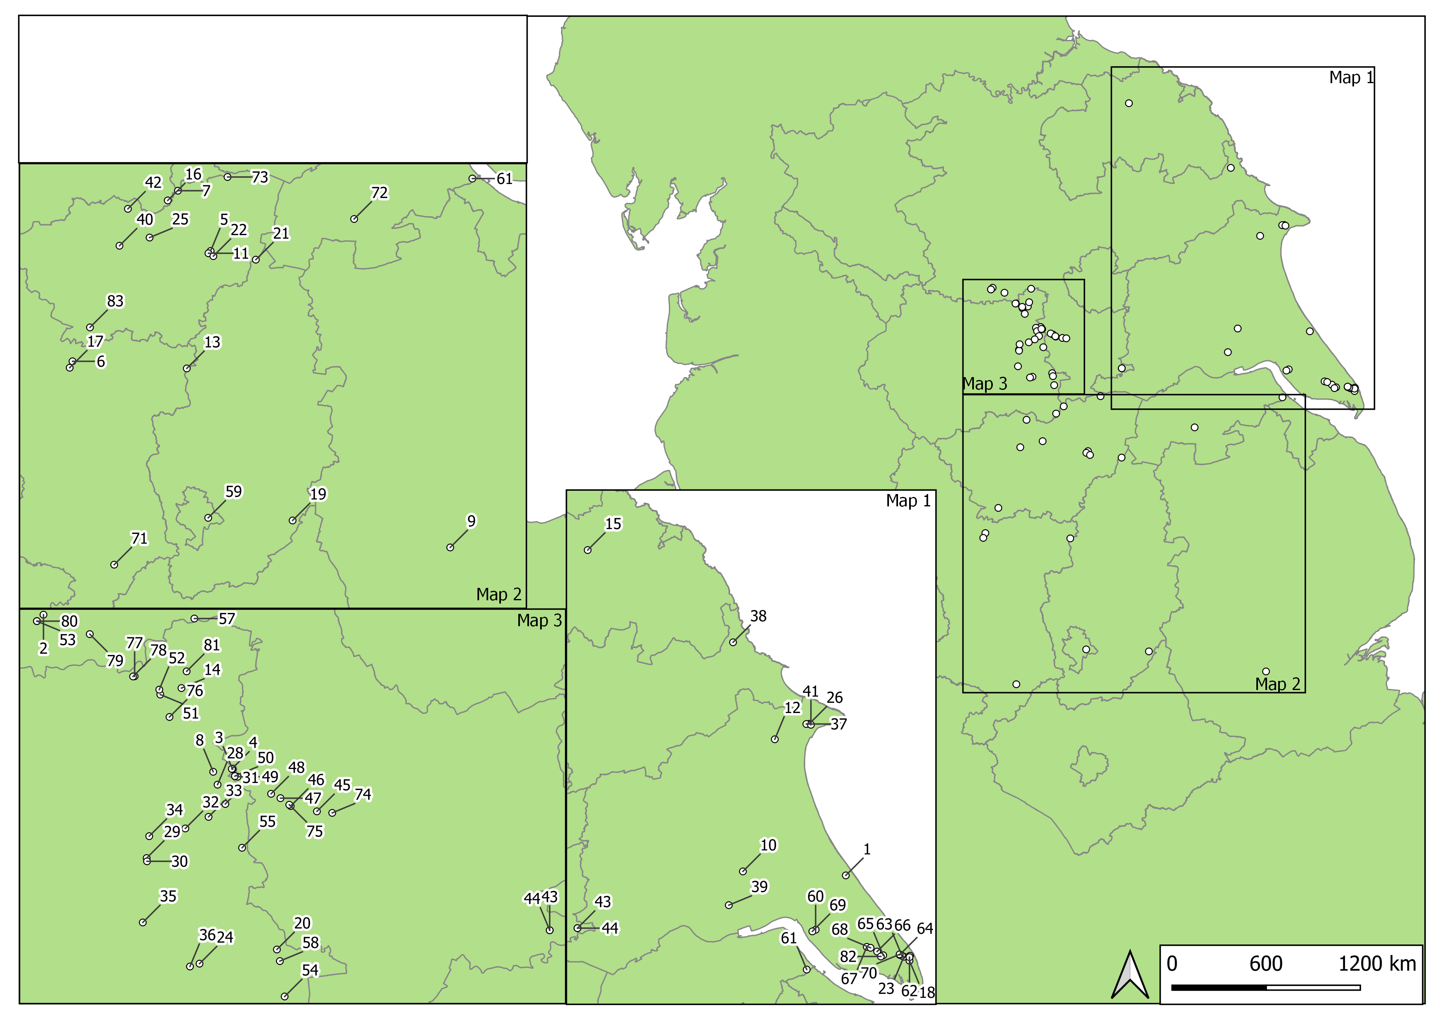

Figure S1: Historic Environment Record (HER) regions and sites with radiocarbon measurements discussed here.
1, Aldborough Gas Storage Facility; 2, AP30, Area 15, Asselby to Pannal Pipeline; 3, AP32, Area 8, Asselby to Pannal pipeline; 4, AP33, Area 8, Asselby to Pannal pipeline; 5, Balby Carr; 6, Bar Brook, Big Moor I, Baslow; 7, Barnsdale Bar Quarry, Norton; 8, Becca Banks, Aberford (Asselby to Pannal pipeline Area 8) ; 9, Billingborough; 10, Site BS13, Area 6, Beverley Southern Relief Road; 11, Carr Lodge Farm, Loversall; 12, Caythorpe Gas Pipeline, Field 0005; 13, Creswell, Fox Meadow; 14, Dalton Parlours; 15, Danby Rigg; 16, Doncaster Road, South Elmsall; 17, Eaglestone Flat; 18, Easington, Easington to Salt End Cable Route; 19, Elton-on-the-Hill; 20, Ferrybridge, Holmfield Interchange; 21, Finningley Quarry Northern Extension; 22, Finningley and Rossington Regeneration Route Scheme (FARRRS) Doncaster, South Yorkshire; 23, Fosse Hill, Easington to Salt End Cable Route; 24, Glasshoughton Coalfields Link Rd; 25, Goldthorpe; 26, High Wold, Bridlington; 27, Landeled Receiving Facilities, Easington; 28, M1-A1 Becca Banks; 29, M1-A1 Bullerthorpe Lane; 30, M1-A1 Grim's Ditch North; 31, M1-A1 Hook Moor; 32, M1-A1 Manor Farm; 33, M1-A1 Parlington Hollins; 34, M1-A1 Swillington Common; 35, Moss Carr, Methley; 36, Normanton Industrial Estate; 37, Pinfold Lane, Bridlington; 38, Racecourse Road, Seamer Moor, Scarborough; 39, Rawdales Drain; 40, Roebuck Hill, Jump, Barnsley; 41, Sewerby Cottage Farm, Bridlington; 42, Shafton Bypass, Shafton, South Yorkshire; 43, Site 1, Area 1, Asselby to Pannal pipeline; 44, Site 2, Area 1, Asselby to Pannal pipeline; 45, Site 17.3, Area 4, Asselby to Pannal pipeline; 46, Site 18.5, Area 5, Asselby to Pannal pipeline; 47, Site 18.10, Area 6, Asselby to Pannal pipeline; 48, Site 18.11B, Area 6, Asselby to Pannal pipeline; 49, Site 20.4 East, Area 7, Asselby to Pannal pipeline; 50, Site 20.4 West (South Dyke), Area 7, Asselby to Pannal pipeline; 51, Site 26.2, Area 12, Asselby to Pannal pipeline; 52, Site 26.3, Area 12, Asselby to Pannal pipeline; 53, Site 35.4, Area 15, Asselby to Pannal pipeline; 54, Site CFAT, A1[M] Darrington to Dishforth; 55, Site M, Castle Hills, Ledsham, A1[M] Darrington to Dishforth; 56, Site Q, A1[M] Darrington to Dishforth; 57, Site WWBP, north of Wetherby, A1[M] Darrington to Dishforth; 58, Site XX8, A1[M] Darrington to Dishforth; 59, Sneinton Fruitmarket; 60, South Hill, Easington to Salt End Cable Route; 61, South Killingholme, Heron Renewable Energy Plant; 62, Site SPE1, Easington to Paull gas pipeline; 63, Site SPE3, Easington to Paull gas pipeline; 64, Site SPE4, Easington to Paull gas pipeline; 65, Site SPE5, Easington to Paull gas pipeline; 66, Site SPE6, Easington to Paull gas pipeline; 67, Site SPE7, Easington to Paull gas pipeline; 68, Site SPE10, Easington to Paull gas pipeline; 69, Site SPE11, Easington to Paull gas pipeline; 70, Site SPE16, Easington to Paull gas pipeline; 71, Swarkestone Lowes; 72, Timberland, Scunthorpe; 73, Topham Farm, Sykehouse Barrier Bank, Sykehouse, Doncaster; 74, Tr 10b, Area 3. Asselby to Pannal pipeline; 75, Tr 20a, Area 5, Asselby to Pannal pipeline; 76, Tr 50, Area 11, Asselby to Pannal pipeline; 77, Tr 71, Area 13, Asselby to Pannal pipeline; 78, Tr 72, Area 13, Asselby to Pannal pipeline; 79, Tr 76, Area 14, Asselby to Pannal pipeline; 80, Tr 78-9, Area 15, Asselby to Pannal pipeline; 81, Wattle Syke, Wetherby; 82, Welwick Drain, Easington to Salt End Cable Route; 83, Whirlow Hall Farm
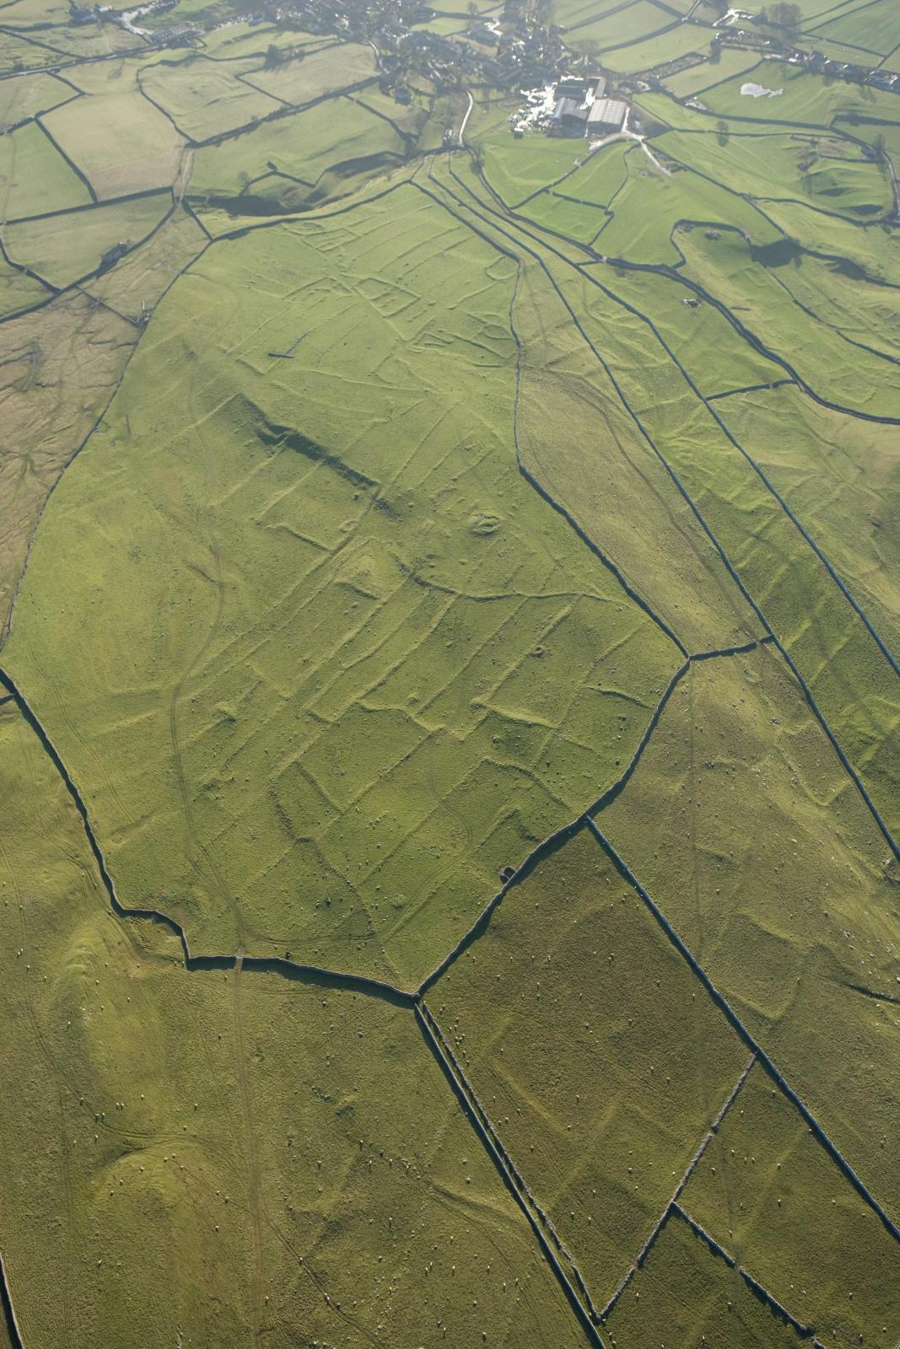

Figure S2: Co-axial fields. Earthwork remains of Iron Age/Roman coaxial fields at High Close, Grassington, North Yorkshire. Co-axial fields are so-called due to their adherence to a dominant alignment, often north-east – south-west, or north-south. These at Grassington, Yorkshire, are associated with a range of other monuments including cairns, trackways, and enclosure compounds. 20845_055. 25-NOV-2008 © Historic England Archive.

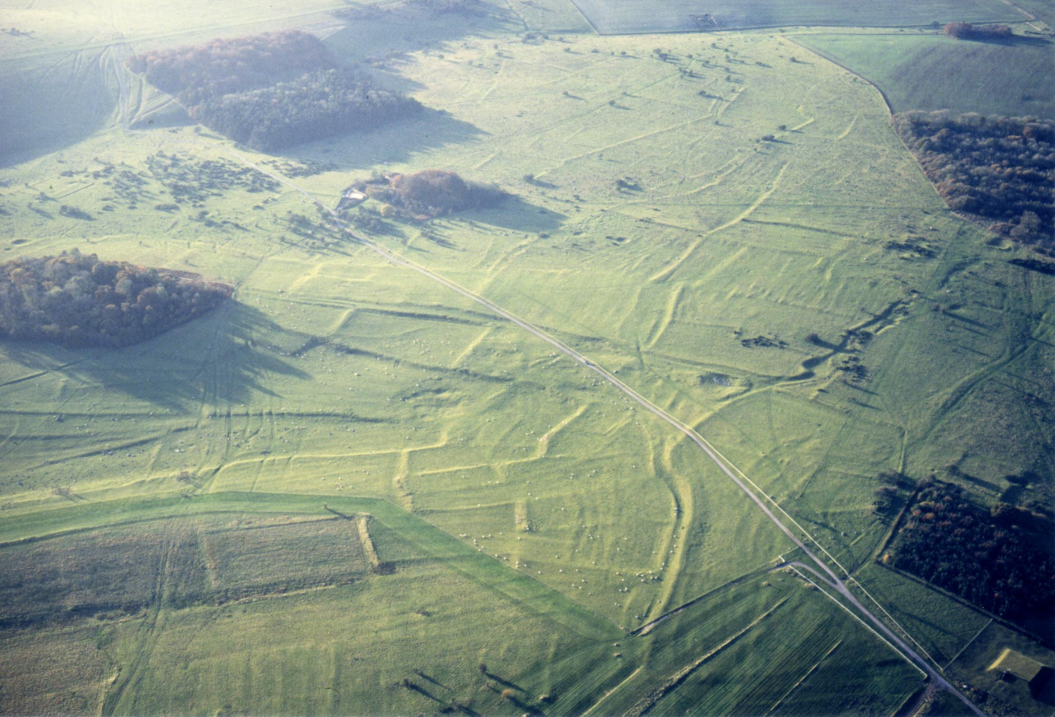

Figure S3: Aggregate Field System: Fyfield Down, Wiltshire The field boundaries, defined by banks and lynchets, as well as the interconnecting trackways, appear to have developed in an organic or piecemeal fashion, certainly without any overall layout plan or dominant symmetry. These fields were established towards the end of the 1st millennium BC and were used throughout the Roman period, with substantial evidence for re-use in the post-Roman period too. NMR SU1371-40 15862-32. 12-NOV-1997 ©Crown copyright. Historic England Archive.

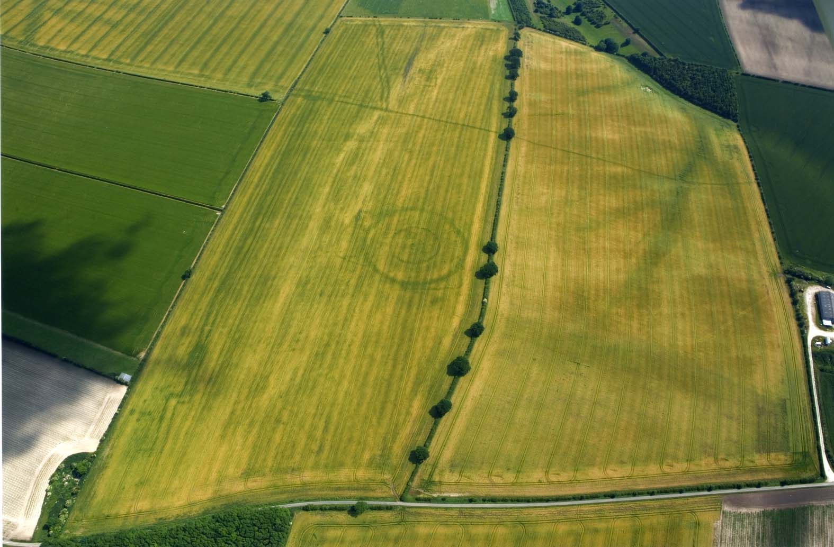

Figure S4: Enclosure: Thwing, East Riding of Yorkshire. The concentric circles of enclosure, defined by deep ditches cut in to the underlying chalk, are evident as is the faint trace of the central house. The complex which includes fields and trackways, too, dates to the 11th-8th centuries BC © English Heritage NMR No. 20799-41.

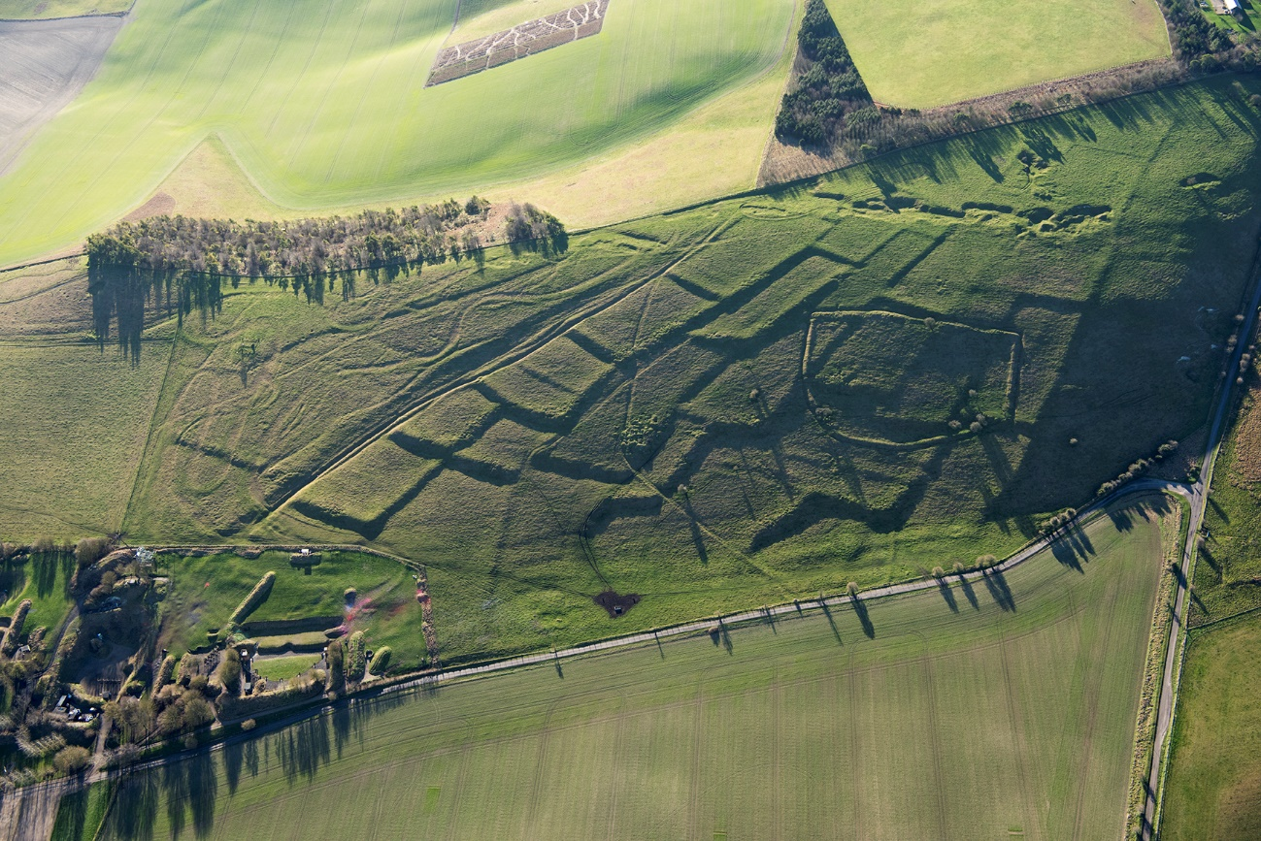

Figure S5: Stock Enclosure: Burderop Down, Wiltshire. The sharply defined ditched boundary of a stock enclosure overlies the lynchets of a regular aggregate field system. Stock enclosures, of this form, though often mistaken for prehistoric enclosures, predominantly date to the medieval period and are associated with sheep or cattle management. Photograph by Damian Grady 33781_017. 17th January 2019 © Historic England.

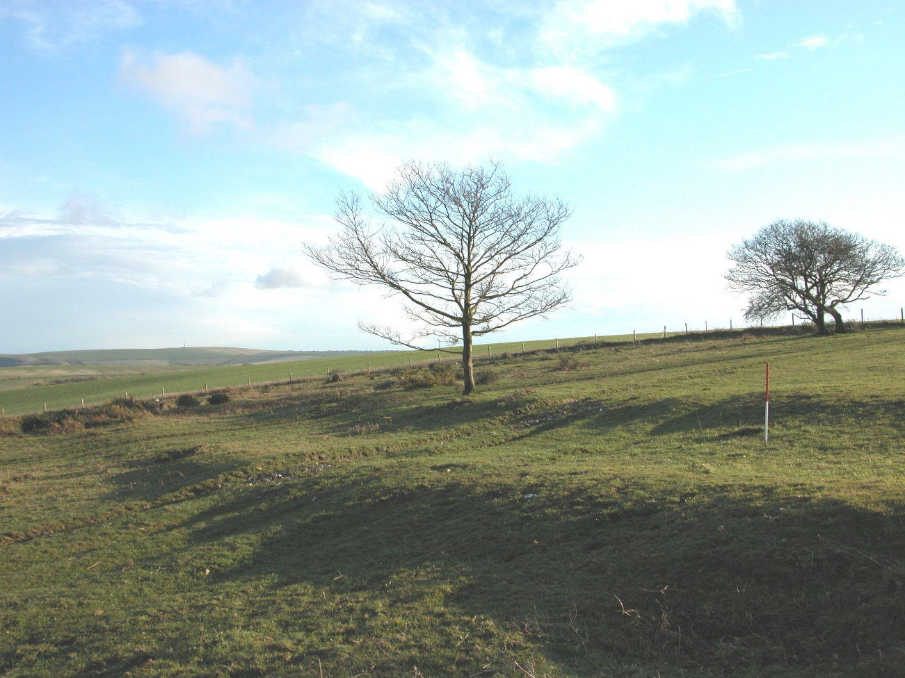

Figure S6: Trackway: This hollowed track, flanked on either side by agricultural lynchets, connects two enclosures which are part of the Plumpton Plain Middle Bronze Age settlement, East Sussex. © David McOmish.
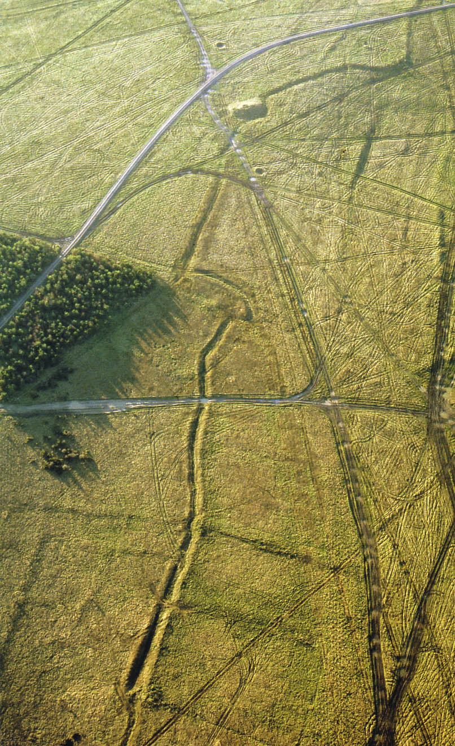

Figure S7: Linear earthwork. On Chapperton Down, Wiltshire, within the Salisbury Plain Training Area, a linear earthwork is aligned on a Neolithic long barrow, cuts through earlier fields, and changes direction sharply to avoid a pre-existing settlement. These linear earthwork boundaries have a wide date range but this example was probably constructed towards the end of the 2nd millennium BC. © Historic England.

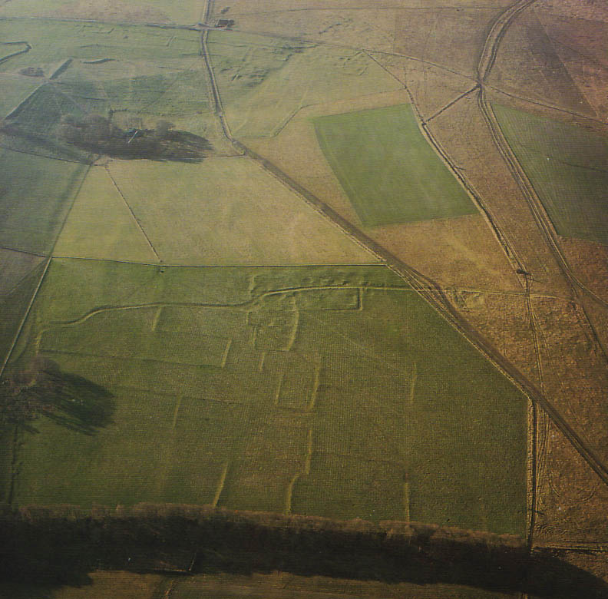

Figure S8: Field Boundary: Knook Down East, Salisbury Plain Training Area, Wiltshire. The edges of the fields here are marked by pronounced lynchets – soil build-ups at the edge of a cultivated space. Other boundaries comprise stone or earth banks, or are ditched. These shown here are connected to a well-defined hollow that serves the Roman period enclosed settlement complex. © Historic England.
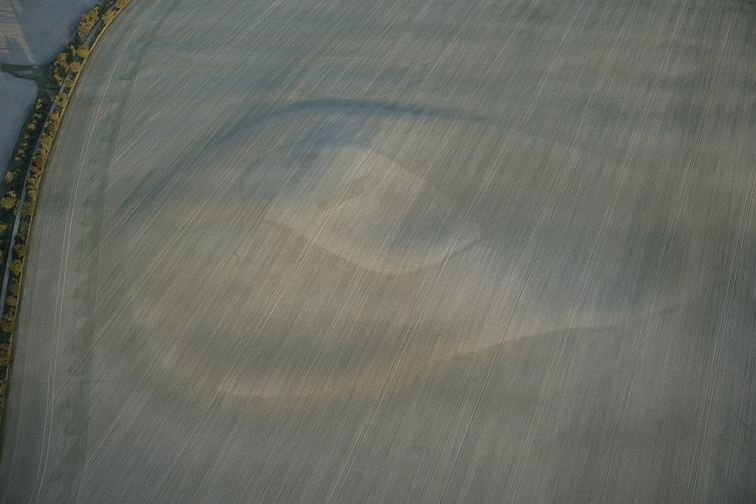

Figure S9: Settlement Enclosure: Ram’s Hill, Berkshire. Ploughing has almost removed every trace of the settlement enclosure complex here but the faint remains of the Bronze Age elements can be seen at the centre of the larger enclosure. © English Heritage NMR No. 26825_018.
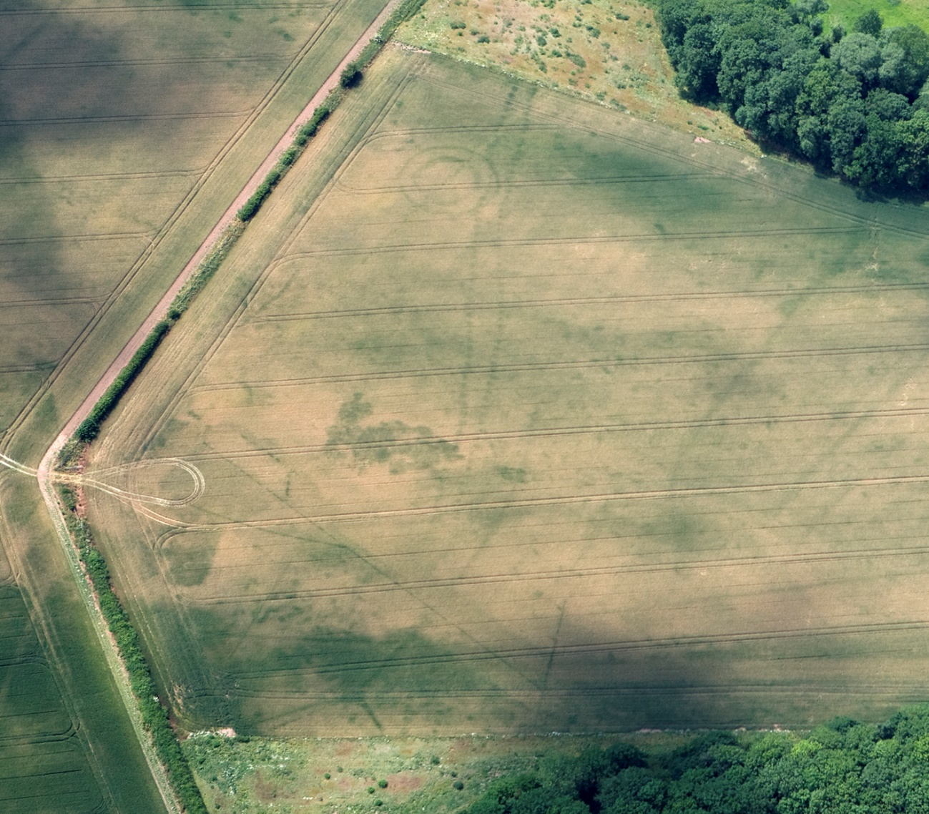

Figure S10: Pit Alignment: Double pit alignment Ingestre, Staffordshire. Pit alignments have a long currency of use and construction but few appear to post-date the Early Iron Age. Photograph by Dave Macleod 28052_024. 30-JUN-2010 © Historic England.

Figure S11: Site-specific model for results from Aldborough Gas Storage facility. Details of the measurements are given in Table S2. Each distribution represents the relative probability that an event occurred at a particular time. Two distributions have been plotted for each of the radiocarbon measurement: one in outline, which is the result of simple radiocarbon calibration, and a solid one based on the chronological model used. Additional distributions are shown in the figure in black. These have been calculated in the model defined here, and may be used in the ‘currency models’ presented below. The large square brackets down the left-hand side of the figure, along with the OxCal keywords, define the model exactly

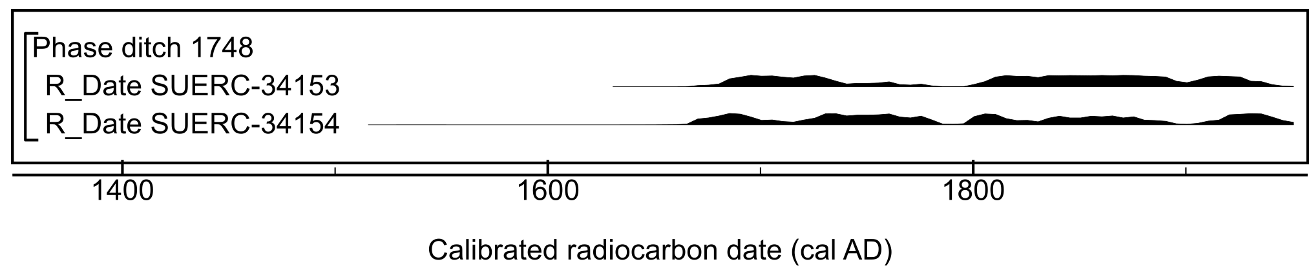

Figure S12: Calibrated radiocarbon results from AP30, Area 15, Asselby to Pannal Natural Gas Pipeline. Details of the measurements are given in Table S2.

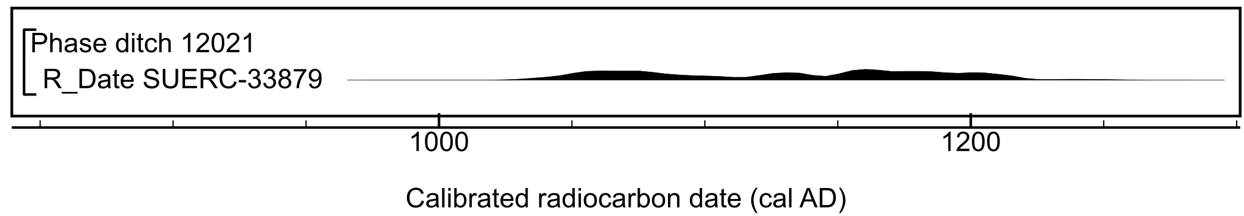

Figure S13: Calibrated radiocarbon result from AP32, Area 8, Asselby to Pannal Natural Gas Pipeline. Details of the measurement are given in Table S2.
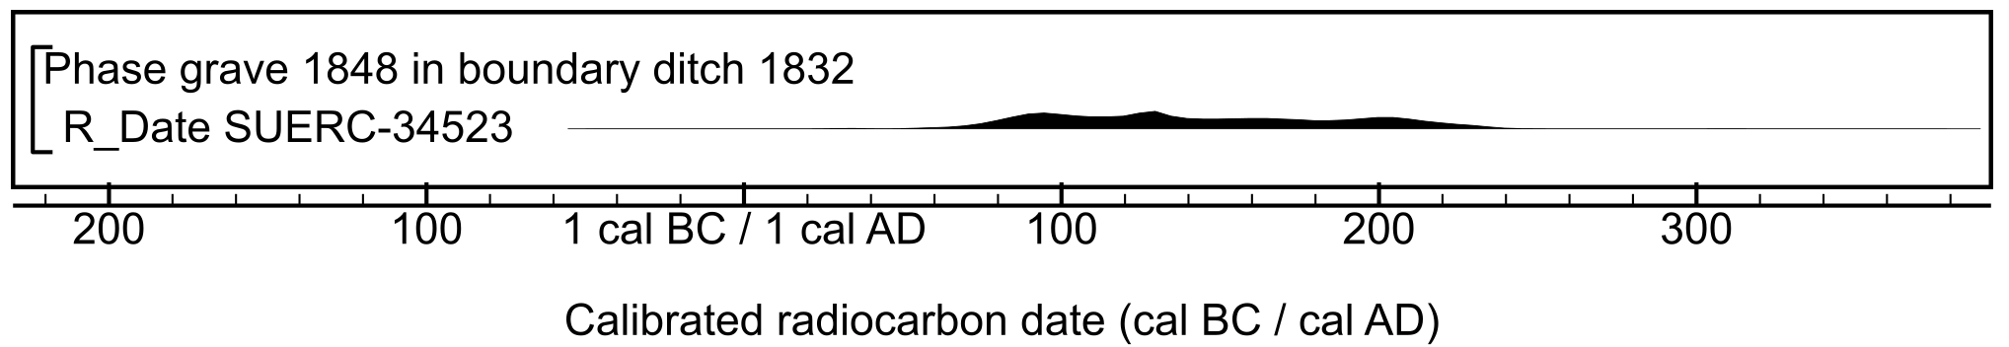

Figure S14: Calibrated radiocarbon result from AP33, Area 8, Asselby to Pannal Natural Gas Pipeline. Details of the measurement are given in Table S2.

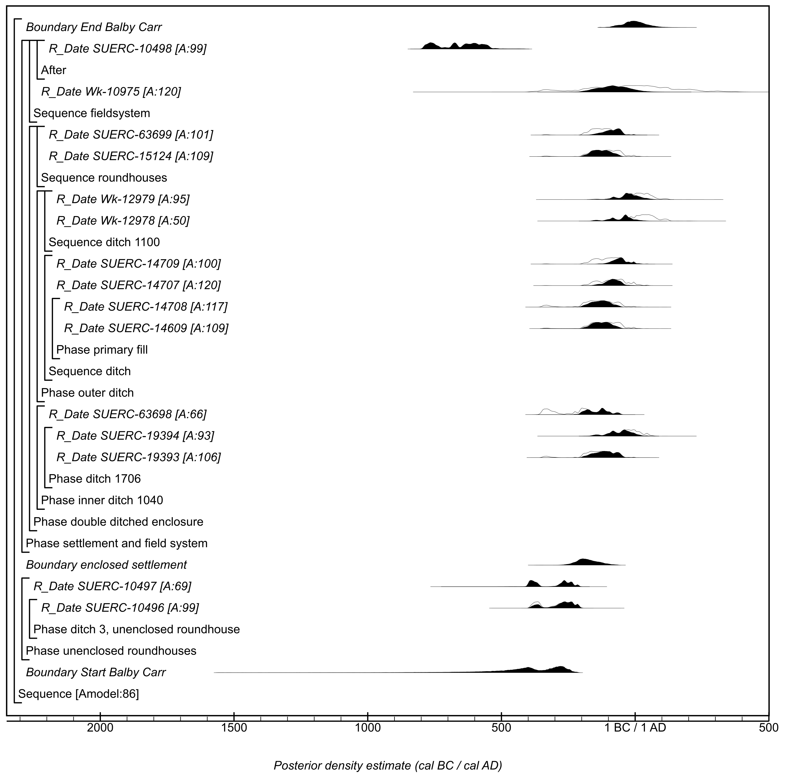
Figure S15: Site-specific model for results from Balby Carr. Details of the measurements are given in Table S2. The format is identical to that of Figure S11. The constraints applied here develop the model recently applied by Daniel & Barclay (2016). The large square brackets down the left-hand side of the figure, along with the OxCal keywords, define the model exactly.

Figure S16: Site-specific model for results from Bar Brook, Big Moor I. Details of the measurements are given in Table S2. The format is identical to that of Figure S11. Results included in this model are those that are stratigraphically related to land divisions at the site (cf. Bayliss et al., 2013). The large square brackets down the left-hand side of the figure, along with the OxCal keywords, define the model exactly.

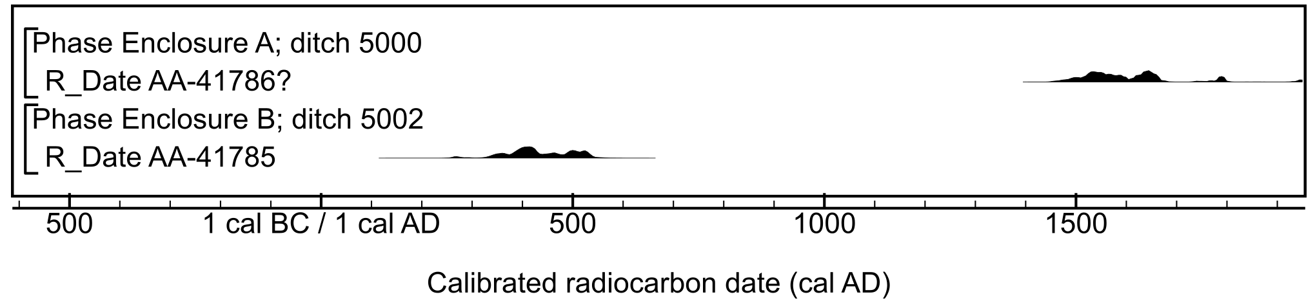

Figure S17: Calibrated radiocarbon results from Barnsdale Bar Quarry, Norton. Details of the measurements are given in Table S2.

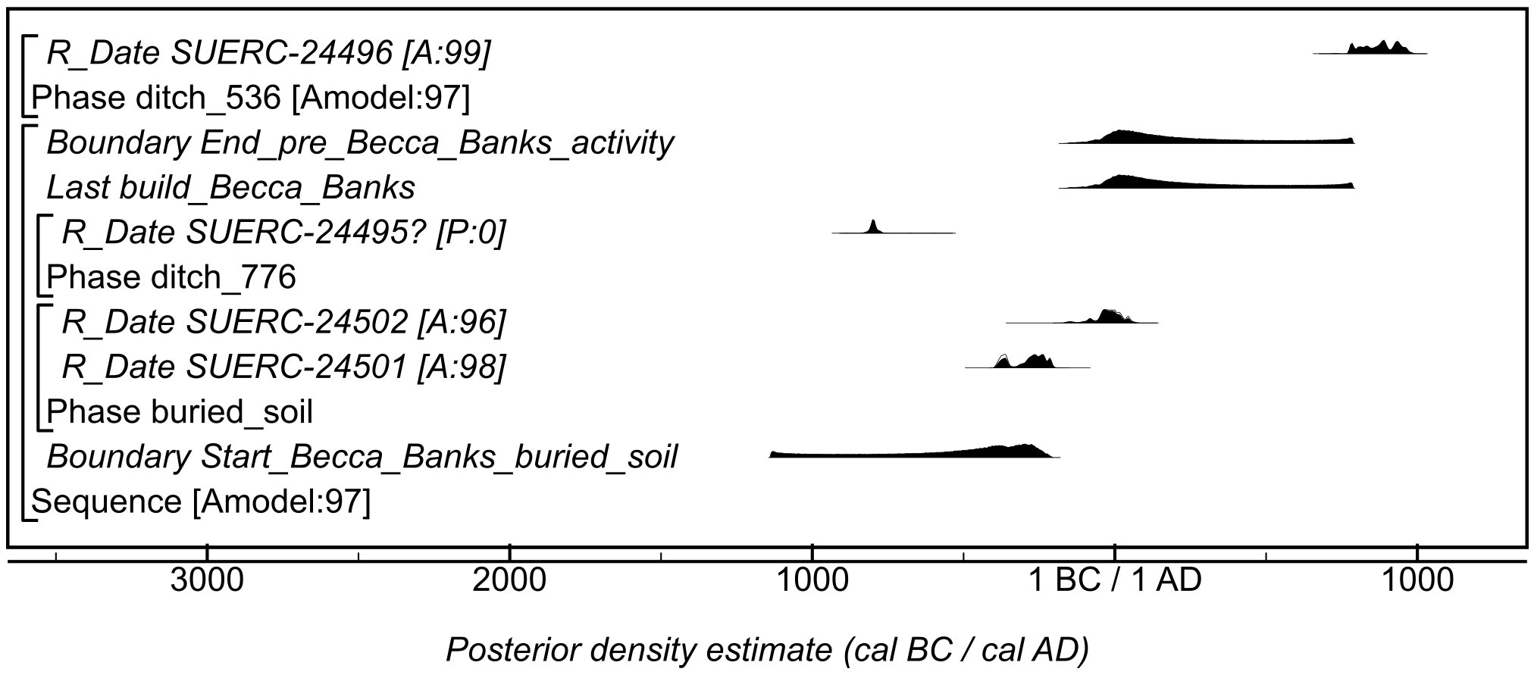

Figure S18: Site-specific model for results from Becca Banks, Aberford (Asselby to Pannal pipeline Area 8). Details of the measurements are given in Table S2. The format is identical to that of Figure S11. The measurement followed by a question mark has been excluded from models and is a simple calibrated date (Stuiver & Reimer, 1993). The large square brackets down the left-hand side of the figure, along with the OxCal keywords, define the model exactly.

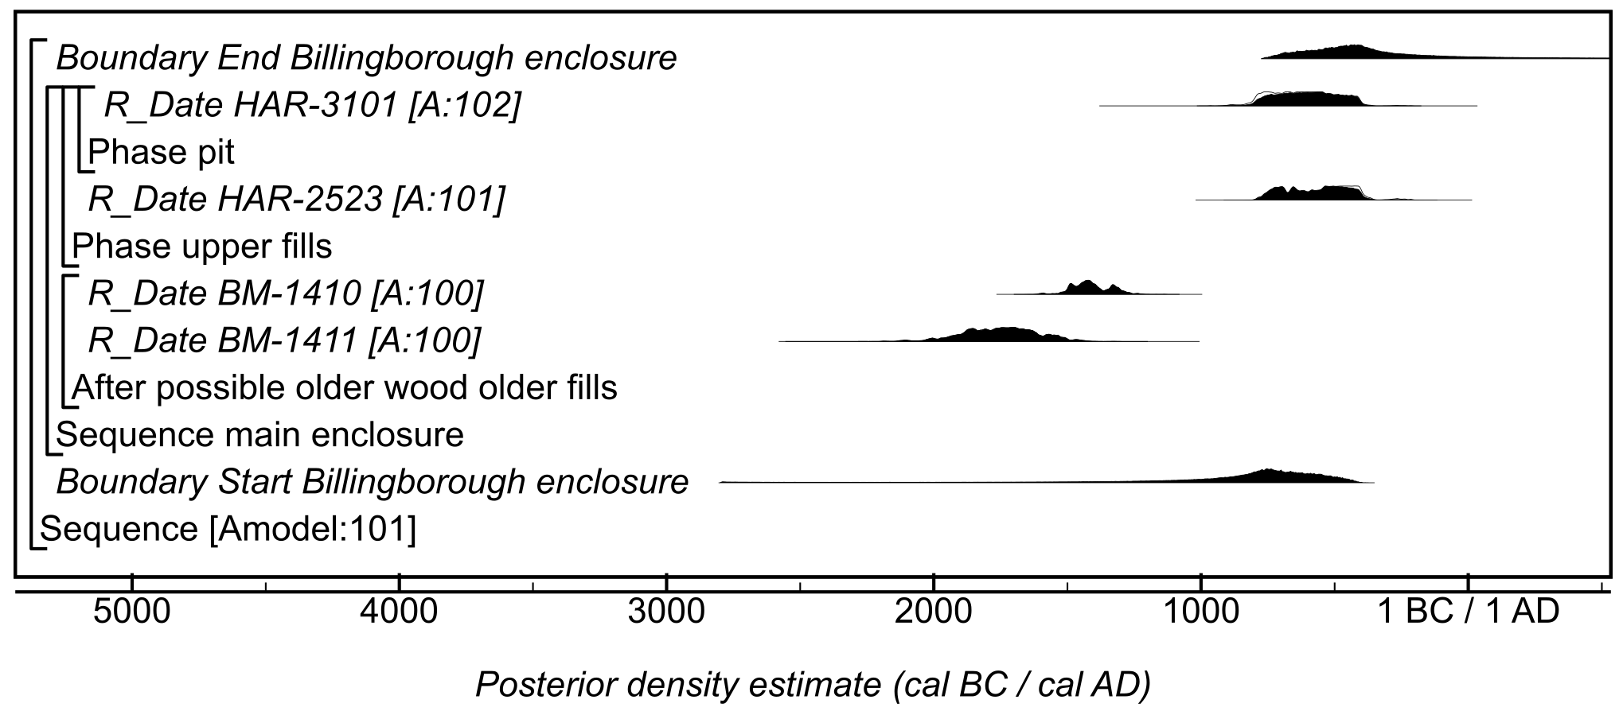

Figure S19: Site-specific model for results from Billingborough enclosure. Details of the measurements are given in Table S2. The large square brackets down the left-hand side of the figure, along with the OxCal keywords, define the model exactly.

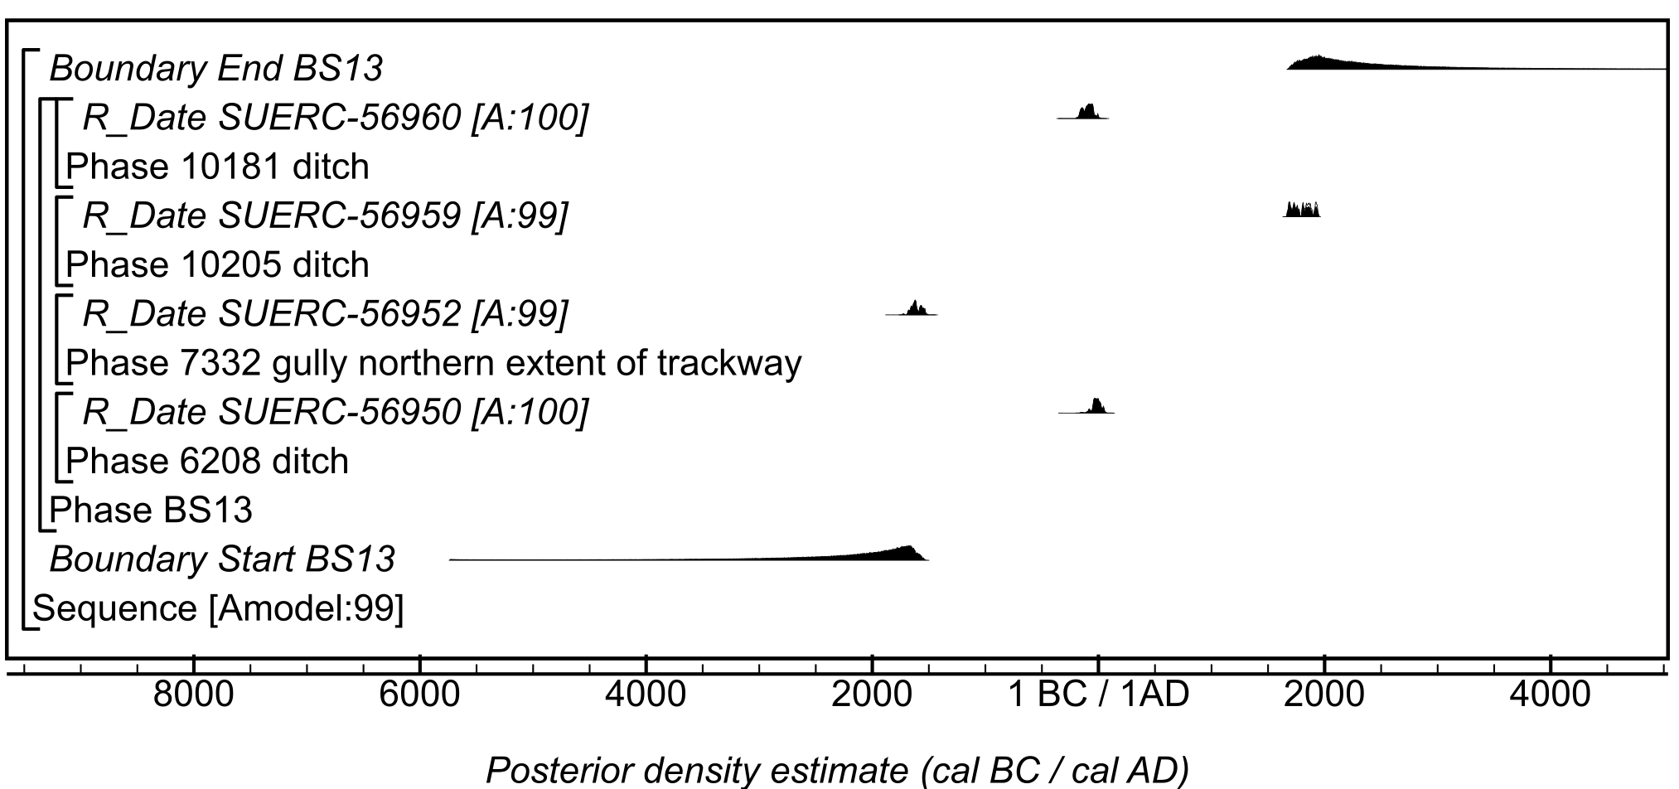

Figure S20: Site-specific model for results from Site BS13, Area 6, Beverley Southern Relief Road. Details of the measurements are given in Table S2. The large square brackets down the left-hand side of the figure, along with the OxCal keywords, define the model exactly.

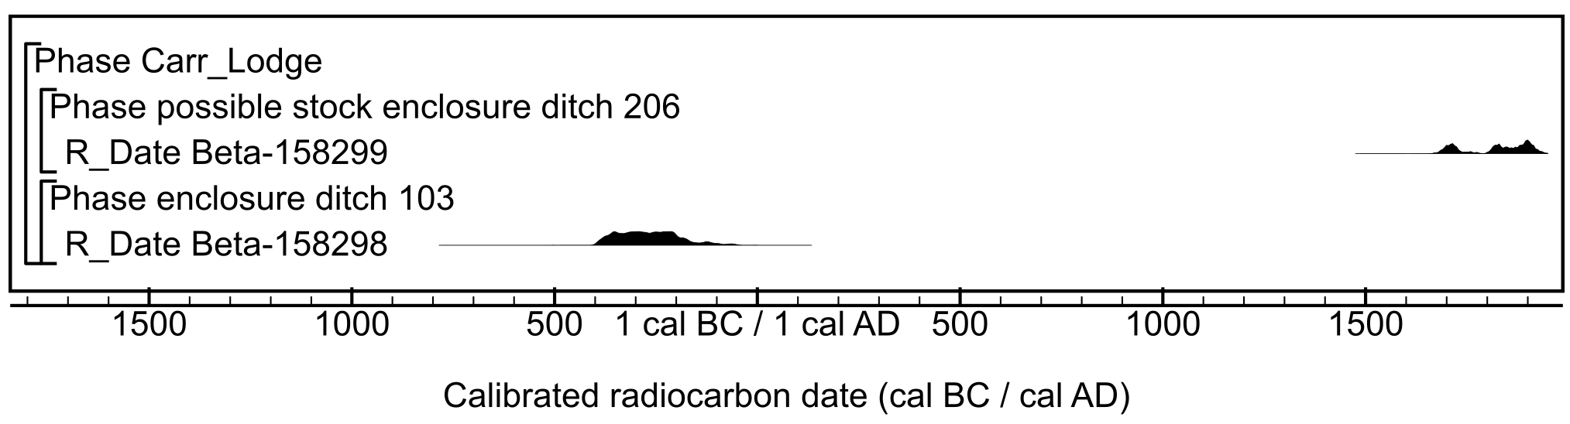

Figure S21: Calibrated radiocarbon results from Carr Lodge, Loversall. Details of the measurements are given in Table S2.

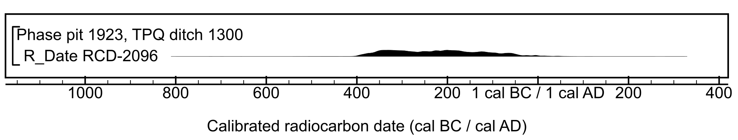

Figure S22: Calibrated radiocarbon result from Caythorpe gas pipeline. Details of the measurement are given in Table S2.

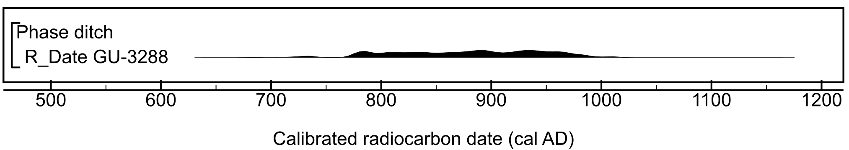

Figure S23: Calibrated radiocarbon result from Creswell Fox Meadow. Details of the measurement are given in Table S2.

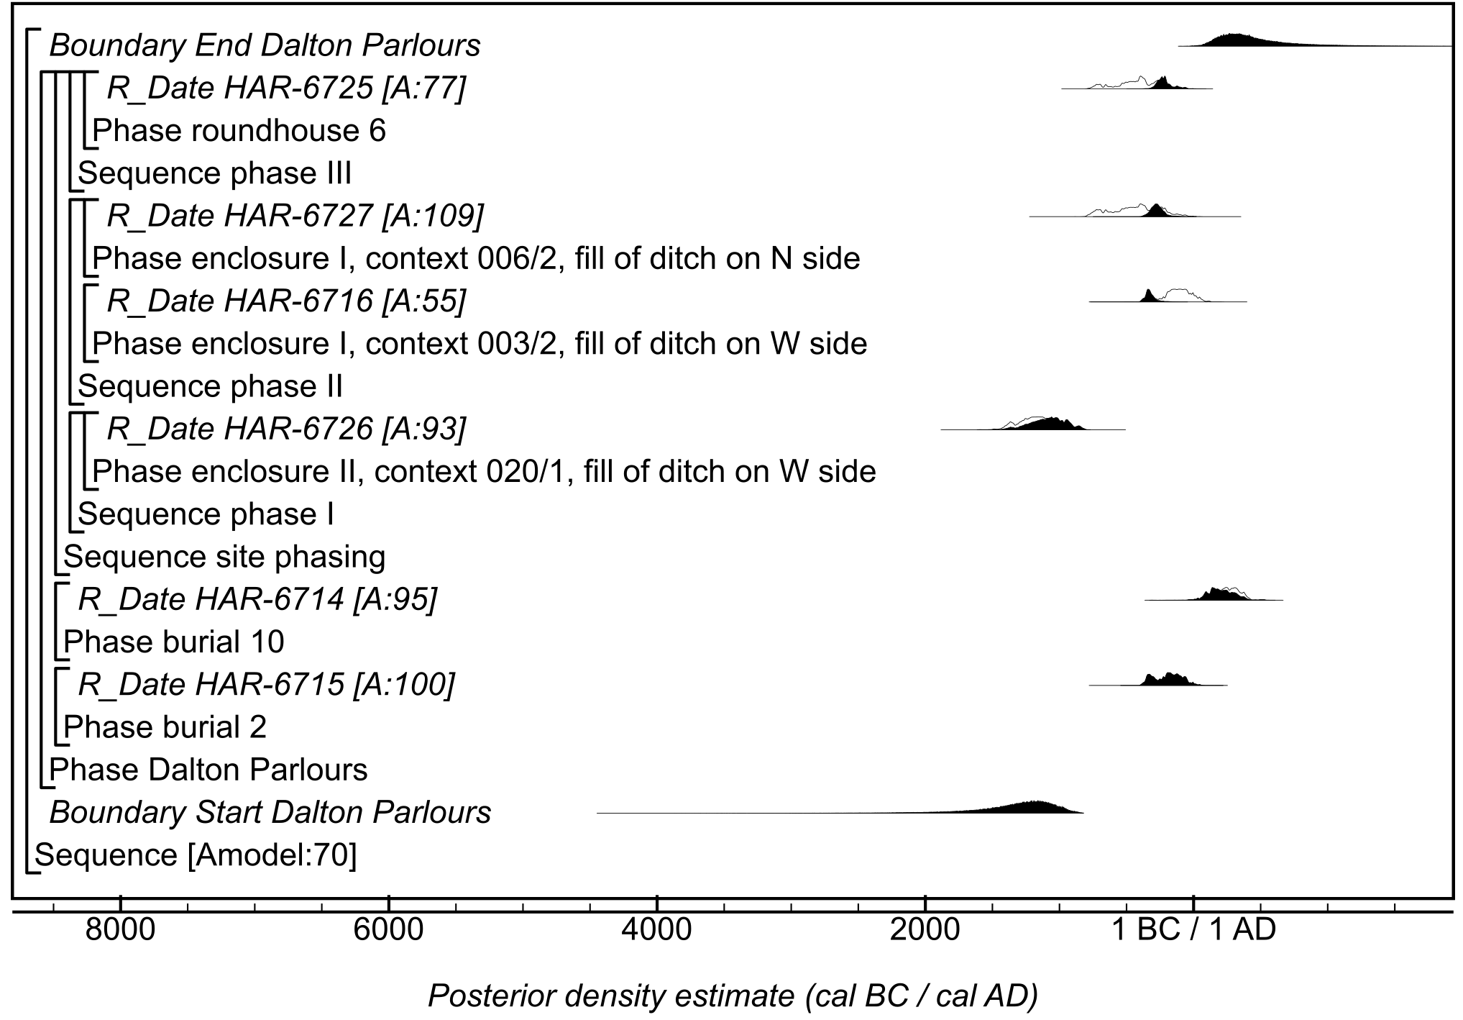

Figure S24: Site-specific model for results from Dalton Parlours. Details of the measurements are given in Table S2. The large square brackets down the left-hand side of the figure, along with the OxCal keywords, define the model exactly.

Figure S25: Site-specific model for results from Danby Rigg. Details of the measurements are given in Table S2. The large square brackets down the left-hand side of the figure, along with the OxCal keywords, define the model exactly.

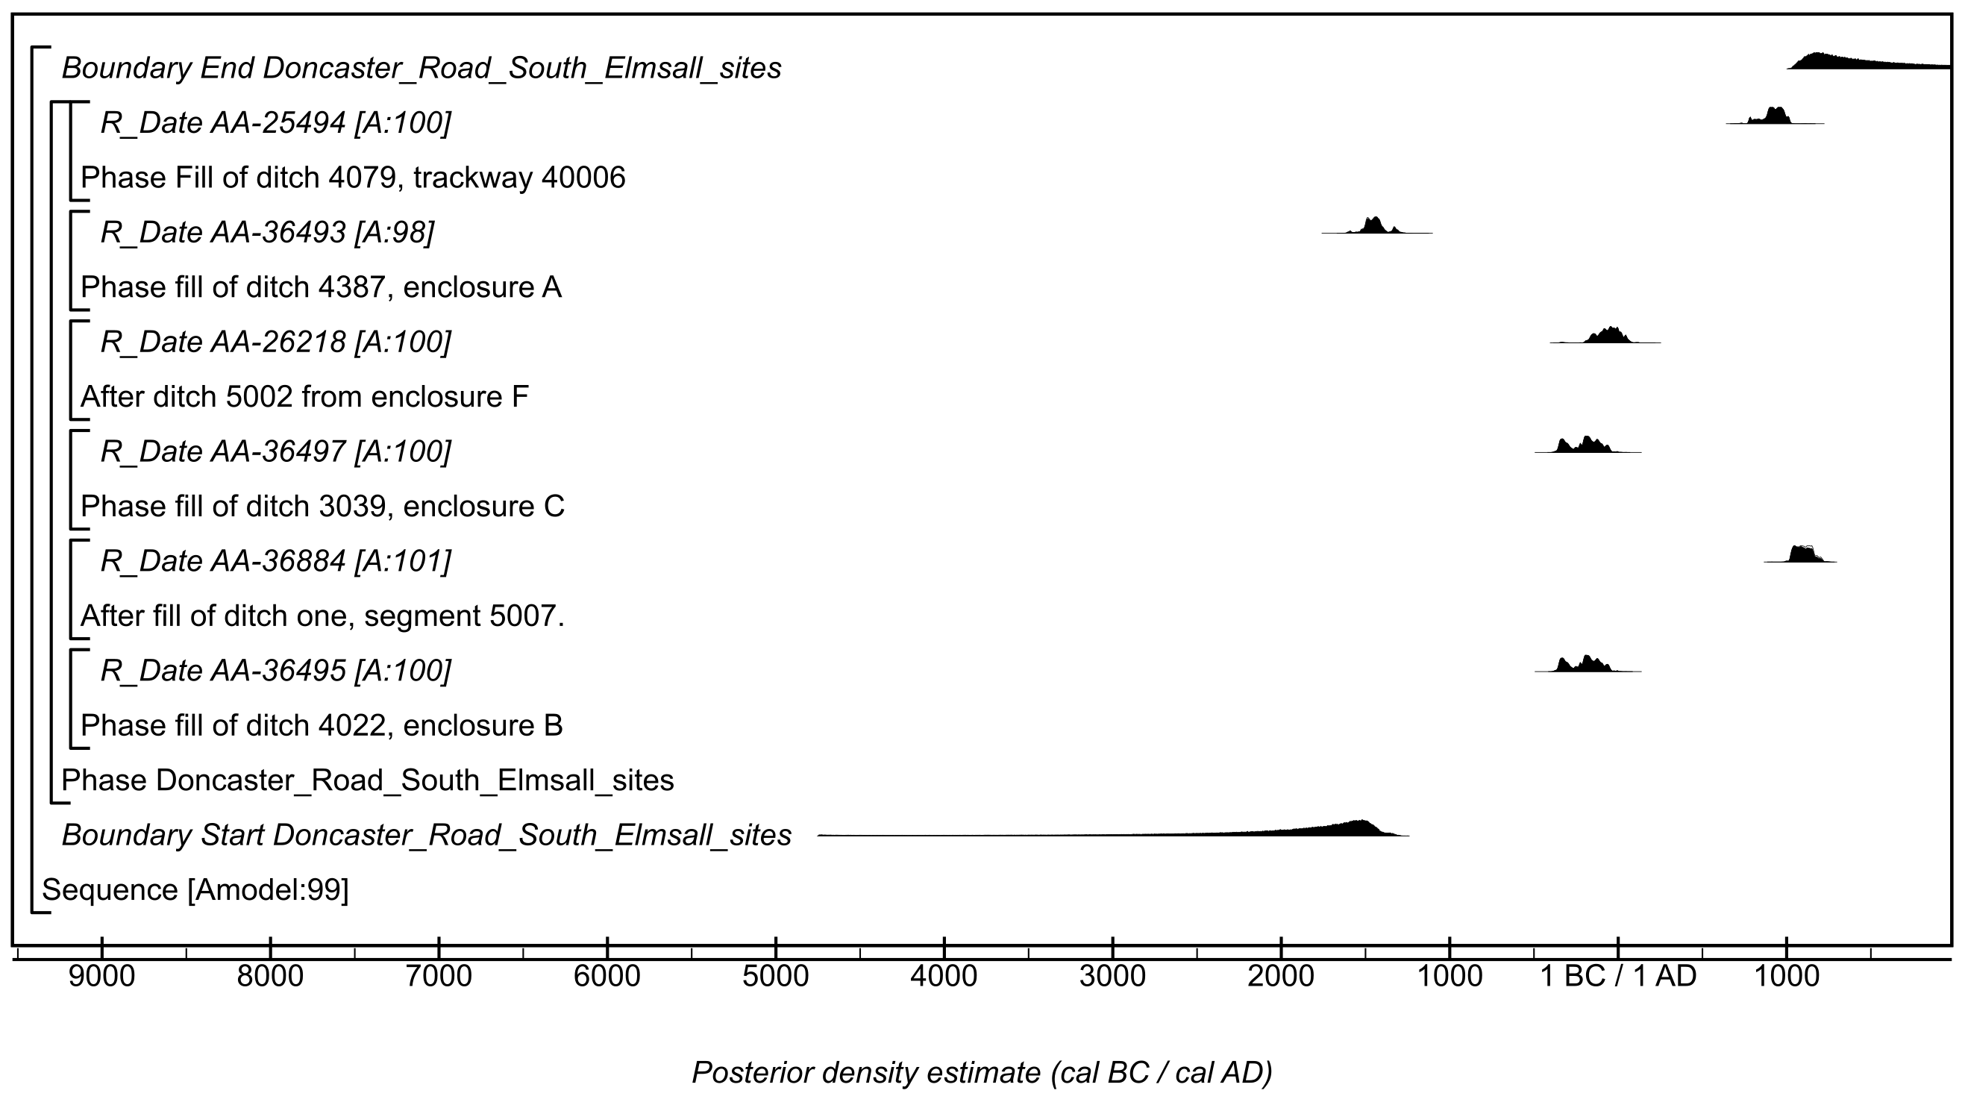

Figure S26: Site-specific model for results from Doncaster Road, South Elmsall sites. Details of the measurements are given in Table S2. The large square brackets down the left-hand side of the figure, along with the OxCal keywords, define the model exactly.

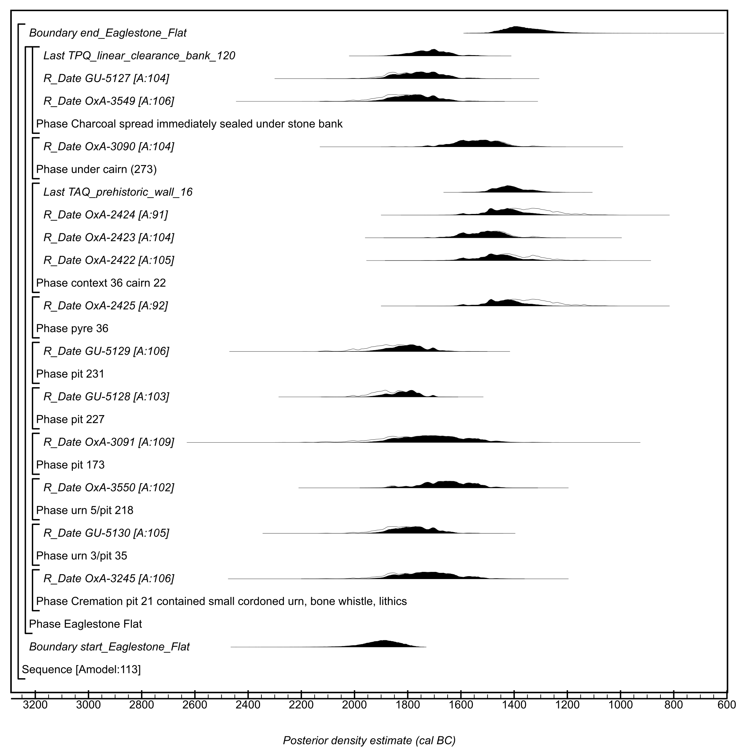

Figure S27: Site-specific model for results from Eaglestone Flat. Details of the measurements are given in Table S2. The large square brackets down the left-hand side of the figure, along with the OxCal keywords, define the model exactly.

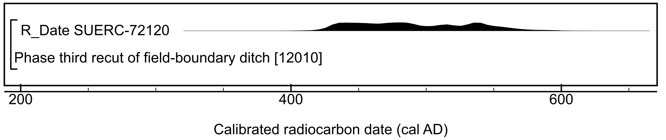

Figure S28: Radiocarbon result from Easington, Easington to Salt End Cable Route. Details of the measurement are given in Table S2.
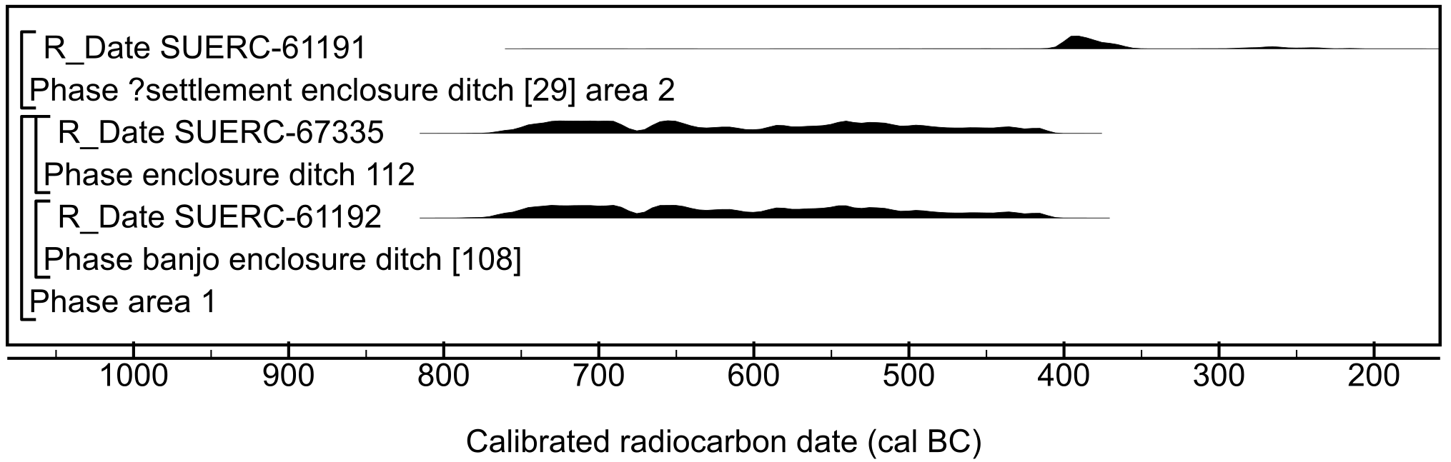

Figure S29: Radiocarbon results from Elton-on-the-Hill. Details of the measurements are given in Table S2.

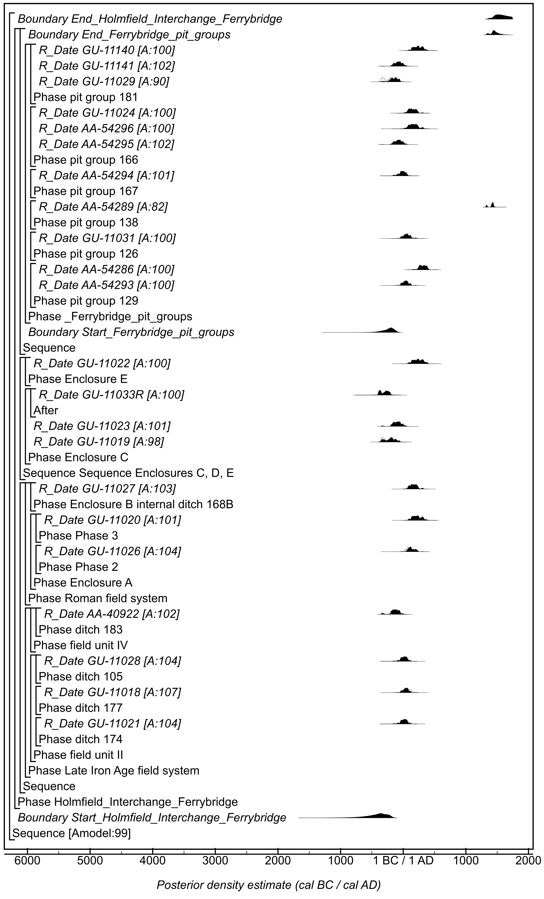
Figure S30: Site-specific model for results from Ferrybridge, Holmfield Interchange. Details of the measurements are given in Table S2. The format is identical to that of Figure S11. The large square brackets down the left-hand side of the figure, along with the OxCal keywords, define the model exactly.
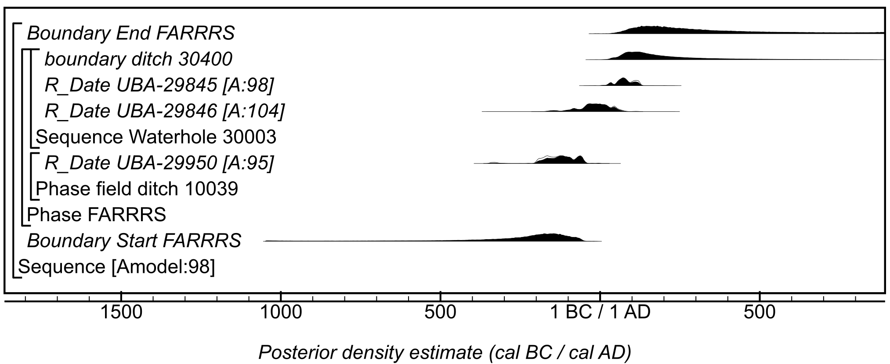

Figure S31: Site-specific model for results from Finningley and Rossington Regeneration Route Scheme. Details of the measurements are given in Table S2. The format is identical to that of Figure S11. The large square brackets down the left-hand side of the figure, along with the OxCal keywords, define the model exactly.

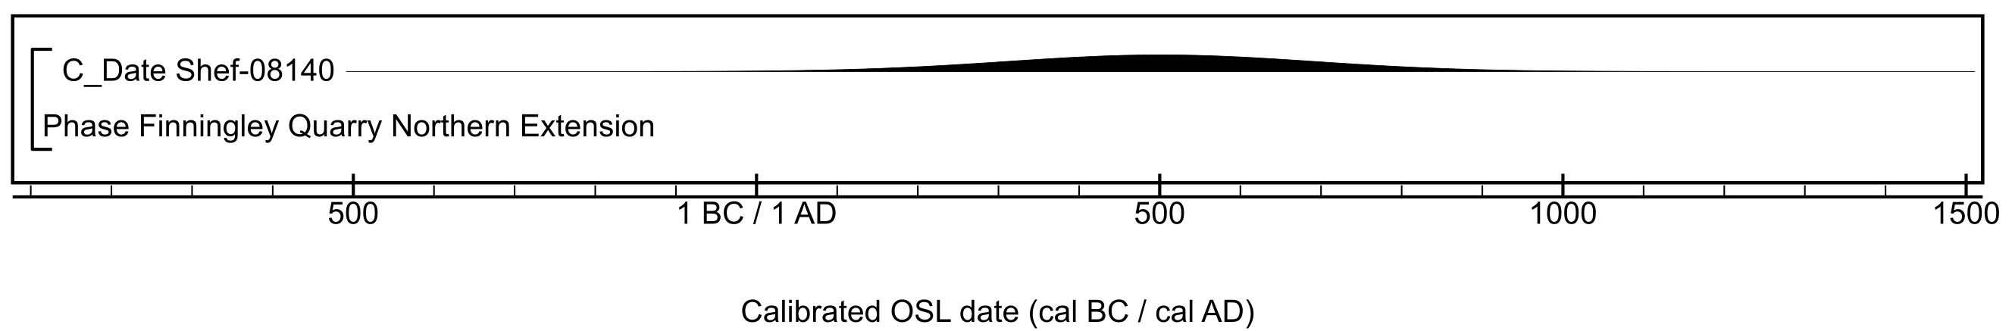

Figure S32: Calibrated OSL results from Finningley Quarry Northern Extension. Details of the measurement are given in Table S2.

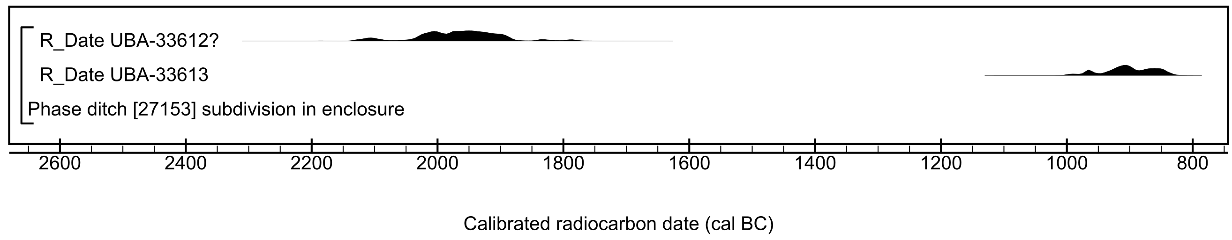

Figure S33: Radiocarbon results from Fosse Hill, Easington to Salt End Cable Route. Details of the measurements are given in Table S2. No Bayesian model has been applied here as there are too few measurements, but the measurement followed by a question mark has been excluded from subsequent models.

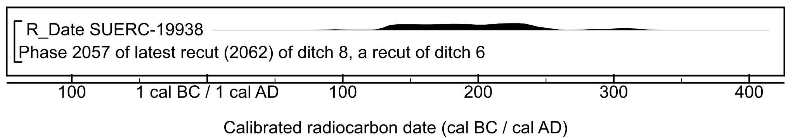

Figure S34: Radiocarbon result from Glasshoughton, Coalfield Link Road. Details of the measurement are given in Table S2.

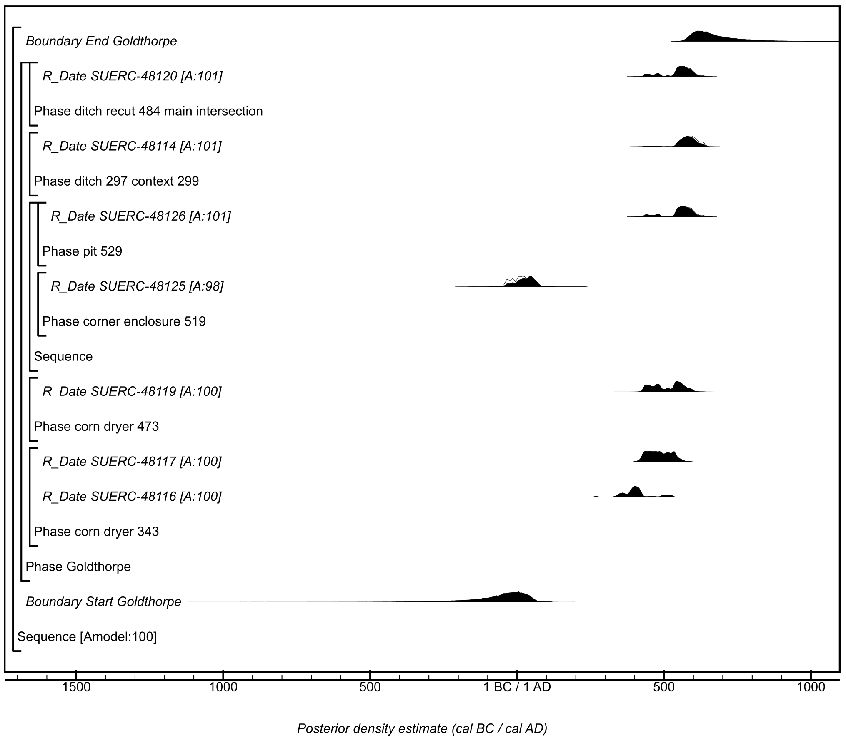

Figure S35: Site-specific model for results from Goldthorpe. Details of the measurements are given in Table S2. The format is identical to that of Figure S11. The large square brackets down the left-hand side of the figure, along with the OxCal keywords, define the model exactly.

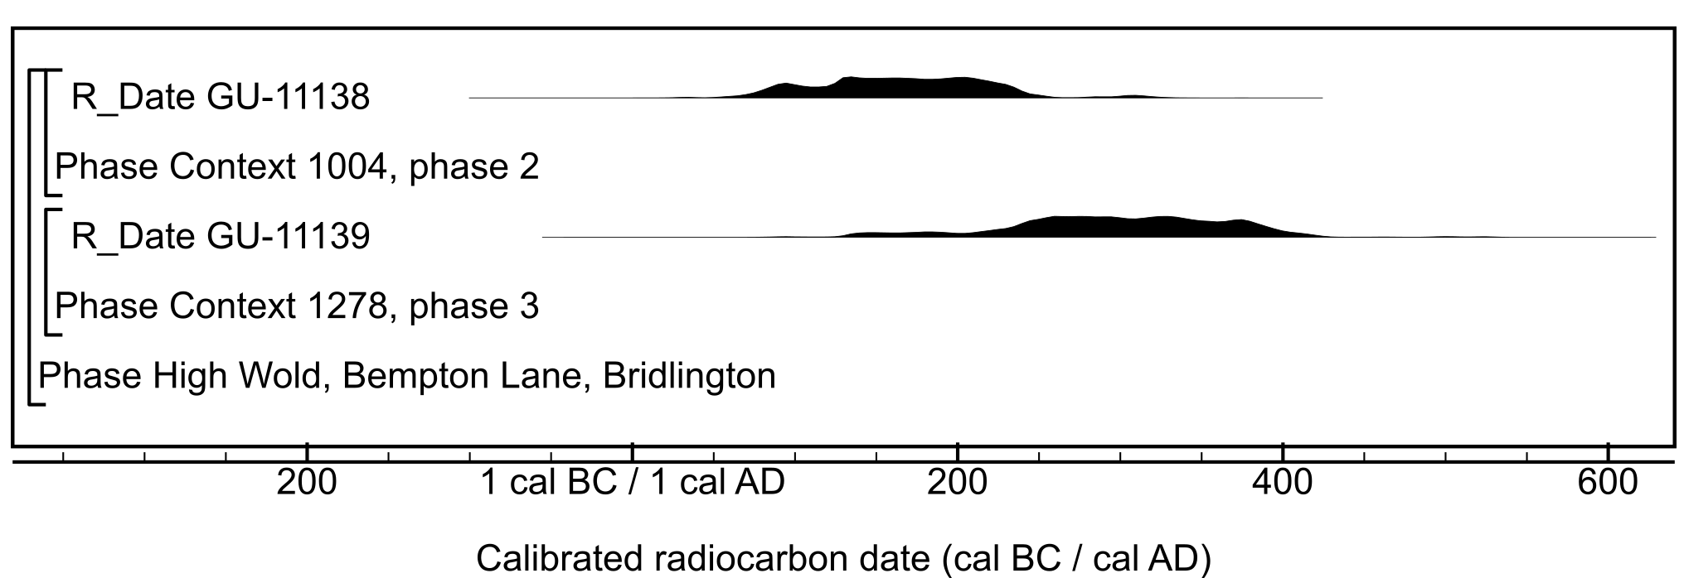

Figure S36: Radiocarbon results from High Wold, Birlington. Details of the measurements are given in Table S2. No Bayesian model has been applied here as there are too few measurements, but the measurement followed by a question mark has been excluded from subsequent models.

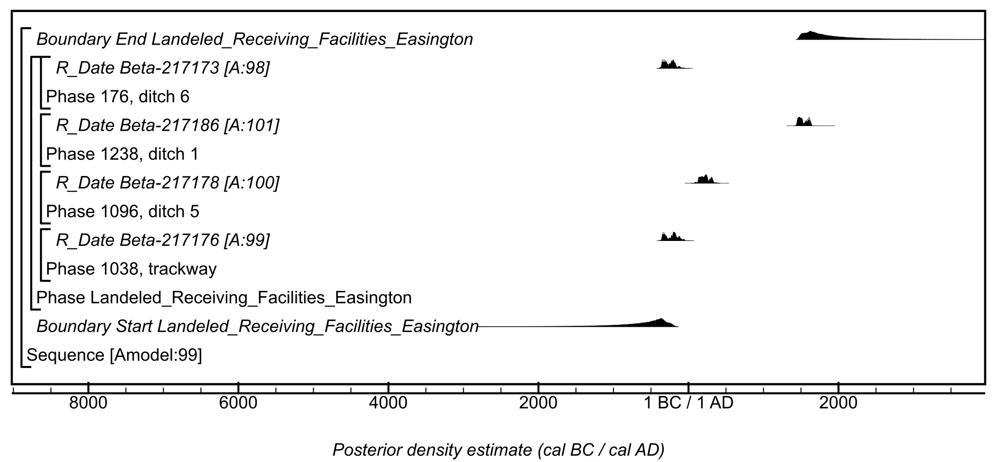

Figure S37: Site-specific model for results from Landeled Receiving Facilities, Easington. Details of the measurements are given in Table S2. The format is identical to that of Figure S11. The large square brackets down the left-hand side of the figure, along with the OxCal keywords, define the model exactly.
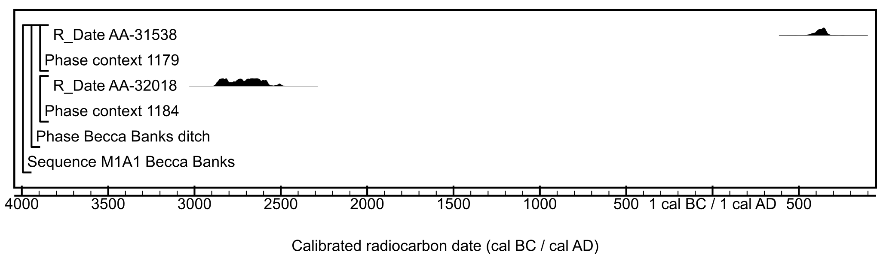

Figure S38: Radiocarbon results from the M1(A1) interventions at Becca Bank. Details of the measurements are given in Table S2. No Bayesian model has been applied here as there are too few measurements.

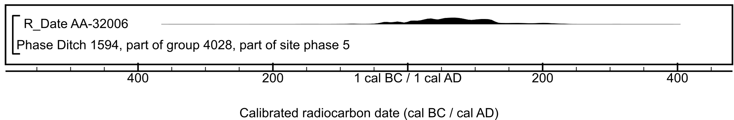

Figure S39: Radiocarbon results from the M1(A1) Bullerthorpe Lane site. Details of the measurements are given in Table S2.

Figure S40: Site-specific model for results from the M1(A1) Grims Ditch intervention. Details of the measurements are given in Table S2. The format is identical to that of Figure S11. The measurement followed by a question mark has been excluded from models and is a simple calibrated date (Stuiver & Reimer, 1993). The large square brackets down the left-hand side of the figure, along with the OxCal keywords, define the model exactly.

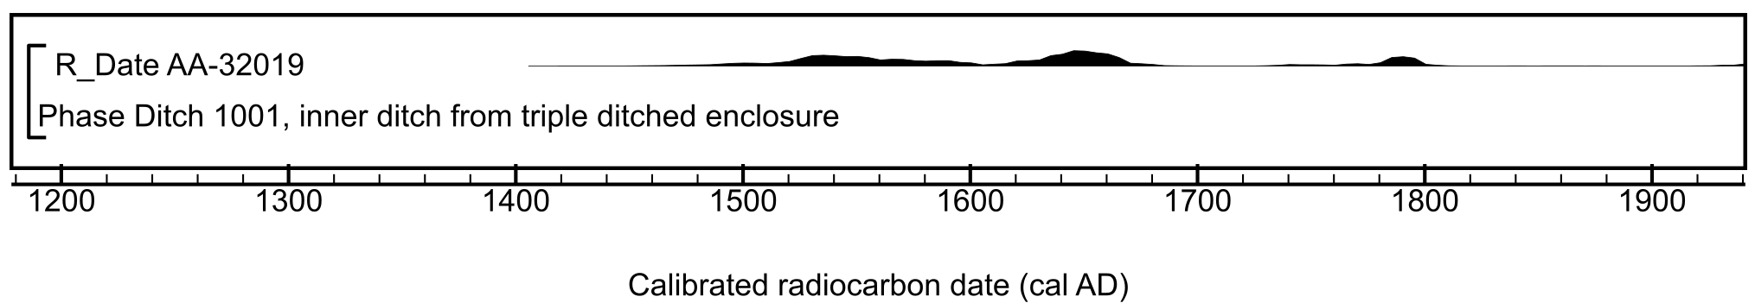

Figure S41: Radiocarbon result from the M1(A1) Hook Moor site. Details of the measurement are given in Table S2.

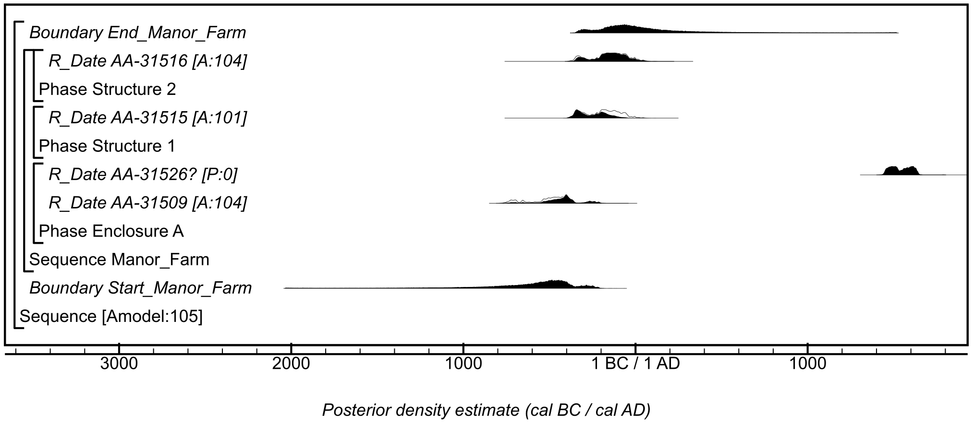

Figure S42: Site-specific model for results from the M1(A1) Manor Farm site. Details of the measurements are given in Table S2. The format is identical to that of Figure S11. The measurement followed by a question mark has been excluded from models and is a simple calibrated date (Stuiver & Reimer, 1993). The large square brackets down the left-hand side of the figure, along with the OxCal keywords, define the model exactly.

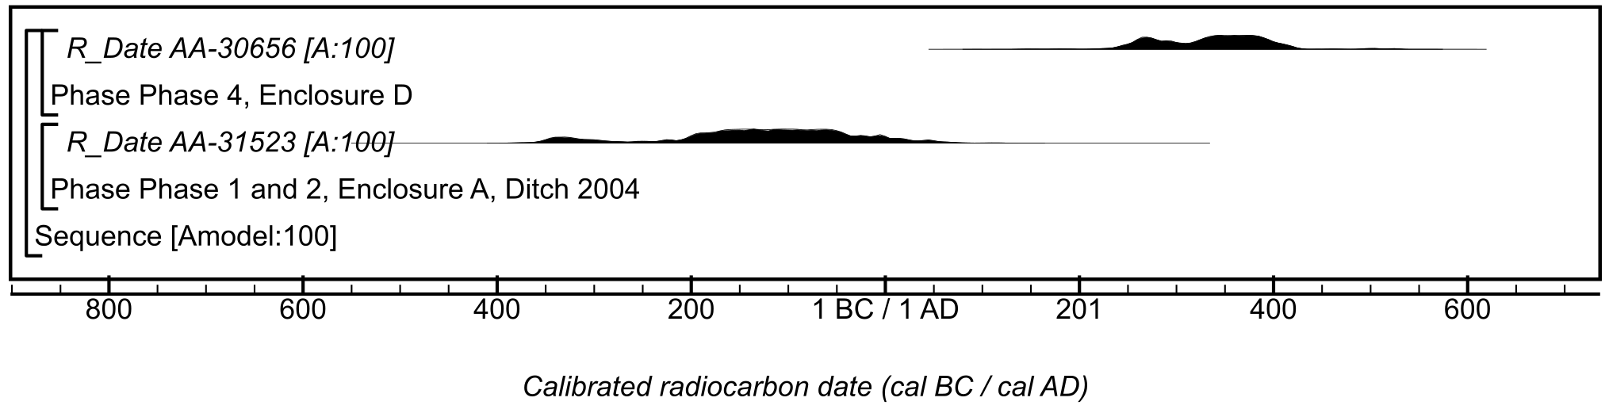

Figure S43: Site-specific model for results from the M1(A1) Parlington Hollings site. Details of the measurements are given in Table S2. The format is identical to that of Figure S11. The large square brackets down the left-hand side of the figure, along with the OxCal keywords, define the model exactly.

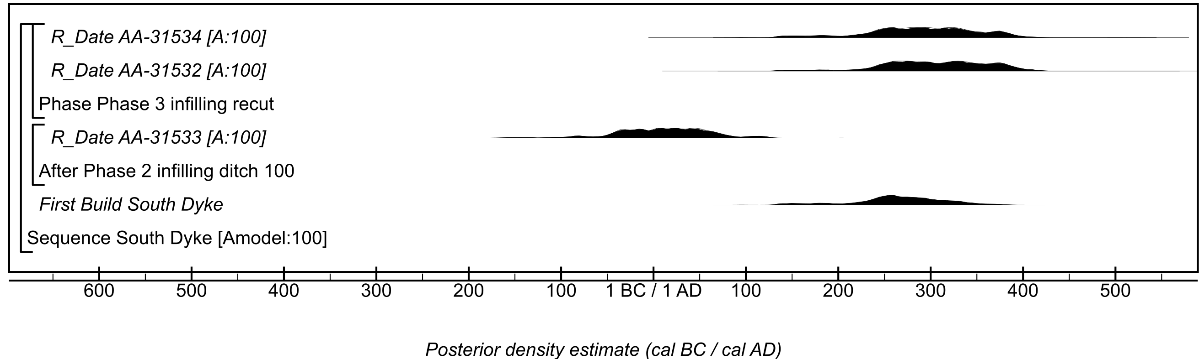

Figure S44: Site-specific model for results from the M1(A1) South Dyke intervention. Details of the measurements are given in Table S2. The format is identical to that of Figure S11. The large square brackets down the left-hand side of the figure, along with the OxCal keywords, define the model exactly.

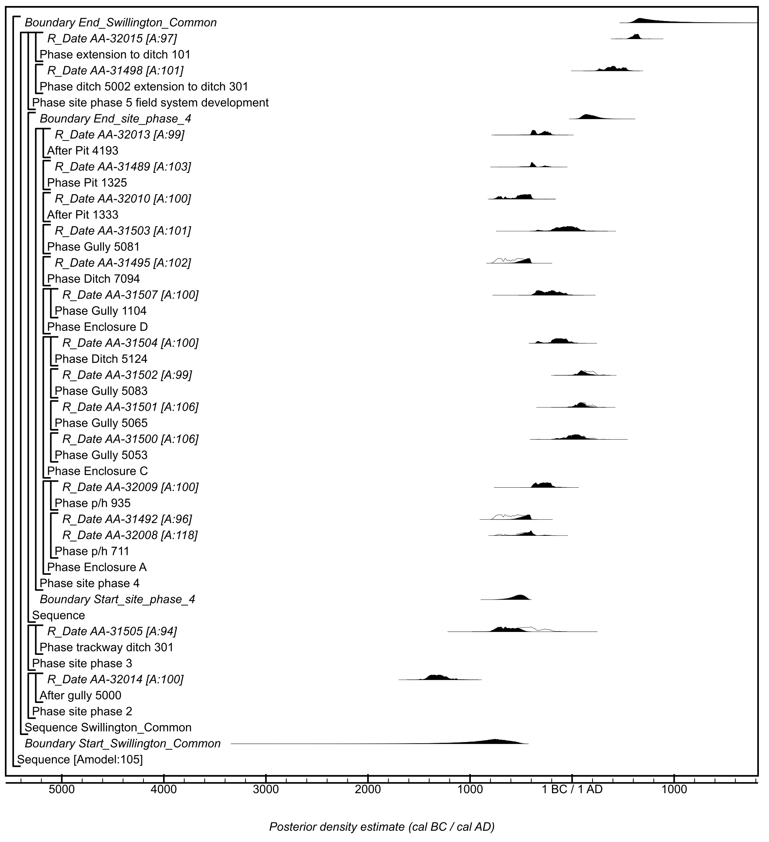

Figure S45: Site-specific model for results from the M1(A1) Swillington Common South site. Details of the measurements are given in Table S2. The format is identical to that of Figure S11. The large square brackets down the left-hand side of the figure, along with the OxCal keywords, define the model exactly.

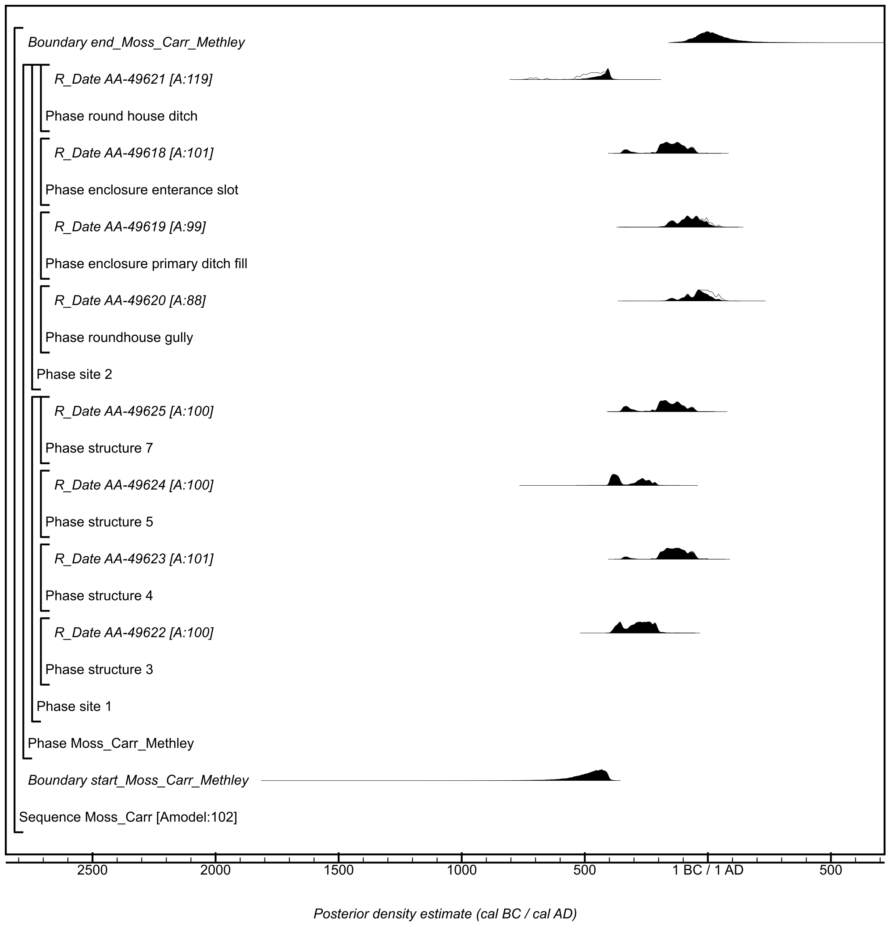

Figure S46: Site-specific model for results from the Moss Carr, Methley site. Details of the measurements are given in Table S2. The format is identical to that of Figure S11. The large square brackets down the left-hand side of the figure, along with the OxCal keywords, define the model exactly.

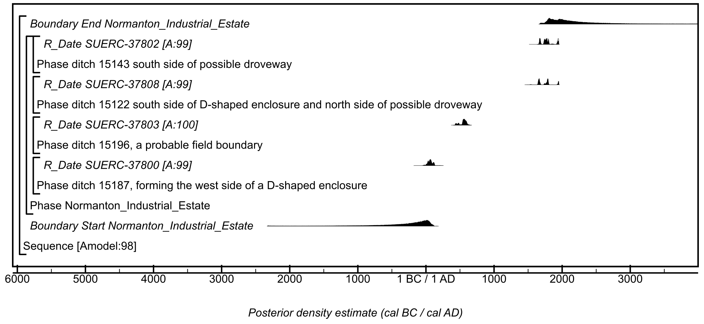

Figure S47: Site-specific model for results from the Normanton Industrial Estate site. Details of the measurements are given in Table S2. The format is identical to that of Figure S11. The large square brackets down the left-hand side of the figure, along with the OxCal keywords, define the model exactly.

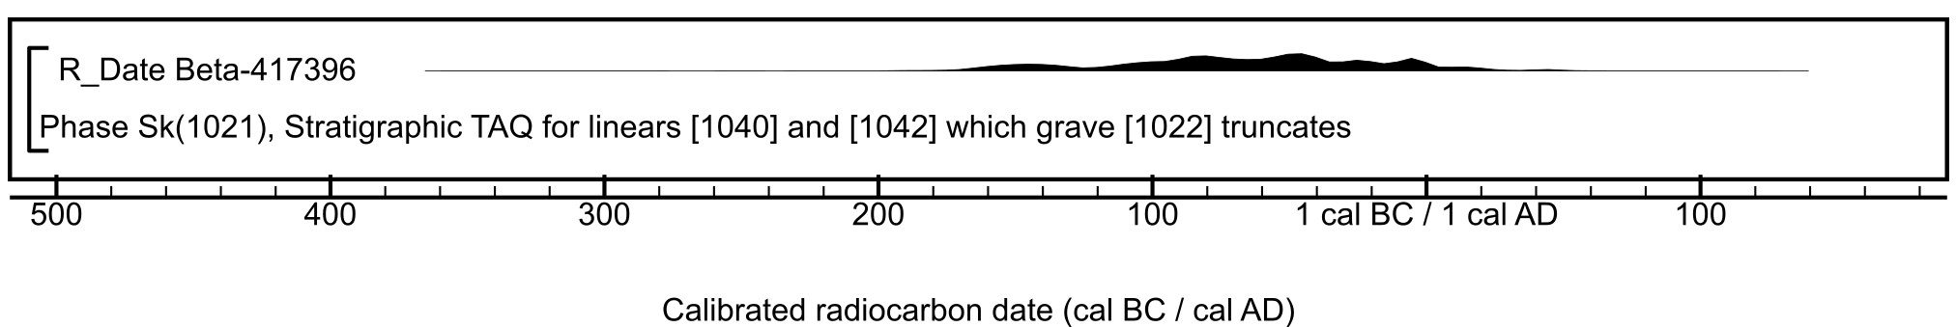

Figure S48: Radiocarbon result from the Pinfold Lane, Bridlington site. Details of the measurement are given in Table S2.

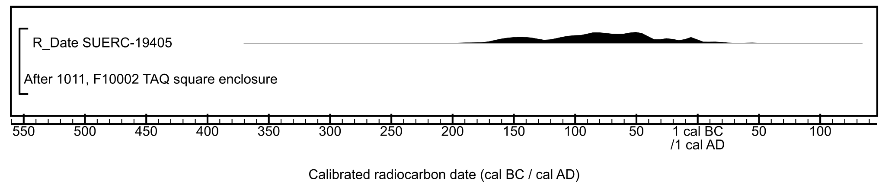

Figure S49: Radiocarbon result from the Racecourse Road, Seamer Moor, Scarborough site. Details of the measurement are given in Table S2.

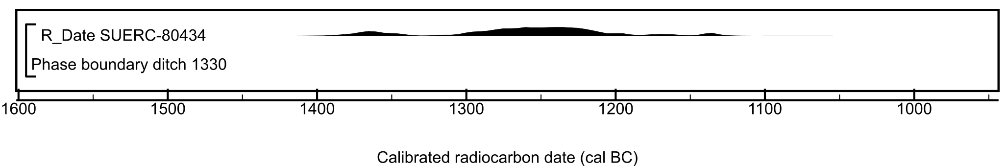

Figure S50: Radiocarbon result from the Rawdales Drain site. Details of the measurement are given in Table S2.

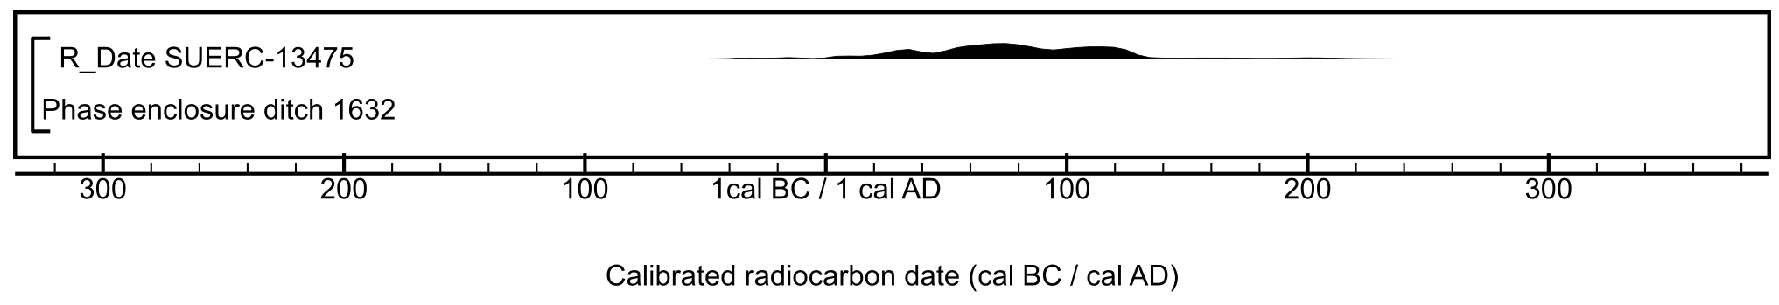

Figure S51: Relevant radiocarbon result from the Roebuck Hill, Jump, Barnsley site. Details of the measurement are given in Table S2.

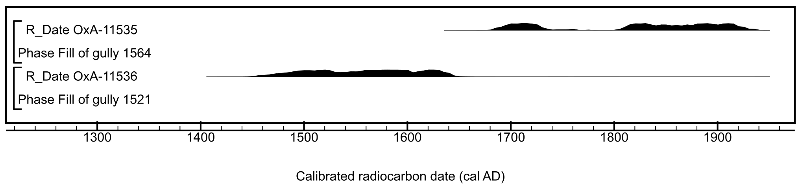

Figure S52: Relevant radiocarbon results from the Sewerby Cottage Farm Bridlington site. Details of the measurements are given in Table S2.
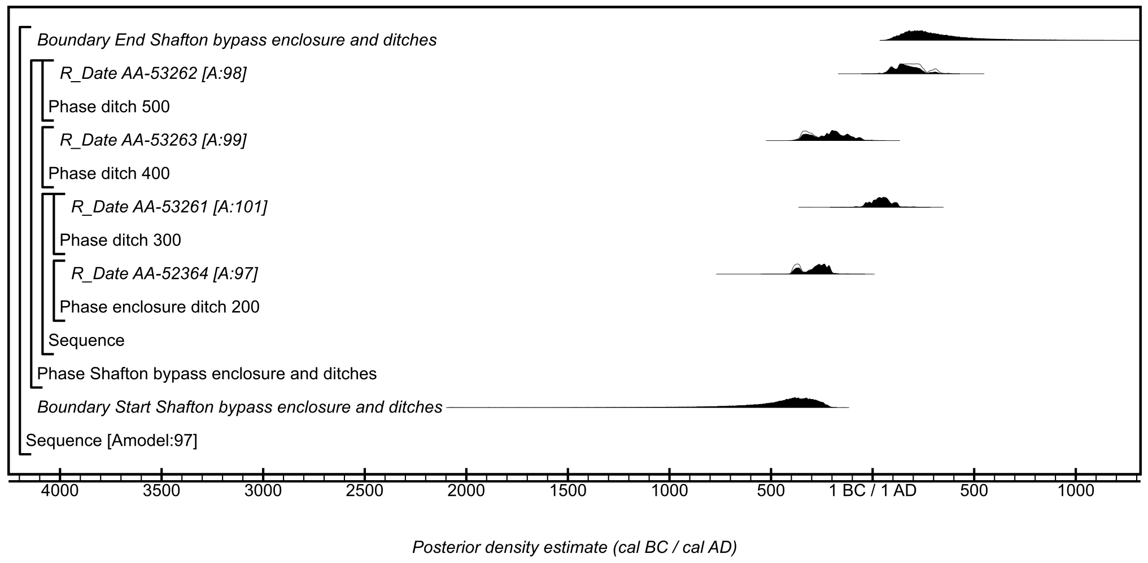

Figure S53: Site-specific model for results from the Shafton Bypass, Shafton site. Details of the measurements are given in Table S2. The format is identical to that of Figure S11. The large square brackets down the left-hand side of the figure, along with the OxCal keywords, define the model exactly.

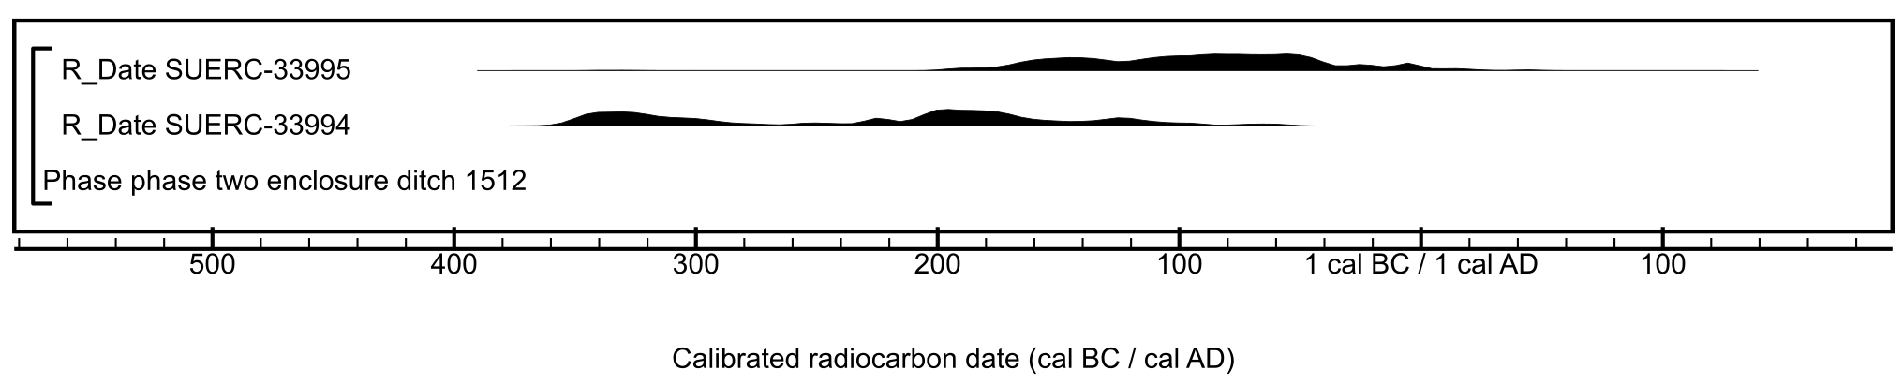

Figure S54: Radiocarbon results from the Site 1, Asselby to Pannal natural gas pipeline site. Details of the measurements are given in Table S2.
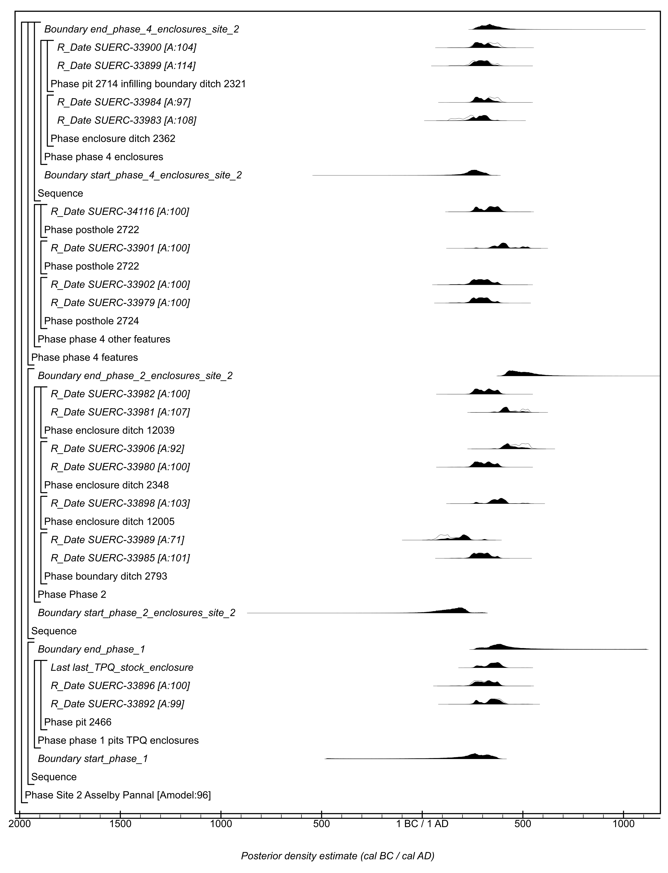

Figure S55: Site-specific model for results from Site 2, Asselby to Pannal gas pipeline. Details of the measurements are given in Table S2. The format is identical to that of Figure S11. The large square brackets down the left-hand side of the figure, along with the OxCal keywords, define the model exactly.
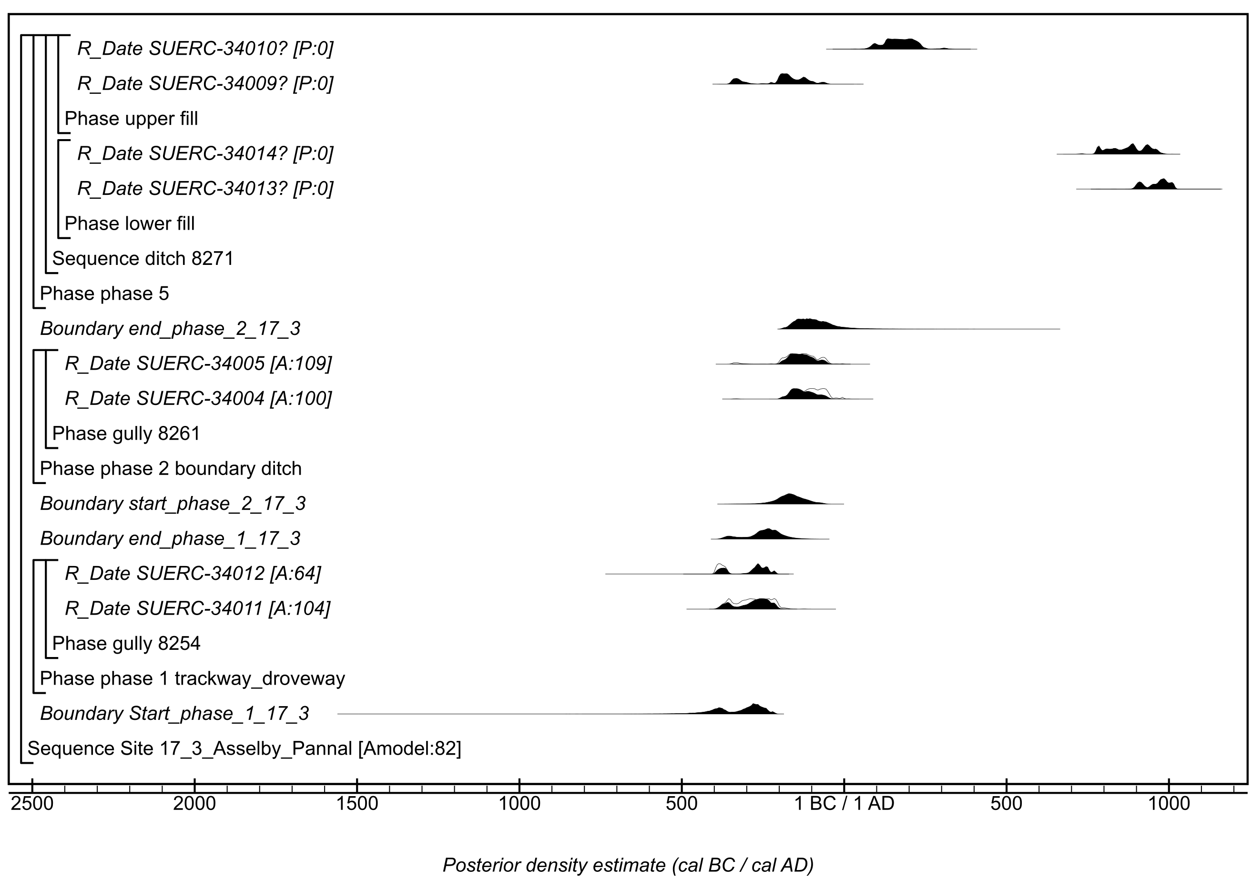

Figure S56: Site-specific model for results from Site 17.3 Asselby to Pannal gas pipeline. Details of the measurements are given in Table S2. The format is identical to that of Figure S11. Measurements followed by a question mark have been excluded from the model for reasons explained in the text, and are simple calibrated dates (Stuiver & Reimer, 1993). The large square brackets down the left-hand side of the figure, along with the OxCal keywords, define the model exactly.

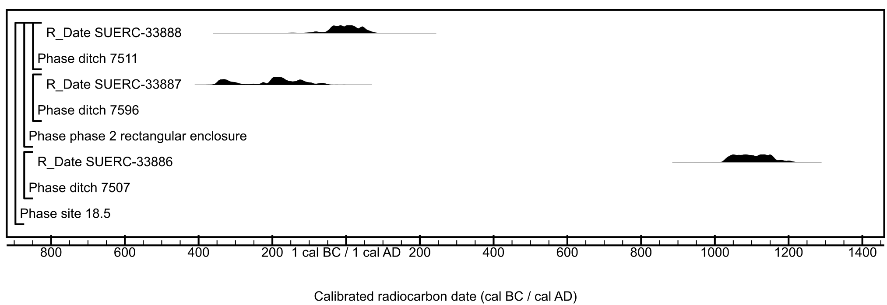

Figure S57: Radiocarbon results from Site 18.5 Asselby to Pannal gas pipeline. Details of the measurements are given in Table S2.

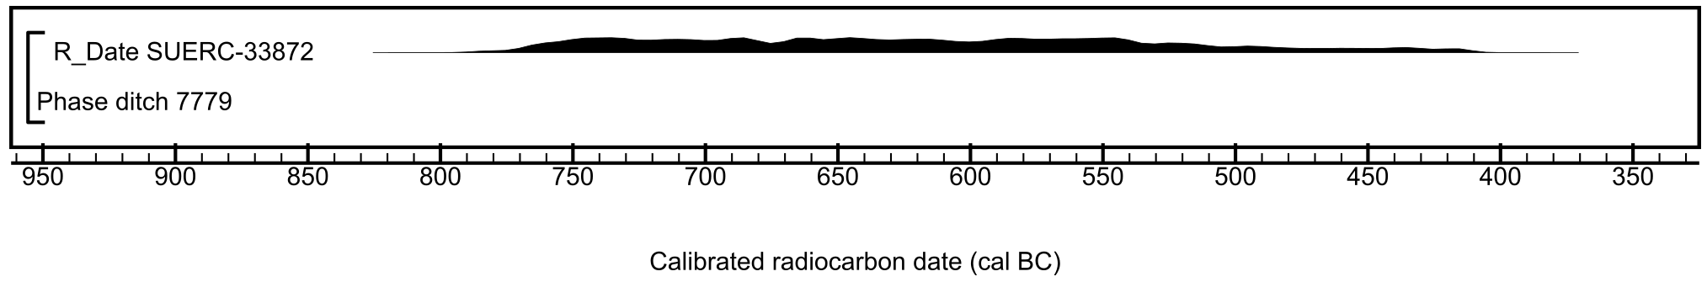

Figure S58: Radiocarbon result from Site 18.10 Asselby to Pannal gas pipeline. Details of the measurement are given in Table S2.

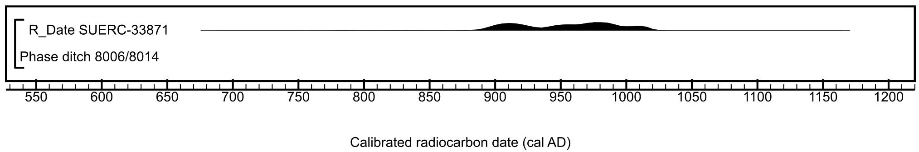

Figure S59: Radiocarbon result from Site 18.11B Asselby to Pannal gas pipeline. Details of the measurement are given in Table S2.
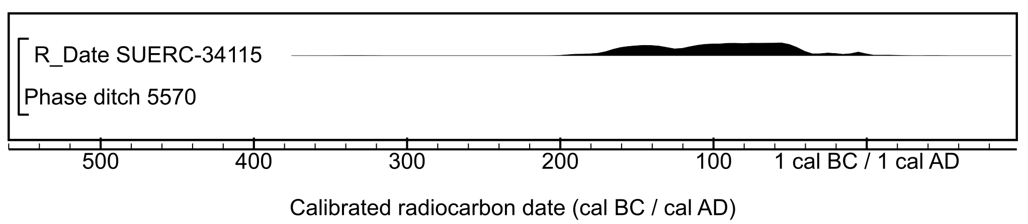

Figure S60: Radiocarbon result from Site 20.4 East, Asselby to Pannal gas pipeline. Details of the measurement are given in Table S2.

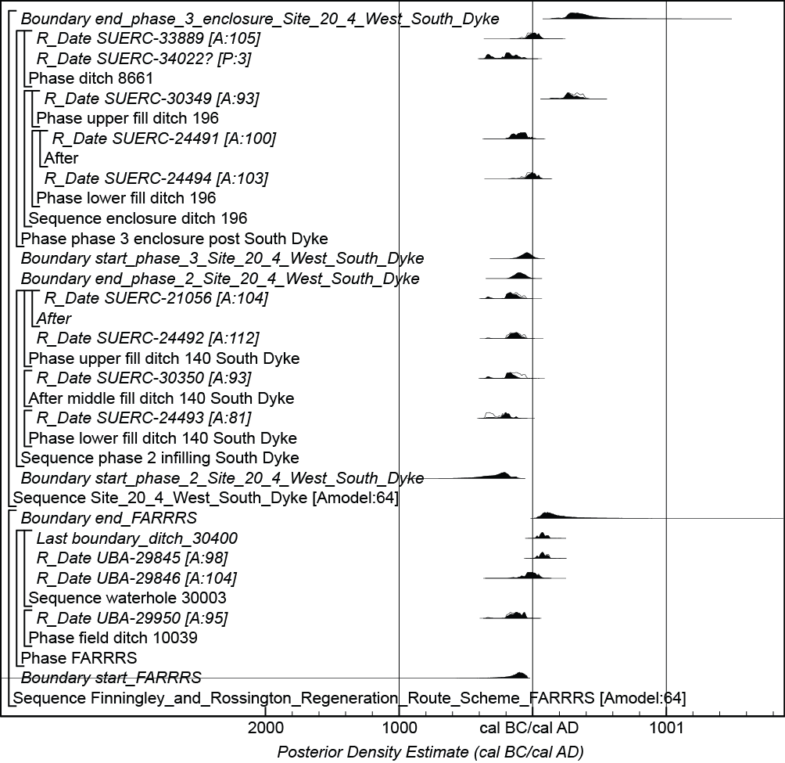

Figure S61: Site-specific model for results from Site 20.4 West, South Dyke, Asselby to Pannal gas pipeline. Details of the measurements are given in Table S2. The format is identical to that of Figure S11. The measurement followed by a question mark has been excluded from models and is a simple calibrated date (Stuiver & Reimer, 1993). The large square brackets down the left-hand side of the figure, along with the OxCal keywords, define the model exactly.

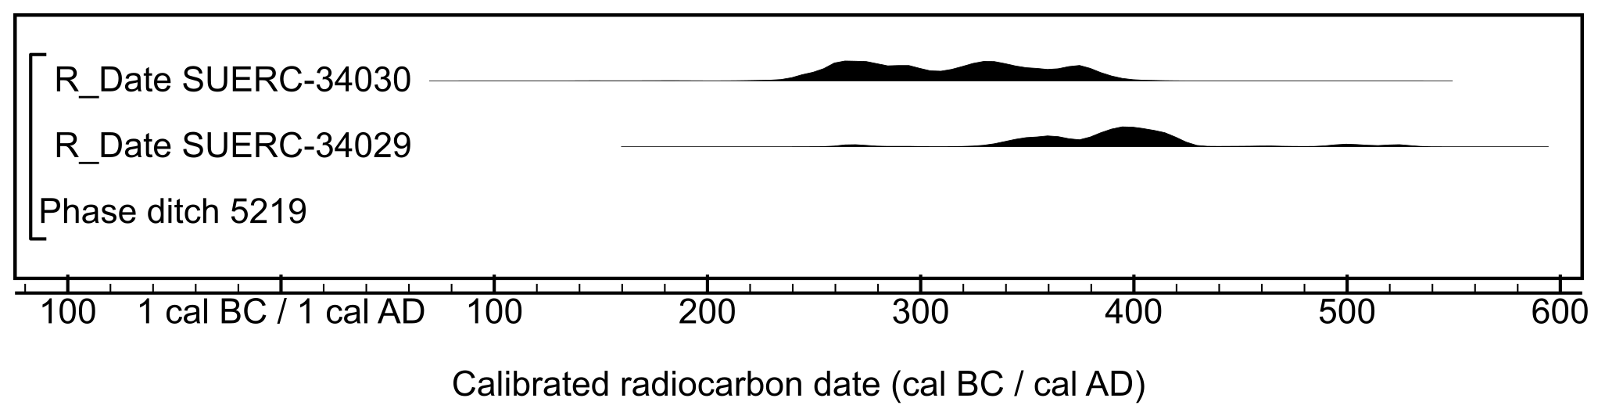

Figure S62: Radiocarbon results from Site 26.2, Asselby to Pannal gas pipeline. Details of the measurements are given in Table S2.

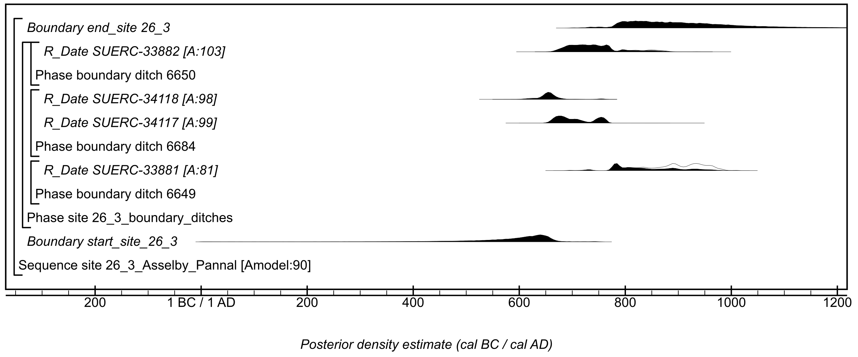

Figure S63: Site-specific model for results from Site 26.3 Asselby to Pannal gas pipeline. Details of the measurements are given in Table S2. The format is identical to that of Figure S11. The large square brackets down the left-hand side of the figure, along with the OxCal keywords, define the model exactly.

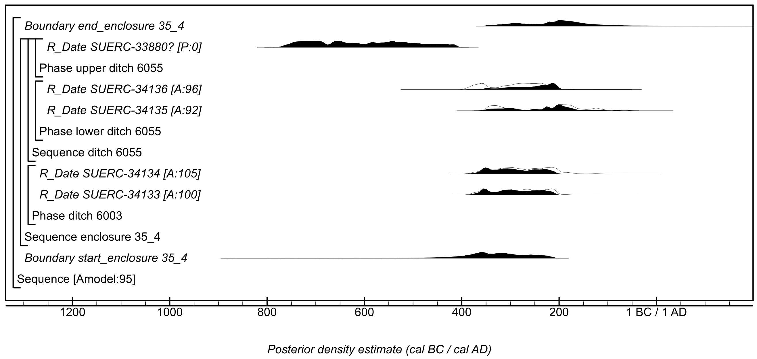

Figure S64: Site-specific model for results from Site 35.4 Asselby to Pannal gas pipeline. Details of the measurements are given in Table S2. The format is identical to that of Figure S11. The measurement followed by a question mark has been excluded from the model for reasons explained in the text, and are simple calibrated dates (Stuiver & Reimer, 1993). The large square brackets down the left-hand side of the figure, along with the OxCal keywords, define the model exactly.

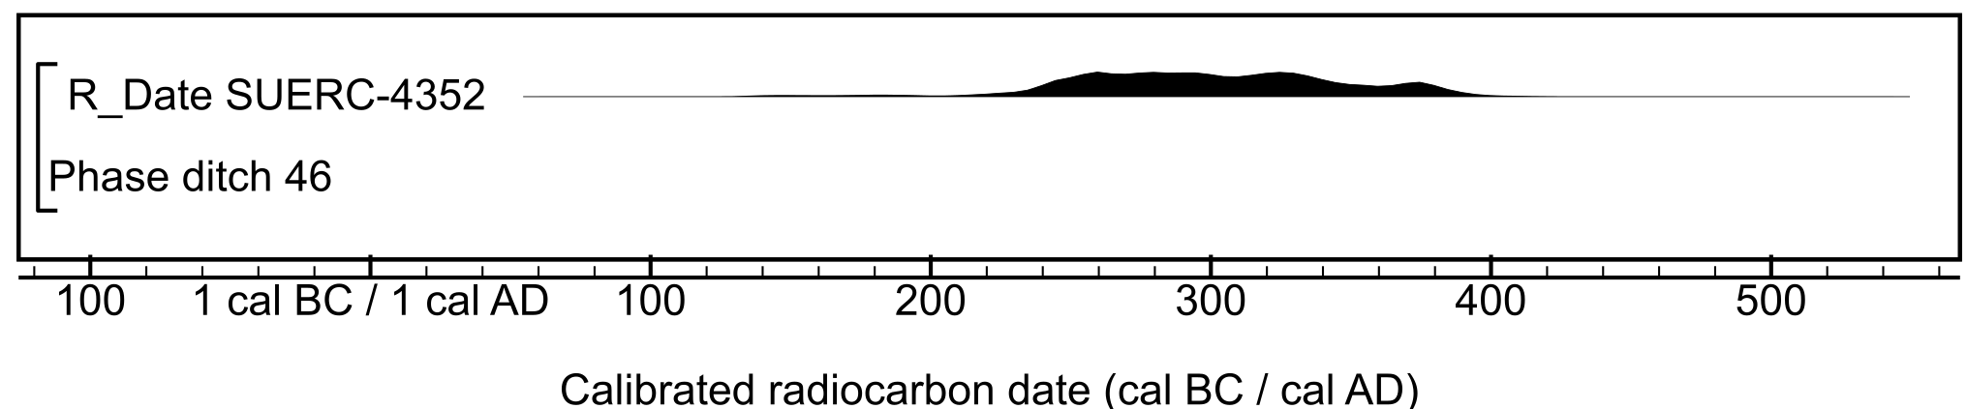

Figure S65: Radiocarbon result from Site CFAT, A1 (M1). Details of the measurement are given in Table S2.

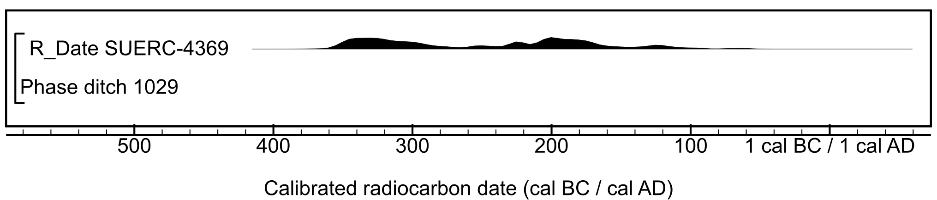

Figure S66: Radiocarbon result from Site M, Castle Hills, A1 (M1). Details of the measurement are given in Table S2.

Figure S67: Site-specific model for results from Site Q A1(M1). Details of the measurements are given in Table S2. The format is identical to that of Figure S11. The large square brackets down the left-hand side of the figure, along with the OxCal keywords, define the model exactly.

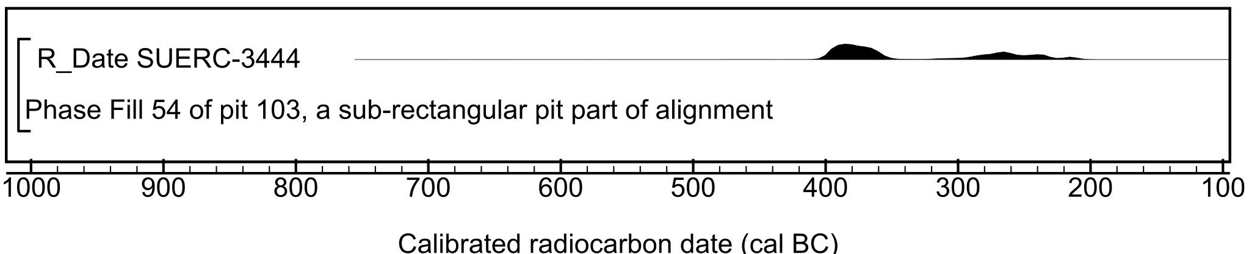

Figure S68: Radiocarbon result from Site WWBP A1 (M1). Details of the measurement are given in Table S2.

Figure S69: Site-specific model for results from Sneinton Fruitmarket. Details of the measurements are given in Table S2. The format is identical to that of Figure S11. The measurement followed by a question mark has been excluded from the model for reasons explained in the text, and are simple calibrated dates (Stuiver & Reimer, 1993). The large square brackets down the left-hand side of the figure, along with the OxCal keywords, define the model exactly.

Figure S70: Site-specific model for results from South Hill, Easington to Salt End Cable Route. Details of the measurements are given in Table S2. The format is identical to that of Figure S11. The large square brackets down the left-hand side of the figure, along with the OxCal keywords, define the model exactly.

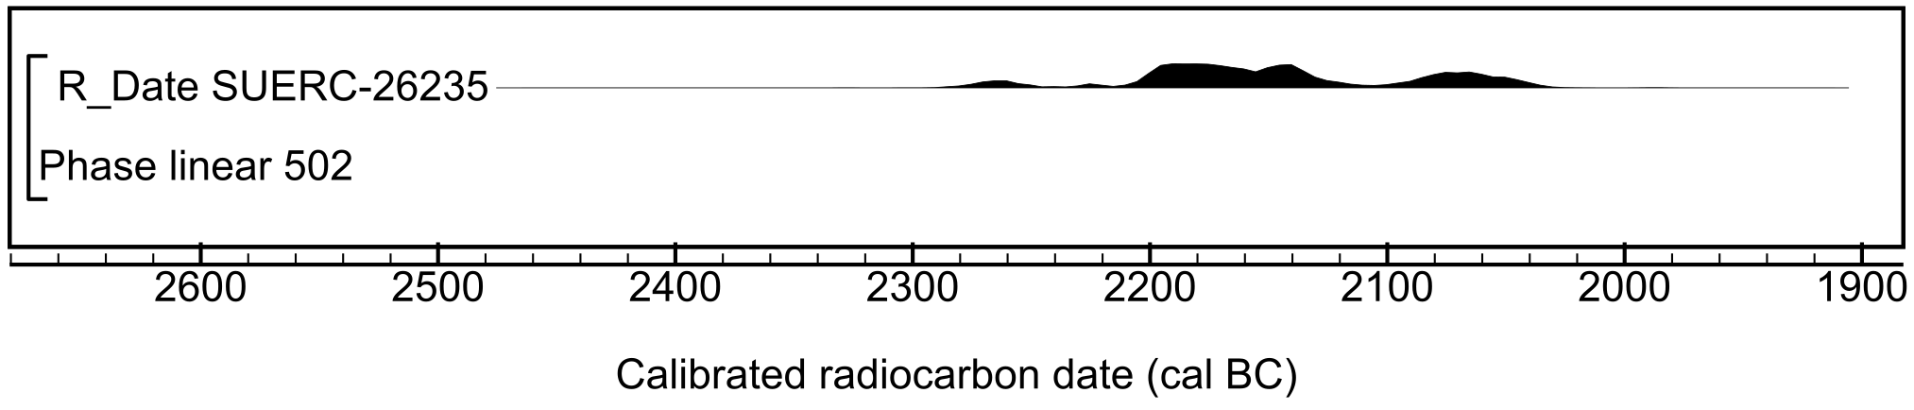

Figure S71: Radiocarbon result from South Killingholme. Details of the measurement are given in Table S2.

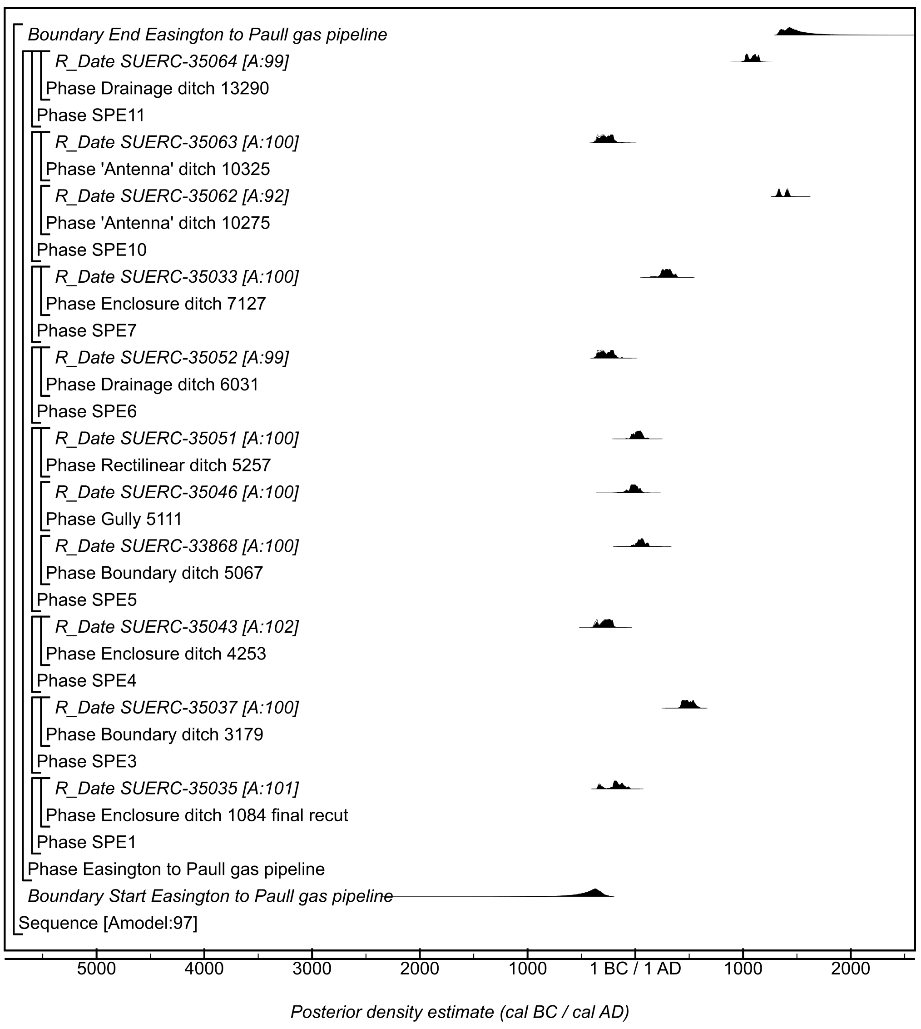

Figure S72: Site-specific model for results from Sites SPE1, SPE3, SPE4, SPE5, SPE6, SPE7, SPE10 and SPE11 from the Easington to Salt End Cable Route. Details of the measurements are given in Table S2. The format is identical to that of Figure S11. The large square brackets down the left-hand side of the figure, along with the OxCal keywords, define the model exactly.

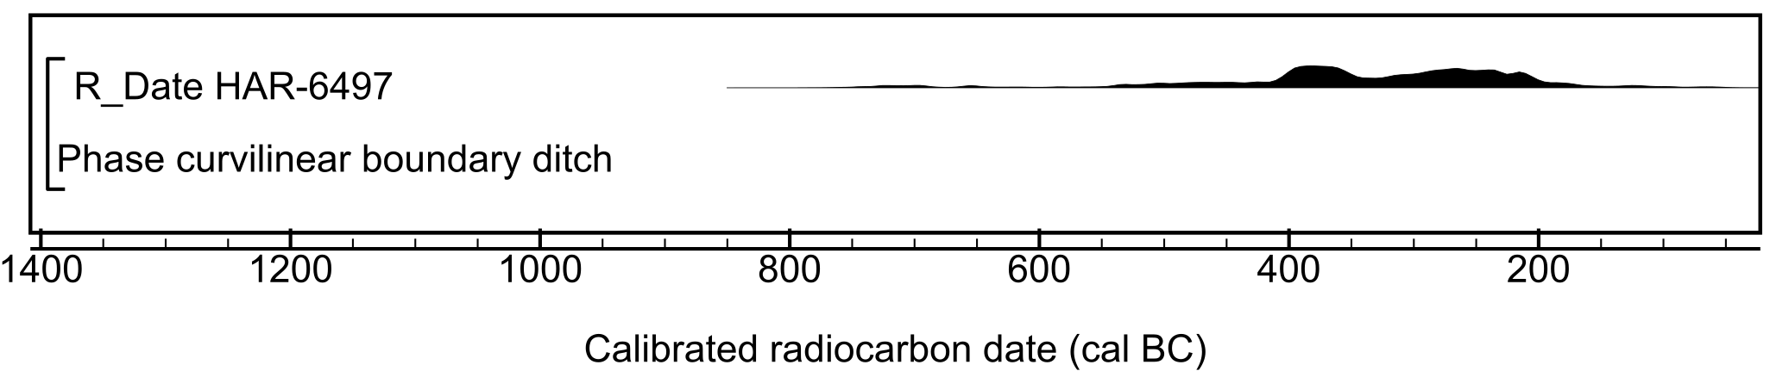

Figure S73: Radiocarbon result from Swarkestone Lowes. Details of the measurement are given in Table S2.

Figure S74: Site-specific model for results from Timberland, Scunthorpe. Details of the measurements are given in Table S2. The format is identical to that of Figure S11. The measurement followed by a question mark has been excluded from models and is a simple calibrated date (Stuiver & Reimer, 1993). The large square brackets down the left-hand side of the figure, along with the OxCal keywords, define the model exactly.

Figure S75: Site-specific model for results from Topham Farm, Sykehouse Barrier Bank, Sykehouse. Details of the measurements are given in Table S2. The format is identical to that of Figure S11. The large square brackets down the left-hand side of the figure, along with the OxCal keywords, define the model exactly.

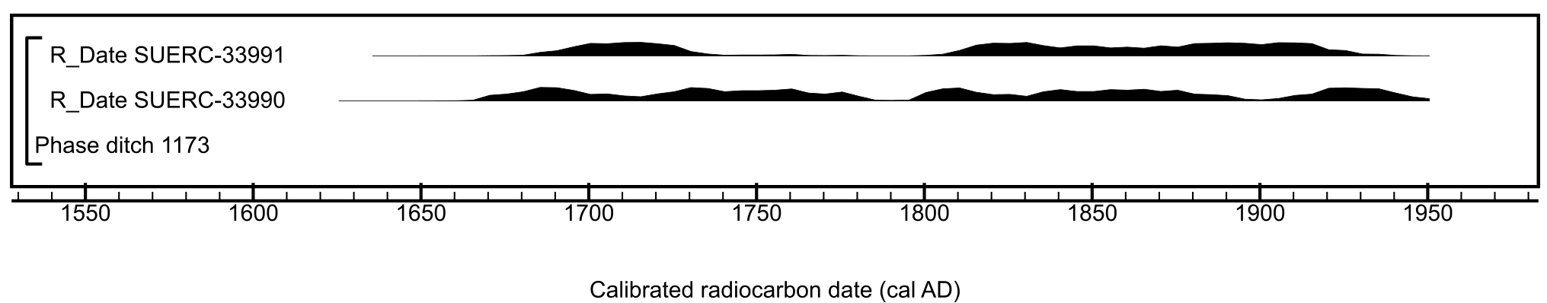

Figure S76: Radiocarbon results from Tr 10b Asselby to Pannal gas pipeline. Details of the measurements are given in Table S2.

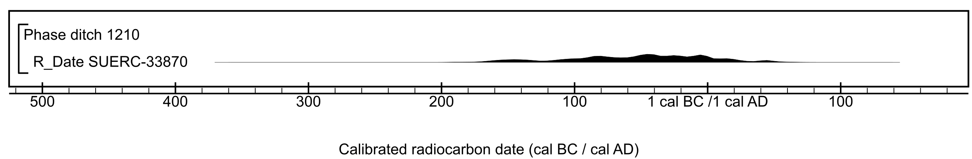

Figure S77: Radiocarbon results from Tr 20a, Area 5, Asselby to Pannal gas pipeline. Details of the measurements are given in Table S2.

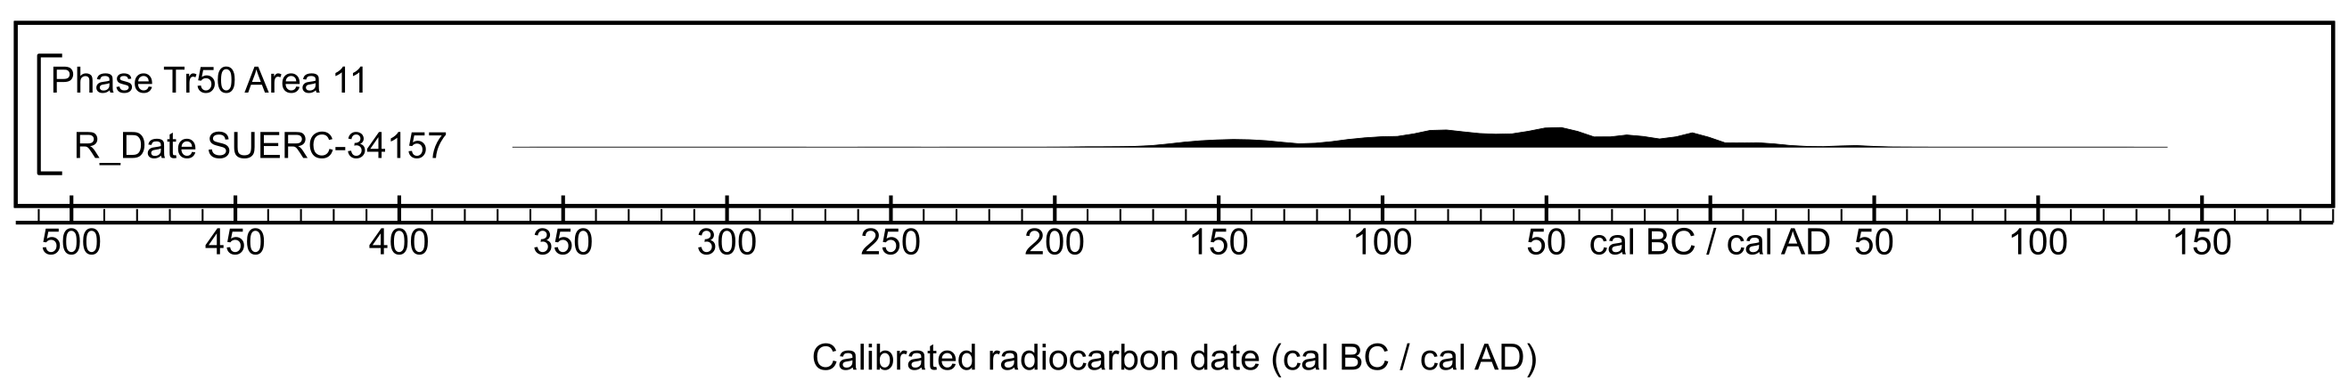

Figure S78: Radiocarbon results from Tr 50, Area 11 Asselby to Pannal gas pipeline. Details of the measurements are given in Table S2.

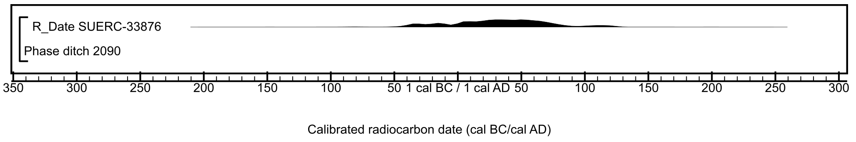

Figure S79: Radiocarbon result from Tr 71 Asselby to Pannal gas pipeline. Details of the measurement are given in Table S2.

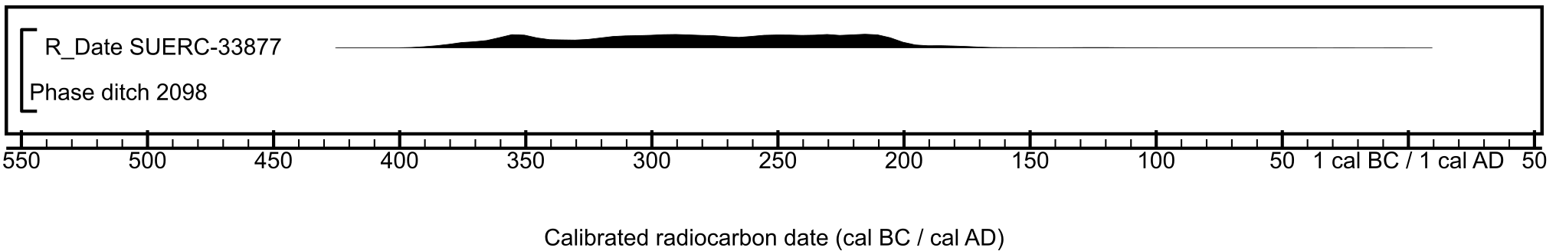

Figure S80: Radiocarbon result from Tr 72 Asselby to Pannal gas pipeline. Details of the measurement are given in Table S2.

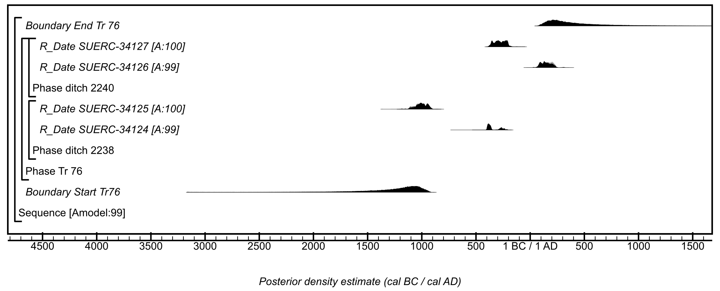

Figure S81: Site-specific model for results from Tr 76 Asselby to Pannal gas pipeline. Details of the measurements are given in Table S2. The format is identical to that of Figure S11. The large square brackets down the left-hand side of the figure, along with the OxCal keywords, define the model exactly.

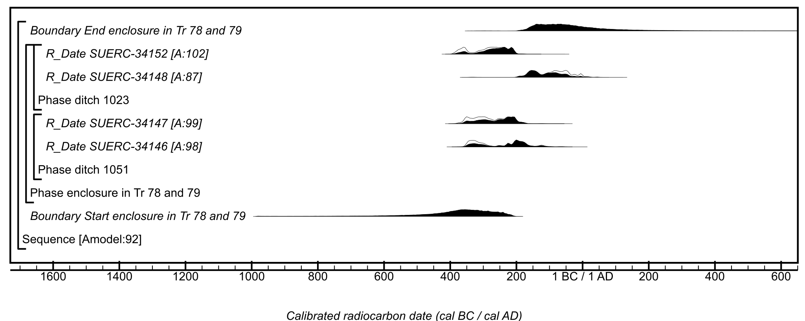

Figure S82: Site-specific model for results from Tr 78 and 79 Asselby to Pannal gas pipeline. Details of the measurements are given in Table S2. The format is identical to that of Figure S11. The large square brackets down the left-hand side of the figure, along with the OxCal keywords, define the model exactly.

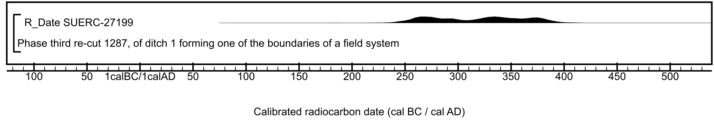

Figure S83: Radiocarbon result from Wattle Syke, Wetherby. Details of the measurement are given in Table S2.

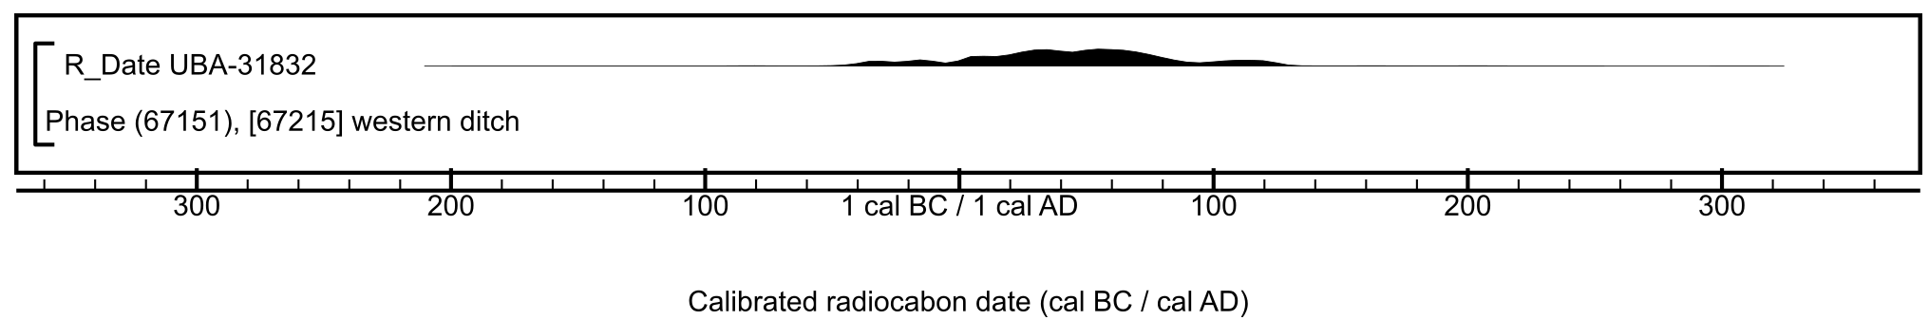

Figure S84: Radiocarbon result from Welwick Drain, Easington to Salt End Cable Route. Details of the measurement are given in Table S2.

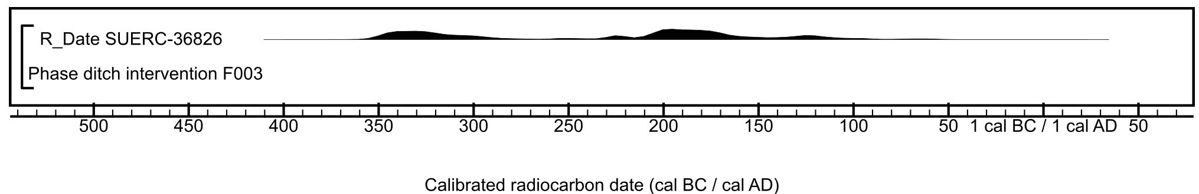

Figure S85: Radiocarbon result from Whirlow Hall Farm. Details of the measurement are given in Table S2.

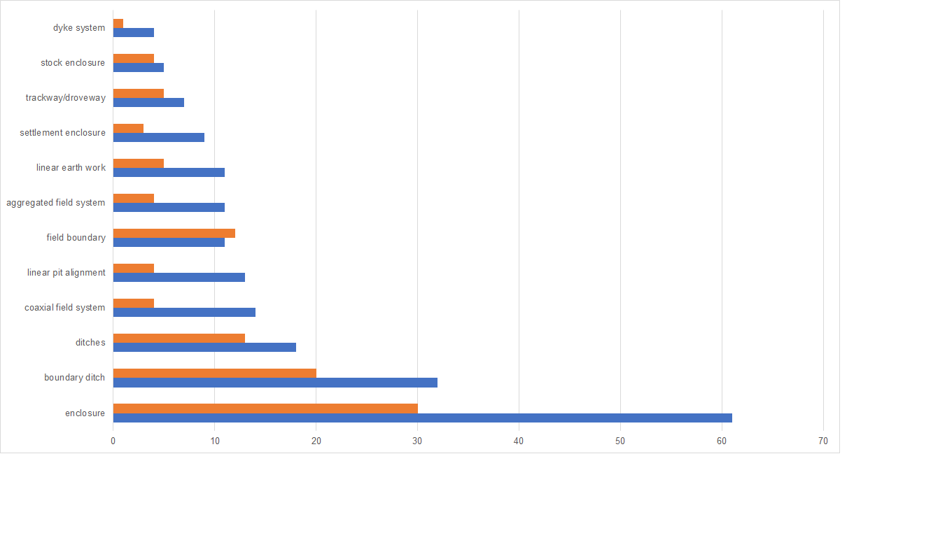Figure S86: The numbers of active likelihoods used in the currency model for different types of feature, and the number of sites with active likelihoods.

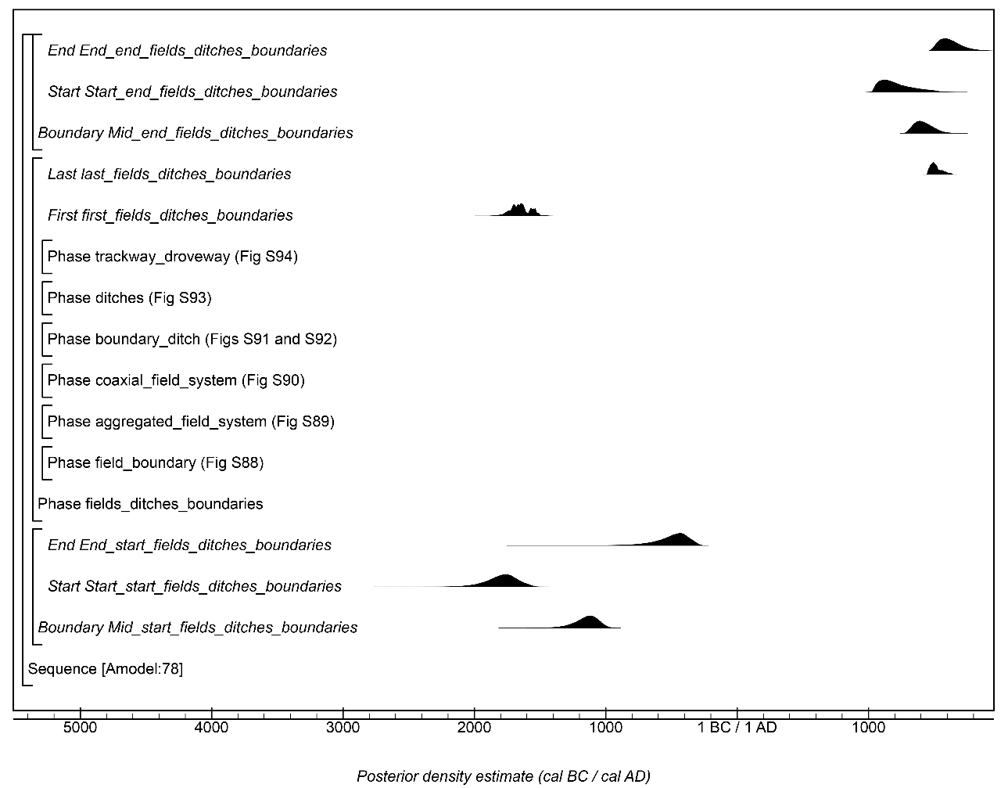

Figure S87: Overall structure of the chronological currency model for results from features classed as field boundaries, aggregated field systems, coaxial field systems, boundary ditches, ditches and trackways or droveways. The component sections of this model are shown in detail in Figures S88–S94. The structure is the same as shown in Figure S11. The large square brackets down the left-hand side of Figures S88–S94 along with the OxCal keywords define the overall model exactly.

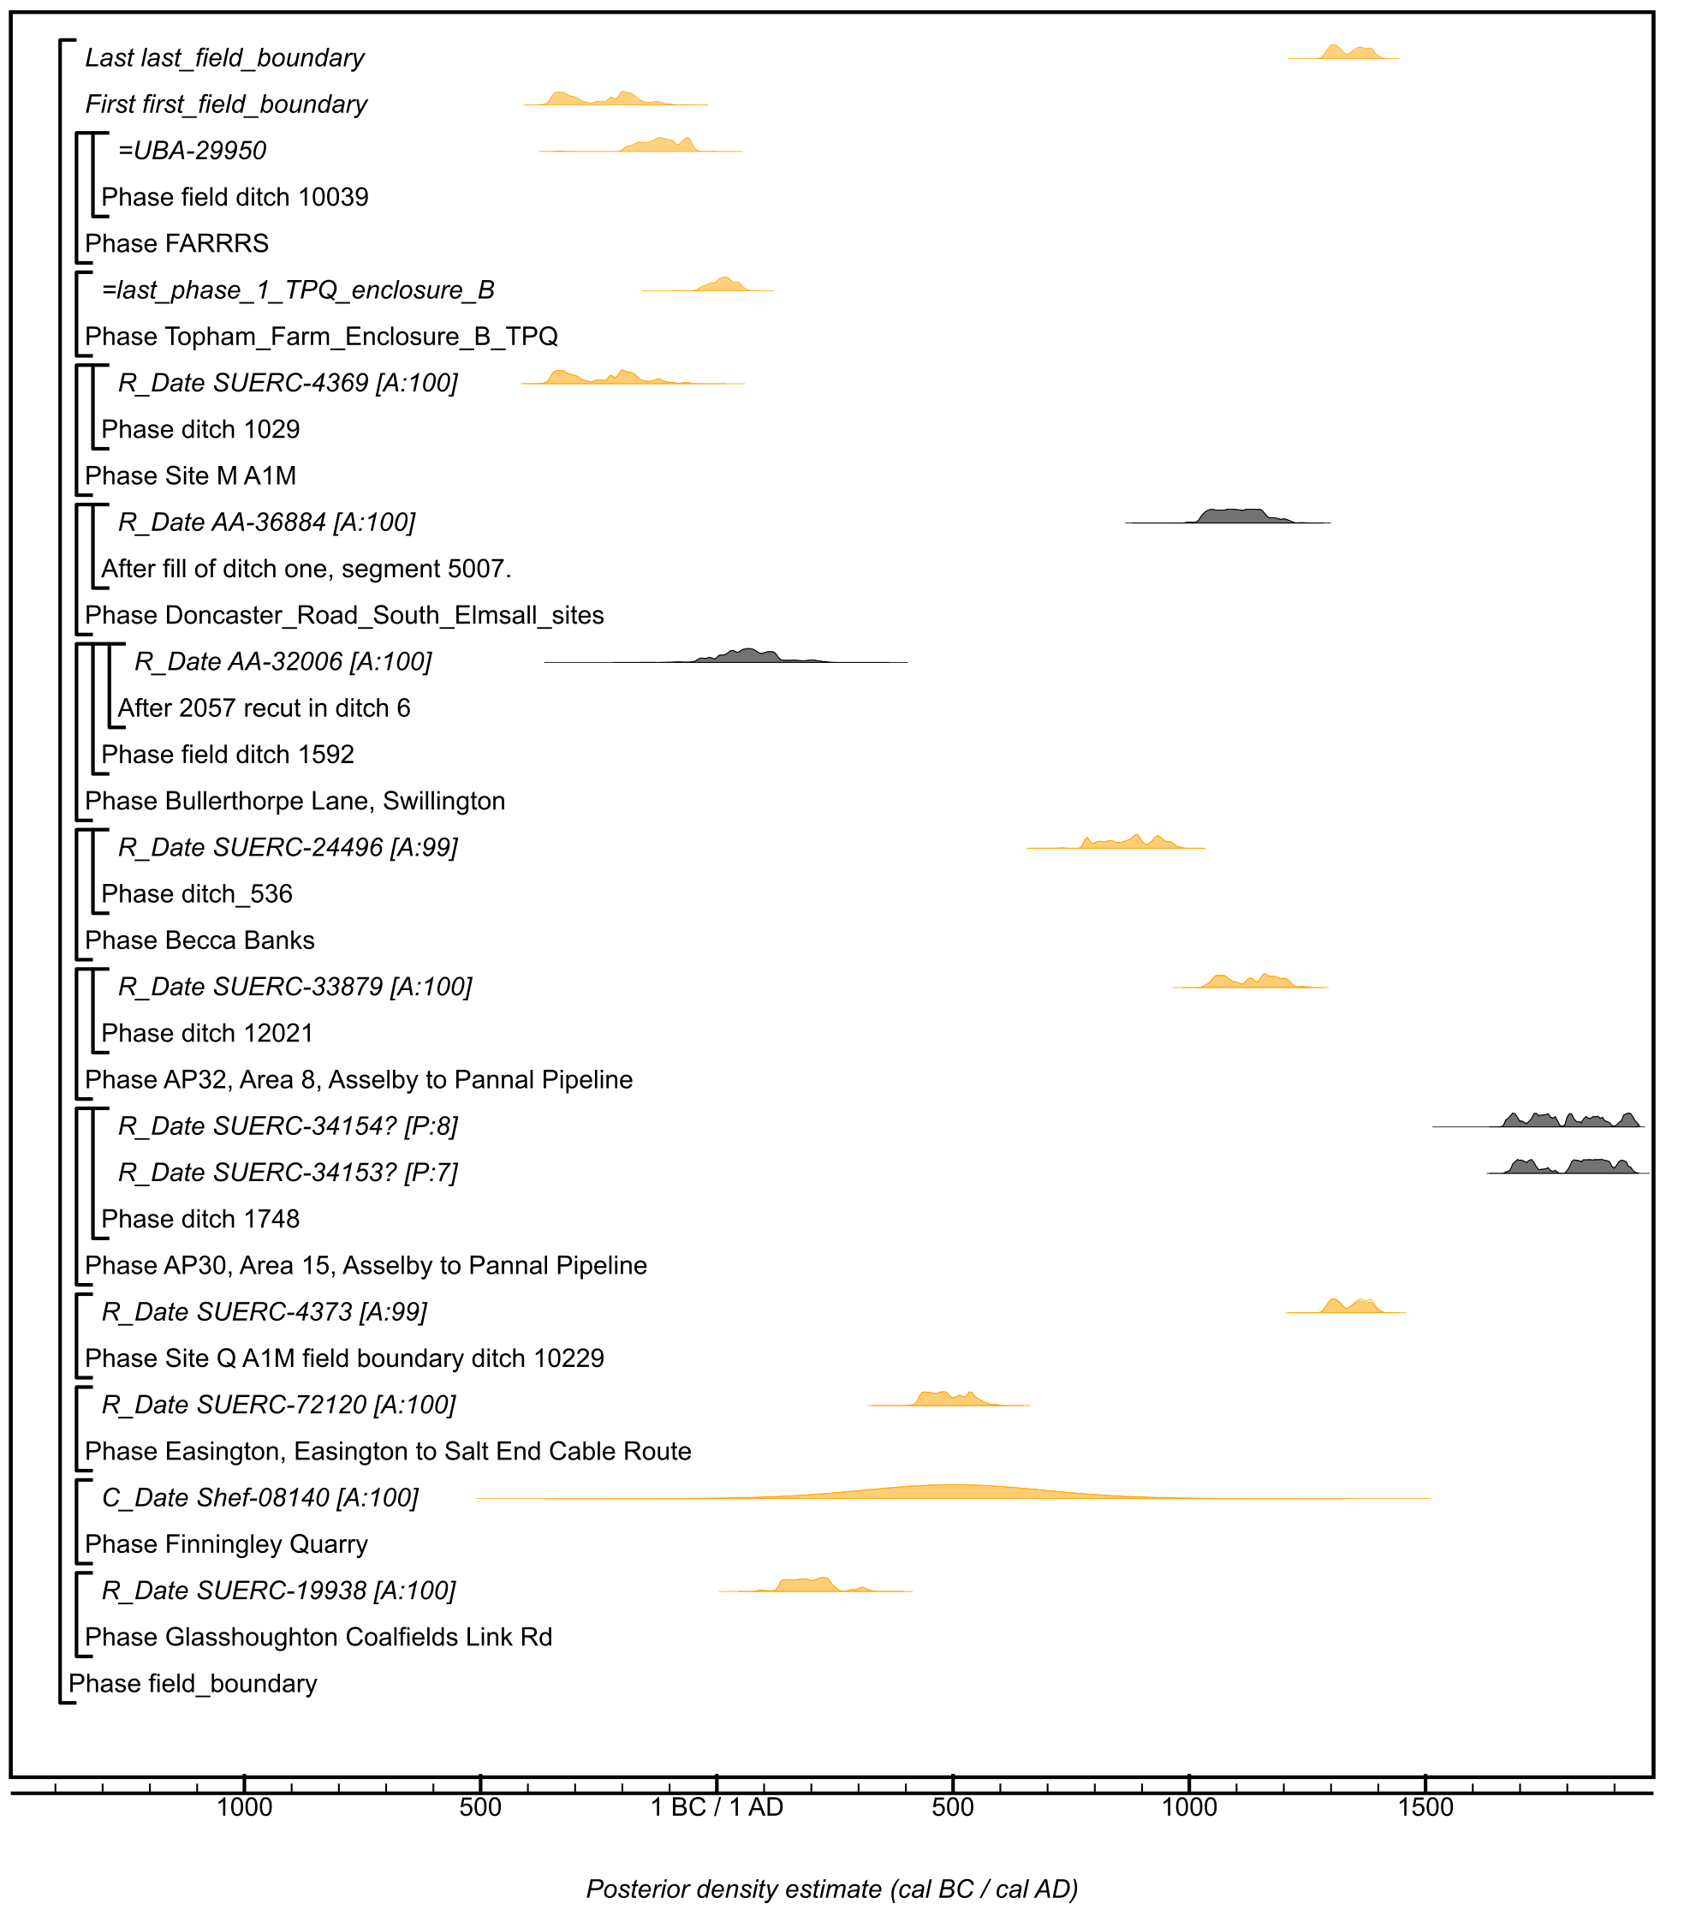

Figure S88: Component model section for likelihoods associated with the use of field boundaries. The format is identical to that of Figure S11. Details of the measurements are given in Table S2. Posterior distributions have been taken from the models defined in Figures S31 and S75. Distributions in black are TPQ or have been excluded from the models as they may represent measurements with unclear associations with the use of features. The large square brackets down the left-hand side of these site-specific figures and in this currency figure, along with the OxCal keywords, define the model exactly.

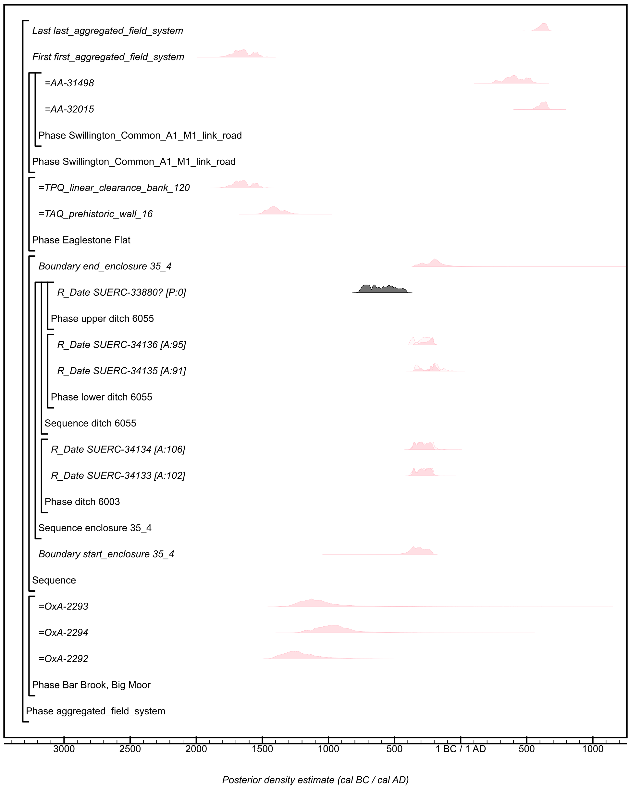

Figure S89: Component model section for likelihoods associated with the use of aggregated field systems. The format is identical to that of Figure S11. Details of the measurements are given in Table S2. Posterior distributions have been taken from the models defined in Figures S16, S27, and S45. The large square brackets down the left-hand side of these site-specific figures and in this currency figure, along with the OxCal keywords, define the model exactly.
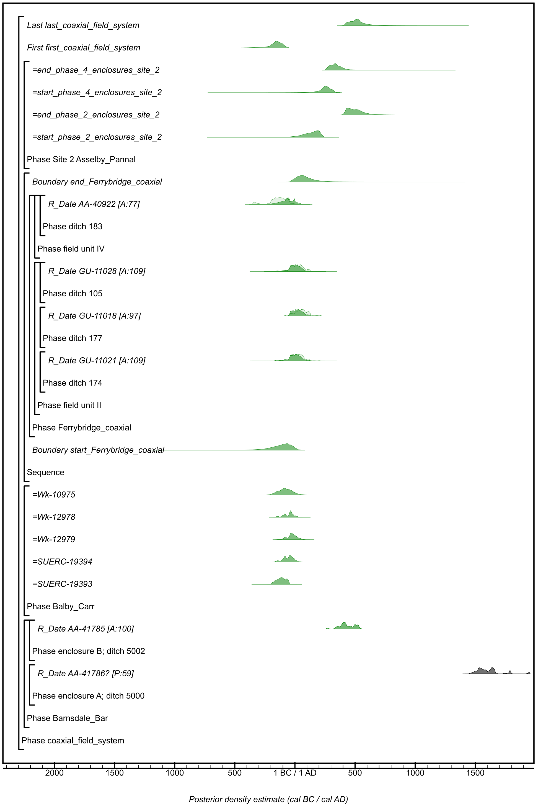

Figure S90: Component model section for likelihoods associated with the use of coaxial field systems. The format is identical to that of Figure S11. Details of the measurements are given in Table S2. Posterior distributions have been taken from the models defined in Figures S15 and S55. The large square brackets down the left-hand side of these site-specific figures and in this currency figure, along with the OxCal keywords, define the model exactly.
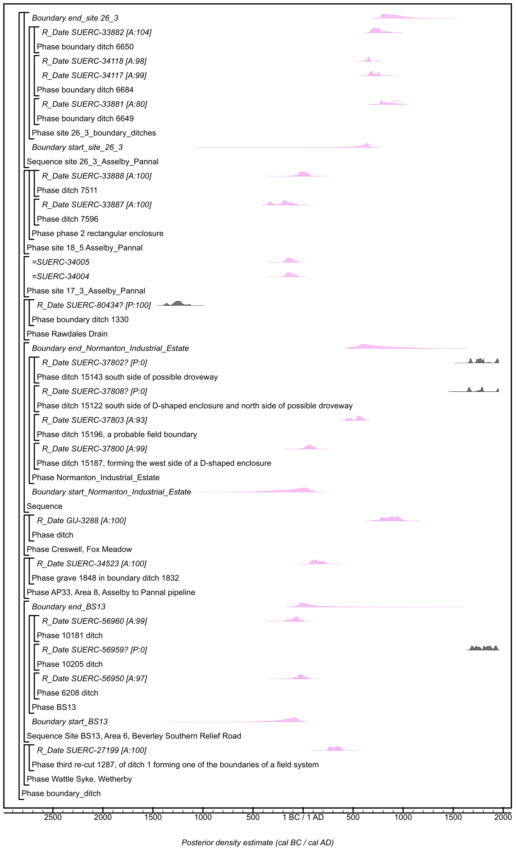

Figure S91: Component model section for likelihoods associated with the use of boundary ditches, this component section is continued in Figure S92. The format is identical to that of Figure S11. Details of the measurements are given in Table S2. Posterior distributions have been taken from the models defined in Figure S56. The large square brackets down the left-hand side of these site-specific figures and in this currency figure, along with the OxCal keywords, define the model exactly.
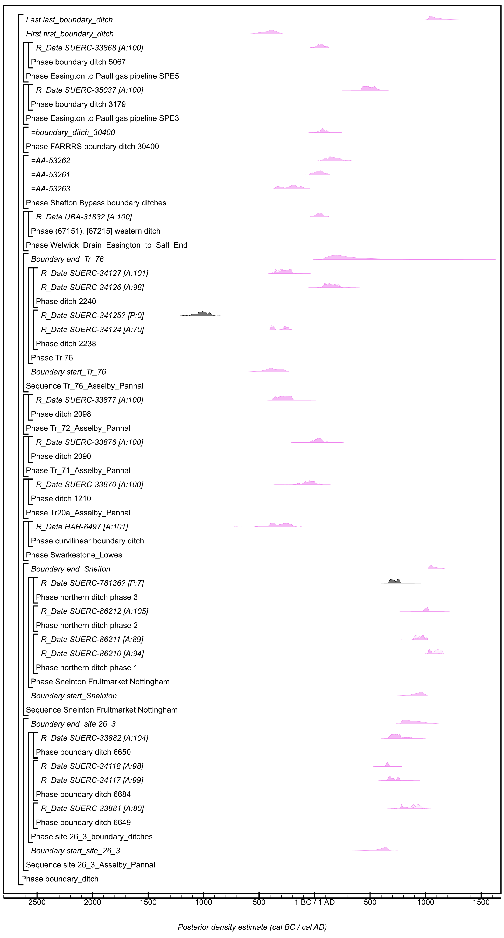

Figure S92: Component model section for likelihoods associated with the use of boundary ditches, this component section continues that shown in Figure S91. The format is identical to that of Figure S11. Details of the measurements are given in Table S2. Posterior distributions have been taken from the models defined in Figures S31 and S53. The large square brackets down the left-hand side of these site-specific figures and in this currency figure, along with the OxCal keywords, define the model exactly.
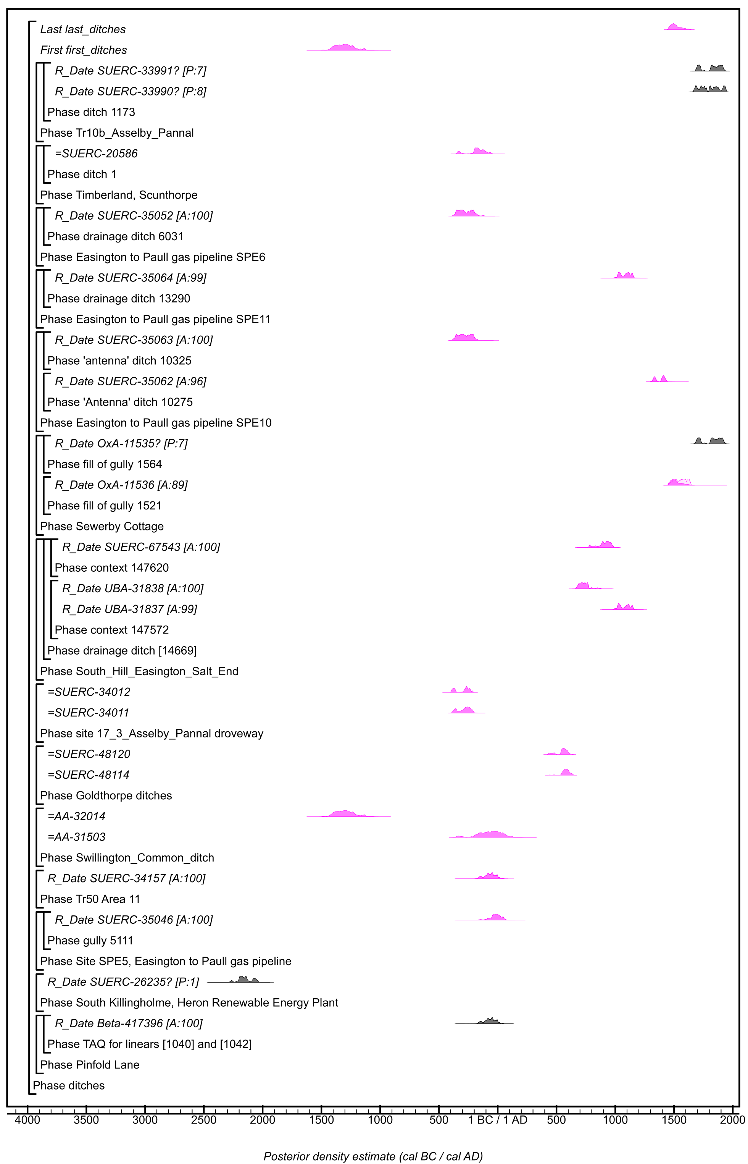

Figure S93: Component model section for likelihoods associated with the use of ditches. The format is identical to that of Figure S11. Details of the measurements are given in Table S2. Posterior distributions have been taken from the models defined in Figures S35, S56, S45, and S74. The large square brackets down the left-hand side of these site-specific figures and in this currency figure, along with the OxCal keywords, define the model exactly.

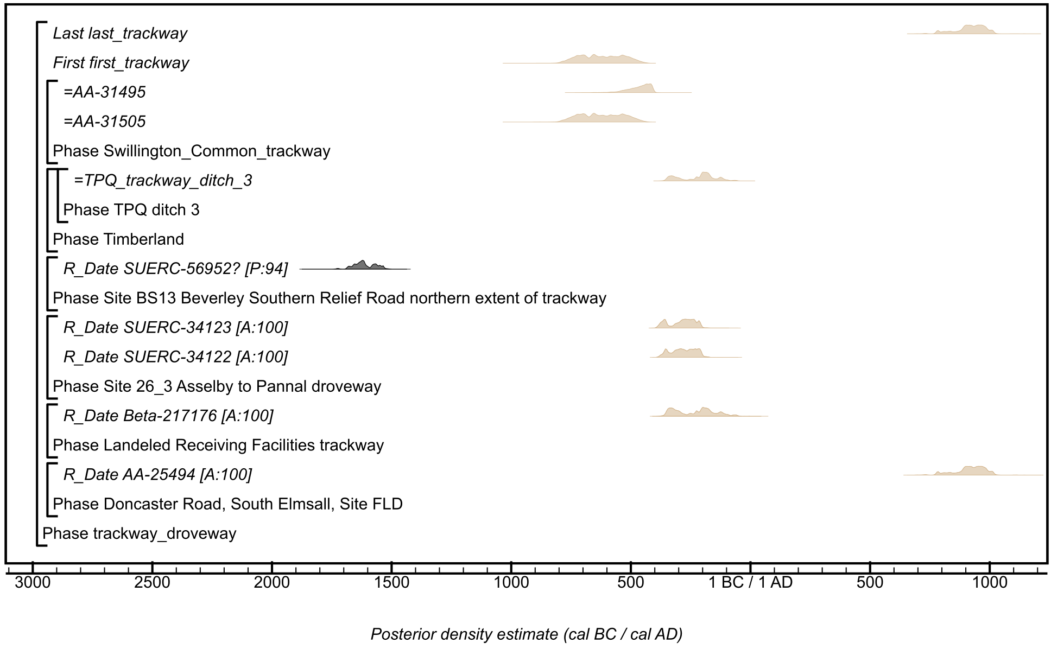

Figure S94: Component model section for likelihoods associated with the use of trackways or droveways. The format is identical to that of Figure S11. Details of the measurements are given in Table S2. Posterior distributions have been taken from the models defined in Figures S45 and S74. The large square brackets down the left-hand side of these site-specific figures and in this currency figure, along with the OxCal keywords, define the model exactly.

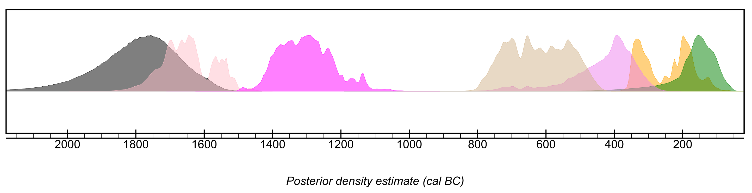

Figure S95: Key parameters calculated for the chronological currency model for results from features classed as field boundaries (orange; first_field_boundary; Figure S88), aggregated fields (light pink; first_aggregated_field_system; Figure S89; distribution to left of Figure S95), coaxial field systems (green; first_coaxial_field_system; Figure 90), boundary ditches (violet; first_boundary_ditch; Figure S92; distribution to right of Figure S95), ditches (magenta; first_ditches; Figure S93), and trackways or droveways (tan; first_trackway; Figure S94). The distribution in dark grey is the estimate for Start_start_field_ditches_boundaries shown in Figure S87.

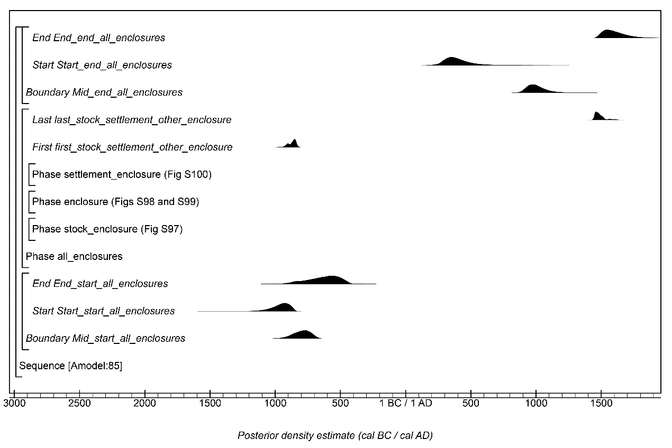

Figure S96: Overall structure of the chronological currency model for results from features classed as stock enclosures, enclosures, or settlement enclosures. The component sections of this model are shown in detail in Figures S97–S100. The structure is the same as shown in Figure S11. The large square brackets down the left-hand side of Figures S97–S100 along with the OxCal keywords define the overall model exactly.

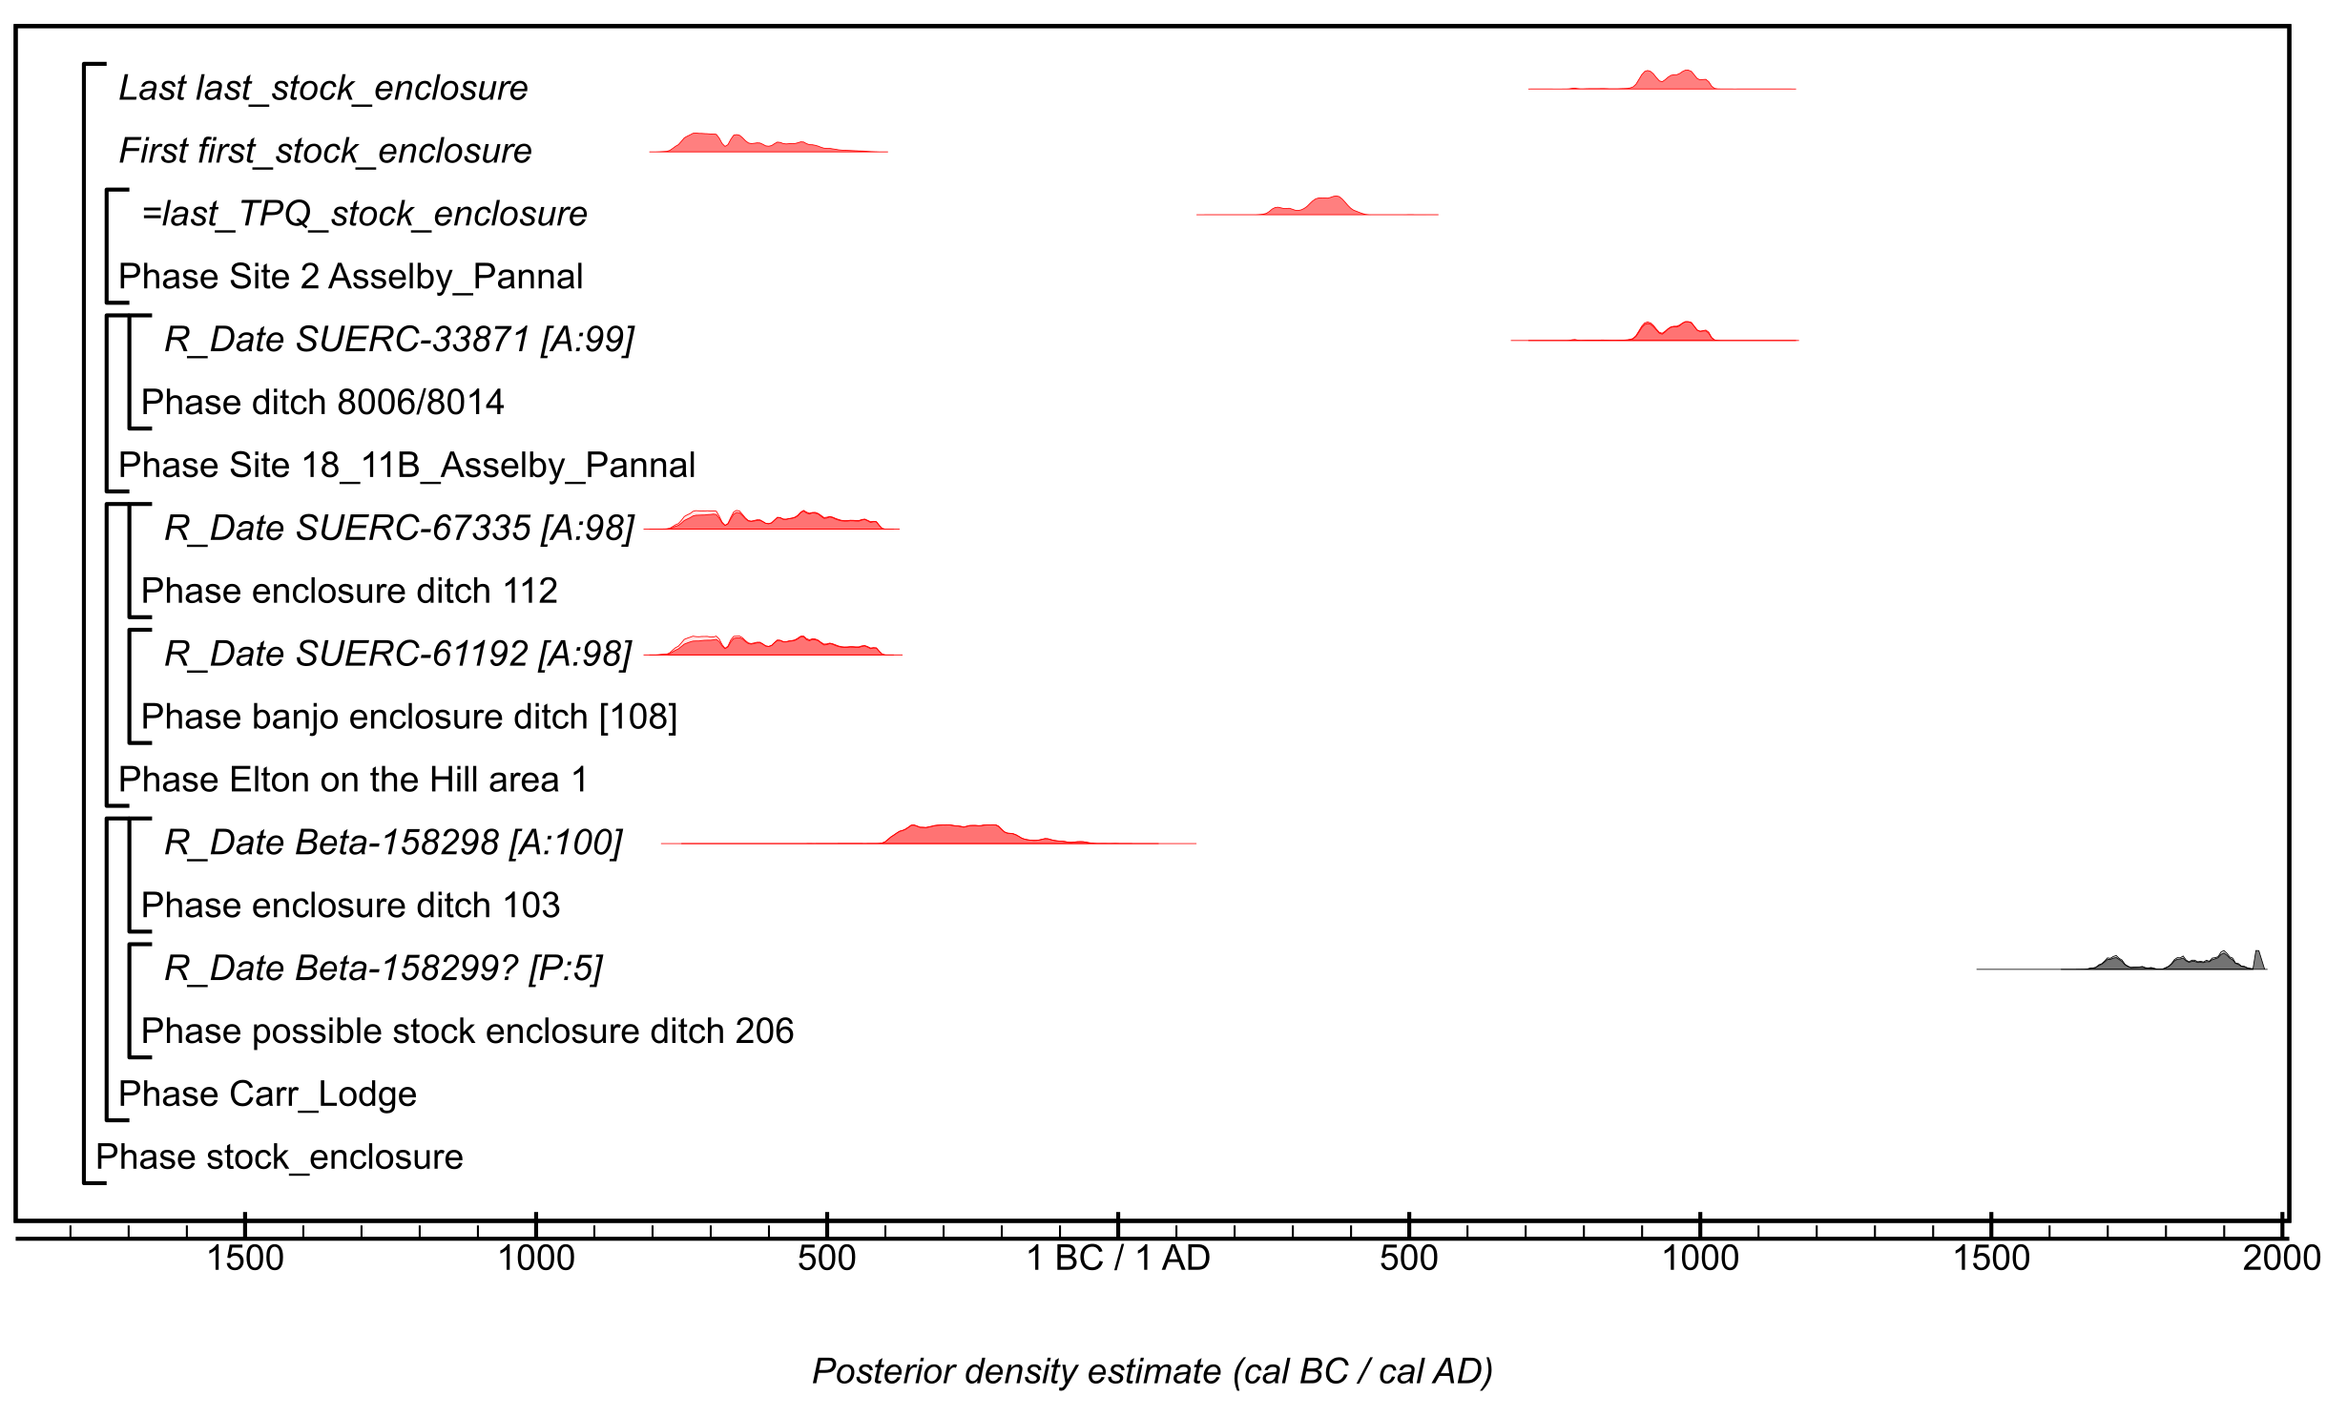

Figure S97: Component model section for likelihoods associated with the use of stock enclosures. The format is identical to that of Figure S11. Details of the measurements are given in Table S2. Posterior distributions have been taken from the models defined in Figure S55. The large square brackets down the left-hand side of these site-specific figures and in this currency figure, along with the OxCal keywords, define the model exactly.

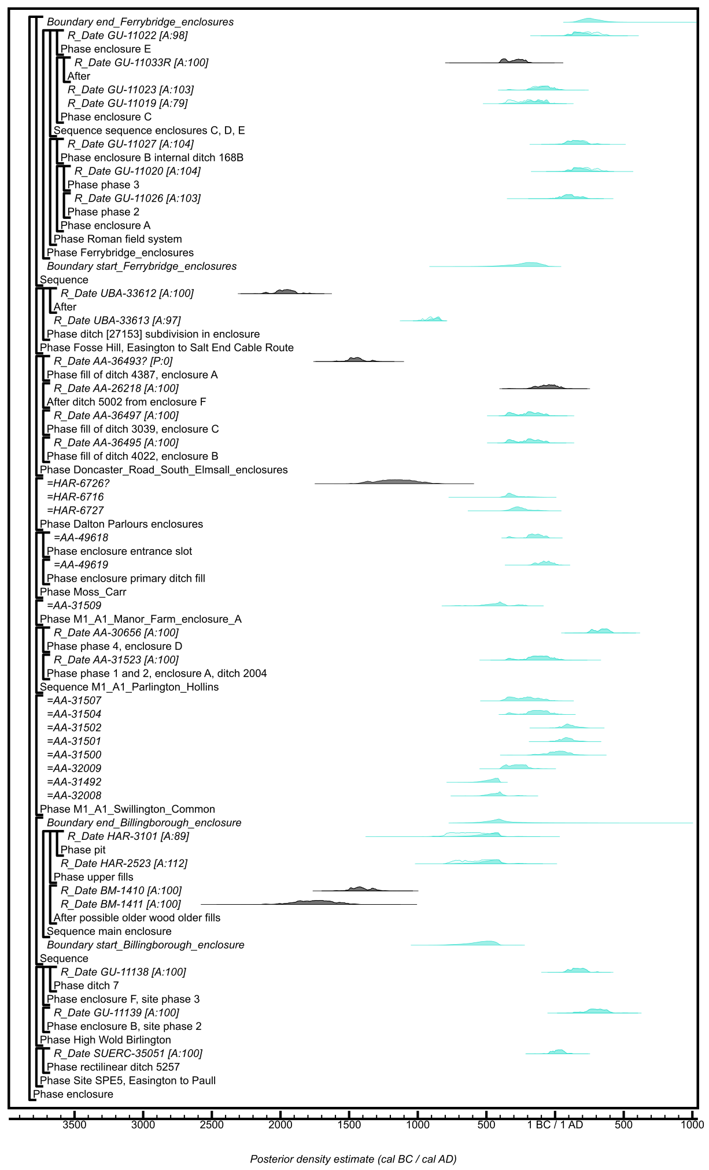

Figure S98: Component model section for likelihoods associated with the use of enclosures, details of this model are continued in Figure S99. The format is identical to that of Figure S11. Details of the measurements are given in Table S2. Posterior distributions have been taken from the models defined in Figures S24, S43, S45, and S46. The large square brackets down the left-hand side of these site-specific figures and in this currency figure, along with the OxCal keywords, define the model exactly.
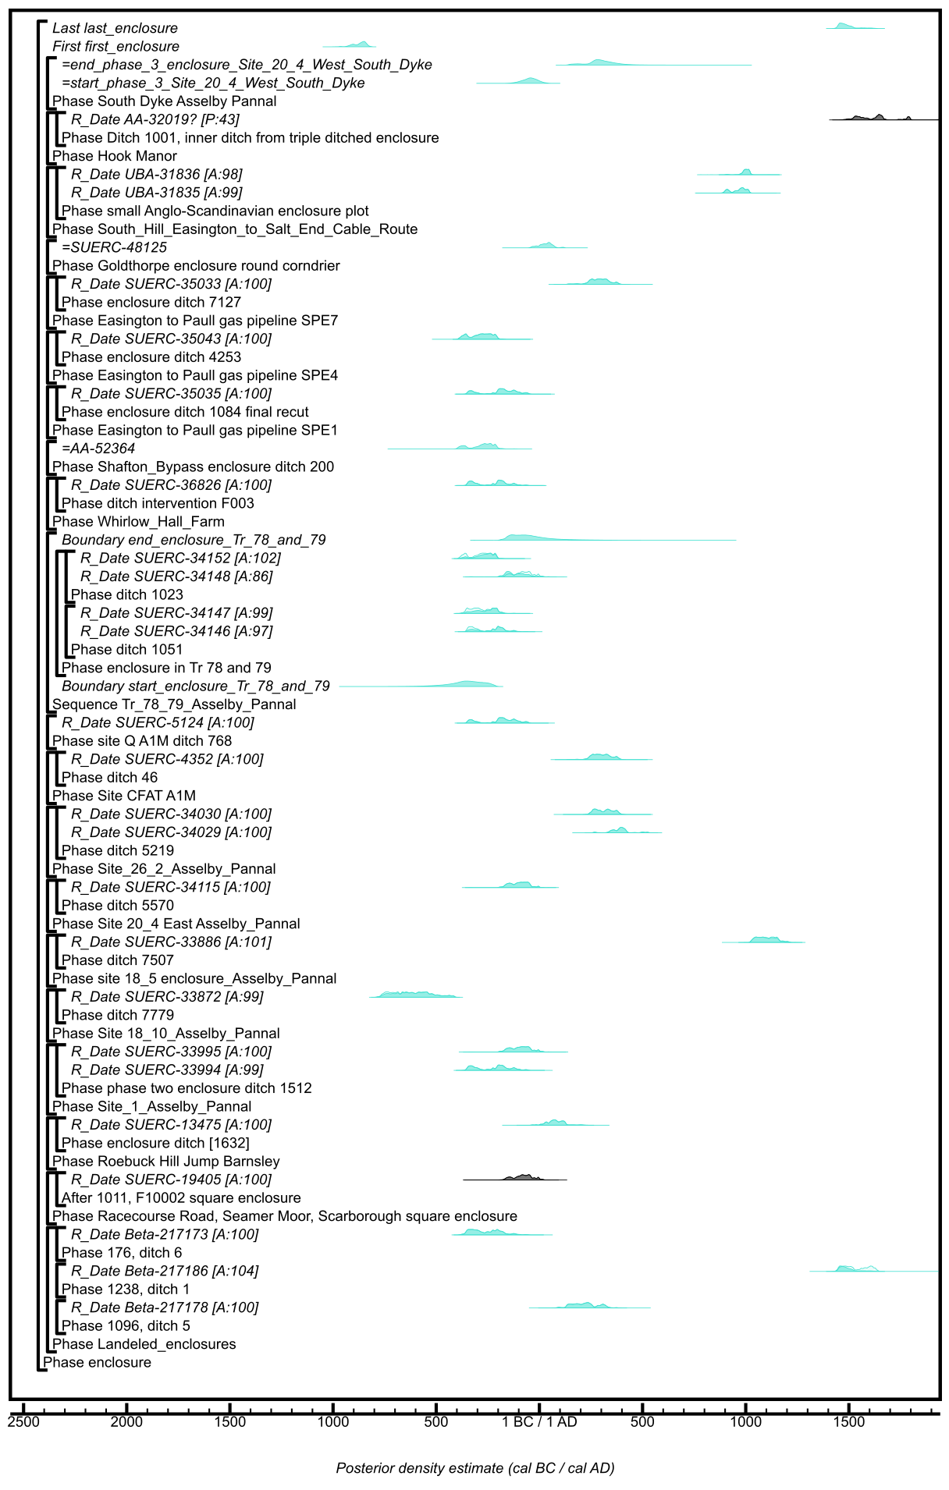

Figure S99: Component model section for likelihoods associated with the use of enclosures, this model continues that shown in Figure 98. The format is identical to that of Figure S11. Details of the measurements are given in Table S2. Posterior distributions have been taken from the models defined in Figures S35, S53, and S61. The large square brackets down the left-hand side of these site-specific figures and in this currency figure, along with the OxCal keywords, define the model exactly.

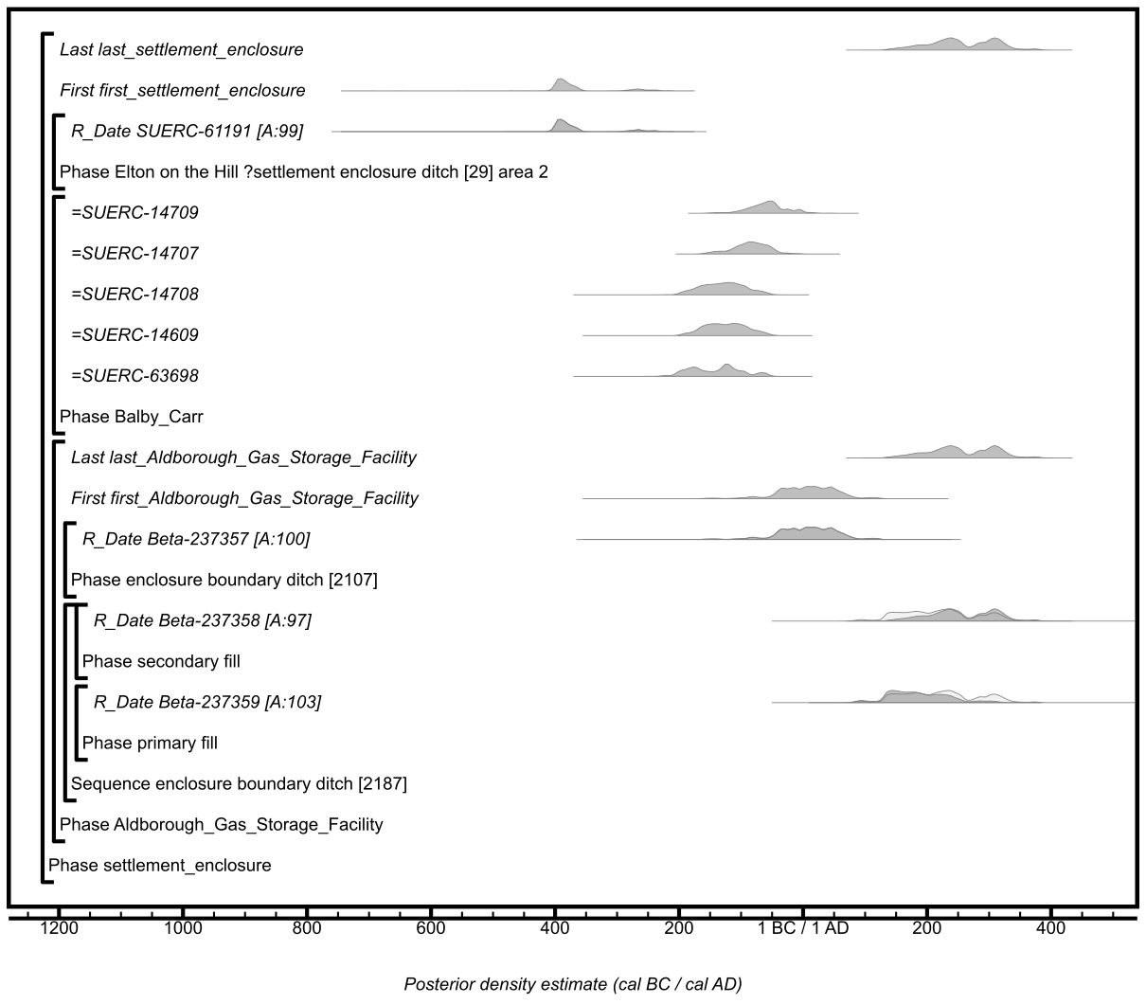Figure S100: Component model section for likelihoods associated with the use of selected settlement enclosures. The format is identical to that of Figure S11. Details of the measurements are given in Table S2. Posterior distributions have been taken from the model defined in Figure S15. The large square brackets down the left-hand side of these site-specific figures and in this currency figure, along with the OxCal keywords, define the model exactly.

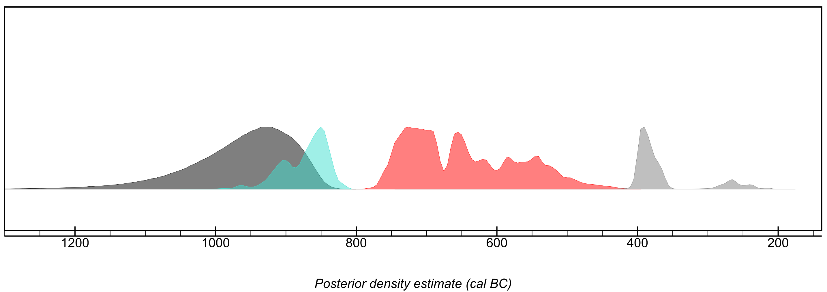

Figure S101: Key parameters calculated for the chronological currency model for results from features classed as enclosures (turquoise; first_enclosure; Figure S99), or as settlement enclosures (grey; first_settlement_enclosure; Figure S100), or stock enclosures (red; first_stock_enclosure; Figure S97). The component sections that calculate these parameters are shown in detail in Figures 97–100. The distribution in dark grey is the estimate for Start_start_all_enclosures shown in Figure S96.

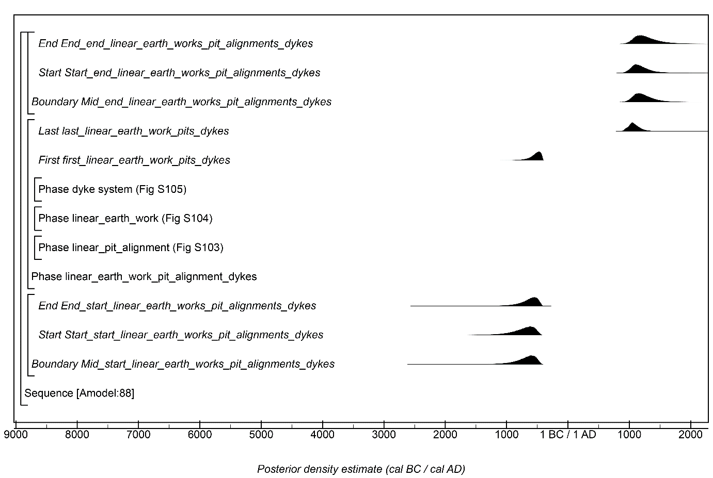

Figure S102: Overall structure of the chronological currency model for results from features classed as linear pit alignments, linear earthworks, or dyke systems. The component sections of this model are shown in detail in Figures S103–S105. The structure is the same as shown in Figure S2. The large square brackets down the left-hand side of Figures S103–S105 along with the OxCal keywords define the overall model exactly.

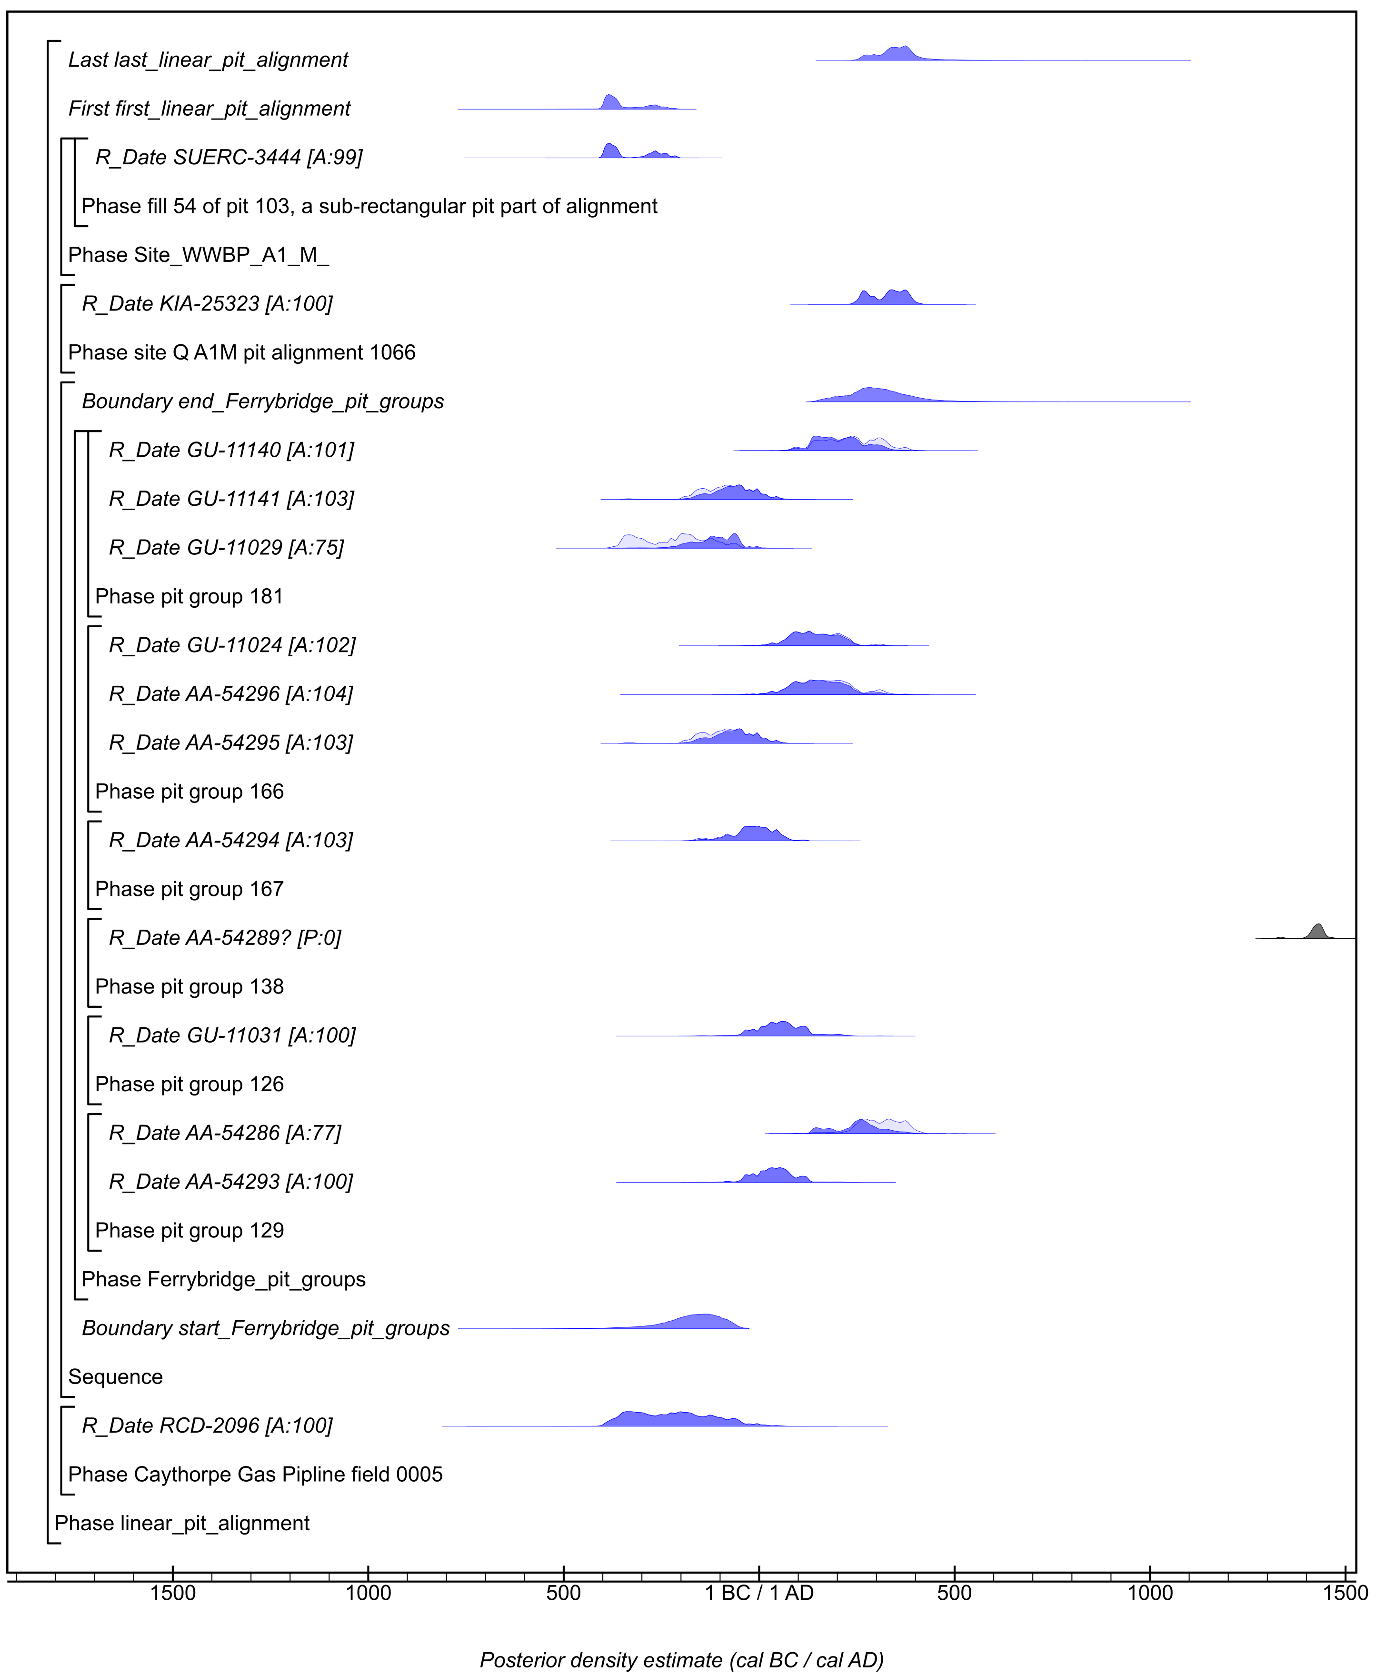

Figure S103: Component model section for likelihoods associated with the use of linear pit alignments. The format is identical to that of Figure S11. Details of the measurements are given in Table S2. The large square brackets down the left-hand side of these site-specific figures and in this currency figure, along with the OxCal keywords, define the model exactly.

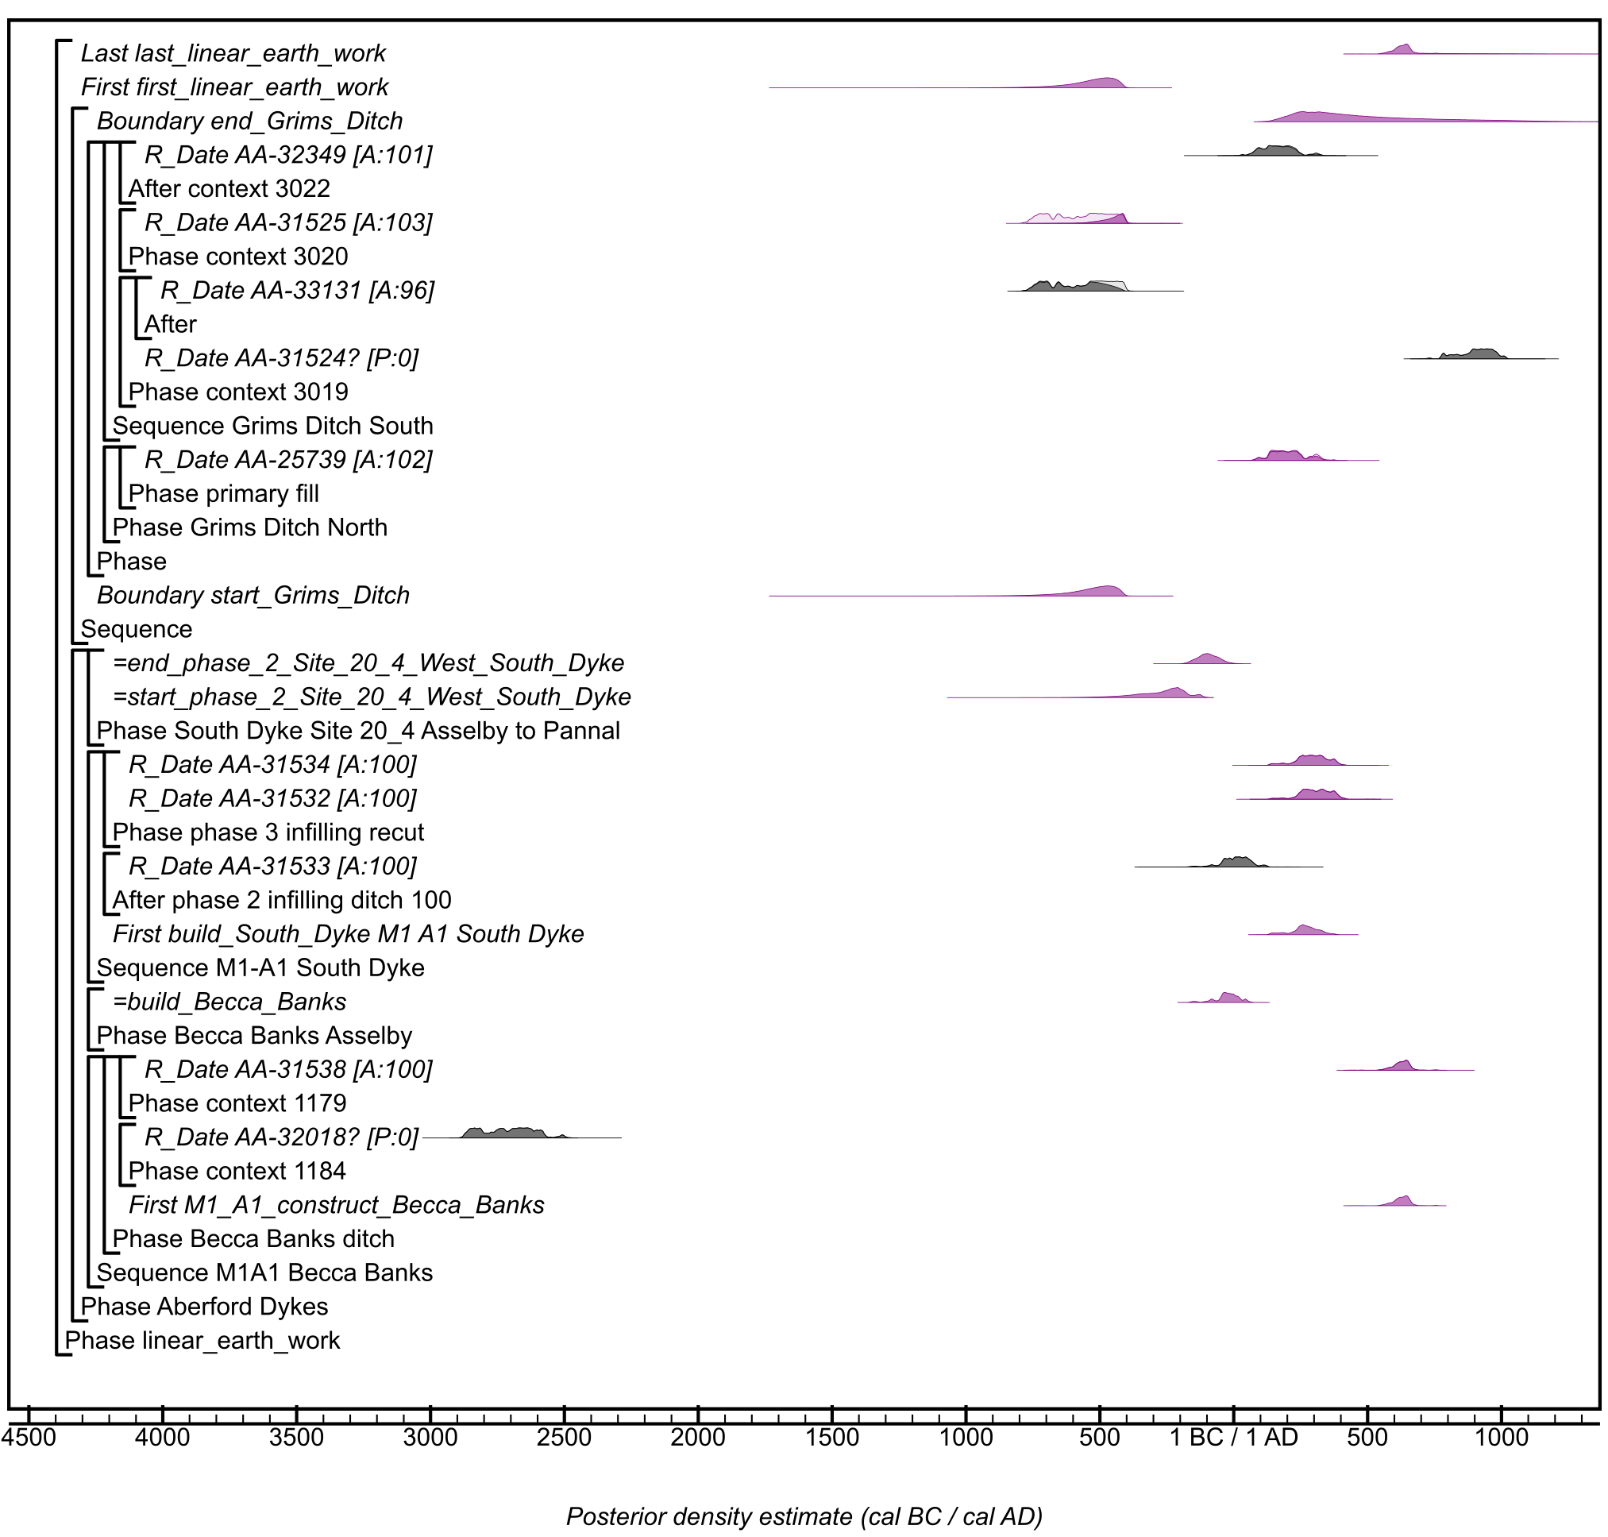

Figure S104: Component model section for likelihoods associated with the use of linear earthworks. The format is identical to that of Figure S11. Details of the measurements are given in Table S2. Posterior distributions have been taken from the models defined in Figures S18 and S61. The large square brackets down the left-hand side of these site-specific figures and in this currency figure, along with the OxCal keywords, define the model exactly.

Figure S105: Component model section for likelihoods associated with dyke systems, in this case only results from Danby Rigg were included, other ‘dykes’ comprising monuments examined in Figure S104. The format is identical to that of Figure S11. Details of the measurements are given in Table S2. The large square brackets down the left-hand side of these site-specific figures and in this currency figure, along with the OxCal keywords, define the model exactly.

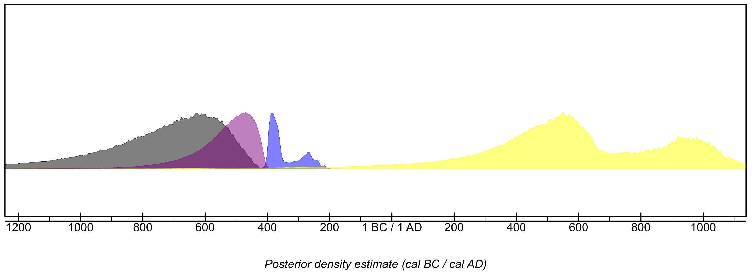

Figure S106: Key parameters calculated for the chronological currency model for results from features classed as dyke systems (yellow; start_Danby_Rigg Figure S105), or linear earth works (purple; first_linear_earth_work; Figure S104), or linear pit alignments (blue; first_linear_pit_alignment; Figure S103). The component sections that calculate these parameters are shown in detail in Figures S103–S105. The distribution in dark grey is the estimate for Start_start_linear_earth_works_pit_alignments_dykes shown in Figure S103.

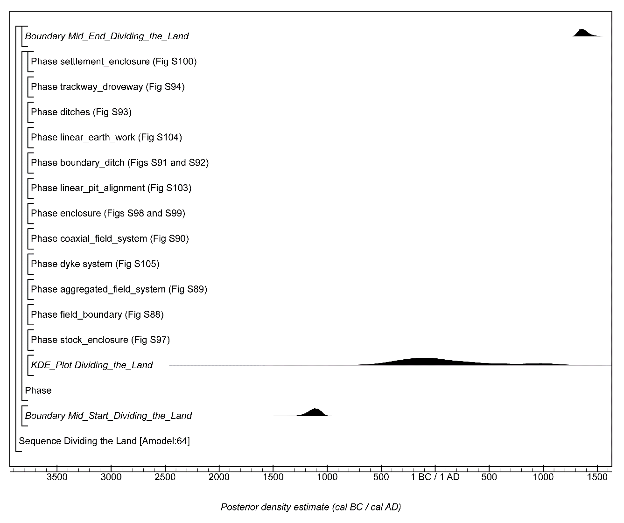

Figure S107: Overall structure of the chronological currency model for all the data analysed as part of ‘Dividing the Land’ calculated using trapezium Boundary parameters (Lee & Bronk Ramsey, 2012). The component sections of this model are shown in detail in Figures S88–S94 and Figures S97–S100 and Figure S103–S105. The structure is the same as shown in Figure S11. The large square brackets down the left-hand side of Figures S88–S94 and Figures S97–S100 and Figure S103–S105 along with the OxCal keywords define the overall currency model and KDE calculation (but the model is only exactly defined by the CQL2 code in Appendix 1).

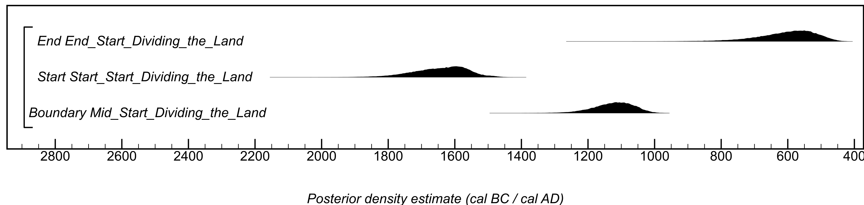

Figure S108: Trapezium boundaries exploring the tempo of activity associated with the start of all land division sampled in the model shown in Figure S107.

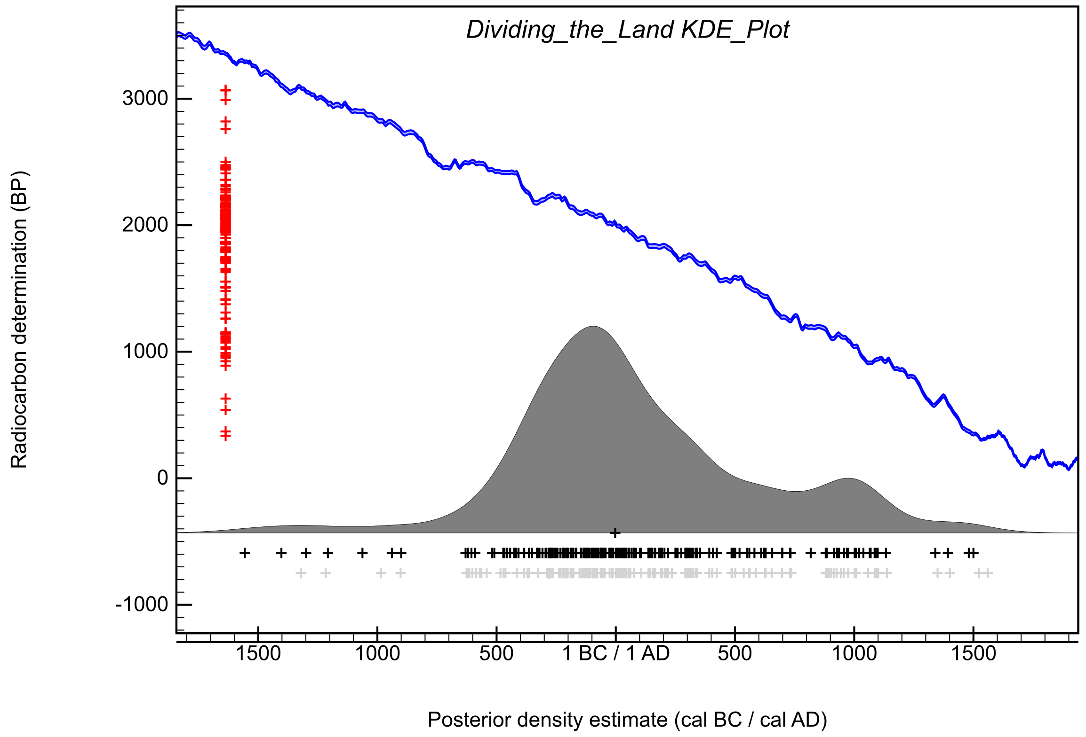

Figure S109: Kernel Density Estimate for the plot of the overall distribution of likelihoods associated with land division in the study area. The estimate is calculated as shown in Figure S107.

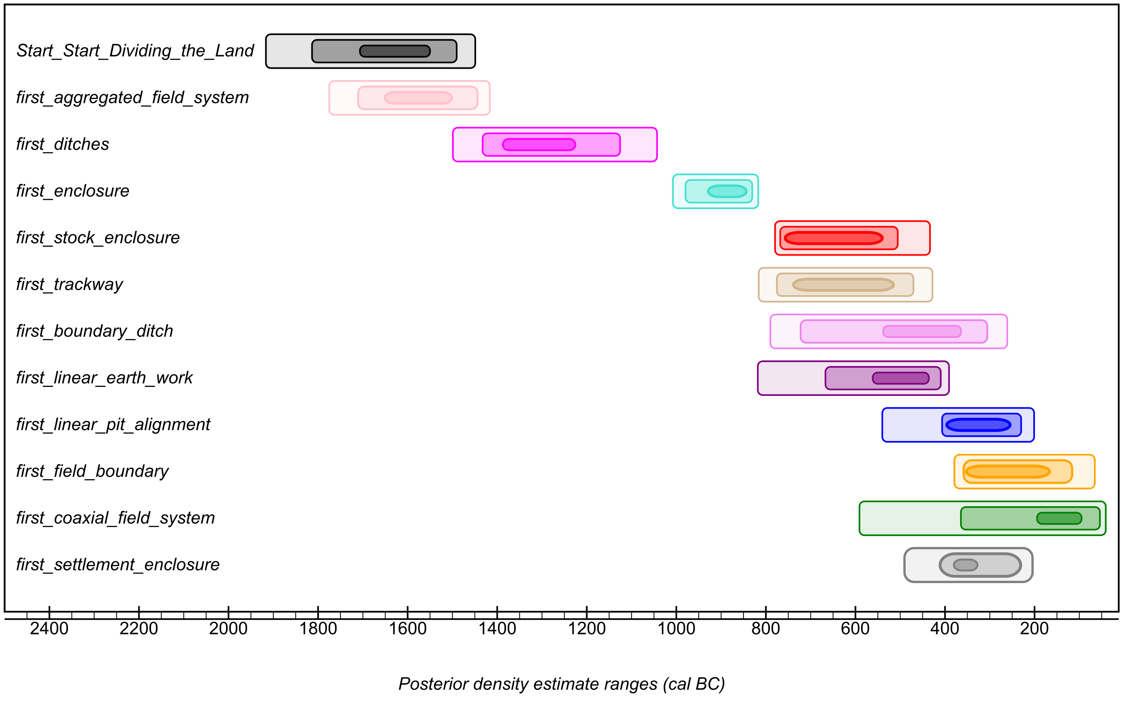

Figure S110: Summary of posterior density date ranges associated with different types of land division analysed in this project. For each distribution three date ranges have been calculated: the darkest is the range at 68% probability, the middle opacity range is at 95% probability, and the lightest date range is at 99% probability. The estimates are calculated in the model shown in Figure S107.

Appendix 1: CQL2 code defining chronological model for the currency of land divisions
Plot()
{
Sequence("Dividing the Land")
{
Boundary("Mid_Start_Dividing_the_Land")
{
Transition("Duration_Start_Dividing_the_Land");
Start("Start_Start_Dividing_the_Land");
End("End_Start_Dividing_the_Land");
};
Phase()
{
KDE_Plot("Dividing_the_Land", )
{
};
Phase("stock_enclosure")
{
Phase("Carr_Lodge")
{
Phase("possible stock enclosure ditch 206")
{
R_Date("Beta-158299", 30, 60)
{
Outlier();
};
};
Phase("enclosure ditch 103 ")
{
R_Date("Beta-158298", 2210, 60)
{
longitude=-1.1273953;
latitude=53.493069;
color="Red";
};
};
};
Phase("Elton on the Hill area 1")
{
Phase("banjo enclosure ditch [108]")
{
R_Date("SUERC-61192", 2462, 32)
{
longitude=-0.85548931;
latitude=52.947370;
color="Red";
};
};
Phase("enclosure ditch 112")
{
R_Date("SUERC-67335", 2456, 29)
{
longitude=-0.85548931;
latitude=52.947370;
color="Red";
};
};
};
Phase("Site 18_11B_Asselby_Pannal")
{
Phase("ditch 8006/8014")
{
R_Date("SUERC-33871", 1085, 35)
{
longitude=-1.2852677;
latitude=53.820764;
color="Red";
};
};
};
Phase("Site 2 Asselby_Pannal")
{
Date("=last_TPQ_stock_enclosure")
{
longitude=-0.95953808;
latitude=53.723131;
color="Red";
};
};
Span("duration_stock_enclosures")
{
color="Red";
};
First("first_stock_enclosure")
{
color="Red";
};
Last("last_stock_enclosure")
{
color="Red";
};
};
Phase("field_boundary")
{
Phase("Glasshoughton Coalfields Link Rd")
{
R_Date("SUERC-19938", 1815, 30)
{
longitude=-1.3713394;
latitude=53.702682;
color="Orange";
};
};
Phase("Finningley Quarry")
{
C_Date("Shef-08140", 502, 190)
{
color="Orange";
longitude=-0.96630873;
latitude=53.478751;
};
};
Phase("Easington, Easington to Salt End Cable Route")
{
R_Date("SUERC-72120", 1554, 29)
{
color="Orange";
longitude=0.10893467;
latitude=53.646661;
};
};
Phase("Site Q A1M field boundary ditch 10229")
{
R_Date("SUERC-4373", 630, 35)
{
longitude=-1.2947151;
latitude=53.710345;
color="Orange";
};
};
Phase("AP30, Area 15, Asselby to Pannal Pipeline")
{
Phase("ditch 1748")
{
R_Date("SUERC-34153", 115, 30)
{
Outlier();
};
R_Date("SUERC-34154", 145, 30)
{
Outlier();
};
};
};
Phase("AP32, Area 8, Asselby to Pannal Pipeline")
{
Phase("ditch 12021")
{
R_Date("SUERC-33879", 890, 35)
{
longitude=-1.3312413;
latitude=53.838412;
color="Orange";
};
};
};
Phase("Becca Banks")
{
Phase("ditch_536")
{
R_Date("SUERC-24496", 1155, 30)
{
longitude=-1.3532299;
latitude=53.836510;
color="Orange";
};
};
};
Phase("Bullerthorpe Lane, Swillington")
{
Phase("field ditch 1592")
{
After("2057 recut in ditch 6")
{
R_Date("AA-32006", 1935, 50);
};
};
};
Phase("Doncaster_Road_South_Elmsall_sites")
{
After("fill of ditch one, segment 5007.")
{
R_Date("AA-36884", 930, 45);
};
};
Phase("Site M A1M")
{
Phase("ditch 1029")
{
R_Date("SUERC-4369", 2165, 35)
{
longitude=-1.3200522;
latitude=53.783296;
color="Orange";
};
};
};
Phase("Topham_Farm_Enclosure_B_TPQ")
{
Date("=last_phase_1_TPQ_enclosure_B")
{
longitude=-1.0590061;
latitude=53.647605;
color="Orange";
};
};
Phase("FARRRS")
{
Phase("field ditch 10039")
{
Date("=UBA-29950")
{
longitude=-0.96630873;
latitude=53.478751;
color="Orange";
};
};
};
Span("duration_field_boundary")
{
color="Orange";
};
First("first_field_boundary")
{
color="Orange";
};
Last("last_field_boundary")
{
color="Orange";
};
};
Phase("aggregated_field_system")
{
Phase("Bar Brook, Big Moor")
{
Date("=OxA-2292")
{
longitude=-1.5922890;
latitude=53.275875;
color="Pink";
};
Date("=OxA-2294")
{
longitude=-1.5922890;
latitude=53.275875;
color="Pink";
};
Date("=OxA-2293")
{
longitude=-1.5922890;
latitude=53.275875;
color="Pink";
};
};
Sequence()
{
Boundary("start_enclosure 35_4")
{
longitude=-1.5598454;
latitude=53.942604;
color="Pink";
};
Sequence("enclosure 35_4")
{
Phase("ditch 6003")
{
R_Date("SUERC-34133", 2220, 30)
{
color="Pink";
};
R_Date("SUERC-34134", 2205, 35)
{
color="Pink";
};
};
Sequence("ditch 6055")
{
Phase("lower ditch 6055")
{
R_Date("SUERC-34135", 2155, 30)
{
color="Pink";
};
R_Date("SUERC-34136", 2235, 35)
{
color="Pink";
};
};
Phase("upper ditch 6055")
{
R_Date("SUERC-33880", 2460, 35)
{
Outlier();
};
};
};
};
Boundary("end_enclosure 35_4")
{
longitude=-1.5598454;
latitude=53.942604;
color="Pink";
};
};
Phase("Eaglestone Flat")
{
Date("=TAQ_prehistoric_wall_16")
{
color="Pink";
};
Date("=TPQ_linear_clearance_bank_120")
{
color="Pink";
};
};
Phase("Swillington_Common_A1_M1_link_road")
{
Phase("Swillington_Common_A1_M1_link_road")
{
Date("=AA-32015")
{
longitude=-1.4295729;
latitude=53.764992;
color="Pink";
};
Date("=AA-31498")
{
longitude=-1.4295729;
latitude=53.764992;
color="Pink";
};
};
};
Span("aggregated_field_system")
{
color="Pink";
};
First("first_aggregated_field_system")
{
color="Pink";
};
Last("last_aggregated_field_system")
{
color="Pink";
};
};
Phase("dyke system")
{
Outlier_Model("Charcoal",Exp(1,-10,0),U(0,3),"t");
Sequence()
{
Boundary("start_Danby_Rigg")
{
longitude=-0.90778469;
latitude=54.447914;
color="Yellow";
};
Phase("Danby_Rigg")
{
Phase("dark layer 327 in north ditch")
{
R_Date("HAR-8908", 1140, 60)
{
color="Yellow";
Outlier(1);
};
R_Date("HAR-8909", 1510, 80)
{
color="Yellow";
Outlier(1);
};
};
Phase("layer in south (outer) ditch")
{
R_Date("HAR-8910", 1120, 80)
{
color="Yellow";
Outlier(1);
};
R_Date("HAR-8911", 990, 60)
{
color="Yellow";
Outlier(1);
};
};
Span("duration_Danby_Rigg_dyke_system")
{
color="Yellow";
};
};
Boundary("end_Danby_Rigg")
{
longitude=-0.90778469;
latitude=54.447914;
color="Yellow";
};
};
};
Phase("coaxial_field_system")
{
Phase("Barnsdale_Bar")
{
Phase("enclosure A; ditch 5000")
{
R_Date("AA-41786", 280, 50)
{
Outlier();
};
};
Phase("enclosure B; ditch 5002")
{
R_Date("AA-41785", 1630, 45)
{
longitude=-1.2289280;
latitude=53.620955;
color="Green";
};
};
};
Phase("Balby_Carr")
{
Date("=SUERC-19393")
{
longitude=-1.1199157;
latitude=53.497599;
color="Green";
};
Date("=SUERC-19394")
{
longitude=-1.1199157;
latitude=53.497599;
color="Green";
};
Date("=Wk-12979")
{
longitude=-1.1199157;
latitude=53.497599;
color="Green";
};
Date("=Wk-12978")
{
longitude=-1.1199157;
latitude=53.497599;
color="Green";
};
Date("=Wk-10975")
{
longitude=-1.1199157;
latitude=53.497599;
color="Green";
};
};
Sequence()
{
Boundary("start_Ferrybridge_coaxial")
{
longitude=-1.2802929;
latitude=53.712057;
color="Green";
};
Phase("Ferrybridge_coaxial")
{
Phase("field unit II")
{
Phase("ditch 174")
{
R_Date("GU-11021", 1980, 50)
{
color="Green";
};
};
Phase("ditch 177")
{
R_Date("GU-11018", 1945, 50)
{
color="Green";
};
};
Phase("ditch 105")
{
R_Date("GU-11028", 1980, 50)
{
color="Green";
};
};
};
Phase("field unit IV")
{
Phase("ditch 183")
{
R_Date("AA-40922", 2105, 45)
{
color="Green";
};
};
};
};
Boundary("end_Ferrybridge_coaxial")
{
longitude=-1.2802929;
latitude=53.712057;
color="Green";
};
};
Phase("Site 2 Asselby_Pannal")
{
Date("=start_phase_2_enclosures_site_2")
{
longitude=-0.95953808;
latitude=53.723131;
color="Green";
};
Date("=end_phase_2_enclosures_site_2")
{
longitude=-0.95953808;
latitude=53.723131;
color="Green";
};
Date("=start_phase_4_enclosures_site_2")
{
longitude=-0.95953808;
latitude=53.723131;
color="Green";
};
Date("=end_phase_4_enclosures_site_2")
{
longitude=-0.95953808;
latitude=53.723131;
color="Green";
};
};
Span("duration_coaxial_field_system")
{
color="Green";
};
First("first_coaxial_field_system")
{
color="Green";
};
Last("last_coaxial_field_system")
{
color="Green";
};
};
Phase("enclosure")
{
Phase("Site SPE5, Easington to Paull")
{
Phase("rectilinear ditch 5257")
{
R_Date("SUERC-35051", 1975, 35)
{
color="Turquoise";
longitude=0.024770068;
latitude=53.658453;
};
};
};
Phase("High Wold Birlington")
{
Phase("enclosure B, site phase 2")
{
R_Date("GU-11139", 1735, 55)
{
longitude=-0.19440620;
latitude=54.106025;
color="Turquoise";
};
};
Phase("enclosure F, site phase 3")
{
Phase("ditch 7")
{
R_Date("GU-11138", 1850, 40)
{
longitude=-0.19440620;
latitude=54.106025;
color="Turquoise";
};
};
};
};
Sequence()
{
Boundary("start_Billingborough_enclosure")
{
longitude=-0.32799019;
latitude=52.886278;
color="Turquoise";
};
Sequence("main enclosure")
{
After("possible older wood older fills")
{
R_Date("BM-1411", 3430, 110);
R_Date("BM-1410", 3148, 57);
};
Phase("upper fills")
{
R_Date("HAR-2523", 2410, 80)
{
color="Turquoise";
};
Phase("pit")
{
R_Date("HAR-3101", 2500, 100)
{
color="Turquoise";
};
};
};
};
Boundary("end_Billingborough_enclosure")
{
longitude=-0.32799019;
latitude=52.886278;
color="Turquoise";
};
};
Phase("M1_A1_Swillington_Common")
{
Date("=AA-32008")
{
longitude=-1.4292073;
latitude=53.791955;
color="Turquoise";
};
Date("=AA-31492")
{
longitude=-1.4292073;
latitude=53.791955;
color="Turquoise";
};
Date("=AA-32009")
{
longitude=-1.4292073;
latitude=53.791955;
color="Turquoise";
};
Date("=AA-31500")
{
longitude=-1.4292073;
latitude=53.791955;
color="Turquoise";
};
Date("=AA-31501")
{
longitude=-1.4292073;
latitude=53.791955;
color="Turquoise";
};
Date("=AA-31502")
{
longitude=-1.4292073;
latitude=53.791955;
color="Turquoise";
};
Date("=AA-31504")
{
longitude=-1.4292073;
latitude=53.791955;
color="Turquoise";
};
Date("=AA-31507")
{
longitude=-1.4292073;
latitude=53.791955;
color="Turquoise";
};
};
Sequence("M1_A1_Parlington_Hollins")
{
Phase("phase 1 and 2, enclosure A, ditch 2004")
{
R_Date("AA-31523", 2090, 65)
{
longitude=-1.3591799;
latitude=53.805083;
color="Turquoise";
};
};
Phase("phase 4, enclosure D")
{
R_Date("AA-30656", 1700, 45)
{
longitude=-1.3591799;
latitude=53.805083;
color="Turquoise";
};
};
};
Phase("M1_A1_Manor_Farm_enclosure_A")
{
Date("=AA-31509")
{
longitude=-1.3866281;
latitude=53.797138;
color="Turquoise";
};
};
Phase("Moss_Carr")
{
Phase("enclosure primary ditch fill")
{
Date("=AA-49619")
{
longitude=-1.4376015;
latitude=53.731774;
color="Turquoise";
};
};
Phase("enclosure entrance slot")
{
Date("=AA-49618")
{
longitude=-1.4376015;
latitude=53.731774;
color="Turquoise";
};
};
};
Phase("Dalton Parlours enclosures")
{
Date("=HAR-6727")
{
longitude=-1.3897599;
latitude=53.895123;
color="Turquoise";
};
Date("=HAR-6716")
{
longitude=-1.3897599;
latitude=53.895123;
color="Turquoise";
};
Date("=HAR-6726")
{
Outlier();
longitude=-1.3897599;
latitude=53.895123;
};
};
Phase("Doncaster_Road_South_Elmsall_enclosures")
{
Phase("fill of ditch 4022, enclosure B")
{
R_Date("AA-36495", 2145, 50)
{
longitude=-1.2640407;
latitude=53.601402;
color="Turquoise";
};
};
Phase("fill of ditch 3039, enclosure C ")
{
R_Date("AA-36497", 2145, 50)
{
longitude=-1.2640407;
latitude=53.601402;
color="Turquoise";
};
};
After("ditch 5002 from enclosure F")
{
R_Date("AA-26218", 2040, 50);
};
Phase("fill of ditch 4387, enclosure A")
{
R_Date("AA-36493", 3175, 50)
{
Outlier();
};
};
};
Phase("Fosse Hill, Easington to Salt End Cable Route")
{
Phase("ditch [27153] subdivision in enclosure")
{
R_Date("UBA-33613", 2762, 28)
{
longitude=0.091171807;
latitude=53.654615;
color="Turquoise";
};
R_Date("UBA-33612", 3603, 46)
{
Outlier();
};
};
};
Sequence()
{
Boundary("start_Ferrybridge_enclosures")
{
longitude=-1.2802929;
latitude=53.712057;
color="Turquoise";
};
Phase("Ferrybridge_enclosures")
{
Phase("Roman field system")
{
Phase("enclosure A")
{
Phase("phase 2")
{
R_Date("GU-11026", 1900, 50)
{
color="Turquoise";
};
};
Phase("phase 3")
{
R_Date("GU-11020", 1805, 55)
{
color="Turquoise";
};
};
};
Phase("enclosure B internal ditch 168B")
{
R_Date("GU-11027", 1855, 50)
{
color="Turquoise";
};
};
};
Sequence("sequence enclosures C, D, E")
{
Phase("enclosure C")
{
R_Date("GU-11019", 2160, 50)
{
color="Turquoise";
};
R_Date("GU-11023", 2075, 50)
{
color="Turquoise";
};
After()
{
R_Date("GU-11033R", 2260, 55);
};
};
Phase("enclosure E")
{
R_Date("GU-11022", 1790, 60)
{
color="Turquoise";
};
};
};
};
Boundary("end_Ferrybridge_enclosures")
{
longitude=-1.2802929;
latitude=53.712057;
color="Turquoise";
};
};
Phase("Landeled_enclosures")
{
Phase("1096, ditch 5")
{
R_Date("Beta-217178", 1800, 40)
{
longitude=0.11091755;
latitude=53.656066;
color="Turquoise";
};
};
Phase("1238, ditch 1")
{
R_Date("Beta-217186", 370, 40)
{
longitude=0.11091755;
latitude=53.656066;
color="Turquoise";
};
};
Phase("176, ditch 6")
{
R_Date("Beta-217173", 2180, 40)
{
longitude=0.11091755;
latitude=53.656066;
color="Turquoise";
};
};
};
Phase("Racecourse Road, Seamer Moor, Scarborough square enclosure")
{
After("1011, F10002 square enclosure")
{
R_Date("SUERC-19405", 2060, 30);
};
};
Phase("Roebuck Hill Jump Barnsley")
{
Phase("enclosure ditch [1632]")
{
R_Date("SUERC-13475", 1925, 35)
{
longitude=-1.4299828;
latitude=53.510175;
color="Turquoise";
};
};
};
Phase("Site_1_Asselby_Pannal")
{
Phase("phase two enclosure ditch 1512")
{
R_Date("SUERC-33994", 2155, 35)
{
longitude=-0.95953808;
latitude=53.723131;
color="Turquoise";
};
R_Date("SUERC-33995", 2070, 35)
{
longitude=-0.95953808;
latitude=53.723131;
color="Turquoise";
};
};
};
Phase("Site 18_10_Asselby_Pannal")
{
Phase("ditch 7779")
{
R_Date("SUERC-33872", 2475, 35)
{
longitude=-1.2742630;
latitude=53.817642;
color="Turquoise";
};
};
};
Phase("site 18_5 enclosure_Asselby_Pannal")
{
Phase("ditch 7507")
{
R_Date("SUERC-33886", 925, 35)
{
longitude=-1.2623462;
latitude=53.812068;
color="Turquoise";
};
};
};
Phase("Site 20_4 East Asselby_Pannal")
{
Phase("ditch 5570")
{
R_Date("SUERC-34115", 2075, 30)
{
longitude=-1.3245063;
latitude=53.832927;
color="Turquoise";
};
};
};
Phase("Site_26_2_Asselby_Pannal")
{
Phase("ditch 5219")
{
R_Date("SUERC-34029", 1655, 30)
{
longitude=-1.4148077;
latitude=53.890745;
color="Turquoise";
};
R_Date("SUERC-34030", 1725, 30)
{
longitude=-1.4148077;
latitude=53.890745;
color="Turquoise";
};
};
};
Phase("Site CFAT A1M")
{
Phase("ditch 46")
{
R_Date("SUERC-4352", 1740, 35)
{
longitude=-1.2717693;
latitude=53.679198;
color="Turquoise";
};
};
};
Phase("site Q A1M ditch 768")
{
R_Date("SUERC-5124", 2140, 35)
{
longitude=-1.2947151;
latitude=53.710345;
color="Turquoise";
};
};
Sequence("Tr_78_79_Asselby_Pannal")
{
Boundary("start_enclosure_Tr_78_and_79")
{
longitude=-1.5598454;
latitude=53.942604;
color="Turquoise";
};
Phase("enclosure in Tr 78 and 79")
{
Phase("ditch 1051")
{
R_Date("SUERC-34146", 2165, 30)
{
color="Turquoise";
};
R_Date("SUERC-34147", 2200, 30)
{
color="Turquoise";
};
};
Phase("ditch 1023")
{
R_Date("SUERC-34148", 2060, 30)
{
color="Turquoise";
};
R_Date("SUERC-34152", 2235, 30)
{
color="Turquoise";
};
};
};
Boundary("end_enclosure_Tr_78_and_79")
{
longitude=-1.5598454;
latitude=53.942604;
color="Turquoise";
};
};
Phase("Whirlow_Hall_Farm")
{
Phase("ditch intervention F003")
{
R_Date("SUERC-36826", 2155, 30)
{
longitude=-1.5323788;
latitude=53.344600;
color="Turquoise";
};
};
};
Phase("Shafton_Bypass enclosure ditch 200")
{
Date("=AA-52364")
{
longitude=-1.4002752;
latitude=53.585084;
color="Turquoise";
};
};
Phase(" Easington to Paull gas pipeline SPE1")
{
Phase("enclosure ditch 1084 final recut")
{
R_Date("SUERC-35035", 2140, 35)
{
longitude=0.10927095;
latitude=53.653398;
color="Turquoise";
};
};
};
Phase("Easington to Paull gas pipeline SPE4")
{
Phase("enclosure ditch 4253")
{
R_Date("SUERC-35043", 2230, 35)
{
longitude=0.077740305;
latitude=53.658444;
color="Turquoise";
};
};
};
Phase("Easington to Paull gas pipeline SPE7")
{
Phase("enclosure ditch 7127")
{
R_Date("SUERC-35033", 1750, 35)
{
longitude=0.077740305;
latitude=53.658444;
color="Turquoise";
};
};
};
Phase("Goldthorpe enclosure round corndrier")
{
Date("=SUERC-48125")
{
longitude=-1.3271909;
latitude=53.526270;
color="Turquoise";
};
};
Phase("South_Hill_Easington_to_Salt_End_Cable_Route")
{
Phase("small Anglo-Scandinavian enclosure plot")
{
R_Date("UBA-31835", 1072, 30)
{
longitude=-0.19091435;
latitude=53.710899;
color="Turquoise";
};
R_Date("UBA-31836", 1036, 26)
{
longitude=-0.19091435;
latitude=53.710899;
color="Turquoise";
};
};
};
Phase("Hook Manor")
{
Phase("Ditch 1001, inner ditch from triple ditched enclosure")
{
R_Date("AA-32019", 265, 45)
{
Outlier();
};
};
};
Phase("South Dyke Asselby Pannal")
{
Date("=start_phase_3_Site_20_4_West_South_Dyke")
{
color="Turquoise";
longitude=-1.3276599;
latitude=53.833358;
};
Date("=end_phase_3_enclosure_Site_20_4_West_South_Dyke")
{
color="Turquoise";
longitude=-1.3276599;
latitude=53.833358;
};
};
Span("duration_enclosure")
{
color="Turquoise";
};
First("first_enclosure")
{
color="Turquoise";
};
Last("last_enclosure")
{
color="Turquoise";
};
};
Phase("linear_pit_alignment")
{
Phase("Caythorpe Gas Pipline field 0005", )
{
R_Date("RCD-2096", 2170, 80)
{
longitude=-0.30797434;
latitude=54.078013;
color="Blue";
};
};
Sequence()
{
Boundary("start_Ferrybridge_pit_groups")
{
longitude=-1.2802929;
latitude=53.712057;
color="Blue";
};
Phase("Ferrybridge_pit_groups")
{
Phase("pit group 129")
{
R_Date("AA-54293", 1960, 45)
{
color="Blue";
};
R_Date("AA-54286", 1725, 45)
{
color="Blue";
};
};
Phase("pit group 126")
{
R_Date("GU-11031", 1945, 50)
{
color="Blue";
};
};
Phase("pit group 138")
{
R_Date("AA-54289", 485, 40)
{
Outlier();
};
};
Phase("pit group 167")
{
R_Date("AA-54294", 2010, 45)
{
color="Blue";
};
};
Phase("pit group 166")
{
R_Date("AA-54295", 2060, 45)
{
color="Blue";
};
R_Date("AA-54296", 1855, 60)
{
color="Blue";
};
R_Date("GU-11024", 1870, 50)
{
color="Blue";
};
};
Phase("pit group 181")
{
R_Date("GU-11029", 2155, 50)
{
color="Blue";
};
R_Date("GU-11141", 2060, 45)
{
color="Blue";
};
R_Date("GU-11140", 1790, 50)
{
color="Blue";
};
};
};
Boundary("end_Ferrybridge_pit_groups")
{
longitude=-1.2802929;
latitude=53.712057;
color="Blue";
};
};
Phase("site Q A1M pit alignment 1066")
{
R_Date("KIA-25323", 1711, 31)
{
longitude=-1.2947151;
latitude=53.710345;
color="Blue";
};
};
Phase("Site_WWBP_A1_M_")
{
Phase("fill 54 of pit 103, a sub-rectangular pit part of alignment")
{
R_Date("SUERC-3444", 2285, 35)
{
longitude=-1.3738184;
latitude=53.943576;
color="Blue";
};
};
};
Span("duration_linear_pit_alignment")
{
color="Blue";
};
First("first_linear_pit_alignment")
{
color="Blue";
};
Last("last_linear_pit_alignment")
{
color="Blue";
};
};
Phase("boundary_ditch")
{
Phase("Wattle Syke, Wetherby")
{
Phase("third re-cut 1287, of ditch 1 forming one of the boundaries of a field system")
{
R_Date("SUERC-27199", 1720, 30)
{
color="Violet";
longitude=-1.3835016;
latitude=53.906775;
};
};
};
Sequence("Site BS13, Area 6, Beverley Southern Relief Road")
{
Boundary("start_BS13")
{
color="Violet";
longitude=-0.42146150;
latitude=53.826072;
};
Phase("BS13")
{
Phase("6208 ditch")
{
R_Date("SUERC-56950", 2017, 29)
{
color="Violet";
};
};
Phase("10205 ditch")
{
R_Date("SUERC-56959", 135, 29)
{
Outlier();
};
};
Phase("10181 ditch")
{
R_Date("SUERC-56960", 2071, 29)
{
color="Violet";
};
};
};
Boundary("end_BS13")
{
color="Violet";
longitude=-0.42146150;
latitude=53.826072;
};
};
Phase("AP33, Area 8, Asselby to Pannal pipeline")
{
Phase("grave 1848 in boundary ditch 1832")
{
R_Date("SUERC-34523", 1870, 30)
{
color="Violet";
longitude=-1.3303941;
latitude=53.838173;
};
};
};
Phase("Creswell, Fox Meadow")
{
Phase("ditch")
{
R_Date("GU-3288", 1150, 50)
{
color="Violet";
longitude=-1.2054616;
latitude=53.259454;
};
};
};
Sequence()
{
Boundary("start_Normanton_Industrial_Estate")
{
color="Violet";
longitude=-1.3825768;
latitude=53.700763;
};
Phase("Normanton_Industrial_Estate")
{
Phase("ditch 15187, forming the west side of a D-shaped enclosure")
{
R_Date("SUERC-37800", 1940, 30)
{
color="Violet";
};
};
Phase("ditch 15196, a probable field boundary")
{
R_Date("SUERC-37803", 1510, 30)
{
color="Violet";
};
};
Phase("ditch 15122 south side of D-shaped enclosure and north side of possible droveway")
{
R_Date("SUERC-37808", 220, 30)
{
Outlier();
};
};
Phase("ditch 15143 south side of possible droveway")
{
R_Date("SUERC-37802", 180, 25)
{
Outlier();
};
};
};
Boundary("end_Normanton_Industrial_Estate")
{
color="Violet";
longitude=-1.3825768;
latitude=53.700763;
};
};
Phase("Rawdales Drain")
{
Phase("boundary ditch 1330")
{
R_Date("SUERC-80434", 3013, 30)
{
Outlier();
longitude=-0.46937796;
latitude=53.761973;
};
};
};
Phase("site 17_3_Asselby_Pannal")
{
Date("=SUERC-34004")
{
color="Violet";
longitude=-1.2315417;
latitude=53.808172;
};
Date("=SUERC-34005")
{
color="Violet";
longitude=-1.2315417;
latitude=53.808172;
};
};
Phase("site 18_5 Asselby_Pannal")
{
Phase("phase 2 rectangular enclosure")
{
Phase("ditch 7596")
{
R_Date("SUERC-33887", 2145, 35)
{
color="Violet";
longitude=-1.2623462;
latitude=53.812068;
};
};
Phase("ditch 7511")
{
R_Date("SUERC-33888", 2000, 35)
{
color="Violet";
longitude=-1.2623462;
latitude=53.812068;
};
};
};
};
Sequence("site 26_3_Asselby_Pannal")
{
Boundary("start_site_26_3")
{
color="Violet";
longitude=-1.4159465;
latitude=53.894193;
};
Phase("site 26_3_boundary_ditches")
{
Phase("boundary ditch 6649")
{
R_Date("SUERC-33881", 1145, 35)
{
color="Violet";
};
};
Phase("boundary ditch 6684")
{
R_Date("SUERC-34117", 1310, 30)
{
color="Violet";
};
R_Date("SUERC-34118", 1375, 30)
{
color="Violet";
};
};
Phase("boundary ditch 6650")
{
R_Date("SUERC-33882", 1260, 35)
{
color="Violet";
};
};
};
Boundary("end_site 26_3")
{
color="Violet";
longitude=-1.4159465;
latitude=53.894193;
};
};
Sequence("Sneinton Fruitmarket Nottingham")
{
Boundary("start_Sneinton")
{
color="Violet";
longitude=-1.1391076;
latitude=52.955147;
};
Phase("Sneinton Fruitmarket Nottingham")
{
Phase("northern ditch phase 1")
{
R_Date("SUERC-86210", 952, 28)
{
color="Violet";
};
R_Date("SUERC-86211", 1101, 26)
{
color="Violet";
};
};
Phase("northern ditch phase 2")
{
R_Date("SUERC-86212", 1023, 29)
{
color="Violet";
};
};
Phase("northern ditch phase 3")
{
R_Date("SUERC-78136", 1287, 29)
{
Outlier();
};
};
};
Boundary("end_Sneiton")
{
color="Violet";
longitude=-1.1391076;
latitude=52.955147;
};
};
Phase("Swarkestone_Lowes")
{
Phase("curvilinear boundary ditch")
{
R_Date("HAR-6497", 2280, 80)
{
color="Violet";
longitude=-1.4563368;
latitude=52.861742;
};
};
};
Phase("Tr20a_Asselby_Pannal")
{
Phase("ditch 1210")
{
R_Date("SUERC-33870", 2040, 35)
{
color="Violet";
longitude=-1.2639855;
latitude=53.812986;
};
};
};
Phase("Tr_71_Asselby_Pannal")
{
Phase("ditch 2090")
{
R_Date("SUERC-33876", 1965, 35)
{
color="Violet";
longitude=-1.4449163;
latitude=53.903615;
};
};
};
Phase("Tr_72_Asselby_Pannal")
{
Phase("ditch 2098")
{
R_Date("SUERC-33877", 2215, 35)
{
color="Violet";
longitude=-1.4467745;
latitude=53.903515;
};
};
};
Sequence("Tr_76_Asselby_Pannal")
{
Boundary("start_Tr_76")
{
color="Violet";
longitude=-1.4974964;
latitude=53.933281;
};
Phase("Tr 76")
{
Phase("ditch 2238")
{
R_Date("SUERC-34124", 2285, 30)
{
color="Violet";
};
R_Date("SUERC-34125", 2850, 35)
{
Outlier();
};
};
Phase("ditch 2240")
{
R_Date("SUERC-34126", 1860, 35)
{
color="Violet";
};
R_Date("SUERC-34127", 2210, 30)
{
color="Violet";
};
};
};
Boundary("end_Tr_76")
{
color="Violet";
longitude=-1.4974964;
latitude=53.933281;
};
};
Phase("Welwick_Drain_Easington_to_Salt_End")
{
Phase("(67151), [67215] western ditch")
{
R_Date("UBA-31832", 1954, 35)
{
color="Violet";
longitude=0.017101732;
latitude=53.656335;
};
};
};
Phase("Shafton Bypass boundary ditches")
{
Date("=AA-53263")
{
color="Violet";
longitude=-1.4002752;
latitude=53.585084;
};
Date("=AA-53261")
{
color="Violet";
longitude=-1.4002752;
latitude=53.585084;
};
Date("=AA-53262")
{
color="Violet";
longitude=-1.4002752;
latitude=53.585084;
};
};
Phase("FARRRS boundary ditch 30400")
{
Date("=boundary_ditch_30400")
{
color="Violet";
longitude=-1.1107889;
latitude=53.487104;
};
};
Phase("Easington to Paull gas pipeline SPE3")
{
Phase("boundary ditch 3179")
{
R_Date("SUERC-35037", 1555, 35)
{
color="Violet";
longitude=0.085212408;
latitude=53.656517;
};
};
};
Phase("Easington to Paull gas pipeline SPE5")
{
Phase("boundary ditch 5067")
{
R_Date("SUERC-33868", 1945, 35)
{
color="Violet";
longitude=0.024770068;
latitude=53.658453;
};
};
};
Span("duration_boundary_ditches")
{
color="Violet";
};
First("first_boundary_ditch")
{
color="Violet";
};
Last("last_boundary_ditch")
{
color="Violet";
};
};
Phase("linear_earth_work")
{
Phase("Aberford Dykes")
{
Sequence("M1A1 Becca Banks")
{
Phase("Becca Banks ditch")
{
First("M1_A1_construct_Becca_Banks")
{
longitude=-1.3482032;
latitude=53.827494;
color="Purple";
};
Phase("context 1184")
{
R_Date("AA-32018", 4120, 50)
{
Outlier();
};
};
Phase("context 1179")
{
R_Date("AA-31538", 1410, 45)
{
color="Purple";
};
};
};
};
Phase("Becca Banks Asselby")
{
Date("=build_Becca_Banks")
{
color="Purple";
color="Purple";
longitude=-1.3532299;
latitude=53.836510;
};
};
Sequence("M1-A1 South Dyke")
{
First("build_South_Dyke M1 A1 South Dyke")
{
color="Purple";
};
After("phase 2 infilling ditch 100")
{
R_Date("AA-31533", 1985, 45)
{
longitude=-1.3382438;
latitude=53.832833;
};
};
Phase("phase 3 infilling recut")
{
R_Date("AA-31532", 1730, 45)
{
longitude=-1.3382438;
latitude=53.832833;
color="Purple";
};
R_Date("AA-31534", 1745, 45)
{
longitude=-1.3382438;
latitude=53.832833;
color="Purple";
};
};
};
Phase("South Dyke Site 20_4 Asselby to Pannal")
{
Date("=start_phase_2_Site_20_4_West_South_Dyke")
{
color="Purple";
longitude=-1.3276599;
latitude=53.833358;
};
Date("=end_phase_2_Site_20_4_West_South_Dyke")
{
color="Purple";
longitude=-1.3276599;
latitude=53.833358;
};
};
};
Sequence()
{
Boundary("start_Grims_Ditch")
{
longitude=-1.4320243;
latitude=53.774441;
color="Purple";
};
Phase()
{
Phase("Grims Ditch North")
{
Phase("primary fill")
{
R_Date("AA-25739", 1810, 45)
{
color="Purple";
};
};
};
Sequence("Grims Ditch South")
{
Phase("context 3019")
{
R_Date("AA-31524", 1125, 50)
{
Outlier();
};
After()
{
R_Date("AA-33131", 2430, 50);
};
};
Phase("context 3020")
{
R_Date("AA-31525", 2440, 50)
{
color="Purple";
};
};
After("context 3022")
{
R_Date("AA-32349", 1850, 50)
{
};
};
};
};
Boundary("end_Grims_Ditch")
{
longitude=-1.4320243;
latitude=53.774441;
color="Purple";
};
};
Span("duration_linear_earth_work")
{
color="Purple";
};
First("first_linear_earth_work")
{
color="Purple";
};
Last("last_linear_earth_work")
{
color="Purple";
};
};
Phase("ditches")
{
Phase("Pinfold Lane")
{
Phase("TAQ for linears [1040] and [1042]")
{
R_Date("Beta-417396", 2050, 30);
};
};
Phase("South Killingholme, Heron Renewable Energy Plant")
{
R_Date("SUERC-26235", 3745, 30)
{
Outlier();
latitude=53.634968;
longitude=-0.22290312;
};
};
Phase("Site SPE5, Easington to Paull gas pipeline")
{
Phase("gully 5111")
{
R_Date("SUERC-35046", 2015, 35)
{
latitude=53.658453;
longitude=0.024770068;
color="Magenta";
};
};
};
Phase("Tr50 Area 11")
{
R_Date("SUERC-34157", 2050, 30)
{
color="Magenta";
longitude=-1.4041824;
latitude=53.875026;
};
};
Phase("Swillington_Common_ditch")
{
Date("=AA-31503")
{
longitude=-1.4292073;
latitude=53.791955;
color="Magenta";
};
Date("=AA-32014")
{
longitude=-1.4292073;
latitude=53.791955;
color="Magenta";
};
};
Phase("Goldthorpe ditches")
{
Date("=SUERC-48114")
{
longitude=-1.3271909;
latitude=53.526270;
color="Magenta";
};
Date("=SUERC-48120")
{
longitude=-1.3271909;
latitude=53.526270;
color="Magenta";
};
};
Phase("site 17_3_Asselby_Pannal droveway")
{
Date("=SUERC-34011")
{
longitude=-1.2315417;
latitude=53.808172;
color="Magenta";
};
Date("=SUERC-34012")
{
longitude=-1.2315417;
latitude=53.808172;
color="Magenta";
};
};
Phase("South_Hill_Easington_Salt_End")
{
Phase("drainage ditch [14669]")
{
Phase("context 147572")
{
R_Date("UBA-31837", 973, 35)
{
longitude=-0.19091435;
latitude=53.710899;
color="Magenta";
};
R_Date("UBA-31838", 1263, 31)
{
longitude=-0.19091435;
latitude=53.710899;
color="Magenta";
};
};
Phase("context 147620")
{
R_Date("SUERC-67543", 1136, 31)
{
longitude=-0.19091435;
latitude=53.710899;
color="Magenta";
};
};
};
};
Phase("Sewerby Cottage")
{
Phase("fill of gully 1521")
{
R_Date("OxA-11536", 336, 32)
{
longitude=-0.18913424;
latitude=54.104148;
color="Magenta";
};
};
Phase("fill of gully 1564")
{
R_Date("OxA-11535", 93, 32)
{
Outlier();
};
};
};
Phase("Easington to Paull gas pipeline SPE10")
{
Phase("'Antenna' ditch 10275")
{
R_Date("SUERC-35062", 540, 35)
{
longitude=-0.015385205;
latitude=53.673509;
color="Magenta";
};
};
Phase("'antenna' ditch 10325")
{
R_Date("SUERC-35063", 2205, 35)
{
longitude=-0.015385205;
latitude=53.673509;
color="Magenta";
};
};
};
Phase("Easington to Paull gas pipeline SPE11")
{
Phase("drainage ditch 13290")
{
R_Date("SUERC-35064", 965, 35)
{
longitude=-0.20164851;
latitude=53.707914;
color="Magenta";
};
};
};
Phase("Easington to Paull gas pipeline SPE6")
{
Phase("drainage ditch 6031")
{
R_Date("SUERC-35052", 2195, 35)
{
longitude=0.0054522883;
latitude=53.665970;
color="Magenta";
};
};
};
Phase("Timberland, Scunthorpe")
{
Phase("ditch 1")
{
Date("=SUERC-20586")
{
longitude=-0.62922939;
latitude=53.558060;
color="Magenta";
};
};
};
Phase("Tr10b_Asselby_Pannal")
{
Phase("ditch 1173")
{
R_Date("SUERC-33990", 140, 30)
{
Outlier();
};
R_Date("SUERC-33991", 90, 30)
{
Outlier();
};
};
};
Span("duration_ditches")
{
color="Magenta";
};
First("first_ditches")
{
color="Magenta";
};
Last("last_ditches")
{
color="Magenta";
};
};
Phase("trackway_droveway")
{
Phase("Doncaster Road, South Elmsall, Site FLD")
{
R_Date("AA-25494", 1110, 50)
{
color="Tan";
longitude=-1.2640407;
latitude=53.601402;
};
};
Phase("Landeled Receiving Facilities trackway")
{
R_Date("Beta-217176", 2160, 40)
{
color="Tan";
longitude=0.11091755;
latitude=53.656066;
};
};
Phase("Site 26_3 Asselby to Pannal droveway")
{
R_Date("SUERC-34122", 2215, 30)
{
color="Tan";
longitude=-1.4159465;
latitude=53.894193;
};
R_Date("SUERC-34123", 2235, 30)
{
color="Tan";
longitude=-1.4159465;
latitude=53.894193;
};
};
Phase("Site BS13 Beverley Southern Relief Road northern extent of trackway")
{
R_Date("SUERC-56952", 3332, 28)
{
Outlier();
longitude=-0.42146150;
latitude=53.826072;
};
};
Phase("Timberland")
{
Phase("TPQ ditch 3")
{
Date("=TPQ_trackway_ditch_3")
{
color="Tan";
longitude=-0.62922939;
latitude=53.558060;
};
};
};
Phase("Swillington_Common_trackway")
{
Date("=AA-31505")
{
color="Tan";
longitude=-1.4292073;
latitude=53.791955;
};
Date("=AA-31495")
{
color="Tan";
longitude=-1.4292073;
latitude=53.791955;
};
};
Span("duration_track_droveway")
{
color="Tan";
};
First("first_trackway")
{
color="Tan";
};
Last("last_trackway")
{
color="Tan";
};
};
Phase("settlement_enclosure")
{
Phase("Aldborough_Gas_Storage_Facility")
{
Sequence("enclosure boundary ditch [2187] ")
{
Phase("primary fill")
{
R_Date("Beta-237359", 1800, 40)
{
color="Grey";
};
};
Phase("secondary fill")
{
R_Date("Beta-237358", 1800, 40)
{
color="Grey";
};
};
};
Phase("enclosure boundary ditch [2107]")
{
R_Date("Beta-237357", 1990, 40)
{
color="Grey";
};
};
First("first_Aldborough_Gas_Storage_Facility")
{
longitude=-0.088823695;
latitude=53.813592;
color="Grey";
};
Last("last_Aldborough_Gas_Storage_Facility")
{
longitude=-0.088823695;
latitude=53.813592;
color="Grey";
};
};
Phase("Balby_Carr")
{
Date("=SUERC-63698")
{
color="Grey";
longitude=-1.1199157;
latitude=53.497599;
};
Date("=SUERC-14609")
{
color="Grey";
longitude=-1.1199157;
latitude=53.497599;
};
Date("=SUERC-14708")
{
color="Grey";
longitude=-1.1199157;
latitude=53.497599;
};
Date("=SUERC-14707")
{
color="Grey";
longitude=-1.1199157;
latitude=53.497599;
};
Date("=SUERC-14709")
{
color="Grey";
longitude=-1.1199157;
latitude=53.497599;
};
};
Phase("Elton on the Hill ?settlement enclosure ditch [29] area 2")
{
R_Date("SUERC-61191", 2307, 32)
{
color="Gray";
longitude=-0.85548931;
latitude=52.947370;
};
};
Span("duration_settlement_enclosure")
{
color="Gray";
};
First("first_settlement_enclosure")
{
color="Grey";
};
Last("last_settlement_enclosure")
{
color="Grey";
};
};
};
Boundary("Mid_End_Dividing_the_Land")
{
Transition("Duration_End_Dividing_the_Land");
Start("Start_End_Dividing_the_Land");
End("End_End_Dividing_the_Land");
};
};
Phase("Topham_Farm_Sykehouse_Barrier_Bank_Sykehouse_Doncaster")
{
Sequence()
{
Boundary("start_Topham_Farm_phase_1");
Phase("Topham Farm phase 1")
{
R_Date("AA-54316", 2000, 45);
R_Date("AA-54317", 2030, 50);
R_Date("AA-54320", 1955, 45);
Last("last_phase_1_TPQ_enclosure_B");
};
Boundary("end_Topham_Farm_phase_1");
Boundary("start_Topham_Farm_phase_2");
Phase("Topham Farm phase 2")
{
R_Date("AA-54318", 1880, 50);
R_Date("AA-54321", 1950, 50);
R_Date("AA-54322", 1965, 45);
R_Date("AA-54319", 1990, 45);
};
Boundary("end_Topham_Farm_phase_2");
};
};
Sequence()
{
Boundary("start_Timberland");
Phase("Timberland")
{
Phase("ditch 1")
{
R_Date("SUERC-20586", 2125, 35);
};
Phase("gully 1007")
{
R_Date("SUERC-20585", 160, 35)
{
Outlier();
};
};
Phase("structure Structure 7. TPQ trackway dich 3")
{
R_Date("SUERC-20587", 2165, 35);
Last("TPQ_trackway_ditch_3");
};
};
Boundary("end_Timberland");
};
Phase("Site 2 Asselby Pannal")
{
Sequence()
{
Boundary("start_phase_1");
Phase("phase 1 pits TPQ enclosures")
{
Phase("pit 2466")
{
R_Date("SUERC-33892", 1690, 35);
R_Date("SUERC-33896", 1735, 35);
Last("last_TPQ_stock_enclosure");
};
};
Boundary("end_phase_1");
};
Sequence()
{
Boundary("start_phase_2_enclosures_site_2");
Phase("Phase 2")
{
Phase("boundary ditch 2793")
{
R_Date("SUERC-33985", 1745, 30);
R_Date("SUERC-33989", 1880, 35);
};
Phase("enclosure ditch 12005")
{
R_Date("SUERC-33898", 1665, 35);
};
Phase("enclosure ditch 2348")
{
R_Date("SUERC-33980", 1730, 30);
R_Date("SUERC-33906", 1595, 35);
};
Phase("enclosure ditch 12039")
{
R_Date("SUERC-33981", 1620, 30);
R_Date("SUERC-33982", 1725, 30);
};
};
Boundary("end_phase_2_enclosures_site_2");
};
Phase("phase 4 features")
{
Phase("phase 4 other features")
{
Phase("posthole 2724")
{
R_Date("SUERC-33979", 1750, 30);
R_Date("SUERC-33902", 1745, 35);
};
Phase("posthole 2722")
{
R_Date("SUERC-33901", 1645, 35);
};
Phase("posthole 2722")
{
R_Date("SUERC-34116", 1710, 30);
};
};
Sequence()
{
Boundary("start_phase_4_enclosures_site_2");
Phase("phase 4 enclosures")
{
Phase("enclosure ditch 2362")
{
R_Date("SUERC-33983", 1780, 35);
R_Date("SUERC-33984", 1715, 30);
};
Phase("pit 2714 infilling boundary ditch 2321")
{
R_Date("SUERC-33899", 1750, 35);
R_Date("SUERC-33900", 1720, 35);
};
};
Boundary("end_phase_4_enclosures_site_2");
};
};
};
Sequence("Goldthrope")
{
Boundary("start_Goldthrope");
Phase("Goldthrope")
{
Phase("corndrier 343")
{
R_Date("SUERC-48116", 1646, 30);
R_Date("SUERC-48117", 1565, 30);
};
Phase("corndrier 473")
{
R_Date("SUERC-48119", 1532, 30);
};
Sequence()
{
Phase("corner enclosure 519")
{
R_Date("SUERC-48125", 1984, 30);
};
Phase("pit 529")
{
R_Date("SUERC-48126", 1502, 30);
};
};
Phase("ditch 297 context 299")
{
R_Date("SUERC-48114", 1480, 30);
};
Phase("ditch recut 484 main intersection")
{
R_Date("SUERC-48120", 1507, 30);
};
};
Boundary("end_Goldthrope");
};
Sequence("Site 17_3_Asselby_Pannal")
{
Boundary("Start_phase_1_17_3");
Phase("phase 1 trackway_droveway")
{
Phase("gully 8254")
{
R_Date("SUERC-34011", 2220, 35);
R_Date("SUERC-34012", 2285, 30);
};
};
Boundary("end_phase_1_17_3");
Boundary("start_phase_2_17_3");
Phase("phase 2 boundary ditch")
{
Phase("gully 8261")
{
R_Date("SUERC-34004", 2085, 30);
R_Date("SUERC-34005", 2110, 30);
};
};
Boundary("end_phase_2_17_3");
Phase("phase 5")
{
Sequence("ditch 8271")
{
Phase("lower fill")
{
R_Date("SUERC-34013", 1075, 30)
{
Outlier();
};
R_Date("SUERC-34014", 1155, 30)
{
Outlier();
};
};
Phase("upper fill")
{
R_Date("SUERC-34009", 2140, 30)
{
Outlier();
};
R_Date("SUERC-34010", 1845, 35)
{
Outlier();
};
};
};
};
};
Sequence("Shafton_Bypass_Shafton_South_Yorkshire")
{
Boundary("start_Shafton_bypass_enclosure_and_ditches");
Phase("Shafton bypass enclosure and ditches")
{
Sequence()
{
Phase("enclosure ditch 200")
{
R_Date("AA-52364", 2260, 45);
};
Phase("ditch 300")
{
R_Date("AA-53261", 1955, 45);
};
};
Phase("ditch 400")
{
R_Date("AA-53263", 2160, 50);
};
Phase("ditch 500")
{
R_Date("AA-53262", 1825, 50);
};
};
Boundary("end_Shafton_bypass_enclosure_and_ditches");
};
Sequence("Finningley_and_Rossington_Regeneration_Route_Scheme_FARRRS")
{
Boundary("start_FARRRS");
Phase("FARRRS")
{
Phase("field ditch 10039")
{
R_Date("UBA-29950", 2115, 28);
};
Sequence("waterhole 30003")
{
R_Date("UBA-29846", 2012, 40);
R_Date("UBA-29845", 1922, 23);
Last("boundary_ditch_30400");
};
};
Boundary("end_FARRRS");
};
Sequence()
{
Boundary("start_Eaglestone_Flat");
Phase("Eaglestone Flat")
{
Phase("Cremation pit 21 contained small cordoned urn, bone whistle, lithics")
{
R_Date("OxA-3245", 3430, 90);
};
Phase("urn 3/pit 35")
{
R_Date("GU-5130", 3480, 70);
};
Phase("urn 5/pit 218")
{
R_Date("OxA-3550", 3360, 75);
};
Phase("pit 173")
{
R_Date("OxA-3091", 3420, 120);
};
Phase("pit 227")
{
R_Date("GU-5128", 3530, 50);
};
Phase("pit 231")
{
R_Date("GU-5129", 3520, 70);
};
Phase("pyre 36")
{
R_Date("OxA-2425", 3105, 80);
};
Phase("context 36 cairn 22")
{
R_Date("OxA-2422", 3155, 80);
R_Date("OxA-2423", 3220, 70);
R_Date("OxA-2424", 3105, 80);
Last("TAQ_prehistoric_wall_16");
};
Phase("under cairn (273)")
{
R_Date("OxA-3090", 3250, 80);
};
Phase("Charcoal spread immediately sealed under stone bank")
{
R_Date("OxA-3549", 3480, 75);
R_Date("GU-5127", 3450, 70);
Last("TPQ_linear_clearance_bank_120");
};
};
Boundary("end_Eaglestone_Flat");
};
Sequence()
{
Boundary("Start_Swillington_Common");
Sequence("Swillington_Common")
{
Phase("site phase 2")
{
After("gully 5000")
{
R_Date("AA-32014", 3065, 60);
};
};
Phase("site phase 3")
{
Phase("trackway ditch 301")
{
R_Date("AA-31505", 2360, 110);
};
};
Sequence()
{
Boundary("Start_site_phase_4");
Phase("site phase 4")
{
Phase("Enclosure A")
{
Phase("p/h 711")
{
R_Date("AA-32008", 2360, 55);
R_Date("AA-31492", 2452, 50);
};
Phase("p/h 935")
{
R_Date("AA-32009", 2225, 50);
};
};
Phase("Enclosure C")
{
Phase("Gully 5053")
{
R_Date("AA-31500", 1960, 75);
};
Phase("Gully 5065")
{
R_Date("AA-31501", 1900, 50);
};
Phase("Gully 5083")
{
R_Date("AA-31502", 1870, 50);
};
Phase("Ditch 5124")
{
R_Date("AA-31504", 2100, 55);
};
};
Phase("Enclosure D")
{
Phase("Gully 1104")
{
R_Date("AA-31507", 2165, 65);
};
};
Phase("Ditch 7094")
{
R_Date("AA-31495", 2445, 45);
};
Phase("Gully 5081")
{
R_Date("AA-31503", 2035, 80);
};
After("Pit 1333")
{
R_Date("AA-32010", 2395, 50);
};
Phase("Pit 1325")
{
R_Date("AA-31489", 2315, 45);
};
Phase("Pit 4193")
{
R_Date("AA-32013", 2275, 50);
};
};
Boundary("End_site_phase_4");
};
Phase("site phase 5 field system development")
{
Phase("ditch 5002 extension to ditch 301")
{
R_Date("AA-31498", 1645, 65);
};
Phase("extension to ditch 101")
{
R_Date("AA-32015", 1415, 45);
};
};
};
Boundary("End_Swillington_Common");
};
Sequence()
{
Boundary("start_Manor_Farm");
Sequence("Manor_Farm")
{
Phase("enclosure A")
{
R_Date("AA-31509", 2360, 65);
R_Date("AA-31526", 360, 45)
{
Outlier();
};
};
Phase("structure 1")
{
R_Date("AA-31515", 2140, 65);
};
Phase("structure 2")
{
R_Date("AA-31516", 2110, 70);
};
};
Boundary("end_Manor_Farm");
};
Sequence("Moss_Carr")
{
Boundary("start_Moss_Carr_Methley");
Phase("Moss_Carr_Methley")
{
Phase("site 1")
{
Phase("structure 3")
{
R_Date("AA-49622", 2230, 35);
};
Phase("structure 4")
{
R_Date("AA-49623", 2110, 35);
};
Phase("structure 5")
{
R_Date("AA-49624", 2280, 40);
};
Phase("structure 7")
{
R_Date("AA-49625", 2130, 35);
};
};
Phase("site 2")
{
Phase("roundhouse gully")
{
R_Date("AA-49620", 2015, 35);
};
Phase("enclosure primary ditch fill")
{
R_Date("AA-49619", 2045, 35);
};
Phase("enclosure enterance slot")
{
R_Date("AA-49618", 2120, 35);
};
Phase("round house ditch")
{
R_Date("AA-49621", 2380, 35);
};
};
};
Boundary("end_Moss_Carr_Methley");
};
Sequence()
{
Boundary("start_Dalton_Parlours");
Phase("Dalton Parlours")
{
Phase("burial 2")
{
R_Date("HAR-6715", 2140, 70);
};
Phase("burial 10")
{
R_Date("HAR-6714", 1780, 80);
};
Sequence("site phasing")
{
Sequence("phase I")
{
Phase("enclosure II, context 020/1, fill of ditch on W side")
{
R_Date("HAR-6726", 2950, 100)
{
Outlier();
};
};
};
Sequence("phase II")
{
Phase("enclosure I, context 003/2, fill of ditch on W side")
{
R_Date("HAR-6716", 2090, 80)
{
};
};
Phase("enclosure I, context 006/2, fill of ditch on N side")
{
R_Date("HAR-6727", 2320, 120);
};
};
Sequence("phase III")
{
Phase("roundhouse 6")
{
R_Date("HAR-6725", 2320, 90);
};
};
};
};
Boundary("end_Dalton_Parlours");
};
Sequence()
{
Boundary("Start Becca Banks Asselby");
Sequence("Becca Banks")
{
Phase("buried_soil")
{
R_Date("SUERC-24501", 2250, 30)
{
};
R_Date("SUERC-24502", 2015, 30)
{
};
};
Phase("ditch_776")
{
R_Date("SUERC-24495", 2610, 30)
{
Outlier();
};
};
Last("build_Becca_Banks")
{
longitude=-1.3532299;
latitude=53.836510;
};
};
Boundary("End Becca Banks Asselby");
};
Sequence("Site_20_4_West_South_Dyke")
{
Boundary("start_phase_2_Site_20_4_West_South_Dyke")
{
};
Sequence("phase 2 infilling South Dyke")
{
Phase("lower fill ditch 140 South Dyke")
{
R_Date("SUERC-24493", 2180, 30)
{
};
};
After("middle fill ditch 140 South Dyke")
{
R_Date("SUERC-30350", 2110, 35)
{
};
};
Phase("upper fill ditch 140 South Dyke")
{
R_Date("SUERC-24492", 2110, 30)
{
};
After()
{
R_Date("SUERC-21056", 2120, 30)
{
};
};
};
};
Boundary("end_phase_2_Site_20_4_West_South_Dyke")
{
};
Boundary("start_phase_3_Site_20_4_West_South_Dyke")
{
};
Phase("phase 3 enclosure post South Dyke")
{
Sequence("enclosure ditch 196")
{
Phase("lower fill ditch 196")
{
R_Date("SUERC-24494", 2020, 30)
{
};
After()
{
R_Date("SUERC-24491", 2075, 30)
{
};
};
};
Phase("upper fill ditch 196")
{
R_Date("SUERC-30349", 1725, 35)
{
};
};
};
Phase("ditch 8661")
{
R_Date("SUERC-34022", 2145, 35)
{
Outlier();
};
R_Date("SUERC-33889", 2005, 35)
{
};
};
};
Boundary("end_phase_3_enclosure_Site_20_4_West_South_Dyke")
{
};
};
Sequence()
{
Boundary("Start Balby Carr");
Phase("unenclosed roundhouses")
{
Phase("ditch 3, unenclosed roundhouse")
{
R_Date("SUERC-10496", 2253, 33);
};
R_Date("SUERC-10497", 2300, 35);
};
Boundary("enclosed settlement");
Phase("settlement and field system")
{
Phase("double ditched enclosure")
{
Phase("inner ditch 1040")
{
Phase("ditch 1706")
{
R_Date("SUERC-19393", 2110, 35);
R_Date("SUERC-19394", 2025, 35);
};
R_Date("SUERC-63698", 2159, 31);
};
Phase("outer ditch")
{
Sequence("ditch")
{
Phase("primary fill")
{
R_Date("SUERC-14609", 2090, 35);
R_Date("SUERC-14708", 2110, 40);
};
R_Date("SUERC-14707", 2065, 35);
R_Date("SUERC-14709", 2075, 35);
};
Sequence("ditch 1100")
{
R_Date("Wk-12978", 1968, 43);
R_Date("Wk-12979", 1989, 43);
};
};
Sequence("roundhouses")
{
R_Date("SUERC-15124", 2090, 35);
R_Date("SUERC-63699", 2095, 31);
};
};
Sequence("fieldsystem")
{
R_Date("Wk-10975", 1999, 123);
After()
{
R_Date("SUERC-10498", 2520, 35);
};
};
};
Boundary("End Balby Carr");
};
Outlier_Model("Charcoal",Exp(1,-10,0),U(0,3),"t");
Sequence("Bar Book field boundary system")
{
Phase("prebank pit")
{
R_Date("OxA-2295", 8130, 90)
{
Outlier(1);
};
};
Boundary("start Bar Book field boundary system");
Sequence()
{
Phase("north-south bank")
{
After()
{
R_Date("OxA-2356", 3190, 60)
{
Outlier(1);
};
};
R_Date("OxA-2292", 3070, 70)
{
Outlier(1);
};
};
Phase("later bank")
{
Phase("pre bank")
{
R_Date("OxA-2294", 2820, 70)
{
Outlier(1);
};
};
Phase("bank body")
{
R_Date("OxA-2293", 2990, 70)
{
Outlier(1);
};
};
};
};
Boundary("end Bar Book field boundary system");
};
};

