The Archaeology of a Landslide: Unravelling the Azores Earthquake Disaster of 1522 and its Consequences

Christopher Gerrard, Paolo Forlin, Melanie Froude, David Petley, Alejandra Gutiérrez, Edward Treasure, Karen Milek and N’zinga Oliveira

Supplementary Material

Supplement 1 - Sedimentology

Methodology
Two sections, one at the centre of the landslide (Trench 4) and a second at the margin (Hillside Exposure 27, for locations see main text Figure 3), were recorded and sampled. After being air dried in the field to obtain the >64 mm, 64–32 mm, and 32–16 mm fractions, sediment samples were oven dried at 90°C for 24 hours and dry sieved. Due to the delicate nature of pumice clasts, the sieves were gently hand-shaken for one minute and the fine material brushed through each sieve. Clasts identified as cemented fine-grained sediment with pumice were carefully broken up by hand and separated into different size fractions using 8 mm, 4 mm, 2 mm and 1.4 mm sieves. Material finer than 1.4 mm was processed using a laser particle size analyser.

Results
Trench 4 (see main text Figure 5 for stratigraphic profile)
The L2 sub-unit contains a train of boulders orientated parallel to the flow direction. The largest boulder is 1.12 m × 0.66 m × 0.37 mm in size, composed of basalt. All boulders are angular to sub-angular. One of the clasts is anthropogenic brick (Supplement 1, Figure S1a, circled in green). Although the boulder train appears to be a local structure within the unit, individual boulder-sized clasts are present elsewhere at this depth. Matrix-supported gravels are weakly stratified around boulders: the deposit surrounding boulders contains a higher concentration of gravel clasts to fine matrix, in comparison with the rest of the sub-unit. L2 contains boulder-sized rip-up clasts of fine-grained ash and basalts (Supplement 1, Figure S1b), as well as fossilized roots and archaeological remains (see stratigraphic profile in main text Figure 5). The L3 sub-unit is gradational from L2 and distinguished by an absence of boulder sized clasts (although cobbles are present), and a higher clast to matrix ratio (Supplement 1, Figure S2a). There is weak wavy horizontal stratification within the sub-unit, and larger elongate clasts (coarse pebbles-cobbles) dip steeply downstream (Supplement 1, Figure S2b). The L4 sub-unit contains more matrix and multiple rip-up clasts of fine-grained ash and basalts. Larger clasts (cobbles) are at a low angle in an upstream direction. Fossilized roots are also present in both L3 and L4 but there is an absence of archaeological remains. The L5 sub-unit is darker in colour and contains evidence of some post-deposition disturbance. The largest clasts are coarse pebbles and there is a higher proportion of matrix compared to L3 and L4. The sub-unit contains archaeological materials and plant remains.

Hillside Exposure 27 (Supplement 1, Figure S3)
The lowermost sub-unit, Lb1, is inversely graded, composed of matrix-supported gravels (Supplement 1, Figure S2a). There is a gradational boundary between Lb1 and Lb2, which contains clast-supported coarse gravels. The Lb2 sub-unit has weak stratification that dips down-fan, although the largest elongate clasts are orientated near vertical (Supplement 1, Figure S2b). Most clasts are rounded pumices, with a small proportion of sub-angular clasts of basalt (~0.2 m). There are abundant plant roots within this sub-unit and occasional rip-up clasts of fine ash. Lb3 contains a higher matrix proportion supporting pebble-sized gravels. There are several inclined lenses of clast-supported open-framework pumice gravels (Supplement 1, Figure S3) that are inter-bedded with matrix-supported gravels. These layers are organized within a longer wavelength (~2 m) asymmetrical concave-up structure, such that they are situated on the down-fan end of this structure and dip up-fan. Lb3 has an erosional base and is not laterally continuous. Lb4 is laterally extensive for over 5 m and coarser than Lb3, containing lenses of clast-supported gravels with gradational boundaries and scour infills. Although there is some organized structure within Lb3 and Lb4, analysis of the clast fabric indicates that both are isotropic. The uppermost sub-unit of the landslide (Lb5) contains matrix-supported gravels with weak concave-up stratification. The sub-unit has a higher proportion of matrix to clasts than unit Lb4 beneath and does not contain boulders or clast-supported gravel lenses. The boundary between Lb4 and Lb5, and Lb5 with the remobilized deposit above is gradational. The landslide may have been thicker in this location, but the surface has been reworked, soils have formed, and vegetation is extensive. A number of vertical cracks containing open-framework fine gravels are present between Lb4, Lb5 and the surface of the landslide deposit. These are associated with penetration of the landslide deposit by roots from surficial vegetation and subsequent weathering.

Supplement 1, Figure S1. a) Site 4 trench with boulder train. The orange circle shows the location of a rip-up clast, the green circle that of a brick. b) Example of rip-up clast in Site 4. Photograph by permission of Melanie Froude.

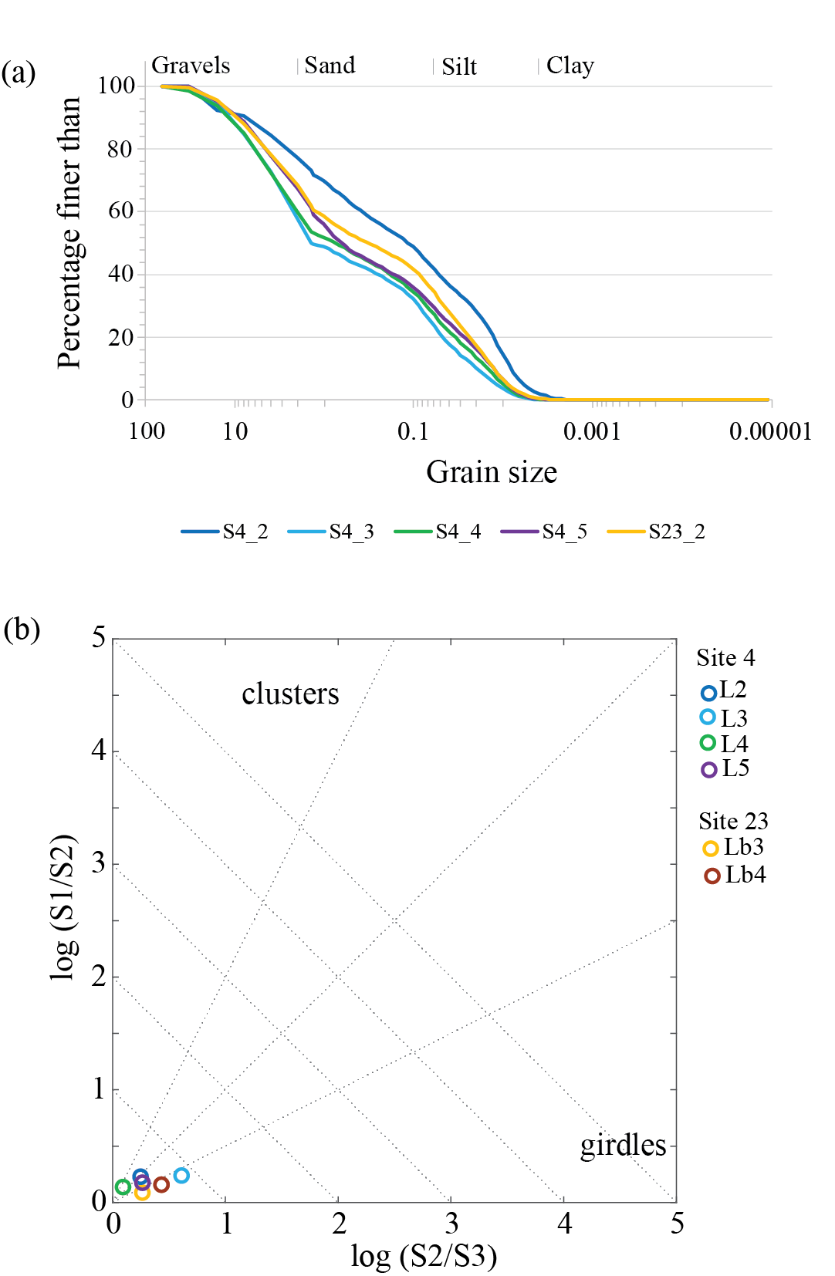

Supplement 1, Figure S2. (a) Grain size distribution curves for samples from Trench 4 and Hill Exposure 27. (b) Logarithmic plot of ratios of normalized eigenvalues for orientations of clast axes, depicting fabric shape. Isotropic (random) distributions plot close to the origin. After Woodcock (1977). Figure by Melanie Froude.

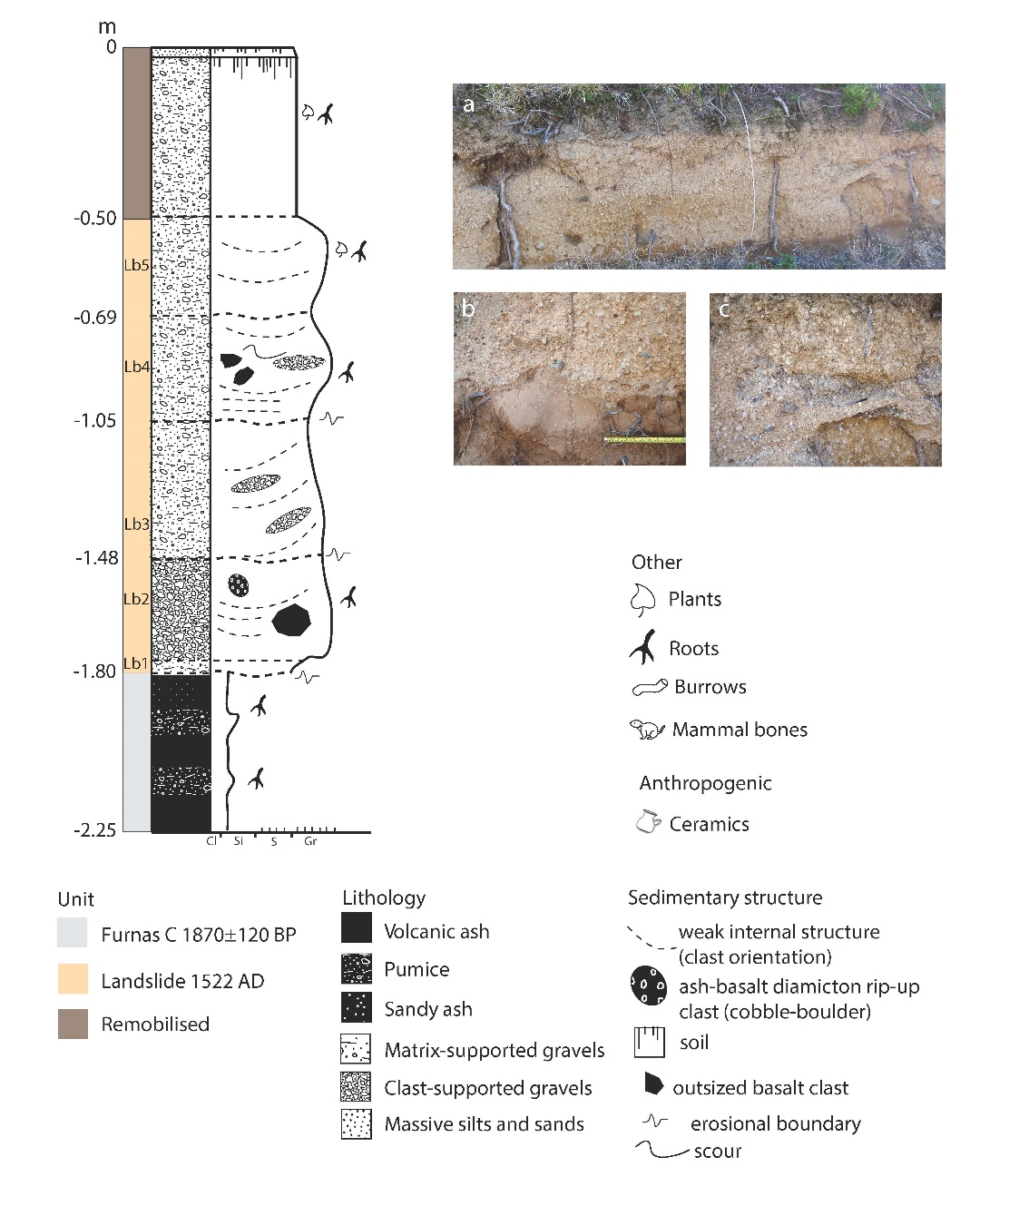

Supplement 1, Figure S3. Stratigraphic profile for Hillside Exposure 27 with (a) overview, (b) base of landslide deposit showing erosion and mixing with Furnas-C ash, and (c) clast-supported scour. Figure by Melanie Froude and Alejandra Gutiérrez.

Supplement 2 – Micromorphology (Trench 4)

Methodology
The block taken in the field from Trench 4 (for location see main text, Figure 3, for stratigraphic position see main text, Figure 5) was encased in plaster of Paris for transport, and sawn open in the laboratory at Durham University, where it was cleaned, moistened, photographed, and sampled using aluminium Kubiena tins. The block samples were air dried, embedded in crystic polyester resin, and thin sectioned on 60 × 90 mm glass slides at the Department of Geology, Ghent University, following the method described by Murphy (1986). Thin sections were scanned on a flatbed scanner, studied on a light table, and analysed with petrographic microscopes at magnifications ranging from ×4–400 with plane-polarized light (PPL), cross-polarized light (XPL) and oblique-incident light (OIL) following Bullock et al. (1985) and Stoops (2003).

Results
The analysis of the stratigraphy visible in the monolith and the two micromorphology samples extracted from it reveals additional details about the physical characteristics of the landslide deposit, the nature of the original soils in this location, and the impact of the landslide on those soils (see Figure 5, main text). The landslide deposit was coarse and poorly sorted, with coarse sand and gravel up to 2 cm in diameter embedded in a yellow-brown silt-loam. The gravel was predominantly a light grey rhyolitic pitchstone with ‘perlitic’ (spherical) cracks, often containing phenocrysts of quartz. Being a volcanic glass, pitchstone fractures easily, and all the gravel pieces in the landslide deposit showed evidence of abrasion by rolling: they had rough edges, but were rounded or subrounded in shape. In thin section 1, which captured the lower 4 cm of the landslide deposit, it was possible to see that each piece of gravel was surrounded by a yellow-brown silt-loam, but compressed between them were aggregates of a different fabric—a darker brown, more organic and better sorted soil similar to the underlying buried soil (Supplement 2, Figure S4a).
There was abundant evidence for the disturbance of the original ground surface during the landslide event. The boundary between the yellowish landslide deposit and the underlying medium-brown soil was sharp but strongly undulating (see Figure 5, main text), and the uppermost layer of vegetation, roots, and root channels had been completely scoured away. Gravel, and indeed pitchstone fragments of any size, were absent from the original soil, but the uppermost 3 cm of the buried soil was perforated by numerous pitchstone gravel pieces from the landslide deposit, which had been pressed down into it when the surface was disturbed. Many of these gravel fragments still had the yellow-brown loam of the landslide deposit adhering to their outer edges (Supplement 2, Figure S4b).
The soil buried by the landslide deposit was a medium-brown silt-loam containing features characteristic of a lower A or A/B horizon, the lowermost part of a topsoil. The colour was caused by the organic pigmentation of the fine organo-mineral material by humic substances (fulvic acid, humic acid, and humin), which are released upon the microbial decomposition of organic matter (Ismail-Meyer et al., 2018). The brown colour visible to the naked eye was also imparted by silt- and clay-sized black and dark brown punctuations in the fine mineral material (5–10%), some of which were fragments of amorphous organic matter, and others of which are more likely to be opaque minerals, such as manganese. Viewed between crossed polars, the fine organo-mineral material had a stipple-speckled birefringence fabric caused by the presence of minute patches of oriented clay that were randomly distributed throughout the matrix. This soil horizon also contained phytoliths (<2%), and a few minute fragments of charred wood (<1%), charred seeds (trace amounts), and bone (trace amounts), which indicate the close proximity of human settlement (Supplement 2, Figures S4c–e).
The buried soil contained numerous soil fauna channels (c. 20%), many of which were partially infilled by excrements. Some of these channels crossed the boundary with the landslide deposit above (see Figure 5, main text), indicating that earthworms and other soil fauna buried by the landslide event had attempted to work their way back up to the surface. Channels dominated the microstructure of the buried soil, but it also had a weakly developed subangular blocky structure, which is caused by the repeated swelling and shrinking of clay. Both channel and subangular blocky microstructures tend to occur in subsurface soils, with channels occurring where soil fauna are still somewhat active, but less so than in the surface horizons, where their intensive reworking of the soil matrix produces crumb and granular microstructures (Kooistra & Pulleman, 2018; Gerasimova & Lebedeva, 2018).
Other pedofeatures visible in the thin sections also support the view that the sealed soil was the lower part of an A horizon or an A/B transition zone. For example, the fine organo-mineral material had a brighter reddish hue in zones where there were weakly or moderately impregnative iron oxide nodules (2–5%) (Supplement 2, Figure S4e). These redoximorphic features form when iron is reduced and translocated by water (in this case rainwater), and then oxidises and precipitates from the soil solution when drier conditions prevail, accumulating as iron oxides in the soil matrix (Vepraskas et al., 2018). Even more telling, the lower surfaces of a few voids contained orange-brown, micro-laminated coatings of illuvial clay (<1%), which was lightly speckled due to the presence of clay-sized black particles (Supplement 2, Figure S4f).
In cross-polarized light, the clay in the coatings was clearly well-oriented: it had first order yellow and orange interference colours, and extinction lines swept through the curved coatings when the stage was rotated. Such clay coatings form when fine clay is dispersed from upper horizons and is transported, suspended in water, downwards through conducting pores. The eluviated clay is then deposited lower down the soil profile on pore walls when the water velocity or supply stops (Kühn et al., 2018). The presence of clay coatings in the buried soil immediately below the landslide deposit therefore provides strong evidence that there had been an upper A horizon, which was truncated by the landslide event. It should be noted that the clay coatings in this buried soil are not the very dusty, greyish-black coatings commonly associated with vegetation disturbance such as deforestation, or with cultivation (Adderley et al., 2018; Kühn et al., 2018).
a | b
c | d
e | f
Supplement 2, Figure S4. Photographs illustrating key features observed in thin sections MM1-2:
- Lower part of the landslide deposit, with rounded and subrounded coarse sand- and gravel-sized rhyolitic pitchstone embedded in yellow-brown silt loam, and, in the centre, an aggregate of brown silt-loam derived from the disturbed A horizon.
- Top of the truncated A horizon, showing a pitchstone gravel fragment pressed down into the soil, with the yellow-brown silt-loam of the landslide deposit still adhering to its edges.
- Charred wood fragment in the lower A or A/B horizon. The surrounding matrix takes its brown colour from organic pigmentation and minute black punctuations.
- Charred trigonous seed, indeterminate, in the lower A or A/B horizon.
- Highly weathered bone in the lower A or A/B horizon. The bone is reddened by the precipitation of iron oxides, and in the surrounding matrix the red hues of weakly to moderately impregnative iron nodules are visible.
- Clay coating in the lower A or A/B horizon.

Supplement 3 – Finds quantifications

Table S1. Density of finds in destruction layers under the landslide in Trench 26. Table by Alejandra Gutiérrez.
 | Volume of excavated soil (m³) | Finds per m³ | Total number of finds
26013 | 0.08 | 7800.0 | 624
26016 | 0.08 | 8275.0 | 662
26017+26018 | 0.13 | 1053.8 | 137
26019 | 0.06 | 4350.0 | 261
26020 | 0.14 | 1614.3 | 226
26023 | 0.13 | 1353.8 | 176
All destruction layers together | 0.62 | 24446.9 | 2086

Table S2. Numbers and densities of finds in the landslide across all trenches. Table by Alejandra Gutiérrez.
Trench | Context | Landslide soil volume (m³) | Total number of finds | Finds per m³
 | Landslide contexts
4 | 4002 | 13.5 | 8 | 0.6
7 | 7002 | 6.3 | 0 | 0
8 | 8002 | 18.4 | 0 | 0
9 | 9002 | 28.6 | 0 | 0
10 | 10002 | 13.0 | 0 | 0
11 | 11002 | 21.6 | 0 | 0
12 | 12006,7,8 | 24.0 | 2 | 0.1
13 | 13002,3 | 17.6 | 0 | 0
17 | 17021 | 8.2 | 0 | 0
18 | 18043,45 | 2.2 | 37 | 16.5
19 | 19005 | 0.5 | 6 | 13.3
22 | 22006 | 12.0 | 10 | 0.8
26 | 26006 | 0.5 | 6 | 12.0
 | Landslide toe contexts
25 | 25027, 25028, 25029, 25030** | 2.1 | 531 (a) | 252.9
 | ** includes 364 pottery sherds, 8 coins, 9 dress pins, 2 lace tags, 1 button, 8 nails, 21 glass sherds

References
Adderley, W.P., Wilson, C.A., Simpson, I.A. & Davidson, D.A. 2018. Anthropogenic Features. In: G. Stoops, V. Marcelino & F. Mees, eds. Interpretation of Micromorphological Features of Soils and Regoliths (2nd ed.). Amsterdam: Elsevier, pp. 753–77.
Bullock, P., Fedoroff, N., Jongerius, A., Stoops, G., Tursina, T. & Babel, U. 1985. Handbook for Thin Section Description. Wolverhampton: Waine Research Publications.
Gerasimova, M. & Lebedeva, M. 2018. Organo-Mineral Surface Horizons. In: G. Stoops, V. Marcelino & F. Mees, eds. Interpretation of Micromorphological Features of Soils and Regoliths (2nd ed.). Amsterdam: Elsevier, pp. 51–538.
Ismail-Meyer, K., Stolt, M.H. & Lindbow, D.L. 2018. Soil Organic Matter. In: G. Stoops, V. Marcelino & F. Mees, eds. Interpretation of Micromorphological Features of Soils and Regoliths (2nd ed.). Amsterdam: Elsevier, pp. 471–512.
Kooistra, M.J. & Pulleman, M.M. 2018. Features Related to Faunal Activity. In: G. Stoops, V. Marcelino & F. Mees, eds. Interpretation of Micromorphological Features of Soils and Regoliths (2nd ed.). Amsterdam: Elsevier, pp. 447–69.
Kühn, P., Aguilar, J., Miedema, R. & Bronnikova, M. 2018. Textural Pedofeatures and Related Horizons. In: G. Stoops, V. Marcelino & F. Mees, eds. Interpretation of Micromorphological Features of Soils and Regoliths (2nd ed.). Amsterdam: Elsevier, pp. 377–423.
Murphy, C.P. 1986. Thin Section Preparation of Soils and Sediments. Berkhampstead: AB Academic Publishers.
Stoops, G. 2003. Guidelines for Analysis and Description of Soil and Regolith Thin Sections. Madison (WI): Soil Science Society of America.
Vepraskas, M.J., Lindbo, D.L. & Stolt, M.H. 2018. Redoximorphic Features. In: G. Stoops, V. Marcelino & F. Mees, eds. Interpretation of Micromorphological Features of Soils and Regoliths (2nd ed.). Amsterdam: Elsevier, pp. 425–45.
Woodcock, N.H. 1977. Specification of Fabric Shapes Using an Eigenvalue Method. Geological Society of America Bulletin, 88: 1231–36.

